Table AI. Demographic information of participating respondents and organizations (n = 340)
 | n | % |  | n | %
Position |  |  | Full-time equivalent employees
Top-level managers | 97 | 28.5 | 201–500 | 81 | 23.8
Mid-level managers | 243 | 71.5 | 501–1,000 | 95 | 27.9
Tenure (years) |  |  | 1,001–5,000 | 98 | 28.8
2–5 | 160 | 47.1 | 5,001–10,000 | 30 | 8.8
6–10 | 108 | 31.8 | > 10,000 | 36 | 10.6
11–20 | 56 | 16.5 | Total assets (VND billion)
> 20 | 16 | 4.7 | 101–200 | 116 | 34.1
Industry type |  |  | 201–500 | 108 | 31.8
Manufacturing | 85 | 25.0 | 501–1,000 | 74 | 21.8
Trading | 75 | 22.1 | > 1,000 | 42 | 12.4
Services | 180 | 52.9 | Organizational age (years)
Ownership structure |  |  | ≤ 5 | 15 | 4.4
Without foreign capital | 223 | 65.6 | 6–10 | 46 | 13.5
With foreign capital | 117 | 34.4 | 11–20 | 143 | 42.1
 |  |  | 21–50 | 120 | 35.3
 |  |  | > 50 | 16 | 4.7

Table AII. Scale items and evaluation
 | Outer loading | t-value
Accountants’ participation in strategic decision making (CR = 094; AVE = 0.76)
Identifying problems and proposing objectives | 0.86 | 41.79
Generating options | 0.91 | 77.28
Evaluating options | 0.90 | 82.82
Developing details about options | 0.87 | 57.85
Taking the necessary actions to put changes into places | 0.80 | 29.75
Accounting capacity (CR = 0.95; AVE = 0.64)
Good professional knowledge of accounting | 0.84 | 17.46
Good general business knowledge | 0.82 | 17.51
Good knowledge of global issues | 0.81 | 25.63
Good knowledge of information technology | 0.83 | 17.80
Good communication skills | 0.75 | 14.61
Good problem-solving skills | 0.85 | 23.27
Good computer skills | 0.74 | 11.70
Good leadership | 0.81 | 14.75
Confident working attitude | 0.82 | 16.58
Professional working style | 0.72 | 16.47
Love the job and gaining new knowledge | 0.73 | 14.36
Work with a serious and honest attitude | 0.77 | 14.40
Have leadership skills | 0.86 | 17.29
Use of Management Accounting Systems
Scope (CR = 0.86; AVE = 0.61)
Information that relates to possible future events (if historical information is most useful for your needs, mark the lower end of the scale) | 0.73 | 23.67
Non-financial information that relates to production and market information such as growth share etc. (If you find that financial information is most useful for needs, please mark the lower end of the scale.) | 0.80 | 33.97
Non-economic information, such as customer references, relations, attitudes of government and consumer bodies, competitive threats, etc. | 0.83 | 44.05
Information on broad factors external to your organization, such as economic conditions, population growth, technological developments, etc. | 0.76 | 31.43
Timeliness (CR = 0.89; AVE =0.66)
Requested information arrives immediately upon request | 0.83 | 49.24
Information supplied to you automatically upon its receipt into information systems or as soon as processing is completed | 0.85 | 56.93
There is no delay between an event occurring and the relevant information being reported to you | 0.79 | 32.84
Requested information arrives immediately upon request | 0.78 | 34.84
Aggregation (CR = 0.88; AVE = 0.70)
Information in forms, which enables you to conduct what-if analysis. | 0.85 | 42.54
Information on the effects of events on particular time periods (e.g., monthly/quarterly/annual summaries, trends, comparisons, etc. | 0.83 | 37.75
Information in formats suitable for input into decision models (such as discounted cash flow analysis or incremental marginal analysis) | 0.84 | 45.37
Integration (CR = 0.90; AVE = 0.69)
Cost and price information of departments of your business unit | 0.79 | 33.02
Presence of precise targets for each activity performed in all sections within your department | 0.86 | 57.52
Information that relates to the impact that your decisions have on the performance of other departments | 0.82 | 40.58
Information on the impact of your decisions throughout your business unit, and the influence of other individual’s decisions on your area of responsibility | 0.84 | 54.69
Firm performance (CR = 0.85; AVE = 0.54)
Return on investments (ROI) | 0.79 | 31.76
Return on sales (ROS) | 0.68 | 16.04
Sales growth | 0.76 | 26.10
Return on assets (ROA) | 0.72 | 22.51
Overall profitability | 0.71 | 18.22

Table AIII. Discriminant validity analysis
 | 1____ | 2____ | 3____ | 4____ | 5____ | 6____ | 7____
1. APAR | 0.87
2. Scope | 0.40** | 0.78
 | 0.46
3. Timeliness | 0.45** | 0.64** | 0.81
 | 0.52 | 0.79
4. Aggregation | 0.42** | 0.53** | 0.65** | 0.84
 | 0.50 | 0.67 | 0.81
5. Integration | 0.48** | 0.59** | 0.69** | 0.72** | 0.83
 | 0.54 | 0.71 | 0.83 | 0.89
6. ACAP | -0.07 | 0.17** | 0.16** | 0.13* | 0.11 | 0.80
 | 0.09 | 0.19 | 0.17 | 0.14 | 0.12
7. Firm performance | 0.27** | 0.36** | 0.44** | 0.36** | 0.38** | 0.22** | 0.73
 | 0.32 | 0.45 | 0.54 | 0.44 | 0.47 | 0.24
Notes: 1st value = Correlation between variables (off diagonal); 2nd value (italic) = HTMT ratio; Square root of average variance extracted (bold diagonal); *, **: Correlations significant at the 5% and 1% levels (two-tailed t-test) respectively

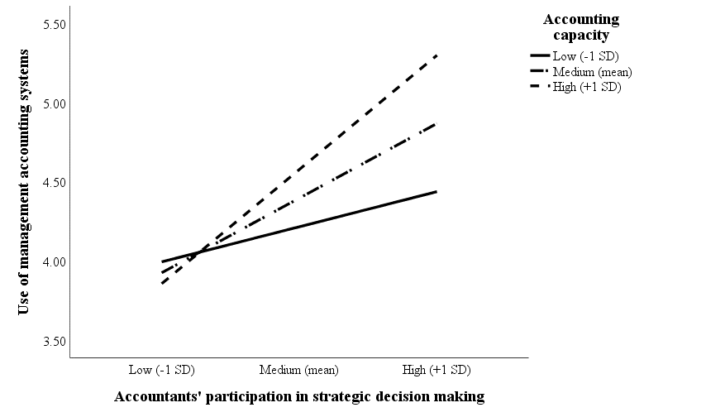
Figure AI. Interaction effect of APAR with ACAP on use of MAS

