Table IV Vignettes of Alpha’s BSRI process developed within the turbulent business network with the support of a third actor
Vignette 1
Turbulent Network’s Influence on the Parties | Key Quotes
Context: 2021.  COVID-19 lockdowns disrupted traditional sales channels (e.g., the Ho.Re.Ca. channel was forced to close), leading to an increased reliance on e-commerce platforms. High levels of uncertainty and vulnerability characterised the business network.  Buyer (Teta): The owner of Teta (an e-commerce platform) felt pressure to increase the number of suppliers to avoid supply chain disruptions.  Seller (Alpha): The CEO of Alpha felt the urge to develop new business relationships to navigate the disruptions caused by the Ho.Re.Ca. crisis. | (a) ‘I remembered Alpha when I was looking for wines for my e-commerce site; my brother-in-law had spoken well of them…’ –Teta’s owner  (b) ‘For me, deciding to contact Alpha was easy; it is a company with a great local reach, plus it had been recommended to me by my brother-in-law...I think contacting it was the logical thing to do…’ –Teta’s owner  (c) ‘He told me that he knew us through a common kinship… I discovered it was the husband of my brother’s wife’s sister’ Alpha’s CEO
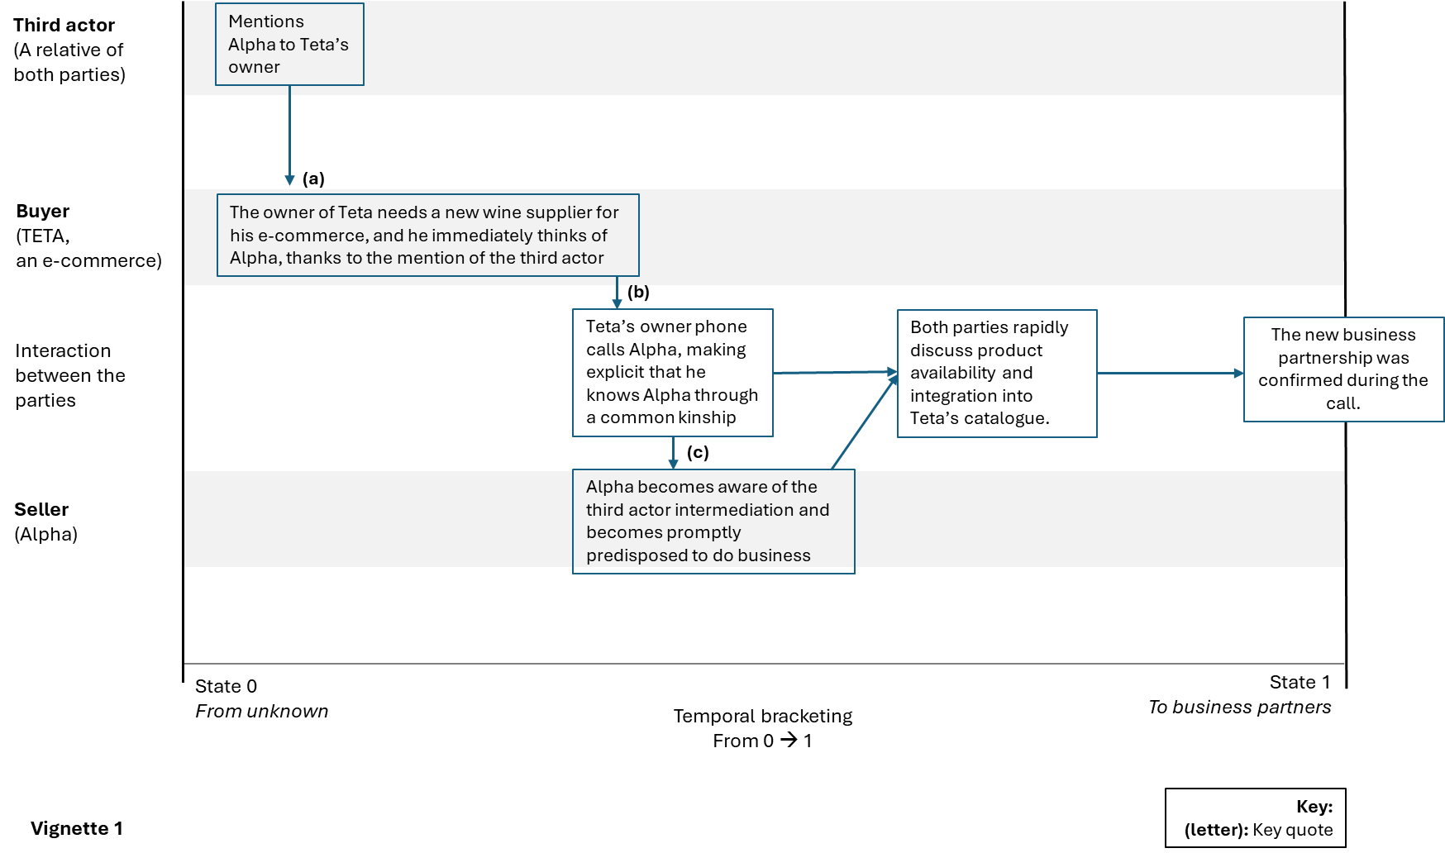
Vignette 2
Context: 2021.  COVID-19 lockdowns disrupted traditional sales channels (e.g., the Ho.Re.Ca. channel was forced to close), causing high levels of uncertainty and vulnerability that characterised the business network.  Buyer (Wine bar): Felt uncertain and urged to recover from revenue losses incurred during lockdowns.  Seller (Alpha): In its efforts to establish new business relationships, Alpha recognised the importance of increasing its reputation and thus sought access to prestigious retailers to enhance its legitimacy in a volatile market context. | (a) ‘An insurance broker put me in touch with the wife of the owner of a famous wine bar where I was interested in being present with my wines. The wife actively helps her husband run the bar. The insurance broker gave me the opportunity to contact her by phone’. –Alpha’s CEO  (b) ‘I tried several times, and the wife answered, but through excuses such as the time of year, full cellar and the like, she always postponed the meeting’. –Alpha’s CEO  (c) Then, one day, the insurance broker invited this woman as a guest to Omega, an association of entrepreneurs devoted to developing business opportunities, which used to meet on Thursday mornings, of which this insurance broker and I are members… On the Thursday in question, it was my turn to present the company… –Alpha’s CEO  (d) …she quickly organised a meeting with her husband, the owner of the wine bar, who then became my client…’ –Alpha’s CEO
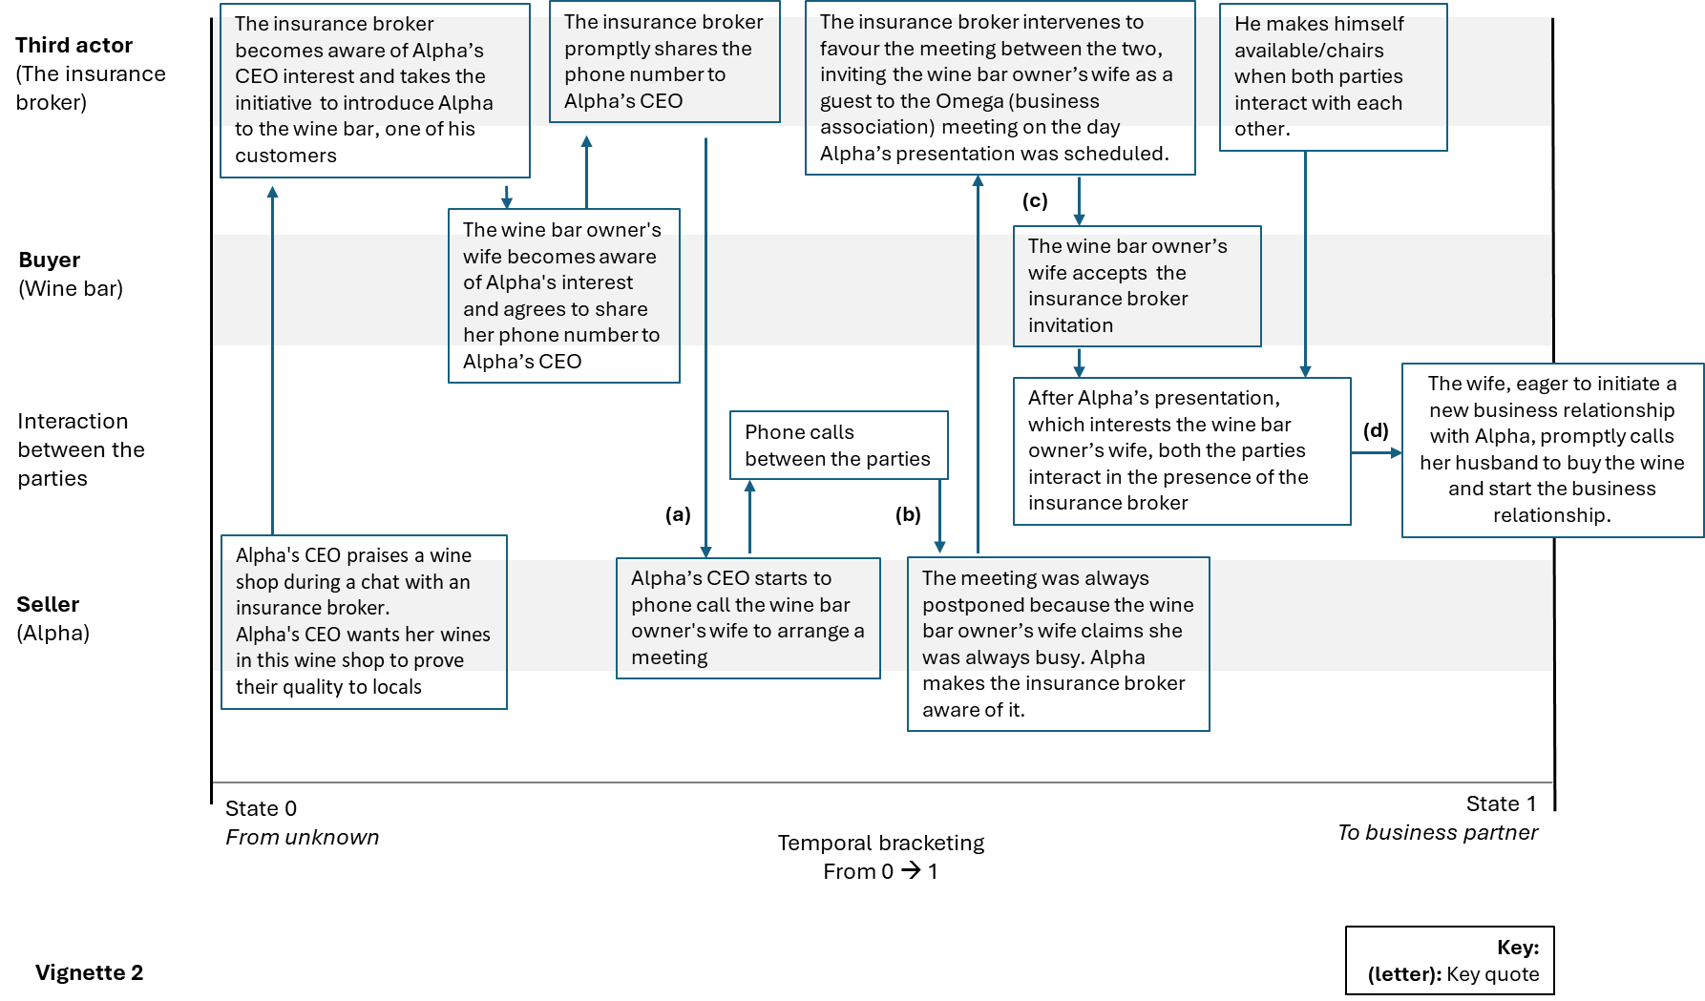
Vignette 3
Context: 2021. A university in the Alpha region was seeking a local wine supplier for its upcoming conference gala dinner. The uncertainty surrounding large-scale events due to the global pandemic and unclear national policies regarding the possibility of organising social events posed a challenge for conference planning. Once the conference was confirmed, the organisers had just two weeks to prepare dinner. Once the relationship had been established, as shown in the vignette, the university continued to rely on the winery also for the conferences that followed.  Buyer (University): Once the conference was confirmed, the organisers had just two weeks to prepare dinner. However, the university’s procurement procedures involved extensive paperwork, which left insufficient time to explore local wineries.  Seller (Alpha): Alpha’s CEO wanted to develop new business relationships after Ho.Re.Ca. disruptions to survive, exploiting any short windows of opportunity. | (a) ‘Having listened to the organisers’ requirements, I immediately thought of Alpha, which was a winery I had heard a lot of good things about…’ –PhD student  (b) ‘I had no budget to manage…my task was just to connect the small winery I thought of and my superiors..’. –PhD student  (c) ‘So, I went to meet the owner of Alpha, who welcomed me to the winery and explained to me which products she had available best suited our needs. Alpha immediately had the availability of that product, which was not taken for granted and was crucial for us at that moment…’ –PhD student  (d) ‘The trust that Alpha’s owner gave me, I immediately made my superiors, the conference organisers, perceive it… I must say that Alpha’s willingness to collaborate right away made all the difference. She was also willing to invoice us immediately and be paid comfortably after the event to meet our tight deadlines and other bureaucratic delays… So, let’s say that she also trusted my intermediation’. –PhD student
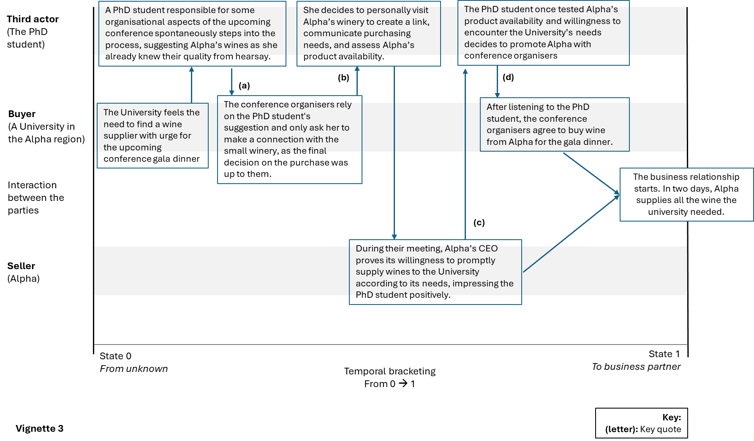
Vignette 4
Context: 2023. The ongoing Russia–Ukraine conflict led to geopolitical instability, resulting in rising energy costs in Italy and a significant increase in inflation. Italian wine businesses faced declining consumption and higher costs for raw materials, energy and transportation in 2023. A major challenge was the increased borrowing costs due to inflation and rising ECB interest rates, which had nearly doubled financial expenses compared to 2022. Furthermore, there was growing uncertainty for small wineries, with new European wine label regulations set to come into force in December 2023, leading to further costs and management complexities as wineries adapted.  Buyer (Sigma): Needed to replace a historical local partner that had suddenly closed while also addressing rising costs.  Seller (Alpha): Urgently needed to develop new business relationships to counteract increasing production and financial costs. | (a) ‘… one day, my daughter tells me: Did you know that Mattia’s dad makes wine? … By dint of hearing that, I became curious..’–Sigma’s owner  (b) ‘...then the first time he came here (Sigma’s site), I told him: Tell your father if he brings us business cards, or maybe a few bottles of wine...It all started really just for fun’.–Sigma’s owner  (c) ‘I contacted them directly …you know, having children who are friends and go out together, it is as if we almost know each other... the cognitive approach is much faster this way’. –Sigma’s owner  (d) ‘... when we are introduced to it by someone we trust, we automatically take the company seriously... you have already stepped forward regarding trust in that company… you have fewer doubts’. –Sigma’s owner
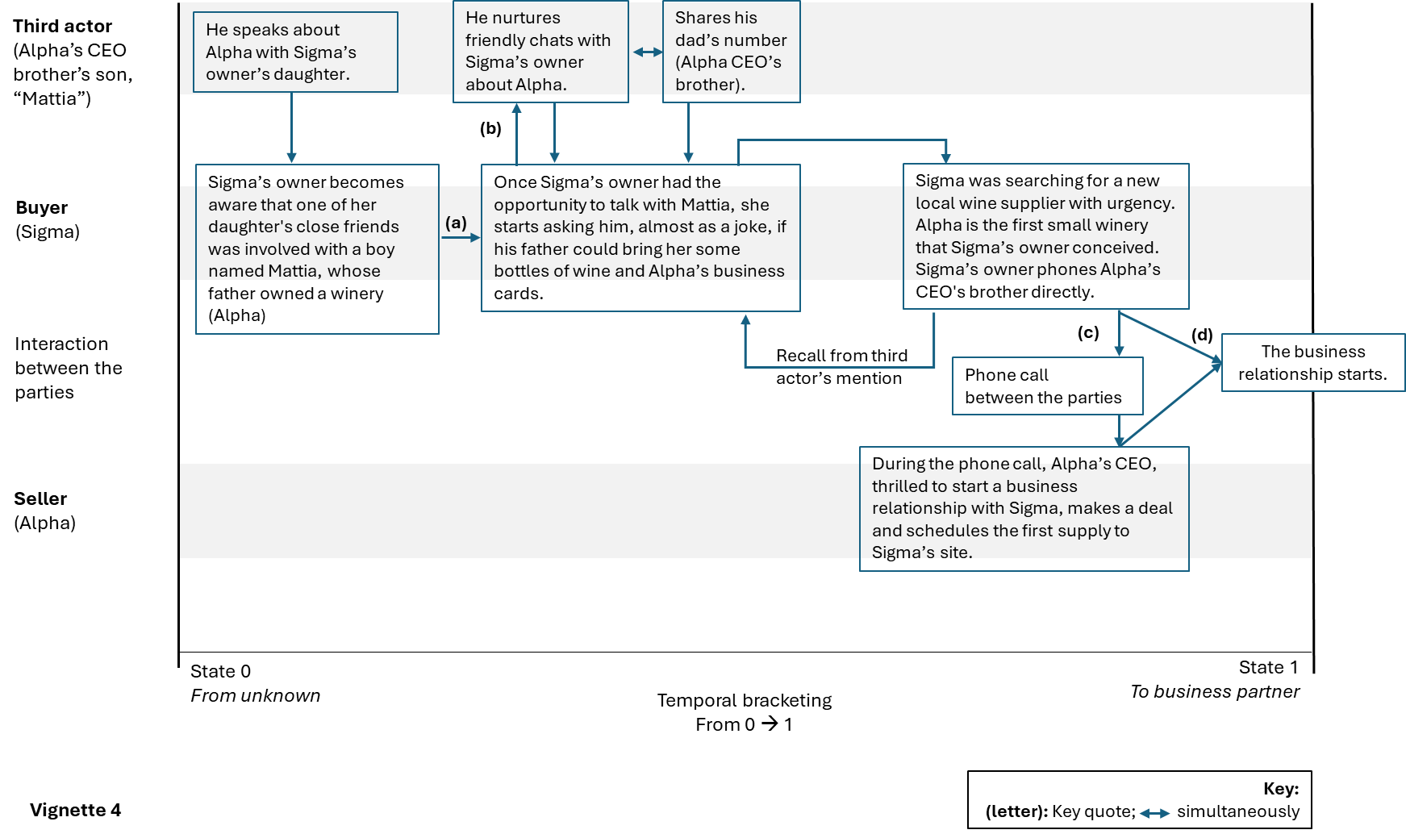
Vignette 5
Context: 2023. New ownership and high-cost pressure due to rising inflation, resulting from the increased costs of raw materials and financial borrowing.  Buyer (Restaurant Gamma): Needed to open quickly before the peak season to limit economic loss.  Seller (Alpha): Needed to replace a lost buyer (the former owner of Gamma) in an increasingly unpredictable business context. | (a) ‘Today’s market is difficult; you always have to go 100 (km) per hour…’ –CEO of Restaurant Gamma  (b) ‘When I took over the restaurant management, I had to review and take over the menu and the relationship with suppliers. So, I spoke to the former owner’ –CEO of Restaurant Gamma  (c) ‘The former owner advised me to arrange a meeting with Alpha; she left me Alpha’s CEO’s phone number’ –CEO of Restaurant Gamma  (d) ‘Convinced by the relationship they had with the former owner, I decided to buy from them too’. –CEO of Restaurant Gamma
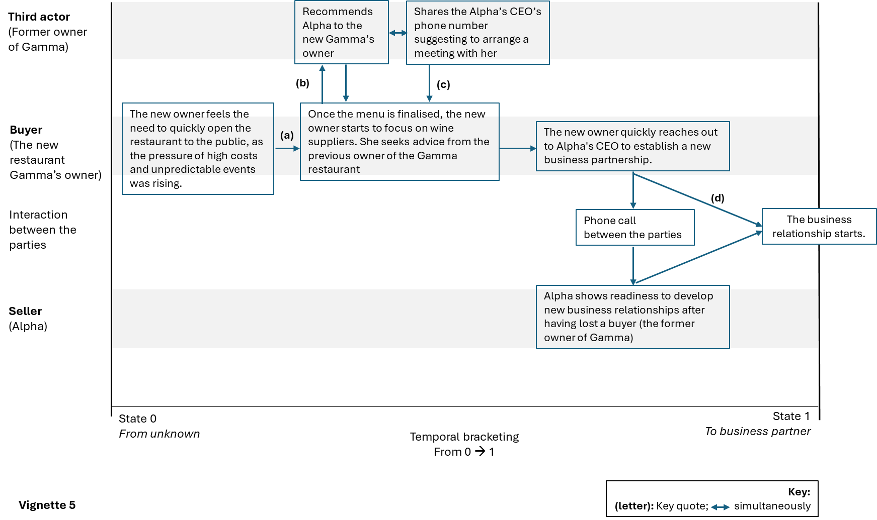
Vignette 6
Context: 2023. New ownership, high-cost pressure due to rising inflation (increasing costs of raw materials, e.g., energy, and financial borrowing).  Buyer (Restaurant Delta): The Delta restaurant’s owner urgently sought wine on tap during the busy summer season. He suddenly discovered that his long-standing distributor had exited the wine-on-tap business due to difficulties that had arisen and had decided to concentrate only on the distribution of soft drinks.  Seller (Alpha): Needed to develop new business relationships to counteract increasing production and financial costs. | (a) ‘I needed wine on tap for my restaurant immediately. I told it to my distributor…’ –CEO of Restaurant Delta  (b) ‘(the distributor) …practically made me put Alpha wine directly into the dispensing system without asking me anything. I trusted my distributor..’ –CEO of Restaurant Delta
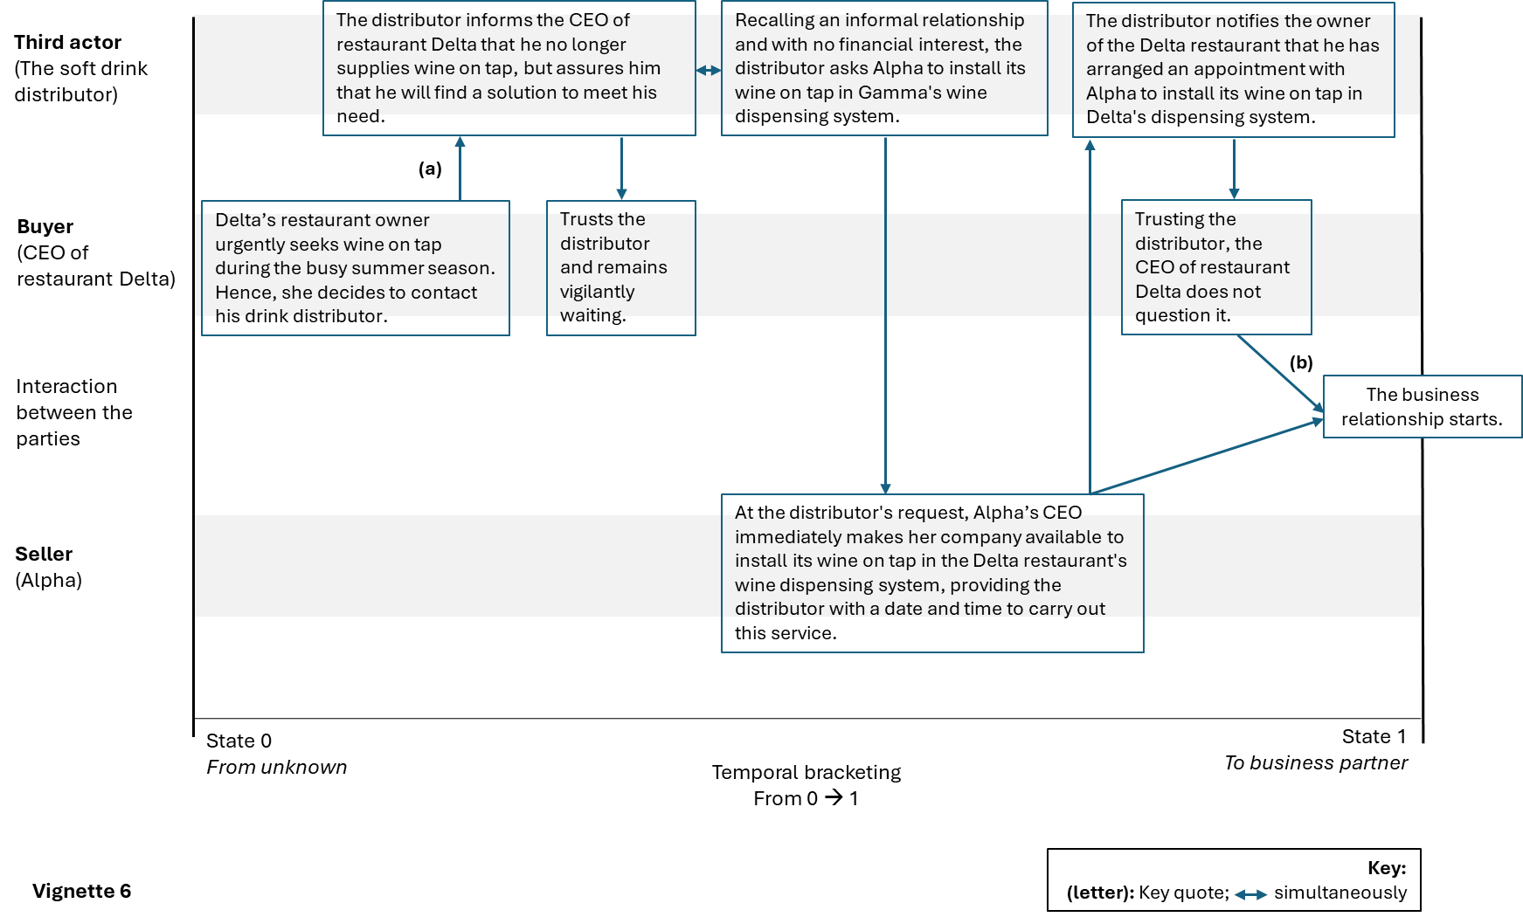
Vignette 7
Context: Just after the second national COVID-19 lockdown ended in 2021. High levels of uncertainty and vulnerability characterised the business network.  Buyer: A restaurant known to Alpha’s CEO’s friend.  Seller (Alpha): For Alpha, every ‘national reopening policy’ was like starting from zero; in fact, during lockdowns, some of his long-standing partners closed, and it was always a race to replace them with new buyers. | (a) ‘...one of these friends once told me: I know this restaurant very well, …’ –CEO of Alpha  (b) ‘If you want, I will take you there. Will you come? So, I went there’–CEO of Alpha  (c) He kept telling me: I would introduce you, so you could talk to him and show him your products’. –CEO of Alpha  (d) ‘Thanks to this friend, the meeting with the restaurateur went well, and we immediately started a business relationship that continues to this day..’. –CEO of Alpha
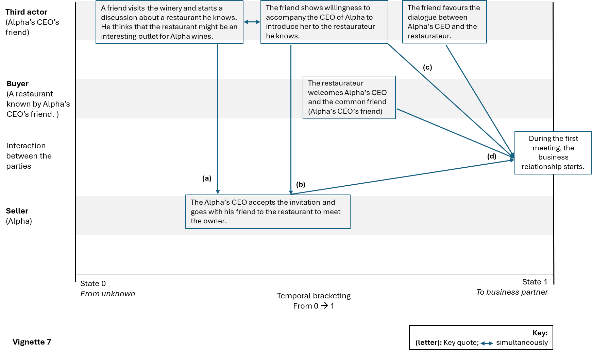
Source: Authors own work

