Supplementary material I

This supplementary appendix (a-b) is linked to the article entitled “The potential of the Blue Economy to promote the generation of sustainable employment in the European Union.” It contains valuable content that could not be accommodated within the journal’s word limit and is made available here for transparency and scholarly completeness. In particular, the document expands upon the introductory part and complements the full methodological framework in its original depth, offering conceptual and procedural elements that were necessarily abbreviated in the main submission.

Appendix A. Extended Introduction
[…] However, strictly speaking the Blue Economy is part of the Green Economy (Dornan et al., 2018; Dziura, 2016; Lavrikova et al., 2021) and represents one of the fundamental pillars of the European Green Deal (European Commission, 2021). In the same way, the Blue Economy targets are represented within the UN Sustainable Development Goals (UN-GA, 2015), fundamentally from SDGS 7, 8, 9, and 14 (“Affordable and clean energy”, “Decent work and economic growth”, “Industry, Innovation and Infrastructure”, and, “Life below water”, respectively) (Jentoft & Chuenpagdee, 2022; Lavrikova et al., 2021; Tirumala & Tiwari, 2022). UIn any event, the Blue Economy also suffers from several weaknesses intrinsic to its own nature since its analyses have to cope with different relative sizes, conceptualizations and characterizations (Graziano et al., 2022). Such elements shape a truly complex field of study (Burgess et al., 2018; Keen et al., 2018), hindering the obtaining of an objective picture of the results achieved by the implementation of blue policies in productive sectors (Reinertsen & Asdal, 2019). Notably, in some cases the variables that characterize this field are difficult to quantify, since not only purely economic effects are recorded, but also the ethical-moral aspect of their implementation such as social inclusion (United Nations, 2017) or social and territorial cohesion (Soma et al., 2018).
Regardless that many countries and transnational areas have opted to adhere to the principles of the Blue Economy, today we are still far away from the creation of 100 million jobs in a 10- year time horizon, one of the goals initially set by Pauli (2010), The European Union has been one of them during the last decade. This research project has chosen to perform a panel data

analysis of the 27 member states of the European Union to determine which are the main drivers of this phenomenon throughout Europe. Likewise, to obtain a greater depth in our analysis, we have analyzed the joint evolution of the Blue Economy in Europe throughout the period 2009- 2017 and we have differentiated the creation of blue jobs from the different oceanic facades belonging to the European Union.

Appendix B. Full Methodological Details
[…] A certain degree of synergies between some of the variables analyzed can be inferred from the correlation matrix (Pearson, 1896) presented in A. As a general rule, all the described correlations are positive, except for the variables OE, PA, SAR, and MT, concerning the dependent variable (BEJ), although their level of correlation may be considered quite limited. In fact, there is no significant correlation between the dependent variable and the explanatory variables. On the other hand, the positive correlation between variables PA versus MT and SAR, and, to a lesser degree, versus LR, is noteworthy. Likewise, the strong relationship between the variables CT and LR is also noteworthy. Such relationships can be explained given the close link and feedback between port activities and maritime transport. In the same way, very often, tourist centers are also, in dual form, fishing centers, a feature that would also explain the correlation between both variables (Table A).

Table A.: Pearson Correlation Matrix. Source: authors’ own elaboration; data from EU Blue Indicators (Blue Indicators, 2020).
Variables | BEJ | LR | NLR | OE | PA | SAR | MT | CT
BEJ | 1 | 0.018 | 0.043 | -0.081 | -0.204***  (0.001) | -0.153***  (0.012) | -0.097 | 0.301***  ( 0.0001)
LR |  | 1 | 0.195***  (0.001) | 0.113 | 0.674***  ( 0.0001) | 0.712***  ( 0.0001) | 0.432***  ( 0.0001) | 0.890***  ( 0.0001)
NLR |  |  | 1 | 0.004 | 0.163***  (0.007) | 0.479***  ( 0.0001) | 0.225***  (0.000) | 0.158***  (0.009)
OE |  |  |  | 1 | 0.540***  ( 0.0001) | 0.309***  ( 0.0001) | 0.598***  ( 0.0001) | 0.055
PA |  |  |  |  | 1 | 0.869***  ( 0.0001) | 0.818***  ( 0.0001) | 0.479***  ( 0.0001)
SAR |  |  |  |  |  | 1 | 0.716***  ( 0.0001) | 0.529***  ( 0.0001)
MT |  |  |  |  |  |  | 1 | 0.329***  ( 0.0001)
CT |  |  |  |  |  |  |  | 1
Where significance level *** denotes the p-values less than 0.001.

[…] Such assumptions are ascertained in Figure A in which it can be noted how the residual terms of the Fixed Effects Model are substantially lower than those of the Random Effects Model (uˆ²).

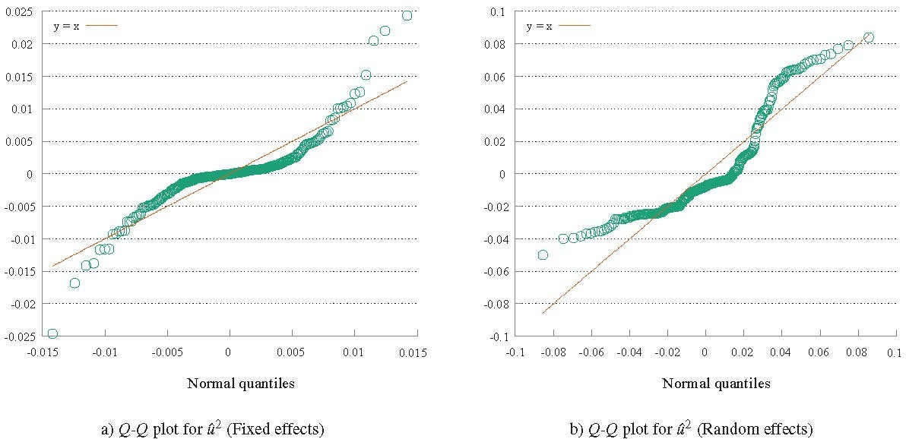

Figure A.: Residual Q-Q plot. Source: authors’ own elaboration; data from EU Blue Indicators (Blue Indicators, 2020).

References

Blue Indicators. (2020), “Sea basin employment”, available at: blueindicators.ec.europa.eu/sites/default/files/2020Employment-Seabasins-web.xlsx, accessed 29 September 2022.
Burgess, M. G., Clemence, M., McDermott, G. R., Costello, C., & Gaines, S. D. (2018). Five rules for pragmatic blue growth. Marine Policy, 87, 331–339. https://doi.org/10.1016/j.marpol.2016.12.005
Dornan, M., Morgan, W., Newton Cain, T., & Tarte, S. (2018). What’s in a term? “Green growth” and the “blue-green economy” in the Pacific islands. Asia and the Pacific Policy Studies, 5(3), 408–425. https://doi.org/10.1002/app5.258
Dziura, B. (2016). Green economy and blue economy as alternative economic models in China (PRC). Actual Problems of Economics, 186(12), 215–221.
European Commission. (2021). European Green Deal: Developing a sustainable blue economy in the European Union. ec.europa.eu/commission/presscorner/detail/en/ip_21_2341, accessed 29 September 2022
Graziano, M., Alexander, K. A., McGrane, S. J., Allan, G. J., & Lema, E. (2022). The many sizes and characters of the Blue Economy. Ecological Economics, 196, 107419. https://doi.org/10.1016/j.ecolecon.2022.107419
Jentoft, S., & Chuenpagdee, R. (2022). Interactive Learning and Governance Transformation for Securing Blue Justice for Small-Scale Fisheries. Administration and Society, 54(7), 1255–1282. https://doi.org/10.1177/00953997211073947
Keen, M. R., Schwarz, A.-M., & Wini-Simeon, L. (2018). Towards defining the Blue Economy: Practical lessons from pacific ocean governance. Marine Policy, 88, 333–341. https://doi.org/10.1016/j.marpol.2017.03.002

Lavrikova, Y. G., Buchinskaia, O. N., & Wegner-Kozlova, E. O. (2021). Greening of Regional Economic Systems within the Framework of Sustainable Development Goals. Economy of Region, 17(4), 1110–1122. https://doi.org/10.17059/EKON.REG.2021-4-5
Pauli, G. A. (2010). The Blue Economy: 10 Years, 100 Innovations, 100 Million Jobs. Taos: Paradigm Publications.
Pearson, K. (1896). Mathematical Contributions to the Theory of Evolution. III. Regression, Heredity, and Panmixia. Philosophical Transactions of the Royal Society of London.
Series A, Containing Papers of a Mathematical or Physical Character, 187, 253–318.
Reinertsen, H., & Asdal, K. (2019). Calculating the Blue Economy: producing trust in numbers with business tools and reflexive objectivity. Journal of Cultural Economy, 12(6), 552–570. https://doi.org/10.1080/17530350.2019.1639066
Soma, K., van den Burg, S. W. K., Hoefnagel, E. W. J., Stuiver, M., & van der Heide, C. M. (2018). Social innovation - A future pathway for Blue growth? Marine Policy, 87, 363–
370. https://doi.org/10.1016/j.marpol.2017.10.008
Tirumala, R. D., & Tiwari, P. (2022). Innovative financing mechanism for blue economy projects. Marine Policy, 139, 104194. https://doi.org/10.1016/j.marpol.2020.104194
UN-GA. (2015). United Nations General Assembly, Resolution adopted by the General Assembly on 25 September 2015: 70/1 - Transforming our world: the 2030 Agenda for Sustainable Development. daccess-ods.un.org/tmp/4647309.78012085.html, accessed 29 September 2022
United Nations. (2017). Diving into the blue economy. www.un.org/fr/desa/diving-blue- economy, accessed 29 September 2022

