Supplementary Material
Supplementary Tables and figures related to manuscript

Figure S1. PEX main Key sectors
Source: Authors

Figure S2 . ASE main Key sectors
Source: Authors
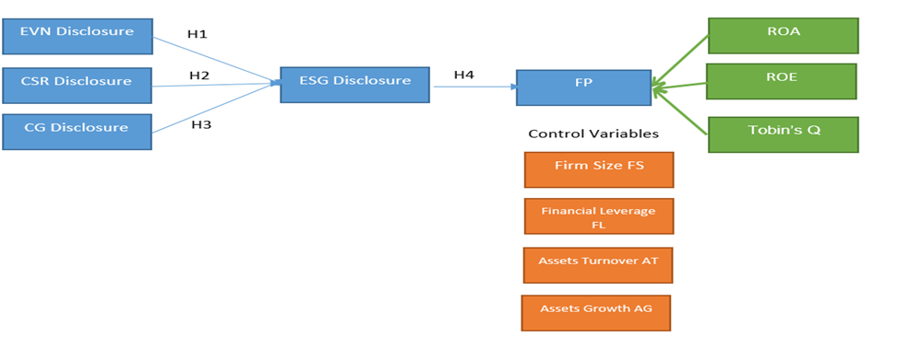
Figure S3. Study model
Source: Authors

Table S1: Descriptive Statistics and Normality Tests of the Study Variables
Variable | Mean | SD | Max | Min | Skewness | Kurtosis | Jarque-Bera (p)
Independent Variables
ESG Index | 41.320 | 15.870 | 79.450 | 13.210 | 0.420 | 2.210 | 0.000
EVN Index | 29.850 | 14.320 | 68.900 | 7.500 | 0.670 | 2.540 | 0.000
CSR Index | 33.110 | 13.950 | 74.200 | 9.800 | 0.590 | 2.380 | 0.000
CG Index | 61.470 | 8.210 | 88.300 | 26.700 | 0.810 | 3.110 | 0.000
Dependent Variables
ROA | 5.210 | 5.980 | 38.600 | -29.400 | -0.120 | 9.210 | 0.000
ROE | 13.870 | 21.430 | 201.500 | -98.700 | 2.910 | 21.870 | 0.000
Tobin’s Q | 2.110 | 1.210 | 8.900 | 0.510 | 2.010 | 8.110 | 0.000
Control Variables
Firm size (Million $) | 62,430 | 181,200 | 1,890,000 | 1,200 | 7.110 | 54.320 | 0.000
Financial Leverage | 3.210 | 3.980 | 62.100 | 1.010 | 5.210 | 41.980 | 0.000
Assets Turnover | 0.690 | 0.540 | 3.900 | 0.030 | 1.710 | 6.210 | 0.000
Assets Growth | 7.320 | 19.870 | 410.200 | -45.800 | 8.110 | 110.320 | 0.000
Source: Authors

Table S2: ESG and Performance through the Years 2015–2024
Year | ESG Index | EVN Index | CSR Index | CG Index | ROA | ROE | Tobin’s Q
2015 | 36.210 | 24.110 | 26.320 | 58.900 | 5.10 | 12.80 | 1.85
2016 | 37.540 | 24.890 | 27.110 | 59.210 | 5.32 | 13.10 | 1.89
2017 | 38.870 | 25.430 | 27.800 | 59.670 | 5.44 | 13.50 | 1.92
2018 | 39.980 | 26.120 | 28.010 | 60.120 | 5.60 | 13.90 | 1.97
2019 | 41.120 | 27.010 | 28.540 | 60.780 | 5.85 | 14.20 | 2.01
2020 | 42.430 | 27.890 | 29.110 | 61.230 | 6.10 | 14.60 | 2.05
2021 | 43.210 | 28.340 | 29.670 | 61.670 | 6.32 | 15.10 | 2.09
2022 | 44.120 | 28.900 | 30.120 | 62.110 | 6.45 | 15.40 | 2.13
2023 | 45.010 | 29.210 | 30.540 | 62.540 | 6.60 | 15.80 | 2.16
2024 | 46.320 | 29.850 | 31.110 | 63.010 | 6.75 | 16.10 | 2.20
Source: Authors

Table S3: Path Analysis for ESG, EVN, CSR, CG Levels and Performance
Performance & Difference Tests | High ESG | Low ESG | High EVN | Low EVN | High CSR | Low CSR | High CG | Low CG
ROA | 7.12 | 5.43 | 7.05 | 5.51 | 7.18 | 5.38 | 7.34 | 5.62
t-statistic | 2.011** |  | 1.782* |  | 2.221** |  | 2.445**
p-value | (0.045) |  | (0.081) |  | (0.029) |  | (0.016)
z-statistic | -2.312** |  | -2.001** |  | -2.554** |  | -2.789**
p-value | (0.021) |  | (0.045) |  | (0.011) |  | (0.005)
ROE | 17.85 | 12.44 | 17.62 | 12.67 | 18.01 | 12.23 | 18.45 | 13.01
t-statistic | 3.112*** |  | 2.654** |  | 3.334*** |  | 3.567***
p-value | (0.002) |  | (0.011) |  | (0.001) |  | (0.000)
z-statistic | -3.445*** |  | -2.998** |  | -3.678*** |  | -3.899***
p-value | (0.001) |  | (0.003) |  | (0.000) |  | (0.000)
Tobin’s Q | 1.92 | 2.18 | 1.95 | 2.13 | 1.91 | 2.16 | 1.89 | 2.21
t-statistic | -2.221** |  | -1.654 |  | -1.998* |  | -2.445**
p-value | (0.029) |  | (0.101) |  | (0.049) |  | (0.016)
z-statistic | -2.554** |  | -1.998* |  | -2.112** |  | -2.789**
p-value | (0.011) |  | (0.049) |  | (0.035) |  | (0.005)
*Significance at: *10%; **5%; ***1% levels.
Source: Authors
Table S4: Path Analysis for ESG Based on Firm’s Size and Financial Leverage
Variable | Big Firms | Small Firms | t-Statistic | z-Statistic | High Leverage | Low Leverage | t-Statistic | z-Statistic
ESG | 44.85 | 37.12 | 4.112*** | -4.305*** | 43.90 | 38.20 | 3.221*** | -3.478***
Obs. | 1,250 | 1,250 | (0.000) | (0.000) | 1,200 | 1,300 | (0.001) | (0.001)
CG | 62.90 | 59.10 | 3.765*** | -3.889*** | 62.10 | 59.80 | 2.998*** | -3.112***
Obs. | 1,250 | 1,250 | (0.000) | (0.000) | 1,200 | 1,300 | (0.003) | (0.002)
EVN | 31.45 | 27.10 | 2.654** | -2.789** | 30.80 | 27.60 | 2.112** | -2.334**
Obs. | 1,100 | 1,100 | (0.008) | (0.005) | 1,050 | 1,150 | (0.035) | (0.020)
CSR | 33.80 | 28.90 | 2.998*** | -3.112*** | 32.90 | 29.10 | 2.445** | -2.789**
Obs. | 1,200 | 1,200 | (0.003) | (0.002) | 1,150 | 1,250 | (0.016) | (0.005)
*Significance at: *10%; **5%; ***1% levels.
The t-statistic is derived from the parametric two-independent samples t-test, while the z-statistic is calculated using the non-parametric Mann-Whitney U test (reported as a z value). In the presentation of results, the upper value indicates the t- or z-statistic, and the lower value (in brackets) represents the corresponding p-value.
Source: Authors

