Supplementary Material

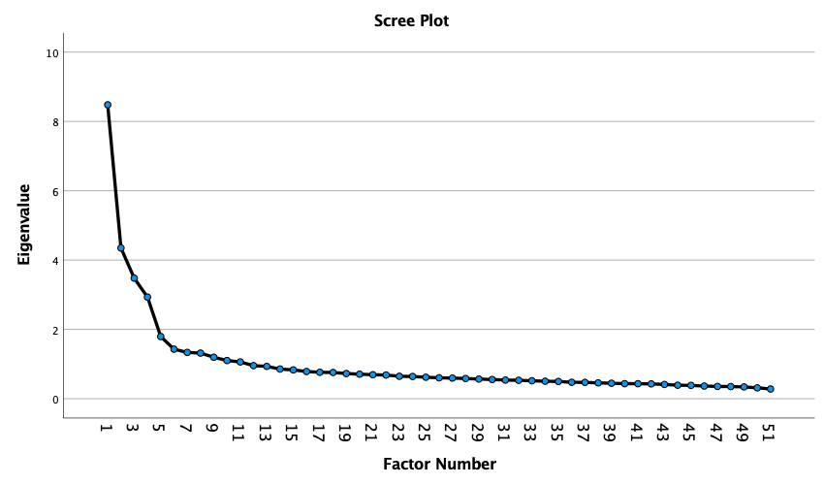
Figure 1 – Scree Plot from EFA

Table 1 – Statements and Factor Loadings
 | Sustainability  and  health | Food Influencers | Joy  and Pleasure | Convenience | Familiarity
Has a low impact on climate change. | 0.716
Is prepared and packaged in environmentally friendly material. | 0.699
Is fair trade. | 0.660
Claims to contain no additives or GMOs. | 0.636
Is produced in a way that respects animals' rights. | 0.622
Is low in animal products. | 0.595
Is organic. | 0.587
Is produced and processed locally. | 0.573
Is not highly processed. | 0.560
Keeps me healthy. | 0.485
Is seasonal. | 0.421
Is low in calories and fat. | 0.418
Is in line with my diet to maintain or reduce my weight. | 0.413
Aligns with my cultural background (e.g nation, country, region). |  | 0.313
I eat food which is recommended by social media influencers. |  | 0.729
I eat food which is advertised in various media (e.g. Television, Online). |  | 0.647
I follow food trends. |  | 0.645
I often eat out or ready-to-eat meals (more than 3 times a week). |  | 0.582
I eat food which is recommended by friends. |  | 0.560
When I am around others, I eat better quality food. |  | 0.466
I eat food which is recommended by nutrition experts. |  | 0.450
Aligns with my religious views (e.g. Halal, Kosher). |  | 0.418
I am willing to try insect protein. |  | 0.384
I make most of my purchasing decisions inside the grocery store. |  | 0.380
I often eat my ethnic/ traditional food. |  | 0.377
People share common food tastes regardless of their cultural backgrounds. |  | 0.317
I enjoy cooking for others and myself. |  |  | 0.722
I consider myself to be a skilled cook. |  |  | 0.672
I enjoy looking through recipes on websites and social media. |  |  | 0.539
Eating is a good way of spending time with other people. |  |  | 0.435
Food makes social gatherings more enjoyable. |  |  | 0.406
Food is an expression of cultural identity. |  |  | 0.392
I often eat my family’s traditional dishes. |  |  | 0.378
Is a good value for the money. |  |  |  | 0.589
Tastes good. |  |  |  | 0.559
Is easy to prepare (in terms of necessary skills, ingredients and, equipment). |  |  |  | 0.549
Is easily available in shops and supermarkets. |  |  |  | 0.519
Is fast to prepare. |  |  |  | 0.505
Makes me feel good. |  |  |  | 0.481
Is on sale. |  |  |  | 0.399
I often eat food from various cultures. |  |  |  |  | -0.524
I am hesitant to eat things I have never had before. |  |  |  |  | 0.503
I am constantly sampling new and different foods. |  |  |  |  | -0.432
I am willing to try plant-based protein foods. |  |  |  |  | -0.387
I prefer food from brands I'm familiar with. |  |  |  |  | 0.345
I eat just as a means of satisfying hunger.
I eat for pleasure.
I prepare my shopping list before going to the grocery store.
Has an appealing presentation (e.g. visual presentation or packaging).
I do most or all of my own food shopping.
I do not trust new food technologies (e.g lab meat).

