Online Appendix
Figure A1
Used Stimuli for Greenwashing Literacy Condition (BLINDED)
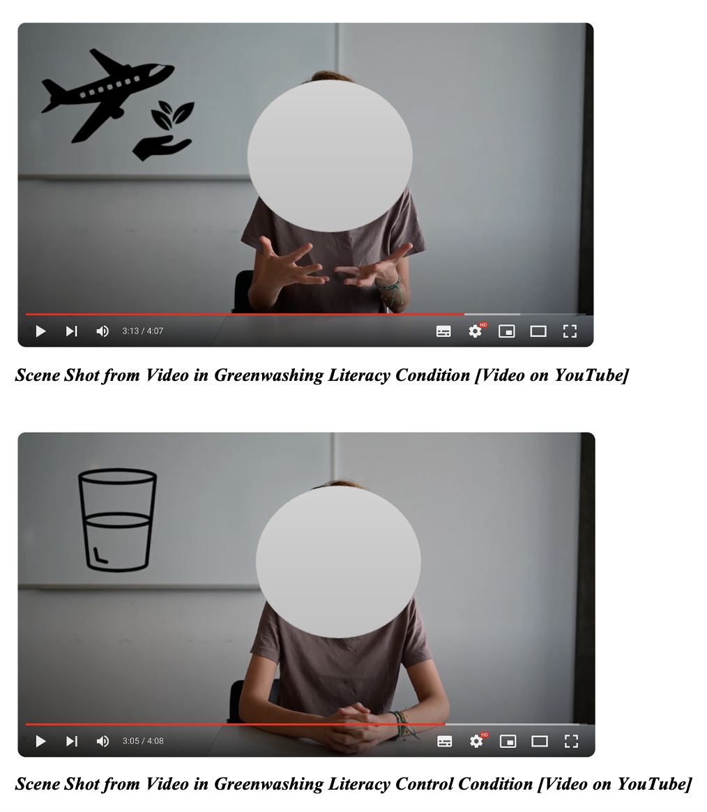
Figure A2
Used Stimuli for Executional Greenwashing Condition

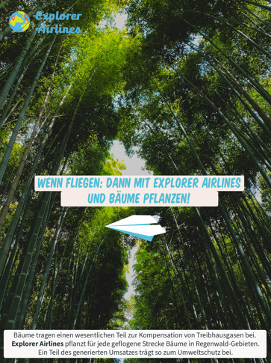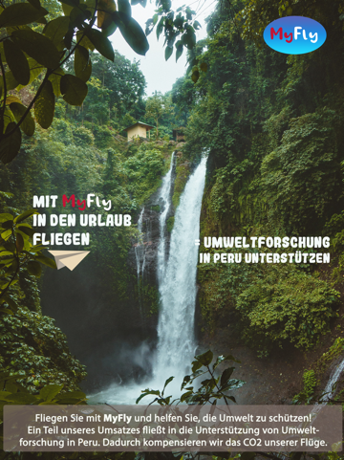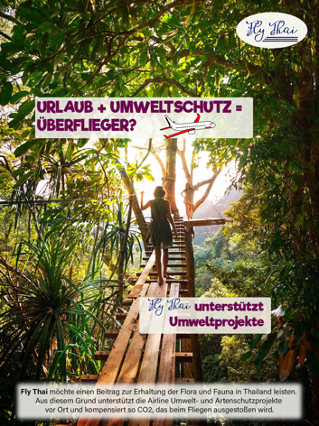
Translation:
Explorer Airlines; [Main claim: If flying: Then with Explorer Airlines and planting trees. Informational text box: Trees make a significant contribution to the compensation of greenhouse gases. For every route flown, Explorer Airlines plants trees in rainforest areas. Part of the sales thus contributes to environmental protection.]
MyFly; [Main claim: Flying on vacation with My Fly = Supporting environmental research in Peru. Informational text box: Fly with My Fly and help to protect the environment! Part of our revenue supports environmental research in Peru. In doing so, we offset the CO2 from our flights.]
FlyThai; [Main claim: Vacation + Environmental protection = High-Flyer? Fly Thai supports environmental projects. Informational text box: Fly Thai wants to contribute to the conservation of fauna and flora in Thailand. For this reason, the airline supports local environmental and species protection projects and thus compensates for the CO2 emitted by flying.]
Examples of Ads in Executional Greenwashing Condition

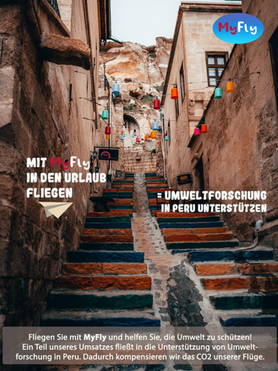
[Text is the same as in the Executional Greenwashing Condition]
Examples of Ads in Executional Greenwashing Control Condition

*Source: Authors own work; photos in Figure A2 from pexels.com (free to use)
Table A1
Used Measures
Type | Variable |  | Type of Scale | Instruction & Items | α; Ω | M (SD)
Control | Flying Frequency |  | 5-point Likert scale ranging from 1 – ‘less than once a year’ to 5 – ‘more often than once a month’ | Now follows a general question about airplanes as a means of transportation. How often do you fly by airplane on average (corona lockdown times excluded)? |  | 2.13 (1.06)
Control | Environmental Concern |  | 7-point Likert scale ranging from 1 – ‘do not agree at all’ to 7 – ‘fully agree’ | Please indicate to what extent the following statements apply to you personally.  I am willing to make great sacrifices to protect the environment.  I care a lot about the environment.  The state of the environment greatly affects my quality of life. | .79  .80 | 4.57 (1.45)
Manipulation Check | Greenwashing Literacy |  | Single-choice variables; sum of correct answers ranging from 0–5 | 1. How many grams of greenhouse gas are released into the atmosphere for every kilometer traveled by airplane?  Approximately 900 grams of greenhouse gases are released into the atmosphere. / Approximately 200 grams of greenhouse gases are released into the atmosphere [correct answer] / Approximately 500 grams of greenhouse gases are released into the atmosphere. / I don´t know. |  | 2.30 (1.54)
Table A1 (Continued)
Type | Variable |  | Type of Scale | Items | α; Ω | M (SD)
2. What substances does a flying aircraft emit?
Carbon dioxide (CO2) and carbon monoxide, among others [correct answer] / Carbon (soot) and glyphosate, among others / Carbon dioxide (CO2) and sulphur monoxide, among others / I don´t know.
3. What is the name given to advertising that misleadingly uses green images of nature?
Executional Greenwashing [correct answer] / Extinction Greenwashing / Initiative Greenwashing / I don´t know.
4. What percentage of green advertisements were identified as greenwashing in a study conducted in the 1990s?
60% [correct answer] / 50% / 40% / I don´t know.
5. Which strategy is not a greenwashing strategy?
Persuasive personalization / Use of lies / Misleading use of images of nature / I don´t know.
Manipulation Check | Executional Greenwashing |  | 7-point Likert scale ranging from 1 – ‘does not apply at all’ to 7 – ‘fully applies’ | The flight advertisements you have just seen contained pictures of ...  ... nature and environment (meadows, forests, etc.).
Table A1 (Continued)
Type | Variable |  | Type of Scale | Items | α; Ω | M (SD)
Dependent Implicit Variable | Fixation Count |  | Open numeric | Sum of all fixations per participant within the AOI(s) of each ad |  | _{ad1} = 28.90 (20.77)  _{ad2} = 26.29 (17.62)  _{ad3} = 18.91 (14.41)  _{ad4} = 17.84 (14.77)  _{ad5} = 18.22 (14.58)  _{ad6} = 17.83 (14.62)  _{ad7} = 23.01 (16.47)  _{ad8} = 30.47 (18.73)  overall: 28.91 (20.77)
Dependent Implicit Variable | Fixation Duration |  | Open numeric | Sum of the durations of all fixations within the AOI(s) of each ad in ms |  | _{ad1} = 7201.42 (6073.59)  _{ad2} = 5931.16 (4415.26)  _{ad3} = 5068.69 (4624.42)  _{ad4} = 4581.62 (4660.18)  _{ad5} = 4716.28 (4387.45)  _{ad6} = 4323.60 (4178.02)  _{ad7} =5274.22 (4217.57)  _{ad8} = 7715.99 (5739.38)  overall: 7201.42 (6073.59)
Dependent Explicit Variable | Perceived Greenwashing |  | 7-point Likert scale ranging from 1 – ‘does not apply to 7 – ‘fully applies’ | The next questions deal with your thoughts while viewing the ad posting.  The airline ads …  … are misleading.  … mislead regarding environmental characteristics of the airlines with visual or graphical features.  … mislead with words regarding the environmental characteristics of the airlines.  … portray airlines as more beneficial to the environment than they are.  ... sound more beneficial the environment than they actually are. | .82  .81 | 5.28 (1.40)

