Supplemental Materials
In this file, you can find the details about the power analysis, the full list of the items used in the study, the stimuli used in the experimental part to manipulate social norms, and the measures included in the questionnaire but not related to the study’s aim.

Sensitivity Power Analysis
We conducted a sensitivity power analysis based on Monte Carlo simulation with the package WebPower (Zhang et al., 2018). We modelled the structural component of a full parallel mediation model and set all hypothesized direct effects to a small size. Results showed that the valid sample size of the correlational model (N = 911) allowed the detection of even a small size (β = 0.10) of all the direct effects with at least 79% of power. Figure 1S below reports the screenshot of the R output about the sensitivity power analysis described in the main document.
Figure 1S. Sensitivity power analysis of the parallel mediation model.
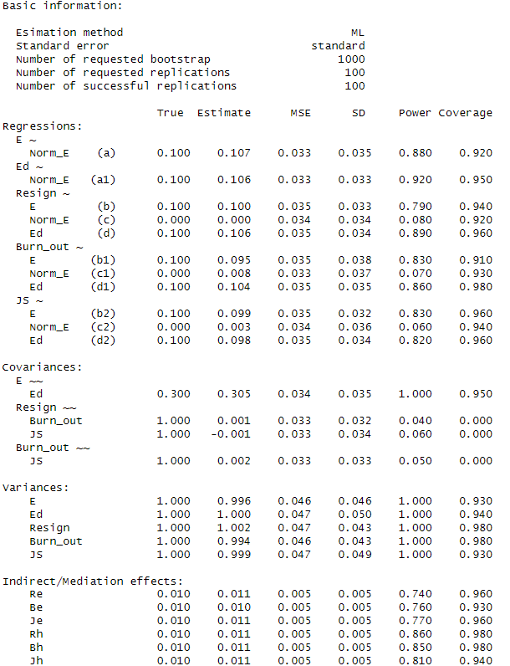
Source: Authors’ own creation.
Study Materials
Full List of Items of the Correlational Measures
Below is a full list of the items of the correlational measures. The initial code is the item code on the dataset. Please note that the measures were not answered in the following order, as the measures were spread throughout the full correlational questionnaire.
Supportive Norms
Descriptive norms.
DE__1. My colleagues pay attention to the emotions of prisoners
DE__2. My colleagues sympathize with prisoners
DE__3. In general, my colleagues tend to listen with interest to the needs and demands of prisoners.
Injunctive norms.
IE__1. My colleagues approve when one stops to listen to prisoners’ stories and complaints
IE__2. It is right that my colleagues take an interest to prisoners for who they really are
IE__3. It is right to set prisoners at their utmost ease
Empathy
CE__1. Usually, I pay attention to the emotions of prisoners
CE__2. I am a good listener of prisoners’ needs and demands
CE__3. I sense when prisoners feel bad or get irritated
CE__4. I am interested to get to know prisoners for who they really are
CE__5. I enjoy listening to prisoners’ stories.
CE__6. I notice when prisoners are in trouble
CE__7. I can sympathize with prisoners
CE__8. In general, I tend to set prisoners at ease
Intergroup and Interpersonal Closeness with Prisoners
Instruction. “In the following section, we will ask you some questions about your interactions with detained people. Indeed, your PROFESSIONAL ROLE in some cases may involve being emotionally close to detained people. We invite you to reflect on the interactions and relationships you have with DETAINED PEOPLE in your work practice and respond to the following questions.”
Intergroup closeness.
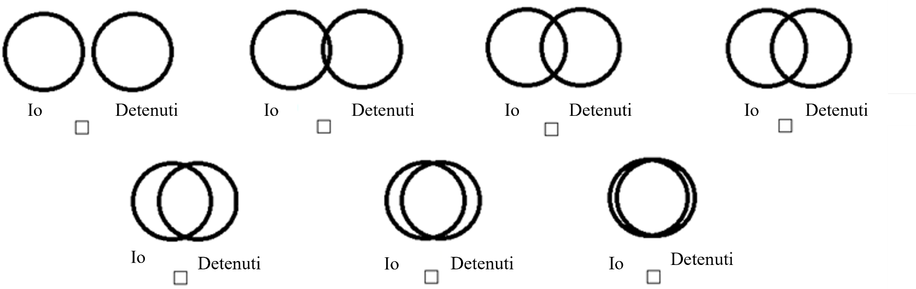
IOSd. “In general, how much does YOUR PROFESSIONAL ROLE lead you to be emotionally close to DETAINED PEOPLE? Note that the circle on the left represents you, and the one on the right represents the detained people. Closer circles indicate greater emotional closeness to the prisoners. Select the image that best describes your feelings of closeness to the prisoners”

Interpersonal closenesess.
QQL_D. “In particular, are there PRISONERS with whom you regularly interact and to whom YOUR PROFESSIONAL ROLE leads you to feel closer? List the first letter of their names below and indicate how close you feel to each of them. You do not need to fill in all the lines, and you can leave them all blank if you do not feel closely connected to anyone.”
 | Not close at all |  | A little close | Moderately close | Very close | Extremely close
1._________________________ |  | 1 | 2 | 3 | 4 | 5
2. _________________________ |  | 1 | 2 | 3 | 4 | 5
3. _________________________ |  | 1 | 2 | 3 | 4 | 5
4. _________________________ |  | 1 | 2 | 3 | 4 | 5
5. _________________________ |  | 1 | 2 | 3 | 4 | 5
6. _________________________ |  | 1 | 2 | 3 | 4 | 5
7. _________________________ |  | 1 | 2 | 3 | 4 | 5
8. _________________________ |  | 1 | 2 | 3 | 4 | 5
9. _________________________ |  | 1 | 2 | 3 | 4 | 5
10. ________________________ |  | 1 | 1 | 2 | 3 | 4

QQLDc. Only if you left all the lines blank do you confirm that you do not feel any connection with any of the prisoners? □ Yes, I confirm it
Hostility
H_1. Prisoners will never change
H_2. Prisoners are basically bad people
H_3. No prisoner should be let out on parole
Educative-Punitive Orientation
PunEdu. In your opinion, in what percentage should the punitive and educational purposes of the prison guide the operation of the Italian penitentiary system? (select a combination)
100%  punitive | 90%  punitive | 80% punitive | 70% punitive | 60% punitive | 50% punitive | 40% punitive | 30% punitive | 20% punitive | 10% punitive | 0% punitive
0% educative | 10% educative | 20% educative | 30% educative | 40% educative | 50% educative | 60% educative | 70% educative | 80% educative | 90% educative | 100% educative

Burn-out
Exhaustion.
E_1. During my work shift, I often feel emotionally drained
E_2. At the end of my work shift, I usually feel worn out and weary
Detachment.
D__1. It happens more and more often that I talk about my work in a negative way
D__2. Sometimes I feel sickened by my work tasks
Job satisfaction
Job satisfaction.
J__1. In general, I like my job
J__2. All in all, I am satisfied with my job
J__3. In general, I like working in the Prison Police
Intentions to quit the job.
IQ__1. I am seriously thinking about quitting my job
IQ__2. I often think about quitting my job
IQ__3. I think that in 5 years I will still be working in the Prison Police
Psychological Distress
Instruction. “Now we would like to investigate your psychological well-being. Think about the last THREE MONTHS, read the following statements, and indicate how often the described events occurred.”
Depression.
DAS__1. I couldn’t feel any positive emotions
DAS__2. I felt down-hearted and blue
DAS__3. I felt that my life was meaningless
Unworthiness.
SE__1. In general, I am satisfied with myself (r)
SE__2. At times, I thought I was useless
SE__3. I thought I did not have much to be proud of
Alienation.
SCS__1. I felt disconnected from the world around me
SCS__2. I felt so distant from people
SCS__3. I had no sense of togetherness with my loved ones
Hopelessness.
BH__1. The future seemed vague and uncertain to me
BH__2. The future seemed dark to me
BH__3. I thought my future was hopeless and cold only get worse

Experimental Materials
Below are reported the mock newspaper articles used to manipulate supportive norms toward prisoners. The original Italian versions of the stimuli come below the translated materials in English.

General Instructions
“In this last section, we ask you to read the following extract from a newspaper article describing the Ledano prison in Slovenia. We ask you to read the text carefully and to identify with the situation described as if you were a Penitentiary Police officer working in the Ledano prison. Finally, we will ask you to answer some questions about what you have read.”

Supportive Norm Condition
______________________________________________________________________________________
The Ledano Prison
To see how an atypical prison works, the representatives of the Associations for the Defense of Human Rights visited the Ledano prison, in Slovenia, where the prisoners retain most of their daily life freedoms.
Dollores Benezic
December 30th, 2022

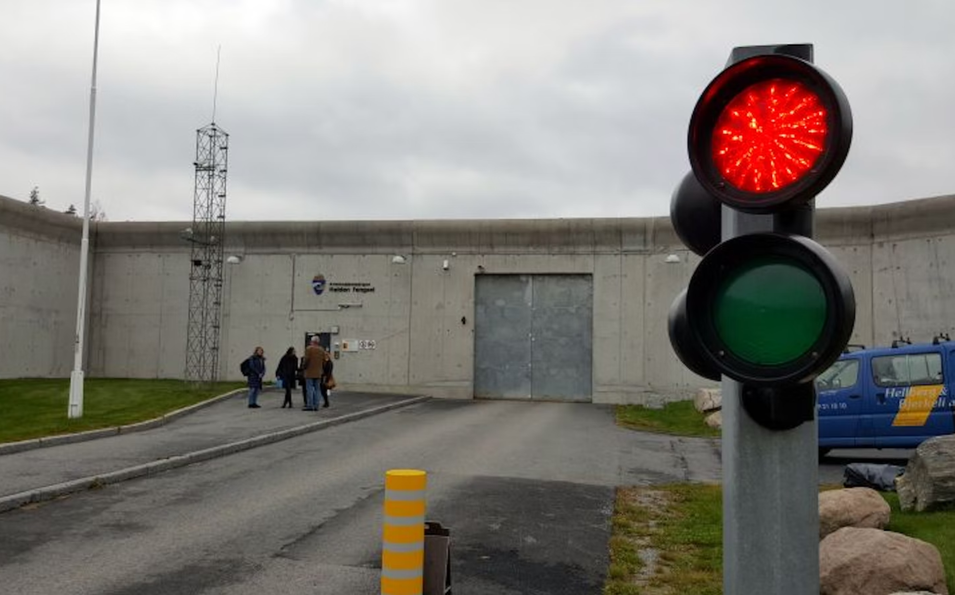
The entrance of the Ledano prison, Slovenia
The Ledano prison is not a typical prison. The windows have no bars, there are no surveillance towers, barbed wire, or electrified fences. There are not even cameras, neither in the corridors nor in the rooms, classrooms, or laboratories.
Prisoners can buy any food product in the prison shop, which looks like a normal grocery shop. There is a kitchen and a common area every 10-12 cells that looks like a typical living room in any house.
The prison system relies on an innovative security concept known as "dynamic security": the officers live in close contact with the prisoners and, – as they are permanently present – can manage and prevent potential conflicts by discussing issues with the prisoners on the spot. There are 258 prisoners in Ledano and the overcrowding rate is below the European average: each prisoner has about 15 square meters at their disposal, more than double the parameters of the European Committee. It is the second largest prison in Slovenia by prisoner population, with 290 people working there.
Hans Høidal, the director of the Ledano prison, states that their goal is to ensure that "prisoners work, pay taxes, have a family, and motivation." For this reason, prisoners are helped to find their motivation from the first day in prison through counseling activities. The fundamental principle underlying the vision of the Ledano prison is a constructive attitude towards inmates.
Today, officers work and eat with inmates, participate in sports, and have walks together. This is the concept of dynamic surveillance. Besides a supervisor, the officer represents a social worker
_______________________________________________________________________________________

Punitive Norm Condition
_______________________________________________________________________________________
The Ledano Prison
To see how a typical prison works, the representatives of the Associations for the Defense of Human Rights visited the Ledano prison in Slovenia, where the prisoners lose most of their daily life freedoms.
Dollores Benezic
December 30th, 2022

The entrance of the Ledano prison, Slovenia
The Ledano prison is a typical prison. The windows have bars, there are surveillance towers, barbed wire, and electrified fences. There are cameras, in the corridors, rooms, classrooms, and laboratories.
The administration decides what prisoners should eat based on the so-called dietary tables, which exist in two versions, one for winter and one for summer. Food is prepared in the central kitchen of the prison and brought to the detention sections with food trolleys. Prisoners must eat inside their cells and cannot vary the menu except for proven needs.
The prison relies on a security concept known as the 'inspection principle': officers monitor prisoners 24/7 and prevent potential conflicts through constant surveillance, cell searches, and resorting to the use of force if necessary. There are 598 prisoners in Ledano out of 390 available places. It is one of the most overcrowded prisons in Slovenia, with an overcrowding rate of 153.3%. There are 350 people working there.
Hans Høidal, the director of the Ledano prison, states that their goal is to ensure that the prisoners is deprived of liberty for having violated the rules of civil life (punitive function) and, at the same time, to transform them through correction techniques into a reformed or socially readjusted citizen (corrective function). For this reason, prisoners are instructed, from the first day in prison, on the distance, subordination, and formality that should characterize the relationship between officers and prisoners. The fundamental principle underlying the vision of the Ledano prison concerns a restrictive attitude toward prisoners.
Officers ensure that measures restricting personal freedom are carried out, maintain order within the prison, and establish its security. This is the essence of the inspection principle. The officers are specialized supervisors.

Full List of the Items of the Experimental Measures
After being randomly presented with one of the experimental stimuli, participants answered the following.
Supportive behavioral intentions.
Instruction. “Now we ask you to read the following scenario: imagine that the situation described happens to you at the end of your REGULAR WORK SHIFT. We ask you to put yourself in the shoes of the officer described in the situation and answer the following questions”
Scenario. “At the end of your work shift in the detention section, an inmate gets closer to talk to you. He tells you that he is struggling with some of the other prisoners and that he is going through a tough period of suffering. He asks you if you could listen to him in a quiet place, away from prying ears, maybe having a walk together in the courtyard. You immediately notice that he is suffering for real and he is really in need”.
Support_exp. In the described situation, how likely would you accept the request from the inmate? (circle your answer).
Not at all | A little | Moderately | Very | Extremely
1 | 2 | 3 | 4 | 5
Anticipated well-being and job satisfaction.
Instruction. Indicate how much you agree with the following statements referred to the situation above-described and the behavior you have decided to undertake.
Anticipated well-being.
R_1. At the end of the work shift, I would feel accepted by others
R_2. At the end of the work shift, I would feel satisfied with myself
R_3. At the end of the work shift, I would feel to have things under control
R_4. At the end of the work shift, I would feel important
Anticipated job satisfaction.
JS_exp. At the end of the work shift, I would feel satisfied with my job
Manipulation check.
Instruction. Before finishing the study, we ask you to answer the following questions referred to the article you read about the Ledano prison:
MC__1. Officers and prisoners have friendly relationships
MC__2. Officers listen to prisoners with empathy and support
MC__3. Officers sympathize with prisoners
Source: Authors’ own creation.
Full List of the Measures Included in the Questionnaire but not Related to the Study’s Aims
The following constructs were measured to assess the broader research project’s aims related to investigating a wide range of risk and protective factors threatening officers’ well-being. The measures were not included in the main study as they were work stressors related to the prison police institutional and corp.
Physical conditions of the work environment: 4 items from Pancani et al. (2021);
Social support from friends and family: 6 items from Multidimensional social support scale (Zimet et al., 1988);
Social support from the prison police institution: 4 items from Eisenberg et al. (1986);
Social Identification with the prison police corp: 3 items from Stone e Crisp (2007);
Perceived stigma of being part of the prison police corp: 3 items from Self-Stigma Scale (Mak & Cheung, 2010);
Relative deprivation referred to other police corps, prisoners, and civilians: 6 items from Relative Deprivation Scale (Callan et al., 2008);
Interpersonal and group closeness with colleagues: same scales used in the main study but referred to the colleagues;
Social exclusion from colleagues: 3 item from Workplace Ostracism Scale (Ferris et al., 2008) and 3 item from Social Undermining Scale (Duffy et al., 2002);
Anticipated social exclusion from colleagues referred to the experimental part: 3 item from Workplace Ostracism Scale (Ferris et al., 2008) and Social Undermining Scale (Duffy et al., 2002).
Additional References
Callan, M. J., Ellard, J. H., Will Shead, N., & Hodgins, D. C. (2008). Gambling as a search for justice: Examining the role of personal relative deprivation in gambling urges and gambling behavior. Personality and Social Psychology Bulletin, 34(11), 1514-1529.
Duffy, M. K., Ganster, D. C., & Pagon, M. (2002). Social undermining in the workplace. Academy of management Journal, 45(2), 331-351.
Eisenberger, R., Hungtington, R., Hutchison, S., & Sowa, D. (1986). Perceived Organizational Support. Journal of Applied Psychology, 71, 500-507.
Ferris, D. L., Brown, D. J., Berry, J. W., & Lian, H. (2008). The development and validation of the Workplace Ostracism Scale. Journal of applied psychology, 93(6), 1348.
Mak, W. W., & Cheung, R. Y. (2010). Self-stigma among concealable minorities in Hong Kong: conceptualization and unified measurement. American Journal of Orthopsychiatry, 80(2), 267.
Pancani, L., Marinucci, M., Aureli, N., & Riva, P. (2021). Forced social isolation and mental health: a study on 1,006 Italians under COVID-19 lockdown. Frontiers in Psychology, 12, 663799.
Stone, C. H., & Crisp, R. J. (2007). Superordinate and subgroup identification as predictors of intergroup evaluation in common ingroup contexts. Group processes & intergroup relations, 10(4), 493-513.
Zhang, Z., Mai, Y., Yang, M. and Zhang, M.Z. (2018), “Package ‘WebPower’”, Basic and Advanced Statistical Power Analysis Version, Vol. 72, p. 555
Zimet, G. D., Dahlem, N. W., Zimet, S. G., & Farley, G. K. (1988). The multidimensional scale of perceived social support. Journal of personality assessment, 52(1), 30-41.

