Appendix A. Derivation of the risk-neutral Weibull specification
Let $S_{T}$ denote the terminal residual value at maturity $T$. Under the physical measure $P$, assume $S_{T}\sim Weibull (θ,$ $δ)$ where scale $θ>0$ and shape $δ>0$, with density,
$$f_{P}\left(s;θ,δ\right)=\frac{δ}{θ}{\left(\frac{s}{θ}\right)}^{δ-1}\exp\left[-{\left(\frac{s}{θ}\right)}^{δ}\right], s≥0.$$
To preserve the structural durability patterns encoded in the Weibull shape parameter, we impose that the risk-neutral terminal distribution belongs to the same parametric family and shares the same shape parameter. Accordingly, under the risk-neutral measure $Q$, $S_{T}\sim Weibull (θ_{Q},$ $δ)$ , where the scale parameter $θ_{Q}$ is allowed to adjust. This shape invariance is a deliberate, potentially restrictive modeling choice for the pricing kernel: among the many admissible risk-neutral measures, we select the one that preserves $δ$ and modifies only $θ$ so as to satisfy the no-arbitrage condition.
The change of measure from $P$ to $Q$ is defined through the Radon–Nikodym derivative,
$$Λ_{T}=\frac{dQ}{dP}\left(S_{T}\right)=\frac{f_{Q}\left(S_{T};θ_{Q},δ\right)}{f_{P}\left(S_{T};θ,δ\right)}.$$
By direct integration,
$$E_{P}\left[Λ_{T}\right]=\int_{0}^{∞}{\frac{f_{Q}\left(s;θ_{Q},δ\right)}{f_{P}\left(s;θ,δ\right)}f_{P}\left(s;θ,δ\right) ds}=\int_{0}^{∞}{f_{Q}\left(s;θ_{Q},δ\right)ds }=1.$$
So $Q$ is a well-defined probability measure that is absolutely continuous with respect to $P$.
Risk-neutral valuation requires that the expected terminal residual value satisfies the standard no-arbitrage condition, $E_{Q}[S_{T}]=S_{0}e^{rT}$. For a Weibull$(θ_{Q},δ)$ random variable, $E_{Q}\left[S_{T}\right]=θ_{Q}Γ\left(1+1/δ\right)$, yielding the uniquely determined risk-neutral scale parameter,
$$θ_{Q}=\frac{S_{0}e^{rT}}{Γ(1+1/δ)}.$$
Substituting this expression into the risk-neutral density gives the closed-form specification,
$$f_{Q}(s;θ_{Q},δ)=\frac{δ}{θ_{Q}}{(\frac{s}{θ_{Q}})}^{δ-1}exp⁡[-{(\frac{s}{θ_{Q}})}^{δ}].$$
Together with the Radon–Nikodym derivative, $Λ_{T}={f_{Q}(S_{T};θ_{Q},δ)}/{f_{P}(S_{T};θ,δ)},$ this provides a rigorous change of measure and yields a fully specified, arbitrage-free, shape-preserving risk-neutral Weibull distribution used in the option-valuation framework.

Appendix B. Cross model robustness
This appendix examines whether the patterns in the Sonata sample extend to other vehicle types. Using the same filters, clustering rules, and Weibull-based valuation framework, we analyze K5, Santa Fe, and Sorento transactions.
Figure A1 shows that all four models share a similar unimodal, left-skewed distribution, and the Weibull curves closely match the empirical densities. Table A1 indicates that roughly one-quarter to one-third of observations fall within the 60-month horizon. k-means consistently identifies employee-discounted units, which appear more frequently in early months under Hyundai and Kia’s biennial discount policy. Silhouette scores of 0.55 to 0.62 confirm reliable separation between discounted and retail transactions.
Table A2 shows that shape and scale parameters cluster tightly across models, 60-month depreciation differs only slightly, and sensitivities remain stable: a 100 bp rate shock changes put values by about 31 to 41 percent, and OTS ranges from 0.31 to 0.41. These results demonstrate that the Weibull-implied valuation properties generalize beyond the Sonata sample.

Figure A1. Distributional comparison of normalized residual values.
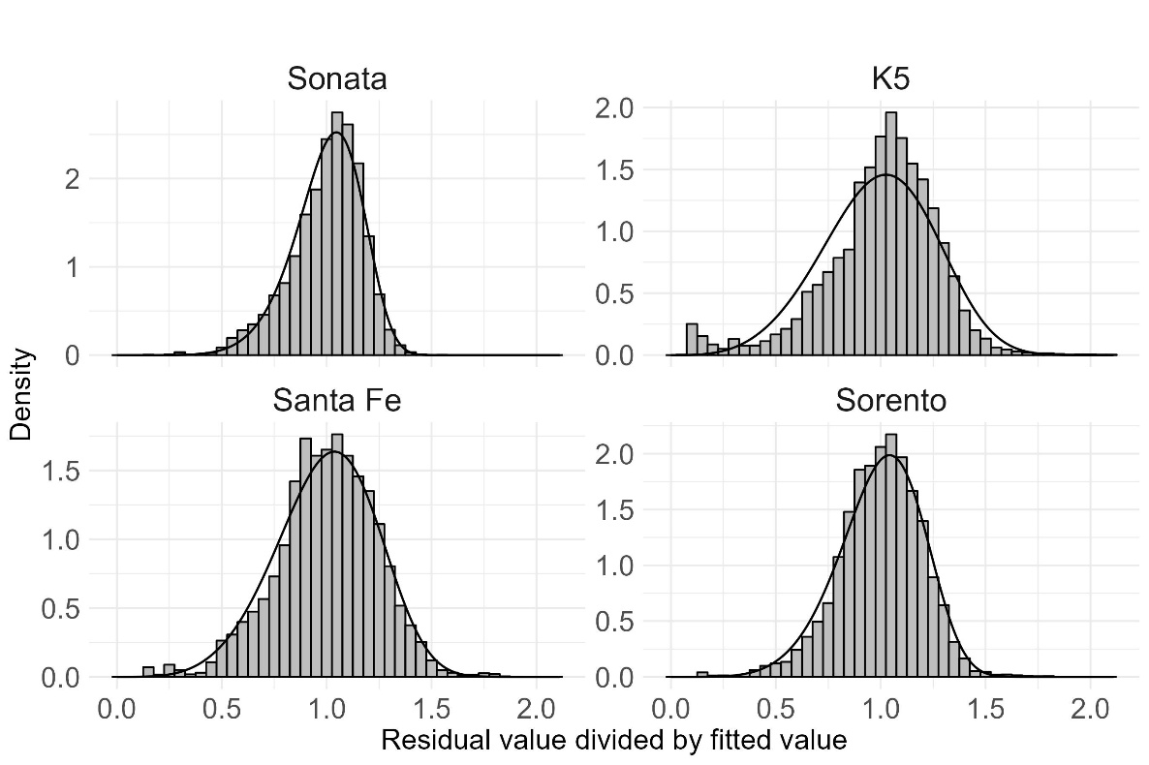
Note. All Weibull fits use RV deviations computed from an NLS trend. For illustration, the Sonata case shows normalized residuals $Y=RV/μ_{t}$ with $μ_{t}=0.555$and the fitted Weibull density. Maximum-likelihood estimates are $δ=7.257$(s.e. 0.046) and $θ=1.068$(s.e. 0.0013). The underlying NLS trend is $RV_{t}=ae^{bt}$with $a=0.938$(s.e. 0.0038), $b=-0.0087$(s.e. 0.0001), and residual s.e. $=0.113$on 15,227 degrees of freedom.

Table A1. Filtering summary for four models.
 | Sonata | K5 | Santa Fe | Sorento
Total transactions | 172,897 | 101,390 | 105,751 | 86,482
data ($≤$60months) | 43,466 | 33,352 | 32,664 | 33,526
Employee discounted data | 23,412 | 15,513 | 13,998 | 12,141
Silhouette score | 0.554 | 0.615 | 0.556 | 0.624
data (RV$>100\%$, RV$≤5\%$) | 4,021 | 3,947 | 6,052 | 6,685
Outliers (EIF method) | 804 | 697 | 629 | 736
Filtered data | 15,229 | 13,195 | 11,985 | 13,964

Table A2. Weibull and sensitivity-based robustness metrics by model.
 | Sonata | K5 | Santa Fe | Sorento
shape parameter ($δ$) | 7.257 | 8.414 | 6.193 | 6.883
scale parameter ($θ$) | 1.068 | 1.060 | 1.076 | 1.071
Estimated RV ($μ_{T})$ | 0.555 | 0.593 | 0.570 | 0.607
Strike price (K) | 15,578,927 | 16,639,420 | 15,997,094 | 17,051,731
Put option price (P) | 784,445 | 727,147 | 936,666 | 902,986
Rate shock cost (OB) | 280,838 | 296,639 | 292,324 | 307,822
Time decay sensitivity (OTS) | 0.358 | 0.408 | 0.312 | 0.341
Note. In this table, OTS happens numerically to equal $OB_{100bp}/P_{0}$ because we use $r=5\%$, maturity $T=5$ years, and a 100-bp rate shock, which implies $OB_{100bp}=Te^{-rT}KF(K)=∣Θ∣$. For different combinations of rate level, maturity, or shock size, this algebraic identity would not hold and OTS and $OB_{100bp}/P_{0}$ would generally diverge.

Appendix C. Distributional Comparison: Weibull, Lognormal, and Gamma
This appendix summarizes the goodness-of-fit comparisons among the Weibull, lognormal, and gamma distributions, all estimated by maximum likelihood using the same residual-value sample. Tables A3 and A4 report AIC, BIC, and KS statistics for filtered and unfiltered samples, respectively, while Figures A2 and A3 present the corresponding QQ plots.

Table A3. Goodness-of-fit metrics (Sonata) with filtered data.
 | AIC | BIC | KS stat | p value
Weibull | -12,239.90 | -12,224.64 | 0.0308 | 6.e-13
Lognormal | -7,553.24 | -7,537.98 | 0.1062 | 0.e+00
Gamma | -8,961.45 | -8,946.19 | 0.0937 | 0.e+00
Note. KS static stands for Kolmogorov-Smirnov statistic.

Table A4. Goodness-of-fit metrics (Sonata), including outliers.
 | AIC | BIC | KS stat | p value
Weibull | 26,914.08 | 26,929.56 | 0.2335 | 0.e+00
Lognormal | 49,309.37 | 49,324.85 | 0.3419 | 0.e+00
Gamma | 34,141.02 | 34,156.5 | 0.2999 | 0.e+00
Note. Outliers include observations flagged by the EIF procedure as well as residual values below 5 percent and above 100 percent. Employee-discounted vehicles are excluded from the outlier definition because ownership remains with the employee, and these units do not generate residual-value risk for the leasing company.

Figure A2. QQ plot comparison with filtered data.
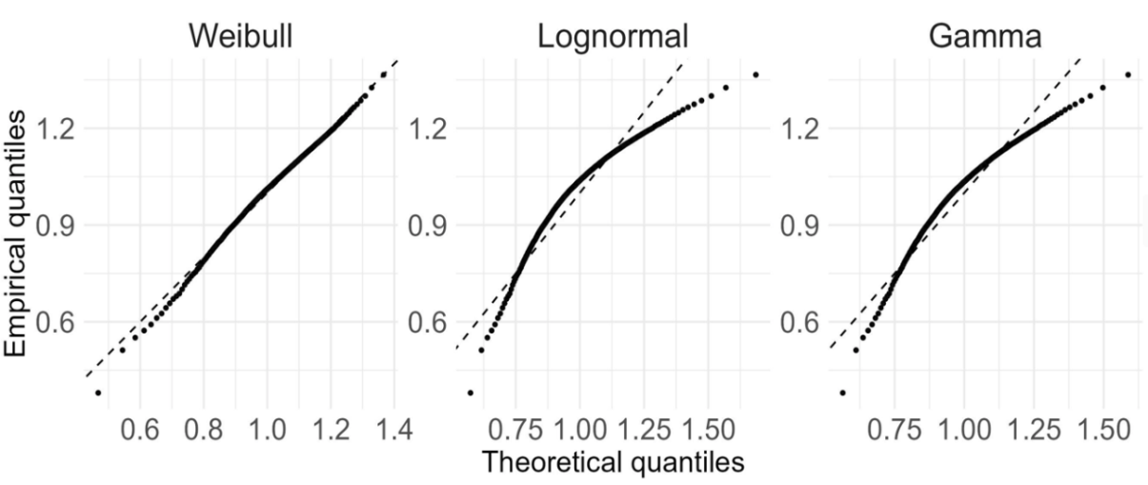

Figure A3. QQ plot comparison including outliers.
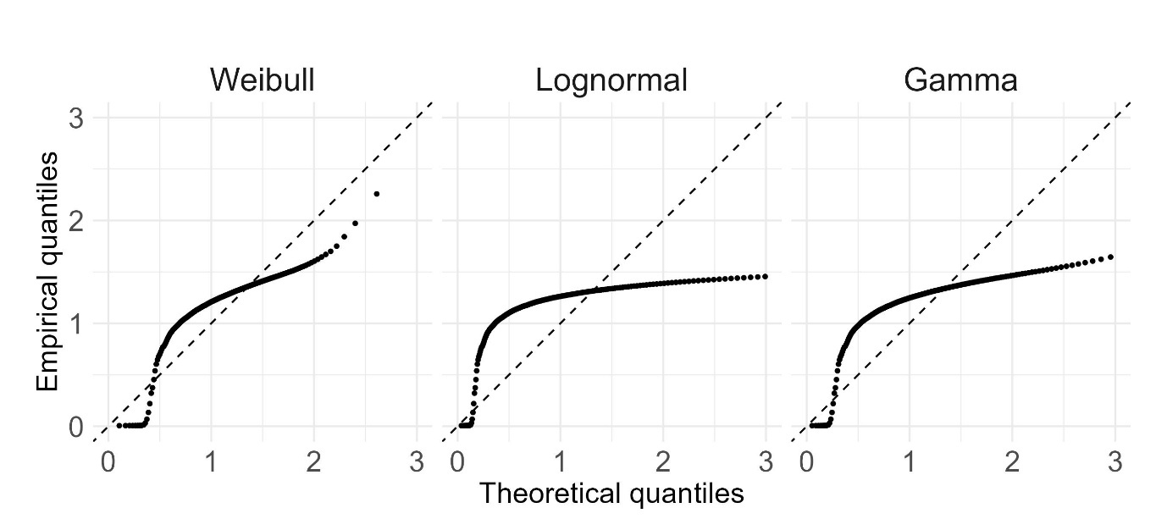
Note. Outliers include observations flagged by the EIF procedure as well as residual values below 5 percent and above 100 percent.

Appendix D. Time-series validation
This appendix assesses the robustness of the Weibull framework by extending the validation to 2020-2023, a period covering both major disruptions and post-pandemic normalization. Figure A4 presents QQ plots of the normalized residuals $Y=RV/μ_{t}$. The Weibull fit is tight throughout, with only mild lower-tail S-shaped departures in 2020-2021, indicating limited misspecification even during the COVID shock. In 2022, the distribution already shows a transitional pattern consistent with a shift out of the turbulence phase, and by 2023, the points align almost perfectly with the 45-degree line, reflecting a fully stabilized one-factor Weibull structure.
Table A5 summarizes the sensitivity metrics. The shape parameter $δ$ is near 3 in 2020-2021 and rises to about 7 in 2022-2023, implying flatter, more dispersed distributions in the crisis years and much more concentrated patterns in the recovery period. The scale parameter $θ$ remains close to 1.1 across all four years, indicating that the core depreciation profile remains structurally stable. The 60-month trend ratio $μ_{T}$ and its risk-neutral strike $K_{0}=μ_{T}×\text{MSRP}$ increase steadily, while the option value $P_{0}$ is highest in 2020-2021 and falls by roughly half in 2022-2023, reflecting the normalization of residual-value risk. The 100-bp offset budget $OB_{100bp}$ is lowest in 2020 (KRW 210K) and climbs to about KRW 280k by 2023, indicating weaker neutralization capacity during turbulence. The offer-timing score (OTS) is about 0.18 in 2020-2021 and about 0.35 in 2022-2023, showing that normalized time decay $|Θ|/P_{0}$ is nearly twice as steep in the stable regime.

Figure A4. QQ plot comparison by year: Sonata case.
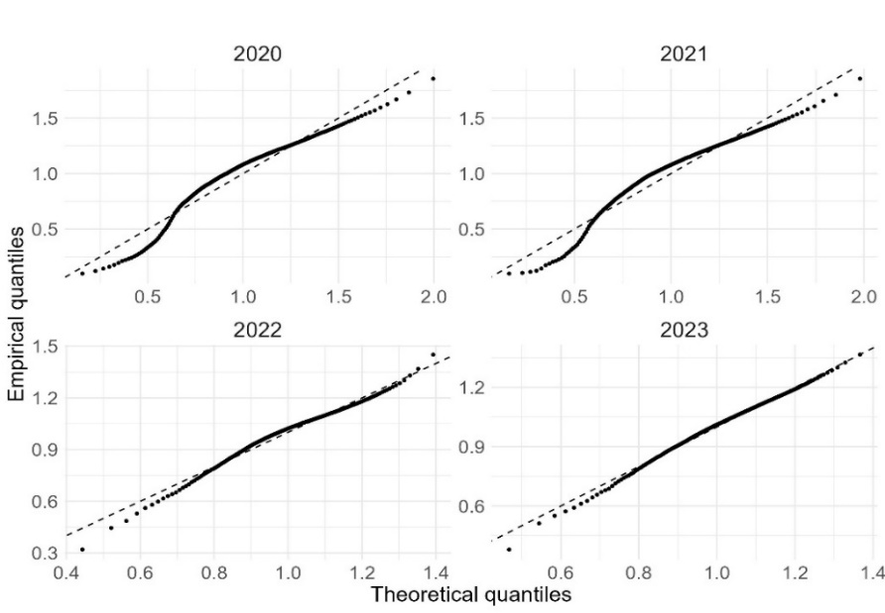

Table A5. Weibull and sensitivity-based robustness metrics by year.
 | 2020 | 2021 | 2022 | 2023
shape parameter ($δ$) | 3.068 | 3.104 | 6.798 | 7.257
scale parameter ($θ$) | 1.114 | 1.112 | 1.070 | 1.068
Estimated RV ($μ_{T})$ | 0.375 | 0.474 | 0.542 | 0.555
Strike price (K) | 10,523,023 | 13,304,959 | 15,211,007 | 15,578,926
Put option price (P) | 1,181,289 | 1,477,927 | 815,097 | 784,445
Rate shock cost (OB) | 210,003 | 265,986 | 276,966 | 280,838
Time decay sensitivity (OTS) | 0.178 | 0.179 | 0.339 | 0.358

