Appendix A
Analytical Models
The data were analyzed using multilevel linear modelling in Mplus with a two-level random model and robust maximum likelihood estimation. Following Bell et al.’s (2018) recommendations, within-school level variables were group-mean centered within schools, while between-school level variables were grand-mean centered across schools, allowing interpretation of estimates relative to within- or across-school averages. Data normality was supported by skewness and kurtosis values within the acceptable absolute range below 1.5, along with non-significant Mahalanobis distances, indicating multivariate normality.
Null Model
Since leadership performance and organizational perceptions are highly contextualized, the values of a variable measured on teachers from a particular school, such as their perceived OL culture or their principal’s TL behavior, may be more similar to each other than to the values of the same variable measured on teachers from different schools. Thus, the first stage of analysis is the null model, which provides the magnitude of multiple sources of teachers’ perceptual variability within and across schools. This allows us to calculate variance components and the intraclass correlation coefficient (ICC). This statistic quantifies the degree to which individual OL perceptions at the lower level (teachers) are correlated across schools. The ICC is calculated as:
ICC = τ₀₀ / (τ₀₀ + σ²)
(Equation 1)
where τ₀₀​ represents the between-school variance and σ₂ represents the within-school variance.
While interpreting the ICC, values close to 0 suggest that little to no variation in the outcome is attributable to variation among upper-level units (schools). Thus, low ICC values indicate that most of the variation in the outcome resides among the lower-level units (teachers). A threshold value of more than five percent of the variance being attributable to between-school differences is generally considered a legitimate justification for a small to medium school-level effect and the use of multilevel models (LeBreton & Senter, 2007).
Random Effects Model
At the second analysis stage, incorporating random effects into a regression model is one way to acknowledge the variation among school units. This is represented by the following multilevel regression equation:
Yᵢⱼ = γ₀₀ + u₁ⱼX₁ᵢⱼ + u₂ⱼX₂ᵢⱼ + u₃ⱼX₃ᵢⱼ + u₄ⱼX₄ᵢⱼ + u₅ⱼX₅ᵢⱼ + eᵢⱼ
u₀ⱼ ~ N(0, τ₀₀)
(Equation 2)
where:
- Y_{ij}​ is the outcome for teacher i in school j (individual OL perception),
- γ₀₀ is the overall intercept,
- X_{1ij}​…X_{5ij}​ are the five teacher-level TL predictors,
- u_{1j},…u_{5j}​ are the random slopes for the five independent variables (individual TL dimensions), allowing their effects to vary across schools,
- e_{ij} is the residual error for teacher i in school j.
The second line of equation indicates that the random effect u_{0j}​ captures the deviation of each school j from the overall intercept γ₀₀​, where u_{0j​} is the random effect for school j, N(0, τ₀₀) denotes a normal distribution with mean 0 and the variance τ₀₀​ represents the between-school variance. By this means, we assume the random effects are normally distributed and centered around 0 across schools, with variability captured by τ₀₀​.
Cross-level Interaction Model
At the third and final stage, cross-level interactions are incorporated to examine how the relationship between teacher-level predictors and the outcome varies as a function of school-level predictors. The model includes three cross-level variables: principal self-efficacy, schoolwide perceived TL performance, and their interaction. Each of these accounts for the random slopes of the transformational leadership dimensions separately at the teacher level. Additionally, the model incorporates teacher-level control variables (teacher gender, age, and teaching experience) and school-level control variables (principal’s age, gender, earlier teaching experience, and leadership experience).
In the within-level part of the model, for teacher i in school j:
Yᵢⱼ ​= γ₀₀ ​+ γ₁₀​TL_{1​ij​} + γ₂₀​TL_{2ij}​+γ₃₀​TL_{3ij} ​+ γ₄₀​TL_{4ij}​ + γ₅₀​TL_{5ij}​ + γ₁​Gender_{ij} ​+ γ₂​Age_{ij}​ + γ₃​Edu_{ij}​ + γ₄Exp_{ij}​ + u_{0j +} u_{1j}​TL_{1ij}​ + u_{2j}​TL_{2ij} ​+ u_{3j}​TL_{3ij}​ + u_{4j}​TL_{4ij}​ + u_{5j}​TL_{5ij}​ + e_{ij​}
(Equation 3.1)
where:
- γ₀₀​ is the overall intercept.
- γ₁₀​,…γ₅₀​ are teacher-level predictors of the five TL dimensions.
- γ₁​,…γ₄​ are the fixed effects of the control variables for Teacher, Gender, Age, Edu (education level), and Exp (teaching experience).
- u_{0j},…u_{5j}​ are the random slopes for the teacher-level predictors, allowing their effects to vary across schools.
- e_{ij}​ is the residual error for teacher i in school j.
As for the between-level model, for school _{j}:
u_{0j} = γ₀₁TLS_{1j} + γ₀₂TLS_{2j} + γ₀₃TLS_{3j} + γ₀₄TLS_{4j} + γ₀₅TL_{5j} + γ₀₆GenderP_{j} + γ₀₇AgeP_{j} + γ₀₈EduP_{j} + γ₀₉ExpP_{j} + γ₀₁₀LExpP_{j} + ϵ_{0j}
(Equation 3.2)
where:
- u_{0j} is random intercept varied across schools.
- γ₀₁​,…,γ₀₁₀​ are the fixed effects for the between-level predictors.
- TLS₁…TLS₅ are school-level predictors of the five TL dimensions (schoolwide perceived TL performance).
- GenderP, AgeP, EduP, ExpP, LExP are the fixed effects of control variables: Principal gender, age, education level, teaching experience, and leadership experience respectively.
- ϵ_{0j} is the random effects for the slopes, assumed to be normally distributed.
The cross-level interactions are explicitly modeled in the between-level equations for the random slopes. For example, modelling the change in the slope of TL₁ in school j:
u_{1j} = γ₁₀ + γ₁₁TLS_{1j} + γ₁₂GSE_{j} + γ₁₃INT_{j} + ϵ_{1j}
u_{2j} = …
(Equation 3.3)
- u_{1j} is the random slope of TL₁.
- γ₁₀ is the intercept of cross-level effect.
- γ₁₁ captures the effect of TLS (schoolwide perceived TL performance).
- γ₁₂​ accounts for the effect of GSE (general self-efficacy).
- γ₁₃ indicates the interaction (INT) of TLS and GSE by the multiplication term,
- ϵ_{1j} is the random effect for the slope of TL_{1.}
In this manner, the estimation of cross-level interactions allows us to examine how the relationship between teacher-level predictors and the outcome varies distinctly for each TL dimension, while controlling for other teacher- and school-level predictors.

Appendix B
Correlation Table
Variables | Age | Teaching experience | TL-IS | TL-IB | TL-IM | TL-IA | TL-IC | TL | OL-CL | OL-ID | OL-TL | OL-ES | OL-E | OL-SC | OL-SL
Age
Teaching experience | .900**
TL: Intellectual stimulation (TL-IS) | -0.05 | -0.05
TL: Idealized behaviors (TL-IB) | -0.06 | -.068* | .854**
TL: Inspirational motivation (TL-IM) | -.064* | -.067* | .806** | .835**
TL: Idealized attributes (TL-IA) | -.067* | -.073* | .806** | .844** | .833**
TL: Individualized consideration (TL-IC) | -.075* | -.076* | .864** | .820** | .787** | .832**
TL: Overall score (TL) | -.068* | -.073* | .934** | .934** | .914** | .928** | .932**
OL: Contninous learning (OL-CL) | -.138** | -.127** | .579** | .575** | .549** | .570** | .599** | .619**
OL: Inquiry dialogue (OL-ID) | -.215** | -.197** | .569** | .557** | .523** | .533** | .549** | .588** | .795**
OL: Team learning (OL-TL) | -.176** | -.165** | .556** | .565** | .527** | .549** | .538** | .589** | .715** | .757**
OL: Embedded system  (OL-ES) | -.191** | -.182** | .675** | .631** | .606** | .579** | .637** | .674** | .744** | .783** | .735**
OL: Empowerment (OL-E) | -.140** | -.135** | .649** | .631** | .620** | .632** | .688** | .695** | .728** | .706** | .690** | .731**
OL: System connection (OL-SC) | -.135** | -.139** | .675** | .649** | .639** | .620** | .657** | .699** | .713** | .724** | .664** | .738** | .794**
OL: Strategic leadership (OL-SL) | -.176** | -.170** | .661** | .643** | .599** | .623** | .640** | .682** | .745** | .756** | .711** | .773** | .744** | .756**
OL: Overall score (OL) | -.189** | -.180** | .709** | .690** | .660** | .667** | .700** | .739** | .881** | .894** | .854** | .893** | .877** | .876** | .890**
Source: Authors own creation
Note: * denotes correlation is significant at the .05 level, ** at the .01 level.

Appendix C
Moderation Effect Graph
The graph below illustrates the moderating effect of the interaction term on the relationship between IS and OL culture at the teacher level. Given the four-unit range of the five-point Likert-type scale used in this study, the average 0.63-point increase—highlighted by the red line representing the average slope across schools—indicates a particularly notable and substantive effect. As also shown, the higher and lower slopes, depicted one standard deviation above and below the average, demonstrate that the effect of the interaction term remains positive, indicating its consistent influence in enhancing teachers’ perception of OL culture.
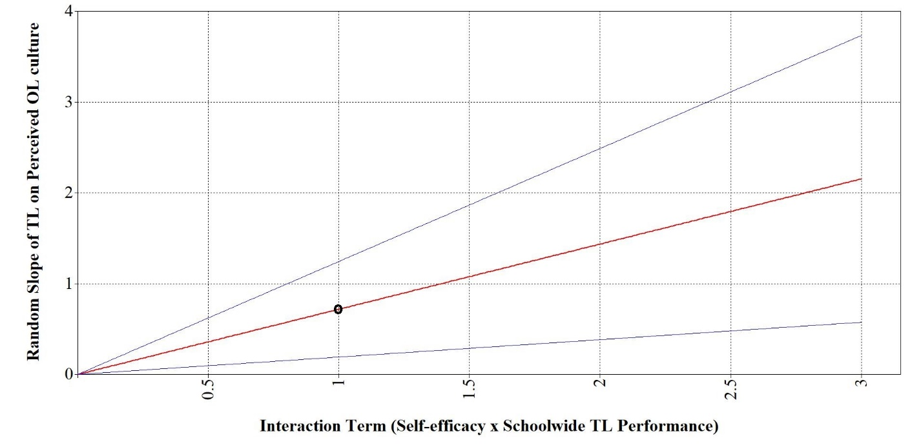
Source: Authors own creation

