Monetary policy spillovers in a fragmented world: The role of geopolitical risk pre- and post-COVID-19 pandemic
Supplementary figures

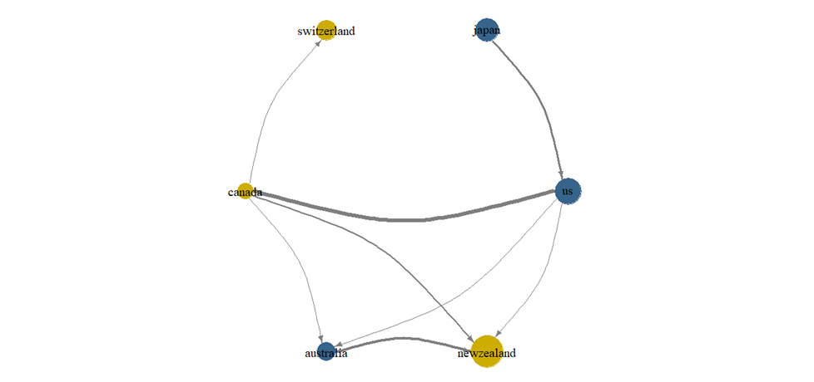
Supplementary figure 3. The network connectedness of monetary policies
(Source: Authors' own work)

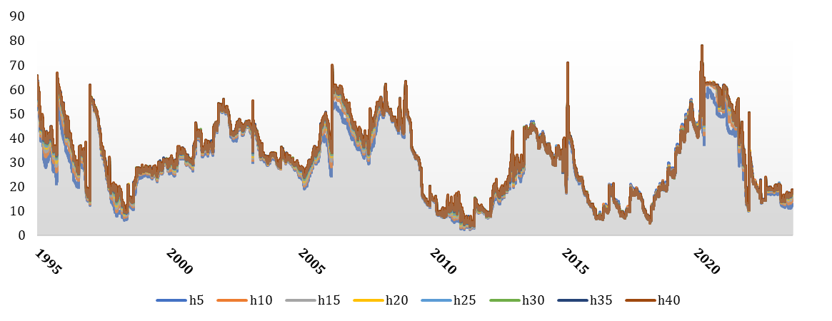
Supplementary figure 4. Forecast horizon sensitivity analysis
(Source: Authors' own work)

