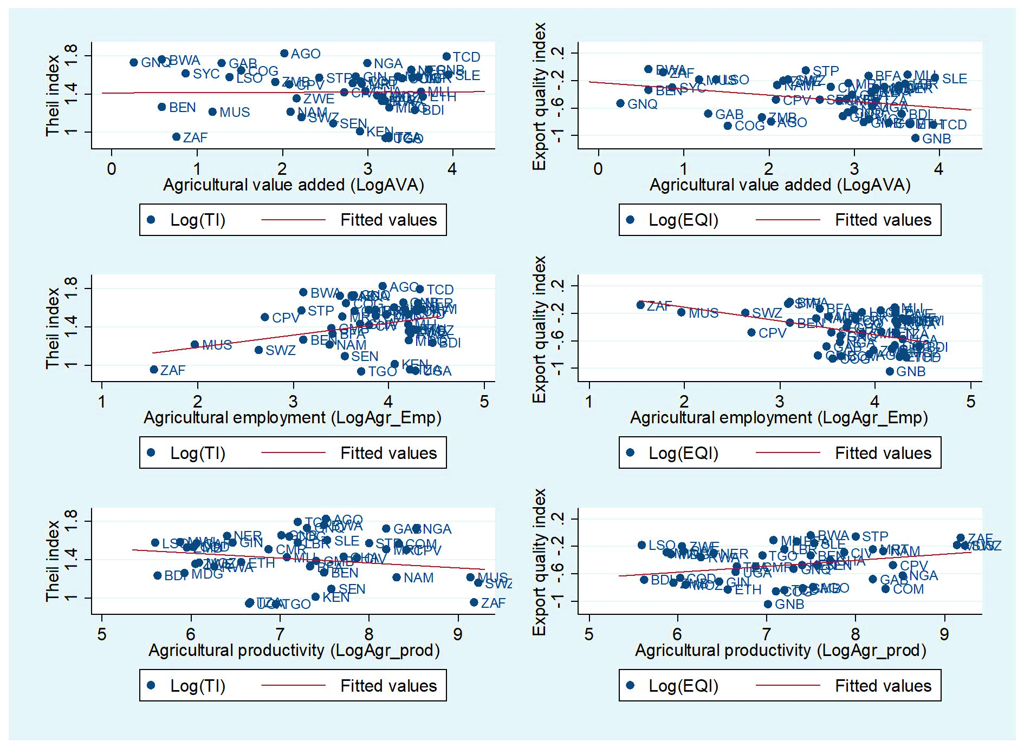
Figure A1: Agricultural development and export structure (source: Authors)

Table A1: List of countries
CRNR: Countries rich in natural resources (RT/PIB ≥ 10%) | CPNR: Countries poor in natural resources (RT/PIB < 10%)
South Africa | Burundi
Angola | Togo
Botswana | Zimbabwe
Cameroon | Senegal
Congo | Mauritius
Gabon | Mozambique
Ghana | Mali
Guinea | Madagascar
Equatorial Guinea | Burkina Faso
Guinea-Bissau | Tanzania
Mauritania | Kenya
Namibia | Éthiopia
Niger | Cabo Verde
Nigeria | Malawi
Dem. Rep. Of the Congo | Ivory Coast
Sierra Leone | Benin
Chad | Rwanda
Zambia | Uganda
 | Seychelles
 | Comoros
 | Lesotho
 | Liberia
 | Central African Republic
 | Sao Tome and Principe
 | Swaziland (Eswatini)
 | Gambia
Source: Authors

Table A2: Variable definitions
Variables | Definitions (measurement) | Data sources
Ti | Theil index, overall. It captures the concentration of the export portfolio | IMF (Diversification Toolkit)
ETi | Theil index, extensive margin | IMF (Diversification Toolkit)
ITi | Theil index, intensive margin | IMF (Diversification Toolkit)
EQi | Export quality index | IMF (Diversification Toolkit)
ECi | Economic Complexity index | Harvard University (Atlas of Economic Complexity)
AVA | Agricultural value added (% GDP) | World Bank (WDI)
MVA | Manufacturing value added (% GDP) | World Bank (WDI)
SVA | Services value added (% GDP) | World Bank (WDI)
Agr_Emp | Agricultural employment (% Total employment) | World Bank (WDI)
Agr_Prod | Agricultural productivity (Constant 2015 US $) | World Bank (WDI)
Pop. | Country’s population. We use it like proxy of economy size (peoples) | World Bank (WDI)
Openness | Trade openness. Share of the sum of exports and imports goods and services (% GDP) | World Bank (WDI)
Invest | Domestic Investments. It is the Gross fixed capital formation (% GDP) | World Bank (WDI)
FDI | Foreign direct investment, net inflow (% GDP) | World Bank (WDI)
Resources | Total natural resources rents in GDP (% GDP) | World Bank (WDI)
Inst. | Institution. Measures the quality of governance through the average calculated on the variables control of corruption, rule of law, government effectiveness and quality of regulation (unity) | World Bank (WGI)
Dist. | Distance index. For this study, we consider the distwces data for ours estimations (miles) | CEPII (DistGeo)
Source: Authors

Table A3: Descriptive Statistics
Variable | Obs | Mean | Std. Dev. | Min | Max
LogTi | 860 | 1.428 | .245 | .577 | 1.845
LogETi | 829 | -1.358 | 1.527 | -4.605 | 1.04
LogITi | 860 | 1.278 | .261 | .507 | 1.785
LogEQi | 856 | -.485 | .318 | -1.607 | .054
LogECi | 533 | -.075 | .717 | -5.364 | 1.169
LogAVA | 844 | 2.788 | .932 | -.114 | 4.37
LogAgr_Emp | 860 | 3.855 | .572 | 1.526 | 4.526
LogAgr_prod | 776 | 7.052 | .959 | 5.341 | 9.296
LogMVA | 789 | 2.218 | .59 | -1.458 | 3.561
LogSVA | 833 | 3.775 | .266 | 2.521 | 4.344
LogPop | 880 | 15.615 | 1.602 | 11.229 | 18.988
LogOpen | 777 | 4.129 | .458 | 3.043 | 5.416
LogInvest | 745 | 2.921 | .512 | -1.228 | 4.09
LogFDI | 823 | .764 | 1.502 | -6.089 | 5.087
LogDist | 860 | 8.934 | .068 | 8.841 | 9.093
LogRes | 863 | 1.816 | 1.566 | -6.676 | 4.128
LogInst | 703 | .204 | .477 | -2.159 | 1.053
Notes: Log: natural logarithm; Ti: Theil index of export concentration; ETi: extensive margin of the Theil index; ITi: intensive margin of the Theil index; EQi: export quality index; ECi: economic complexity index; AVA: share of agricultural value added in GDP; Agr_Emp: share of agricultural employment in total employment; Agr_prod: agricultural productivity; MVA: share of manufacturing value added in GDP; SVA: share of services value added in GDP; Pop: total population of the country; Open: trade openness; Invest: domestic investment; FDI: foreign direct investment; Dist: average distance of the country from its trading partners; Res: natural resource rents; Inst: governance quality of institutions.
Source: Authors

Table A4: Pairwise correlations
Variables | (1) | (2) | (3) | (4) | (5) | (6) | (7) | (8) | (9) | (10) | (11) | (12) | (13) | (14) | (15) | (16) | (17)
(1) LogTi | 1.000
(2) LogETi | 0.306 | 1.000
(3) LogITi | 0.771 | -0.256 | 1.000
(4) LogEQi | -0.303 | -0.082 | -0.229 | 1.000
(5) LogECi | -0.612 | -0.315 | -0.528 | 0.426 | 1.000
(6) LogAVA | 0.014 | 0.180 | -0.110 | -0.260 | -0.165 | 1.000
(7) LogAgr_Emp | 0.293 | 0.199 | 0.133 | -0.360 | -0.291 | 0.720 | 1.000
(8) LogAgr_prod | -0.195 | -0.067 | -0.153 | 0.255 | 0.166 | -0.431 | -0.795 | 1.000
(9) LogMVA | -0.308 | -0.155 | -0.223 | 0.217 | 0.383 | -0.262 | -0.217 | 0.071 | 1.000
(10) LogSVA | -0.382 | -0.432 | -0.125 | 0.277 | 0.455 | -0.282 | -0.369 | 0.243 | 0.256 | 1.000
(11) LogPop | -0.200 | 0.171 | -0.203 | -0.146 | -0.187 | 0.367 | 0.356 | -0.418 | -0.020 | -0.230 | 1.000
(12) LogOpen | 0.132 | -0.218 | 0.292 | 0.206 | 0.038 | -0.566 | -0.457 | 0.393 | -0.025 | 0.076 | -0.468 | 1.000
(13) LogInvest | 0.146 | -0.110 | 0.251 | 0.103 | -0.202 | -0.352 | -0.215 | 0.221 | -0.074 | 0.086 | -0.077 | 0.446 | 1.000
(14) LogFDI | 0.108 | -0.129 | 0.201 | 0.088 | -0.098 | -0.280 | -0.192 | 0.101 | -0.145 | 0.055 | -0.158 | 0.426 | 0.345 | 1.000
(15) LogDist | -0.297 | -0.365 | -0.092 | 0.162 | 0.428 | -0.430 | -0.416 | 0.175 | 0.348 | 0.419 | -0.221 | 0.377 | 0.019 | -0.008 | 1.000
(16) LogRes | 0.294 | 0.403 | 0.083 | -0.372 | -0.442 | 0.358 | 0.549 | -0.457 | -0.294 | -0.583 | 0.472 | -0.268 | -0.097 | -0.008 | -0.516 | 1.000
(17) LogInst | -0.341 | -0.364 | -0.149 | 0.347 | 0.404 | -0.335 | -0.454 | 0.339 | 0.174 | 0.495 | -0.167 | 0.177 | 0.286 | 0.105 | 0.385 | -0.578 | 1.000
Source: Authors

Table A5: Sys-GMM regression on extensive and intensive concentration margin
 | LogETi |  |  |  |  | LogITi
 | (1) | (2) | (3) |  | (4) |  | (5) | (6)
LlogETi | .747*** | .771*** | .802***
 | (.183) | (.056) | (.028)
LlogITi |  |  |  |  | .831*** |  | .73*** | .743***
 |  |  |  |  | (.028) |  | (.044) | (.041)
LogAVA | -.56*** |  |  |  | .028*
 | (.149) |  |  |  | (.017)
LogAgr_Emp |  | -.283*** |  |  |  |  | .036**
 |  | (.082) |  |  |  |  | (.017)
LogAgr_prod |  |  | -.122** |  |  |  |  | -.045*
 |  |  | (.057) |  |  |  |  | (.025)
LogMVA | -.348** | -.159*** | -.178*** |  | -.037*** |  | -.033** | -.065***
 | (.15) | (.054) | (.05) |  | (.011) |  | (.014) | (.013)
LogSVA | -.096 | -.162 | -.546** |  | -.001 |  | -.097*** | -.019
 | (.714) | (.249) | (.23) |  | (.03) |  | (.028) | (.048)
LogPop | -.056 | -.164*** | -.052* |  | -.004 |  | -.016* | -.01*
 | (.065) | (.032) | (.029) |  | (.005) |  | (.008) | (.006)
LogOpen | -1.092*** | -1.137*** | -.318*** |  | .094** |  | .028 | .108*
 | (.295) | (.221) | (.074) |  | (.035) |  | (.042) | (.058)
LogInvest | .006 | .293*** | .046 |  | .005 |  | .042** | .003
 | (.159) | (.102) | (.053) |  | (.01) |  | (.017) | (.011)
LogFDI | .054 | .055*** | .008 |  | .001 |  | .003 | .001
 | (.037) | (.018) | (.015) |  | (.002) |  | (.002) | (.002)
LogDist | -1.797 | .835 | -.404 |  | -.147 |  | -.142 | -.286
 | (1.881) | (.798) | (.536) |  | (.106) |  | (.122) | (.178)
LogRes | -.04 | .062** | .009 |  | -.006 |  | .0003 | -.011*
 | (.057) | (.03) | (.029) |  | (.005) |  | (.005) | (.006)
LogInst | -.554*** | -.351*** | -.205*** |  | -.022* |  | -.043** | -.007
 | (.194) | (.102) | (.07) |  | (.011) |  | (.018) | (.03)
_cons | 23.904 | .634 | 4.53 |  | 1.09 |  | 1.193 | 3.131**
 | (17.089) | (6.311) | (4.633) |  | (.853) |  | (.987) | (1.446)
Observations | 469 | 457 | 432 |  | 499 |  | 487 | 462
Countries | 39 | 38 | 38 |  | 39 |  | 38 | 38
Instruments | 29 | 35 | 37 |  | 38 |  | 35 | 38
AR(1) | .032 | .018 | .013 |  | .007 |  | .008 | .005
AR(2) | .283 | .275 | .234 |  | .605 |  | .457 | .506
Sargan | .927 | .847 | .737 |  | .869 |  | .745 | .461
Hansen | .807 | .850 | .615 |  | .751 |  | .287 | .502
Note: Standard errors are in parentheses, *** p<.01, ** p<.05, * p<.1
Source: Authors

Table A6: Summary of database construction procedure
Steps | Procedure
- Definition of the spatial and temporal horizon | Depending on data availability, we observe 44 Sub-Saharan African countries (see Table A1) over 20 years (1995-2014).
- Data collection | We extracted data for each variable from credible sources (see Table 1).
- Coding | The countries making up the panel were coded by their 3-letter ISO identifier. Then, following the alphabetical order of the ISO codes, we assigned a unique number between 1 and 44 to each country. This numeric country identifier (ID) enables the STATA software to recognise the country variable as being a numeric variable. We also coded each variable with a short name or an easily recognisable abbreviation.
- Integration | Data is entered into the database with the utmost care. In order to limit the risk of error associated with incorrect merging of the databases, we chose to copy, paste and check the data for each variable, for each country and corresponding time period. The first column of our database, built on an Excel spreadsheet, is reserved for the full names of the countries. Each country is repeated consecutively 20 times to correspond to the number of years used in the study. The 2th and 3th columns are reserved respectively for the ISO code and the country identifier. The 4th column is reserved for consecutive years from 1995 to 2014. This incrementation is repeated 44 times to correspond to the number of countries studied. From the 5th column onwards, each variable is integrated into the database. The data are integrated with missing values when this is the case.
- Harmonisation | Missing values in the database are harmonised using empty cells.
- Transformation | To facilitate interpretation of the estimation results and reduce the risk of outliers, each variable in the database was log-transformed, resulting in the creation of new variables. Finally, the Excel file (.xls) was imported into STATA and converted into a DTA file (.dta) that could be used by the software.
Source: Authors

