Revisiting liquidity spillovers: Evidence of the US dual role as shock source and absorber
Table S1: Systematic review of the US as a unidirectional shock source
Study | Stance/ Classification | Mechanism Framing | Notes / Limitations | Type of Proxy for liquidity/ Method
Zhou et al. (2018) | US = dominant transmitter to Europe | Contagion view: one-way shocks from US → Europe | No examine of absorption or feedback from Europe | Price/return-based
Aladesanmi (2020) | US = leading shock source | Emphasizes contagion nature | No verification of two-way mechanism | Stock market return
Li (2021) | Developed markets transmit risk; emerging markets receive | Volatility and asymmetric volatility spillovers | spillovers surged in COVID | Volatility measurement
Balli et al. (2021) | US = dominant global center | Transmission path US → Europe | Lack of mutual adjustment analysis | Cross-market linkage models
K.-H. Choi and Yoon (2023) | DE, EU, US, UK are net risk shock source; CN, IN, JP are net receivers; | International stock market risk connectedness | Downside risk connectedness is stronger than upside. | Daily  stock returns/ARMA (1, 1)-GJR-GARCH (1, 1)
Muñoz Mendoza et al. (2023) | US and Austria are net shock sources. | Developed markets are the source of shock. | Only using Spread, not reflecting multi-dimensional liquidity | Liquidity spread only
Source: The authors synthesize
Table S2. Statistical description and Stationary test
 | AUSTRIA | BELGIUM | FRANCE | GERMANY | NETHERLAND | POLAND | PORTUGAL | SPAIN | SWITZERLAND | UK | US
Mean | 0.464 | 0.466 | 0.467 | 0.469 | 0.467 | 0.468 | 0.460 | 0.457 | 0.466 | 0.467 | 0.460
Median | 0.430 | 0.444 | 0.448 | 0.451 | 0.450 | 0.457 | 0.440 | 0.407 | 0.450 | 0.448 | 0.438
Maximum | 0.956 | 0.909 | 0.863 | 0.972 | 0.895 | 0.817 | 0.973 | 0.994 | 0.922 | 0.951 | 0.972
Minimum | 0.173 | 0.240 | 0.257 | 0.236 | 0.239 | 0.332 | 0.181 | 0.238 | 0.205 | 0.190 | 0.209
Std. Dev. | 0.150 | 0.121 | 0.110 | 0.117 | 0.107 | 0.070 | 0.133 | 0.159 | 0.127 | 0.125 | 0.140
Skewness | 0.872 | 0.758 | 0.770 | 0.714 | 0.644 | 1.152 | 0.736 | 1.222 | 0.465 | 0.776 | 0.679
Kurtosis | 3.255 | 3.177 | 3.184 | 3.250 | 3.038 | 5.134 | 3.306 | 3.862 | 2.773 | 3.565 | 2.959
t-Statistic | -4.524*** | -4.203*** | -7.945*** | -7.632*** | -9.005*** | -7.897*** | -7.817*** | -3.163* | -4.194*** | -5.619*** | -5.389***
*,**,***: statistically significant at 10%, 5% and 1%
Note: The Augmented Dickey-Fuller for Stationary test. The unit root test results show that all the t-statistics are significantly negative, with most having p-values close to zero. Spain is the only country with a slightly higher p-value (0.0223). However, it is still below the standard threshold of 0.05, allowing us to reject the unit root hypothesis, suggesting that the data is stationary. Since the time series data does not exhibit unit roots, it is suitable for regression analysis and calculating the accurate transfer entropy estimation between stock markets, as non-stationary data could lead to misleading results in capturing information flows between market.
Source: Estimated by authors

Table S3. PC1 loadings across all four liquidity sub-indices
PC1 | Bid-ask | Roll | Amihud | Volume
Austria | 0.554576 | 0.587768 | 0.587287 | 0.045466
Belgium | 0.588509 | 0.515228 | 0.618877 | 0.072028
France | 0.581434 | -0.365694 | 0.451506 | 0.569512
Germany | 0.615009 | -0.418873 | 0.304873 | 0.594442
Netherland | 0.405380 | -0.467186 | 0.464786 | 0.633545
Poland | 0.404062 | 0.580088 | 0.594981 | -0.382401
Portugal | 0.698121 | 0.014304 | -0.094947 | 0.709512
Spain | 0.577693 | 0.528371 | 0.537771 | 0.312885
Switzerland | 0.442315 | 0.479512 | 0.690733 | -0.311953
UK | 0.693223 | 0.200591 | 0.530520 | 0.444695
USA | 0.671559 | 0.297327 | 0.395517 | 0.551517
(Source: Estimated by authors)

Table S4. Weights of 4 sub-indexes
 | Bid-Ask | Roll | Amihud | Volume
Austria | 0.31242014 | 0.33111891 | 0.33084771 | 0.02561325
Belgium | 0.32792575 | 0.28709238 | 0.34484688 | 0.04013498
France | 0.29542208 | 0.18580644 | 0.22940674 | 0.28936474
Germany | 0.31813049 | 0.21667385 | 0.15770391 | 0.30749174
Netherland | 0.20568286 | 0.23704226 | 0.23582477 | 0.32145010
Poland | 0.20599298 | 0.29573211 | 0.30332483 | 0.19495008
Portugal | 0.4602337 | 0.00942971 | 0.06259315 | 0.46774344
Spain | 0.29523552 | 0.27002903 | 0.27483279 | 0.15990266
Switzerland | 0.22983219 | 0.24916011 | 0.35891327 | 0.16209443
UK | 0.37090039 | 0.10732346 | 0.28384771 | 0.23792844
USA | 0.35051504 | 0.15518754 | 0.20643708 | 0.28786033
(Source: Estimated by authors)

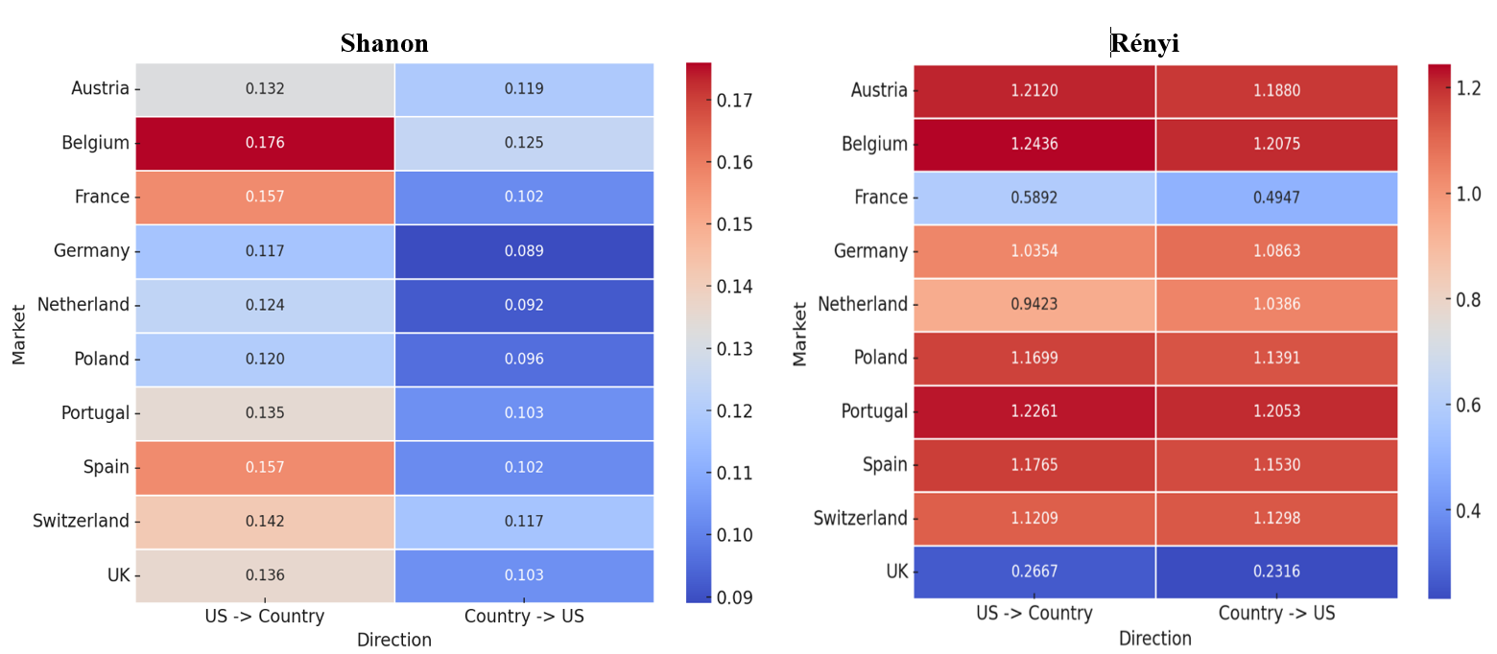
Figure S1. Information transmition between US and EU stock market
Source: Estimated by authors

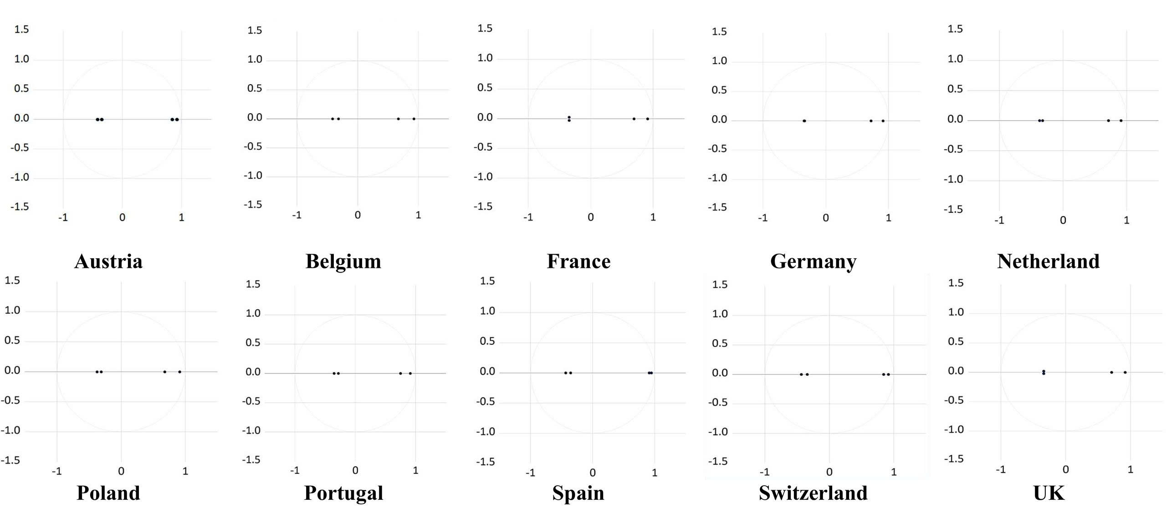
Note: The stability of the VAR models has been confirmed, as all eigenvalues lie inside the unit circle, ensuring the robustness of the estimations. This strengthens the validity of our results and reinforces the earlier findings from the Transfer Entropy and Granger causality analyses.
Figure S2. Eigenvalue stability condition
Source: Estimated by authors

