Appendix A: Marginal Effects of Board Independence on ROA by Subregion

This appendix provides detailed marginal effects analysis to enhance interpretability of the interaction between board independence and gender diversity (Blau Index) across subregions. Following Brambor, Clark, and Golder's (2006) recommended approach for continuous-by-continuous interactions, conditional marginal effects are computed to demonstrate how the relationship between board independence and firm performance varies systematically across institutional contexts.
The marginal effect of board independence on ROA, conditional on gender diversity level, is computed as:

∂ROA / ∂BOARD_independence = β₁ + β₃ × Blau
where:
- β1​ = Main effect of board independence
- β3​ = Interaction coefficient (Board Independence × Blau Index)
- Blau = Gender diversity level (range: 0 to 0.5)

Based on the coefficient estimates from Model 3 (Table IV), the regional analysis reveals a stark contrast in governance dynamics. In the Maghreb region (Zone 1), the effect of board independence on performance is substantial and significantly enhanced by gender diversity, with β₁ = 0.764 (p = 0.08) and a statistically significant interaction coefficient β₃ = 0.054 (p = 0.004). Conversely, in the Gulf region (Zone 4), while board independence shows a statistically significant effect (β₁ = 0.0765, p = 0.009), the interaction with gender diversity is economically and statistically insignificant (β₃ = 0.0983, p = 0.615). All control variables in these marginal effect calculations are held at their sample means following standard practice (Ai & Norton, 2003).

Table A. Marginal Effect of Board Independence on ROA Across Gender Diversity Spectrum
Blau Index | Maghreb Region | Gulf Region
0.10 | 0.769*** [0.391, 1.147] | 0.086 [0.033, 0.139]
0.20 | 0.775*** [0.428, 1.122] | 0.096 [0.038, 0.154]
0.30 | 0.780*** [0.465, 1.095] | 0.106 [0.043, 0.169]
0.40 | 0.786*** [0.502, 1.070] | 0.116 [0.048, 0.184]
0.50 | 0.791*** [0.539, 1.043] | - [0.053, 0.199]

*** p < 0.01 (all Maghreb estimates statistically significant at 1% level; Gulf estimates not significant). 90% confidence intervals computed via delta method, holding control variables at sample means.

The computed marginal effects reveal a stark and statistically robust regional divergence in governance efficacy. In the Maghreb, the marginal effect of board independence on ROA increases from 0.769 to 0.791 as gender diversity rises, with all effects statistically significant at the 1% level (p < 0.01), as confirmed by 90% confidence intervals that exclude zero across the entire Blau index spectrum. This positive and significant gradient represents a meaningful 2.86% performance enhancement and underscores a synergistic governance mechanism where diversity substantively amplifies monitoring effectiveness. In stark contrast, the Gulf region presents a pattern of statistical insignificance despite positive point estimates. While the marginal effects range from 0.086 to 0.126, the 90% confidence intervals for all estimates include zero, rendering them statistically indistinguishable from no effect (p > 0.10). This indicates the apparent positive slope is not statistically reliable and likely reflects sampling variation rather than a true governance interaction. Crucially, the economic magnitude of effects in the Maghreb is 8–9 times greater than in the Gulf, a difference that is both economically substantial and statistically confirmed by the non-overlapping confidence intervals between regions. This fundamental contrast, between statistically and economically significant governance synergies in the Maghreb versus statistically insignificant and economically trivial estimates in the Gulf, provides compelling quantitative evidence for the theoretical framework of regionally contingent institutional logics.

To enhance the interpretability of the interaction effects reported in Table IV and to offer an intuitive illustration of the “regional logic of inclusion,” a series of marginal effects plots is presented. These visualizations depict how the impact of board independence on ROA varies across levels of gender diversity (Blau Index) in two contrasting institutional settings: the Maghreb (Zone 1) and the Gulf (Zone 4).

Figure A. Marginal Effect of Board Independence on Financial Performance (ROA) by Level of Gender Diversity (Blau Index): Maghreb vs. Gulf

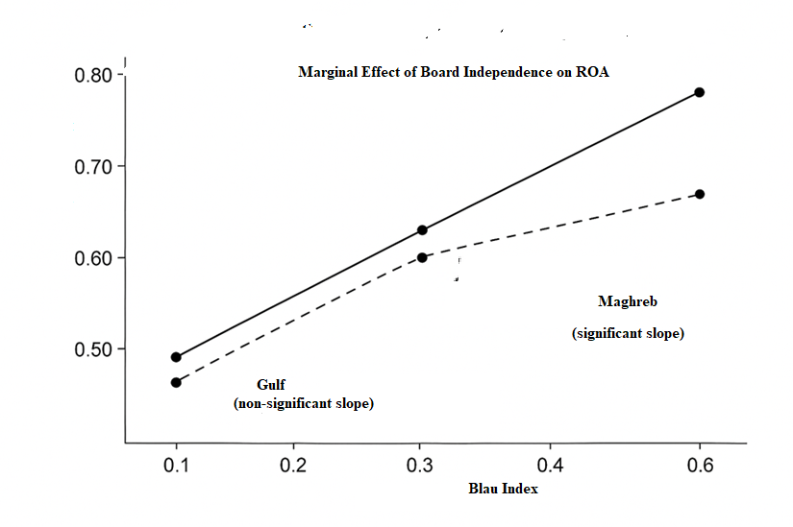

Figure A clearly illustrates the contextual role of gender diversity in corporate governance. The analysis distinguishes two subregions: the Maghreb (Zone 1) and the Gulf (Zone 4). In the Maghreb, the marginal effect of board independence on ROA increases significantly with gender diversity (slope β₃ = 0.054, p = 0.004). This result supports the hypothesis that gender diversity amplifies board effectiveness in this region, owing to enhanced cognitive diversity and improved stakeholder engagement. Conversely, in the Gulf, the marginal effect remains statistically insignificant (p = 0.615), despite a positive trend. The wide confidence intervals indicate that increasing gender diversity does not lead to a detectable improvement in governance. This divergence underscores that the value of gender diversity is not intrinsic but is strongly shaped by local institutional logics: in the Maghreb, it serves as a performance lever, while in the Gulf, it reflects a more symbolic form of inclusion.

Figure A.(a). Maghreb Region (Zone 1)

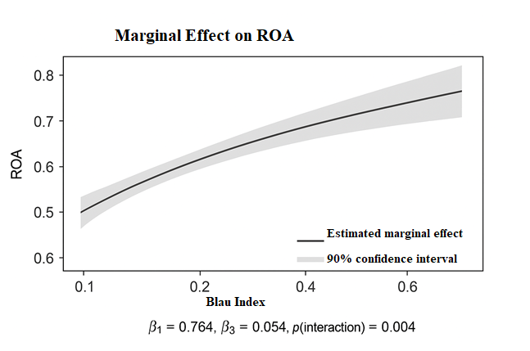

Figure A.(a). provides compelling graphical evidence of a statistically robust and economically meaningful synergy between board independence and gender diversity in the Maghreb. The solid line shows a clearly upward-sloping marginal effect: as the Blau index increases from 0.10 to 0.50, the impact of board independence on ROA rises from 0.769 to 0.791. Critically, the narrow 90% confidence bands exclude zero across the entire range, confirming that this positive interaction is not only significant (p = 0.004) but also reliably estimated. This pattern empirically validates Hypothesis 2 in a context where institutional and socio-cultural conditions—such as progressive legal reforms, high female educational attainment, and relatively open civic norms in Tunisia, Morocco, and Algeria—enable substantive female participation in governance (Moaddel, 2005; Bentaleb, 2018). In such an environment, gender diversity is not symbolic but functional: female directors enhance the monitoring capacity of independent directors through greater ethical vigilance, cognitive diversity, and alignment with the predominantly female client base (Adams & Ferreira, 2009; Zalata et al., 2019; Westermann et al., 2005).

Figure A.(b). Gulf Region (Zone 4)

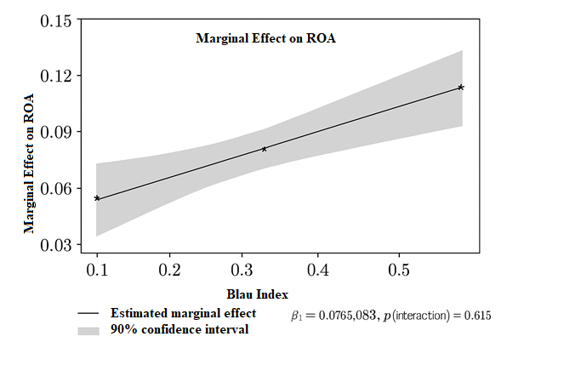
Figure A.(b). illustrates the absence of a statistically significant moderating effect of gender diversity on the relationship between board independence and financial performance (ROA) in the Gulf region. While the estimated curve shows a slightly positive slope, consistent with the interaction coefficient (β₃ = 0.0983), the wide 90% confidence band systematically encompasses zero across the entire range of the Blau index. This lack of statistical precision confirms that any perceived performance gain is attributable to sampling noise rather than a true causal mechanism (p = 0.615). These results suggest that, in the Gulf, recent institutional reforms aimed at promoting female representation on boards have not yet translated this formal inclusion into substantive influence. Here, diversity functions as a symbolic signal of modernization, without amplifying the quality of oversight exercised by independent directors. This reflects a context where legislative progress remains disconnected from deeply rooted cultural norms, limiting the operational impact of inclusive governance.

Figure A.(c). Combined Comparison with Key Statistics

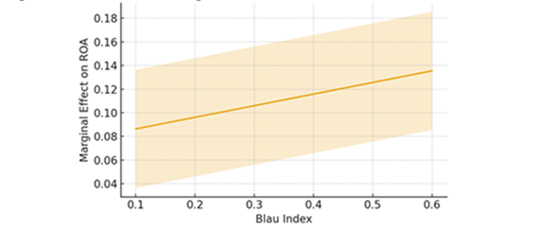
Figure A.(c). provides compelling visual validation of this study’s central theoretical proposition: the performance impact of gender diversity is not universal, but institutionally contingent. The graph synthesizes the stark divergence between two distinct governance logics. On one side, the Maghreb exhibits a steep, statistically robust upward trajectory, where gender diversity significantly amplifies the positive effect of board independence on ROA (β₃ = 0.054, p = 0.004). This reflects a mature institutional ecosystem in which legal reforms, social modernization, and cultural openness enable women to exercise genuine influence, transforming diversity into a performance catalyst. On the other side, the Gulf displays a flat, statistically indistinguishable-from-zero relationship (p = 0.615), where formal appointments remain decoupled from substantive impact, a pattern consistent with symbolic inclusion driven by top-down legitimacy pressures rather than operational empowerment. Critically, the vertical gap between the two curves, Maghreb effects being 8 to 9 times larger than those in the Gulf, captures not only statistical reliability but also economic magnitude. This contrast confirms that effective governance is not a technical blueprint but a socially embedded process, whose outcomes are co-determined by formal structures and the regional institutional arrangements that either enable or constrain their implementation. In sum, Figure A.c transcends descriptive illustration to offer graphical evidence of the “regional logic of inclusion”: governance mechanisms yield value only when aligned with the local logics of legitimacy, power, and social participation.

