APPENDIX

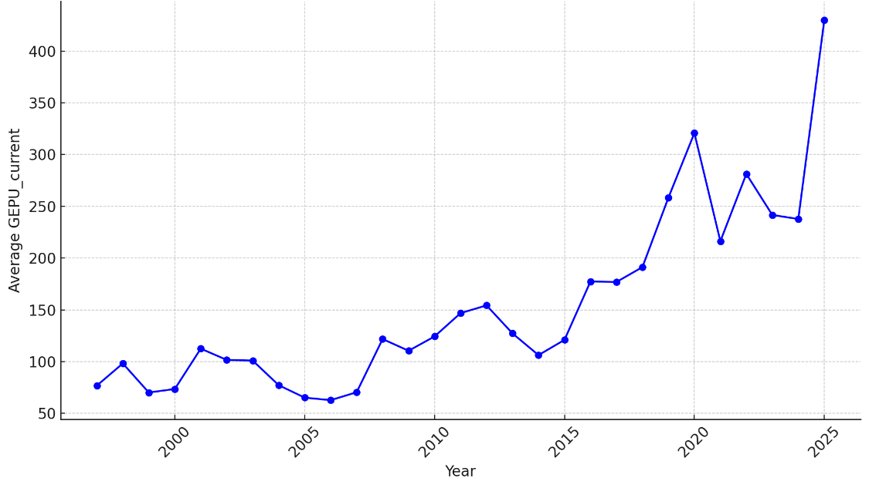
Figure 1. Trends in the Global Economic Policy Uncertainty Index (GEPU)
Source: Figure created by the authors

Table 3. Descriptive statistics of variables
Variable | Obs | Mean | S.D. | Min | Median | Max
ROA | 371 | 0.007 | 0.008 | -0.045 | 0.007 | 0.048
NPL | 337 | 0.053 | 0.078 | 0.005 | 0.038 | 1.249
GEPU | 390 | 5.204 | 0.329 | 4.666 | 5.178 | 5.771
EA | 372 | 0.089 | 0.041 | -0.070 | 0.079 | 0.256
GROW_CRE | 370 | 0.189 | 0.188 | -0.364 | 0.167 | 1.481
INC | 371 | 0.049 | 0.018 | 0.004 | 0.045 | 0.131
COST | 371 | 0.016 | 0.005 | 0.004 | 0.016 | 0.051
SIZE | 372 | 32.493 | 1.254 | 29.738 | 32.411 | 35.554
GDP | 390 | 6.096 | 1.540 | 2.554 | 6.423 | 8.124
INF | 390 | 5.060 | 4.327 | 0.631 | 3.520 | 18.68
Source: Table created by authors.
Table 4. Correlation matrix of variables
Variables | (1) | (2) | (3) | (4) | (5) | (6) | (7) | (8) | (9) | (10)
(1) ROA | 1.000
(2) NPL | -0.211*** | 1.000
(3) GEPU | 0.067 | -0.091* | 1.000
(4) EA | 0.433*** | 0.063 | -0.250*** | 1.000
(5) GROW_CRE | 0.095* | -0.066 | -0.233*** | 0.002 | 1.000
(6) INC | -0.093* | 0.106* | -0.270*** | 0.135*** | -0.006 | 1.000
(7) COST | 0.205*** | 0.028 | -0.087* | 0.381*** | -0.203*** | 0.001 | 1.000
(8) SIZE | 0.100* | -0.122** | 0.359*** | -0.621*** | -0.089* | -0.292*** | -0.237*** | 1.000
(9) GDP | -0.056 | 0.012 | -0.206*** | 0.012 | 0.101* | -0.041 | 0.060 | -0.061 | 1.000
(10) INF | 0.202*** | 0.092* | -0.351*** | 0.263*** | 0.144*** | 0.668*** | 0.064 | -0.268*** | 0.045 | 1.000
*** p<0.01, ** p<0.05, * p<0.1
Source: Table created by authors.

Table 5. Estimation Results on the Effects of GEPU and Bank Equity (EA) on Bank Performance (NIM) and Risk (SDROA)
 | Two-step system GMM |  | Two-step system GMM
 | (5) |  | (6)
 | NIM |  | SDROA
L.NIM | 0.2475***
 | (0.0597)
L.SDROA |  |  | 0.7322***
 |  |  | (0.0464)
GEPU | -0.0086*** |  | 0.0031***
 | (0.0033) |  | (0.0009)
EA | -0.3551* |  | 0.2047***
 | (0.1986) |  | (0.0570)
GEPUxEA | 0.0930** |  | -0.0467***
 | (0.0374) |  | (0.0115)
GROW_CRE | 0.0032 |  | 0.0012*
 | (0.0024) |  | (0.0006)
INC | -0.0622*** |  | -0.0510***
 | (0.0135) |  | (0.0129)
COST | 0.7158*** |  | 0.2371***
 | (0.1828) |  | (0.0421)
SIZE | 0.0043*** |  | 0.0000
 | (0.0007) |  | (0.0003)
GDP | 0.0001 |  | 0.0001*
 | (0.0001) |  | (0.0000)
INF | 0.0008*** |  | 0.0002**
 | (0.0001) |  | (0.0001)
_cons | -0.0986*** |  | -0.0163
 | (0.0266) |  | (0.0101)
Marginal (net) effect of GEPU conditional on EA (evaluated at mean EA) | -0.0003 |  | -0.0011
Observations | 339 |  | 292
No. of instruments | 26 |  | 21
No. of groups | 26 |  | 26
AR(1) test (p-value) | 0.077 |  | 0.020
AR(2) test (p-value) | 0.720 |  | 0.942
Hansen test (p-value) | 0.186 |  | 0.304
Difference-in-Hansen tests (p-value) | 0.356 |  | 0.239
Standard errors in parentheses, * p < 0.1, ** p < 0.05, *** p < 0.01
Source: Table created by authors.

Table 6. Estimation Results on the Effects of US–China Trade Tension (UCT) and Bank Equity (EA) on Bank Performance (ROA, NIM) and Bank Risk (NPL, SDROA)
 | Two-step system GMM |  | Two-step  system GMM |  | Two-step  system GMM |  | Two-step  system GMM
 | (7) |  | (8) |  | (9) |  | (10)
 | ROA |  | NIM |  | NPL |  | SDROA
L.ROA | 0.2832**
 | (0.1200)
L.NIM |  |  | 0.7810***
 |  |  | (0.0831)
L.NPL |  |  |  |  | 0.2358***
 |  |  |  |  | (0.0554)
L.SDROA |  |  |  |  |  |  | 0.6122***
 |  |  |  |  |  |  | (0.1405)
UCT | -0.0092* |  | -0.0130*** |  | 0.0314** |  | 0.0097***
 | (0.0052) |  | (0.0033) |  | (0.0123) |  | (0.0036)
EA | -0.4548*** |  | -0.6104*** |  | 1.7009** |  | 0.5712***
 | (0.1668) |  | (0.1606) |  | (0.6656) |  | (0.2056)
UCTxEA | 0.1198*** |  | 0.1382*** |  | -0.2986** |  | -0.1196***
 | (0.0368) |  | (0.0338) |  | (0.1453) |  | (0.0438)
GROW_CRE | 0.0259*** |  | -0.0172** |  | 0.0016 |  | 0.0029
 | (0.0052) |  | (0.0071) |  | (0.0144) |  | (0.0044)
INC | -0.0017 |  | 0.2255*** |  | 0.2342 |  | 0.0684*
 | (0.0567) |  | (0.0635) |  | (0.1751) |  | (0.0366)
COST | -0.4580*** |  | 0.3123 |  | 0.4177 |  | 0.2211**
 | (0.1590) |  | (0.2905) |  | (0.6354) |  | (0.1100)
SIZE | 0.0033*** |  | 0.0024*** |  | -0.0005 |  | 0.0002
 | (0.0009) |  | (0.0005) |  | (0.0024) |  | (0.0003)
GDP | -0.0000 |  | -0.0001 |  | -0.0002 |  | -0.0001
 | (0.0001) |  | (0.0002) |  | (0.0004) |  | (0.0001)
INF | 0.0003* |  | -0.0015*** |  | -0.0000 |  | -0.0006
 | (0.0002) |  | (0.0003) |  | (0.0003) |  | (0.0005)
_cons | -0.0666* |  | -0.0200 |  | -0.1422* |  | -0.0558***
 | (0.0351) |  | (0.0212) |  | (0.0782) |  | (0.0215)
Marginal (net) effect of UCT conditional on EA (evaluated at mean EA) | 0.0015 |  | -0.0007 |  | 0.0048 |  | -0.0009
Observations | 343 |  | 313 |  | 301 |  | 266
No. of instruments | 20 |  | 19 |  | 25 |  | 15
No. of groups | 26 |  | 26 |  | 26 |  | 26
AR(1) test (p-value) | 0.041 |  | 0.006 |  | 0.067 |  | 0.050
AR(2) test (p-value) | 0.916 |  | 0.122 |  | 0.219 |  | 0.380
Hansen test (p-value) | 0.475 |  | 0.885 |  | 0.242 |  | 0.726
Difference-in-Hansen tests (p-value) | 0.420 |  | 0.870 |  | 0.452 |  | 0.535
Standard errors in parentheses, * p < 0.1, ** p < 0.05, *** p < 0.01
Source: Table created by authors.

Table 7. Estimation Results Results on the Effects of GEPU and The ratio of Tier 1 capital to Total risk-weighted assets (TIER1) on Bank Performance (ROA, NIM) and Bank Risk (NPL, SDROA)
 | Two-step system GMM |  | Two-step system GMM |  | Two-step system GMM |  | Two-step system GMM
 | (9) |  | (10) |  | (11) |  | (12)
 | ROA |  | NIM |  | NPL |  | SDROA
L.ROA | 0.4828***
 | (0.0361)
L.NIM |  |  | 0.5698***
 |  |  | (0.0764)
L.NPL |  |  |  |  | 0.7325***
 |  |  |  |  | (0.0227)
L.SDROA |  |  |  |  |  |  | 1.0381***
 |  |  |  |  |  |  | (0.2136)
GEPU | -0.0250*** |  | -0.0287*** |  | 0.0624*** |  | 0.0162**
 | (0.0068) |  | (0.0095) |  | (0.0130) |  | (0.0067)
TIER1 | -0.8296*** |  | -0.8985*** |  | 1.5931*** |  | 0.5690**
 | (0.2444) |  | (0.2963) |  | (0.4548) |  | (0.2251)
GEPUxTIER1 | 0.1670*** |  | 0.1803*** |  | -0.3021*** |  | -0.1132***
 | (0.0484) |  | (0.0576) |  | (0.0862) |  | (0.0434)
GROW_CRE | -0.0177*** |  | 0.0013 |  | -0.0159 |  | 0.0236**
 | (0.0026) |  | (0.0049) |  | (0.0186) |  | (0.0112)
INC | -0.0397 |  | 0.0878 |  | -0.1887 |  | -0.1041***
 | (0.0275) |  | (0.1283) |  | (0.2064) |  | (0.0217)
COST | -0.0906 |  | 0.3121 |  | -0.8890* |  | 0.3539**
 | (0.1353) |  | (0.2770) |  | (0.5219) |  | (0.1494)
SIZE | 0.0006 |  | 0.0013 |  | 0.0001 |  | 0.0021***
 | (0.0008) |  | (0.0009) |  | (0.0016) |  | (0.0007)
GDP | -0.0003* |  | 0.0002 |  | 0.0004 |  | 0.0000
 | (0.0002) |  | (0.0002) |  | (0.0002) |  | (0.0001)
INF | 0.0000 |  | -0.0008** |  | 0.0017* |  | -0.0001
 | (0.0001) |  | (0.0004) |  | (0.0010) |  | (0.0003)
_cons | 0.1150* |  | 0.1028* |  | -0.3046*** |  | -0.1557***
 | (0.0608) |  | (0.0549) |  | (0.1102) |  | (0.0558)
Marginal (net) effect of GEPU conditional on TIER1 (evaluated at mean TIER1) | 0.0022 |  | 0.0007 |  | 0.0132 |  | -0.0023
Observations | 262 |  | 262 |  | 249 |  | 262
No. of instruments | 23 |  | 21 |  | 21 |  | 17
No. of groups | 23 |  | 23 |  | 23 |  | 23
AR(1) test (p-value) | 0.005 |  | 0.005 |  | 0.085 |  | 0.027
AR(2) test (p-value) | 0.200 |  | 0.378 |  | 0.418 |  | 0.505
Hansen test (p-value) | 0.250 |  | 0.135 |  | 0.218 |  | 0.639
Difference-in-Hansen tests (p-value) | 0.398 |  | 0.338 |  | 0.684 |  | 0.208
Standard errors in parentheses, * p < 0.1, ** p < 0.05, *** p < 0.01
Source: Table created by authors.
Table 8. Estimation Results Results on the Effects of GEPU and Capital Adequacy Ratio (CAR) on Bank Performance (ROA, NIM) and Bank Risk (NPL, SDROA)
 | Two-step system GMM |  | Two-step system GMM |  | Two-step system GMM |  | Two-step system GMM
 | (13) |  | (14) |  | (15) |  | (16)
 | ROA |  | NIM |  | NPL |  | SDROA
L.ROA | 0.5663***
 | (0.0630)
L.NIM |  |  | 0.2840**
 |  |  | (0.1266)
L.NPL |  |  |  |  | 0.5383***
 |  |  |  |  | (0.0363)
L.SDROA |  |  |  |  |  |  | 0.3789***
 |  |  |  |  |  |  | (0.0704)
GEPU | -0.0129*** |  | -0.0345*** |  | 0.0871*** |  | 0.0035*
 | (0.0021) |  | (0.0125) |  | (0.0307) |  | (0.0018)
CAR | -0.5444*** |  | -1.3432*** |  | 3.3350*** |  | 0.1688**
 | (0.0858) |  | (0.4871) |  | (1.1713) |  | (0.0744)
GEPUxCAR | 0.1119*** |  | 0.2819*** |  | -0.5939*** |  | -0.0350**
 | (0.0175) |  | (0.0954) |  | (0.2302) |  | (0.0150)
GROW_CRE | -0.0029* |  | -0.0025 |  | -0.0230 |  | 0.0000
 | (0.0017) |  | (0.0052) |  | (0.0186) |  | (0.0010)
INC | -0.0662*** |  | -0.1353*** |  | 0.4948*** |  | -0.0359**
 | (0.0132) |  | (0.0316) |  | (0.1070) |  | (0.0151)
COST | -0.1589 |  | 0.6597* |  | -1.8323** |  | 0.0981
 | (0.1784) |  | (0.3588) |  | (0.8055) |  | (0.0658)
SIZE | 0.0027*** |  | 0.0043*** |  | 0.0002 |  | 0.0001
 | (0.0004) |  | (0.0011) |  | (0.0023) |  | (0.0003)
GDP | -0.0001 |  | -0.0003* |  | 0.0020*** |  | 0.0005***
 | (0.0001) |  | (0.0002) |  | (0.0004) |  | (0.0001)
INF | 0.0005*** |  | 0.0008*** |  | 0.0001 |  | 0.0005***
 | (0.0001) |  | (0.0001) |  | (0.0005) |  | (0.0001)
_cons | -0.0186 |  | 0.0406 |  | -0.4736*** |  | -0.0232
 | (0.0229) |  | (0.0773) |  | (0.1374) |  | (0.0178)
Marginal (net) effect of GEPU conditional on CAR (evaluated at mean CAR) | 0.0015 |  | 0.0019 |  | 0.0105 |  | -0.0010
Observations | 314 |  | 314 |  | 288 |  | 268
No. of instruments | 24 |  | 21 |  | 24 |  | 23
No. of groups | 25 |  | 25 |  | 25 |  | 25
AR(1) test (p-value) | 0.030 |  | 0.053 |  | 0.015 |  | 0.020
AR(2) test (p-value) | 0.693 |  | 0.224 |  | 0.272 |  | 0.169
Hansen test (p-value) | 0.420 |  | 0.110 |  | 0.731 |  | 0.220
Difference-in-Hansen tests (p-value) | 0.576 |  | 0.799 |  | 0.853 |  | 0.218
Standard errors in parentheses, * p < 0.1, ** p < 0.05, *** p < 0.01
Source: Table created by authors.

