Appendix

Table A1. Full Test Statistics: BMP, Sign, and Corrado Rank Tests for Tier 1 Firms
Event | Dir. | CAAR  [−1,+1] | BMP-t | Sign-z | Corrado-K | CAAR  [−5,+5] | BMP-t | Sign-z | Corrado-K | N
E1 | Neg | −1.43** | −2.23 | −1.21 | −0.72 | −3.80** | −2.74 | −2.18 | −0.87 | 17
E2 | Neg | 1.15 | 1.73 | 1.70 | 1.11 | 5.51*** | 4.34 | 3.15 | 1.73* | 17
E3 | Pos | 0.77* | 1.92 | 1.21 | 0.75 | 2.25** | 2.74 | 3.15 | 1.26 | 17
E4 | Pos | −2.89** | −2.78 | −1.21 | −1.65* | −2.23** | −2.24 | −0.73 | −0.57 | 17
E5 | Pos | −0.62 | −0.73 | −0.24 | −0.05 | −8.72*** | −4.10 | −3.15 | −2.27** | 17
E6 | Pos | −0.48 | −0.23 | −2.18 | 0.19 | −1.48 | −0.95 | −2.18 | 0.07 | 17
Notes: CAAR for Tier 1 EUDR-exposed firms (%). BMP-t = Boehmer, Musumeci & Poulsen (1991) standardized cross-sectional test. Sign-z = nonparametric sign test. Corrado-K = Corrado (1989) rank test. * p<0.10, ** p<0.05, *** p<0.01.

Table A2. Macroeconomic Environment and Confounding Factors Around EUDR Events
Event | Date | Dir. | CAAR  [−1,+1]% | IHSG  [−10,+30]% | CPO  ($/t) | ΔCPO  (%) | IDR/EUR | ΔIDR  (%) | Primary? | Confounding Factor
E1 | 26 Apr 2023 | Neg | −1.43* | −1.6 | 935 | +2.7 | 90 | +2.0 | Yes | -
E2 | 09 Jun 2023 | Neg | 1.15 | 2.4 | 769 | −7.9 | 89 | −0.3 | No | Already anticipated
E3 | 02 Oct 2024 | Pos | 0.77* | −6.7 | 1034 | +9.7 | 92 | −1.6 | Yes | -
E4 | 14 Nov 2024 | Pos | −2.89** | −5.4 | 1133 | +9.6 | 90 | −2.1 | No | US election shock
E5 | 04 Dec 2025 | Pos | −0.62 | 7.0 | 981 | +0.4 | 105 | +2.7 | Yes | IDR/EUR peak + domestic policy
E6 | 23 Dec 2025 | Pos | −0.48 | −6.6 | 981 | +0.4 | 105 | +2.7 | No | -
Notes: CAAR = Cumulative Average Abnormal Return for Tier 1 firms, window [−1,+1]. IHSG = Indonesian composite index return during [−10,+30]. CPO = crude palm oil price (USD/metric ton). IDR/EUR = Rupiah per Euro (positive = IDR depreciation). * p<0.10, ** p<0.05, *** p<0.01.

Table A3. Placebo Tests: Actual versus Pseudo-Event Date CARs
Event | Actual CAAR  [−1,+1]% | Placebo  (−90 TD)% | Placebo  (−180 TD)%
E1 | −1.43** | 0.00 | −2.19***
E2 | 1.15 | 1.50 | 0.64
E3 | 0.77* | 0.64 | 0.01
E4 | −2.89** | 0.75 | −2.76***
E5 | −0.62 | 7.39*** | 0.34
E6 | −0.48 | 4.02* | −0.75
Notes: Tier 1 firms only. Placebo dates are shifted by −90 and −180 trading days from each EUDR announcement. Significant CARs at placebo dates would invalidate identification. * p<0.10, ** p<0.05, *** p<0.01.

Table A4. Robustness: Multifactor Market Model (Market + CPO + FX) Abnormal Returns
Event | [−1,+1] |  | [−5,+5]
Event | Single-Factor | Multifactor | Single-Factor | Multifactor
E1 (Adoption) | −1.43* | −1.52** | −3.80** | −4.29***
E3 (Delay Proposal) | 0.77* | 0.87** | 2.25* | 2.67**
E5 (2nd Revision) | −0.62 | −0.70 | −8.72*** | −9.17***
Notes: Tier 1 CAAR (%). Single-Factor = baseline market model $R_{it}=α_{i}+β_{i}R_{mt}+ε_{it}$ (Brown and Warner, 1985). Multifactor = $R_{it}=α_{i}+β_{imkt}R_{mt}+β_{icpo}R_{tcpo}+β_{ifx}R_{tfx}+ε_{it}$, with daily crude palm oil futures return (CME “CPO=F”) and daily IDR/EUR return as additional factors, estimation window [−252,−31] trading days (identical to baseline). ​*p<0.10, ​**p<0.05, ​***p<0.01.

Table A5. Cross-Sectional Regression Diagnostics: F-Statistics and Cross-Sectional Dependence Robustness
Event | N | F-stat | Tier 1 coef. | SE (HC3) | SE (cluster) | p (wild boot.) | G
E1 (Adoption) | 75 | 0.89 | −2.470 | (2.370) | (1.886) | 0.497 | 4
E3 (Delay Proposal) | 75 | 1.14 | 0.963 | (0.939) | (0.650) | 0.382 | 4
E5 (2nd Revision) | 75 | 0.93 | −2.975 | (1.686) | (0.988) | 0.184 | 4
Notes: Specification (3) from Table 3 (tier dummies, RSPO, ISPO, Physical Risk, and firm controls), dependent variable CAR[−1,+1] (%). F-stat = overall model F-test (joint significance of all regressors). SE (cluster) = cluster-robust standard error, clustered by commodity (palm oil / soy / rubber / none, G=4). p (wild boot.) = wild cluster bootstrap p-value for the Tier 1 coefficient (Cameron et al., 2008; null-imposed, Rademacher weights, 4,999 replications). With only G=4 commodity clusters, the wild-bootstrap and cluster-robust results are reported as diagnostic robustness checks, not as a replacement for the HC3 standard errors used as the main specification. ​*p<0.10, ​**p<0.05, ​***p<0.01 (on F-stat, HC3-based).

Table A6. Cross-Sectional Determinants of Cumulative Abnormal Returns, Window [−5,+5]
 | E1 (Negative) |  |  | E3 (Positive) |  |  | E5 (Positive)
 | (1) | (2) | (3) | (1) | (2) | (3) | (1) | (2) | (3)
Tier 1 | −3.684** | 1.383 | −0.569 | −0.597 | −1.206 | 0.081 | −6.714*** | −4.090 | −5.733
 | (1.805) | (2.903) | (3.572) | (1.417) | (3.088) | (3.211) | (2.283) | (4.142) | (4.809)
Tier 2 | 3.309 | 3.256 | 2.732 | −2.308 | −2.299 | 0.460 | −1.186 | −1.222 | −2.818
 | (2.277) | (2.251) | (3.598) | (1.473) | (1.457) | (2.368) | (2.857) | (3.025) | (5.116)
RSPO Certified | — | −0.999 | −2.557 | — | 0.733 | 2.885 | — | 1.790 | 0.497
 |  | (3.428) | (4.305) |  | (3.129) | (3.237) |  | (5.649) | (4.984)
ISPO Certified | — | −0.146 | −0.532 | — | −0.871 | −1.905 | — | −1.002 | −0.834
 |  | (2.979) | (3.715) |  | (2.985) | (3.357) |  | (6.735) | (6.380)
Physical Risk (z) | — | −3.088** | −2.597 | — | 0.523 | 1.732 | — | −2.133* | −3.417
 |  | (1.234) | (2.281) |  | (0.766) | (1.925) |  | (1.245) | (2.266)
Log Size | — | — | 0.487 | — | — | −0.883* | — | — | −0.222
 |  |  | (0.838) |  |  | (0.514) |  |  | (0.650)
Book-to-Market | — | — | 1.810 | — | — | −2.864** | — | — | −0.730
 |  |  | (1.589) |  |  | (1.436) |  |  | (1.296)
Leverage | — | — | 0.485 | — | — | −6.952 | — | — | 9.375
 |  |  | (6.071) |  |  | (4.940) |  |  | (8.301)
ROA | — | — | −16.902 | — | — | −9.493 | — | — | −6.652
 |  |  | (15.197) |  |  | (13.040) |  |  | (16.789)
Market Beta | — | — | −0.700 | — | — | 1.904 | — | — | −1.167
 |  |  | (1.111) |  |  | (1.167) |  |  | (1.329)
N | 75 | 75 | 75 | 75 | 75 | 75 | 75 | 75 | 75
R² | 0.061 | 0.170 | 0.328 | 0.011 | 0.018 | 0.147 | 0.144 | 0.188 | 0.280
Notes: Dependent variable: CAR[−5,+5] (%), the same window emphasized as the primary window in Table 2. Specifications (1)-(3) as in Table 3. Reported alongside Table 3 (window [−1,+1]) so that both windows used elsewhere in the paper are represented in the cross-sectional analysis. OLS with HC3 heteroskedasticity-robust standard errors in parentheses. ​*p<0.10, ​**p<0.05, ​***p<0.01.

Table A7. Cross-Sectional Determinants of Cumulative Abnormal Returns: Confirmation Events (E2, E4, E6)
 | E2 (Tightening) |  |  | E4 (Relief) |  |  | E6 (Relief)
 | (1) | (2) | (3) | (1) | (2) | (3) | (1) | (2) | (3)
Tier 1 | 0.781 | −1.300 | −0.530 | −2.759** | 0.815 | −0.130 | −1.342 | −1.261 | −0.492
 | (0.890) | (2.102) | (2.086) | (1.320) | (1.747) | (1.694) | (0.911) | (1.759) | (1.882)
Tier 2 | 1.071 | 1.090 | 0.362 | 0.831 | 0.838 | 0.976 | −2.903** | −2.900* | −0.921
 | (1.977) | (1.953) | (2.738) | (0.800) | (0.782) | (1.868) | (1.471) | (1.484) | (1.988)
RSPO Certified | — | −0.244 | −0.785 | — | −2.727 | −2.414 | — | −3.560 | −2.477
 |  | (1.613) | (2.051) |  | (3.282) | (3.169) |  | (2.489) | (3.529)
ISPO Certified | — | 0.981 | 2.215 | — | −4.022 | −3.381 | — | 2.686 | 1.905
 |  | (1.537) | (2.326) |  | (3.126) | (3.021) |  | (2.172) | (3.169)
Physical Risk (z) | — | 1.119 | 0.197 | — | 0.445 | −0.154 | — | 0.194 | 1.276
 |  | (0.734) | (1.500) |  | (0.661) | (1.199) |  | (0.799) | (1.666)
Log Size | — | — | 0.483 | — | — | −0.214 | — | — | −0.026
 |  |  | (0.493) |  |  | (0.323) |  |  | (0.358)
Book-to-Market | — | — | 1.818* | — | — | −0.518 | — | — | −0.643
 |  |  | (0.944) |  |  | (0.693) |  |  | (1.114)
Leverage | — | — | −0.753 | — | — | −1.076 | — | — | −3.390
 |  |  | (3.709) |  |  | (3.046) |  |  | (3.885)
ROA | — | — | 22.060* | — | — | −12.970 | — | — | −12.114
 |  |  | (11.603) |  |  | (8.995) |  |  | (10.247)
Market Beta | — | — | −0.158 | — | — | −0.671 | — | — | 1.014
 |  |  | (0.688) |  |  | (0.727) |  |  | (0.875)
N | 75 | 75 | 75 | 75 | 75 | 75 | 75 | 75 | 75
R² | 0.012 | 0.073 | 0.285 | 0.116 | 0.237 | 0.345 | 0.045 | 0.085 | 0.155
Notes: Dependent variable: CAR[−1,+1] (%). Confirmation events (E2, E4, E6) were previously reported only as CAAR in Table 2/Appendix; this table extends the same cross-sectional specification used for primary events (Table 3) to the confirmation events, so that the tier/certification/physical-risk pattern can be compared across all six events, not only the three primary ones. OLS with HC3 heteroskedasticity-robust standard errors in parentheses. ​*p<0.10, ​**p<0.05, ​***p<0.01.

Table A8. Cross-Sectional Regression with PROPER Environmental Rating
 | E1 (Negative) | E3 (Positive) | E5 (Positive)
Tier 1 | −3.613 | 0.245 | −2.094
 | (2.870) | (1.212) | (1.693)
Tier 2 | 0.084 | 0.316 | −0.575
 | (2.693) | (1.630) | (1.308)
RSPO Certified | −3.631 | 0.824 | 2.715
 | (3.605) | (1.679) | (2.249)
ISPO Certified | 2.192 | −1.375 | 1.633
 | (2.645) | (1.524) | (1.964)
Physical Risk (z) | −0.384 | 1.442** | −0.818
 | (2.255) | (0.690) | (0.714)
PROPER Rated | 2.613 | 1.351 | −1.800
 | (2.710) | (1.018) | (1.178)
PROPER Good (≥ Green) | −3.277 | −0.071 | 1.078
 | (2.220) | (1.594) | (1.262)
Log Size | −0.298 | 0.050 | 0.379
 | (0.940) | (0.289) | (0.266)
Book-to-Market | 1.685 | 0.118 | 0.698
 | (1.035) | (0.622) | (0.564)
Leverage | −0.142 | −0.986 | 3.005
 | (5.199) | (1.988) | (3.229)
ROA | 8.769 | −5.490 | 2.445
 | (12.307) | (5.642) | (4.605)
Market Beta | −0.244 | 0.670 | −0.447
 | (0.951) | (0.535) | (0.556)
N | 75 | 75 | 75
R² | 0.168 | 0.228 | 0.208
Notes: Dependent variable: CAR[−1,+1] (%). Specification (7) adds proper_rated (=1 if the firm has any PROPER facility rating) and proper_good (=1 if the firm’s best PROPER rating is Green or Gold) to Specification (3). PROPER ratings cover only 21 of 75 sample firms, so this specification is reported separately rather than pooled into the main Table 3 (which would otherwise mix full-sample and PROPER-subsample identification within the same table). OLS with HC3 heteroskedasticity-robust standard errors in parentheses. ​*p<0.10, ​**p<0.05, ​***p<0.01.

Table A9. Extended Placebo Test: Fraction of Pseudo-Dates with Significant CAAR
Tier | Window | N pseudo-dates | Frac. sig. (α=0.10) | Frac. sig. (α=0.05)
Tier 1 | [−1,+1] | 48 | 27.1% | 20.8%
Tier 1 | [−5,+5] | 48 | 25.0% | 16.7%
Tier 2 | [−1,+1] | 48 | 18.8% | 4.2%
Tier 2 | [−5,+5] | 48 | 27.1% | 10.4%
Tier 3 | [−1,+1] | 48 | 43.8% | 35.4%
Tier 3 | [−5,+5] | 48 | 43.8% | 33.3%
Notes: Placebo event dates shifted by −60 through −270 trading days (30-day increments, 8 pseudo-dates per real event × 6 events). Under the null of no systematic pattern around arbitrary calendar dates, the fraction significant should be approximately equal to the nominal level (α). Fractions substantially above nominal indicate excess false-positive risk, consistent with cross-sectional dependence within the small, commodity-concentrated Tier 1 subsample (N=17, 3 commodities).

Table A10. Variance Inflation Factors, Specification (3) Design Matrix
 | VIF
Tier 1 | 3.50
Tier 2 | 1.49
RSPO Certified | 3.12
ISPO Certified | 3.21
Physical Risk ($z$) | 5.06
Log Size | 1.93
Book-to-Market | 1.87
Leverage | 1.65
ROA | 3.05
Momentum | 2.48
Market Beta | 1.73
Amihud Illiquidity ($ln$) | 3.48
N | 75
Notes: Variance Inflation Factors (VIF) for every regressor in Specification (3) of Table 3 (Tier 1, Tier 2, RSPO, ISPO, standardised Physical Risk, and firm controls). A single column is reported because every regressor is a static, firm-level characteristic (certification status, size, leverage, etc.) rather than an event-specific variable, so the design matrix, and therefore the VIF, which depends only on regressor correlations, not on the dependent variable, is identical whichever event’s CAR is being explained (E1, E3, or E5). VIF $>10$ conventionally flags severe multicollinearity; VIF between 5 and 10 flags moderate-to-high collinearity worth noting.

Table A11. Cross-Sectional Determinants of CAR Using Multifactor-Model Abnormal Returns
 | E1 |  |  | E3 |  |  | E5
 | Baseline | Multifactor | Baseline |  | Multifactor | Baseline |  | Multifactor
Tier 1 | -2.470 | -2.703 | 0.963 |  | 2.250*** | -2.975* |  | -3.038*
 | (2.370) | (2.449) | (0.939) |  | (0.755) | (1.686) |  | (1.680)
Tier 2 | 0.472 | 0.472 | 0.680 |  | 1.050 | -0.961 |  | -0.937
 | (2.503) | (2.539) | (1.298) |  | (1.504) | (1.553) |  | (1.583)
RSPO Certified | -2.539 | -2.460 | 0.613 |  | -0.046 | 2.526 |  | 2.510
 | (2.823) | (2.834) | (1.464) |  | (1.034) | (1.848) |  | (1.818)
ISPO Certified | 1.773 | 1.790 | -1.303 |  | -2.860** | 1.711 |  | 1.781
 | (2.433) | (2.461) | (1.357) |  | (1.243) | (1.733) |  | (1.707)
Physical Risk ($z$) | -0.548 | -0.521 | 1.870*** |  | 1.975* | -1.077 |  | -1.138
 | (1.731) | (1.753) | (0.704) |  | (1.070) | (0.757) |  | (0.760)
N | 75 | 75 | 75 |  | 75 | 75 |  | 75
R² | 0.143 | 0.141 | 0.200 |  | 0.196 | 0.182 |  | 0.186
Notes: Dependent variable: CAR$\left[-1,+1\right]$ (%), Specification (3) (tier dummies, RSPO, ISPO, standardised Physical Risk, and firm controls: size, B/M, leverage, ROA, momentum, beta, Amihud illiquidity). “Baseline” reproduces Table 3 (single-factor market model CAR, Brown and Warner 1985). “Multifactor” uses CAR computed from the multifactor market model (market + CPO futures + IDR/EUR, Appendix Table A4), which nets out each firm’s own estimated loadings on commodity price and currency movements before computing the abnormal return, and therefore provides a firm-varying test of whether results survive controlling for commodity/ currency exposure – unlike the event-level macro controls in the confounding analysis, which do not vary within a single-event cross-section and cannot serve as valid controls there (see Diagnostic Tests and Robustness Checks). HC3 robust standard errors in parentheses. *p<0.10, **p<0.05, ***p<0.01.

Figure A1. Cumulative Average Abnormal Returns by Certification Status Across Event Windows
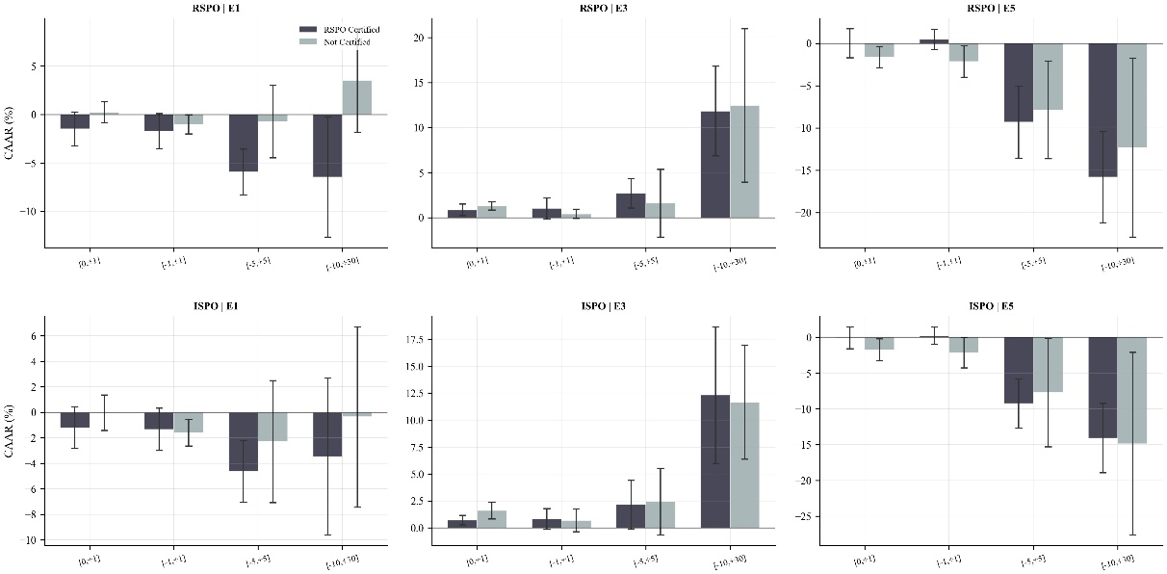
Notes: Mean CAAR (%) for Tier 1 firms at primary events E1, E3, and E5, disaggregated by RSPO (top row) and ISPO (bottom row) certification status, across four event windows: [0,+1], [-1,+1], [-5,+5], and [-10,+30]. Error bars denote 90% confidence intervals. Certified firms show larger losses than uncertified firms at E1, and comparable or modestly larger gains at E3.

Figure A2. Placebo Test: Actual versus Pseudo-Event CAAR by Event
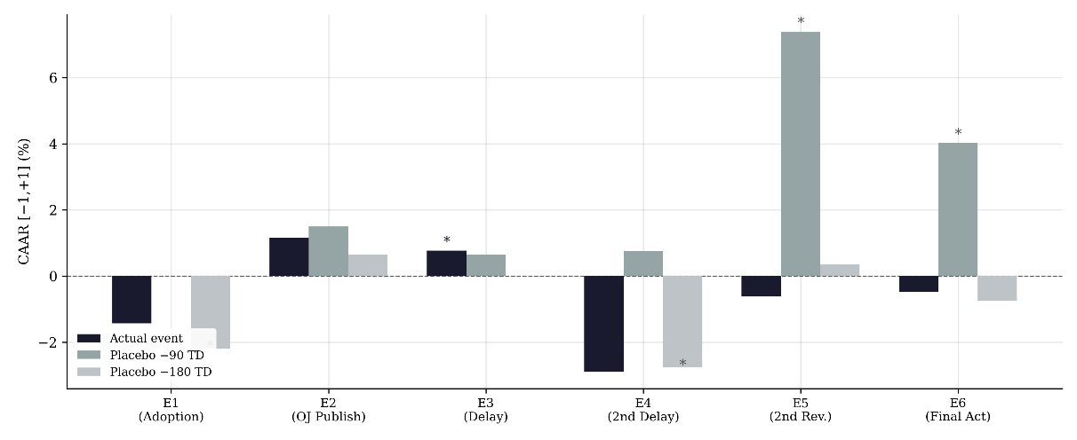
Notes: CAAR[-1,+1] (%) for Tier 1 firms at each of the six EUDR events, comparing the actual event date against two placebo dates shifted -90 and -180 trading days earlier. Asterisks denote significance at the 10% level (one-sample t-test). Several placebo dates also show significant CAAR, consistent with the elevated false-positive rate documented in the extended eight-date placebo exercise (Table A9).

