APPENDIX

Figure A1. Relationship between child penalty and kindergarten teachers by region
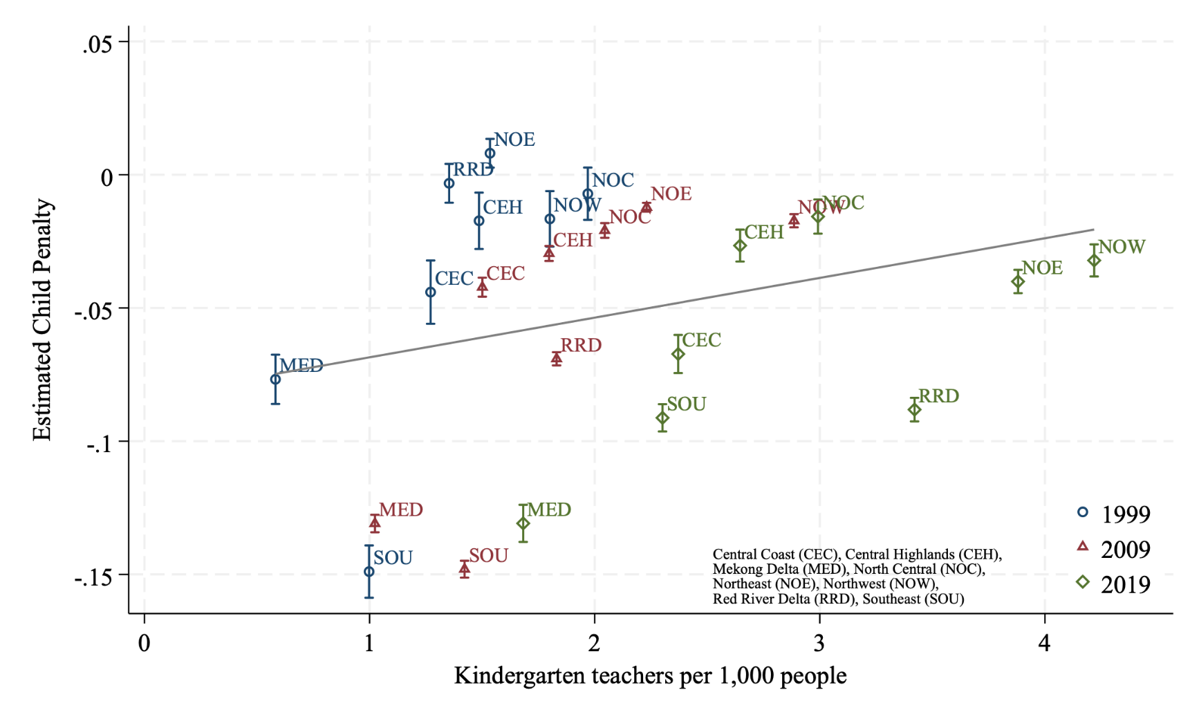
Notes: This figure plots the relationship between the estimated child penalty and the availability of kindergarten teachers across regions in Vietnam, for the census years 1999, 2009, and 2019. The y-axis shows the estimated child penalty, while the x-axis shows the number of kindergarten teachers per 1,000 people in each region, with data collected from GSO. Each marker corresponds to a region-year estimate with 95% confidence intervals. The fitted line illustrates the overall association between kindergarten services and child penalty.
Source: Authors’ own illustration

Figure A2. Relationship between child penalty and kindergarten students by region
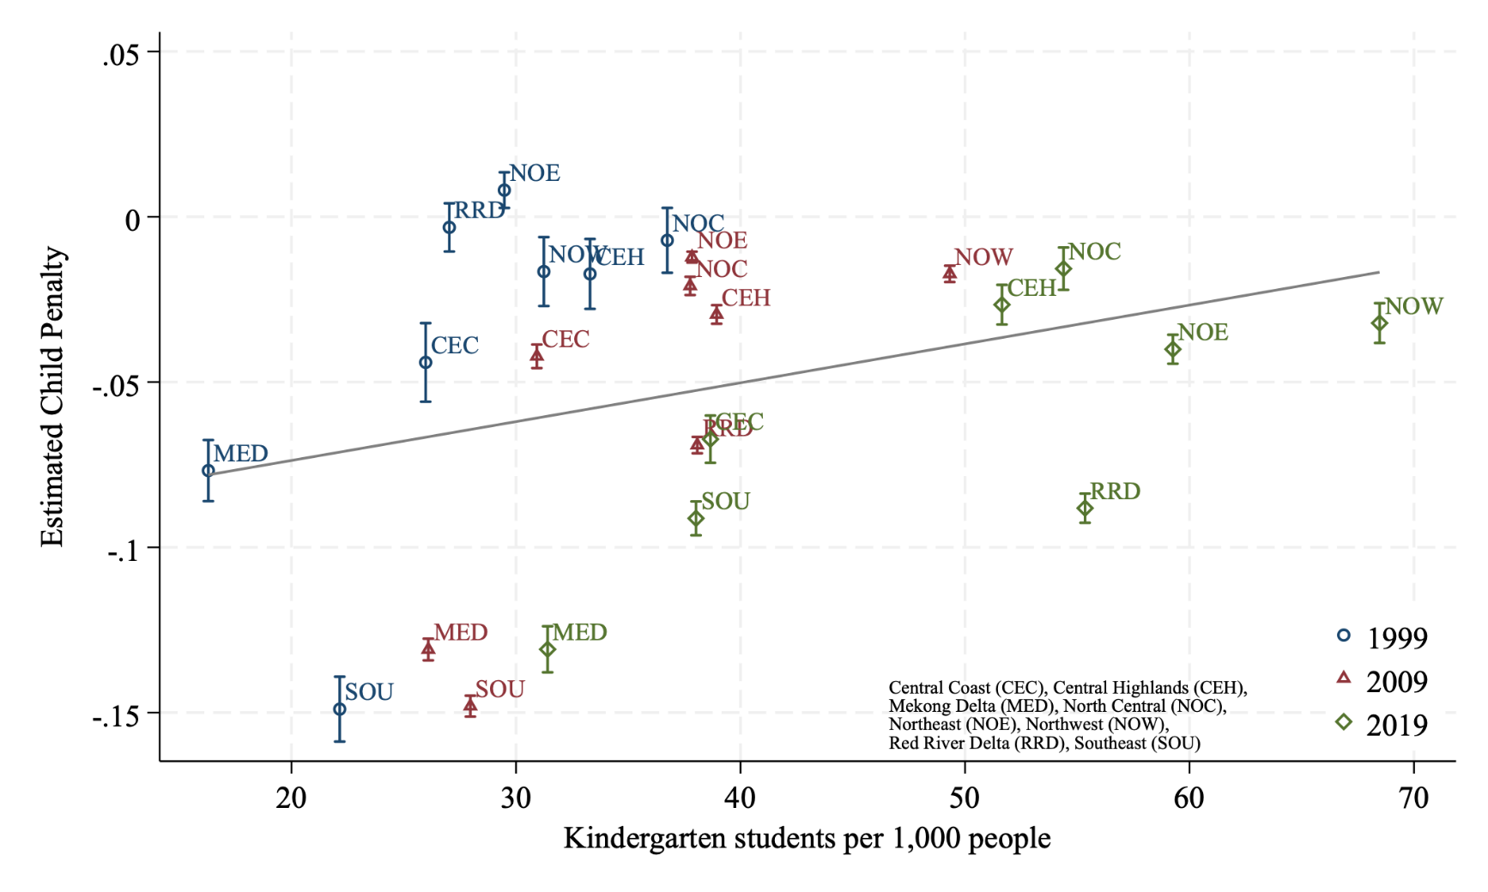
Notes: This figure plots the relationship between the estimated child penalty and the availability of kindergarten students across regions in Vietnam, for the census years 1999, 2009, and 2019. The y-axis shows the estimated child penalty, while the x-axis shows the number of kindergarten students per 1,000 people in each region, with data collected from GSO. Each marker corresponds to a region-year estimate with 95% confidence intervals. The fitted line illustrates the overall association between kindergarten services and child penalty.
Source: Authors’ own illustration

Figure A3. Relationship between changes in child penalty and kindergarten teachers by region per decade
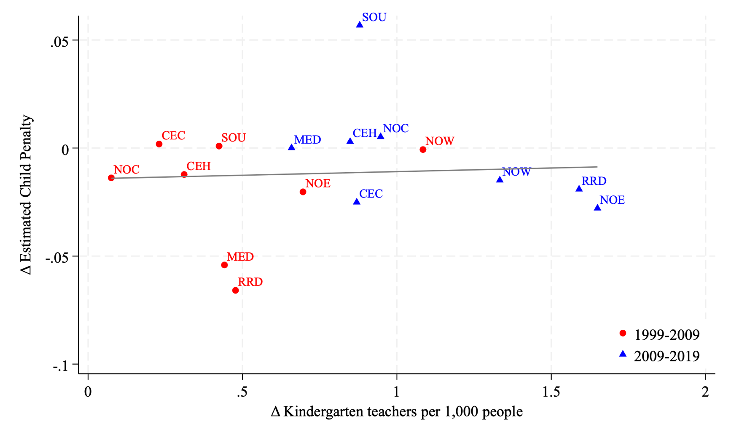
Notes: This figure depicts the relationship between changes in estimated child penalty and changes in the availability of kindergarten teachers across regions in Vietnam. The y-axis shows the change in estimated employment penalty for women after childbirth, while the x-axis shows the change in the number of kindergarten teachers per 1,000 people in each region. Red circles represent changes between 1999 and 2009, and blue triangles represent changes between 2009 and 2019. The fitted line illustrates the overall association between changes in kindergarten services and changes in child penalty.
Source: Authors’ own illustration

Figure A4. Relationship between changes in child penalty and kindergarten students by region per decade

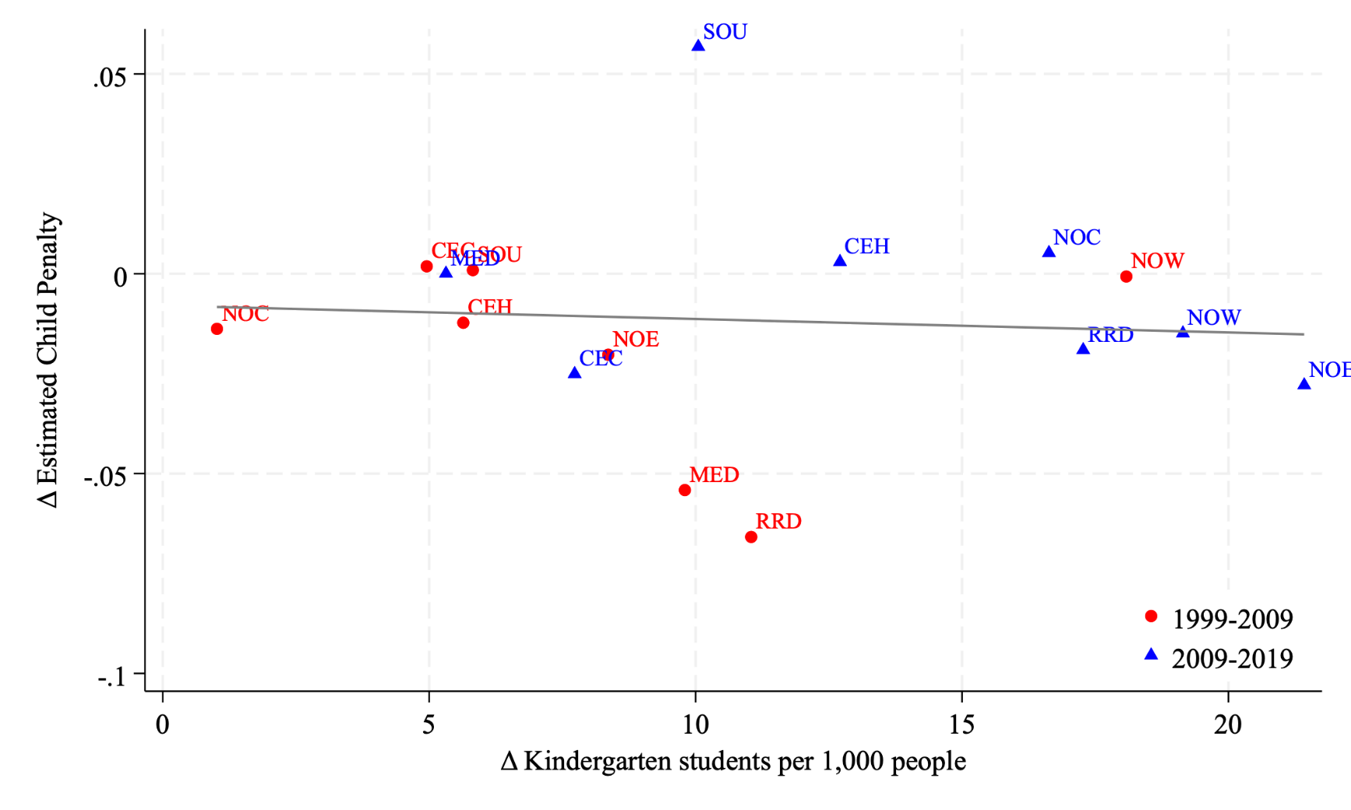
Notes: This figure depicts the relationship between changes in estimated child penalty and changes in the availability of kindergarten students across regions in Vietnam. The y-axis shows the change in estimated employment penalty for women after childbirth, while the x-axis shows the change in the number of kindergarten students per 1,000 people in each region. Red circles represent changes between 1999 and 2009, and blue triangles represent changes between 2009 and 2019. The fitted line illustrates the overall association between changes in kindergarten services and changes in child penalty.
Source: Authors’ own illustration

Table A1. Vietnam census data used to construct pseudo-event panels (1989–2019)
 | Census 1989 |  |  |  | Census 1999 |  |  |  | Census 2009 |  |  |  | Census 2019
 | Women |  | Men |  | Women |  | Men |  | Women |  | Men |  | Women |  | Men
 | Mean [SD] |  | Mean [SD] |  | Mean [SD] |  | Mean [SD] |  | Mean [SD] |  | Mean [SD] |  | Mean [SD] |  | Mean [SD]
Age | 32.20 [6.64] |  | 33.01 [6.28] |  | 33.77 [6.77] |  | 34.79 [6.24] |  | 33.93 [7.07] |  | 35.14 [6.54] |  | 34.99 [6.56] |  | 35.95 [6.18]
Urban status = 1 | 0.39 [0.49] |  | 0.36 [0.48] |  | 0.49 [0.50] |  | 0.47 [0.50] |  | 0.25 [0.43] |  | 0.24 [0.43] |  | 0.29 [0.46] |  | 0.28 [0.45]
Less than primary education = 1 | 0.00 [0.00] |  | 0.00 [0.00] |  | 0.00 [0.00] |  | 0.00 [0.00] |  | 0.00 [0.01] |  | 0.00 [0.01] |  | 0.00 [0.00] |  | 0.00 [0.00]
Completed primary education = 1 | 0.41 [0.49] |  | 0.30 [0.46] |  | 0.29 [0.46] |  | 0.24 [0.43] |  | 0.32 [0.47] |  | 0.29 [0.46] |  | 0.25 [0.43] |  | 0.23 [0.42]
Completed secondary education = 1 | 0.44 [0.50] |  | 0.51 [0.50] |  | 0.49 [0.50] |  | 0.53 [0.50] |  | 0.52 [0.50] |  | 0.54 [0.50] |  | 0.42 [0.49] |  | 0.46 [0.50]
Completed tertiary education = 1 | 0.12 [0.32] |  | 0.14 [0.35] |  | 0.18 [0.39] |  | 0.19 [0.39] |  | 0.11 [0.31] |  | 0.11 [0.31] |  | 0.19 [0.39] |  | 0.18 [0.38]
Married/In union = 1 | 0.92 [0.27] |  | 0.97 [0.18] |  | 0.93 [0.25] |  | 0.96 [0.19] |  | 0.92 [0.27] |  | 0.95 [0.22] |  | 0.91 [0.28] |  | 0.92 [0.28]
Separated/Divorced/Spouse Absent = 1 | 0.02 [0.14] |  | 0.00 [0.07] |  | 0.02 [0.13] |  | 0.01 [0.07] |  | 0.02 [0.13] |  | 0.01 [0.09] |  | 0.02 [0.15] |  | 0.02 [0.13]
Single/Never Married = 1 | 0.03 [0.16] |  | 0.02 [0.15] |  | 0.02 [0.15] |  | 0.03 [0.17] |  | 0.03 [0.18] |  | 0.04 [0.20] |  | 0.04 [0.20] |  | 0.06 [0.24]
Widowed = 1 | 0.03 [0.18] |  | 0.00 [0.06] |  | 0.03 [0.16] |  | 0.00 [0.06] |  | 0.03 [0.16] |  | 0.00 [0.06] |  | 0.02 [0.15] |  | 0.00 [0.06]
N | 313,859 |  | 240,842 |  | 326,358 |  | 273,723 |  | 2,016,589 |  | 1,715,431 |  | 1,002,832 |  | 837,335
Notes: This table summarizes demographic characteristics from all four rounds of the Vietnam Population and Housing Census used to construct the pseudo-event panel for the analysis. The table reports means and standard deviations in brackets separately for women and men in the 1989, 1999, 2009, and 2019 censuses. Key variables include age, urban residence, educational attainment, and marital status. The sample is restricted to individuals aged 20-45 at the time of each census. These data form the basis for constructing synthetic event panels, following the pseudo-event study approach of Kleven (2022).
Source: Authors’ calculations.

