Supplementary information 1: numerical analysis of consolidation transient used in test BC1
    - Numerical model: linear elastic skeletal deformation
The fluid flow through a compressible porous medium may be described by Biot’s model [1], where the governing equation for flow is obtained by combining Darcy’s law with the mass conservation equation. Thus,
$∇∙(\frac{k}{μ}∇p)= ϕβ\frac{∂p}{∂t}+\frac{∂}{∂t}(∇∙u)$ (1)
where $u$ is the solid displacement [m], $p$ is the fluid pressure [Pa], $k$ is the intrinsic permeability [m²], $μ$ is the dynamic viscosity of the fluid [Pa$∙$s], $ϕ$ is the porosity [-] and $β$ is the compressibility of the fluid [Pa⁻¹]. Note that an isotropic permeability, represented by the scalar $k$, is here assumed.
In this work, an elastic deformation of the matrix is assumed. Hence,
$∇∙τ+f= 0$ (2)
where $f$ is the body force per unit volume of the medium [N/m²] and $τ$ is the total stress on the medium [Pa], which can be expressed as
$τ= σ-αp\text{I}$ (3)
where $σ$ is the effective stress tensor [Pa], $α$ is the Biot’s coefficient [-] and $\text{I}$ is the identity tensor. Note that, under the assumption of small strains and an isotropic linear elastic material, the effective stress tensor takes the form
$σ=λtr\left(ε\right)\text{I}\text{+}2Gε$ (4)
where $λ$ is the first Lamé’s constant [Pa], $G$ is the shear modulus [Pa] and $tr$ stands for the trace operator. For the sake of simplicity, $α=1$ is here assumed. This is a reasonable assumption for a saturated porous medium and leads to the equation
$\frac{E}{2(1+ν)(1-2ν)} ∇\left(∇∙u\right)+\frac{E}{2(1+ν)}∇^{2}u -∇p= -f$ (5)
where $E$ is the Young’s modulus [Pa] and $ν$ is the Poisson’s coefficient [-]. Note that the relationships $ε=∇^{s}u$, $λ=\frac{Eν}{(1+ν)(1-2ν)}$ and $G=\frac{E}{2(1+ν)}$ have here been used.

    - Finite element formulation
Following standard procedures, the numerical solution of Biot’s model is solved using the Galerkin finite element method. Hence, the coupled-system of discretized equations
${\text{L}}^{\text{T}}\frac{d\text{u}}{dt}+\text{Hp }\text{+ }\text{S}\frac{d\text{p}}{dt}\text{ = }{\text{-F}}_{\text{p}}$ (6.1)
$\text{K}{\text{u}}^{n+1}-\text{L}{\text{p}}^{n+1}\text{ = }{\text{F}}_{\text{u}}$ (6.2)
is solved. By using the backward Euler finite difference time scheme, system (6) becomes
$\left[\begin{matrix}\text{K} & \text{L} \\ {\text{L}}^{\text{T}} & -∆t\text{H}\text{-}\text{S}\end{matrix}\right]∙\left[\begin{matrix}{\text{u}}^{n+1} \\ {\text{p}}^{n+1}\end{matrix}\right] =\left[\begin{matrix}{\text{F}}_{\text{u}} \\ {\text{L}}^{\text{T}}{\text{u}}^{n}-\text{S}{\text{p}}^{n}+∆t{\text{F}}_{\text{p}}\end{matrix}\right]$ (7)
with the matrices defined in Table 10.

Table 10: Block matrices of the discretized Biot's system of equations.
Matrix | Symbol | Expression
Flux matrix | $${\text{F}}_{\text{p}}$$ | ${\text{F}}_{\text{p}}\text{ = }\int_{Γ_{\text{p}}}^{ }{{\text{N}}^{\text{T}}\text{q}}\text{d}Ω$, where $\text{q}$ is the flux vector prescribed on the boundary $Γ_{\text{p}}$.
Load matrix | $${\text{F}}_{\text{u}}$$ | ${\text{F}}_{\text{u}}\text{ = }\int_{Γ_{\text{u}}}^{ }{{\text{N}}^{\text{T}}\text{t}}\text{d}Ω$, where $\text{t}$ is the traction vector prescribed on the boundary $Γ_{\text{u}}$.
Permeability matrix | $$\text{H}$$ | $$\text{H = }\int_{Ω}^{ }{{(∇\text{N}\text{)}}^{\text{T}}\frac{k}{μ}∇\text{N}}\text{d}Ω$$
Soil stiffness matrix | $$\text{K}$$ | $\text{K = }\int_{Ω}^{ }{{\text{B}}^{\text{T}}\text{CB}}\text{d}Ω,$where $\text{B}$ is the matrix of shape function derivatives and $\text{C}$ is the elastic stiffness tensor.
Coupling matrix | $$\text{L}$$ | $\text{L = }\int_{Ω}^{ }{{\text{B}}^{\text{T}}\text{mN}}\text{d}Ω,$where $\text{m}={\left[1,1,1,0,0,0\right]}^{\text{T}}$.
Compressibility matrix | $$\text{S}$$ | $$\text{S = }\int_{Ω}^{ }{{\text{N}}^{\text{T}}ϕβ\text{N}}\text{d}Ω$$

    - Model parametrisation: Young’s modulus and permeability estimation for FPR-19-006
The coupled system of equations (7) is solved to estimate the rock properties (namely the hydraulic permeability and the Young’s modulus) of geological materials subjected to a consolidation test. Due to the nature of this problem, a two-dimensional axisymmetric finite element model is used here. As detailed in [4], the facts that (a) the Young’s modulus mainly determines the total volume of fluid expelled (line 11) and (b) the permeability mainly determines the rate at which fluid is expelled (line 12) are used to estimate the two parameters.
This algorithm provided reasonable theoretical flow-time curves (Figure 15) for the Boom Clay sample, with input parameters summarised in Table 11 and a fitted Young’s modulus of 316 MPa and a fitted permeability of 5.1x10⁻¹⁹ m².

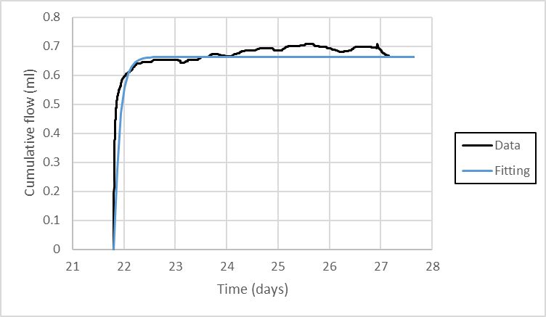
Figure 15: Boom Clay specimen: comparison of model to flow data.
Table 11: Geometrical and material parameters used in the numerical fittings for the Boom Clay specimen. Note that ⁽¹⁾ the Poisson’s coefficient reported by Barnichon and Volckaert (2003) and Bésuelle et al. (2013) is used here.
Meaning | Symbol [units] | Value
Radius of the sample | r [mm] | 24.96
Length of the sample | L [mm] | 42.67
Poisson’s coefficient | $ν$ [-] | 0.125 ⁽¹⁾
Dynamic viscosity | $μ$ [$\text{Pa}∙\text{s}$] | 2.32 x 10⁻³
Appendix references
[1] Biot, M.A. (1941). General Theory of Three‐Dimensional Consolidation. Journal of Applied Physics, 12(2), 155-164. DOI: 10.1063/1.1712886.
[2] Barnichon, J.D. and Volckaert G. (2003). Observations and predictions of hydromechanical coupling effects in the Boom clay, Mol Underground Research Laboratory, Belgium. Hydrogeology Journal, 11(1), 193-202. doi: 10.1007/s10040-002-0240-6.
[3] Bésuelle, P., Viggiani, G., Desrues, J., Coll, C. and Charrier, P. (2013). A Laboratory Experimental Study of the Hydromechanical Behavior of Boom Clay. Rock Mechanics and Rock Engineering, 47(1), 143–155. doi: 10.1007/s00603-013-0421-8.
[4] Tamayo-Mas E., Harrington J.F., Graham C.C. (2018). On modelling of consolidation processes in geological materials. International Journal of Engineering Science, 131, 61 – 79. DOI: 10.1016/j.ijengsci.2018.05.008

Supplementary information 2: X-ray CT imaging
The X-Ray CT scanner within the BGS Core Scanning Facility is a Geotek Rotating X-Ray Computed Tomography scanner (see Figure 14) and is capable of scanning core of up to 150 mm in diameter and 1.5 m in length. The sample sits between an X-ray source and detector which rotate around the sample. This is distinct from most scientific XCTs, which rotate the sample rather than the machine – the RXCT does this to preserve core integrity. For this project, two-dimensional scans (radiographies) were quickly produced and were taken orthogonally from each other to give further detail of the structure of the sample. For 3D imaging the sample was scanned at 3600 projections on an angle increment of 0.1°.

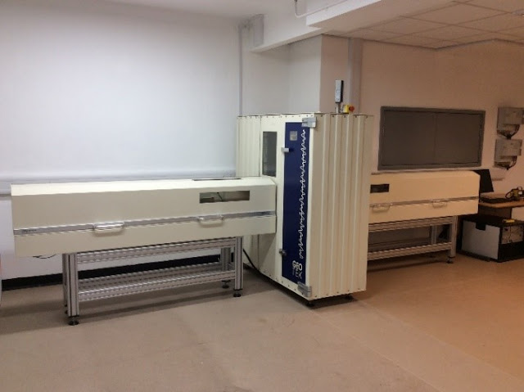
Figure 14: Geotek Rotating X-Ray CT scanner in the BGS Core Scanning Facility. The scanner is capable of scanning in both 2D (radiography) and 3D (XCT). For the current study both modes were used. For the three-dimensional image, files were taken in an XY orientation down the length of the sample from the injection face to the backpressure face.
CT scans were reconstructed from the raw sinograms into a stack of 2D images known as ‘slices’ which represent a singular voxel thick (60-80 µm) XY plane through the sample. During this process, ring and noise filtration was applied. These slices were then rendered together using the PerGeos Digital Rock Analysis software to produce a 3D visualisation of the sample which could be manipulated and analysed. Cropping of the image was also required to remove unnecessary air and packaging surrounding the sample.
Once cropped, the sample was passed through a Non-Local Means (NLM) filter. This was chosen to reduce the noise and smooth out any artefacts remaining from the scanning process. An NLM algorithm compares the local neighbourhoods of all voxels in a defined search window to determine the new corrected value for the current voxel. The similarity and proximity between the neighbours determine the weight with which this affects the current voxel after NLM filtration, Thomson et al., (2018).
There may be features within the sample, whether they are low-density areas (such as open pores, fractures, etc), or high-density areas (such as dense mineral phases, epigenetically modified burrow structures, etc) which need to be segmented to be analysed. Such features were separated from the bulk mass of the sample through a series of user-defined interactive overlay thresholds, top-hat thresholds and an automated watershed threshold. Overlay and top hat thresholding was done by eye within the software by applying a slight threshold where the user believed the boundaries best lay. When combined, these techniques improve identification of thin features such as fractures or pore networks when compared to simple greyscale thresholding. Further detail on this type of image processing is provided in Thomson et al., (2018).
These segmented structures were analysed to obtain the overall volume, distribution and shape on a feature-by-feature basis to give a broad understanding of the sample feature behaviour. Resolution of XCT images was around 50 µm.

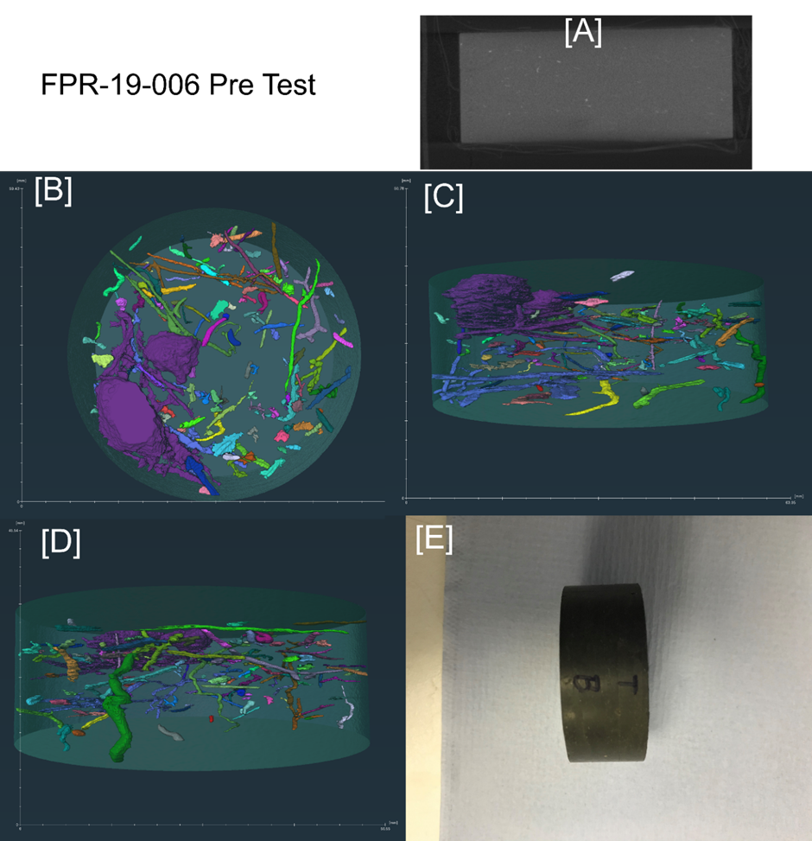
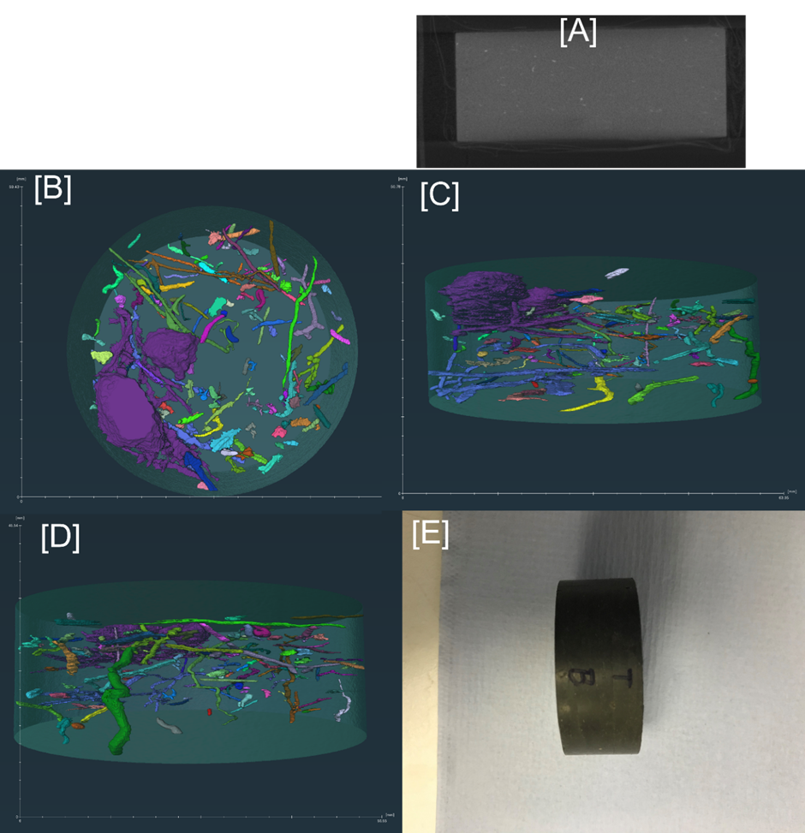
Interconnected feature network
Figure 15: Pre-test imaging of sample BC1. [A] Orthogonal XCT; [B] XCT image of features first orientation; [C] XCT image of features secondary orientation; [D] XCT image of features tertiary orientation; [E] side view of sample. Voxel resolution is 0.000212 mm³.
BC1 contains a large high-density feature towards one edge which may encourage anisotropic flow behaviour within the sample. Also visible in Figure 15[D] are many broad intersecting features both perpendicular and parallel to the flat faces of the sample. In Figure 15[C] a network of interconnected features (labelled) is highlighted. These may impact material behaviour.
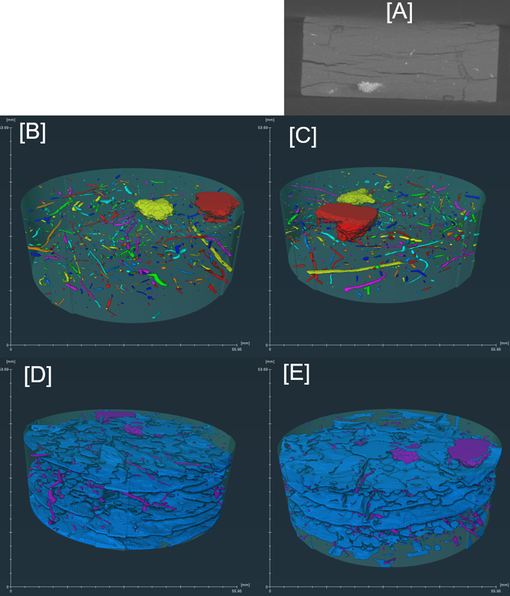
Figure 16: Post-test imaging of sample BC1. This test was oven dried prior to scanning showing desiccation cracks along the bedding. [A] Orthogonal XCT; [B] XCT image of features first orientation; [C] XCT image of features secondary orientation; [D] combined XCT image of drying low-density fractures (blue) and high-density features (purple); [E] secondary combined XCT image of drying fractures (blue) and features (purple). Voxel resolution is 0.000334 mm³.
After drying, FPR-19-006 contained a series of open fractures which run parallel to the sample face, seen best in Figure 16 [A]. These fractures bisect the high-density features within the sample shown in Figure 16 [B] and [C]. Comparing the pre-test data in Figure 15 [C] and [D] to the post-test data in Figure 16 [B] and [C] appears to show that most of the features in the post-test sample are reduced in volume and shape, with features becoming flatter and more constrained possibly as sample contraction during drying.
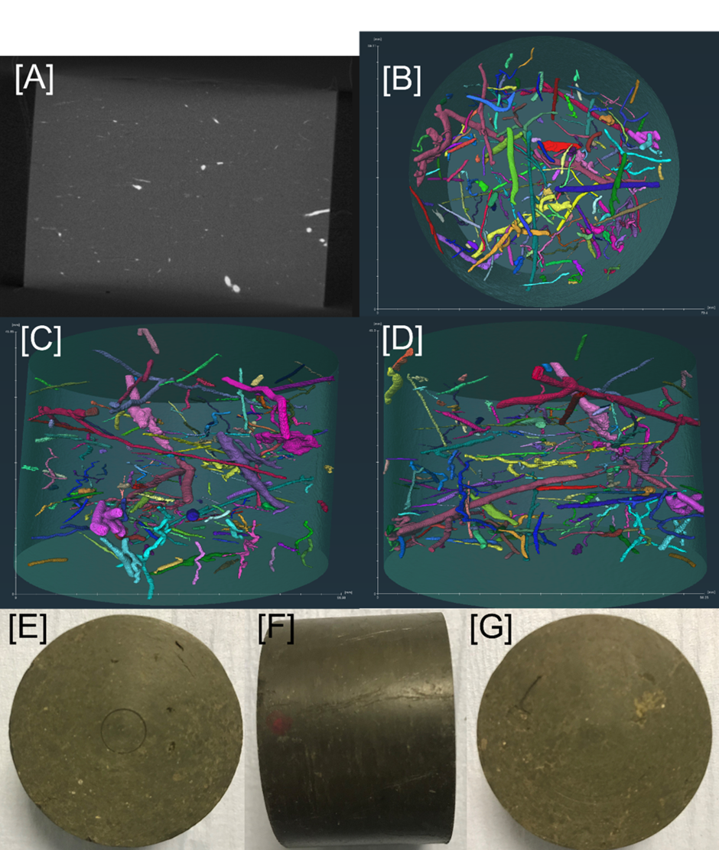
Figure 17: Pre-test imaging of sample BC2. [A] Orthogonal XCT; [B] XCT image of features XY orientation; [C] XCT image of features XZ orientation; [D] XCT image of features YZ orientation; [E] injection face of sample [F] side view of sample; [G] backpressure face of sample. Voxel resolution is 0.000356 mm³.
BC2 contains long, wide-aperture, high-density features best visible in Figure 17 [D] some of which extend the entire length and/or height of the sample. Feature tortuosity varies reflecting the connectivity and distribution of features.
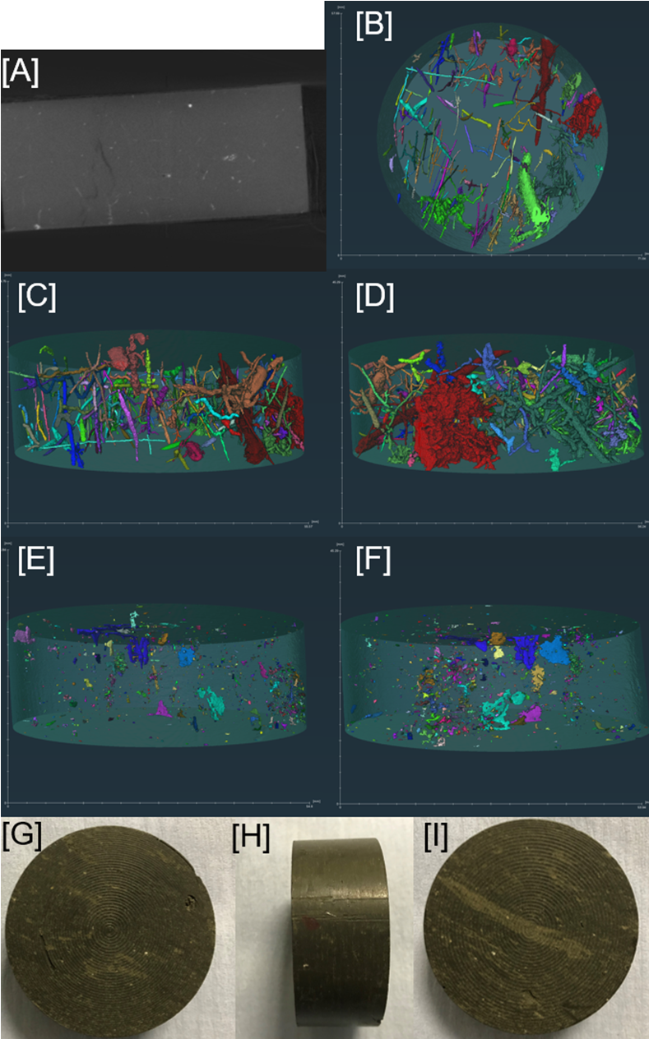
Densely packed features
Figure 18: Pre-test imaging of sample BC3. [A] Orthogonal XCT; [B] XCT image of features XY orientation; [C] XCT image of features XZ orientation; [D] XCT image of features YZ orientation; [E] XCT image of fractures XZ orientation; [F] XCT image of fractures YZ; [G] injection face; [H] side view of sample; [I] backpressure face of sample. Voxel resolution is 0.000277 mm³.
BC3 shown in Figure 18 contains a series of features almost exclusively perpendicular to the flat sample faces best shown in Figure 18 [B], with some larger complexes of densely packed tortuous features, two of which are labelled in Figure 18 [D]. This orientation of features is unlike any other samples studied, which may impact material behavior. Within this sample are a series of small open fractures visible in Figure 18 [E] and [F] with areas of concentration best highlighted in the center of Figure 18 [F], the largest portions of which are parallel to the dense feature phase.
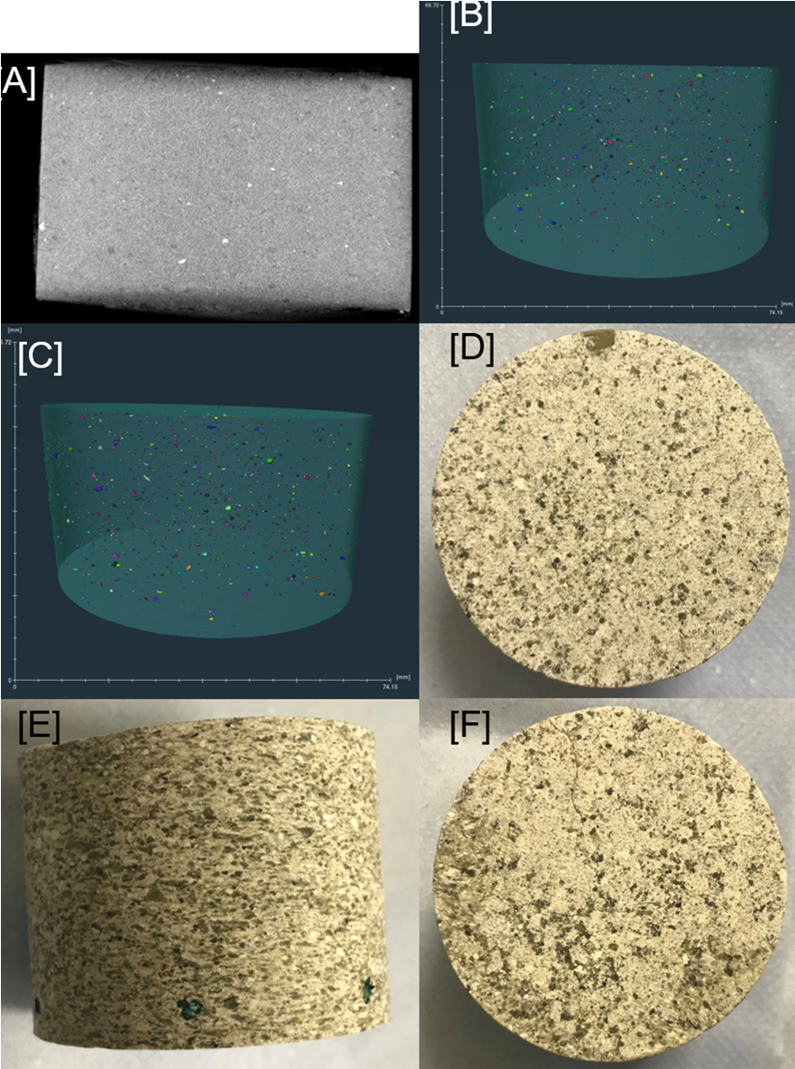
Figure 19: Pre-test imaging of sample SM1. [A] Orthogonal XCT; [B] XCT image of features XZ orientation; [C] XCT image of features YZ orientation; [D] injection face of sample [E] side view of sample; [F] backpressure face of sample. SM1 was not filtered to >0.5 mm³ for this image as very few features were present above this range. Voxel resolution is 0.000453 mm³.
SM1 is distinct visually Figure 19 [E] from the BC samples, lacking the tube-like, high-density features present in BC samples. Instead, its denser mineral phase, visible in Figure 19 [A], is well distributed across the sample, and is much finer in size, rounded and unconnected, and when combined indicates there are no distinct features which may adversely affect the material response during testing.
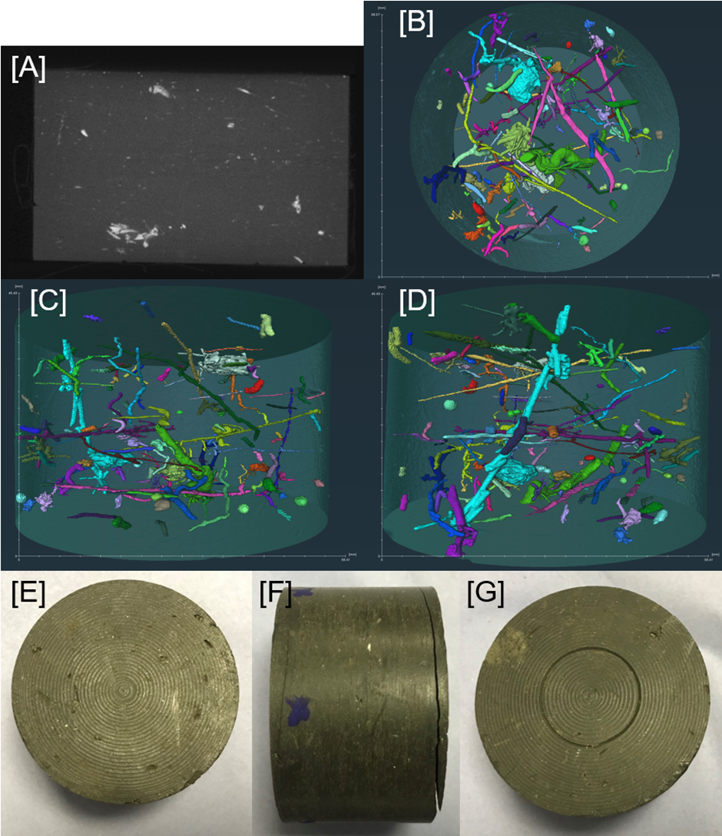
Densely packed features
Figure 20: Pre-test imaging of sample BC4. [A] Orthogonal XCT; [B] XCT image of features XY orientation; [C] XCT image of features XZ orientation; [D] XCT image of features YZ orientation; [E] injection face of sample [F] side view of sample; [G] backpressure face of sample. Voxel resolution is 0.000228 mm³.
BC4 contains coarse, more randomly orientated, dense features within the sample best visible in Figure 20 [D]. Other features are smaller and near spherical in shape. Some larger dense feature complexes exist, one of which is labelled in Figure 20 [A], noting the unusual shape and apparent conjunction of more planar dense features into a singular mass.
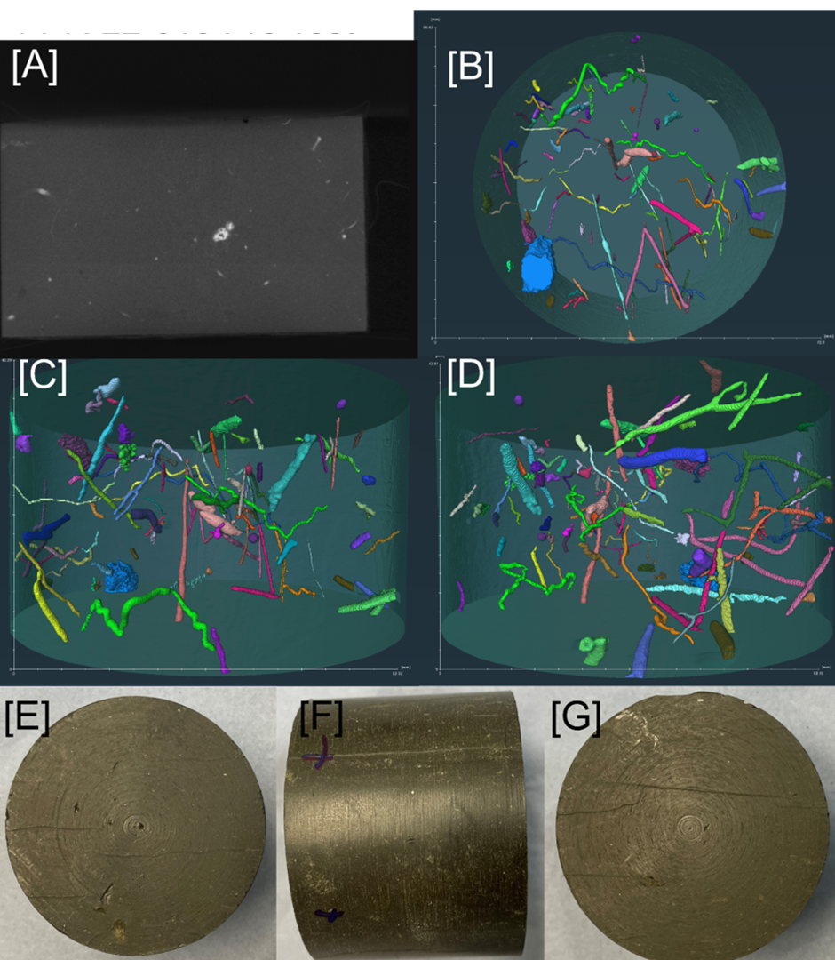
Interconnected high-density zone and pipe-like feature
Dense pipe-like features
Figure 21: Pre-test imaging of sample BC5. [A] Orthogonal XCT; [B] XCT image of features XY orientation; [C] XCT image of features XZ orientation; [D] XCT image of features YZ orientation; [E] injection face of sample [F] side view of sample; [G] backpressure face of sample. Voxel resolution is 0.000239 mm³.
BC5 shown in Figure 21 [C] and [D] display several thin high-density features (labelled) running both parallel and perpendicular to the sample length. These features however are significantly more spatially dispersed compared to other samples in this study which contain the same high-density features. Figure 21 [B] notes a feature in light blue (labelled) with a thin additional high-density feature, protruding from a dense area.
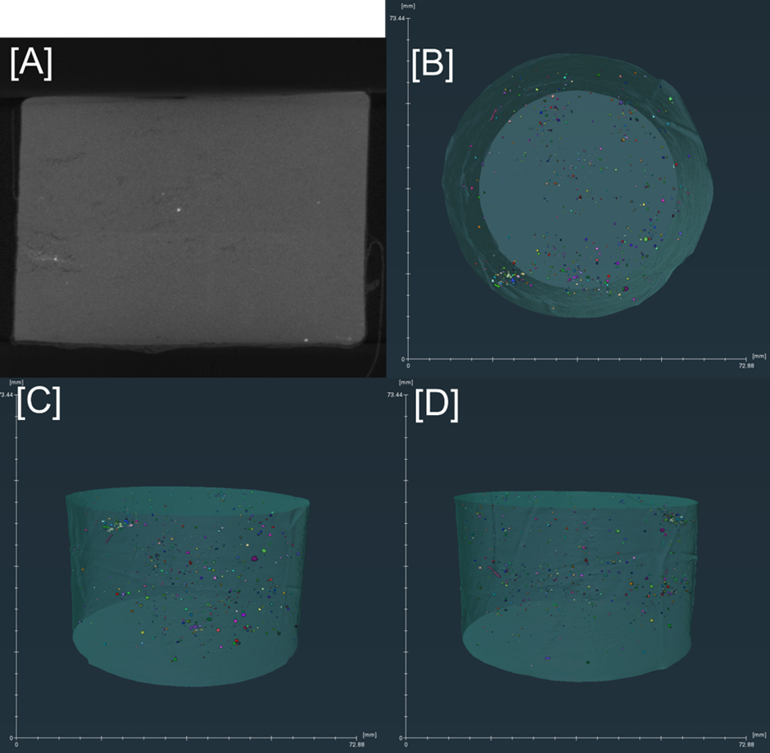
Figure 22: Pre-test imaging of sample ES1. [A] Orthogonal XCT; [B] XCT image of features XY orientation; [C] XCT image of features XZ orientation; [D] XCT image of features YZ orientation. ES1 was not filtered to >0.5 mm³ for this image as very few features were present above this range. Voxel resolution is 0.00033 mm³.
ES1 lacks a significant dense mineral phase (see Figure 22 [A]) and only contains small quantities of high-density material (shown in bright colours) greatly dispersed amongst the lower density matrix. Features, if noted, are rounded and unconnected although in Figure 22 [B] it appears that the distribution of high-density features is not uniform.
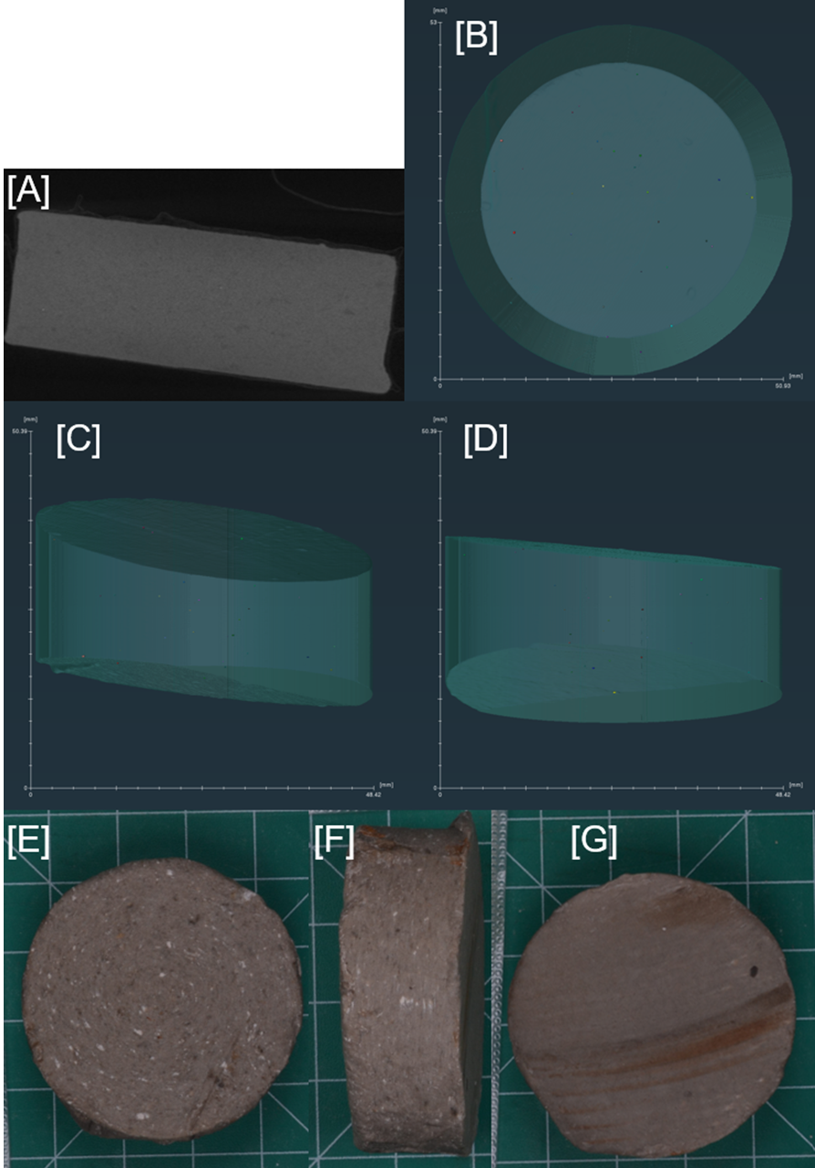
Figure 23: Pre-test imaging of sample SM3. [A] Orthogonal XCT; [B] XCT image of features XY orientation; [C] XCT image of features XZ orientation; [D] XCT image of features YZ orientation. SM3 was not filtered to >0.5mm³ for this image as very few features were present above this range; [E] upper face of sample [F] side view of sample; [G] lower face of sample. Voxel resolution is 0.000297 mm³.
SM3 contains very few high-density materials of note and is almost completely featureless within the XCT (Figure 23). Any segmented features were close to the voxel resolution and therefore may be a result of error.

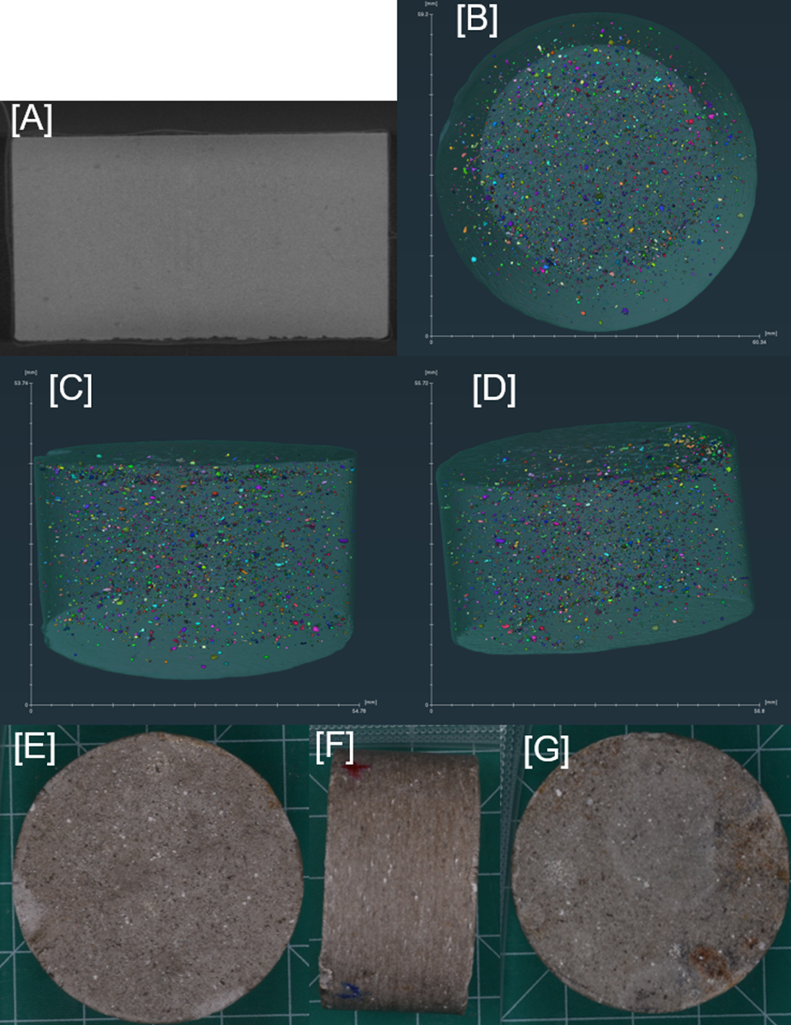
Figure 24: Pre-test imaging of sample SM5. [A] Orthogonal XCT; [B] XCT image of features XY orientation; [C] XCT image of features XZ orientation; [D] XCT image of features YZ orientation. SM5 was not filtered to >0.5 mm³ for this image as very few features were present above this range; [E] injection face of sample [F] side view of sample; [G] backpressure face of sample. Voxel resolution is 0.000395 mm³.
SM5 is unlike previously analysed samples. Its high quartz content is visible in all XCT images (bright coloured particles). This phase is rounded, fine-grained and well distributed throughout the sample.

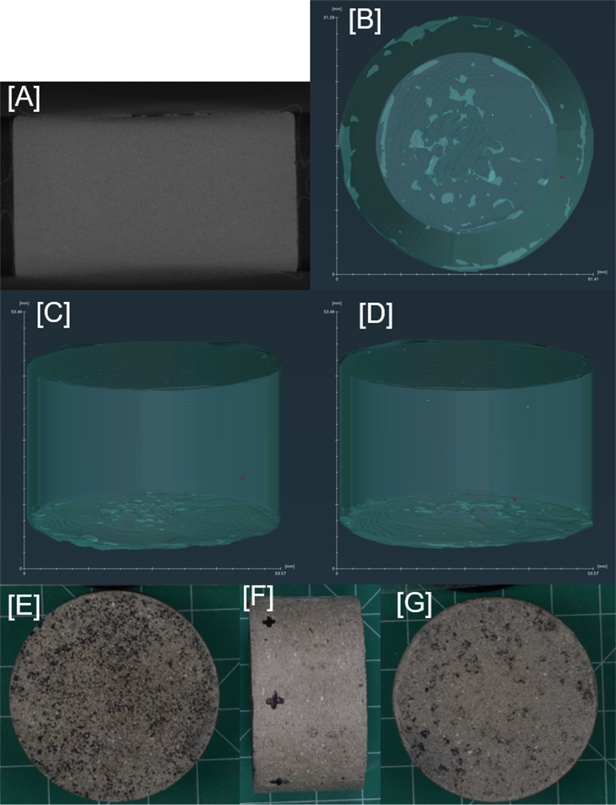
Figure 25: Pre-test imaging of sample SM6. [A] Orthogonal XCT; [B] XCT image of features XY orientation; [C] XCT image of features XZ orientation; [D] XCT image of features YZ orientation. SM6 was not filtered to >0.5 mm³ for this image as very few features were present above this range; [E] injection face of sample [F] side view of sample; [G] backpressure face of sample. Voxel resolution is 0.000305 mm³.
SM6 contains virtually no visible density variation despite the outward texture shown in the images in Figure 25 [E], [F] and [G]. The sample is near homogenous, demonstrating that the 40:30:30 split between clay, silt and sand are evenly distributed. A small number of minor low-density features were picked out in the segmentation but as they were very few and small in size, they are likely a result of error within the segmentation analysis.
References for supplementary materials
Thomson, P.R., Aituar-Zhakupova, A. and Hier-Majumder, S., 2018. Image segmentation and analysis of pore network geometry in two natural sandstones. Frontiers in Earth Science, 6, p.58.

