Supporting Information
This document provides supporting information to the main paper entitled: ‘Scenario analysis of embodied greenhouse gas emissions in UK construction’. It is composed of two sections providing further detail on the UK BIEC model and the scenario analysis respectively.

UK BIEC Model
The basic structure of the model is described in Section 2 of the main paper. This supporting information offers more detail on the calculation of historic output profiles.

Calculation of historic output profiles
Section 2.3 sets out the basic means by which the historic output profiles were calculated from ONS financial output data and historic prices from past editions of Spon’s Architects’ and Builders’ Price Book. The specific price data used for each class are presented below, with all output profiles compared with other estimates of total stock. The other estimates are principally from statistics gathered by The Valuation Office Agency (VOA) on the hereditament floor area and rateable value of property liable for business rates for the period 1998-2008 (DCLG, 2012). The VOA figures are divided into retail premises, commercial offices, ‘other’ offices, factories, warehouses, other bulk premises and non-bulk premises. Statistics for the period until 2012 are also available, though only for four categories of ‘Retail’, ‘Offices’, ‘Industrial’ and ‘Other’ as part of an ‘experimental’ statistical release. A comparison of these two releases indicates a discrepancy for the total 2005 rateable stock of some 29,148,000 m², indicating the level of uncertainty. Revaluation of properties occurs on a five yearly cycle (recently 2000, 2005, and 2010). The VOA data does not reveal the demolish/rebuild cycle or indicate the extent of change of property use but does give some indication of the magnitude of stock within each class and the general trend (i.e. expansion or decline in stock).

Factories
VOA floor area data for factories from 1998-2008 varied between a peak of 231,579,000m² in 2000 and a low of 208,171,000m² in 2008. The decline over this period is likely due to the long term decline of the UK manufacturing sector. Annual changes in stock of 2-4 million m² were typical, suggesting a turnover exceeding 2% of stock per year. In Spon’s a variety of prices are quoted for factories depending on size, ownership, facilities and use. The most common was assumed to be ‘Factories for letting (including lighting, power and heating)’. Central price estimates for this class were used alongside ONS new work data to establish new build floor areas. The resulting estimate ranges between 3-7 million m² per annum.

Warehouses
VOA floor area data for warehouses indicates a largely uninterrupted expansion in stock from 130,333,000 m² in 1998 to 158,942,000 m² by 2008. During this period total stock grew at a rate of 2-4 million m² per year. ONS new work data for warehouses confirms this rapid expansion of warehouse production until 2007, followed by a dramatic decline brought on by the recession. This expansion in warehousing also coincided with a substantial increase in the typical size of warehouses. This is reflected in the changing classification of warehouses in the Spon’s price books. For example, the 1998 edition includes warehouse classifications of:
- Low bay (6-8m high) for letting (no heating)
- Low bay for owner occupation (including heating)
- High bay (9-18m high) for owner occupation (including heating)
By comparison the 2015 edition classifies warehouses as:
- High bay (10-15m high) for owner occupation (no heating) up to 10,000m²
- High bay (10-15m high) for owner occupation (no heating) over 10,000m² up to 20,000m²
- High bay (16-24m high) for owner occupation (no heating) over 10,000m² up to 20,000m²
- High bay (16-24m high) for owner occupation (no heating) over 20,000m²
To account for the changing size of warehouses during this period, a mix of classifications were used to form an average price for each year. It has been assumed that a gradual shift occurred from predominantly low bay to increasingly large high bay warehouses over the analysis period. This gives an estimate of 3-9 million m² per year, which broadly agrees with the increases observed in the VOA data.

Offices
VOA statistics for office floor area suggest that total stock grew from 82,011,000 m² in 1998 to 101,456,000 m² in 2008. Spon’s prices were available for a wide variety of office types. ‘Medium rise, air conditioned’ was selected as the most representative, with an equal split between ‘offices for owner occupation’ and ‘offices for letting’. Around half of all UK office space is rented, with the remainder owner occupied, and these proportions have remained stable over the last decade (Property Industry Alliance, 2014 p. 6). Combining price data with ONS new work data gives estimated annual new build floor areas of 5-8 million m² per year.

Retail
VOA statistics for retail floor area suggest that total stock fluctuated between 101,827,000 m² and 110,840,000 m² between 1998 and 2008. The majority of this stock is composed of small or medium sized shops with past estimates suggesting only around 18% of retail floor area is large stores or supermarkets (Bruhns et al., 2000). A typical price was therefore calculated from a mix of small (82%) and large (18%) ‘shop shells including fitting out’. Combining price data with ONS new work data gives estimated new build floor areas of 3-5 million m² per year.

Education
It can be concluded from past estimates of the educational building stock that the combined floor area of schools is comfortably greater than the combined floor area of all other educational building types (universities, colleges etc.). For this reason prices for ‘Secondary/middle schools’ were taken as representative of spending on educational buildings. Updating past estimates to current stock would suggest an educational stock in the region of 100 million m². Combining price data with ONS new work data gives an estimate of new build annual floor area of 3-6 million m² per year.

Health
Similarly the combined floor area of hospitals constitutes the overwhelming majority of buildings serving as healthcare facilities. For this reason prices for ‘District hospitals’ were taken as representative of health spending. Past estimates suggest a stock in the region of 30 million m² (Bruhns et al., 2000). Combining price data with ONS new work data gives an estimate of new build floors areas between 1-4 million m² per year.

Entertainment
Entertainment expenditure is distributed across a wide variety of building types, e.g. art galleries, sports facilities, theatres, night clubs and casinos. Consequently establishing a typical price for entertainment buildings is difficult. Past estimates suggest that of the 68 million m² of buildings of this nature, the most common are pubs (33% of total) and hotels (28%). The remainder could be broadly grouped into: sports facilities (16%); restaurants, cafes and takeaways (8%); theatres and cinemas (2%); and museums and art galleries (2%); with a diverse range of structures making up the remaining 11% (Bruhns et al., 2000). A combination of prices representing ‘public houses’, ‘hotels’ and ‘health and fitness clubs’ was used alongside ONS new work data resulting in annual estimates of new build floor area of 3-5 million m² per year.

This gives historic output profiles as shown in Figure S1.

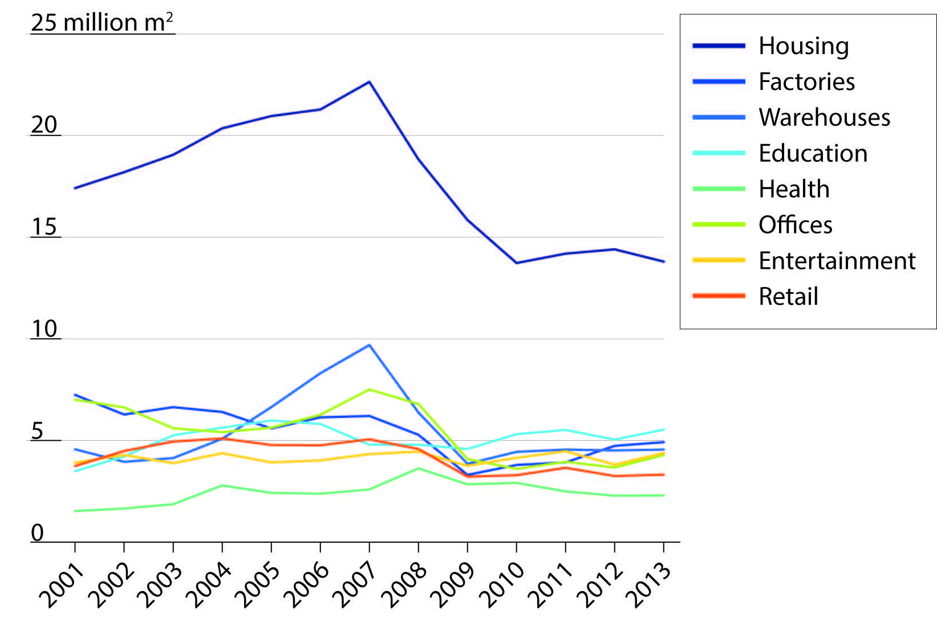
Figure S1: Estimated new build floor areas by building class 2001-2013

Scenario analysis
This section provides further details on the scenario analysis outlined in Section 3 of the main paper. This includes a detailed description of the data and assumptions used to determine the demand projections and interim targets.

Demand projections
The data sources used and assumptions made are as follows.

Economic Growth
Central projections of short term economic growth were taken from OBR forecasts of annual GDP growth to 2019 (OBR, 2015). Long term projections beyond 2019 were taken from the OBR’s 2012 Fiscal Sustainability Report (OBR, 2012). Alternate projections for high and low growth scenarios were estimated assuming trends in line with the typical discrepancies between highest and lowest forecasts published in HM Treasury’s regular review of independent forecasts for the UK economy (HM Treasury, 2015).

Population
Population projections were taken from the ONS’ 2010-based national population projections (ONS, 2011). The ONS provides 9 alternative projections based upon varying assumptions about fertility, life expectancy and migration. Three of these were used in the scenarios: HP (high fertility, high life expectancy, high migration); P (principal projection); and LP (low fertility, low life expectancy, low migration).

Housing
DCLG projections assume a gradual decline in the average household size from 2.36 people in 2012 to 2.25 people by 2030 (DCLG, 2015). Combined with other demographic trends, this results in a central projection of households as shown in Table S1. High and low projections of likely housing demand attributable to population growth were calculated by combining the ONS’s high and low population estimates with the average household size projections. However, as can be seen from the current housing crisis, growth in supply does not directly respond to demographic demands. Therefore low and high scenarios were developed that correspond to a continued failure to meet demand or, by contrast, a successful reduction of the existing housing shortage. The high projection assumed that it will take 3 years to return to house building levels that meet the highest anticipated annual increase in population, and subsequently increases to clear the estimated housing shortage by 2030. The low projection assumes that it will take 7 years to return to house building levels that meet the lowest anticipated increases in population, and no attempt is made to address the existing shortage. The central projection assumes that it will take 5 years to return to house building levels that meet the central estimates of population increases.

Table S1: DCLG central household projection
Year | Households (thousands)
2012 | 26,729
2013 | 26,956
2014 | 27,210
2015 | 27,468
2016 | 27,735
2017 | 27,996
2018 | 28,256
2019 | 28,515
2020 | 28,771
2021 | 29,026
2022 | 29,276
2023 | 29,523
2024 | 29,771
2025 | 30,015
2026 | 30,263
2027 | 30,506
2028 | 30,746
2029 | 30,982
2030 | 31,213

Non-domestic stock
The future working age population was estimated from the ONS population and age distribution projections. By assuming a continued employment rate of 73.3% to 2030 the expected annual increase in the UK workforce was calculated. The central scenario assumes that 50% of this additional workforce will work in offices and 10% will work in retail, similar to the current distribution of UK employment. The requisite increases in floor area to accommodate these additional workers were estimated based upon an assumed worker density of 10.9 m²/worker for offices and 35 m²/worker for retail (BCO, 2013). High and low scenarios reflected the expected changes in workforce under the HP and LP population scenarios. Output of warehouses, factories and miscellaneous buildings were assumed to follow trends in economic growth. Output in the entertainment class has remained fairly consistent for the preceding 17 years for which data is available, so the central projection continues average output from 1998-2012. High and low projections assume a slow return to the highest and lowest levels of output observed during this period. Over the same period, a 10% increase and a general aging of the UK population has resulted in a 60% increase in output of new buildings for healthcare. The central scenario assumes this trend continues with the additional growth in expenditure proportional to population growth. Projections for the education class assume that recent output represents the ongoing replacement rate of stock and that additional demand for stock will be due to population growth. Anticipated trends in the total number of school pupils have been used as a proxy, with the assumption that new build schools will accommodate the same density of pupils per unit area. The high, low and central projections for each class are summarised in Figure S2.

Infrastructure
Three scenarios for infrastructure development were established: low, medium and high investment. The low scenario assumes investment until 2016 corresponding to the investment across National Infrastructure Pipeline (NIP) (HM Treasury, 2014) projects under construction at the time of writing, followed by an extension of average investment for 2014-2016 until 2020, with a rolling 5 year average thereafter. The medium investment scenario assumes that 80% of desired investment set out in the NIP is achieved until 2020, with a rolling 5 year average thereafter. The high investment scenario assumes all desired investment in the NIP is achieved until 2020; with additional projects contributing to a sustained high level of infrastructure expenditure beyond 2020, similar to average levels observed between 2012 and 2017.
It should be noted that the NIP employs a much broader definition of ‘infrastructure’ than that used by the ONS. The NIP definition includes non-construction measures such as the roll out of smart meters, introduction of ticketless payment schemes on public transport and the replacement of rolling stock. The NIP definition also fails to distinguish between expenditure on new work and repair and maintenance. The ONS publish data evaluating infrastructure output in the construction industry as far back as 1955. However, comparable time series data for the definition of infrastructure utilised in the NIP do not exist. As the NIP and ONS figures are not directly comparable adjustments have been made to the scenario values. The adjusted expenditure series was produced by multiplying future NIP expenditure (in 2013 prices) by an adjustment factor based upon the ratio between the 2013 ONS output for new work in infrastructure and the 2013 NIP expenditure.
Thus using different combinations of economic growth, population growth and infrastructure investment 27 alternate demand projections were established. The respective trajectories for each class are shown in Figure S2.

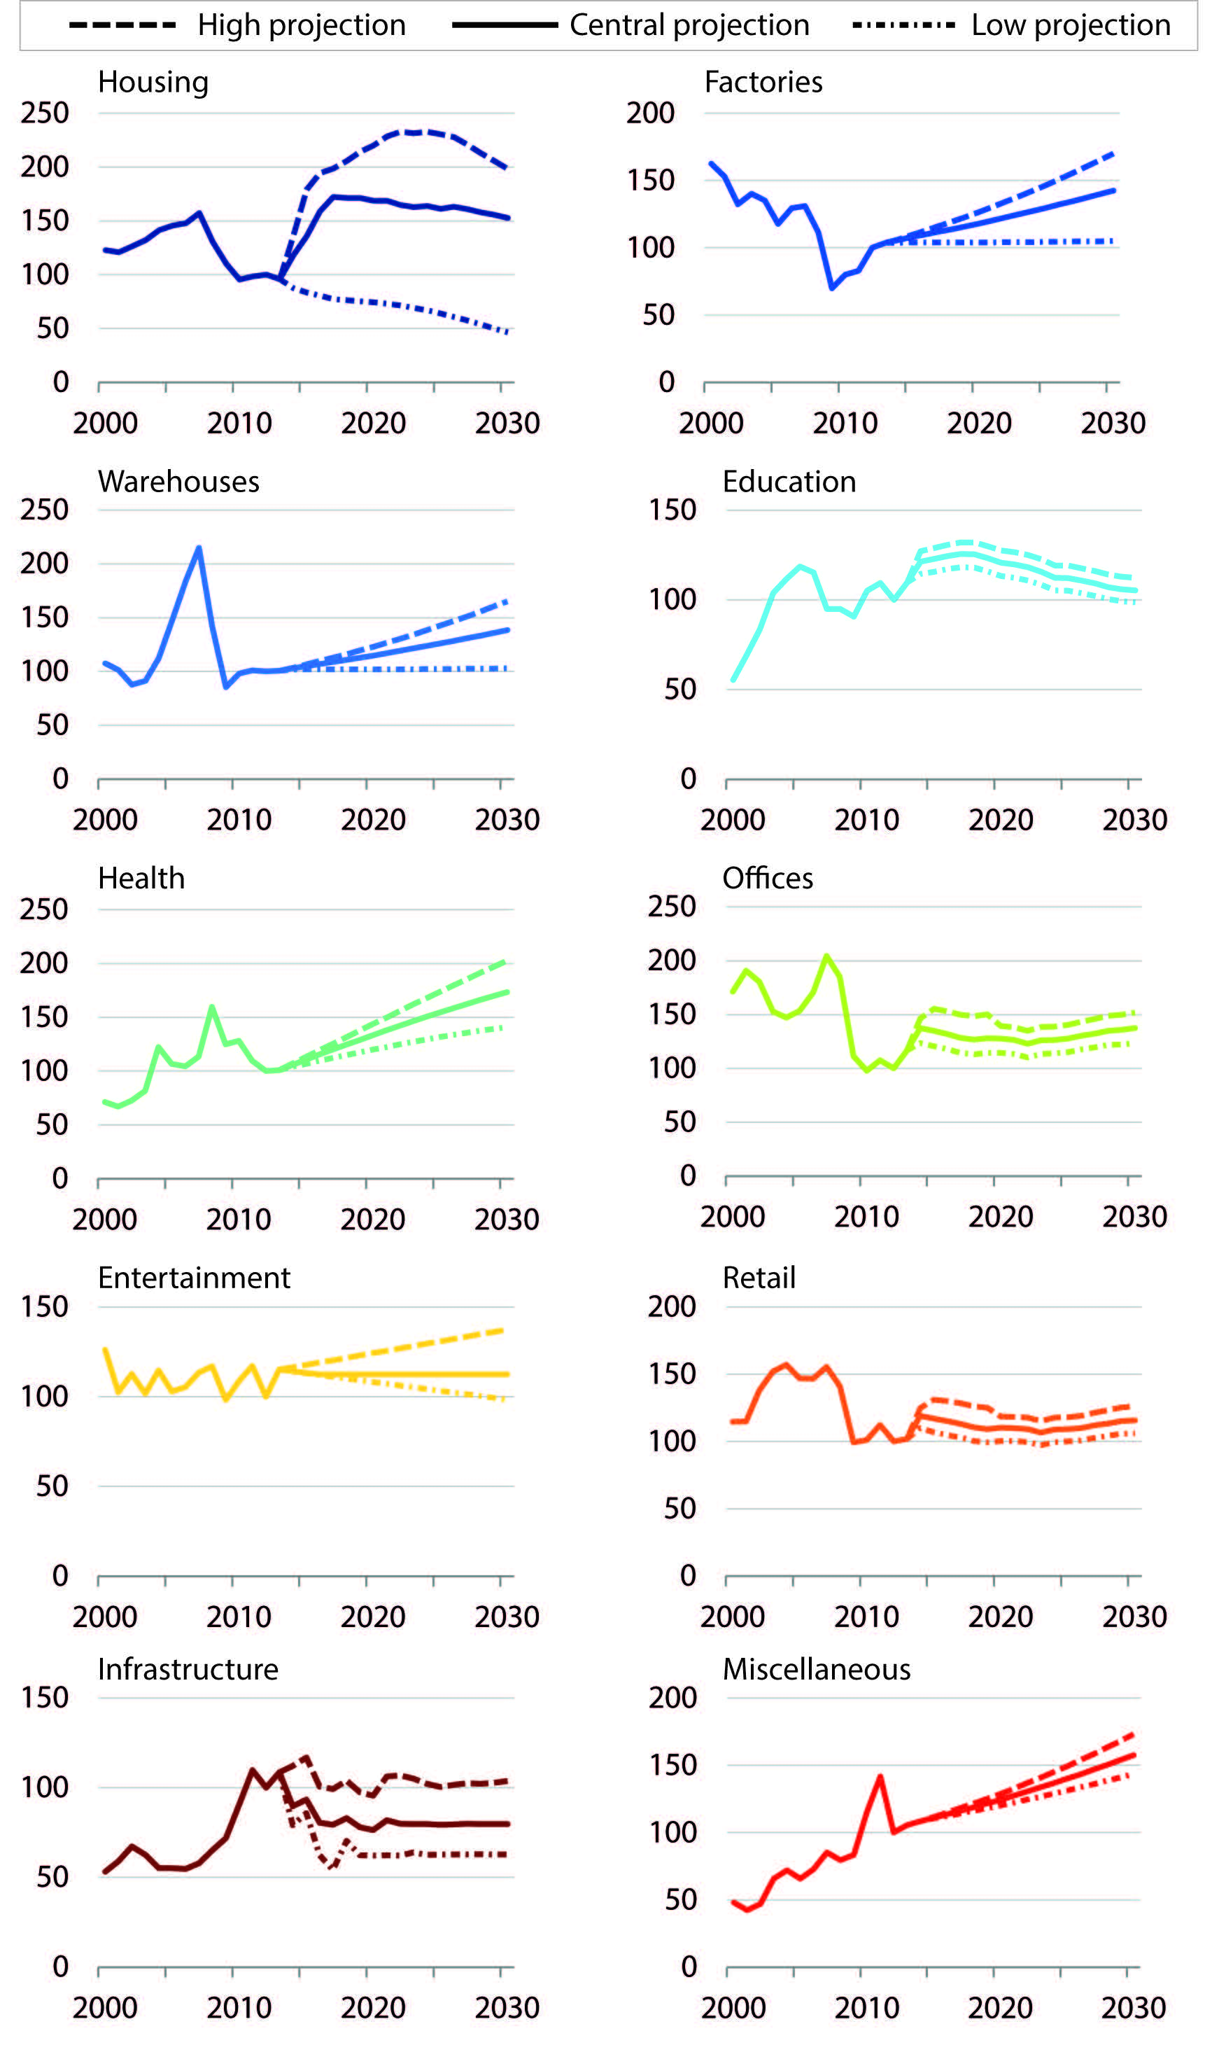
Figure S2: Demand projections by class (indexed to 2012 = 100)

Scaling of targets for comparison
As stated in Section 3.1 of the main paper, adjustments were made to the UK Carbon Budgets and interim Routemap targets in order to account for the differing baselines and accounting approaches. These adjustments are set out below.

Routemap Interim Targets
The first interim target for capital carbon in the Routemap (GCB, 2013) is a 21% reduction by 2022 against a 2010 baseline, equivalent to achieving capital carbon emissions totalling 26.6 MtCO₂e. Further suggested targets included 29% by 2027 (23.9 MtCO₂e), 34% by 2037 (22.2 MtCO₂e) and 39% by 2050 (20.5 MtCO₂e). A further reduction attributable to installation of carbon capture and storage technologies on all steel and cement facilities could restrict the 2050 total to 11 MtCO₂e. However, the Routemap interim targets were set against a 2010 baseline of 33.6 MtCO₂e for capital carbon emissions. The UK BIEC model estimates embodied emissions in 2010 to be 42.5 MtCO₂e. Therefore an adjustment of the reduction targets is required to ensure consistency. Taking the UK BIEC embodied emissions estimate alongside domestic, non-domestic and infrastructure operational carbon emissions of 103, 48.2 and 5 MtCO₂e respectively (as estimated in the Routemap), then total emissions from the built environment amounted to 198.7 MtCO₂e in 2010. Assuming that the Routemap targets for domestic and non-domestic operational carbon are achieved then embodied carbon emissions would need to reduce to 16.5 MtCO₂e by 2050 to achieve the sector’s ambition of an 80% reduction against a 1990 baseline. This translates into interim targets of 33.6 MtCO₂e for 2022, 30.2 MtCO₂e for 2027 and 28.0 MtCO₂e for 2037.

UK Carbon Budgets
An alternate approach to aiming for interim annual targets is to compare cumulative emissions over the analysis period with the UK’s 5-year Carbon Budgets. The Carbon Budgets are expressed in absolute terms and as reductions against a 1990 baseline, when UK territorial emissions were 809.4 MtCO₂e. As the UK BIEC model considers consumption-based emissions it is necessary to scale the budgets for a fair comparison. Unfortunately, estimates of the UK’s consumption-based footprint are not available before 1997 (DEFRA, 2015). Therefore the percentage reductions have been translated into reductions against a 2012 territorial emissions baseline of 582.2 MtCO₂e. These reductions were applied to 2012 consumption based emissions of 863.9 MtCO₂e to establish a set of equivalent consumption-based carbon budgets (see Table S1 below). It should be noted that this approach implicitly assumes that the ratio between territorial and consumption based emissions remains the same as in 2012. This ratio has varied historically, falling year-on-year in 5 of the last 14 years and rising in the remaining 9. It is unclear how this ratio may vary in future. The results presented in the main paper are expressed as relative proportions of these equivalent consumption-based carbon budgets.

Table S1 – UK territorial and consumption-based carbon budgets

Carbon Budget (period) | Budget level (MtCO₂e) | Reduction below 1990 | Equivalent consumption-based budget (MtCO₂e)
1st Carbon Budget (2008-12) | 3,018 | 23% | 4,487
2nd Carbon Budget (2013-17) | 2,782 | 29% | 4,128
3rd Carbon Budget (2018-22) | 2,544 | 35% | 3,775
4th Carbon Budget (2023-27) | 1,950 | 50% | 2,894

References
BCO (British Council for Offices) (2013) Occupier Density Study. Available from: http://www.architectsjournal.co.uk/Journals/2013/09/10/c/y/n/BCO-Occupier-Density-Study---Final-report-2013.pdf.
Bruhns, H.R., Steadman, P., Herring, H., Moss, S., and Rickaby, P.A. (2000) Types, numbers, and floor areas of nondomestic premises in England and Wales, classified by activity. Environment and Planning B: Planning and Design 27(5),pp.641–665.
DCLG (Department for Communities and Local Government) (2015) Household projections, United Kingdom, 1961-2037. Available from: https://www.gov.uk/government/statistical-data-sets/live-tables-on-household-projections [Accessed March 30, 2015].
DCLG (Department for Communities and Local Government) (2012) Live tables on commercial and industrial floorspace and rateable value statistics. Available from: https://www.gov.uk/government/statistical-data-sets/live-tables-on-commercial-and-industrial-floorspace-and-rateable-value-statistics [Accessed March 16, 2015].
DEFRA (Department for Food, Environment and Rural Affairs) (2015) UK’s Carbon Footprint 1997–2012. Available from: https://www.gov.uk/government/statistics/uks-carbon-footprint.
GCB (Green Construction Board) (2013) Low Carbon Routemap for the UK Built Environment. Available from: http://www.greenconstructionboard.org/otherdocs/Routemap final report 05032013.pdf.
HM Treasury (2015) Forecasts for the UK economy. Available from: https://www.gov.uk/government/collections/data-forecasts [Accessed September 3, 2015].
HM Treasury (2014) National Infrastructure Plan 2014. ISBN 978-1-910337-41-7
OBR (Office for Budget Responsibility) (2015) Economic and fiscal outlook - March 2015. Available from: http://budgetresponsibility.org.uk/category/topics/economic-forecasts/ [Accessed March 30, 2015].
OBR (Office for Budget Responsibility) (2012) Fiscal sustainability report. The Stationery Office, London, UK. ISBN: 9780108511844
ONS (Office for National Statistics) (2011) 2010-Based National Population Projections. Available from: http://www.ons.gov.uk/ons/rel/npp/national-population-projections/2010-based-projections/rep-2010-based-npp-results-summary.html#tab-Results [Accessed March 30, 2015].
Property Industry Alliance (2014) Property Data Report. Available from: http://www.bco.org.uk/Research/Publications/Property_Data_Report_2014.aspx.

Retrospectively comparing anticipated investment for 2013 in the first edition of the NIP with recorded investment for the period demonstrates that just under 80% of anticipated investment was achieved.

