Calculation of the mean winter temperatures
We started by selecting available automatic weather stations (AWS) within and around the study area and identifying the altitude of each station. We then downloaded databases containing the monthly average temperature for each selected station from regional official sources (ARPAV, 2023b). The datasets for the study area consist of monthly averages, which limited our ability to analyze temperature variables in other ways, such as the number of days in which the temperature exceeded a given threshold. After collecting the available data, we calculated the monthly ATLR using the following equation:
(1) | $$ATLR=\left[\frac{T_{awsl}-T_{awsu}}{{EL}_{awsu}-{EL}_{aswl}}\right]*100$$
where T_{awsl} is the temperature acquired by the AWS located at the lower level (°C), T_{awsu} is the temperature acquired by the AWS located at the upper level (°C), EL_{awsu} is the elevation of the AWS located at the upper level (m), and EL_{awsl} is the elevation of the AWS located at the lower level (m).
Using GIS tools, we identified the altitude of each dwelling and extrapolated the temperature (ET) to these specific locations (Equation 2).
(2) | $$ET=T_{awsu}-\left[\frac{{EL}_{d}-{EL}_{awsu}}{100*ATLR}\right]$$

where T_{awsu} is the temperature acquired by the AWS located at the upper level (°C), EL_{d} is the elevation of the dwelling (m), EL_{awsu} is the elevation of the AWS located at the upper level (m), and ATLR was obtained from Equation 1.

Supplementary Table 1. Continuous variables summary. Source: Authors own work.
Variable | Unit | n | Min | Q1 | Median | Mean | Q3 | Max
Price/m² | €/ m² | 447 | 92 | 799 | 1426 | 1525 | 2102 | 6277
Log of price/m² | €/ m² | 447 | 4.522 | 6.683 | 7.263 | 7.134 | 7.651 | 8.745
Property size | m² | 447 | 27 | 68 | 91 | 102 | 122 | 400
Building age (in 2024) | years | 447 | 1 | 27 | 48 | 59 | 74 | 324
Bathrooms | count | 447 | 0 | 1 | 1 | 1 | 1 | 6
Number of hotels (250 m radius) | count | 447 | 0 | 0 | 0 | 1 | 1 | 7
Forest cover (250 m radius) | % | 447 | 0 | 14 | 33 | 34 | 52 | 89
Distance to ski lift | m | 447 | 60 | 1782 | 3941 | 5461 | 7769 | 14779
Distance to primary road | m | 447 | 5 | 101 | 398 | 944 | 864 | 6332
Mean Winter temperature | °C | 447 | -5 | -2 | -1 | -1 | 0 | 1
Supplementary Table 2. Categorical variables summary. Source: Authors own work.
Variable | Levels | n. | %
EPC | ABCD | 108 | 24%
EPC | E | 60 | 13%
EPC | F | 102 | 23%
EPC | G | 177 | 40%
EPC | All | 447 | 100%
Dwelling type | 0 = apartment | 265 | 59%
Dwelling type | 1 = house | 30 | 7%
Dwelling type | 2 = portion of house | 152 | 34%
Dwelling type | All | 447 | 100%
Mediation | 0 = absent | 269 | 60%
Mediation | 1 = present | 178 | 40%
Mediation | All | 447 | 100%

Supplementary Table 3. Moran's I statistics and Lagrange multiplier (LM) test results. Source: Authors own work.
Test | Value
Moran's I (error) | 0.009***
Lagrange Multiplier (lag) | 8.894**
Robust LM (lag) | 9.512**
Lagrange Multiplier (error) | 0.505
Robust LM (error) | 1.124
Note. The dependent variable is logged dwelling price/m²; ˑp<0.1; *p<0.05; **p<0.01; ***p<0.001.
Supplementary Table 4. Spatial hedonic models results. Source: Authors own work.
Variables | Indirect effects | Total effects
Intrinsic variables
Property size | -0.002*** | -0.005***
EPC (Ref = G)
ABCD | 0.214*** | 0.552***
E | 0.148*** | 0.381***
F | 0.131*** | 0.336***
Building age | -0.007*** | -0.019***
Building age ^2 | 0.000*** | 0.000***
Dwelling type (Ref = Apartment)
House | -0.056 | -0.143
Portion of house | -0.127*** | -0.328***
Bathrooms | 0.100*** | 0.257***
Mediation (Ref = No mediation) | 0.076** | 0.195**
Extrinsic variables
Number of hotels | 0.032* | 0.081*
Forest cover (250 m radius) | -0.002** | -0.005**
Log of distance to ski lift | -0.017 | -0.045
Log of distance to primary road | 0.034*** | 0.087***
Winter temperature | -0.056** | -0.145**
Winter temperature (^2) | -0.015* | -0.037*
Spatial multiplier (1/(1-(ρ)) | 1.639
Note. Dependent variable = logged dwelling prices/m²; EPC = Energy Performance Certificate; *p<0.05; **p<0.01; ***p<0.001
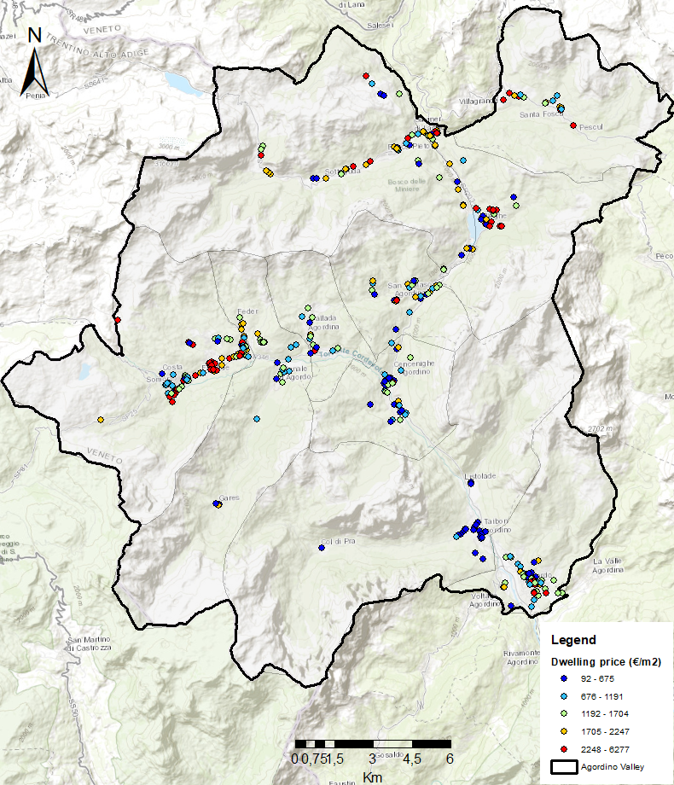
Supplementary Figure 1. Dwelling price distribution of the dwellings. Distribution of property prices within the study area, expressed in euros per square meter (€/m²). The map shows a concentration of higher property values in the northern and western sides of the study area, while lower values are observed in the south. Source: Authors own work. The map was generated using ArcGIS (ESRI, 2023).

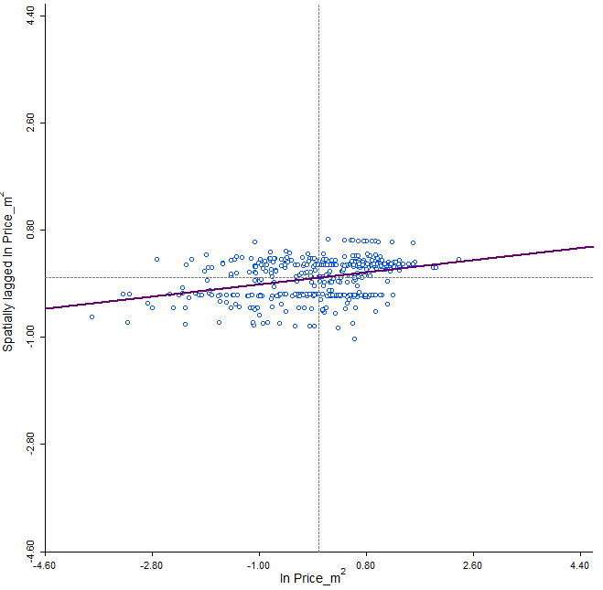
Supplementary Figure 2. Moran Plot. The plot illustrates the relationship between property values at a given location and the average values of neighboring locations. Each point represents a single observation (dwelling) in the dataset. The x-axis shows the value of the dependent variable (natural logarithm of property value per square meter), while the y-axis displays the corresponding spatial lag value. Source: Authors own work. The analysis was conducted using GeoDa™ .

