- DHQi= 1Nin=1Ni Distn,i

- HHIi= l=1L(Pi,lNi)2

- HOME_PLUSi= 1Nin=1NiDn,i

- Fund Total Returni=β0+β1Fund Agei+ β2Number of Buildingsi+β3Xi

- Fund Sharpe Ratioi=β0+β1Fund Agei+ β2Number of Buildingsi+β3Xi

- Fund Net Asset Valuei=β0+β1Fund Agei+ β2Number of Buildingsi+β3Xi

Appendix:

Table A1. Variable Definitions

Variable | Definition
Fund Age | Average age of buildings in the fund's portfolio, calculated as 2024 minus the year of the first published NAV.
Fund Beta | Average monthly beta, where beta is defined as the return of the fund divided by the benchmark SXI Real Estate Broad total return index (R_{fund} – R_{f}) / (Mkt – R_{f}).
Fund NAV (m CHF) | Fund Net Asset Value (in million CHF): The total value of a fund’s assets minus its liabilities, indicating the overall value of the fund.
Fund Sharpe Ratio | Sharpe Ratio of the fund, assuming a risk-free rate (Rf) of 0%
Fund Total Return | Average annualized total return of the fund over 5 years
Location of property | Full address of the fund property within Switzerland
Distance to MSA | Distance in km between the building and the main metropolitan markets, calculated using Google Maps API for the zip codes of the buildings and cities
Average Distance to HQ | Average distance from the building to the fund’s HQ as measured by Google Maps API between the postal codes
DHQ | Average of the square root distances of the building to the fund’s HQ
HHI | Herfindahl-Hirschman Index: A measure of geographic concentration of properties within a metropolitan area, ranging from 0 (perfect diversification) to 1 (maximum concentration in one location). Higher values indicate greater concentration
Home Plus | A variable representing the fund’s propensity to invest in properties in the canton of its headquarters or the neighboring cantons, accounting for potential home bias
HQ Language Proximity | The degree to which a fund’s properties are located in areas where the primary language is the same as the language of the fund's headquarters.
Building price per m2 | The apartment price per square meter in the postal code region, expressed as CHF/m², average across all the fund’s properties
Source: Authors own work.

Table A2. Overview of European Real Estate Investment Markets
Country | Number of Distinct Investment Products | Total Net Asset Value (Euro billion) | Number of Listed and Non-ListedReal Estate Funds, Q4 2024 | Number of Listed and Non-ListedReal Estate Funds, Q4 2024 | Total Net Asset Value (Euro billion) Q4 2024 | Real Estate Market Focus | Population (million)
Source | Refinitiv Eikon | Refinitiv Eikon | ECB | (National and Commercial Sources) | (National and Commercial Sources)
Austria | 8  (6 mutual funds, 2 wholesale investment funds | 3.2 | 17 | NA | NA | The market includes both listed and non-listed vehicles, such as open- and closed-ended funds and Real Estate Investment Companies (REICs). | 9.1
Czech Republic | 5 mutual funds | 2.3 | 155 | NA | NA | Investments are primarily in listed products, with a focus on local retail and office space, and growing interest in residential and logistics. | 10.8
Finland | 22 specialized real estate funds | 6,6 | 184 | NA | NA | strong presence in residential rental investments, often tied closely with cross-border activity—particularly investments in Sweden. Office and retail portfolios are common, and specialized vehicles are increasingly targeting niche sectors such as hotels and public properties | 5.6
France | NA | NA | 667 | 275 | 363 | France has one of the most structured and regulated real estate fund landscapes, dominated by SCPI (non-listed, open-ended funds for individuals), OPCI (mixed open-ended funds), and SIICs (REIT-equivalents). The market focus is predominantly on office properties, with significant activity in retail, logistics, and specialized sectors such as healthcare. | 67.8
Germany | 65 (51 RE investment funds, 14 special assets for real estate | 121.8 | 2’619 | 320 | 301 | The largest and most diversified institutional real estate fund market in Europe, with over 2,600 listed and non-listed funds and a high number of distinct investment products. The market includes both public investment vehicles and Spezialfonds targeted at institutional investors. Portfolios tend to be broadly diversified across commercial property sectors | 83.2
Hungary | NA | NA | 235 | NA | NA | Locally held, non-listed funds, with increasing attention to office and retail sectors in Budapest | 9.6
Italy | 3 closed-end real estate funds | 0.27 | 918 | NA | NA | Italy’s market includes Real Estate Investment Funds (REIFs) and SIIQs (listed REIT-equivalents). increasing interest in logistics and redeveloped urban assets, although residential investment remains underdeveloped compared to other countries. | 59
Ireland | NA | NA | 298 | NA | NA | REITs and cross-border fund structures, particularly domiciled in Dublin for regulatory reasons. The market has seen strong institutional interest in commercial properties, especially office and logistics assets. | 5.3
Luxembourg | NA | NA | 1’663 | NA | NA | major hub for cross-border real estate fund domiciliation. Many pan-European and global real estate vehicles are registered here due to favorable regulatory and tax frameworks, although the domestic property market plays a limited role. | 0.7
Netherlands | NA | NA | 463 | NA | NA | The Netherlands has a well-established real estate sector, especially in logistics and residential rental housing. Dutch pension funds are significant players, often investing in sustainable and long-hold strategies. | 17.9
Portugal | NA | NA | 270 | NA | NA | Traditionally focused on retail investors and local development funds. However, in recent years, foreign investors have shown increasing interest, especially in the hospitality and residential redevelopment sectors in urban centers like Lisbon and Porto. | 10.6
Sweden | NA | NA | 55 | 35 | 66 | Strong and professionalized residential rental sector, with significant holdings in urban areas. Listed REIT-like structures and real estate companies play an important role, with growing investment in logistics and green-certified buildings. | 10.5
Switzerland | 144  (66 real estate funds, 72 investment foundations and 6 SICAVs) | 147.5 | NA | NA | NA | Listed investments including REITs. Strong preference for residential rental properties, often focused on urban centers and well-connected regions. Listed funds dominate, and there is also a growing segment of mixed-use and commercial investments. | 8.8
UK | 206 (89 pension funds, 63 Property Life funds, 16 RE unit trusts, 14 investment trusts, other) | 51.8 | NA | 80 | 100 | Listed investments, including REITs; diversified commercial real estate holdings (office, retail, industrial/warehousing). Specialized funds include healthcare and logistics-focused REITs. Larger funds often hold mixed commercial portfolios. | 67.7

Sources: ECB: European Central Bank (European Central Bank, 2024), Germany: BVI (German Fund Association), France: ASPIM (France); INREV; EPRA, United Kingdom: LSE; QuotedData; DTZ; MSCI, Sweden: EPRA; Statista

Table A3. Fund Overview and Geographic Metrics
Fund Name | NAV (in million CHF) | HQ Canton | Number of Cantons under Coverage | Average Distance to HQ in km | HQ Language Proximity
UBS Swiss Mixed Sima | 7 423 | BS | 18 | 110 | 85%
Credit Suisse Real Estate Fund Siat | 2 679 | ZH | 19 | 71 | 79%
Credit Suisse Real Estate Fund Green Property | 2 343 | ZH | 14 | 52 | 93%
Credit Suisse Real Estate Fund LivingPlus | 2 340 | ZH | 17 | 88 | 99%
Residentia | 2 303 | BS | 2 | 254 | 11%
Edmond de Rothschild Real Estate SICAV | 2 002 | VD | 12 | 65 | 88%
Swiss Life REF ESG Swiss Properties | 1 842 | ZH | 19 | 82 | 79%
Credit Suisse Real Estate Fund Interswiss | 1 700 | ZH | 10 | 90 | 98%
Realstone | 1 692 | VD | 15 | 153 | 33%
Schroder ImmoPLUS | 1 547 | ZH | 9 | 143 | 55%
UBS Swiss Residential Anfos | 1 532 | BS | 17 | 80 | 99%
UBS Swiss Commercial Swissreal | 1 532 | BS | 12 | 125 | 74%
UBS Léman Residential Foncipars | 1 447 | BS | 5 | 224 | 0%
Immofonds Schweizerischer Immo.-Anlagefonds | 1 434 | ZH | 16 | 52 | 95%
La Fonciere | 1 405 | VD | 7 | 35 | 100%
Swisscanto Real Estate Fund Responsible IFCA | 1 337 | ZH | 18 | 106 | 76%
Fonds Immobilier Romand FIR | 1 263 | VD | 6 | 25 | 100%
Solvalor 61 Fonds de placement immobilier | 1 168 | VD | 5 | 34 | 93%
Immo Helvetic | 1 045 | BE | 15 | 58 | 93%
SF Sustainable Property Fund | 1 008 | ZH | 15 | 93 | 83%
Bonhôte Immobilier | 909 | VD | 11 | 76 | 90%
Procimmo Real Estate SICAV | 877 | VD | 6 | 214 | 0%
Swissinvest Real Estate Investment Fund | 842 | ZH | 14 | 79 | 88%
Credit Suisse Real Estate Fund LogisticsPlus | 820 | ZH | 5 | 68 | 86%
Patrimonium Swiss Real Estate Fund | 811 | ZG | 9 | 194 | 16%
Baloise Swiss Property Fund | 768 | BS | 19 | 118 | 74%
UBS Direct Residential | 676 | BS | 12 | 83 | 99%
Cronos Immo Fund | 663 | VD | 9 | 42 | 92%
Credit Suisse Real Estate Fund Hospitality | 658 | ZH | 7 | 174 | 78%
SF Retail Properties Fund | 616 | ZH | 15 | 111 | 88%
Swisscanto REF Responsible Swiss Commercial | 518 | ZH | 6 | 47 | 100%
Helvetica Swiss Commercial Fund | 499 | ZH | 8 | 47 | 92%
Procimmo Swiss Commercial Fund II | 489 | VD | 6 | 215 | 0%
UBS Direct Urban | 422 | BS | 12 | 99 | 88%
Swiss Central City Real Estate Fund | 392 | SZ | 8 | 130 | 82%
Dominicé Swiss Property Fund | 370 | VD | 7 | 32 | 96%
Procimmo Residential Lemanic Fund | 356 | VD | 6 | 54 | 96%
Suisse Romande Property Fund | 283 | GE | 5 | 57 | 98%
Good Buildings Swiss Real Estate Fund | 259 | BE | 7 | 84 | 100%
SF Commercial Properties Fund | 211 | ZH | 6 | 129 | 80%
Streetbox Real Estate Fund | 154 | VD | 2 | 32 | 100%
Source: Authors own work.

Table A4. OLS Regression Analysis with Fund Sharpe Ratio as Dependent Variable

 | (1) | (2) | (3) | (4) | (5) | (6)
Constant | 0.13 (0.10) | 0.07 (0.07) | 0.00 (0.07) | 0.11** (0.05) | 0.08 (0.07) | 0.11 (1.29)
Fund Age | -0.00 (0.00) | -0.00 (0.00) | -0.00 (0.00) | 0.00 (0.00) | -0.00 (0.00) | -0.00 (0.00)
Number of Buildings | -0.00 (0.00) | 0.00 (0.00) | -0.00 (0.00) | -0.00 (0.00) | -0.00 (0.00) | -0.00 (0.00)
DHQ | -0.00 (0.01)
HHI |  | 0.06 (0.13)
HQ Language Proximity |  |  | 0.14* (0.08)
Home Plus |  |  |  | -0.04 (0.08)
Nb Cantons Covered |  |  |  |  | 0.00 (0.01)
Building Price (Ln) |  |  |  |  |  | -0.00 (0.10)
R-squared | 0.00 | 0.01 | 0.07 | 0.01 | 0.00 | 0.00
No. of Observations | 41 | 41 | 41 | 41 | 41 | 41
Notes: Standard Errors in Parentheses. * 𝑝 ≤ 0.10, ** 𝑝 ≤ 0.05, *** 𝑝 ≤ .01. Source: Authors own work.

Table A5. Sub-Sample OLS Regression Analysis with Fund Total Return as Dependent Variable

 | (1) | (2) | (3) | (4) | (5) | (6)
Constant | -0.03 (0.04) | -0.03 (0.03) | 0.02 (0.03) | -0.01 (0.02) | 0.02 (0.02) | 0.56 (0.46)
Fund Age | 0.00 (0.00) | 0.00 (0.00) | 0.00* (0.00) | 0.00 (0.00) | 0.00 (0.00) | 0.00* (0.00)
Number of Buildings | 0.00* (0.00) | 0.00** (0.00) | 0.00** (0.00) | 0.00* (0.00) | 0.00** (0.00) | 0.00* (0.00)
DHQ | 0.00 (0.00)
HHI |  | 0.04 (0.06)
HQ Language Proximity |  |  | -0.04 (0.03)
Home Plus |  |  |  | -0.00 (0.03)
Nb Cantons Covered |  |  |  |  | -0.00 (0.00)
Building Price (Ln) |  |  |  |  |  | -0.04 (0.03)
R-squared | 0.24 | 0.25 | 0.28 | 0.24 | 0.29 | 0.29
No. of observations | 34 | 34 | 34 | 34 | 34 | 34
Notes: Standard errors in parentheses. * 𝑝 ≤ 0.10, ** 𝑝 ≤ 0.05, *** 𝑝 ≤ .01. Source: Authors own work.

Table A6. Sub-Sample OLS Regression Analysis with Fund Fund NAV (Logged) as as Dependent Variable

 | (1) | (2) | (3) | (4) | (5) | (6)
Constant | 7.63*** (0.46) | 8.71*** (0.39) | 9.21*** (0.34) | 8.66*** (0.24) | 7.99*** (0.33) | -1.25 (6.18)
Fund Age | 0.05*** (0.02) | 0.04** (0.02) | 0.04*** (0.01) | 0.04** (0.02) | 0.06*** (0.02) | 0.03* (0.02)
Number of Buildings | 0.00*** (0.00) | 0.00*** (0.00) | 0.00*** (0.00) | 0.00*** (0.00) |  | 0.00*** (0.00)
DHQ | 0.09** (0.04)
HHI |  | -0.41 (0.76)
HQ Language Proximity |  |  | -0.94** (0.37)
Home Plus |  |  |  | -0.48 (0.38)
Nb Cantons Covered |  |  |  |  | 0.10*** (0.03)
Building Price (Ln) |  |  |  |  |  | 0.74 (0.47)
R-squared | 0.55 | 0.47 | 0.56 | 0.50 | 0.45 | 0.51
No. of Observations | 34 | 34 | 34 | 34 | 34 | 34
Notes: Standard errors in parentheses. * 𝑝 ≤ 0.10, ** 𝑝 ≤ 0.05, *** 𝑝 ≤ .01. Source: Authors own work.

Figure A1: Matrix Representing the Jaccard Values for Pairwise Spatial Similarity for 41 Funds

Source: Authors own work.

Figure A2. Correlation Matrix of the variables used in the regression tables

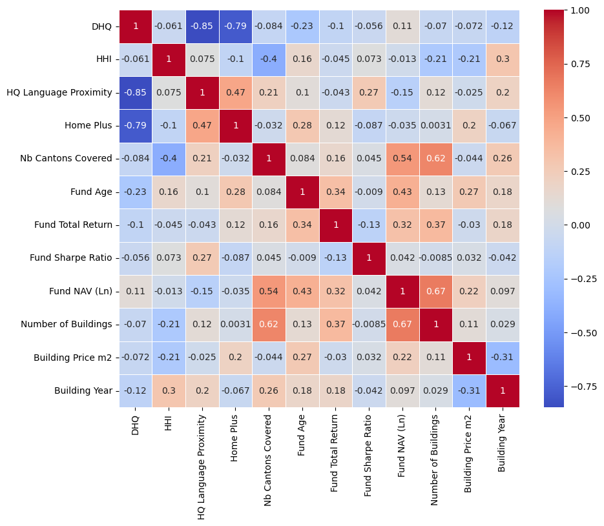
Source: Authors own work.

Figure A3. Variance Inflation Factor showing the collinearity between the distance of a building to the fund’s HQ and HQ language

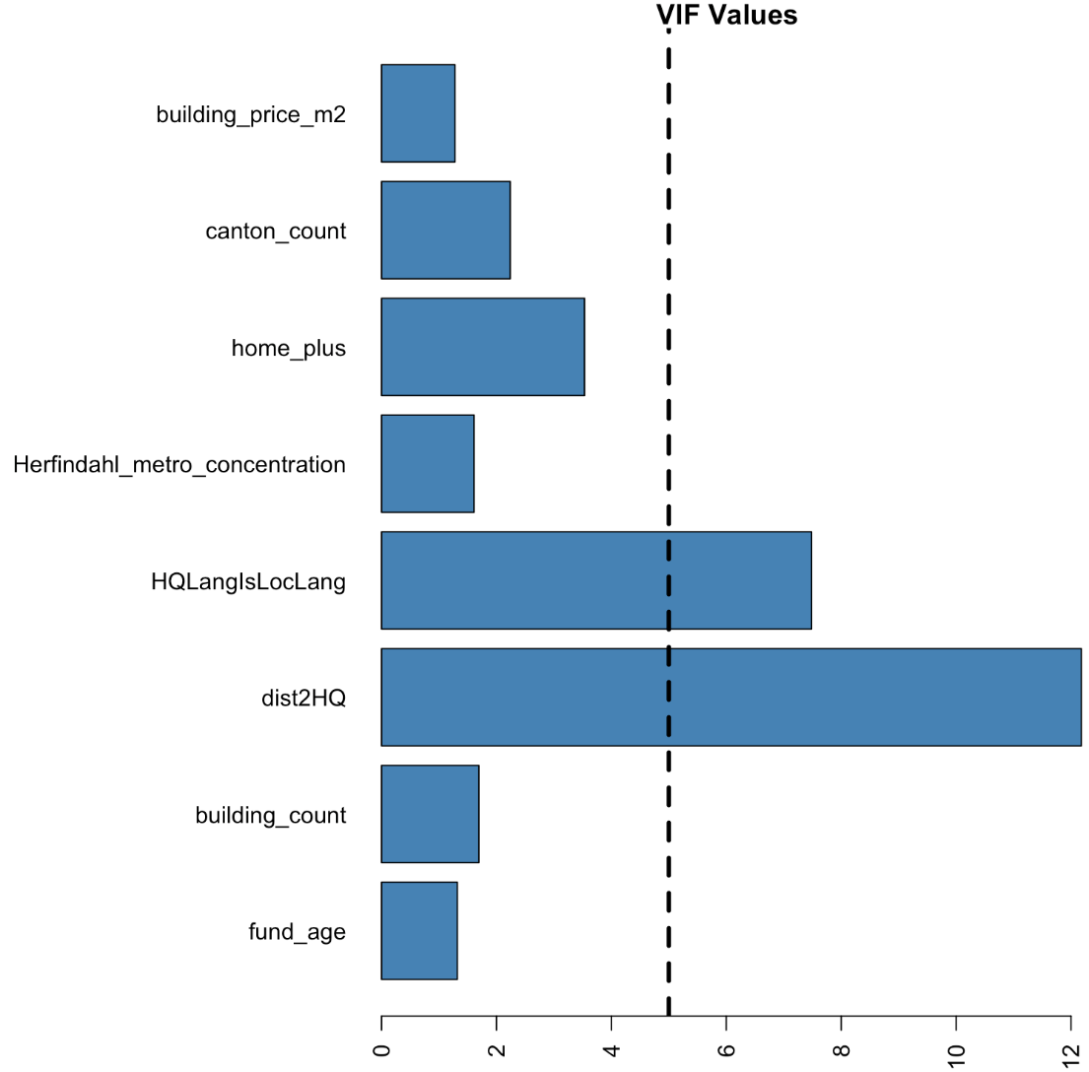
Source: Authors own work.

