Appendix
Figure A: Evolution of bootstrap-DEA public health efficiency scores over the period 2000-2016
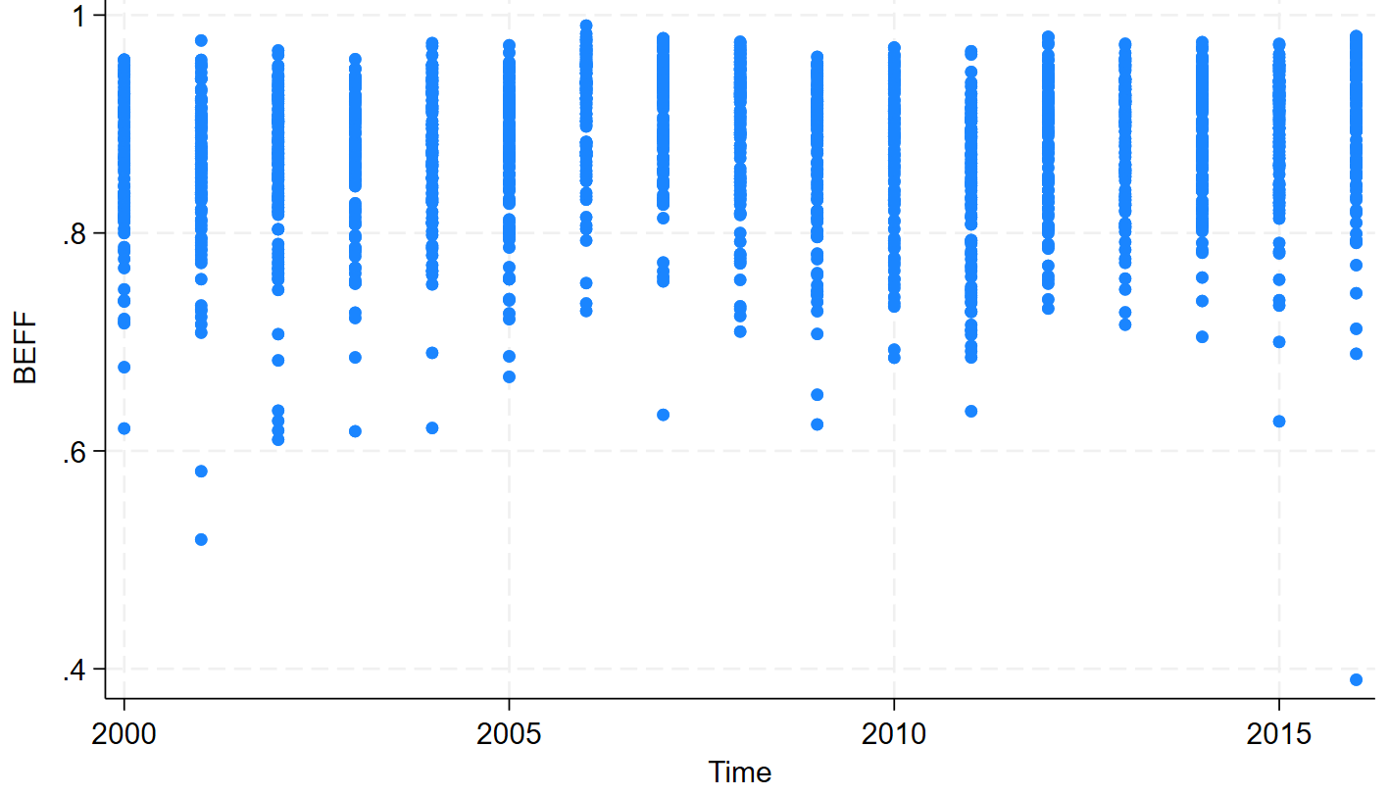
Source: Author’s own elaboration
Figure A shows the variation and increase of the bootstrap-DEA public health efficiency scores over the period 2000-2016. There is an outlier representing the poor performance of the province of Catanzaro, which rated less than the sample mean of the country in 2016.
Table A: Domains and dimensions of the Equitable and Sustainable Well-being and the composite well-being indices respectively.
Equitable and Sustainable well-being (BES) |  | Composite well-being index
Domains | Indicators | Dimensions | Indicators
Health (6) | Life expectancy at birth | Health (4) | Life expectancy at birth (male)
Health (6) | Avoidable mortality (0-74) -  dropped | Health (4) | Life expectancy at birth (female)
Health (6) | Infant mortality - dropped | Health (4) | Mortality rate
Health (6) | Road traffic mortality (15-34 years) - dropped | Health (4) | Fertility rate
Health (6) | Cancer mortality (20-64 years) - dropped | Health (4) | Fertility rate
Health (6) | Mortality due to dementia and diseases of the nervous system (65 years and over) - dropped | Health (4) | Fertility rate
Education and training (9) | Childcare (Rights and citizenship) | Education and training (3) | Move to rights and citizenship dimension
Education and training (9) | High-school diploma | Education and training (3) | High-school diploma
Education and training (9) | University degree | Education and training (3) | University degree
Education and training (9) | Continuing training | Education and training (3) | Continuing training
Education and training (9) | Participation of 4-5 year olds in the school system - dropped | Education and training (3) | Continuing training
Education and training (9) | Transfer to university - dropped | Education and training (3) | Continuing training
Education and training (9) | Young adults | Education and training (3) | Move to gender equity and equal opportunity dimension
Education and training (9) | Inadequate numerical competence (secondary school) - dropped | Education and training (3) | Move to gender equity and equal opportunity dimension
Education and training (9) | Inadequate literacy (secondary school) - dropped | Education and training (3) | Move to gender equity and equal opportunity dimension
Work and life balance (6) | Unemployment rate | Economy and labour (3) | Unemployment rate
Work and life balance (6) | Non-participation rate in employment - dropped | Economy and labour (3) | Theil index
Work and life balance (6) | Rate of fatal accidents and permanent disability - dropped | Economy and labour (3) | Financial risk
Work and life balance (6) | Youth employment rate (15-29 years)- dropped | Economy and labour (3) | Financial risk
Work and life balance (6) | Youth labour non-participation rate (15-29 years) - dropped | Economy and labour (3) | Financial risk
Work and life balance (6) | Paid days in the year (employees) - dropped | Economy and labour (3) | Financial risk
Economic well-being (6) | Financial risk | Rights and citizenship (5) | Migrant integration
Economic well-being (6) | Average disposable income per capita - dropped | Rights and citizenship (5) | Migrant integration
Economic well-being (6) | Average annual salary for employees - dropped | Rights and citizenship (5) | Electricity interruption
Economic well-being (6) | Average per capita annual pension income - dropped | Rights and citizenship (5) | Home assistance
Economic well-being (6) | Retirees with low pension income - dropped | Rights and citizenship (5) | Childcare
Economic well-being (6) | Assets per capita - dropped | Rights and citizenship (5) | Crime rate
Social relationships (2) | No-profit organisations | Gender equity and equal opportunity (3) | Young adults
Social relationships (2) | School accessibility | Gender equity and equal opportunity (3) | Female administrators
Social relationships (2) | School accessibility | Gender equity and equal opportunity (3) | Gender equity
Politics and institutions (7) | Municipal administrators | Democratic participation (2) | Municipal administrators
Politics and institutions (7) | Municipal administrators | Democratic participation (2) | Voter turnout
Politics and institutions (7) | Electoral participation | Democratic participation (2) | dropped
Politics and institutions (7) | Regional electoral participation | Democratic participation (2) | dropped
Politics and institutions (7) | Female administrators | Democratic participation (2) | dropped
Politics and institutions (7) | Prison crowding | Democratic participation (2) | dropped
Politics and institutions (7) | Municipalities: collection capacity | Democratic participation (2) | dropped
Politics and institutions (7) | Provincial governments: collection capacity | Democratic participation (2) | dropped
Safety (6) | Crime rate | dropped | Move to rights and citizenship
Safety (6) | Other fatal crimes reported | dropped | dropped
Safety (6) | Reports of residential theft | dropped | dropped
Safety (6) | Pickpocketing complaints | dropped | dropped
Safety (6) | Robbery complaints | dropped | dropped
Safety (6) | Non-urban road mortality | dropped | dropped
Landscape and cultural heritage (3) | Density and relevance of museum heritage | dropped | dropped
Landscape and cultural heritage (3) | Spread of agritourism farms | dropped | dropped
Landscape and cultural heritage (3) | Urban green density | dropped | Move to environment dimension
Environment (13) | Waste recycling | Environment (7) | Waste recycling
Environment (13) | Urban green | Environment (7) | Urban green
Environment (13) | Air quality | Environment (7) | Air quality
Environment (13) | Index of duration of hot periods - dropped | Environment (7) | Motorisation rate
Environment (13) | Days with extremely heavy precipitation - dropped | Environment (7) | Public transport
Environment (13) | Consecutive rainless days - dropped | Environment (7) | Population density
Environment (13) | Population exposed to landslide risk - dropped | Environment (7) | Population density
Environment (13) | Population exposed to the risk of flooding - dropped | Environment (7) | Population density
Environment (13) | Leakage from the municipal water network - dropped | Environment (7) | Population density
Environment (13) | Protected areas - dropped | Environment (7) | Population density
Environment (13) | Urban waste generated -dropped | Environment (7) | Population density
Environment (13) | Electricity from renewable sources - dropped | Environment (7) | Population density
Research and innovation (4) | Propensity to patent | dropped | dropped
Research and innovation (4) | Municipalities with services for families entirely online | dropped | dropped
Research and innovation (4) | Mobility of Italian graduates (25-39 years) | dropped | dropped
Research and innovation (4) | Employees in cultural enterprises | dropped | dropped
Quality of services (8) | Electricity interruption | dropped | Move to rights and citizenship
Quality of services (8) | Post-km offered by the Tpl | dropped | dropped
Quality of services (8) | Fixed network coverage of ultra-fast internet access | dropped | dropped
Quality of services (8) | urban separate collection of 65% or more. | dropped | dropped
Quality of services (8) | Posti letto per specialità ad elevata assistenza | dropped | dropped
Quality of services (8) | Out patients | dropped | dropped
Quality of services (8) | Specialised physicians | dropped | dropped
Quality of services (8) | Hospital beds | dropped | dropped
Source: Author’s own elaboration based on Istat (2023)
Table A shows that the indicators used to construct our composite well-being index are a subset of those used to construct the BES at the provincial level. We follow the methodological framework of Segre et al (2011) and Calcagnini & Perugini (2019) and used the same dimensions of their studies.
The domains of social relationships, landscape and cultural heritage and research and innovation did not find correspondence in our set-up because we follow another methodological framework (Segre et al., 2011; Calcagnini & Perugini, 2019). Moreover, ISTAT did not measure subjective well-being at the provincial level, either as a domain or as an indicator of other domains. Many indicators were excluded because they were neither reliable (Chelli et al., 2016) nor did they allow the construction of a panel.
Figure B: The evolution of well-being index (WIAG, WIGG, WIGA and WIGH) over the period 2000-2016 for the 102 Italian provinces
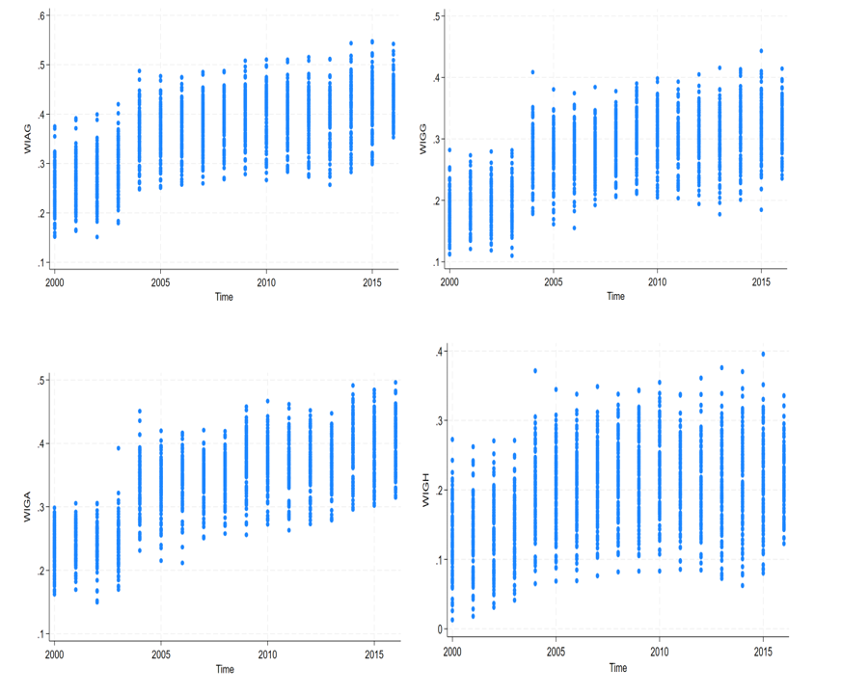
Source: Author’s own elaboration
Figure B illustrates variations and changes in each composite well-being index for the 102 Italian provinces over the period 2000-2016. A positive trend is observed in all quarter panels.
Figure C: Evolution of WIAG, WIGG, WIGA and WIGH over the period 2000-2016
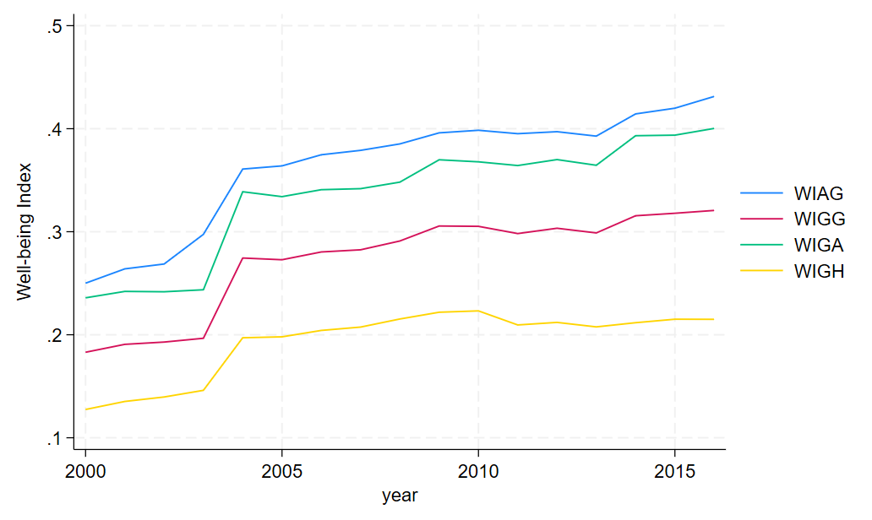
Source: Author’s own elaboration
Figure C displays the evolution of composite well-being indices WIAG, WIGG, WIGA and WIGH in Italy over the period 2000-2016. As can be observed, each year, the composite well-being indices are synthesised by a single number. Italy is taken as the average of the 102 Italian provinces from 2000 to 2016.

Table B: Evolution of key variables of the main model (BEFF and WIAG) between 2000 and 2016
province_names | BEFF2000 | province_names | BEFF2016 | Province names | WIAG2000 | province_names | WIAG2016 | rank
Teramo | 0,959156 | Savona | 0,980717 | Milano | 0,375008 | Trento | 0,542087 | 1
Macerata | 0,959033 | Terni | 0,979985 | Pisa | 0,370717 | Milano | 0,527375 | 2
Bolzano | 0,958243 | Macerata | 0,97995 | L'Aquila | 0,354915 | Firenze | 0,520842 | 3
Frosinone | 0,95397 | Pesaro e Urbino | 0,978067 | Siena | 0,32389 | Bologna | 0,509153 | 4
Piacenza | 0,952613 | Genova | 0,97661 | Brescia | 0,322308 | Bolzano | 0,499184 | 5
Treviso | 0,950003 | Trento | 0,973319 | Bolzano | 0,320833 | Aosta | 0,494467 | 6
Imperia | 0,948754 | Rovigo | 0,972822 | Trento | 0,317368 | Padova | 0,490693 | 7
Savona | 0,945997 | Brindisi | 0,970751 | Ancona | 0,313274 | Modena | 0,490324 | 8
Taranto | 0,945629 | Asti | 0,969416 | Firenze | 0,313026 | Udine | 0,479983 | 9
Chieti | 0,945285 | Verona | 0,965495 | Roma | 0,305898 | Perugia | 0,477547 | 10
Prato | 0,945141 | Ferrara | 0,965141 | Padova | 0,305831 | La Spezia | 0,477305 | 11
Trento | 0,943443 | Ancona | 0,964624 | Verona | 0,305379 | Cagliari | 0,47608 | 12
Viterbo | 0,938575 | Pescara | 0,964309 | Ravenna | 0,302811 | Pisa | 0,474777 | 13
Aosta | 0,937948 | Varese | 0,964179 | Belluno | 0,301594 | Reggio nell'Emilia | 0,471346 | 14
Mantova | 0,933716 | Modena | 0,962572 | Treviso | 0,300507 | Ancona | 0,468146 | 15
Verbano-Cusio-Ossola | 0,929947 | Foggia | 0,962548 | Reggio nell'Emilia | 0,299309 | Parma | 0,467808 | 16
Varese | 0,928219 | Bergamo | 0,960272 | Venezia | 0,297571 | Siena | 0,465391 | 17
L'Aquila | 0,928121 | Imperia | 0,956402 | Vicenza | 0,296985 | Ravenna | 0,462857 | 18
Verona | 0,92796 | Milano | 0,955116 | Bergamo | 0,295382 | Pesaro e Urbino | 0,462314 | 19
Foggia | 0,927895 | Padova | 0,954119 | Bologna | 0,291617 | Grosseto | 0,462005 | 20
Potenza | 0,927107 | Isernia | 0,950308 | Varese | 0,284975 | Bergamo | 0,461179 | 21
Padova | 0,924816 | Parma | 0,949241 | Torino | 0,284947 | Prato | 0,460673 | 22
Matera | 0,921958 | Napoli | 0,948491 | Como | 0,284541 | Pescara | 0,46044 | 23
Isernia | 0,921057 | Benevento | 0,947602 | Aosta | 0,28359 | Rimini | 0,460297 | 24
Latina | 0,920409 | Brescia | 0,94421 | Pordenone | 0,2824 | Pordenone | 0,459195 | 25
Genova | 0,92011 | Bologna | 0,943744 | Massa-Carrara | 0,28218 | Sondrio | 0,45747 | 26
Vicenza | 0,915556 | Teramo | 0,943452 | La Spezia | 0,27839 | Piacenza | 0,457141 | 27
Brescia | 0,913746 | Mantova | 0,942538 | Lecco | 0,278095 | Roma | 0,456955 | 28
Bologna | 0,913322 | Lodi | 0,942485 | Prato | 0,277029 | Treviso | 0,456444 | 29
Cosenza | 0,913288 | Alessandria | 0,942353 | Biella | 0,276701 | Como | 0,453857 | 30
Enna | 0,912935 | Lecce | 0,941597 | Grosseto | 0,276512 | Vicenza | 0,4536 | 31
Campobasso | 0,911991 | Torino | 0,94134 | Cagliari | 0,27552 | Verona | 0,452053 | 32
Oristano | 0,911282 | Taranto | 0,935954 | Terni | 0,272829 | Lecco | 0,451642 | 33
Rieti | 0,911 | Frosinone | 0,934407 | Cuneo | 0,271592 | Forlì-Cesena | 0,4513 | 34
Venezia | 0,910907 | Pavia | 0,934209 | Parma | 0,271443 | L'Aquila | 0,451292 | 35
Crotone | 0,91032 | Reggio nell'Emilia | 0,933513 | Modena | 0,270364 | Ferrara | 0,449369 | 36
La Spezia | 0,908396 | Treviso | 0,933045 | Mantova | 0,269354 | Cremona | 0,447874 | 37
Vibo Valentia | 0,907773 | Venezia | 0,930637 | Pesaro e Urbino | 0,268153 | ITALIA | 0,4476 | 38
Roma | 0,907455 | Lecco | 0,930221 | Pavia | 0,268055 | Matera | 0,446406 | 39
Napoli | 0,906819 | Caserta | 0,930161 | Udine | 0,266678 | Venezia | 0,446105 | 40
Parma | 0,901738 | Verbano-Cusio-Ossola | 0,930001 | Lucca | 0,265672 | Terni | 0,444638 | 41
Torino | 0,898926 | Vibo Valentia | 0,929371 | Novara | 0,26401 | Brescia | 0,444563 | 42
Salerno | 0,898577 | La Spezia | 0,92871 | ITALIA | 0,263459 | Mantova | 0,442632 | 43
Rovigo | 0,897175 | Roma | 0,928625 | Perugia | 0,262647 | Potenza | 0,442542 | 44
Pavia | 0,892544 | Rieti | 0,928618 | Arezzo | 0,261851 | Oristano | 0,441366 | 45
Trapani | 0,890961 | Enna | 0,928277 | Nuoro | 0,261513 | Viterbo | 0,439888 | 46
Belluno | 0,887608 | Pistoia | 0,927416 | Verbano-Cusio-Ossola | 0,260313 | Rovigo | 0,43883 | 47
Bari | 0,886358 | Catania | 0,923883 | Brindisi | 0,259694 | Isernia | 0,437985 | 48
Arezzo | 0,885 | Piacenza | 0,923466 | Rimini | 0,259288 | Avellino | 0,437896 | 49
Modena | 0,879927 | Bolzano | 0,919647 | Pistoia | 0,258583 | Campobasso | 0,437583 | 50
Reggio nell'Emilia | 0,876435 | Vicenza | 0,91686 | Matera | 0,254198 | Lodi | 0,43709 | 51
Lecce | 0,872558 | Rimini | 0,911877 | Piacenza | 0,253227 | Macerata | 0,436327 | 52
Cuneo | 0,869781 | Forlì-Cesena | 0,911497 | Genova | 0,251847 | Nuoro | 0,43626 | 53
Milano | 0,869151 | Como | 0,908052 | Cremona | 0,25177 | Belluno | 0,434584 | 54
Firenze | 0,868153 | Bari | 0,907437 | Macerata | 0,245064 | Trieste | 0,43325 | 55
Ancona | 0,864452 | Prato | 0,905252 | Napoli | 0,24464 | Savona | 0,432735 | 56
Rimini | 0,864192 | Perugia | 0,904284 | Pescara | 0,243604 | Chieti | 0,429789 | 57
Novara | 0,864105 | L'Aquila | 0,904028 | Trieste | 0,243019 | Teramo | 0,429423 | 58
Caserta | 0,862228 | Crotone | 0,90252 | Asti | 0,241858 | Livorno | 0,428686 | 59
Pesaro e Urbino | 0,858519 | Oristano | 0,900241 | Rieti | 0,240828 | Varese | 0,427369 | 60
Ferrara | 0,856175 | Biella | 0,896474 | Lecce | 0,239938 | Arezzo | 0,426507 | 61
Benevento | 0,849777 | Matera | 0,896057 | Forlì-Cesena | 0,237423 | Genova | 0,424386 | 62
Nuoro | 0,843766 | Salerno | 0,895199 | Viterbo | 0,234784 | Lucca | 0,42291 | 63
Brindisi | 0,842601 | Palermo | 0,893592 | Livorno | 0,230846 | Pistoia | 0,422555 | 64
Bergamo | 0,837087 | Nuoro | 0,893122 | Teramo | 0,22751 | Messina | 0,419588 | 65
Como | 0,836902 | Agrigento | 0,885492 | Savona | 0,22665 | Pavia | 0,418913 | 66
Caltanissetta | 0,836295 | Trieste | 0,879828 | Sondrio | 0,226472 | Benevento | 0,418043 | 67
Grosseto | 0,836139 | Sassari | 0,879252 | Cosenza | 0,224459 | Ascoli Piceno | 0,41618 | 68
Reggio di Calabria | 0,836023 | Cremona | 0,876289 | Salerno | 0,223324 | Salerno | 0,414946 | 69
Terni | 0,833457 | Aosta | 0,873258 | Sassari | 0,223217 | Torino | 0,413876 | 70
Sondrio | 0,833141 | Trapani | 0,868621 | Bari | 0,223064 | Vibo Valentia | 0,413506 | 71
Alessandria | 0,830974 | Avellino | 0,867041 | Ragusa | 0,222925 | Rieti | 0,410289 | 72
Ravenna | 0,828069 | Ravenna | 0,867029 | Chieti | 0,222845 | Frosinone | 0,409517 | 73
Perugia | 0,827258 | Cosenza | 0,86673 | Ascoli Piceno | 0,222637 | Sassari | 0,40324 | 74
Pisa | 0,824295 | Caltanissetta | 0,866687 | Catania | 0,222313 | Bari | 0,402462 | 75
Cagliari | 0,822982 | Ragusa | 0,86575 | Alessandria | 0,221161 | Catania | 0,398271 | 76
Lodi | 0,820784 | Firenze | 0,862663 | Palermo | 0,219626 | Latina | 0,397454 | 77
Lucca | 0,818081 | Udine | 0,861273 | Lodi | 0,217798 | Biella | 0,397388 | 78
Cremona | 0,81622 | Pisa | 0,861185 | Imperia | 0,21689 | Napoli | 0,396289 | 79
Biella | 0,815501 | Cuneo | 0,861176 | Ferrara | 0,216517 | Cosenza | 0,395689 | 80
Pescara | 0,814777 | Massa-Carrara | 0,855342 | Avellino | 0,21365 | Enna | 0,394222 | 81
Catania | 0,814555 | Campobasso | 0,855211 | Frosinone | 0,212225 | Massa-Carrara | 0,39354 | 82
Forlì-Cesena | 0,814251 | Latina | 0,851775 | Benevento | 0,208348 | Ragusa | 0,390628 | 83
Trieste | 0,81383 | Belluno | 0,851509 | Vercelli | 0,204615 | Lecce | 0,389566 | 84
Pistoia | 0,811156 | Novara | 0,844371 | Latina | 0,203305 | Brindisi | 0,387193 | 85
Ascoli Piceno | 0,810269 | Grosseto | 0,843003 | Vibo Valentia | 0,200957 | Novara | 0,385877 | 86
Avellino | 0,803788 | Arezzo | 0,838998 | Caserta | 0,20081 | Siracusa | 0,385756 | 87
Catanzaro | 0,799911 | Siracusa | 0,833143 | Oristano | 0,200733 | Taranto | 0,384725 | 88
ITALIA | 0,789882 | Viterbo | 0,830446 | Rovigo | 0,199694 | Reggio di Calabria | 0,38444 | 89
Sassari | 0,787035 | Messina | 0,820951 | Trapani | 0,197441 | Catanzaro | 0,383158 | 90
Lecco | 0,784141 | Ascoli Piceno | 0,818277 | Campobasso | 0,196504 | Agrigento | 0,382558 | 91
Palermo | 0,782913 | Chieti | 0,809324 | Catanzaro | 0,195866 | Verbano-Cusio-Ossola | 0,380452 | 92
Asti | 0,776154 | Livorno | 0,799346 | Reggio di Calabria | 0,193125 | Cuneo | 0,376936 | 93
Udine | 0,7679 | Sondrio | 0,793627 | Potenza | 0,192637 | Foggia | 0,37599 | 94
Livorno | 0,748257 | Lucca | 0,79212 | Taranto | 0,18883 | Asti | 0,374137 | 95
Siena | 0,738132 | Cagliari | 0,791901 | Foggia | 0,178052 | Alessandria | 0,372774 | 96
Massa-Carrara | 0,737652 | Potenza | 0,790927 | Messina | 0,177512 | Crotone | 0,370876 | 97
Agrigento | 0,737135 | Siena | 0,770487 | Siracusa | 0,174493 | Palermo | 0,367697 | 98
Siracusa | 0,721075 | Vercelli | 0,744705 | Enna | 0,169597 | Caserta | 0,364102 | 99
Vercelli | 0,718529 | Pordenone | 0,712059 | Agrigento | 0,169321 | Imperia | 0,362858 | 100
Ragusa | 0,717182 | Reggio di Calabria | 0,689136 | Isernia | 0,15985 | Vercelli | 0,36235 | 101
Pordenone | 0,67687 | ITALIA | 0,685342 | Crotone | 0,154309 | Caltanissetta | 0,360621 | 102
Messina | 0,620608 | Catanzaro | 0,389967 | Caltanissetta | 0,15191 | Trapani | 0,353112 | 103
Source: Author’s own elaboration

Table C: Descriptive statistics of key variables by (year)
2000 | Obs | Mean | Std.Dev. | Min | Max
WIAG | 102 | .25 | 0.047 | .152 | .375
BEFF | 102 | .865 | 0.069 | .621 | .959
GDPPC | 102 | 10.163 | 0.859 | 7.552 | 12.628
Taxes | 102 | .001 | 0.000 | 0 | .001
Transfers | 102 | .02 | 0.015 | 0 | .057
POPDENS | 102 | 5.134 | 0.760 | 3.601 | 7.868

2001
WIAG | 102 | .264 | 0.047 | .164 | .391
BEFF | 102 | .858 | 0.074 | .519 | .977
GDPPC | 102 | 10.18 | 0.861 | 7.529 | 12.662
Taxes | 102 | 0 | 0.000 | 0 | .001
Transfers | 102 | .025 | 0.014 | 0 | .069
POPDENS | 102 | 5.134 | 0.761 | 3.604 | 7.867

2002
WIAG | 102 | .269 | 0.047 | .151 | .399
BEFF | 102 | .856 | 0.075 | .61 | .968
GDPPC | 102 | 10.18 | 0.857 | 7.562 | 12.677
Taxes | 102 | 0 | 0.000 | 0 | .001
Transfers | 102 | .03 | 0.014 | .001 | .072
POPDENS | 102 | 5.134 | 0.762 | 3.605 | 7.865

2003
WIAG | 102 | .297 | 0.051 | .179 | .42
BEFF | 102 | .863 | 0.065 | .618 | .96
GDPPC | 102 | 10.176 | 0.857 | 7.584 | 12.666
Taxes | 102 | 0 | 0.000 | 0 | .001
Transfers | 102 | .029 | 0.013 | 0 | .071
POPDENS | 102 | 5.137 | 0.763 | 3.613 | 7.865

2004
WIAG | 102 | .361 | 0.051 | .248 | .487
BEFF | 102 | .875 | 0.063 | .621 | .974
GDPPC | 102 | 10.178 | 0.853 | 7.628 | 12.697
Taxes | 102 | 0 | 0.000 | 0 | .001
Transfers | 102 | .026 | 0.013 | .001 | .073
POPDENS | 102 | 5.143 | 0.763 | 3.623 | 7.867

2005
WIAG | 102 | .364 | 0.050 | .251 | .477
BEFF | 102 | .873 | 0.065 | .668 | .972
GDPPC | 102 | 10.179 | 0.856 | 7.577 | 12.704
Taxes | 102 | 0 | 0.000 | 0 | .004
Transfers | 102 | .027 | 0.015 | .002 | .089
POPDENS | 102 | 5.149 | 0.765 | 3.634 | 7.869

2006
WIAG | 102 | .375 | 0.049 | .257 | .475
BEFF | 102 | .913 | 0.054 | .728 | .99
GDPPC | 102 | 10.195 | 0.858 | 7.521 | 12.721
Taxes | 102 | 0 | 0.000 | 0 | .001
Transfers | 102 | .025 | 0.013 | 0 | .071
POPDENS | 102 | 5.152 | 0.766 | 3.643 | 7.867

2007
WIAG | 102 | .379 | 0.048 | .26 | .485
BEFF | 102 | .91 | 0.060 | .633 | .979
GDPPC | 102 | 10.212 | 0.858 | 7.536 | 12.737
Taxes | 102 | 0 | 0.000 | 0 | .001
Transfers | 102 | .028 | 0.014 | 0 | .072
POPDENS | 102 | 5.154 | 0.767 | 3.648 | 7.865

2008
WIAG | 102 | .385 | 0.047 | .268 | .487
BEFF | 102 | .894 | 0.065 | .71 | .976
GDPPC | 102 | 10.178 | 0.867 | 7.476 | 12.719
Taxes | 102 | 0 | 0.000 | 0 | .001
Transfers | 102 | .03 | 0.014 | 0 | .073
POPDENS | 102 | 5.162 | 0.768 | 3.656 | 7.865

2009
WIAG | 102 | .396 | 0.052 | .279 | .508
BEFF | 102 | .869 | 0.072 | .624 | .962
GDPPC | 102 | 10.117 | 0.868 | 7.397 | 12.688
Taxes | 102 | 0 | 0.000 | 0 | .002
Transfers | 102 | .033 | 0.014 | .003 | .083
POPDENS | 102 | 5.167 | 0.768 | 3.662 | 7.862

2010
WIAG | 102 | .398 | 0.053 | .267 | .51
BEFF | 102 | .874 | 0.069 | .686 | .97
GDPPC | 102 | 10.139 | 0.872 | 7.431 | 12.69
Taxes | 102 | 0 | 0.000 | 0 | .001
Transfers | 102 | .031 | 0.013 | .001 | .075
POPDENS | 102 | 5.17 | 0.770 | 3.665 | 7.864

2011
WIAG | 102 | .395 | 0.052 | .283 | .51
BEFF | 102 | .838 | 0.073 | .636 | .967
GDPPC | 102 | 10.154 | 0.876 | 7.447 | 12.704
Taxes | 102 | .001 | 0.000 | 0 | .001
Transfers | 102 | .028 | 0.013 | 0 | .079
POPDENS | 102 | 5.171 | 0.771 | 3.665 | 7.864

2012
WIAG | 102 | .397 | 0.053 | .273 | .515
BEFF | 102 | .886 | 0.060 | .731 | .98
GDPPC | 102 | 10.133 | 0.879 | 7.426 | 12.663
Taxes | 102 | .001 | 0.000 | 0 | .001
Transfers | 102 | .022 | 0.014 | 0 | .08
POPDENS | 102 | 5.171 | 0.772 | 3.664 | 7.864

2013
WIAG | 102 | .393 | 0.053 | .257 | .512
BEFF | 102 | .885 | 0.059 | .716 | .974
GDPPC | 102 | 10.105 | 0.882 | 7.357 | 12.635
Taxes | 102 | .001 | 0.000 | 0 | .001
Transfers | 102 | .021 | 0.014 | 0 | .084
POPDENS | 102 | 5.174 | 0.773 | 3.674 | 7.864

2014
WIAG | 102 | .414 | 0.059 | .283 | .544
BEFF | 102 | .885 | 0.056 | .705 | .975
GDPPC | 102 | 10.094 | 0.885 | 7.334 | 12.626
Taxes | 102 | .001 | 0.000 | 0 | .001
Transfers | 102 | .021 | 0.015 | 0 | .082
POPDENS | 102 | 5.187 | 0.778 | 3.68 | 7.888

2015
WIAG | 102 | .42 | 0.057 | .299 | .547
BEFF | 102 | .89 | 0.061 | .627 | .974
GDPPC | 102 | 10.102 | 0.889 | 7.315 | 12.623
Taxes | 102 | .001 | 0.003 | 0 | .032
Transfers | 102 | .022 | 0.013 | 0 | .073
POPDENS | 102 | 5.186 | 0.779 | 3.677 | 7.885

2016
WIAG | 102 | .431 | 0.040 | .353 | .542
BEFF | 102 | .895 | 0.079 | .39 | .981
GDPPC | 102 | 10.106 | 0.893 | 7.304 | 12.682
Taxes | 102 | 0 | 0.000 | 0 | .003
Transfers | 102 | .026 | 0.011 | .001 | .074
POPDENS | 102 | 5.182 | 0.780 | 3.67 | 7.883
Source: Author’s own elaboration

Table D: Pairwise correlation matrix between WIAG and the 27 indicators
 | WIAG | popdens | recy | motrate | putran | urgre | urdens | airqua | unemp
WIAG | 1
popdens | 0.124* | 1
recy | 0.713* | 0.055* | 1
motrate | 0.114* | -0.151* | 0.036 | 1
putran | 0.288* | 0.484* | 0.157* | -0.138* | 1
urgre | 0.049* | -0.123* | -0.14* | 0.027 | -0.086* | 1
urdens | 0.161* | 0.116* | -0.065* | 0.023 | 0.123* | 0.690* | 1
airqua | 0.181* | 0.162* | -0.011 | 0.307* | 0.124* | -0.177* | 0.042 | 1
unemp | -0.381* | 0.02 | -0.316* | -0.071* | -0.177* | -0.045 | -0.129* | -0.131* | 1
theil | 0.09* | 0.049* | 0.128* | 0.084* | 0.101* | -0.112* | -0.046 | 0.135* | 0.00
finrisk | 0.085* | -0.079* | 0.089* | -0.031 | -0.155* | -0.072* | -0.174* | -0.166* | 0.452*
liexpfe | 0.777* | -0.073* | 0.612* | 0.039 | 0.112* | -0.070* | -0.052* | -0.040 | -0.267*
liexpma | 0.73* | -0.02 | 0.522* | 0.003 | 0.075* | -0.104* | -0.128* | -0.113* | -0.014
fertrate | 0.348* | 0.171* | 0.292* | 0.1* | 0.039 | -0.101* | 0.009 | 0.082* | -0.102*
mortra | 0.163* | -0.185* | 0.088* | -0.050 | -0.067* | 0.026 | -0.057* | -0.012 | -0.243*
migint | 0.76* | 0.102* | 0.649* | 0.023 | 0.177* | -0.106* | -0.029 | -0.064* | -0.392*
elinter | -0.60 | -0.132 | -0.515* | -0.084* | -0.203* | 0.003 | -0.045 | -0.083* | 0.586*
homass | -0.087* | -0.162* | -0.066* | 0.331* | -0.025 | 0.020 | -0.043 | 0.170* | -0.092*
childcare | 0.463* | 0.033 | 0.283* | 0.135* | 0.200* | 0.008 | 0.103* | 0.053* | -0.508*
crime | -0.175* | 0.015 | -0.134* | -0.012 | -0.045 | -0.006 | -0.030 | 0.016 | 0.175*
diploma | 0.736* | 0.055* | 0.409* | 0.015 | 0.254* | -0.017 | 0.049 | 0.046 | -0.287*
graduate | 0.676* | 0.127* | 0.338* | 0.01 | 0.289* | -0.054* | 0.005 | 0.048 | -0.113*
form | 0.548* | 0.053 | 0.236* | 0.04 | 0.210* | 0.036 | 0.070* | 0.052 | -0.114*
young | -0.593* | 0.023 | -0.332* | -0.068* | -0.183* | -0.072* | -0.148* | -0.113* | 0.897*
femad | 0.665* | -0.021 | 0.605* | 0.046 | 0.097* | -0.108* | -0.060* | -0.050 | -0.161*
gendiff | -0.656* | -0.02 | -0.52* | -0.129* | -0.194* | 0.022 | -0.059* | -0.036 | 0.371*
munad | -0.012 | -0.191* | -0.04 | 0.048 | -0.163* | 0.018 | -0.047 | -0.103* | 0.285*
vote | 0.307* | -0.019 | 0.074* | -0.108* | -0.008 | 0.021 | 0.029 | -0.203* | -0.277*

theil | finrisk | liexpfe | liexpma | fertrate | mortra | migint | elinter | homass | childcare
1
-0.057* | 1
0.014 | 0.168* | 1
-0.104* | 0.326* | 0.846* | 1
0.070* | -0.059* | 0.24* | 0.318* | 1
-0.287* | 0.035 | -0.078* | -0.191 | -0.262* | 1
-0.055* | 0.068* | 0.665* | 0.687* | 0.461* | 0.209* | 1
0.043 | 0.148* | -0.536* | -0.409* | -0.187* | -0.232* | -0.598* | 1
0.199* | -0.195* | -0.170* | -0.289* | 0.055* | -0.132* | -0.234* | 0.134* | 1
-0.125* | -0.179* | 0.310* | 0.239* | 0.144* | 0.308* | 0.467* | -0.507* | -0.051 | 1
0.025 | 0.042 | -0.119* | -0.107* | -0.009 | -0.097* | -0.156* | 0.199* | -0.018 | -0.116*
-0.059* | 0.121* | 0.526* | 0.561* | 0.088 | 0.381* | 0.622* | -0.444* | -0.205* | 0.42*
-0.018 | 0.211* | 0.515* | 0.611* | 0.019 | 0.318* | 0.510* | -0.375* | -0.235* | 0.356*
-0.013 | 0.065* | 0.436* | 0.410* | -0.058* | 0.186* | 0.286* | -0.278* | -0.073* | 0.312*
-0.024 | 0.471* | -0.353* | -0.067* | -0.193* | -0.251* | -0.491* | 0.636* | -0.085* | -0.596*
-0.051 | 0.183* | 0.565* | 0.615* | 0.090* | 0.364* | 0.663* | -0.511* | -0.188* | 0.567
0.04 | -0.029 | -0.493* | -0.437* | 0.118* | -0.48* | -0.613* | 0.562* | 0.088* | -0.621*
0.018 | 0.233* | -0.009 | 0.066* | 0.007 | -0.158* | -0.110* | 0.191* | 0.12* | -0.026
0.089* | -0.085* | 0.139* | 0.115* | 0.016 | 0.107* | 0.276* | -0.215* | -0.254* | 0.25*

crime | diploma | graduate | form | young | femad | gendiff | munad | vote
1
-0.151* | 1
-0.119* | 0.829* | 1
-0.073* | 0.608* | 0.603* | 1
0.176* | -0.375* | -0.192* | -0.231* | 1
-0.120* | 0.502* | 0.523* | 0.424* | -0.268* | 1
0.136* | -0.631* | -0.566* | -0.433* | 0.458* | -0.698* | 1
0.087* | -0.172* | -0.07* | -0.05 | 0.272* | 0.193* | 0.089* | 1
-0.058* | 0.182* | 0.139* | 0.055* | -0.272* | 0.161* | -0.133* | -0.068* | 1
Source: Author’s own elaboration
The WIAG level is positive and significantly correlated with waste recycling, women’s life expectancy, men’s life expectancy, migrants' integration, high-school diploma, university degree and women administrators with values of respectively 0,71, 0,78, 0,73, 0,76, 0,74, 0,67 and 0,66. However, it is negative and significantly correlated with electricity interruption, young people who do not study or work and gender equity with values of -0.60, -0.59 and -0.66 respectively.

