A. DATA
I use the well-known trade data of Glick and Rose (2016), who use Direction of Trade statistics from the IMF to construct bilateral trade data for more than 200 countries from
1948-2013. I merge this with population-by-age data from the United Nations Population Prospects data from 2022 (UN, 2022). After doing so, I am left with 192 of these countries over the period from 1970 to 2013. When structured as ‘one-way’ export data, where each country-pair appears twice to reflect flows in both directions, this results in a sample of 1,613,568 (192*191*44). A well-known problem in trade datasets are missing trade flows and there are 925,453 missing values in this data for bilateral exports, making the maximum usable sample for log gravity models only 688,025. Both of these are further reduced by the availability of covariates, in particular, GDP data, which is missing for 321,572 country-pairs (many, but not all of which have missing trade data).
In addition to log gravity equations I will use the Poisson pseudo-maximum likelihood
(PPML) estimators suggested in Silva and Tenreyro (2006). These correct bias introduced by the presence of heterosketasticity for estimates with log approximations, but are also able to include zero trade flows. For my PPML estimates I will assume that missing flows are zero. This leaves me with a maximum sample size of 1,291,996 for PPML estimators and 651,474 for log gravity equations. My estimates below will be on samples that are further reduced for two reasons. The first is due to removal of singleton groups. There are 1135 such cases in the log gravity equation, though none in the PPML specification. The second sample reduction comes from issues associated with existence of the maximum likelihood function in PPML estimations, which is shown by Silva and Tenreyro (2010) to be a problem for Poisson estimation in the presence of multicollinearity among regressors. This is potentially magnified with high dimensions of fixed effects. While Silva and Tenreyro (2010) suggest dropping problematic regressors, Correia et al. (2019) show that existence can be also be guaranteed by dropping “separated” observations, and provide a method for estimating the PPML with high dimensionality of fixed effects in Correia et al. (2020), which I utilize. Their method drops 205,862 separated observations, leaving my PPML sample at 1,086,134. However, I note that there does not appear to be any change in my coefficients of interest when including these. I summarize some of my key trade, gravity, and demographic variables in Table 4.
Table 4: Descriptive Statistics
 | mean | sd | count
log($Exports_{ij}$) | .9453812 | 3.77182 | 688025
$Exports_{ij}$ | 157.1436 | 2432.65 | 1613568
log($GDP_{i}×GDP_{j}$) | 47.62321 | 3.25624 | 1291996
log($GDPpc_{i}×GDPpc_{j}$) | 16.84038 | 1.865577 | 1291996
Regional Trade Agreement | .0407631 | .1977409 | 1613568
Working Age Population Country $i$ | .5929518 | .0713934 | 1613568
Share Retirees Country $i$ | .0623437 | .0426818 | 1613568
Difference ($i-j$): Working Age Population | 0 | .09428 | 1613568
Difference ($i-j$): Share of Retirees | 0 | .0850498 | 1613568
Demographic Polynomial Control 1 | 0 | 1.560091 | 1613568
Demographic Polynomial Control 2 | 0 | 20.98249 | 1613568
Demographic Polynomial Control 3 | 0 | 266.2446 | 1613568

Because data are constructed as “one-way” exports, each country-pair appears twice. Therefore the difference variables used in my main analysis are mean zero by construction as they contain symmetric information for each of the two country-pair observations (EG: $WAP_{USA}-WAP_{China}andWAP_{China}-WAP_{USA}$). The demographic polynomial controls are constructed as in [12], and defined in eq:DemogConstruct.

B. CONSTRUCTION OF DEMOGRAPHIC CONTROLS
Consider a version of Equation 1 that includes a full set of differences in population age shares as a demographic control in the traditional gravity equation of trade:
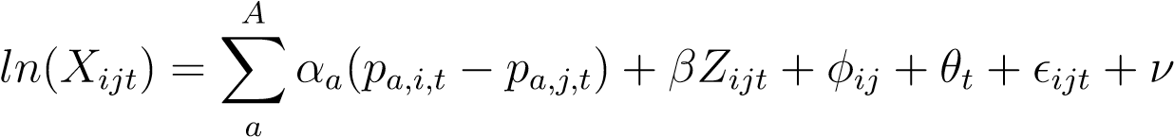 (5)
Where p_{a,i,t} is the share of population age group a in country i at time t. This equation is inestimable as currently specified due to the perfect colinearity of the population shares p_{a,i,t}, which for every time period some to one within a particular country, and whose difference between two countries thus sums to zero in every period. One might also prefer to estimate a large number of A groups to allow for the most flexibility possible within the model specification. Population shares are highly colinear, increasingly so as the number of groups increases. The Fair and Dom´ınguez (1991) approach to estimating these α_{a} coefficients suggests making the following two assumptions:
- Letting α_{a} be the coefficient on the difference in population shares (p_{a,i,t} − p_{a,j,t}) of age group a between countries i and j at time t. Assume that all of the effects of these coefficients across the age distribution sum to zero. In other words:
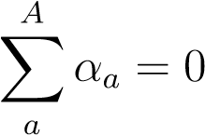
- Assume also that the age coefficients α_{a} can be fitted with a K order polynomial. In other words:
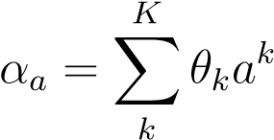 (6)
The problem can thus be transformed from one of estimating A, α_{a} coefficients for each age group, to one that estimates the K, θ coefficients that determine the shape of the polynomial. Requiring that these coefficients sum to zero allows for joint estimation without dropping the regression constant. This assumption also implicitly defines the constant of the polynomial, θ₀, as a function of the estimates for θ_{1−K}. By requiring that the individual age coefficients lie on a polynomial, these assumptions allow limited changes from one age group to the next, while imposing restrictions on how dramatically such estimated coefficients can swing from group to group. While the first assumption makes Equation 5 possible, simply imposing it tends to yield estimations with highly unstable α_{a} parameters from one age group to the next, and so this imposition is useful in limiting overfitting such a model with highly colinear regression controls. To see how this methodology works, substitute α_{a} as defined in Equation 6 into Equation 5. As in the paper, I set K = 3, using a third order polynomial. This yields:
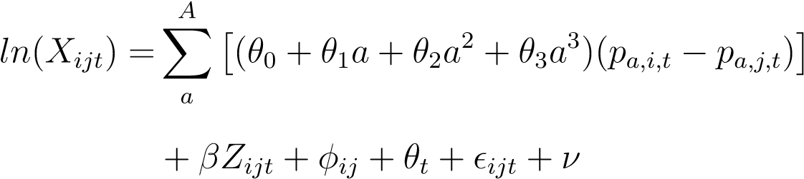 (7)
Taking the sum of both sides of Equation 6, and using the assumption that the sum of α_{a} must be zero, it can easily be shown that θ₀ is equal to:
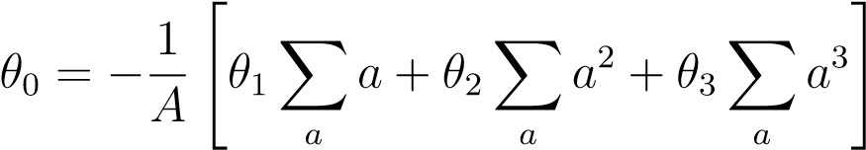 (8)
Distributing the summation term in Equation 7, and recognizing that the first term is zero (θ₀ ^{P}_{a}(p_{a,i,t} − p_{a,j,t}) = 0) this can then be expressed as:
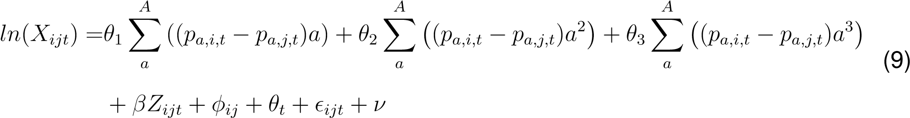
The terms in parenthesis are the demographic variables I describe in Equation 4 in
the paper, which when used in this regression yield estimates of the polynomial fitting of the age specific coefficients. Notably in the original Fair and Dom´ınguez (1991) paper population shares are used, rather than changes in these shares. This creates a small difference as these sum to one, instead of zero, which means that the θ₀ term does not drop out as it did here. The first term in this case is rather: θ₀ ^{P}_{a} p_{i,t} = θ₀, which simply requires one additional step of substituting the expression for θ₀ in Equation 8 into Equation 7 and combining like terms. The resulting demographic variables are each simply adjusted by a constant so ultimately this is not a critical distinction.
C. FURTHER RESULTS AND QUANTITATIVE ANALYSIS USING TRADE

BALANCE
In this appendix I document additional results related to the trade balance estimation in section 4. Because the model fit is much weaker than traditional gravity estimates, and the preferred PPML estimators are not usable, these estimates should be taken with some caution. However, they provide useful context and support the general implications of estimates using those more robust estimates of bilateral exports.
Here the age specific coefficients have a similar shape to Figure 3, but with a reduction in the size of coefficients earlier in working life. There are now relatively larger negative estimated impacts of both young dependents, with coefficients remaining close to zero throughout late career and retirement. While very young economies are predicted to have strong negative pressure on their trade balances, those with large shares of young workers are estimated to have positive demographic pressure toward trade surpluses, declining as they move to middle and old age. Like the results using traditional gravity estimates in section 3, the polynomial controls for the full age distribution suggest that working age shares likely capture much of the relevant variation here.
The effect of demographics on trade balance appears to be somewhat skewed toward
Figure 6: Age Specific Coefficients
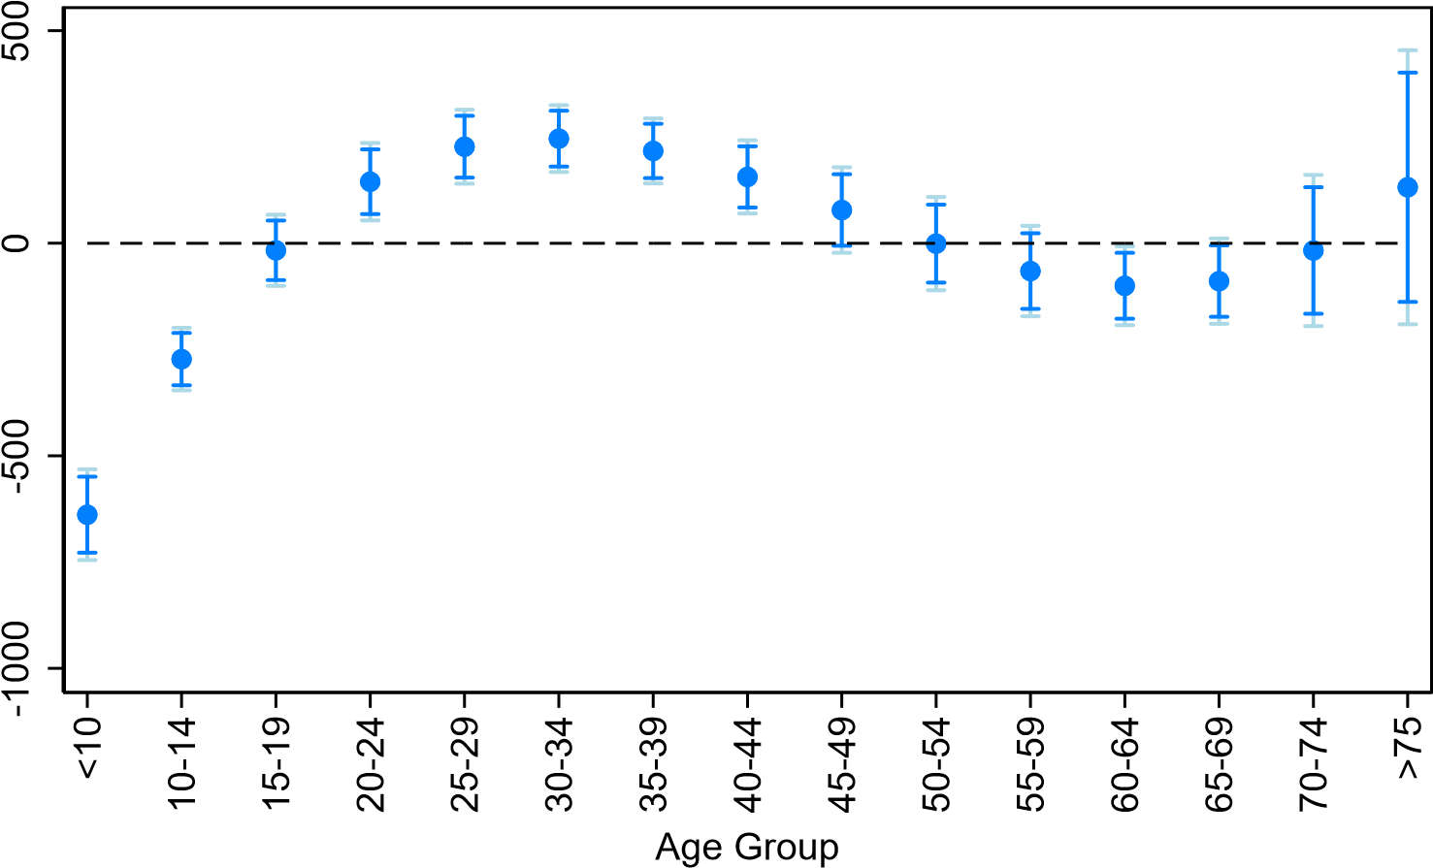
95% Confidence Intervals 90% Confidence Interval
Age Specific Coefficient Estimate
younger age groups than their effect on exports in a standard gravity equation. These results look slightly different when adjusting for GDP, as I report in Appendix E. While using trade balance as a share of GDP has consistent estimates for working age population, which remains significantly positive, specifications using the Fair and Dom´ınguez (1991) style polynomial fits appear to be skewed further toward middle aged, consistent with existing work by Higgins (1998), which studies the effects of similar demographic controls on the current account.
Carrying out the same exercise for the results of section 4 I show the changes in the model predicted China and USA balance of trade due to demographic movements, holding all other variables fixed. Here I caution that I use the Column 1 specification of Table 3, including only the relative WAP as a control. This is because neither the old-age dependency, nor the Fair and Dom´ınguez (1991) controls were robust in sign or significance across the OLS and PPML specifications in section 3. The relative WAP, is fairly robust so I present their estimates in this quantitative exercise. The predicted trade balance moves as one might expect given the quantitative exercise from imports in Figure 4. Demographics are expected to exert downward pressure on China’s surplus with the United States, Japan, and Vietnam, while providing potential growth in their surplus with Hong Kong and Vietnam. The United States is expected to see population forces helping to improve deficits with all of its major trading partners with the exception of Mexico.
Figure 7: Predicted Change in Trade Balance
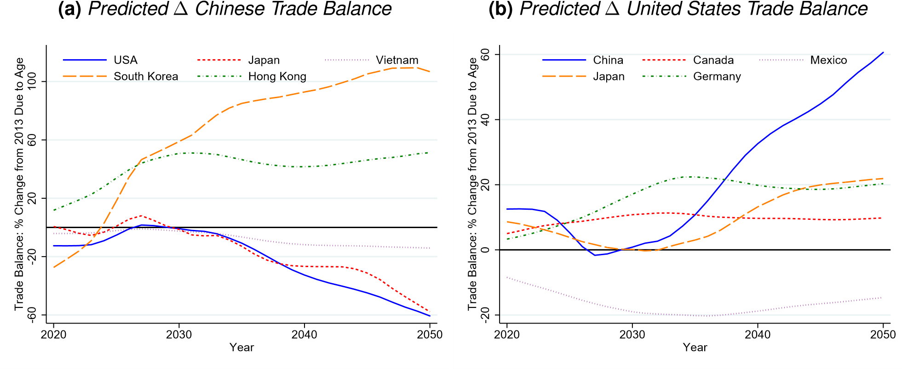
Figure 4 plots predicted change in trade balance using specification in Column 1 Table 3, holding non-demographic controls fixed. Values are reported as their change relative to final year of sample (2013).
While the quantitative size of the estimates in Figure 7 are large I caution strongly against reading too closely into any specific point estimate. One reason is the already mentioned issues of the OLS estimator, which have been well documented in the trade literature by Silva and Tenreyro (2006) and Silva and Tenreyro (2010). Another is that, unlike the gravity equation estimates in section 3, these estimates fit the data relatively poorly with an R² of 0.48. While predictions of movements in trade balances between countries generally match the data well, they are often extremely imprecise in their point estimates. This puts this exercise on somewhat shaky ground relative to that of Figure 4. I include these estimates, both for completeness and to show that the economic size of the correlations estimated in Table 3 are substantial. Further consideration should be made by both policymakers and researchers to understand how age structure might affect trade relationships in terms of balance.

D. ROBUSTNESS: SAMPLE SELECTION
To test the sensitivity of the above results to outliers in young and old populations I replicate the primary results from Table 1, Table 2, and Table 3 on my estimation sample where countries with one and two standard deviation outliers in the differences between working age populations are removed. The first four columns are the PPML gravity estimation using both the difference in working age population and the polynomial fitting of five-year population age groups. In the first two of these columns are estimated on a truncated sample that excludes any observations where the differences in working age population between the country-pairs are greater than one standard deviation from the sample mean (which is zero, by construction). The next two use a two standard deviation threshold for truncation. The coefficients are slightly larger for the more limited sample, perhaps suggesting that these estimates are weaker as populations grow further apart, although this change could also be affected by the fact that countries with similar demographics may be more closely linked due to similar levels of development. These differences are much larger for estimates of trade balance on these limited samples. In either case, the results remain of a broadly similar magnitude, and identical sign, to those in the main body of the paper. The same can be seen for estimates on the balance of trade in columns 5-8.
Table 5: Robustness to limited sample

 | Gravity: $X_{ijt}$ |  |  |  | Trade Balance: Millions
 | (1) | (2) | (3) | (4) | (5) | (6) | (7) | (8)
 | $$X_{ijt}$$ | $$X_{ijt}$$ | $$X_{ijt}$$ | $$X_{ijt}$$ | $$TB_{Mill}$$ | $$TB_{Mill}$$ | $$TB_{Mill}$$ | $$TB_{Mill}$$
$WAP_{ex}-WAP_{im}$ | 1.25$^{***}$ |  | 0.75$^{***}$ |  | 2330.66$^{***}$ |  | 830.71$^{***}$
 | (0.16) |  | (0.15) |  | (106.86) |  | (56.99)
$$OldAge_{ex}-OldAge_{im}$$ | -0.21 |  | -0.20 |  | 3235.27$^{***}$ |  | 1151.30$^{***}$
 | (0.28) |  | (0.25) |  | (262.69) |  | (150.43)
D1 |  | 0.28$^{†}$ |  | 0.07 |  | 1097.14$^{***}$ |  | 640.05$^{***}$
 |  | (0.17) |  | (0.15) |  | (137.56) |  | (77.52)
D2 |  | 0.13 |  | 0.25 |  | -104.84$^{***}$ |  | -82.51 ^***$^{***}$
 |  | (0.29) |  | (0.25) |  | (23.06) |  | (13.28)
D3 |  | -0.23$^{*}$ |  | -0.21$^{*}$ |  | 3.22$^{***}$ |  | 3.17$^{***}$
 |  | (0.14) |  | (0.11) |  | (1.05) |  | (0.62)
Z_ijt | X | X | X | X | X | X | X | X
Pair FEs | X | X | X | X | X | X | X | X
Year FEs | X | X | X | X | X | X | X | X
Samp. Red: $>1sd(WAP_{Diff})$ | X | X |  |  | X | X
Samp. Red: $>2sd(WAP_{Diff})$ |  |  | X | X |  |  | X | X
R2 |  |  |  |  | 0.50 | 0.50 | 0.48 | 0.48
psuedo-R2 | 0.98 | 0.98 | 0.97 | 0.97
N | 674645 | 674645 | 1049366 | 1049366 | 465004 | 465004 | 724076 | 724076

$Z_{ijt}$ contains controls for GDP and GDP per capita as well as for regional trade agreements between country-pairs. Samp. Red. refers to removing all observations either one or two standard deviations from the mean for the differences in working age population between exporter and importer countries.

E. RESULTS WITH TRADE BALANCE AS SHARE OF GDP
In this section I replicate the results from section 4 when the dependent variables is scaled as a share of exporter GDP. Additionally I now do not control for exporter GDP and GDP per capita on the RHS as in Equation 3. These results are reported in Table 6, with the implied coefficients from the polynomial-style demographic controls plotted in Figure 8. Similar to in the results on dollar values of trade balances the difference in working age population has a positive correlation, as in the traditional gravity estimations, while the share of retirees is puzzlingly positive. Recall however, that while the difference in WAP was robust to OLS and PPML specifications in the gravity estimates, the sign on the share of old-aged individuals was not.

Table 6: Gravity Equation of Trade: Full Age Distribution
 | (1) | (2) | (3) | (4)
 | $$TB_{GDP}$$ | $$TB_{GDP}$$ | $$TB_{GDP}$$ | $$TB_{GDP}$$
$WAP_{ex}-WAP_{im}$ | 0.44 ^*** |  | 0.51 ^***
 | (0.09) |  | (0.09)
$$OldAge_{ex}-OldAge_{im}$$ |  | 1.02 ^*** | 1.20 ^***
 |  | (0.25) | (0.21)
D1 |  |  |  | -0.31 ^**
 |  |  |  | (0.13)
D2 |  |  |  | 0.75 ^***
 |  |  |  | (0.22)
D3 |  |  |  | -0.36 ^***
 |  |  |  | (0.10)
Z_ijt | X | X | X | X
Pair FEs | X | X | X | X
Year FEs | X | X | X | X
F-stat |  |  |  | 30.75
R2 | 0.33 | 0.33 | 0.33 | 0.33
N | 749736 | 749736 | 749736 | 749736

Coefficients and standard errors for D2/D3 scaled by 10/100 respectively to improve readability. F-stat is the F statistic resulting from a test of joint significance of three demographic variables. $Z_{ijt}$ contains controls for GDP and GDP per capita for both countries as well as regional trade agreements between the country-pair.
The implication of the Fair and Dominguez (1991) style polynomial results are slightly different than when looking at the dollar value of trade flues. Results suggest that middle aged economies have strong positive trade balances, with younger trading partners tending to have a large deficits. Older age groups now return to a noisily estimated negative coefficient only for the oldest group. Notably this shape is nearly identical to the current account relationship studied in Higgins (1998). This trade balance does not include other income and transfer flows in the current account, and is estimated on trading pairs rather than on net balances with the rest of the world as in Higgins (1998), but likely is consistent with the broader financial picture of older middle-aged
Figure 8: Age Specific Coefficients
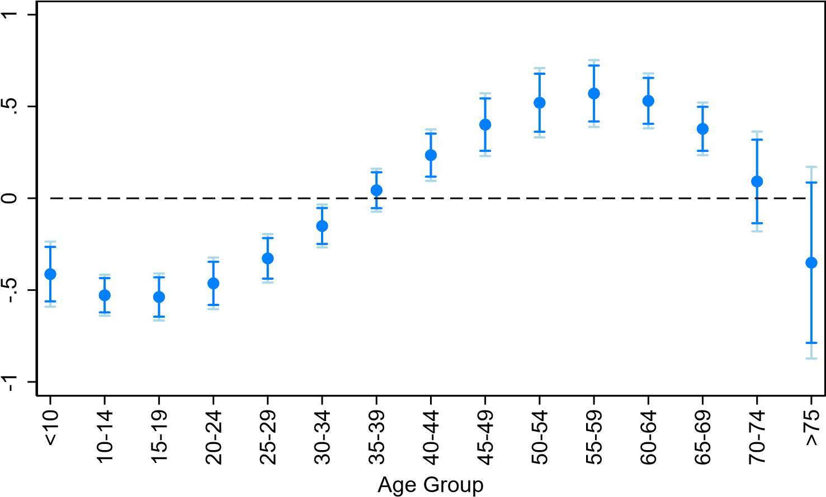
95% Confidence Intervals 90% Confidence Interval
Age Specific Coefficient Estimate
countries running a larger surplus, which is a well documented relationship in this financial flows literature. This could be due to the direct impact of trade export patterns seen in Figure 3, which remain positive up until retirement, as well as other demand effects coming from savings and wealth, which peak around retirement.
If accurate, these coefficients may represent some of the catching up of developing economies in terms of both their demographics and trade. Taking again as an example the Chinese-American trade relationship, consider the five-year demographic picture in Figure 1b and balance of trade relationship in Figure 2b. Early in the sample China, and many other developing economies had relatively large trade deficits with advanced economies, while having much smaller shares of middle-old age populations. As these economies experienced both rapid export led growth and improvements in longevity they saw increases in both these middle-age groups and their trade relationships. Though China still has fewer late-to-working age and old age individuals than the United States they, along with many other large exporters, have closed the gap rapidly.
Figure 9: Predicted Change in Trade Balance
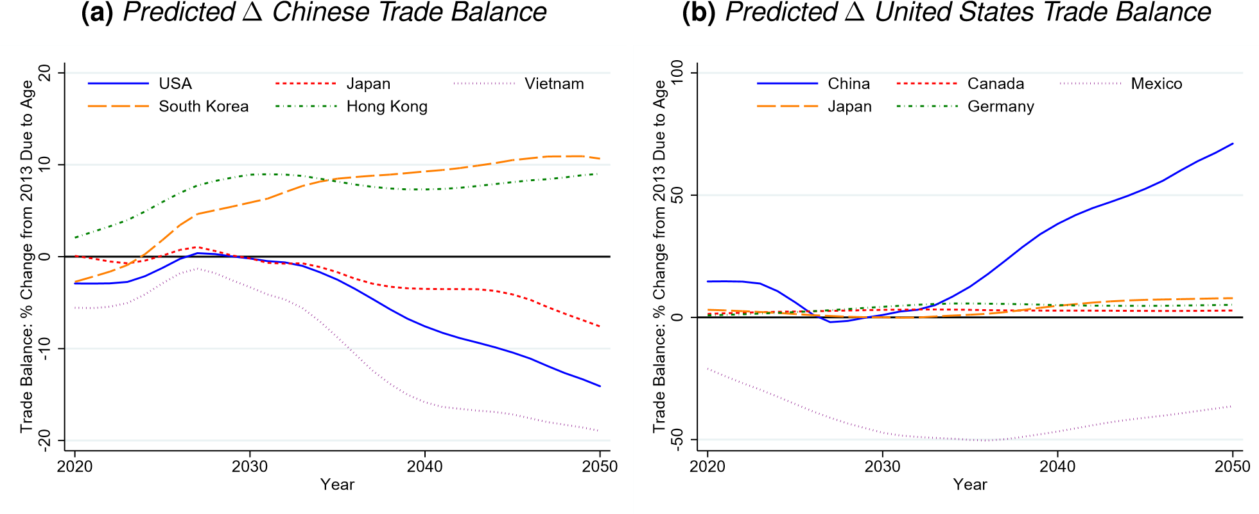
Figure 4 plots predicted change in trade balance using specification in Column 1 Table 6, holding non-demographic controls fixed. Values are reported as their change relative to final year of sample (2013). Note that since specifications are no longer identical on the RHS these are not perfect mirrors for symmetric country pairs (eg: China and US). This is because the predicted end-of-sample trade balance is no longer identical (but opposite signed) as exporter gdp is not a predictor. The US has a small (less than one) trade balance with China which makes the point estimate particularly unstable as a share of this value.

In all of my estimates I use the standard gravity variables used in Glick and Rose (2016) and easily accessible for replication on both the journal and Andrew Rose’s personal website.
Their work appeals to similarities with a well studied problem of non-existence of maximum liklihood estimates in binary choice models, which is generally referred to as separation.
For example very young African countries that have underdeveloped trade networks with very old advanced economies for reasons unrelated to age structure.

