Implementation of Virtual Reality for Neurodivergent Individuals: Perspectives of Disability Care Staff

Supplemental Material - Survey Questions

Q1 By completing and submitting the questionnaire/survey, you are indicating that you have read and understood the Participant Information Sheet and give your consent to be involved in the research. Do you want to participate in this study?
- Yes
- No

Q2 In which country do you currently reside?
▼ Afghanistan (1) ... Zimbabwe (1357)

Display This Question:
If In which country do you currently reside? = Australia
Q3 In which state do you currently reside in?
- New South Wales
- Victoria
- Queensland
- Western Australia
- South Australia
- Tasmania
- Northern Territory
- Australian Capital Territory

Q4 What gender do you identify with?
- Male
- Female
- Non-binary / third gender
- Prefer not to say

Q5 How old are you?
________________________________________________________________

Q6 Are you currently working for a disability organisation that has clients with neurodevelopmental disorders?
For example, autism spectrum disorder (ASD), intellectual disability, learning disabilities, attention deficit hyperactivity disorder (ADHD) etc.
- Yes
- No

Q7 What is your primary role at your organisation?
- Clinical care of clients
- Administrative
- Managerial
- Student
- Other (please specify) __________________________________________________

Display This Question:
If What is your primary role at your organisation? = Clinical care of clients
Q8 Please indicate your occupation (clinical)
- Psychiatrist
- Psychologist
- General Practitioner
- Nurse
- Occupational Therapist
- Developmental Educator
- Support Coordinator
- Social Worker
- Physiotherapist
- Behavioural Therapist
- Support Worker
- Allied Health Therapist
- Other (please specify) __________________________________________________

Display This Question:
If What is your primary role at your organisation? = Administrative

Q9 Please indicate your occupation (admin)
- Reception
- Organisational / operational
- Financial
- Other (please specify) __________________________________________________

Display This Question:
If What is your primary role at your organisation? = Mangerial

Q10 Please indicate your occupation (managerial)
- Regional manager
- Operations manager
- Project manager
- Executive Director
- Chief executive
- CEO
- Other (please specify) __________________________________________________

Q11 How many years of experience do you have working in disability care?
________________________________________________________________

Q12 Do you have direct contact with clients (e.g. providing therapies, support, training, any other forms of assistance to clients)?
- Yes
- No

Display This Question:
If Do you have direct contact with clients (e.g. providing therapies, support, training, any other f... = Yes

Q13 What does your direct contact primarily involve?
- Mainly individual contact
- Mainly group contact
- A combination of individual and group contact

Q14 Have you heard of Virtual Reality before?
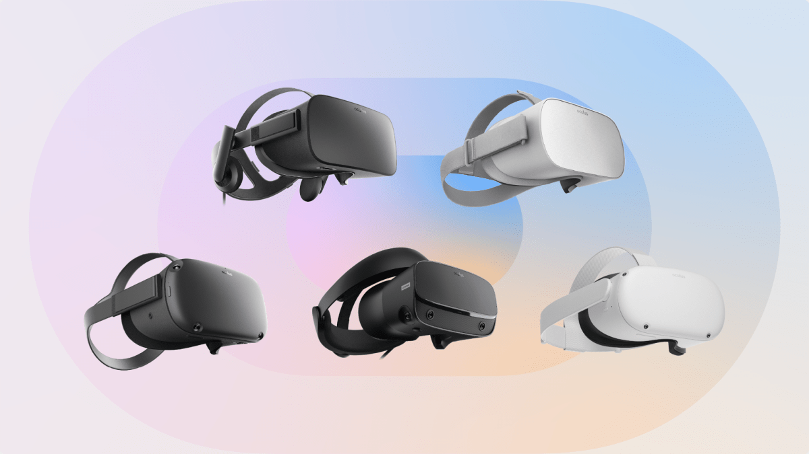
- Yes
- Maybe
- No

Q15 Have you ever used Virtual Reality before?
- Yes
- No

Display This Question:
If Have you ever used Virtual Reality before? = Yes

Q16 Where have you used Virtual Reality?
- At home, I have my own virtual reality device
- At a friend or family house- they have their own virtual reality device
- At a commercial virtual reality games outlet
- At work
- Other, please describe: __________________________________________________

Q17 Please indicate to what degree you agree with the following statements:
I consider myself to be tech savvy
- 1 - strongly disagree
- 2
- 3
- 4 - neither disagree/agree
- 5
- 6
- 7 - strongly agree

Q18 How would you rate your knowledge of Virtual Reality?
- 1 - no knowledge
- 2
- 3
- 4 - moderate knowledge
- 5
- 6
- 7 - Expert knowledge

Q19 What is your impression of Virtual reality (even if it’s not very much)?
- 1- Strongly negative
- 2
- 3
- 4 - Neutral
- 5
- 6
- 7 - Strongly positive

Q20 (optional) it would be great if you would share one or more reasons for your impression
________________________________________________________________

Q21 Have you personally used Virtual Reality technology for clients with neurodevelopmental disorders?
- Yes
- No

Display This Question:
If Have you personally used Virtual Reality technology for clients with neurodevelopmental disorders? = Yes

Q22 Can you please indicate the specific purposes or applications you have used it for (select all that apply):
- Life-skills training (i.e. cooking, driving etc)
- Communication and social skills training
- Vocational and job training
- Rehabilitation/physical therapy
- Sensory integration and stimulation
- Cognitive training
- Clinical assessment and diagnosis
- Recreation and leisure activities
- Other (please specify): ________________________

Q23 What is your impression of using Virtual Reality for clients with neurodevelopmental disorders?
- 1- Strongly negative
- 2
- 3
- 4 - Neutral
- 5
- 6
- 7 - Strongly positive

Q24 (optional) it would be great if you would share one or more reasons for your impression
________________________________________________________________

Q25 Please indicate to what degree you agree with the following statements in regard to Virtual Reality (VR) and individuals with neurodevelopment disorders:
 | Strongly disagree |  | neither disagree or agree |  | Strongly agree

 | 1 | 2 | 3 | 4 | 5 | 6 | 7

VR has the potential to benefit individuals | 
VR can offer unique experiences in comparison to other methods of care
VR can improve engagement and motivation
VR can create realistic and immersive experiences
VR can help individuals learn and practice real world skills
VR can create safe and controlled environments

Q26 Please indicate to what degree you agree with the following statements in regards to VR for individuals with neurodevelopment disorders:
 | Strongly disagree |  | neither disagree or agree |  | Strongly agree

 | 1 | 2 | 3 | 4 | 5 | 6 | 7

VR could increase feelings of loneliness
VR could be stress inducing
VR could be disorienting
VR could increase accidents or injuries
VR is too expensive
Individuals would distrust its use

Q27 Please indicate what degree you agree with the following statement:
I have concerns about adopting Virtual Reality in disability organisations for neurodevelopmental disorders
- 1 - strongly disagree
- 2
- 3
- 4 - neither agree or disagree
- 5
- 6
- 7- strongly agree

Q28 (optional) it would be great if you could share one or more reasons your concerns
________________________________________________________________

Q29 To what extent do you agree with the below concerns associated with implementing Virtual Reality in disability organisations:
 | Strongly disagree |  | neither disagree or agree |  | Strongly agree

 | 1 | 2 | 3 | 4 | 5 | 6 | 7

Lack of financial resources for VR ()
Limited time available to learn and use VR ()
Insufficient staff resources for VR implementation ()
Difficulty and complexity in using VR ()
Challenges in integrating VR with existing technology ()
Technical expertise required for effective use of VR ()

Q30 Please indicate to what you agree with the following statement:
I think it is important for Virtual Reality to be implemented into disability organisations
- 1 - Strongly disagree
- 2
- 3
- 4 - Neither agree nor disagree
- 5
- 6
- 7- Strongly agree

Q31 (optional) In your opinion, what do you think would contribute to the success of Virtual Reality in disability organisations

Q32 How important do you think the below factors are in facilitating the implementation of Virtual Reality in disability organisations?
 | Not at all important | Neutral | Extremely important

 | 1 | 2 | 3 | 4 | 5 | 6 | 7

Knowledge about what VR can do ()
Having IT support with technical issues ()
Having adequate infrastructure (e.g., space, power, connectivity) ()
VR works well with existing programs and services ()
Easy-to-use VR interfaces and controls ()
Research that shows VR is effective ()
Compatibility with client needs and preferences ()

Q33 How important is it for disability organisations to have clear guidelines and standards in place for the ethical and inclusive use of VR technology?
- 1 - Not at all important
- 2
- 3
- 4 - Neutral
- 5
- 6
- 7 - Extremely important

Q34 If you have any additional feedback, suggestions, or concerns regarding the use of Virtual Reality in disability organisations, please feel free to share them here.
________________________________________________________________

