Appendix 1

H2 Businesses that are 100% family managed are significantly less likely to implement digitizing in their business than businesses that also have non-family managers
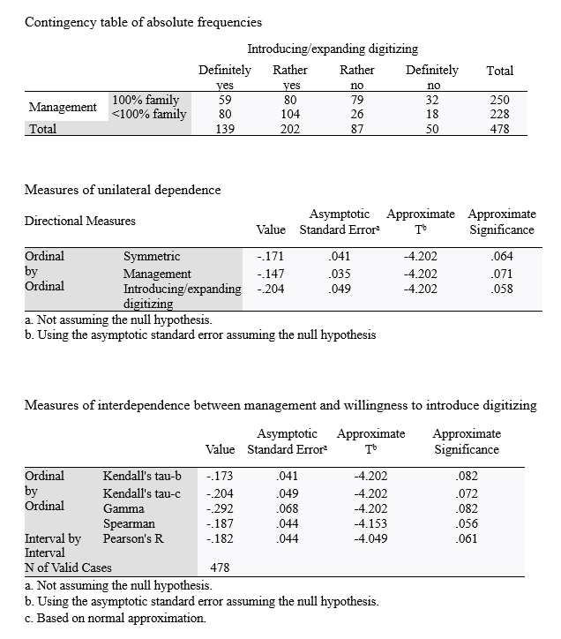

Source: Authors own creation

H3 FBs that are managed by 2nd generation have the highest interest in digital
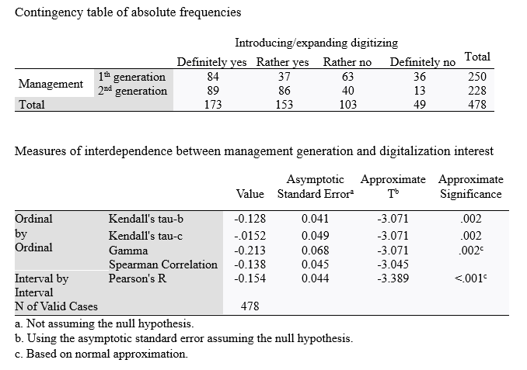
Source: Authors own creation

H4 FBs that are 1st generation owned have currently the least interest in going digital
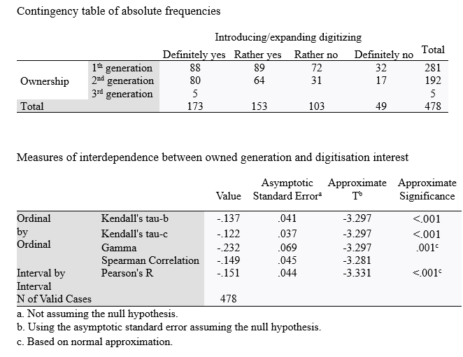
Source: Authors own creation

H5 The overall cost of digital transformation implementation is the most cited barrier for businesses with an annual turnover of up to €1m
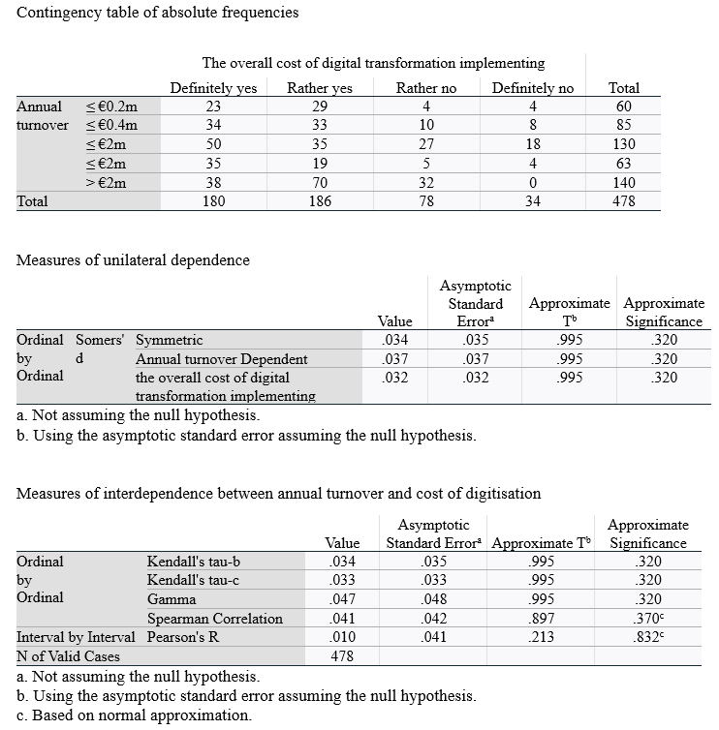
Source: Authors own creation

H6 Managers approach the introduction of digitization because they are aware of its benefits
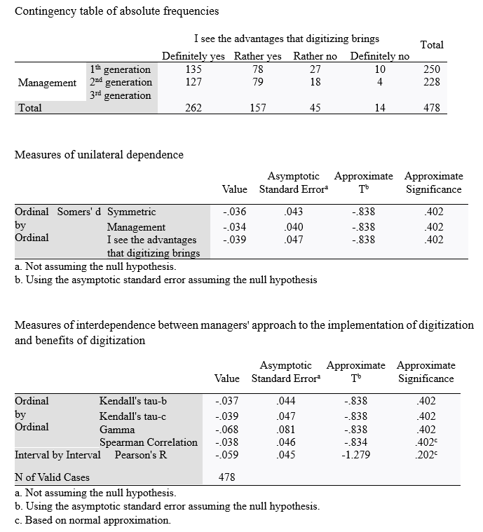
Source: Authors own creation

H7 The increse in business performance is the most expected benefit for second generation managed businesses

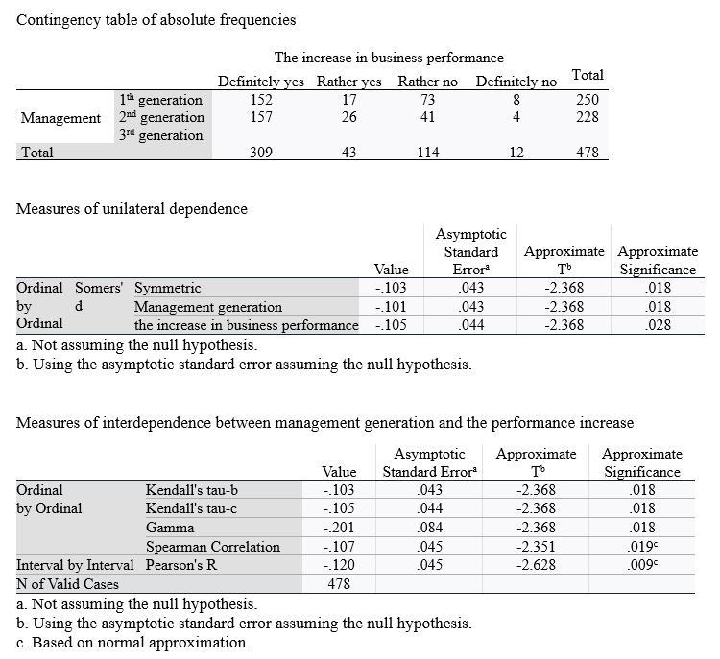
Source: Authors own creation

H8 The increse in employee satisfaction is the most expected benefit for first generation managed businesses

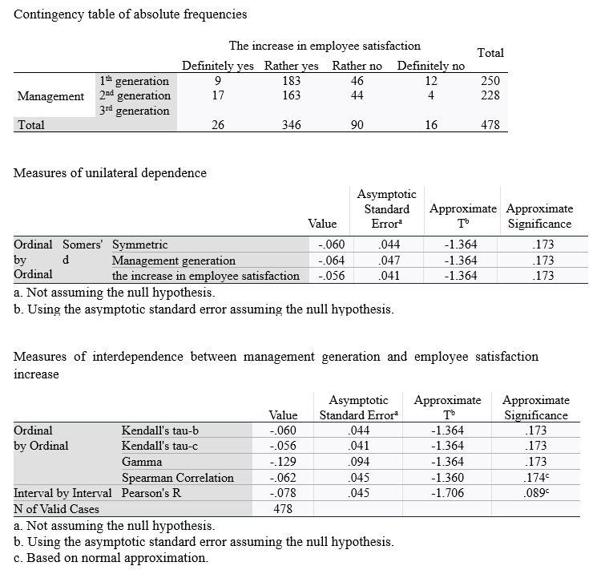

Source: Authors own creation

H9: There is no dependence between generation in management and the absence of the benefits of digitalisation outweighing its costs as a reason not to digitise

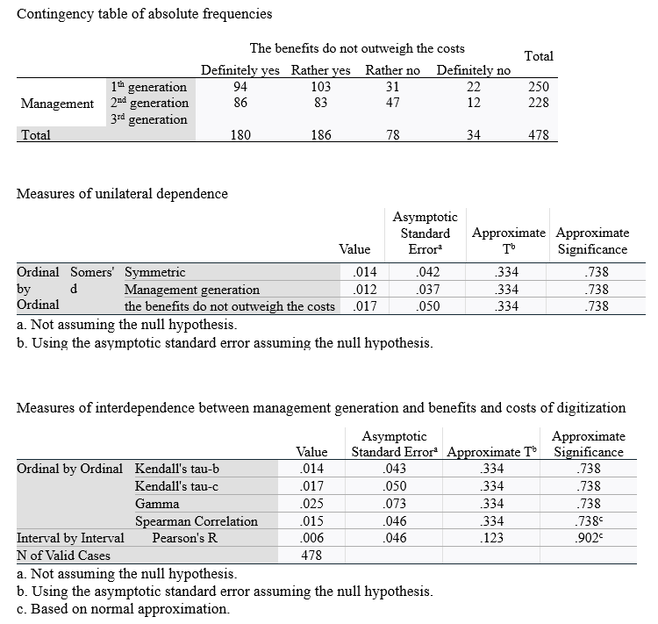
Source: Authors own creation

