Supplementary information: Detailed description of the construction of the Concourse Tunnel
Tunnelling works started at Terminal 4 on 10th May 1994 but were suspended by the end of October 1994 following the collapse of the sprayed concrete lined Concourse and Platform Tunnels at Heathrow’s Central Terminal Area (HSE, 1996), approximately 1.5 km North of the Terminal 4 station. At the time of the collapse approximately 25 m of the Downline Platform Tunnel and 65 m of the Upline Platform Tunnel at Terminal 4 had been constructed, both commencing from the North Ventilation Tunnel.
Tunnelling works at Terminal 4 resumed with Downline Platform Tunnel construction on 15th September 1995, followed by the Upline Platform Tunnel on 2nd December 1995. Construction of the Concourse Tunnel commenced in September 1996 after completion of the adjacent sections of the permanent secondary lining in the Upline and Downline Platform Tunnels. The Concourse Tunnel headwall was completed on 7th November 1996.
The construction sequence for the Concourse Tunnel used a top heading, bench, top heading, bench, double-invert sequence. The invert was closed five rounds from the face. The construction sequence is schematically illustrated in Figure 3. The advance length varied from 0.8 m to 1.2 m depending on ground conditions and design requirements, including the proximity of sensitive structures. The primary support for the Concourse Tunnel consisted of 350 mm of sprayed concrete (shotcrete), reinforced with two layers of welded wire mesh (8 mm diameter at 150 mm centres) and full-section lattice girders ‘Type 110 ROM E3’. The exposed ground was supported by a 50–100 mm shotcrete sealing layer applied immediately after each advance. The 350 mm total thickness included the sealing layer.
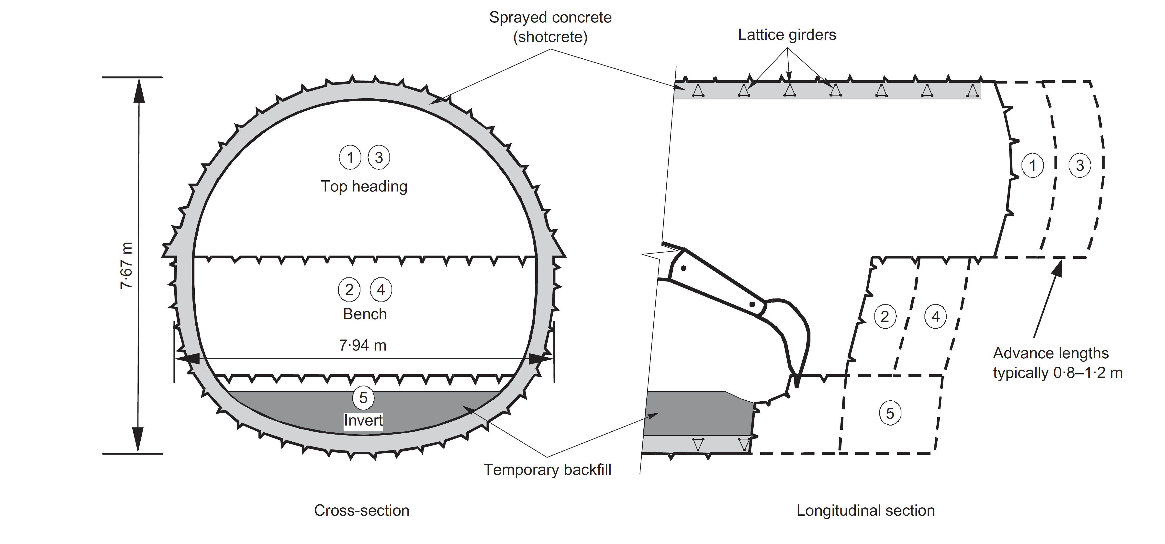
Figure 3: Concourse Tunnel construction sequence (from van der Berg et al., 2003)
The typical construction procedure was as follows. Excavation was carried out using a track-mounted excavator. With a skilled operator, the excavation could be carried out sufficiently accurately that only limited hand trimming was needed to bring the tunnel to the required shape. After the excavation had been trimmed with pneumatic clay spades, spacers comprising T-shaped pieces of mesh were driven into the London Clay. Areas where the radial pressure cells were to be placed were prepared and covered with timber (van der Berg et al., 1998). The sprayer then applied a sealing layer of shotcrete, typically between 50 mm and 100 mm thick, on all the exposed London Clay surfaces, including the face. Following the application of the sealing layer, the radial pressure cells were installed against the ground. Then the lattice girder and first layer of mesh were installed. The mesh was secured tightly to the overlapping mesh and lattice girders to avoid vibration during shotcreting. The area was cleaned using compressed air, to remove all rebound from the sealing layer. The first layer of shotcrete was then applied. The tangential pressure cells were then secured in their positions in the centre of the lining thickness with their longest dimension (200 mm) in the longitudinal tunnel direction and 100 mm dimension in the radial orientation. A second layer of shotcrete was then applied. Then the second layer of mesh was fixed and finally, a third layer of shotcrete was applied. Some excavated material was used to fill the invert of the tunnel, which served as a working platform and access when excavating the top heading and bench.
Strain gauges were welded to approximately 500 mm long 8 mm diameter reinforcement bars and the bars were then fixed to either the outer or the inner layer of mesh in the tangential orientation.
This paper will focus on the pressure cells installed in Main Monitoring Section I (MMS I) and Main Monitoring Section VIII (MMS VIII) of the Concourse Tunnel. The locations of these sections are shown in Figure 4 and in the location plan (Figure 1).
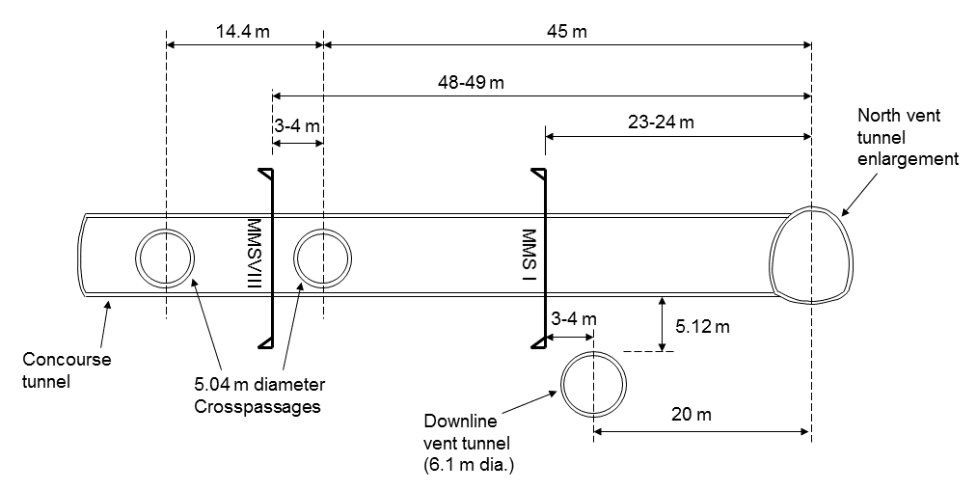
Figure 4: Long section of the Concourse Tunnel showing locations of MMS I and MMS VIII
At each section, 12 tangential pressure cells and 12 radial pressure cells were installed. The locations are shown in Figure 5. In MMS I there were no tangential pressure cells installed at positions 10 and 11, but positions 4 and 5 were equipped with two tangential pressure cells, one near the extrados and one near the intrados. In MMS VIII again no tangential pressure cells were installed at positions 10 and 11, but two were installed at positions 6 and 7 near the extrados and intrados. Where two tangential cells were installed at the same position, the ‘OUT’ one was centred 110 mm from the extrados and the ‘IN’ one was centred 230 mm from the extrados and 120 mm from the intrados. Therefore, the ‘OUT’ pressure cell had a cover of at least 60 mm, the ‘IN’ pressure cell had a cover of 70 mm to the theoretical spraying profile, and there was 20 mm between the ‘OUT’ and ‘IN’ pressure cells.
For 5 m either side of the centreline of the Downline Vent Tunnel, which encompasses MMS I, additional welded wire mesh with 7 mm bars at 100 mm spacing in the longitudinal direction and 7 mm bars at 200 mm spacing in the circumferential direction was placed at the intrados in the invert. The same type of additional mesh was placed in the crown intrados over a 22.5 m length encompassing both pairs of crosspassages, and hence including the location of MMS VIII.
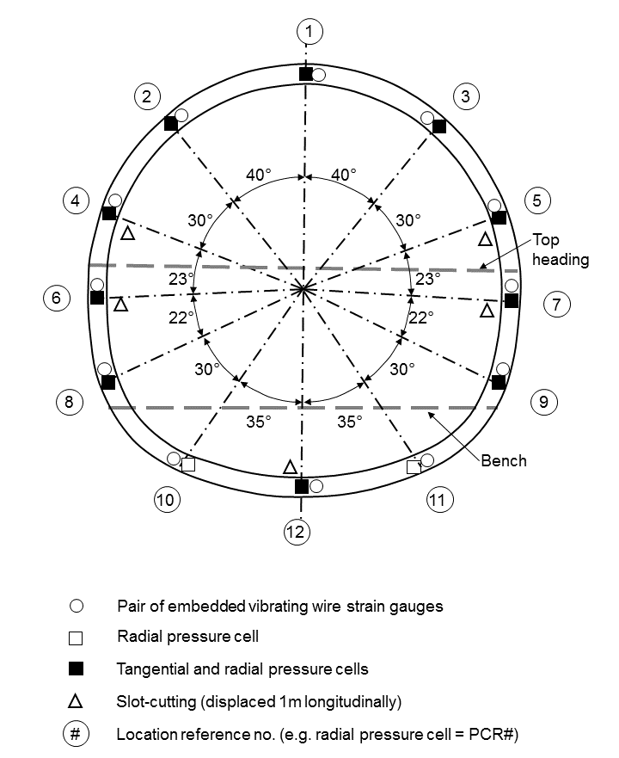
Figure 5: Main monitoring section schematically showing locations of pressure cells and strain gauges embedded in the sprayed concrete primary lining
The radial pressure cells installed in the Concourse Tunnel were Geokon model 4850-2 oil-filled vibrating wire cells, and the tangential pressure cells were Geokon model 4850-1 oil-filled vibrating wire cells. The technical specifications were given in Jones & Clayton (2021).
Table 1 lists construction events that may have affected stress measurements at MMS I and MMS VIII. The timings of excavation steps and pouring of the cast in situ secondary lining come from the construction records and the timings of spraying the primary lining are identified by a temperature rise measured in the thermistors attached to the tangential pressure cells. For the top heading and invert of MMS VIII, it is likely that the excavation was completed at least 30 minutes earlier than indicated in the construction records. Compensation grouting events were reported in Clayton et al. (2006). The timing of installation of the full round of the secondary lining is not known precisely but the construction programme indicates it would have begun approximately 6 weeks after waterproof membrane installation was complete and would have taken approximately 4 weeks to travel from the headwall to the North Vent Tunnel Enlargement. It therefore would have been completed around the middle of March 1997.
MMS I
14th October 1996 02:00 | Top heading excavated
14th October 1996 11:00 | Top heading primary lining sprayed
15th October 1996 14:00 | Bench excavated
15th October 1996 15:00 | Bench primary lining sprayed
16th October 1996 16:00 | Invert excavated
17th October 1996 03:00 | Invert primary lining sprayed
18th November 1996 | Compensation grouting
18th November 1996 11:30 | Invert secondary lining cast
29th November 1996 | Full round sheet waterproofing membrane installed
3rd December 1996 (approx.) | Underpassing of Downline Ventilation Tunnel (c.f. Figure 4)
MMS VIII
26th October 1996 12:00 | Top heading excavated
26th October 1996 12:00 | Top heading primary lining sprayed at positions 1-3
27th October 1996 05:30 | Top heading primary lining sprayed at positions 4 and 5
27th October 1996 17:00 | Bench excavated
28th October 1996 19:00 | Bench primary lining sprayed
28th October 1996 15:30 | Invert excavated and primary lining sprayed
7th – 14th November 1996 | Crosspassage construction (c.f. Figure 4)
18th November 1996 | Compensation grouting
12th December 1996 (approx.) | Invert secondary lining cast
6th January 1997 | Full round sheet waterproofing membrane installed
Table 1: Construction events that may affect stress measurements at MMS I and MMS VIII

Supplementary information: Detailed interpretation of pressure cell readings

Interpretation of tangential pressure cells
The tangential pressure cell readings were interpreted according to the procedure set out in Jones & Clayton (2021). The temperature sensitivity of the vibrating wire transducer was removed. The cell action factor was assumed to be equal to unity. The mean 28 day compressive strength of sprayed concrete cores at Heathrow Terminal 4 was 35.8 MPa. The compressive strength development was assumed to be similar in shape to the relationship of Kuwajima (1999) based on a form of equation first proposed by Byfors (1980), given in Equation 1. The equation is bilinear in log-log space with the transition occurring at compressive strength $f_{c}=10 MPa$.
$$f_{c}=\frac{a_{1}t^{b_{1}}}{1+\frac{a_{1}}{a_{2}}t^{\left(b_{1}-b_{2}\right)}}∙\frac{f_{c,28d}}{100}$$ | (Equation 1)
where $t$ is the age of the sprayed concrete in hours, $a_{1}$ is the strength ratio at 1 hour in percent (i.e. ${f_{c,1h}}/{f_{c,28d}}$), $b_{1}$ is the gradient of the first line ($f_{c}<10 MPa$), $b_{2}$ is the gradient of the second line ($f_{c}>10 MPa$), and $a_{2}$ is the remaining constant to give $f_{c}=f_{c,28d}$ at $t=672 h \left(=28 d\right)$.
Kuwajima (1999) proposed the following values in Table 1 for the constants, for an alkaline accelerator used in Edmonton, Canada. For comparison, values for unaccelerated plain concrete by Byfors (1980), and values fitted by Jones (2005) to early age core tests for Heathrow Terminal 5 using an alkali-free accelerator are given. In particular, Kuwajima’s value for the strength ratio at 1 h is much higher than for T5, because alkaline accelerators give a much higher strength at 1 h than modern alkali-free accelerators. Since the T4 concourse tunnel used alkaline accelerator, the Kuwajima values were used.
 | 𝑎 ₁ (%) | 𝑎 ₂ (%) | 𝑏₁ | 𝑏₂ | 𝑓_{cc}^{28d} (Mpa)
Byfors (1980) | 0.001-0.005 | 41.52 | 3.236 | 0.135 | various
Kuwajima (1999) | 0.300 | 29.446 | 2.676 | 0.188 | 29.022
T5 (Jones, 2005) | 0.023258 | 36.9089 | 3.23525 | 0.1531 | 62.8
Used in this study | 0.300 | 29.446 | 2.676 | 0.188 | 35.8
Table 1: Comparison of constants for Byfors' equation
The Young’s modulus $E$ was estimated from the compressive strength using the relationship proposed by Chang & Stille (1993), shown in Equation 2. The 28 day Young’s modulus $E_{28d}$ was therefore 33 GPa.
$$E=3.86f_{c}^{0.6}$$ | (Equation 2)
No laboratory tests were available for shrinkage parameters so a value of 500 microstrain was used for the final shrinkage $ε_{sh,∞}$ and shrinkage parameter $B$ was assumed to be 55 days. Shrinkage was assumed to stop after installation of the sheet waterproofing membrane, thus the maximum shrinkage strain varied between 180 and 230 microstrain, depending on location. For the invert pressure cells (PCT10-12), this occurred just prior to pouring the invert secondary lining. For the rest of the pressure cells, this occurred at the time of membrane installation. Dates were given in Table 1. There were no laboratory tests for coefficient of thermal expansion of the shotcrete, so it was assumed to be 11.8 microstrain/°C.

MMS I tangential pressure cells
At the time the secondary lining invert was cast approximately 1 month after installation, all the tangential pressure cells were still functioning. However, at the time of the underpassing of the vent tunnel, about 50 days after installation, PCT2 and PCT3 stopped functioning. The reason for this is not known. At some point between readings at 95 and 171 days, PCT4-IN stopped functioning. Then between 3.1 and 7.7 years, PCT1, PCT5-OUT and PCT6 all stopped functioning. For the most recent readings at 18.5 and 18.6 years, only PCT7, PCT8, PCT9 and PCT12 were still working.

MMS VIII tangential pressure cells
Survivability of the MMS VIII tangential cells was marginally better than for MMS I, with 6 still functioning at 18.6 years. PCT4 stopped functioning at 25 days, just after being crimped. PCT8 stopped between 46 and 71 days. PCT1, PCT3, PCT6-OUT and PCT7-OUT stopped responding at some point between 8.3 and 18.5 years. In addition, results from 4 pressure cells have been curtailed because recorded pressures decreased below zero indicating they had lost contact. This occurred for PCT2 at 38 days, PCT3 at 44 days, PCT6-IN at 46 days and PCT6-OUT at 71 days.

Supplementary information: Strain gauge details

Strain gauge installation details
The strain gauges used were Gage Technique type TES/5.5/T embedment strain gauges and have the technical specification given in Table 1, according to the manufacturer (Gage Technique Ltd., 2014).
Gauge length | 13.97 cm (5.5 inches)
Full scale measurement range | 3000 με
Linear coefficient of thermal expansion of vibrating wire | 11 με/°C
Resolution | 1 με
Accuracy (± 0.5% of full scale range) | ± 15 με
Table 1: Specification of Gage Technique type TES/5.5/T embedded strain gauges
The mounting blocks at each end of the strain gauges were welded to a 500 mm long 8 mm diameter steel reinforcement bar, which was then tied to either the inner (denoted “-INT”) or outer (denoted “-EXT”) layer of welded wire mesh. The outer strain gauges were sprayed with sprayed concrete before the inner layer of mesh and inner strain gauges were fixed and then subsequently they too were sprayed in. The theoretical positions of the strain gauges give them 40-50 mm concrete cover at the extrados and intrados of the 350 mm thick lining, meaning they are approximately 250 mm apart.
Readings from the vibrating wire strain gauges were generally reliable and stable. There were a small number of anomalous readings, which were removed from the dataset. There were also occasions when no reading could be obtained, but on a subsequent visit the strain gauge would respond.

MMS I strain gauges
SG01-EXT (the strain gauge near the extrados at position 1) stopped responding after 172 days. SG03-EXT and SG03-INT stopped responding after 95 days, SG04-EXT after 50 days, SG07-INT after 31 days, SG08-EXT after 408 days, SG08-INT after 85 days, SG10-INT after 8.4 years and SG11-INT after 172 days. SG09-INT stopped after 95 days, although one reading was obtained at 3.1 years before it fell silent again. SG05-EXT never worked from the time of installation.

MMS VIII strain gauges
SG02-EXT stopped responding after 38 days, SG09-EXT after 72 days, and SG09-INT and SG11-INT after 83 days. SG03-EXT stopped after 83 days but responded for the most recent reading at 18.6 years. SG05-INT and SG07-INT were malfunctioning from the start. SG10-EXT stopped responding after 24 days but returned after 1 year and seemed stable and reliable from then on. Survivability was relatively good, with 18 out of 24 strain gauges still functioning at 18.6 years, compared to 12 at MMS I.

Additional references to supplementary information not included in paper references
Byfors, J. (1980). Plain concrete at early ages, CBI Forskning Fo 3:80, 464pp. Stockholm: Swedish Cement and Concrete Research Institute.
Chang, Y. & Stille, H. (1993). Influence of early age properties of shotcrete on tunnel construction sequences. Proc. Shotcrete for Underground Support VI (eds. D. F. Wood and D. R. Morgan), Niagara-on-the-lake, Canada, pp.110-117. USA: ASCE.
HSE (1996). Safety of New Austrian Tunnelling Method (NATM) tunnels, Health and Safety Executive, 86pp. London: HSE Books, HMSO.
Jones, B. D. (2005). Ageing shells. Internal report, Mott MacDonald.
Kuwajima, F. M. (1999). Early age properties of the shotcrete. Proc. Shotcrete for Underground Support VIII (eds. T. B. Celestino and H. W. Parker), São Paulo, Brazil. Reston, Virginia, USA: ASCE.
van der Berg, J. P., Clayton, C. R. I., Powell, D. B. & Savill, M. (1998). Monitoring of the Concourse Tunnel at Heathrow Express Terminal 4 station constructed using the NATM. Tunnels and Metropolises, Proc. World Tunnel Congress (eds. A. Negro Jr. and A. A. Ferreira), São Paulo, Brazil, pp.1163-1168. Rotterdam: Balkema.

