SUPPLEMENTARY INFORMATION
for
A 190-m-long flume for investigation of debris flow impacts on multiple flexible barriers
Ng, C.W.W.,¹ Poudyal, S.,^{1*} Cui, P.,² Liu, H.,³ Li, Z.,¹ Zheng, M.,¹ Jia, Z.,¹ Bhatta, A.,^{1,4} De Silva, W.A.R.K.,¹ Zhou, G.G.D,² Petrini, C.,⁵ Denk, M.⁵ & Song, D.^{2,6}
¹ The Hong Kong University of Science and Technology
² Institute of Mountain Hazards and Environment, Chinese Academy of Sciences
³ University of Sheffield
⁴Department of Electricity Development, Ministry of Electricity, Water Resources and Irrigation, Government of Nepal
⁵ Geobrugg AG
⁶Joint Laboratory of Mountain Hazard Prevention and Mitigation, Institute of Mountain Hazards and Environment, Chinese Academy of Sciences

Description of additional supplementary files
- Supplementary information.docx (THIS FILE)
  - Supplementary note 1: Location of the newly built flume, layout of installed sensors and instrumentation
  - Supplementary note 2: Particle size distribution (PSD) analysis of debris material and its preparation
  - Supplementary note 3: Designs of multiple flexible barriers tested in the 190-m-long flume
  - Supplementary note 3: Videos of debris flow – flexible barrier interaction
  - Supplementary note 4: Detailed kinematics of debris flow impact on 1st, 2nd, 3rd and 4th flexible barriers
  - Supplementary note 5: Detailed kinematics of debris flow impact on 1st, 2nd, 3rd and 4th flexible barriers
  - Supplementary note 6: Flow height time-histories of all laser sensors at each barrier location
  - Supplementary note 7: Method used in deducing flow velocity from different video footage
  - Supplementary references
- Supplementary video V1-UAV.mp4
  - UAV video of overall impact kinematics at first barrier
- Supplementary video V2-FB1.mp4
  - DJI action camera video of impact kinematics at the first barrier
- Ng_et_al_190_m_flume_test_data.xlsx
  - Microsoft Excel spreadsheet file of test data for figures reported in the paper
  - Each sheet is named with respective Figure number
The dataset used in the study is published in an online repository DataSpace@HKUST. The dataset can be accessed using the below DOI and cited as follows:
Ng, C. W. W., Poudyal, S., Cui, P., Liu, H., Li, Z., Zheng, M., Jia, Z., Bhatta, A., De Silva, W. A. R. K., Zhou, G. G. D., Petrini, C., Denk, M., & Song, D. (2025). A 190-m-long flume for investigation of debris flow impacts on multiple flexible barriers. DataSpace@HKUST. https://doi.org/10.14711/ dataset/WMVMNZ

Supplementary note 1: Location of the newly built flume, layout of installed sensors and instrumentation
Fig. S1a shows the location of the newly established 190-m-long flume facility in Dongchuan, Yunnan Province, China at 26°14’47” N and 103°08’06” E, at an elevation of approximately 1500 m. Fig. S1b shows the location of the flume facility marked on the map along the northeastern part of Yunnan province. Fig. S1c shows the topographic map around the newly built flume facility and the Dongchuan Debris Flow Observation and Research Station (DDFORS) adjacent to the Jiangjia ravine and Dazi Gully. Fig. S1d depicts a Google Earth image with annotations showing the locations of the DDFORS station, 190-m-long flume, and the current extents of the Jiangjia ravine.
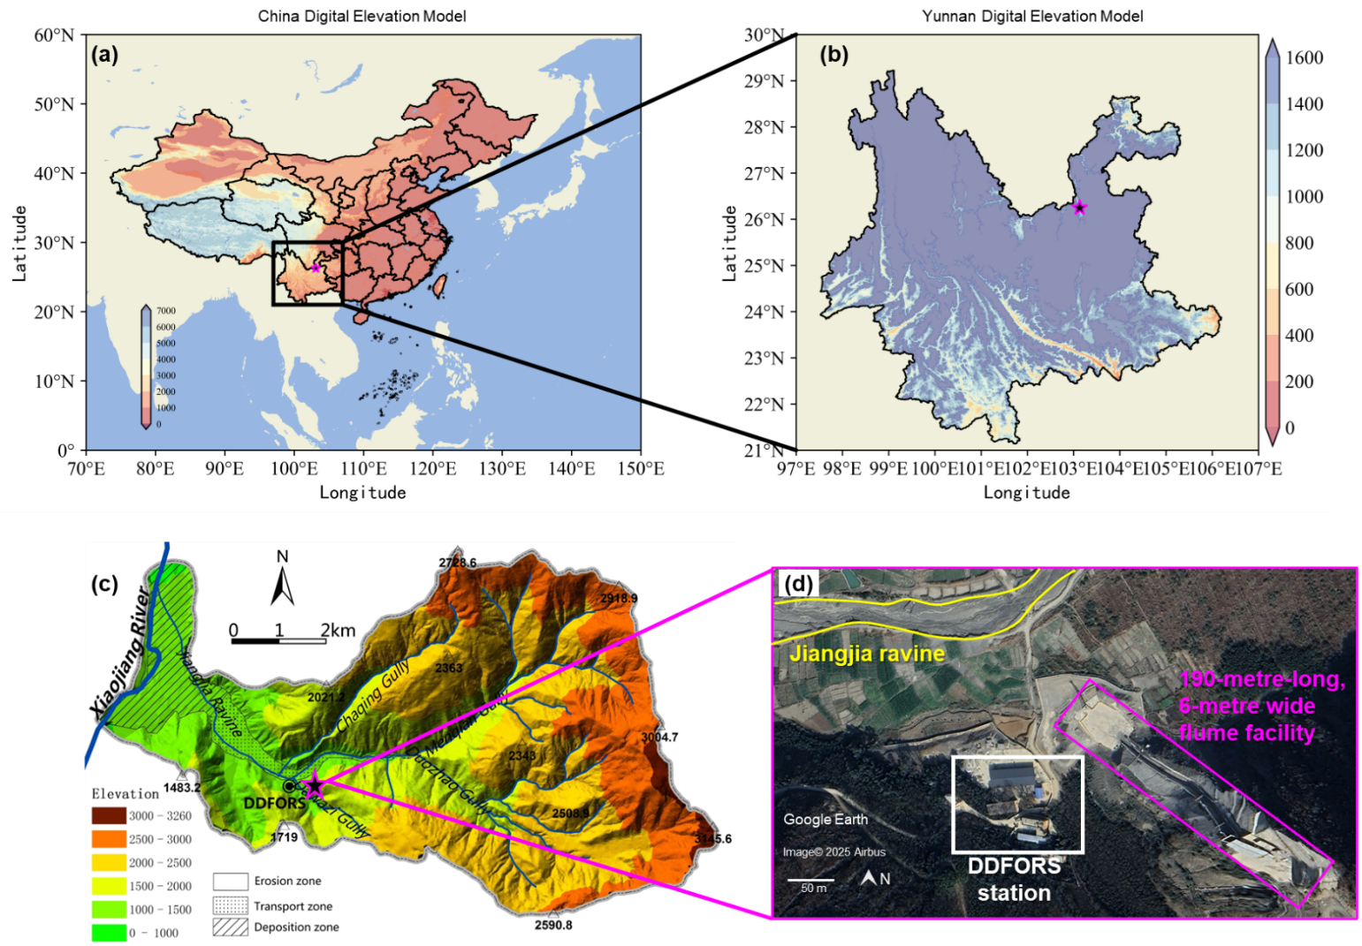
Fig. S1 Location map of the newly established 190-metre-long flume facility (pink star) (a) in Mainland China, (b) Yunnan province, (c) adjacent to the DDFORS station and Jiangjia ravine, and (d) satellite image of the flume (pink rectangle)
Fig. S2 shows an aerial view of the flume, illustrating the layout of the instrumentation installed along the transportation zone. Five types of instruments are used to monitor the tests—basal instrumentation cells, laser sensors, high-speed cameras, DJI action cameras, uncrewed aerial vehicles (UAVs), and LIDAR sensors. Each of these sensors are strategically positioned (as labelled in the figure) to measure debris flow parameters.
Basal instrumentation cells (C1 to C7) are embedded in the flume bed at specific locations to record basal normal stress, shear stress, and pore pressure of the debris flow. Laser sensors (L1 to L12, and IMHE1 to 3), mounted on towers (TOWER 1, 2, and 3) and on the flume side walls, measure flow height as debris move downstream. High-speed cameras on towers capture footage to deduce debris flow velocity and overflowing debris landing distance. Additionally, DJI action cameras and UAVs offer multiple perspectives on flow-barrier interaction. The dynamic light detection and ranging (LIDAR) sensor on Tower 3 captures 3D point cloud data during flow-barrier interaction. After the test, the LIDAR sensor is relocated to Towers 1 and 2 to capture the 3D point cloud of the deformed flexible barrier and debris deposition. Flexible barriers are equipped with load cells on the supporting cables to measure impact forces during flow-barrier interaction. Sensor data is recorded at a sampling frequency of 1000 Hz. The raw sensor data are filtered using a low-pass 2nd order Butterworth filter with 50 Hz critical frequency and second-order sections output.
Fig. S3a shows the second monitoring tower (Tower 2) located above the second flexible barrier. Fig. S3b shows a detailed view of the monitoring tower (looking downstream) with three laser sensors and cameras installed across the width of the tower platform. In Tower 2, laser sensors L6 (left), IMHE2 (middle) and L7 (right) are installed respectively over the left, middle and right basal instrumentation cells at C4 location. The laser sensors are oriented to measure the flow height perpendicular to the flume bed. Three different types of cameras are installed on Tower 2 to capture the kinematics of debris flow and debris flow–barrier interaction during impact. First, the high-speed cameras HSC3 and HSC4 are installed to respectively look upstream and downstream, to capture flow–barrier interaction with a resolution of 4200 x 2160 pixels at 240 frames per second. Second, the DJI5 camera is installed to look upstream towards the first barrier (1920 x 1080 pixels; 60 frames per second) as a redundant measure to capture the debris flow-barrier interaction and the velocity of debris flow as it arrives at the second barrier. Third, the CCTV2 camera is installed to look at the debris flow perpendicular to the bed (1920 x 1080 pixels; 30 frames per second) as it approaches the cell C4.
Fig. S4a illustrates the details of a basal instrumentation cell installed in the 190-metre-long flume, featuring a basal triaxial load cell mounted on a stainless-steel box frame in the flume bed. The sensing area measures 700 mm x 700 mm, with the load cell oriented such that the X-axis spans the flume width, the Y-axis aligns with the flow direction, and the Z-axis is perpendicular to the bed. The load cell's rated capacity is 40 kN along the X- and Y- axes, and 60 kN along the Z- axis. Fig. S4b shows the basal cell's top sensing plate installed on the triaxial load cell, alongside two pressure transducers measuring basal pore water pressure: PPT1 upstream and PPT2 downstream. A 1-mm mesh is used to prevent solid particles from percolating into the chamber housing the PPTs.
Fig. S4c depicts the pressure plate installed in the flume before the first barrier FB1 and the measured impact pressure of debris flow. The pressure plate is located 3 m upstream from FB1, in the middle of the flume. Fig. S4d shows the 20 mm thick stainless-steel sensing plate measuring 150 mm by 150 mm, fastened to a low-profile axial load cell and mounted on a steel bracket anchored to the flume bed. The plate is oriented perpendicular to the flume bed to measure frontal impact pressure of debris flow.
Table S1 provides a tabulated summary of the sensors and instrumentation utilised in the 190-metre-long flume, their measurement range, recording frequency, accuracy and usage.

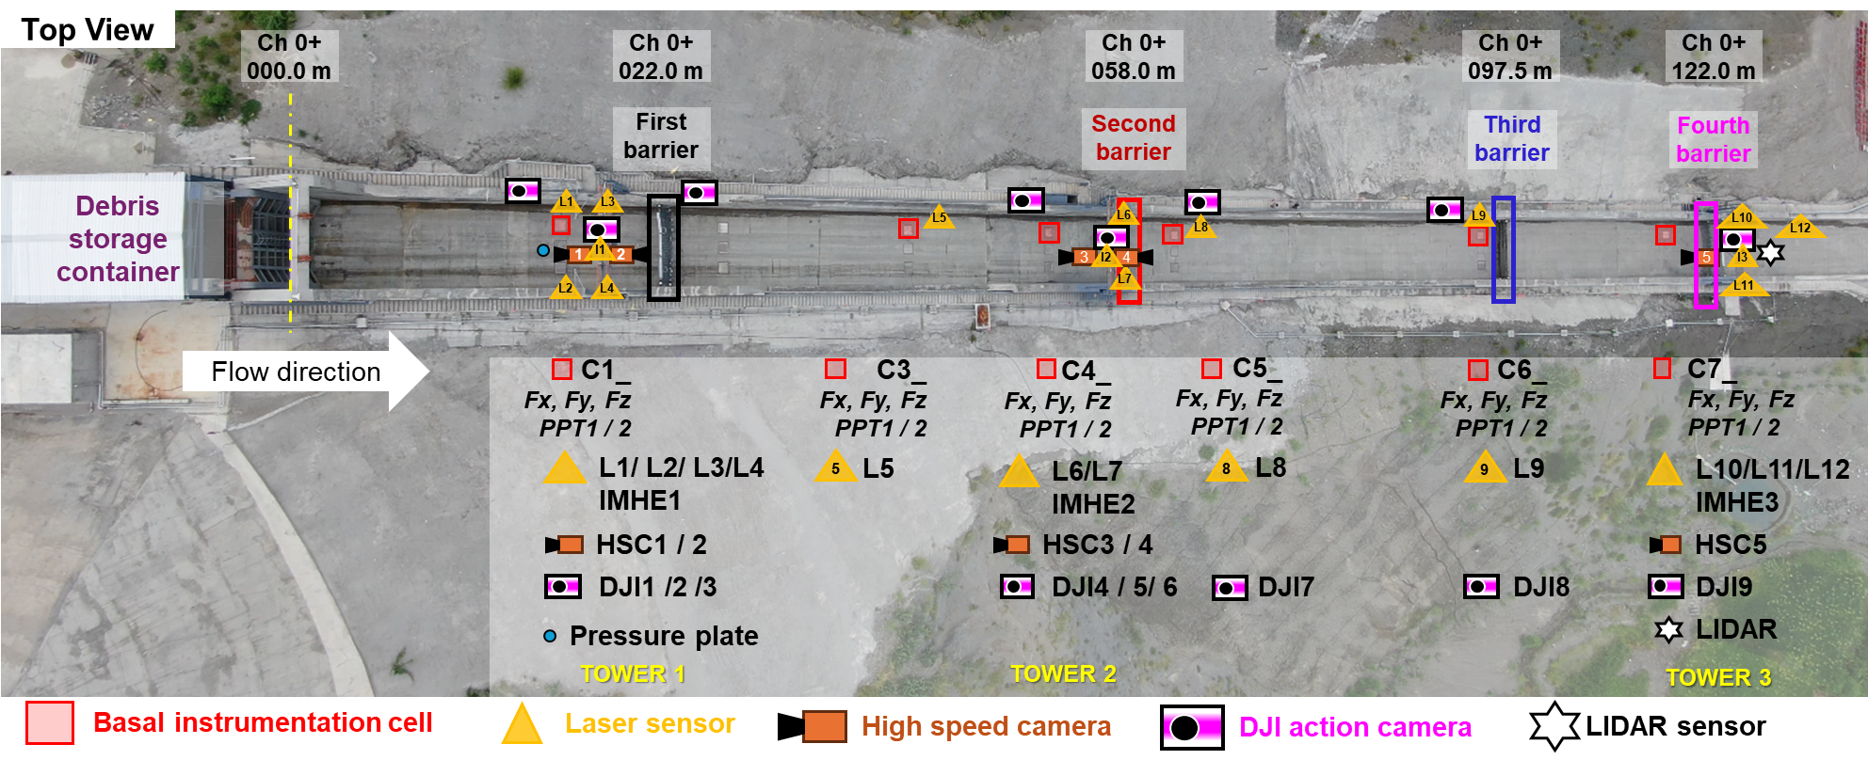
Fig. S2 Aerial view of the 190-metre-long flume with the layout of instrumentation and sensors at different locations

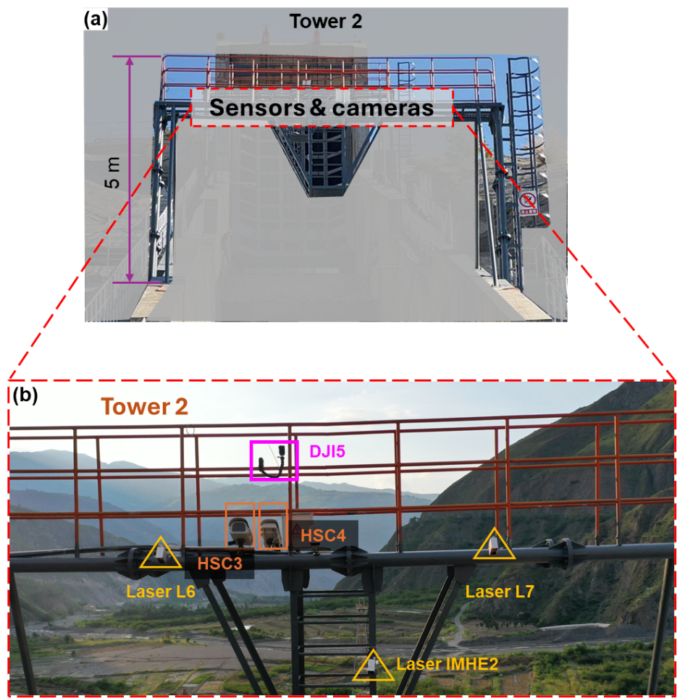
Fig. S3 (a) Tower 2 located above flexible barrier in the flume and (b) close up of Tower 2 showing the layout of multiple cameras and sensors

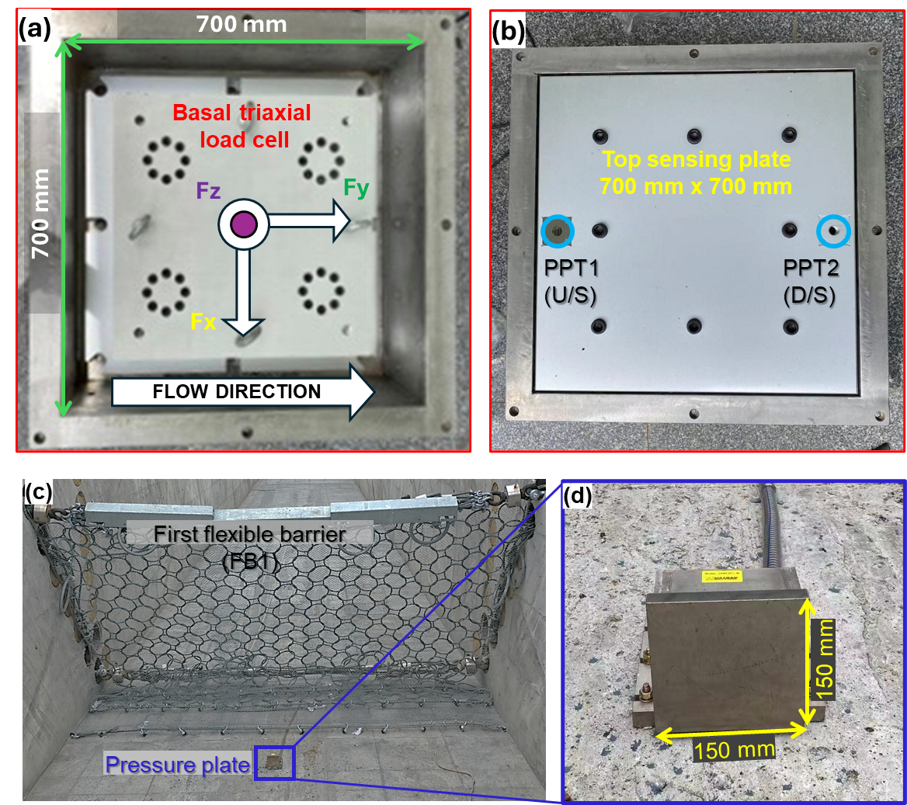
Fig. S4 Layout of sensors for measuring basal pressures (a) triaxial load cell, (b) pore pressure transducers (PPTs) and impact pressure (c) pressure plate apparatus installed immediately in front of barrier FB1, and (d) closeup view of the pressure plate apparatus

Table S1 Sensors and instruments used in the 190-metre-long flume
Sensors/ Instrumentation | Model | Measuring range | Recording frequency | Accuracy | Usage
Laser sensor | SICK DT50 | <30.0 m | 1.0 kHz | $$±0.10\%$$ | Measure flow depth
Cable load cell | HUATRAN LP278t | <500 kN | 1.0 kHz | $$±0.10\%$$ | Measure impact force of debris flow
Basal instrumentation cell | Triaxial load cell  (HUATRAN PW500)  Pressure transducer (Keller 25PAy) | Fz <60 kN,  Fx, Fy <40 kN  < 2 bar | 1.0 kHz  1.0 kHz | $$±0.05\%$$  $$±0.01\%$$ | Measure basal normal and shear stress of debris flow  Measure basal pore fluid pressure of debris flow
High speed camera | NORPIX HB4000 colour | – | 240 fps @ (4096 x 2160) pixels | – | Capture flow barrier interactions kinematics (flow depth/ velocity)
Action camera | DJI Action 4 | – | 60 fps & 120 fps @ (1980 x 1080) pixels | – | Capture flow barrier interactions kinematics (flow velocity/ barrier deformation)
CCTV camera | HIKVision | - | 30 fps @ (1980 x 1080 pixels) |  | Capture debris flow velocity
Uncrewed aerial vehicles (UAV) | DJI Phantom 3Pro  DJI Mavic2 Pro/ Zoom | – | 30 – 60 fps @ (1980 x 1080) pixels  30 – 120 fps @ (2560 x 1440) pixels | – | Capture flow barrier interactions kinematics (flow velocity/ barrier deformation/ Structure-from-motion 3D model)
LIDAR | HESAI AT128 | 0.5 m to 250 m  Horizontal FOV: 120°  Vertical FOV: 25.4° | 0.2° – 0.42° @ 20 Hz | $±5 cm$ @ 250 m | Capture the flow barrier interactions/ Retention volume after the test

Supplementary note 2: Particle size distribution (PSD) analysis of debris material and its preparation
Debris material in this study is excavated from the Jiangjia ravine and sieved through a 200 mm mesh to remove larger boulders. The maximum particle size of 200 mm is adopted to prevent any collision induced damage to the flume bed and the basal instrumentation cells. A total of 72 m³ of sieved debris material (solid fraction) is hauled to the storage container in trucks, and end-dumped into the storage container located at the top of the flume (see Fig 2a). A representative sample of test material is then collected from the storage container for particle size distribution (PSD) analysis.
Fig. S5 shows the PSD curve of the debris material in used in this study. The results show an average coefficient of uniformity $C_{u}$ of 55.4 ($C_{u}>4.0$) and a coefficient of curvature $C_{c}$ of 1.1 ($1.0≤C_{c}≤3.0$). Over 15% of the material is sand, with a characteristic grain size (D₅₀) of 20 mm. This material is coarser than that previously reported by Cui et al. (2005) and Hu et al. (2011), where the D_{max} cutoff was at 100 mm. The PSD curve of the debris material in this study shifts towards the right with a D_{max} of 200 mm, and a lower proportion of fines. It must be acknowledged that using finer materials would enable excess pore water pressure to sustain for a longer period along the increased drainage path in a large-scale flume (Iverson, 2015). While pertinent for exploring the dynamics of debris flow propagation and runout, this finer material would readily filter out through the flexible barrier mesh (25 mm opening). Since the multiple barrier tests in this study is designed to induce retention and overflow at barriers with limited flow volume, using predominantly finer materials that can discharge through the mesh would defeat the intended purpose. For comparison, debris material used by Ng et al. (2020a) in the 28-metre-long flume in Hong Kong is significantly finer, not only with a maximum particle size of 25 mm but also fines due to the 2.5% Kaolin clay used in the designed mixture.
An image in the inset shows the preparation of debris material in the storage container at the top of the flume. Then, workers shovel this material behind the gate, forming a triangular wedge. This manual preparation of debris material in smaller lifts essentially minimizes size segregation otherwise expected in end-dumped material. Thereafter, the required water volume (fluid fraction) is pumped from an adjacent water tank into the container, saturating the debris material without mechanically mixing the solid and fluid components.
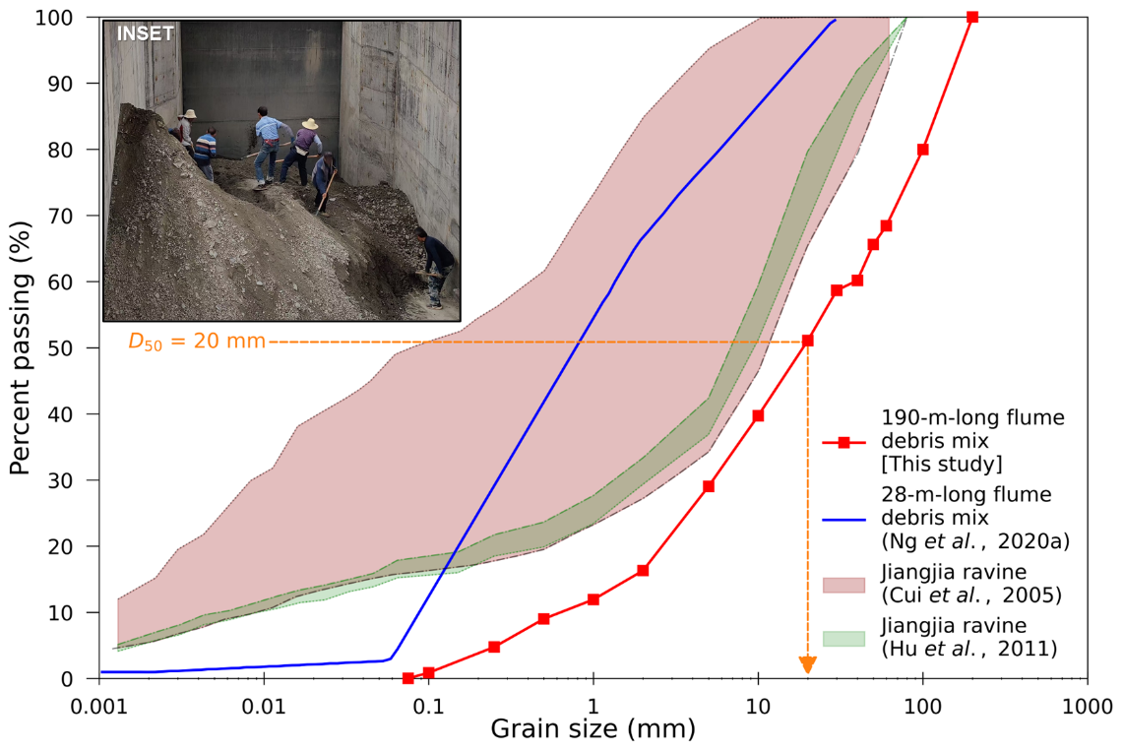
Fig. S5 Particle size distribution of debris material used in this study. INSET: preparation of sieved debris material in the storage container

Supplementary note 3: Designs of multiple flexible barriers tested in the 190-m-long flume
Fig. S6a shows the schematic of the Geobrugg VX type flexible barrier adapted to the site conditions. This barrier is constructed from ROCCO 16/3/300 steel ring nets with a width of 6.0 metres and a height of 3.0 metres. Each steel ring, measuring 300 mm in diameter, is composed of 16 windings of 3 mm diameter high-yield strength steel wire. The ring net panel is supported by horizontal top and bottom supporting cables—each made of four 22 mm GEOBINEX steel ropes (shown in blue and labelled W1 and W2). These horizontal supporting cables are connected to tension load cells at each end and anchored to the side walls of the flume. Each 22 mm rope is equipped with two brake elements at either end, totalling eight brake elements in both the top and bottom cables, respectively. Abrasion protection elements shield the top supporting cables from overflowing debris. Lateral cables (shown in green and labelled K1 and K2), made of two 22 mm GEOBINEX steel ropes, restrain the nets on the side walls, each equipped with two brake elements. A total of sixteen brake elements are used in the modified Geobrugg VX type barrier. The ring net panel includes a 1.5 m surplus height, folded upstream and anchored to the flume bed by a 22 mm steel rope to reduce debris passage through the basal clearance. This anchoring with a rope allows the folded ring net panel to freely slide and deform with the barrier during impact while preventing vertical uplift. As such, uplift load transfer on these anchors will have minimal effect on the measured barrier cable forces. A 25 mm chain link secondary mesh overlays the ring net barrier to trap coarse debris while permitting the discharge of muddy water and fines.
Fig. S6b depicts the schematic of the third barrier (FB3), a newly developed Kevlar flexible barrier at HKUST. This barrier measures 6 metres in width and 2 metres in height. Unlike the steel ring net panel of the modified Geobrugg VX barrier, the Kevlar barrier (see Fig. 2a INSET 2) is built with a primary mesh made of sewn Kevlar webbings with 50 mm openings. Kevlar offers a strength-to-weight ratio five times higher than steel (Ashby & Cebon, 1993), making this barrier lighter than the ring net panels of similar size. The Kevlar barrier is supported by three levels of horizontal supporting cables — top, middle, and bottom — each consisting of two 22 mm independent wire rope core (IWRC) steel ropes. These cables connect to the tension load cells installed on the side wall anchors, similarly to the modified Geobrugg VX barriers. The lateral cable, made of a single 22 mm IWRC steel rope, restrains the Kevlar barrier mesh at the side walls. Due to its higher deformability and strength, the Kevlar barrier is not equipped with brake elements.
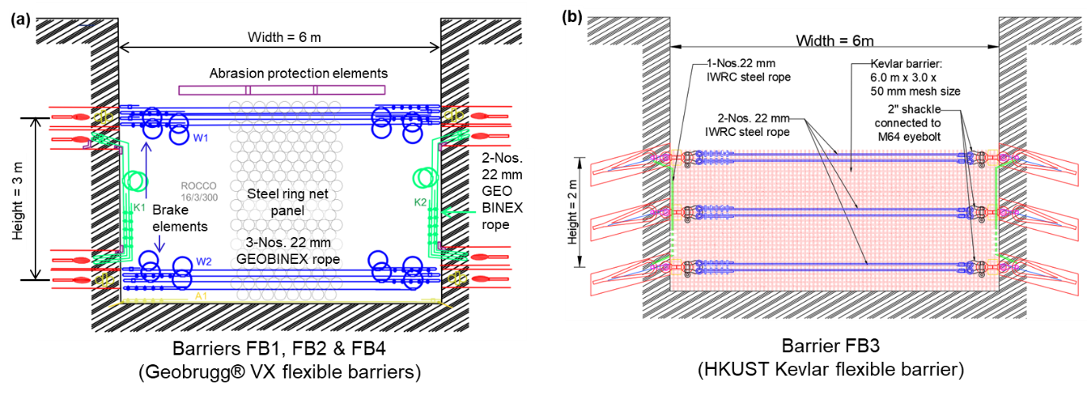
Fig. S6 Schematic front elevation drawings showing the designs of (a) Geobrugg VX flexible barrier (b) HKUST Kevlar flexible barrier

Supplementary note 4: Videos of debris flow – flexible barrier interaction
The top view of the overall test captured by an uncrewed aerial vehicle (UAV) is shown in Supplementary video V1. The detailed impact kinematics at the first barrier (FB1) captured by DJI action camera mounted on the flume side wall and looking downstream at the barrier is shown in Supplementary video V2-FB1. In each of the above-mentioned videos, timestamps are annotated for reference. The time t = 0 s corresponds to the start of gate opening and recording of sensor measurements by the data logger. For manageable file sizes, the videos are trimmed and provided at a resolution of 1980 x 1080p and 30 frames per second.

Supplementary note 5: Detailed kinematics of debris flow impact on 1st, 2nd, 3rd and 4th flexible barriers
Fig. S7 illustrates key instances of debris flow impact at the first barrier (FB1), captured by action camera DJI1 (see Supplementary video V2-FB1.mp4). The timestamps align with those in Fig. 2, providing a focused view of FB1. At t = 37 s (Fig. S7a), the debris flow front reaches FB1, marked by a white dashed line indicating the flow front with saltating particles. Large particles (>100 mm) are visible in the lower left part of the image, while muddy discharge passes through the barrier base without deformation. By t = 40 s (Fig. S7b), frontal impact deforms the barrier FB1, which is evident in the curvature of the top supporting cables and rotation of abrasion protection elements. Figure 6b shows an outward bulge of the barrier FB1 at this instant. The debris flow head can be seen predominantly on the left side, while the flow body spans the entire width of the flume. Farther downstream, muddy water reaches the second barrier (FB2). At t = 46 s (Fig. S7c), FB1 is impacted across its width, with debris running up and rolling back. Mud stains on the right wall indicate maximum flow height. The top supporting cables’ deformation is pronounced, contrasting with the pre-impact state. The debris flow is water-rich compared to the granular body observed earlier (Fig. S7b). Downstream, a muddy spray can be seen when debris impacts FB2. At t = 49 s (Fig. S7d), debris reaches maximum run-up height at FB1, with turbulent mixing at the barrier. Granular debris surges towards FB2. By t = 59 s (Fig. S7e), FB1 is filled with debris, which turbulently overflows downstream (Fig. 2e). The debris deposition zone extends 4.5 m upstream from FB1, marked by a mudline on the right wall. Debris reaches the third barrier (FB3). At t = 166 s (Fig. S7f), debris is depleted from the storage tank, ceasing the incoming flow. The impact process ends, with granular debris visible behind FB1 as water drains through the mesh. Downstream, small debris wedges are deposited behind FB2, FB3, and FB4.
Fig. S8 shows the kinematics of debris flow impact against the 2nd barrier (FB2). At t = 40 s (Fig. S8a), muddy water reaches the barrier along the left side. By t = 43 s (Fig. S8b), muddy water is uniformly spread across the flume width as it reaches FB2. Muddy water can be seen farther downstream from FB2 as it filters past the mesh without impedance. Since most of the debris flow is retained by the 1st barrier (FB1), granular debris material is observed in the video frame only at t = 55 s (Fig. S8c) after overflow from FB1 lands on the flume and flows downslope. The surge of granular debris is along the right half of the flume. Debris flow splashes are seen at FB2 as muddy water hits the horizontal cables constraining the ring net to the flume bed. At this instance, the muddy water reaches the third barrier FB3 and is uniform across the flume width. At t = 70 s (Fig. S8d), violent spray of muddy water is seen at FB2 with a small wedge of debris material at the base. A similar spray of debris can be seen at FB3 as well. The mud stains on the right-side wall of the flume, immediately next to the barrier, shows the trajectory of debris run up. Further upstream, the mud stains mark the turbulence of landed debris flow, which tends to reach a height of around 400 mm after splashing on the bed. As the overflow ceases at FB1 by t = 120 s (Fig. S8e), a wedge-shaped deposit can be seen at the base of FB2. Farther downstream, debris material passing FB2 and flowing towards FB3 can be seen along with the deposition behind FB3. By t = 180 s (Fig. S8f), debris deposit behind FB2 has started to dewater, revealing the granular debris material. This essentially signals the end of impact at FB2. The kinematics shows that debris material at FB2 predominantly contained muddy water and fines with limited solid fraction, which readily discharged past the barrier with limited resistance. The secondary mesh overlaid on FB2 measures 25 mm opening, which is larger than the median particle size (i.e., see Fig. S5; D₅₀ = 20 mm) of the debris solid fraction used in this study. As such, mechanical trapping was inefficient, resulting in limited retention. Deformation of barrier FB2 is not apparent from this captured kinematics.
Similarly to FB2, Fig. S9 shows the observed impact kinematics at FB3. Unlike FB1, FB2 and FB4 measuring 3 m high, FB3 only measures 2 m high (see Fig. S6b). Furthermore, FB3 is supported on three horizontal supporting cables, made of Kevlar webbings and overlain by 25 mm opening secondary mesh. Fig. S9a shows that the flow front of muddy water reaches FB3 along the left half of the flume at t = 49 s. At t = 59 s (Fig. S9b), a surge of granular debris flow is seen approaching FB3 along the right half of the flume. Muddy water and a prior surge is seen impacting the barrier with splashes of debris along the entire width of the barrier. A thin layer of watery flow can be seen farther downstream of FB2, approaching the fourth barrier FB4. At t = 80 s (Fig. S9c), a turbulent wedge of debris flow material is seen behind FB3, reaching up to the height of the middle supporting cables (i.e., 1.0 m height). Incoming debris flow is uniform across the flume with highly turbulent surface. Farther downstream at FB4, a splash of muddy debris can be seen. Between FB3 and FB4, granular debris material can be seen across the flume width. At t = 100 s (Fig. S9d), an enlarge wedge of debris material is seen behind FB3, with a calmer free surface. Small turbulent hydraulic jump can be seen at the interface of the deposited material and the incoming debris. Mud stains on the right-side wall of the flume between t = 80 s and t = 100 s clearly show the enlargement of the debris wedge along with the runup and spray past the barrier mesh. The free surface of the deposit height is at level of the middle supporting cable. A pronounced sag of the top supporting cable is also seen due to barrier deformation. Downstream at FB4, a small wedge of debris material can be seen with muddy water flowing towards the barrier. At t = 140 s (Fig. S9e), only the muddy water discharging past FB2 arrives at FB3. Furthermore, discharge of muddy water through FB3 reduces the deposit height. Similarly, drainage at the small wedge of debris behind FB4 is apparent with a darker edge of granular material visible at the right free surface of deposit. The mud stains on the right-side wall of the flume show the flow depth reaching FB3 before mixing with the deposit. Laser sensor L9 measured a flow depth reaching 80 mm before the enlarged deposit was captured. By t = 190 s (Fig. S9f), the impact process at FB3 is complete with the coloured balls collected at the middle of the deposit free surface. On the left side, free surface of debris material is visible as muddy water drains away.
Fig. S10 illustrates the kinematics captured at FB4 with debris flow front arriving at t = 67 s (Fig. S10a), impact continuing through t = 80 s (Fig. S10b) with violent splash of muddy water as debris discharges through the mesh. Deposited wedge of debris material with free surface of muddy water is seen at t = 120 s (Fig. S10c). The muddy water continues to drain, revealing the free surface of granular material as well as the ring net and secondary mesh anchored to the flume from t = 160 s onwards (Fig. S10d). As incoming flow ceases the coloured balls are revealed on the deposit surface at t = 180 s (Fig. S10e). By t = 200 s (Fig. S10f), the impact process at FB4 has ended. Similarly to FB2, barrier deformation is not apparent in FB4.

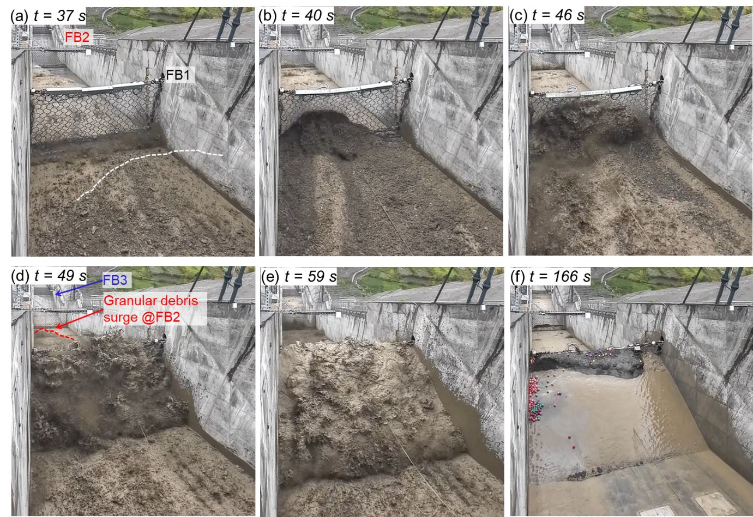
Fig. S7 Observed impact kinematics at the second flexible barrier FB1
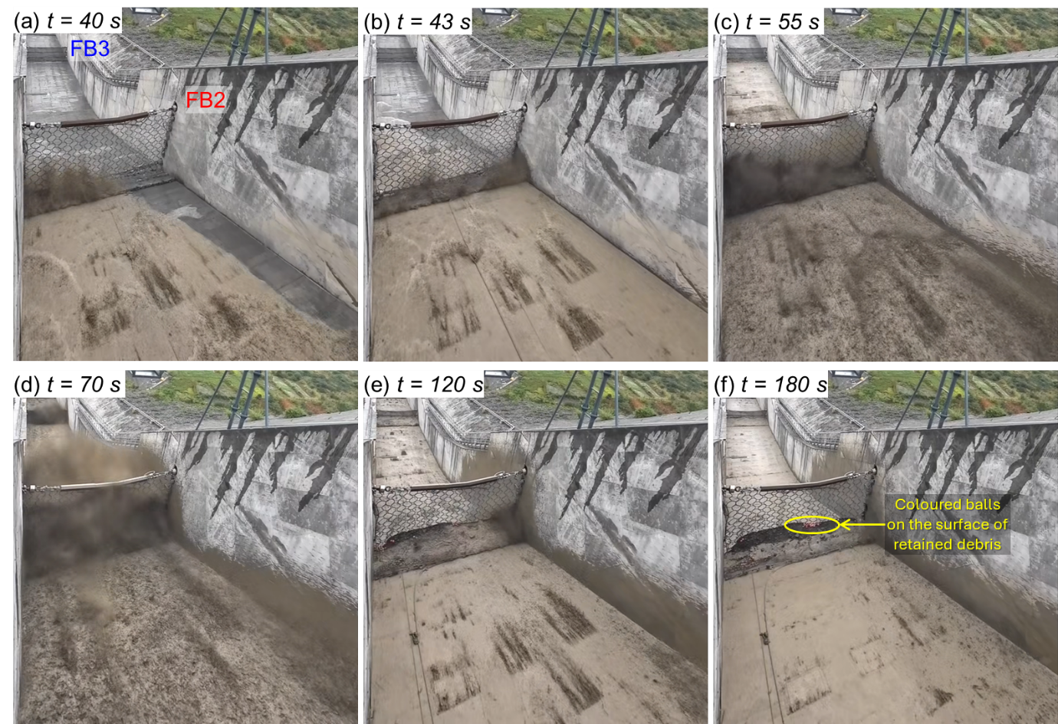
Fig. S8 Observed impact kinematics at the second flexible barrier FB2
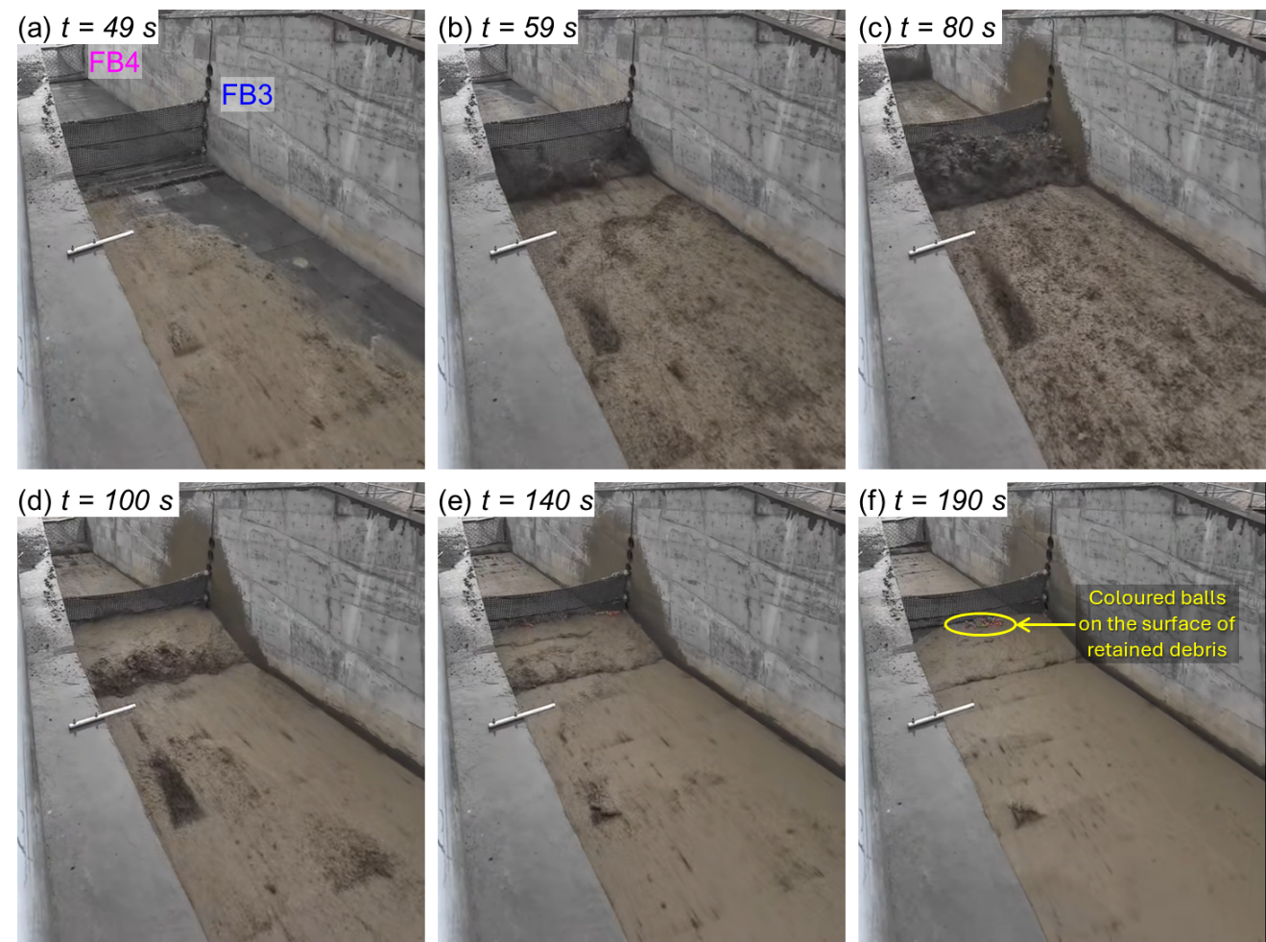
Fig. S9 Observed impact kinematics at the third flexible barrier FB3
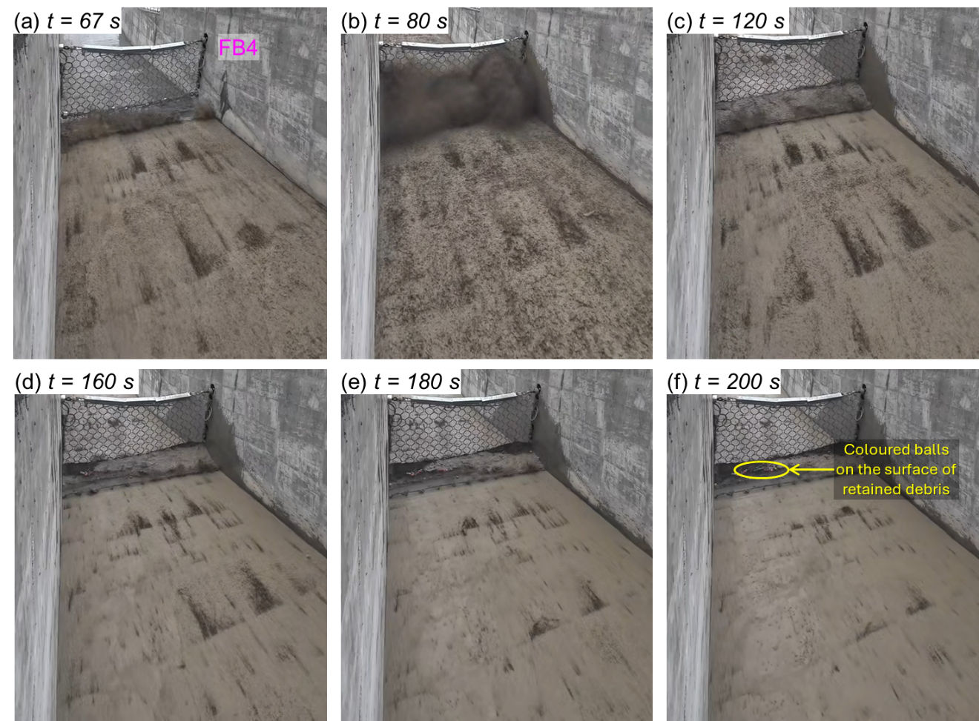
Fig. S10 Observed impact kinematics at the fourth flexible barrier FB4

Supplementary note 6: Flow height time-histories of all laser sensors at each barrier location
Fig. S11 shows the time histories of flow height in front of each barrier, measured by multiple laser sensors available at respective locations. Fig. S11a shows the measurements from laser sensors L1 and L2 in front of the first barrier (FB1). The measured data at the left and right side of the flume by L1 and L2 respectively show that the initial flow front arrival at FB1 is concentrated along the left side at t = 39 s. This initial surge measured around 145 mm by L1 but only around 50 mm by L2. This difference in measurement is corroborated by the kinematics shown in Fig. 2b in the main text and Fig. S7b in the main text. Thereafter, once the debris flow spans across the width of the flume, the peak flow depth of around 250 mm is measured by both the sensors L1 and L2, indicating a uniform flow across the flume width. While subsequent surges show slight discrepancies in the measured peaks, these are not as pronounced as that measured at the flow front. Furthermore, the two measured time histories align well with each other throughout the flow duration until t = 90 s when debris flow ends at FB1. This result shows that the debris flow height is uniform before interacting with a barrier.
Fig. S11b shows the flow height time histories at the second barrier FB2, measured by three laser sensors located at the left (L6), middle (IMHE2), and right (L7) of the flume on the monitoring tower 2. The sensors L6 and L7 show large fluctuation in the measured data compared to sensor IMHE2. Such transient fluctuations (see Supplementary video V1-UAV) may occur due to the highly turbulent free surface and spraying particles near the flume side walls compared to the middle. Especially, since the debris flow reaching FB2 predominantly consists of muddy water and landed overflow from FB1, which was highly turbulent as shown in Fig. 9a in the main text. Nonetheless, the measured time histories successfully capture the arrival of the flow front initially along the left by sensor L6 at t = 46 s. The granular debris along the right-side observed in Fig. S8c at t = 55 s is also captured by the sensor L7. Then, the debris flow is once again uniform until the flow height increases to a peak value of around 150 mm at t = 70 s and recedes. From t = 90 s onwards, debris flow continues to recede in the left and middle as overflow from FB1 ceases. However, a large quantity of muddy water continues to discharge along the right side of FB1 (see Supplementary video S1-UAV.mp4) until the end of impact process at t = 180 s. This continued discharge of muddy water is captured by sensor L7 as a series of surges (roll waves) well beyond the end of impact.
Fig. S11c shows the flow height time history at the third barrier (FB3) with laser sensor L9, mounted on the left-side wall of the flume. The flow front arrives at t = 60 s, with the incoming flow depth reaching a maximum value of 80 mm by t = 69 s. The laser sensor L9 readings are then affected by the reflection of debris deposit behind FB3. As such, the true peak flow depth of the incoming debris flow is not measured accurately at FB3. The deposited debris material registers a transient pulse of 300 mm height at t = 70 s and recedes by t = 80 s. By this time, the debris deposit is found to continuously enlarge and more debris material arrives. The peak deposition depth directly below L9 reaches around 550 mm at 97 s and reduces thereafter as muddy water drains rapidly. Incoming surges of debris material register transient impulses while the deposition wedge continuously shrinks. By the end of impact at t = 180 s, the deposited debris starts to stabilise, yet water continues to discharge well past the end of impact as shown in Fig. S9. Due to the use of a single sensor on the left-side wall of the flume, the uniformity of flow depth at FB3 could not be assessed. However, observing the kinematics in Figs. S7, S8, and S9, the flow front was aligned along the left, followed by granular debris surge along the right and a rather uniform flow body across the flume width. These results are consistent with what was observed in FB2.
Finally, Fig. S11d shows flow height time histories at the fourth barrier (FB4), which is similar to that observed in FB2. The laser sensor IMHE3 located in the middle of the flume above monitoring tower 3 captured a smooth signal compared to the sensors L10 and L11 installed at the left and right, respectively. The flow front arrives at t = 63 s along the left edge. A uniform flow head across the flume width reaches the barrier at t = 67 s. The peak flow depth arrives at between t = 75 s and t = 80 s and recedes thereafter. The surges of muddy water from FB1, originally aligned along the left of the flume gets mixed with the discharge at FB2 and FB3 before reaching FB4. The supplementary video V1-UAV shows a train of muddy water roll waves emanating from FB3 and travelling to FB4, prominently along the sides, compared to the middle. Regardless of the fluctuations, the measured time histories by multiple laser sensors at each barrier locations show that the modelled debris flow in the 190-m flume is uniform across the flume width at the flow head and body despite a slightly non-uniform flow front.
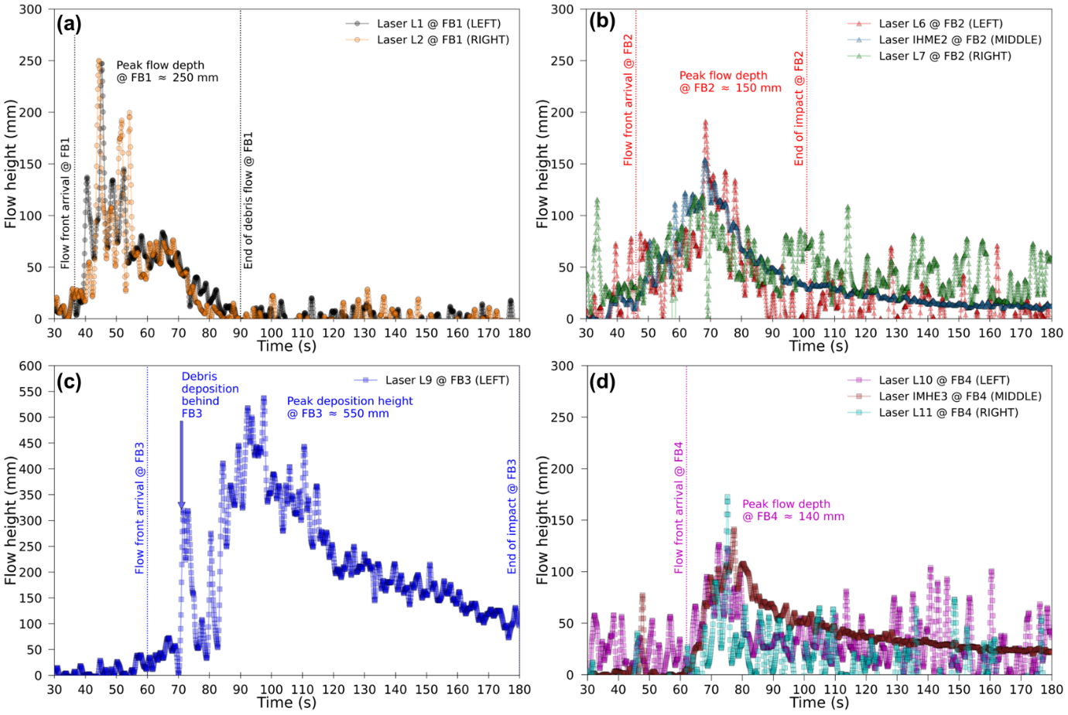
Fig. S11 Measured time histories of flow depth by multiple laser sensors at each barrier location (a) FB1, (b) FB2, (c) FB3, and (d) FB4

Supplementary note 7: Method used in deducing flow velocity from different video footage
Figure S12 and Fig. S13 show a series of selected frames obtained from video cameras observing the same location from two different viewpoints. The time steps are marked on each selected frame considering the frame rate of each camera. The tracked flow surge fronts are distinguished using a red line and the flow direction is also indicated for clarity. In Fig. 12, yellow dashed lines with a spacing of 1.85 m are plotted using the pre-existing distinct lines on the flume wall. Time steps are selected such that the surge reaches each of the lines. In Fig. S13, the video recorded from the top elevation is manually adjusted to correct the fish-eye effect and perspective. The corrected video is calibrated using known lengths of instrumentation cell, width of flume and length of viewing window. The spacing between the shown yellow dashed lines is 2 m. Using the specified distances and the known time steps, velocity of each surge is calculated from multiple angles of cameras. The maximum, minimum, and average values of deduced velocities at each barrier location are shown in Fig. 4.

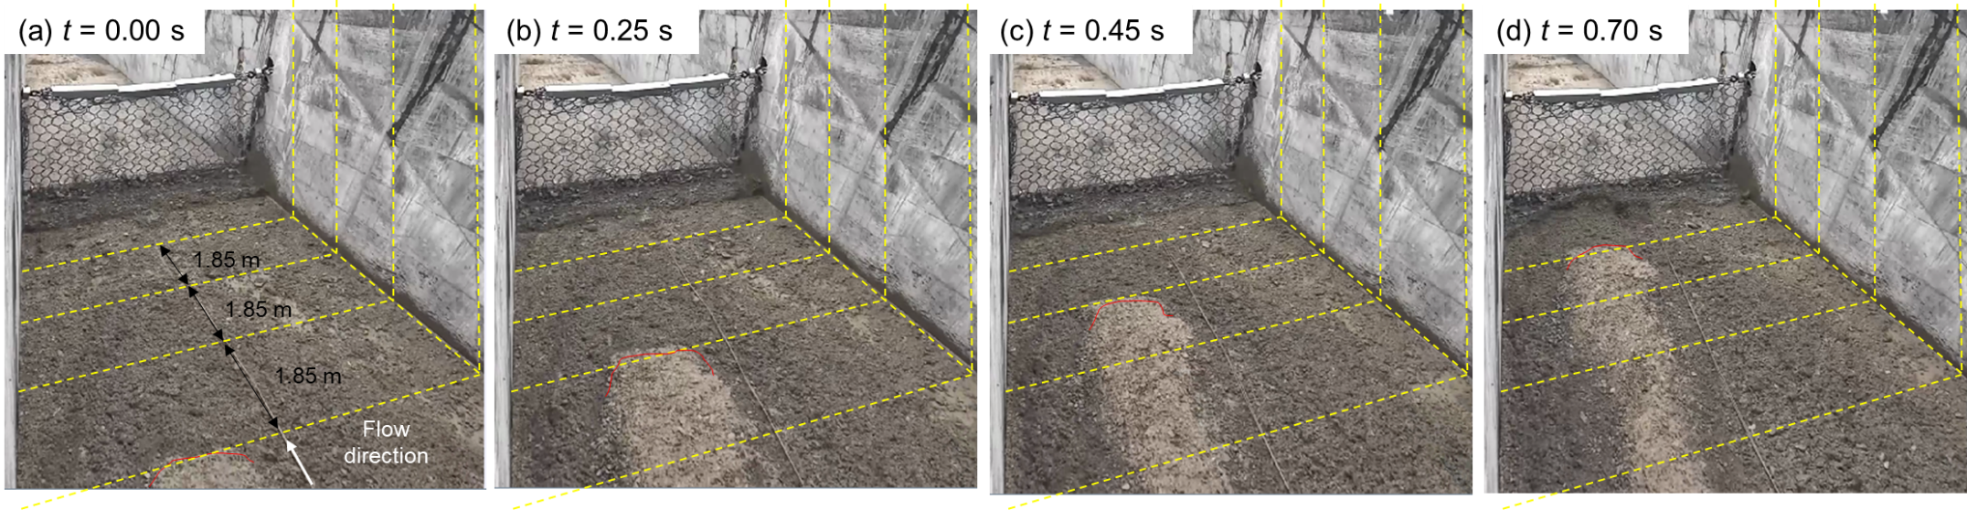
Fig. S12 Debris flow surge velocity deduction at the first barrier from side view frames recorded by the action camera (DJI1) using the selected time steps of (a) t = 0.00 s (b) t = 0.25 s (c) t = 0.45 s, and (d) t = 0.70 s
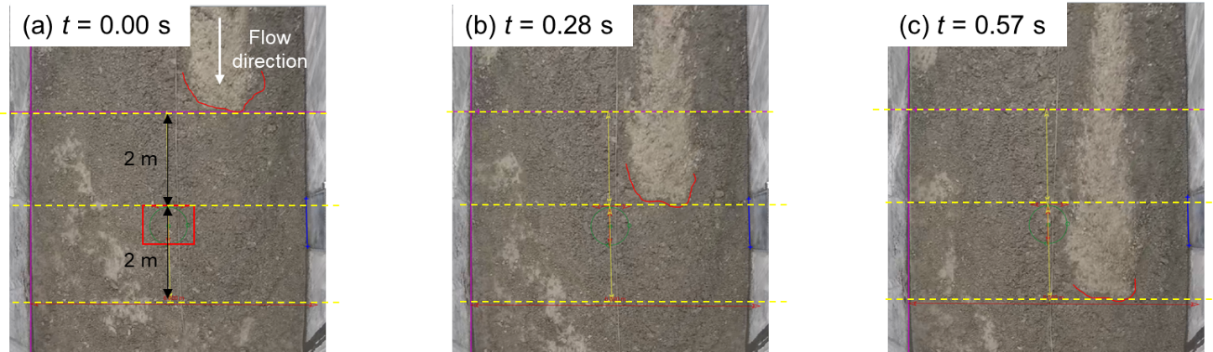
Fig. S13 Debris flow surge velocity deduction at the first barrier from top view recorded by the action camera (DJI2) using the selected time steps of (a) t = 0.00 s (b) t = 0.28 s, and (c) t = 0.57 s

Supplementary references
Ashby, M. F., & Cebon, D. (1993). Materials selection in mechanical design. J. Phys. IV France, 03, No. C7, C7-9. https://www.doi.org/10.1051/jp4:1993701.
Cui, P., Chen, X., Wang, Y., Hu, K., & Li, Y. (2005). Jiangjia Ravine debris flows in south-western China. In Debris-flow Hazards and Related Phenomena. (M. Jakob & O. Hungr eds). Springer, Berlin, Heidelberg. pp. 565–594.
Hu, K., Wei, F., & Li, Y. (2011). Real-time measurement and preliminary analysis of debris-flow impact force at Jiangjia Ravine, China. Earth Surf.Process.Landforms, 36, No. 9, 1268–1278. https://www.doi.org/10.1002/esp.2155.
Iverson, R. M. (2015). Scaling and design of landslide and debris-flow experiments. Geomorphology, 244, 9–20. https://www.doi.org/10.1016/j.geomorph.2015.02.033.
Ng, C. W. W., Choi, C. E., Liu, H., Poudyal, S., & Kwan, J. S. H. (2020a). Design Recommendations for Single and Dual Debris Flow Barriers with and Without Basal Clearance. In Understanding and Reducing Landslide Disaster Risk. WLF2020. ICL contribution to landslide disaster risk reduction (eds K. Sassa, M. Mikoš, S. Sassa, P.T. Bobrowsky, K. Takara, & K. Dang). Springer International Publishing, Switzerland. pp. 33–53.

