Supplementary Material for “Optimizing a Multimodal Hub and Spoke Network for Vaccine Distribution using Regional Vulnerability Index During Healthcare Emergencies”

Contents of this file
- Introduction
- Sensitivity analysis report.
- Figs. S-1, S-2.
- Tables S-1.
Introduction
Since the paper titled “Optimizing a Multimodal Hub and Spoke Network for Vaccine Distribution using Regional Vulnerability Index during Healthcare Emergencies” presents a two-phase method, the reader might wonder how the output of Phase 1 affects the results of Phase 2. To give an overview of this relation, we have conducted some sensitivity analysis. In this analysis, we try generating the networks for different combination of two ModSIR model viz., $β$ and$γ$. However, for some scenarios, the Phase 1 results does not affect the Phase 2 results. We have explained the reason behind this and tried applying it to a different scenario where we can see the effect of $β$ and$γ$ values. The detailed report of this analysis is shown below.
Results from the sensitivity Analysis
The proposed two-phase model has two different outputs in each phase. It is to be noted here that, when the outcome of the second phase is concerned, the key input from ModSIR is the RVI and not the infection patterns. Thus, it may so happen that even though the infection pattern is changed with the change in ModSIR parameters, the graphs generated from MIQCP are unchanged. The reason behind this is that the optimum locations from MIQCPs are governed by the rank of the regions/states based on their RVI values. Thus, to affect the outcome of Phase -2 of the model, the RVI has to be big or small enough to get its rank changed. For example, if the rank of state 1 is 3 among all the states under consideration, the infection pattern from ModSIR should be such that the rank changes from 3. Thus to conduct a sensitivity analysis we must check if the rank of all the states is changed. Moreover, the state-wise sensitivity analysis is a challenge as the input parameters are a real dataset. Here, we want to bring the readers’ attention to the fact that in the ModSIR model, the key parameters are$β$, the infection transmission rate, and$γ$, the recovery rate, which are primarily estimated from the real COVID-19 data for each state. Thus, we understand that there is not much scope for sensitivity analysis by changing the parameters for the ModSIR model, or SIR model for that matter. However, there is an alternative way to conduct the analysis, where instead of feeding the original infection data for parameter estimation of the ModSIR model and using a range of values for $β$ and$γ$. The analysis is shown in Table S1 of this document.
Table S1: Sensitivity analysis of the ModSIR model with $β$ and $γ$ values for RVI estimation. (Source: Authors' own work.)
State Capitals | $$β=0.3$$ |  |  | $$β=0.5$$ |  |  | $$β=0.7$$ |  |  | $$β=0.9$$
State Capitals | $$γ=0.1$$ | $$γ=0.2$$ | $$γ=0.3$$ | $$γ=0.1$$ | $$γ=0.2$$ | $$γ=0.3$$ | $$γ=0.1$$ | $$γ=0.2$$ | $$γ=0.3$$ | $$γ=0.1$$ | $$γ=0.2$$ | $$γ=0.3$$
Agartala | 0.018 | 0.017 | 0.015 | 0.018 | 0.016 | 0.015 | 0.016 | 0.015 | 0.015 | 0.014 | 0.016 | 0.014
Aizawl | 0.005 | 0.005 | 0.004 | 0.005 | 0.005 | 0.004 | 0.005 | 0.005 | 0.005 | 0.006 | 0.006 | 0.004
Amaravati | 0.248 | 0.225 | 0.203 | 0.238 | 0.231 | 0.211 | 0.245 | 0.234 | 0.209 | 0.277 | 0.238 | 0.222
Bengaluru | 0.306 | 0.277 | 0.250 | 0.321 | 0.282 | 0.243 | 0.318 | 0.293 | 0.226 | 0.343 | 0.317 | 0.246
Bhopal | 0.363 | 0.329 | 0.298 | 0.349 | 0.332 | 0.307 | 0.331 | 0.299 | 0.307 | 0.378 | 0.299 | 0.270
Bhubaneswar | 0.210 | 0.190 | 0.172 | 0.202 | 0.196 | 0.181 | 0.186 | 0.196 | 0.168 | 0.202 | 0.204 | 0.143
Chandigarh-City | 0.005 | 0.005 | 0.004 | 0.005 | 0.005 | 0.004 | 0.005 | 0.005 | 0.004 | 0.006 | 0.005 | 0.004
Chandigarh-H | 0.127 | 0.115 | 0.104 | 0.121 | 0.110 | 0.102 | 0.116 | 0.100 | 0.096 | 0.124 | 0.096 | 0.090
Chandigarh-P | 0.139 | 0.126 | 0.114 | 0.146 | 0.128 | 0.111 | 0.149 | 0.115 | 0.115 | 0.167 | 0.104 | 0.101
Chennai | 0.361 | 0.327 | 0.296 | 0.343 | 0.340 | 0.307 | 0.360 | 0.374 | 0.289 | 0.396 | 0.351 | 0.298
Dadra And Nagar Haveli | 0.002 | 0.002 | 0.001 | 0.002 | 0.002 | 0.001 | 0.002 | 0.002 | 0.002 | 0.002 | 0.002 | 0.001
Daman | 0.001 | 0.001 | 0.001 | 0.001 | 0.001 | 0.001 | 0.001 | 0.001 | 0.001 | 0.001 | 0.001 | 0.001
Dehradun | 0.050 | 0.046 | 0.041 | 0.050 | 0.048 | 0.040 | 0.052 | 0.044 | 0.040 | 0.050 | 0.050 | 0.037
Delhi | 0.084 | 0.076 | 0.069 | 0.087 | 0.078 | 0.069 | 0.080 | 0.074 | 0.067 | 0.080 | 0.066 | 0.063
Dispur | 0.156 | 0.141 | 0.128 | 0.155 | 0.144 | 0.133 | 0.148 | 0.151 | 0.137 | 0.140 | 0.170 | 0.141
Gandhinagar | 0.302 | 0.274 | 0.248 | 0.302 | 0.279 | 0.255 | 0.299 | 0.288 | 0.247 | 0.258 | 0.331 | 0.260
Gangtok | 0.003 | 0.003 | 0.003 | 0.003 | 0.003 | 0.003 | 0.003 | 0.003 | 0.003 | 0.003 | 0.003 | 0.002
Hyedrabad | 0.175 | 0.159 | 0.143 | 0.173 | 0.155 | 0.138 | 0.182 | 0.148 | 0.138 | 0.184 | 0.127 | 0.135
Imphal | 0.013 | 0.012 | 0.011 | 0.012 | 0.012 | 0.010 | 0.013 | 0.012 | 0.010 | 0.014 | 0.013 | 0.011
Itanagar | 0.007 | 0.006 | 0.006 | 0.007 | 0.006 | 0.006 | 0.007 | 0.006 | 0.005 | 0.007 | 0.006 | 0.005
Jaipur City | 0.343 | 0.310 | 0.281 | 0.333 | 0.304 | 0.270 | 0.319 | 0.289 | 0.248 | 0.345 | 0.260 | 0.233
Kavaratti | 0.000 | 0.000 | 0.000 | 0.000 | 0.000 | 0.000 | 0.000 | 0.000 | 0.000 | 0.000 | 0.000 | 0.000
Kohima | 0.010 | 0.009 | 0.008 | 0.010 | 0.009 | 0.008 | 0.011 | 0.009 | 0.008 | 0.012 | 0.010 | 0.008
Kolkata | 0.457 | 0.413 | 0.374 | 0.439 | 0.417 | 0.370 | 0.478 | 0.438 | 0.404 | 0.502 | 0.491 | 0.420
Ladakh | 0.001 | 0.001 | 0.001 | 0.001 | 0.001 | 0.001 | 0.001 | 0.001 | 0.001 | 0.001 | 0.000 | 0.001
Lucknow | 1.000 | 0.905 | 0.819 | 1.050 | 0.923 | 0.819 | 1.124 | 0.923 | 0.851 | 0.966 | 0.821 | 0.766
Mumbai | 0.562 | 0.509 | 0.460 | 0.579 | 0.529 | 0.451 | 0.614 | 0.487 | 0.406 | 0.602 | 0.482 | 0.366
Panaji | 0.007 | 0.007 | 0.006 | 0.008 | 0.007 | 0.006 | 0.008 | 0.007 | 0.006 | 0.008 | 0.007 | 0.006
Patna | 0.521 | 0.471 | 0.427 | 0.547 | 0.462 | 0.448 | 0.492 | 0.439 | 0.417 | 0.556 | 0.496 | 0.404
Pondicherry | 0.006 | 0.006 | 0.005 | 0.006 | 0.006 | 0.005 | 0.006 | 0.006 | 0.006 | 0.005 | 0.006 | 0.006
Port Blair | 0.002 | 0.002 | 0.002 | 0.002 | 0.002 | 0.002 | 0.002 | 0.002 | 0.001 | 0.002 | 0.002 | 0.001
Raipur City | 0.128 | 0.116 | 0.105 | 0.133 | 0.121 | 0.108 | 0.134 | 0.118 | 0.118 | 0.115 | 0.107 | 0.125
Ranchi | 0.165 | 0.149 | 0.135 | 0.157 | 0.155 | 0.141 | 0.163 | 0.160 | 0.128 | 0.161 | 0.171 | 0.147
Shillong | 0.015 | 0.013 | 0.012 | 0.015 | 0.013 | 0.012 | 0.016 | 0.013 | 0.011 | 0.017 | 0.015 | 0.012
Shimla | 0.034 | 0.031 | 0.028 | 0.033 | 0.031 | 0.027 | 0.030 | 0.032 | 0.028 | 0.033 | 0.033 | 0.029
Srinagar | 0.062 | 0.056 | 0.051 | 0.060 | 0.055 | 0.052 | 0.063 | 0.059 | 0.049 | 0.071 | 0.055 | 0.053
Thiruvananthapuram | 0.167 | 0.151 | 0.137 | 0.169 | 0.150 | 0.138 | 0.174 | 0.159 | 0.142 | 0.181 | 0.175 | 0.135
We have also analyzed how the facility hubs change their location based on the β and γ values on which we have conducted the sensitivity analysis. As evident from the Fig S 1 of this document we can see that, although the RVI values are changing, when fed into the MIQCP model, without a change in the rank of the states or regions, there is no change in the facility locations. The reason behind this is explained in the previous section. The analysis is presented below.
 | $$γ=0.1$$ | $$γ=0.2$$ | $$γ=0.3$$
$$β=0.3$$ | 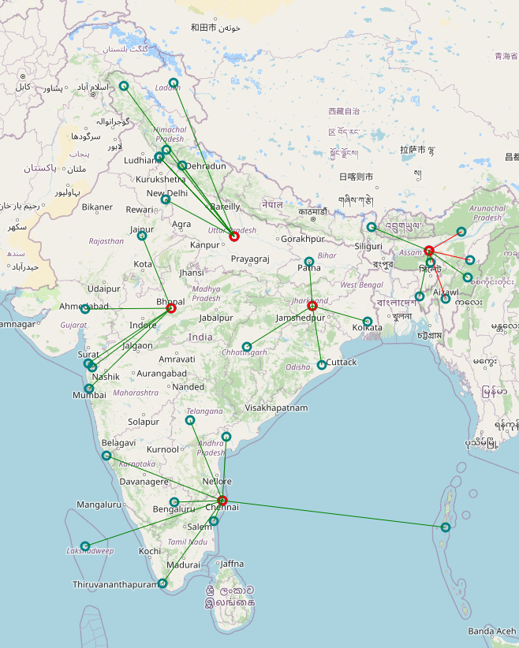 | 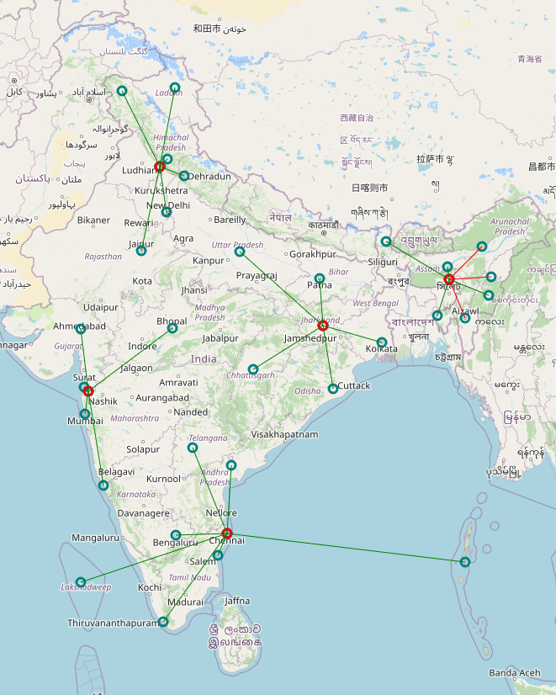
$$β=0.5$$
$$β=0.7$$
$$β=0.9$$
Figure S 1: Sensitivity analysis on the facility locations on different β and γ values. (Source: Authors' own creation.)
However, it may be noted that this phenomenon is specific to the data set used. It may not be so for other datasets. We agree that this may confuse the readers as well. Therefore, to remove this dataset related bias, we construct a new a dataset pertaining to a specific state in India and carryout the steps. It observed that the parameter values do change as indicated below.
In order to demonstrate the impact of SIR or ModSIR model parameters on network structure, we show the results for a state called Andhra Pradesh (AP) in India. Here, the district-level segregations are of similar sizes (Visually). We present the change in the network in Fig S1 for the different parameters. As we can see, for smaller$γ≤0.2$, the networks generated for similar. However, for a relatively higher value$γ≥0.4$, the network generated is different. Thus, we can conclude that the proper estimation of model attributes affects the location for a case of homogeneous geographical segregation.
$$γ=0.1$$ |  | $$γ=0.2$$
$$β=0.1$$ | $$β=0.6$$ | $$β=0.1$$ | $$β=0.8$$
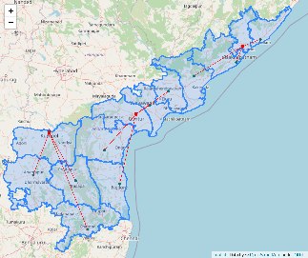
$$γ=0.4$$ |  | $$γ=0.6$$
$$β=0.6$$ | $$β=0.4$$ | $$β=0.4$$ | $$β=0.8$$
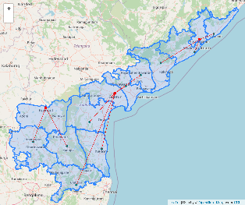 |  | 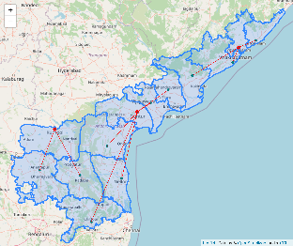 | 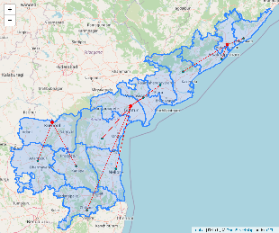
Figure S 2: Change in network with the change in the model parameters. (Source: Authors' own creation.)
To explain the benefits of ModSIR over SIR model we have conducted experiments to represent the results from both models. As explained in the original manuscript, the SIR model considers a single period to predict the peak infection rate. On the other hand, ModSIR considers multiple periods. As shown in Fig S3, we have calculated multiple Regional Vulnerable Indices (RVI) by incorporating data from each period. The figure shows a gradual change in the heat map shades with change in the periods, as it considers the effect of each month, which aligns more with the real-life scenarios with each extra period considered. It may be noted that except for the first period, which uses SIR model, the other periods follow ModSIR. Thus, with a very small relaxation of computational complexity, ModSIR can replicate real-life scenarios. Thus, ModSIR is more appropriate than SIR for applications.
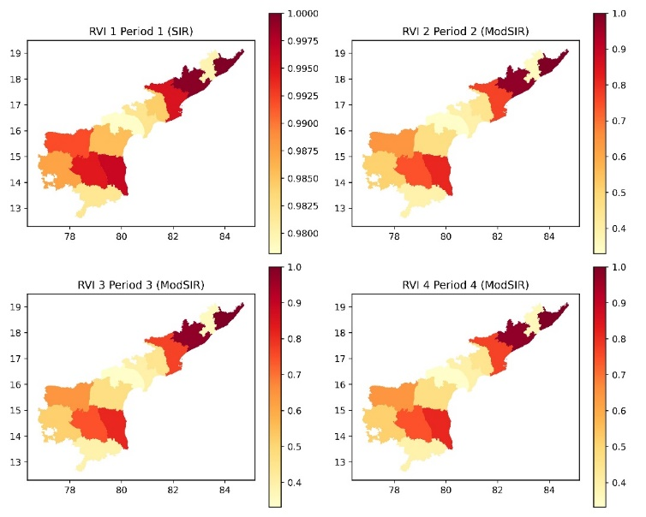
Figure S 3: Comparing the results of SIR and ModSIR for four periods. (Source: Authors' own creation.)
The parameters $β$ and $γ$ are very robust parameters and thus the network generated from the prioritization, are mostly unaffected by small changes in these parameters. These parameters estimated from the ModSIR model helps the practitioner to predict the peak infection time much more accurately than other classical epidemiological models. This index from the output helps locating the facility locations prioritizing the vulnerable regions.

