Supplementary material 1. Stockholm archipelagos and their situation.
Scale: 1:50 000 (the map to the right)
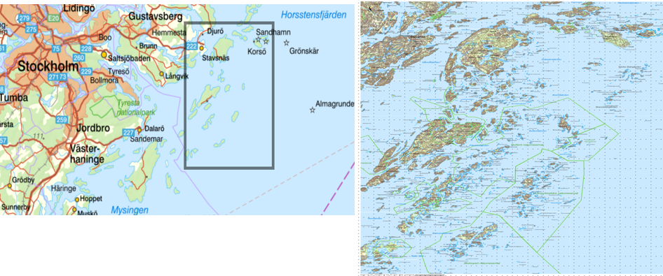Source: Copyright Lantmäteriet (www.lantmateriet.se)

