Supplementary material

Contents
Annexe 1. Varying approaches to the tourism destination ecosystem structure 2
Annexe 2. Methodologies of network analysis and technical aspects of web entities operationalisation 4
Annexe 3. Methodology: Main steps of data collection 6
Annexe 4. Structural components of the extended tourism destination ecosystem 7
Annexe 5. Typology elaboration 8
Annexe 6. A more detailed analysis of the extended ecosystem 18
Annexe 7. The comparison of linking behaviours of the “core” tourism sectors 21
Annexe 8. Indexes distributions 22
Annexe 9. “Passive” behaviours 25
Annexe 10. Comparison of the connecting activity of tourism sectors 26
Annexe 11. Relationship between varying networking behaviours of tourism actors, ecosystem leadership, integration levels, and mediation engagement 29
Annexe 12. Comparison of clusters according to structural and behavioural characteristics 30

Annexe 1. Varying approaches to the tourism destination ecosystem structure
Table 1. Tourism destination ecosystem structure: standard entities and smart destination entities
Destination actors’ typology | Source
Standard entities of a tourism destination
Accommodation for visitors  Food and beverage serving activities  Railway passenger transport  Road passenger transport  Water passenger transport  Air passenger transport  Transport equipment rental  Travel agencies and other reservation service activities  Cultural activities  Sports and recreational activities  Retail trade of country-specific tourism characteristic goods  Other country-specific tourism characteristic activities | World Tourism Organization (Ed.). (2021), Methodological Notes to the Tourism Statistics Database, World Tourism Organization (UNWTO), doi: 10.18111/9789284422517.
Entities of a smart tourism destination
Tourists  Government  Scenic zones  Businesses Information exchange centers | Zhu, W., Zhang, L. and Li, N. (2014), “Challenges, function changing of government and enterprises in Chinese Smart Tourism”, E-Review of Tourism Research (eRTR), presented at the ENTER 2014: Volume 5 Research Notes.
Touristic consumers  Residential consumers  Tourism suppliers  Other industry suppliers  Government agencies  Media  Destination Marketing Organisations  Intermediaries | Gretzel, U., Werthner, H., Koo, C. and Lamsfus, C. (2015), “Conceptual foundations for understanding smart tourism ecosystems”, Computers in Human Behavior, Vol. 50, pp. 558–563, doi: 10.1016/j.chb.2015.03.043.
Local administration  Other administrations at different scales  Residents  Tourists  Destination companies  Technology companies  Public and private municipal service providers  Investors and financial companies  Universities and R&D+i centers  Consulting companies | Authors’ translation of Ivars Baidal, J., Celdrán Bernabeu, M.A. and Femenia Serra, F. (Eds.). (2017), “Guía de implantación: DTI CV”, - Agència Valenciana del Turisme. Invat.tur.
Digital technologies  Consumers (tourists, residents)  Businesses (tourism businesses, businesses from other industries)  Tourism destination (space governed by DMOs, government) | Gajdošík, T. (2018), “Smart Tourism: Concepts and Insights From Central Europe”, doi: 10.1515/cjot-2018-0002.
Public administration  Tourism industry and related sectors  Mobility and transport  Technology companies  Other companies  Research and academia  Civil society | Ivars-Baidal, J., Casado-Díaz, A.B., Navarro-Ruiz, S. and Fuster-Uguet, M. (2024), “Smart tourism city governance: exploring the impact on stakeholder networks”, International Journal of Contemporary Hospitality Management, Vol. 36 No. 2, pp. 582–601, doi: 10.1108/IJCHM-03-2022-0322.
Source: Created by authors.

Annexe 2. Methodologies of network analysis and technical aspects of web entities operationalisation
This study employs two complementary methodologies of network analysis: Hyperlink Network Analysis (HNA) and webometrics. HNA originates from social network analysis and is distinct in that hyperlink data is used as a proxy for the relationships between social and economic actors. Focusing on the relational aspects of digital networks—such as connections between entities and the origins and destinations of links—serves to uncover ecosystem structure and networking behaviours. Webometrics, by contrast, emphasises the quantitative study of digital networks using link counts and statistical methods. Less concerned with relational data, webometrics is suitable for characterising ecosystem leadership.
Table 2. Technical aspects of web entities' operationalisation adopted in this research
Actor | Definition | Example | Specifications
Distinguishing web entities
1. Tourism actors (initial sample of core destination actors, seed pages) | A collection of publicly accessible, interlinked web pages that share a single domain name and appear under the common legal or commercial name of an organisation (“organisational website” or “institutional website”) |  | Excludes digital representations of tourism actors on travel and other aggregation platforms over which organisations cannot fully control their connections
1.1. Web entities with a unique domain name | Domain name and top-level domain | example.eus
1.2. Web entities hosted at a platform | Subdomain, domain name, top-level domain, directory. Subdomain and directory represent a unique identifier of a tourism actor, while the domain name reflects the hosting platform | Example.Hosting  PlatformName.com /Example
2. Discovered actors (discovered after web crawling) | A collection of publicly accessible, interlinked web pages that share a single domain name and appear under a common name (legal, commercial, or other) | example.eus
Merging web entities
3. The most frequently linked discovered actors | Entities that received five or more links from the initial sample of tourism actors. To ensure each actor appears only once in this category, entities with multiple web domains were merged into a single entity.*  The following rules were applied:  - Merging old domains with new domains.  - Merging actors with the same domain name but different top-level domains. | oldwebsiteABC.com + newwebsiteABC.eus  Santelmomuseoa.com+ Santelmomuseoa.eus  exampleABCD.es + exampleABCD.com  Tripadvisor.com + Tripadvisor.es  Google.com+  Google.es
Note. *The same actor may possess multiple web identities, represented by two or more distinct websites (i.e., web domains), such as euskadi.eus and euskadi.net. This occurs in various situations, including:
- A domain change (e.g., euskadi.net → euskadi.eus).
- The use of separate domains for different language versions (e.g., deusto.es and deusto.eus).
- Geo-targeting, whereby content is tailored to users based on geographic location (e.g., google.es and google.com; airbnb.com and airbnb.es).
- Representation of a multinational corporation (or holding company) through distinct regional offices.
The presence of multiple web identities undermines efforts to identify the most integrated actors, as the indicator of integration (e.g., number of incoming links or indegree) may be split across different web domains. This can result in the same actor being represented more than once, thereby distorting the analysis. To ensure each actor appeared only once among entities with five or more links, those with multiple web domains were merged into single entities.
Source: Created by authors.

Annexe 3. Methodology: Main steps of data collection

Figure 1. Main steps of data collection for exploring the extended ecosystem of the Gipuzkoa destination in Spain
Note. Web crawler captured hyperlinks from a starting list of URLs, detected at stage 2. In the network analysis, only one directional link from Website A to Website B was retained, irrespective of the number of hyperlinks between them. The identified websites were crawled to a depth of three using the web crawler Hyphe (Jacomy et al., 2016; Ooghe-Tabanou et al., 2018). Crawling to depth three means that the crawler followed hyperlinks starting from the initial tourism actor websites (depth 0) and continued through up to three successive layers of linked pages (depths 1, 2, and 3), enabling the capture of broader hyperlink connections.
Source: Created by authors.
References:
Jacomy, M., Girard, P., Ooghe-Tabanou, B. and Venturini, T. (2016), “Hyphe, a curation-oriented approach to web crawling for the social sciences”, in Gummadi, K.P. and Strohmaier, M. (Eds.), Proceedings of the International AAAI Conference on Web and Social Media, Vol. 10(1), Cologne, Germany, pp. 595–598.
Ooghe-Tabanou, B., Jacomy, M., Girard, P. and Plique, G. (2018), “Hyperlink is not dead!”, in Reyes, E., Bernstein, M., Ruffo, G. and Saleh, I. (Eds.), WS.2 2018: Proceedings of the 2nd International Conference on Web Studies, presented at the WS.2 2018: International conference on Web Studies, ACM, Paris, France, pp. 12–18, doi: 10.1145/3240431.

Annexe 4. Structural components of the extended tourism destination ecosystem
Figure 2. Structural components of the extended tourism destination ecosystem
Structural components | %¹ | Definition and network integration level |  | %²
Core actors (n = 670) | 2% | Initially selected actors in the primary tourism sectors
Discovered entities  (n = 36,813) | 98% | 5+ links from core actors |  | 1%
Discovered entities  (n = 36,813) | 98% | 2-4 links from core actors |  | 5%
Discovered entities  (n = 36,813) | 98% | 1 link from the primary core |  | 94%
Note. The entities highlighted in bold represent an approximation to the extended ecosystem of a tourism destination examined in this study.
¹% to the total number of entities in the ecosystem (n = 37,483).
²% to the number of entities discovered via web crawling (n = 36,813).
Visualisation generated with Gephi (version 0.10.1) (Bastian et al., 2009).
Source: Created by authors.
References: Bastian, M., Heymann, S., & Jacomy, M. (2009). Gephi: An open source software for exploring and manipulating networks. In W. W. Cohen & N. Nicolov (Eds.), Proceedings of the International AAAI Conference on Web and Social Media (Vol. 3, Issue 1, pp. 361–362). https://ojs.aaai.org/index.php/ICWSM/article/view/13937

Annexe 5. Typology elaboration
A typology of the discovered ecosystem was developed, using both deductive and inductive coding methods (Saldaña, 2021).
To elaborate on the typology, a thematic analysis was carried out. Researchers studied the entities’ websites and Wikipedia entries about organisations (if available). Researchers elaborated short descriptions of each entity. They were complemented by the descriptions of the websites by a generative artificial intelligence chatbot (Microsoft Copilot). Any misalignment between the descriptions was verified, and the final description was elaborated. Accounting for the similarities in the entities’ activities, the codes that described them were elaborated. The codes were aggregated into types and subtypes, and their definitions were elaborated.
The initial “core” of tourism actors (n = 670) was complemented by the discovered entities of the same type and belonging to the same destination (n = 31). However, as these discovered actors were not crawled, they are not accounted for in all the metrics.
See Table 3 for the definitions of the types.
References: Saldaña, J. (2021), The Coding Manual for Qualitative Researchers, Fourth edition., SAGE, Los Angeles.
Table 3. Typology of actors
Type | Subtype | Definition | Included: Specific entities (but do not always reflect the entire category) | Excludes | Example
Tourism Actors (Primary Sectors) | 1. Destination Management Organizations (DMOs) | Entities responsible for managing and promoting tourism destinations to enhance visitors' experiences, including sustainable development initiatives. | Tourism offices  Public companies | City halls | turismozarautz.eus  sansebastianturismoa.eus  behemendi.eus
 | 2. Tourism-Related Public Bodies | Organisations that provide public services and manage public affairs in tourism or in a wider domain, with dedicated tourism departments. Includes town halls, government-sponsored development organisations, and associations of municipalities. | City halls and other governmental agencies with tourism departments.  “Mancomunidades” as associations of city halls (with tourism departments). | Public bodies without tourism departments. | donostia.eus  azpeitia.eus  debagoiena.eus
 | 3. Natural and Cultural Resources | Organisations that manage natural and cultural attractions, such as parks, museums, and historical sites. | Museums and galleries.  Natural parks.  Preserving and promoting a specific area or community's cultural, historical, and natural heritage.  Aquarium.  Religious sites.  Exposition/exhibition centres.  Gastronomy experiences.  Promotion of Basque culture.  Orchestra and choir. | Annual cultural festivals and sports events.  Operating of sports facilities. Sports events.  Social activism.  Basque language development programs that promote language use among locals. | albaola.org  aizkorriaratzparkea.eus  aquariumss.com  arantzazu.org  arazi.eus  armaplaza.eus  ekoetxea.eus  eurekamuseoa.eus
 | 4. Accommodations | Establishments offering short-term stays, including hotels, bed and breakfasts, and campgrounds. | Groups of hotels. Tourist apartments (officially registered). |  | agroturismobasitegi.com  akelarre.net  apartamentos-florida.es  barcelo.com  campingjaizkibel.com  pensionkaia.com
 | 5. Sports and Recreation Service Companies | Businesses offering sports activities and active tourism leisure activities and adventure experiences, such as boat tours, hiking trips, and sports equipment rentals. | Horse riding.  Boat tours.  Hiking trips.  Sports equipment rentals.  Underwater activities.  Surf experiences.  Mountain activities.  Recreational fishing.  Flying activities.  Amusement parks. | Operation of sports facilities.  Organisation of outdoor or indoor sports events.  Music festivals.  Cultural events.  Sports clubs. | alarpezalditegia.com  begi-bistan.com  boattripssansebastian.com  central-surf.com  menditxik.com
 | 6. Travel Agencies and Other Reservation Services | Intermediary agencies that sell travel, tour, transportation and accommodation services to the general public or other businesses. | Activities of tourist guides.  Customised trips. | Ticket sales activities for theatrical, sports, and other amusement and entertainment events. | baskforall.com  basquedestination.com  basquelandsway.com  basquetours.com  bthetravelbrand.com  viajesazulmarino.com
Tourism Actors (Added sectors) | 7. Annual Events | Recurring cultural or sports events, such as music festivals and marathons, that attract tourists. | Music festivals.  Film festivals.  Culinary events.  Performing arts fairs. Running events. |  | Jazzaldia.eus Sansebastianfestival.com Dferia.eus  Behobia-Sansebastian.com Sansebastiangastronomika.com
 | 8. Food and Beverage Serving Activities | Provision of food and beverage services to customers, including restaurants, cafes, and other establishments. | Restaurants, cafes, and other establishments.
 | 9. Sports Facilities and Organizations | Organisations managing sports facilities and providing membership-based sports activities for professional or recreational purposes. | Operation of stadiums and racetracks for horse riding.  Ice-hockey arenas.  Sports clubs. Golf clubs.  Sports federations. | Surf schools. | gmf.eus  hipodromoa.com  goiburugolf.com
 | 10. Production and Tourism | Non-tourism businesses offering tourism activities, such as winery tours or cultural experiences related to their primary operations. | Wine or cider production with food and beverage services and guided visits.  Fishing heritage and food and beverage services.  Chocolate production, museum, and experiences.
 | 11. Tourism Information | Resources periodically publishing information on various destinations and topics, including travel news, guides, and trends and targeted tourism information about specific types of destination natural and cultural resources. | Digital news media on tourism. |  | Traveler.es  Timeout.com
 | 12. Transport Services | Passenger transport services, including car rentals, rail, bus, and other forms of transportation for tourists. | Bus stations.  Parking lots.  Car rentals. | Renting of water bikes. Boat tours.
ICT Actors | 13. Travel Tech | Technology firms focused on the tourism industry and providing it with technological advancements and digital solutions. | Travel platforms.  Leisure platforms.  Tourism management software. |  | Booking.com  Entradium.com  Wikiloc.com  Witbooking.com
 | 14. General ICT actors | Technology products or services not specifically focused on tourism. | Social media  Content technologies  Marketing tools  Web development  Multifunctional web portals  Software development and electronics  Web browsing  Video conferencing and instant messaging  Mapping and location technologies  ICT providers
Institutional and Socio-Economic Non-tourism (ISEN) Actors | 15. Development Actors | Non-profits, community groups, social enterprises, and multistakeholder initiatives for social and economic development. | Association supporting people with intellectual disabilities.  Campaign promoting gender equality and preventing violence against women.  Non-profit organisation offering free legal tools to share and use creativity and knowledge.  Multistakeholder initiative to provide holidays in peace for children living in conflict zones.  A social enterprise working for local employment.  Promotion and support of local products. | Actors that operate historical sites and promote cultural heritage, enabling visiting and experiences for visitors.  Social and cultural events. | atzegi.eus  beldurbarik.eus  creativecommons.org  errigora.eus
 | 16. Governmental and Intergovernmental Agencies | Organisations that provide public services, manage public affairs, and are responsible for implementing the collective economic and social policies (public bodies) and organisations formed by multiple governments (intergovernmental agencies) without a primary focus on tourism. | Public administrations.  The central government.  Regional governments.  Local administrations.  The institutional public sector.  Public law entities linked to or dependent on public administrations.  Private law entities associated with or dependent on public administrations.  State-owned corporations, consortia, and municipal associations (“mancomunidades”).  Public bodies at the local, regional, national, or European Union levels.
 | 17. Non-Tourism Information Services | Entities with the principal function to inform or provide content on various issues, not specialised in tourism, including news media, repositories, and streaming services. | Literature portal.  Music portal.  Libraries.  Digital encyclopaedia.  Archives.  Job search portals.  Weather and sea. levels broadcasts.  Food recipes. |  | Eitb.eus  Diariovasco.com  Hiztegia.net  Kutxateka.eus  Wikipedia.org  Aboutcookies.org  Infoempleo.com  Windguru.cz  Sukaldean.com
 | 18. Research and Education | Educational or research bodies, including professional training institutions. | Music schools. Basque language education and research.  Online courses. Educational portal. Summer schools.
 | 19. Retail Services, Banks, and Other Businesses | Retail shops, financial institutions, and other businesses with no direct tourism activity.
Not Identified | 20. Not Identified | Entities that cannot be clearly classified due to insufficient information.
Source: Created by authors.

Annexe 6. A more detailed analysis of the extended ecosystem
A more detailed analysis of the extended ecosystem (n = 1,117) shows that tourism actors’ presence in the extended ecosystem grew by 23% compared to the initial core (n = 670). On the one hand, this growth included additional tourism actors from the studied and other destinations (n = 69) integrated into the six original core types: “destination management organisations,” “tourism-related public bodies,” “natural and cultural resources,” “accommodations,” “sports and recreation service companies,” and “travel agencies and other reservation services.” On the other hand, additional types of tourism actors were also identified, forming an “added core” (n = 88): “transport services,” “food and beverage serving activities,” “annual events”, “sports facilities and organisations,” “tourism information,” and “production and tourism.”
The appearance of some of these types in the destination ecosystem suggests the need to include actors beyond the well-recognised tourism sectors (e.g., accommodations, DMOs, transport) to achieve a more comprehensive understanding of the destination ecosystem. These additional actors include cultural festivals, mass sports competitions, public sports organisations, sports clubs and federations, diverse forms of tourism media, and companies that incorporate and develop tourism-related services despite their primary focus on non-tourism activities.
ISEN actors were also closely related to the ecosystem, getting 23% of links (13 links per actor). Among them, “governmental and intergovernmental agencies” were the most connected (9%). They were followed by various “non-tourism information services” (7%) and “development actors,” which included non-profits, community groups, social enterprises, and multistakeholder initiatives for social and economic development (3%). Fewer connections had “research and education” (2%) and “retail services, banks, and other businesses” (1%). Thus, governmental and intergovernmental agencies emerged as important relational nodes within the ecosystem, while categories like research, education, and retail services showed more peripheral roles.
Although representing the smallest group of actors (9%), ICT actors were a crucial part of the destination network by attracting as many connections as tourism actors (37%). On average, an ICT actor had 38 links from tourism actors, further underlining their significance as their elimination from the network would affect many relations.
Being highly integrated, the subtype of ICT actors—general ICT actors (n = 66)—was the most significant group in the ecosystem, having 32% of all links. However, another subtype—travel tech, with targeted services to the tourism sector—had less weight in the destination ecosystem, numerically (3%) and relationally (5%). General ICT actors proved to be the most significant contributors to the ecosystem’s connectivity, while travel tech actors had comparatively limited influence despite their tourism-specific focus.
Among general ICT actors, social media were the most integrated, receiving 39.2% of all directed links to ICT actors despite accounting for only 12% of the ICT actors (Figure 3). They were followed by the types of “software development and electronics” (12.2%) and “multifunctional web portals” (12.1%). In contrast, travel tech categories—comprising travel platforms, leisure platforms, and tourism management software—accounted for only 13% of the links from tourism actors to ICT actors. Thus, general ICT actors surpassed travel tech in number and their connections with tourism actors, highlighting their indispensable role in the ecosystem, at least as significant as travel tech.
Distant ICT actors—headquartered outside Spain, the country of the studied tourism destination—played a more significant role in the extended tourism ecosystem than those within Spain, structurally and relationally. They accounted for the majority (61%) of ICT actors and had a dominant share (89%) of the links directed to ICT actors. Importantly, distant ICT actors received 33% of all links created by tourism actors, which reveals the well-integrated positions and prominent role of foreign technologies in shaping the tourism destination ecosystem (Figure 3).
Figure 3. Ecosystem presence and integration level of ICT actors (n = 101) according to the location of their headquarters

Note. Percentages reflect the share among (A) the total number of ICT actors (n = 101) and (B) the total number of links to ICT actors.
Domestic: Headquartered within Spain.
Foreign: Headquartered outside Spain.
Source: Created by authors.

Annexe 7. The comparison of linking behaviours of the “core” tourism sectors
Table 4. The comparison of linking behaviours of the “core” tourism sectors: External index, ICT index, and T-Tech index
Destination ecosystem actors | N | External index¹ |  | ICT index² |  | T-Tech index³
Destination ecosystem actors | N | Mean | SD | Mean | SD | Mean | SD
Core tourism actors | 670 | 0.44 | 0.55 | 0.54 | 0.52 | -0.72 | 0.4
Primary tourism sectors
DMOs | 19 | -0.41 | 0.05 | 0.6 | 0.32 | -0.46 | 0.22
Tourism-related public bodies | 89 | 0.41 | 0.02 | -0.25 | 0.29 | -0.83 | 0.19
Natural and cultural resources | 51 | 0.32 | 0.49 | 0.38 | 0.46 | -0.9 | 0.18
Accommodations | 382 | 0.42 | 0.61 | 0.76 | 0.39 | -0.62 | 0.47
Sports and recreation service companies | 62 | 0.67 | 0.46 | 0.58 | 0.49 | -0.89 | 0.27
Travel agencies and other reservation services | 67 | 0.7 | 0.39 | 0.55 | 0.44 | -0.88 | 0.30
Note. “N” reflects the total number of actors in the actor category. The number of actors included in each index calculation varies, as not all actors had the outgoing links necessary for computing the indexes. SD – standard deviation.
¹ Linking to internal actors (-1.0…-0.01) vs external actors (0.1...1.0); n = 631.
² Linking to institutional and socio-economic non-tourism (ISEN) actors (-1.0…-0.01) vs linking to ICT actors (0.01...1.0); n = 622.
³ Linking to general ICT actors (-1.0…-0.01) vs linking to travel tech actors (0.01...1.0); n = 613.
Source: Created by authors.

Annexe 8. Indexes distributions
Figure 4. Dispositions of tourism actors to link to external actors as opposed to internal actors (External index) and to link to ICT actors as opposed to institutional and socio-economic non-tourism actors (ICT index)
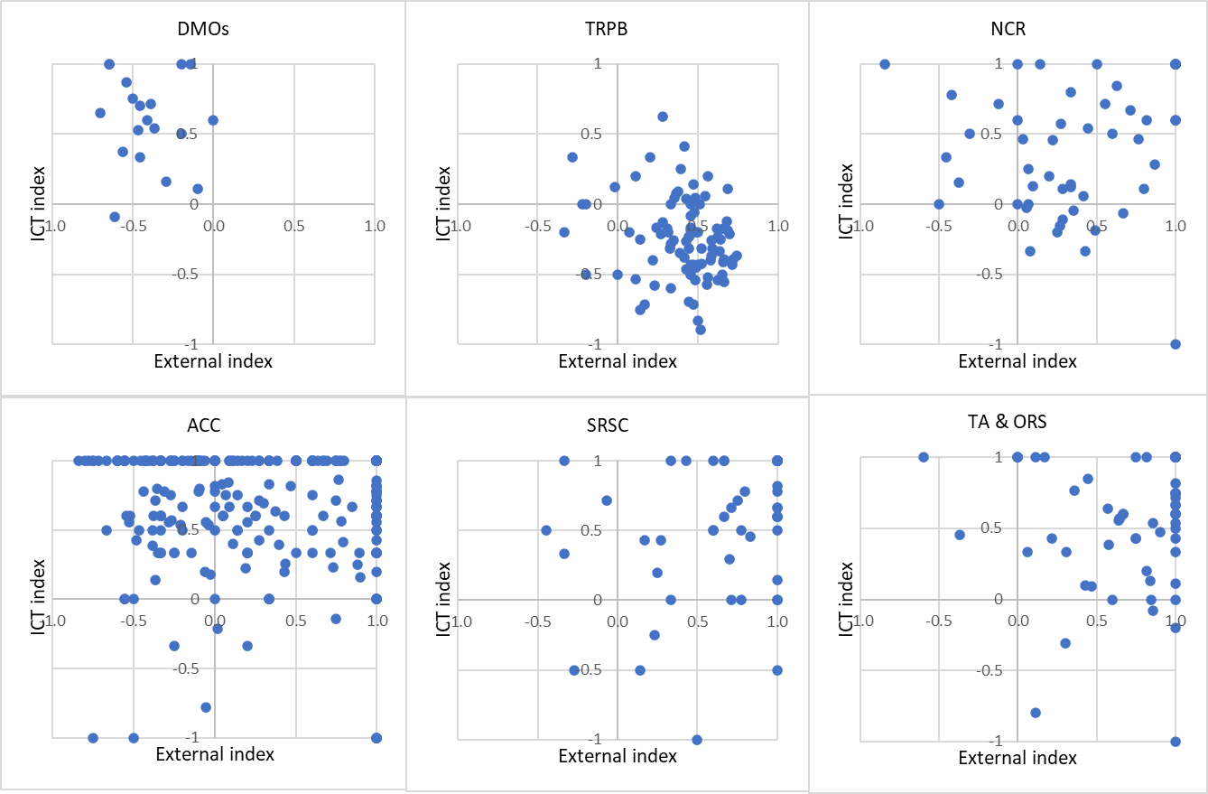
Note. Scores range from -1.0 to +1.0. External index: +1.0 represents complete linkage to external actors, -1.0 represents exclusive linkage to internal actors, and 0 indicates a balanced state of linking to both categories. ICT index: +1.0 represents complete linkage to ICT actors, -1.0 represents exclusive linkage to institutional and socio-economic non-tourism actors, and 0 indicates a balanced state of linking to both categories. In the visualisation, only actors with both calculable indexes are included. For a more detailed representation of the distributions of each index, refer to the complementary materials.
Source: Created by authors.
Figure 5. The External index distribution: A disposition of core tourism actors to link to external actors as opposed to internal (tourism) actors
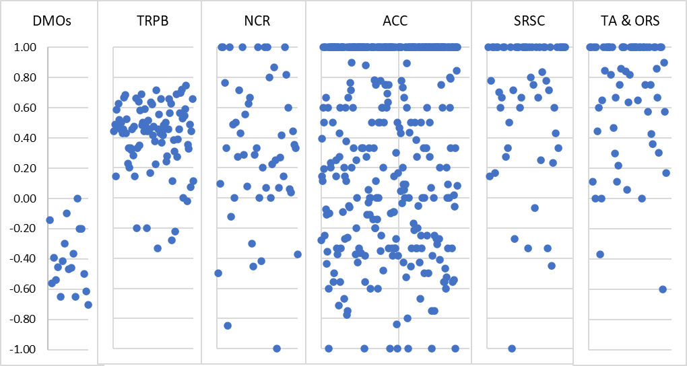
Note. Scores range from -1.0 to +1.0, where +1.0 represents complete linkage to external (non-tourism) actors, -1.0 represents exclusive linkage to internal (tourism) actors, and 0 indicates a balanced state of linking to both categories.
Source: Created by authors.
Figure 6. The ICT index distribution: A disposition of tourism actors to link to ICT actors as opposed to institutional and socio-economic non-tourism (ISEN) actors
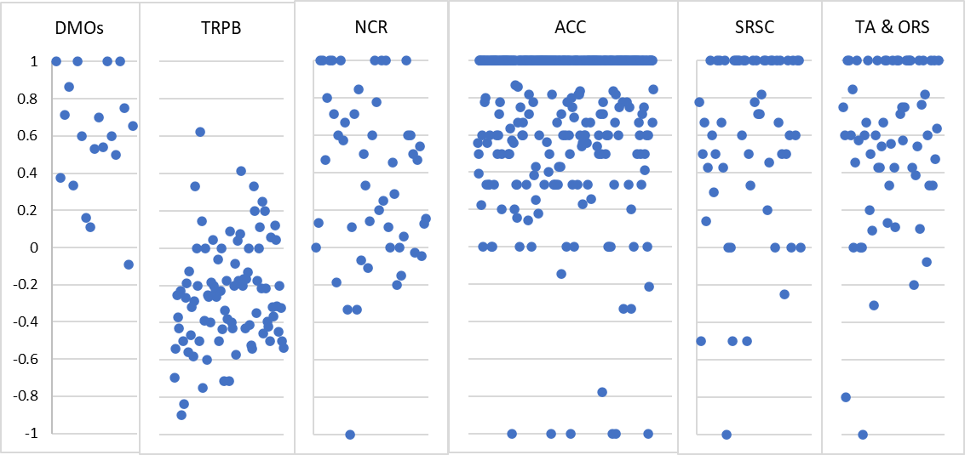
Note. Scores range from -1.0 to +1.0, where +1.0 represents complete linkage to ICT actors, -1.0 represents exclusive linkage to ISEN actors, and 0 indicates a balanced state of linking to both categories.
Source: Created by authors.
Figure 7. The T-Tech index distribution: A disposition of tourism actors to link to travel tech actors as opposed to general ICT actors
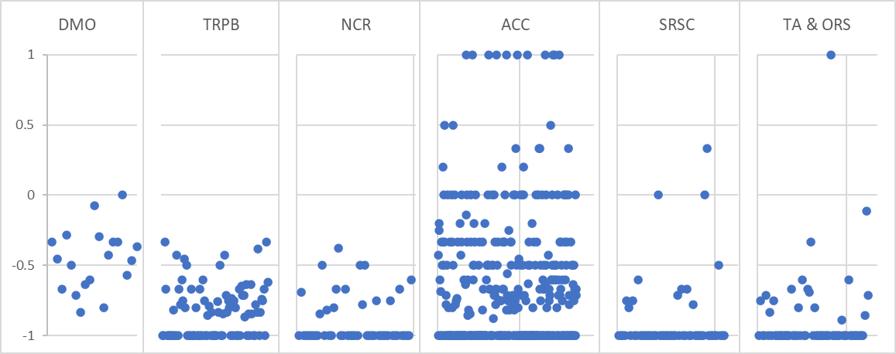

Note. Scores range from -1.0 to +1.0, where +1.0 represents complete linkage to travel tech actors, -1.0 represents exclusive linkage to general ICT actors, and 0 indicates a balanced state of linking to both categories.
Source: Created by authors.

Annexe 9. “Passive” behaviours
Table 5. “Passive” behaviours in varying tourism sectors
Destination ecosystem actors | N | “Passive” behaviours according to the index
Destination ecosystem actors | N | External index¹ | ICT index² | T-Tech index³
The “core” tourism actors (total) | 670 | 6% | 7% | 9%
DMOs | 19 | 0% | 0% | 0%
Tourism-related public bodies | 89 | 0% | 0% | 0%
Natural and cultural resources | 51 | 0% | 2% | 4%
Accommodations | 382 | 8% | 10% | 11%
Sports and recreation service companies | 62 | 8% | 10% | 11%
Travel agencies and other reservation services | 67 | 6% | 6% | 7%
Note. The percentage reflects the proportion of actors whose index could not be calculated due to the absence of links to the specified categories. Percentages are calculated based on the total number of actors in each category (N); they indicate the proportion of actors exhibiting “passive” behaviour within a given sector.
¹ Percentage of actors lacking outgoing links to internal (tourism) and external actors (institutional and socio-economic non-tourism actors; ICT actors).
² Percentage of actors lacking outgoing links to external actors, including institutional and socio-economic non-tourism actors and ICT actors.
³ Percentage of actors lacking outgoing links to ICT actors, including general ICT actors and travel tech actors.
Source: Created by authors.

Annexe 10. Comparison of the connecting activity of tourism sectors
Table 6. Comparison of the connecting activity of tourism sectors: the Mann–Whitney test
Connecting activity of tourism actors with particular types of actors | Compared tourism sectors |  | Mean Rank Sector 1 | Mean Rank Sector 2 | Sum of Ranks Sector 1 | Sum of Ranks Sector 2 | Mann-Whitney U | Wilcoxon W | Z | Asymp. Sig. (2-tailed)
 | Sector 1 | Sector 2
ICT actors | DMO | TRPB | 60 | 53 | 1134 | 4753 | 748 | 4753 | -0.793 | 0.428
ICT actors | DMO | NCR | 44 | 32 | 832 | 1654 | 328 | 1654 | -2.078 | 0.038
ICT actors | DMO | AC | 331 | 195 | 6280 | 74322 | 1169 | 74322 | -5.013 | <.001
ICT actors | DMO | SRSC | 63 | 34 | 1201 | 2120 | 167 | 2120 | -4.721 | <.001
ICT actors | DMO | TARS | 61 | 39 | 1153 | 2589 | 311 | 2589 | -3.403 | <.001
ICT actors | TRPB | NCR | 76 | 61 | 6763 | 3108 | 1782 | 3108 | -2.118 | 0.034
ICT actors | TRPB | AC | 347 | 210 | 30903 | 80254 | 7101 | 80254 | -8.592 | <.001
ICT actors | TRPB | SRSC | 95 | 49 | 8463 | 3013 | 1060 | 3013 | -6.441 | <.001
ICT actors | TRPB | TARS | 92 | 60 | 8226 | 4021 | 1743 | 4021 | -4.446 | <.001
ICT actors | NCR | AC | 306 | 205 | 15615 | 78346 | 5193 | 78346 | -5.442 | <.001
ICT actors | NCR | SRSC | 73 | 44 | 3709 | 2732 | 779 | 2732 | -4.644 | <.001
ICT actors | NCR | TARS | 68 | 53 | 3454 | 3567 | 1289 | 3567 | -2.286 | 0.022
ICT actors | AC | SRSC | 223 | 219 | 85196 | 13594 | 11641 | 13594 | -0.216 | 0.829
ICT actors | AC | TARS | 217 | 270 | 82938 | 18088 | 9785 | 82938 | -3.089 | 0.002
ICT actors | SRSC | TARS | 56 | 73 | 3472 | 4913 | 1519 | 3472 | -2.641 | 0.008
ISEN actors | DMO | TRPB | 17 | 62 | 331 | 5555 | 141 | 331 | -5.69 | <.001
ISEN actors | DMO | NCR | 33 | 36 | 629 | 1857 | 439 | 629 | -0.613 | 0.54
ISEN actors | DMO | AC | 311 | 196 | 5902 | 74700 | 1547 | 74700 | -4.854 | <.001
ISEN actors | DMO | SRSC | 54 | 37 | 1030 | 2292 | 339 | 2292 | -2.903 | 0.004
ISEN actors | DMO | TARS | 51 | 41 | 977 | 2764 | 486 | 2764 | -1.601 | 0.109
ISEN actors | TRPB | NCR | 89 | 38 | 7908 | 1963 | 637 | 1963 | -7.079 | <.001
ISEN actors | TRPB | AC | 422 | 193 | 37582 | 73574 | 421 | 73574 | -15.482 | <.001
ISEN actors | TRPB | SRSC | 106 | 33 | 9458 | 2018 | 65 | 2018 | -10.233 | <.001
ISEN actors | TRPB | TARS | 109 | 38 | 9733 | 2514 | 236 | 2514 | -9.856 | <.001
ISEN actors | NCR | AC | 332 | 202 | 16937 | 77024 | 3871 | 77024 | -7.86 | <.001
ISEN actors | NCR | SRSC | 71 | 45 | 3641 | 2800 | 847 | 2800 | -4.342 | <.001
ISEN actors | NCR | TARS | 70 | 52 | 3551 | 3471 | 1193 | 3471 | -2.848 | 0.004
ISEN actors | AC | SRSC | 216 | 265 | 82349 | 16441 | 9196 | 82349 | -3.233 | 0.001
ISEN actors | AC | TARS | 212 | 297 | 81105 | 19920 | 7952 | 81105 | -5.591 | <.001
ISEN actors | SRSC | TARS | 59 | 71 | 3652 | 4733 | 1699 | 3652 | -1.853 | 0.064
Tourism actors | DMO | TRPB | 83 | 48 | 1583 | 4303 | 298 | 4303 | -4.432 | <.001
Tourism actors | DMO | NCR | 54 | 29 | 1026 | 1459 | 133 | 1459 | -4.649 | <.001
Tourism actors | DMO | AC | 372 | 193 | 7062 | 73539 | 386 | 73539 | -6.89 | <.001
Tourism actors | DMO | SRSC | 71 | 32 | 1350 | 1972 | 19 | 1972 | -6.608 | <.001
Tourism actors | DMO | TARS | 75 | 35 | 1422 | 2319 | 41 | 2319 | -6.392 | <.001
Tourism actors | TRPB | NCR | 76 | 60 | 6794 | 3076 | 1750 | 3076 | -2.256 | 0.024
Tourism actors | TRPB | AC | 364 | 206 | 32407 | 78749 | 5596 | 78749 | -10.146 | <.001
Tourism actors | TRPB | SRSC | 104 | 36 | 9246 | 2230 | 277 | 2230 | -9.455 | <.001
Tourism actors | TRPB | TARS | 105 | 43 | 9336 | 2910 | 632 | 2910 | -8.466 | <.001
Tourism actors | NCR | AC | 296 | 207 | 15072 | 78890 | 5737 | 78890 | -4.976 | <.001
Tourism actors | NCR | SRSC | 76 | 41 | 3876 | 2565 | 612 | 2565 | -5.748 | <.001
Tourism actors | NCR | TARS | 77 | 46 | 3920 | 3101 | 823 | 3101 | -4.925 | <.001
Tourism actors | AC | SRSC | 228 | 188 | 87140 | 11651 | 9698 | 11651 | -2.425 | 0.015
Tourism actors | AC | TARS | 228 | 208 | 87112 | 13913 | 11635 | 13913 | -1.254 | 0.21
Tourism actors | SRSC | TARS | 62 | 68 | 3837 | 4548 | 1884 | 3837 | -0.983 | 0.326
General ICT | DMO | TRPB | 50 | 56 | 943 | 4943 | 753 | 943 | -0.748 | 0.454
General ICT | DMO | NCR | 37 | 35 | 699 | 1786 | 460 | 1786 | -0.325 | 0.745
General ICT | DMO | AC | 316 | 195 | 6003 | 74598 | 1445 | 74598 | -4.458 | <.001
General ICT | DMO | SRSC | 59 | 36 | 1116 | 2205 | 252 | 2205 | -3.774 | <.001
General ICT | DMO | TARS | 54 | 40 | 1032 | 2710 | 432 | 2710 | -2.142 | 0.032
General ICT | TRPB | NCR | 75 | 63 | 6653 | 3217 | 1891 | 3217 | -1.643 | 0.1
General ICT | TRPB | AC | 354 | 209 | 31471 | 79686 | 6533 | 79686 | -9.097 | <.001
General ICT | TRPB | SRSC | 94 | 50 | 8396 | 3080 | 1127 | 3080 | -6.188 | <.001
General ICT | TRPB | TARS | 91 | 61 | 8128 | 4118 | 1840 | 4118 | -4.097 | <.001
General ICT | NCR | AC | 320 | 203 | 16302 | 77660 | 4507 | 77660 | -6.273 | <.001
General ICT | NCR | SRSC | 73 | 44 | 3715 | 2727 | 774 | 2727 | -4.676 | <.001
General ICT | NCR | TARS | 68 | 53 | 3469 | 3553 | 1275 | 3553 | -2.365 | 0.018
General ICT | AC | SRSC | 220 | 237 | 84112 | 14678 | 10959 | 84112 | -0.949 | 0.343
General ICT | AC | TARS | 214 | 286 | 81845 | 19181 | 8692 | 81845 | -4.216 | <.001
General ICT | SRSC | TARS | 56 | 74 | 3458 | 4927 | 1505 | 3458 | -2.708 | 0.007
Travel tech | DMO | TRPB | 83 | 48 | 1578 | 4309 | 304 | 4309 | -4.587 | <.001
Travel tech | DMO | NCR | 56 | 28 | 1070 | 1416 | 90 | 1416 | -5.662 | <.001
Travel tech | DMO | AC | 335 | 194 | 6358 | 74243 | 1090 | 74243 | -5.559 | <.001
Travel tech | DMO | SRSC | 69 | 32 | 1313 | 2008 | 55 | 2008 | -6.848 | <.001
Travel tech | DMO | TARS | 72 | 35 | 1371 | 2371 | 93 | 2371 | -6.362 | <.001
Travel tech | TRPB | NCR | 77 | 59 | 6874 | 2996 | 1670 | 2996 | -2.871 | 0.004
Travel tech | TRPB | AC | 247 | 234 | 21950 | 89207 | 16054 | 89207 | -0.887 | 0.375
Travel tech | TRPB | SRSC | 88 | 59 | 7820 | 3656 | 1703 | 3656 | -4.551 | <.001
Travel tech | TRPB | TARS | 89 | 65 | 7919 | 4327 | 2049 | 4327 | -3.759 | <.001
Travel tech | NCR | AC | 174 | 223 | 8871 | 85090 | 7545 | 8871 | -2.867 | 0.004
Travel tech | NCR | SRSC | 60 | 54 | 3082 | 3359 | 1406 | 3359 | -1.357 | 0.175
Travel tech | NCR | TARS | 61 | 58 | 3111 | 3910 | 1632 | 3910 | -0.534 | 0.594
Travel tech | AC | SRSC | 233 | 156 | 89122 | 9668 | 7715 | 9668 | -4.861 | <.001
Travel tech | AC | TARS | 234 | 172 | 89471 | 11554 | 9276 | 11554 | -3.957 | <.001
Travel tech | SRSC | TARS | 63 | 67 | 3892 | 4493 | 1939 | 3892 | -0.894 | 0.371
Note. AC: Accommodations; DMO: Destination management organisations; NCR—Natural and cultural resources; TRPB—Tourism-related public bodies; TARS: Travel agencies and other reservation services; SRSC: Sports and recreation service companies.
Source: Created by authors.

Annexe 11. Relationship between varying networking behaviours of tourism actors, ecosystem leadership, integration levels, and mediation engagement

Table 7. Relationship between varying networking behaviours of tourism actors (n = 670), ecosystem leadership, integration levels, and mediation engagement
Networking behaviours | Ecosystem leadership | Integration level | Mediation  engagement
Variety of connections | .460* | .454* | .505*
Connecting activity (CA) | .502* | .469* | .518*
CA: tourism actors | .401* | .457* | .547*
CA: institutional and socio-economic non-tourism actors | .455* | .365* | .392*
CA: ICT actors | .488* | .390* | .414*
CA: general ICT | .487* | .372* | .392*
CA: travel tech | .192* | .226* | .274*
Note. *Correlation is significant at the 0.01 level (2-tailed). Method: Spearman’s rank correlation coefficient. The strength of the correlation is described according to the scale: 0 < |ρ| ≤ 0.39 weak, 0.40 < |ρ| ≤ 0.69 moderate, 0.70 < |ρ| ≤ 0.99 strong, 1.0 perfect, according to Corder, G.W. and Foreman, D.I. (2014), Nonparametric Statistics: A Step-by-Step Approach, John Wiley & Sons, p. 140.
Source: Created by authors.

Annexe 12. Comparison of clusters according to structural and behavioural characteristics
Table 8. Comparison of clusters according to structural and behavioural characteristics (the Mann–Whitney test)
Structural and behavioural characteristics | Compared clusters |  | Mean Rank Cluster 1 | Mean Rank Cluster 2 | Sum of Ranks Cluster 1 | Sum of Ranks Cluster 2 | Mann-Whitney U | Wilcoxon W | Z | Asymp. Sig. (2-tailed)
Structural and behavioural characteristics | Cluster 1 | Cluster 2
Ecosystem leadership | Inward-ICT | Outward-ISEN | 133 | 198 | 22407 | 31549 | 8042 | 22407 | -6.29 | <.001
Ecosystem leadership | Inward-ICT | Outward-general-ICT | 220 | 205 | 37220 | 51611 | 19733 | 51611 | -1.28 | 0.202
Ecosystem leadership | Inward-ICT | Outward-travel-tech | 105 | 83 | 17766 | 2738 | 2177 | 2738 | -1.99 | 0.046
Ecosystem leadership | Outward-ISEN | Outward-general-ICT | 260 | 172 | 41413 | 43253 | 11375 | 43253 | -7.38 | <.001
Ecosystem leadership | Outward-ISEN | Outward-travel-tech | 107 | 45 | 17036 | 1492 | 931 | 1492 | -5.83 | <.001
Ecosystem leadership | Outward-general-ICT | Outward-travel-tech | 145 | 126 | 36599 | 4156 | 3595 | 4156 | -1.27 | 0.206
Integration level | Inward-ICT | Outward-ISEN | 154 | 176 | 25944 | 28013 | 11579 | 25944 | -2.2 | 0.028
Integration level | Inward-ICT | Outward-general-ICT | 244 | 189 | 41282 | 47549 | 15671 | 47549 | -4.79 | <.001
Integration level | Inward-ICT | Outward-travel-tech | 107 | 75 | 18039 | 2464 | 1903 | 2464 | -2.99 | 0.003
Integration level | Outward-ISEN | Outward-general-ICT | 255 | 175 | 40478 | 44188 | 12310 | 44188 | -6.78 | <.001
Integration level | Outward-ISEN | Outward-travel-tech | 104 | 61 | 16501 | 2027 | 1466 | 2027 | -4.04 | <.001
Integration level | Outward-general-ICT | Outward-travel-tech | 144 | 137 | 36221 | 4534 | 3973 | 4534 | -0.44 | 0.661
Mediation | Inward-ICT | Outward-ISEN | 165 | 163 | 27964 | 25992 | 13272 | 25992 | -0.23 | 0.818
Mediation | Inward-ICT | Outward-general-ICT | 247 | 187 | 41721 | 47111 | 15233 | 47111 | -7.78 | <.001
Mediation | Inward-ICT | Outward-travel-tech | 106 | 76 | 17994 | 2510 | 1949 | 2510 | -3.47 | <.001
Mediation | Outward-ISEN | Outward-general-ICT | 241 | 184 | 38355 | 46312 | 14434 | 46312 | -7.62 | <.001
Mediation | Outward-ISEN | Outward-travel-tech | 101 | 73 | 16121 | 2408 | 1847 | 2408 | -3.42 | <.001
Mediation | Outward-general-ICT | Outward-travel-tech | 143 | 141 | 36110 | 4646 | 4085 | 4646 | -0.46 | 0.648
Variety of connections | Inward-ICT | Outward-ISEN | 151 | 179 | 25461 | 28496 | 11096 | 25461 | -2.74 | 0.006
Variety of connections | Inward-ICT | Outward-general-ICT | 324 | 135 | 54693 | 34139 | 2261 | 34139 | -15.7 | <.001
Variety of connections | Inward-ICT | Outward-travel-tech | 115 | 32 | 19436 | 1068 | 506.5 | 1068 | -7.48 | <.001
Variety of connections | Outward-ISEN | Outward-general-ICT | 316 | 137 | 50200 | 34466 | 2588 | 34466 | -15.1 | <.001
Variety of connections | Outward-ISEN | Outward-travel-tech | 110 | 32 | 17488 | 1041 | 479.5 | 1041 | -7.41 | <.001
Variety of connections | Outward-general-ICT | Outward-travel-tech | 140 | 163 | 35362 | 5394 | 3484 | 35362 | -1.58 | 0.115
Connecting activity (CA) | Inward-ICT | Outward-ISEN | 143 | 188 | 24085 | 29872 | 9720 | 24085 | -4.33 | <.001
Connecting activity (CA) | Inward-ICT | Outward-general-ICT | 295 | 155 | 49833 | 38998 | 7120 | 38998 | -11.6 | <.001
Connecting activity (CA) | Inward-ICT | Outward-travel-tech | 114 | 35 | 19340 | 1163 | 602 | 1163 | -7.12 | <.001
Connecting activity (CA) | Outward-ISEN | Outward-general-ICT | 300 | 147 | 47668 | 36998 | 5120 | 36998 | -12.7 | <.001
Connecting activity (CA) | Outward-ISEN | Outward-travel-tech | 110 | 31 | 17520 | 1008 | 447 | 1008 | -7.5 | <.001
Connecting activity (CA) | Outward-general-ICT | Outward-travel-tech | 148 | 107 | 37232 | 3523 | 2962 | 3523 | -2.7 | 0.007
CA: tourism actors | Inward-ICT | Outward-ISEN | 181 | 147 | 30615 | 23342 | 10622 | 23342 | -3.29 | 0.001
CA: tourism actors | Inward-ICT | Outward-general-ICT | 333 | 129 | 56307 | 32524 | 646 | 32524 | -17.5 | <.001
CA: tourism actors | Inward-ICT | Outward-travel-tech | 116 | 29 | 18577 | 1926 | 411.5 | 972.5 | -7.75 | <.001
CA: tourism actors | Outward-ISEN | Outward-general-ICT | 312 | 139 | 49563 | 35103 | 3225 | 35103 | -15.1 | <.001
CA: tourism actors | Outward-ISEN | Outward-travel-tech | 108 | 41 | 17173 | 1356 | 794.5 | 1356 | -6.32 | <.001
CA: tourism actors | Outward-general-ICT | Outward-travel-tech | 139 | 170 | 35130 | 5625 | 3252 | 35130 | -2.47 | 0.014
CA: ISEN actors | Inward-ICT | Outward-ISEN | 97 | 236 | 16365 | 37592 | 2000 | 16365 | -13.5 | <.001
CA: ISEN actors | Inward-ICT | Outward-general-ICT | 240 | 192 | 40532 | 48300 | 16422 | 48300 | -4.41 | <.001
CA: ISEN actors | Inward-ICT | Outward-travel-tech | 108 | 69 | 19531 | 973 | 1705 | 2266 | -3.8 | <.001
CA: ISEN actors | Outward-ISEN | Outward-general-ICT | 323 | 132 | 51404 | 33263 | 1385 | 33263 | -16.4 | <.001
CA: ISEN actors | Outward-ISEN | Outward-travel-tech | 112 | 20 | 17863 | 665 | 104 | 665 | -8.69 | <.001
CA: ISEN actors | Outward-general-ICT | Outward-travel-tech | 146 | 120 | 36800 | 3956 | 3395 | 3956 | -2.03 | 0.043
CA: ICT actors | Inward-ICT | Outward-ISEN | 147 | 183 | 24822 | 29135 | 10457 | 24822 | -3.48 | <.001
CA: ICT actors | Inward-ICT | Outward-general-ICT | 215 | 209 | 36256 | 52575 | 20697 | 52575 | -0.49 | 0.624
CA: ICT actors | Inward-ICT | Outward-travel-tech | 110 | 58 | 18237 | 2266 | 1365 | 1926 | -4.66 | <.001
CA: ICT actors | Outward-ISEN | Outward-general-ICT | 240 | 185 | 38085 | 46581 | 14703 | 46581 | -4.56 | <.001
CA: ICT actors | Outward-ISEN | Outward-travel-tech | 106 | 50 | 16862 | 1666 | 1105 | 1666 | -5.25 | <.001
CA: ICT actors | Outward-general-ICT | Outward-travel-tech | 152 | 75 | 38273 | 2482 | 1921 | 2482 | -5.05 | <.001
CA: general ICT | Outward-general-ICT | Outward-travel-tech | 157 | 35 | 39589 | 1167 | 605.5 | 1167 | -8.03 | <.001
CA: general ICT | Outward-ISEN | Outward-travel-tech | 110 | 30 | 17541 | 987 | 426 | 987 | -7.6 | <.001
CA: general ICT | Outward-general-ICT | Outward-ISEN | 185 | 239 | 46596 | 38071 | 14718 | 46596 | -4.55 | <.001
CA: general ICT | Inward-ICT | Outward-travel-tech | 114 | 36 | 19318 | 1186 | 624.5 | 1186 | -7.11 | <.001
CA: general ICT | Outward-general-ICT | Inward-ICT | 220 | 198 | 55445 | 33387 | 19022 | 33387 | -1.87 | 0.062
CA: general ICT | Outward-ISEN | Inward-ICT | 192 | 138 | 30554 | 23402 | 9037 | 23402 | -5.15 | <.001
CA: travel tech | Outward-general-ICT | Outward-travel-tech | 130 | 241 | 32803 | 7953 | 924.5 | 32803 | -8.22 | <.001
CA: travel tech | Outward-ISEN | Outward-travel-tech | 86 | 146 | 13701 | 4827 | 981 | 13701 | -6.12 | <.001
CA: travel tech | Outward-general-ICT | Outward-ISEN | 199 | 217 | 50177 | 34490 | 18299 | 50177 | -1.73 | 0.084
CA: travel tech | Inward-ICT | Outward-travel-tech | 96 | 129 | 16238 | 4266 | 1873 | 16238 | -3.17 | 0.002
CA: travel tech | Outward-general-ICT | Inward-ICT | 172 | 269 | 43355 | 45476 | 11477 | 43355 | -8.78 | <.001
CA: travel tech | Outward-ISEN | Inward-ICT | 136 | 191 | 21646 | 32311 | 8926 | 21646 | -5.59 | <.001

Source: Created by authors.

