Supplementary File

S1. Relationship between ethical orientations and AI acceptance by context
[Source: Authors’ own work]
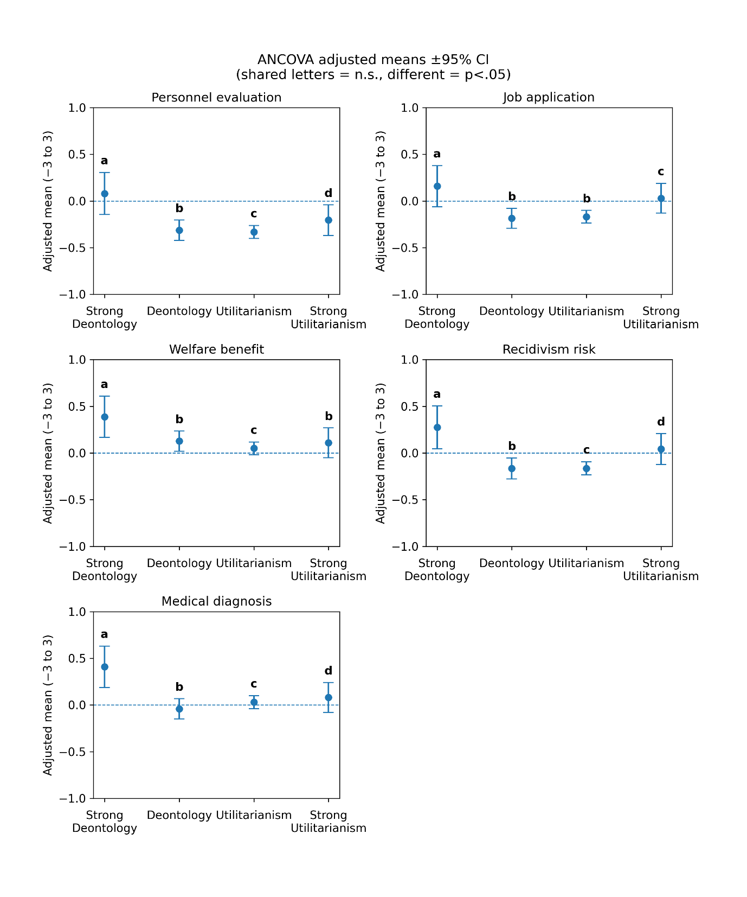

S2. Relationship between mind attribution and AI acceptance by context
[Source: Authors’ own work]
