Supplementary Table A1. Panel cross-sectional dependence tests
Model | Pesaran CD | Frees | Friedman
FE | 12.706***  (0.000) | 0.918***  (α = 0.01: 0.213) | 71.503***  (0.000)
RE | 12.532***  (0.000) | 0.777***  (α = 0.01: 0.213) | 66.516***  (0.000)
Notes: Panel reports the Pesaran’s CD test, Frees’s test, and Friedman’s test for fixed effect and random effect models. *** denote statistical significance of the coefficients at 1% level.
Source: Authors’ estimation

Supplementary Table A2. Panel unit root test results
Variable | CIPS test
Variable | Level | First difference
GDP | -4.269*** | -5.748***
ES | -3.265*** | -5.531***
EE | -2.904*** | -5.308***
ENS | -1.906 | -4.024***
POP | -0.622 | -2.881***
TRADE | -1.255 | -3.816***
Notes: *** denote statistical significance at 1% level.
Source: Authors’ estimation

Supplementary Table A3. Westerlund panel cointegration test results
 | G_{t} | G_{a} | P_{t} | P_{a}
Statistic Value | -3.604*** | -8.934** | -7.780** | -9.626**
Z- value | -3.655 | 0.961 | -2.293 | -0.530
Bootstrap p-value | 0.002 | 0.032 | 0.028 | 0.012
Notes: The bootstrap p-value is simulated with 500 steps. ***, ** denote significance at 1% and 5% levels, respectively. Bartlett-Kernel Window width is set based on 4 (T/100) 2/9 ≈ 3; The test was performed with the xtwest command in Stata according to Persyn and Westerlund (2008).
Source: Authors’ estimation

Supplementary Appendix A: Variable definition
Type | Variable | Variable definition | Source
Dependent variable | GDP | GDP growth is annual percentage growth rate of GDP at market prices based on constant local currency | World Development Indicators
Independent variables | EE | Energy equity assesses a country’s ability to provide universal access to affordable, fairly priced and abundant energy for domestic and commercial use | World Energy Council
Independent variables | ES | Energy security measures reflect a nation’s ability to meet current and future energy demands reliably, withstand and bounce back swiftly from system shocks with minimal disruption to supplies | World Energy Council
Independent variables | ENS | Environmental Sustainability represents the transition of a country’s energy system toward mitigating and avoiding potential environmental harm and climate change impacts | World Energy Council
Control variables | POP | Population growth is measured as the exponential rate of growth of the population from year t-1 to t | World Development Indicators
Control variables | TRADE | Trade openness is the sum of exports and imports of goods and services measured as a share of gross domestic product. | World Development Indicators

Supplementary Appendix B. Robustness and Stability Diagnostics for the PMG–ARDL Model
This appendix provides additional diagnostic evidence to verify the stability and robustness of the PMG–ARDL model. Following standard practices in applied econometrics and aligned with Emerald’s academic style, the residual behaviour is examined using Histogram and Q–Q plots for all seven ASEAN countries. These graphical diagnostics are essential for assessing the adequacy of dynamic panel models and the validity of inference (Wilk and Gnanadesikan, 1968; Thode, 2002; Gujarati and Porter, 2009).
The histogram results presented in Figure B1 show that the residuals are distributed approximately symmetrically around zero and closely follow the fitted normal density curves. None of the countries exhibits substantial skewness, multimodality, or irregular peaks. Minor deviations at the tails—observed particularly in Malaysia and Singapore—are typical of macroeconomic data and do not indicate misspecification. These patterns suggest that the residuals behave randomly and do not reflect omitted-variable biases or an incorrect functional form.
The Q–Q plots in Figure B2 reinforce this conclusion. Most empirical quantiles align closely with the 45-degree theoretical line representing the normal distribution. Cambodia, Indonesia, Thailand and Vietnam display particularly strong linear conformity, while slight departures at the extreme tails in some countries remain within acceptable limits and do not impair inferential reliability. Such behaviour is consistent with the expectations for the PMG estimator, which relies on approximate normality and dynamic stability of residuals for accurate long-run estimation (Pesaran, Shin and Smith, 1999; Blackburne and Frank, 2007).
The overall consistency between the histogram and Q–Q plot diagnostics confirms that the PMG–ARDL model is well specified and exhibits stable residual properties. No evidence of structural distortions, problematic outliers, or distributional violations is detected. This strengthens confidence in the model’s dynamic structure and supports the robustness of both short-run and long-run coefficient estimates reported in the main analysis.
In summary, the diagnostic results indicate that the PMG–ARDL model is stable and adequately specified. This supports the credibility and robustness of the empirical findings for ASEAN countries.

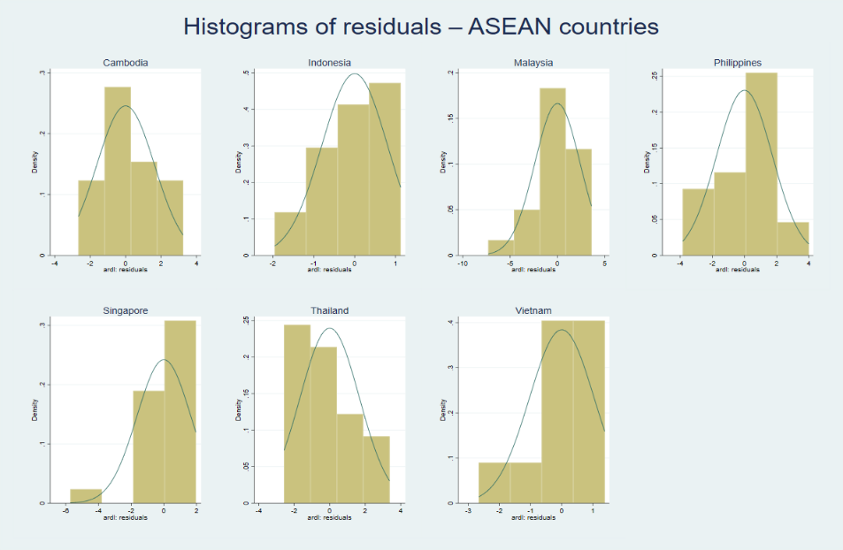
Figure B1. Histogram of residuals for ASEAN countries
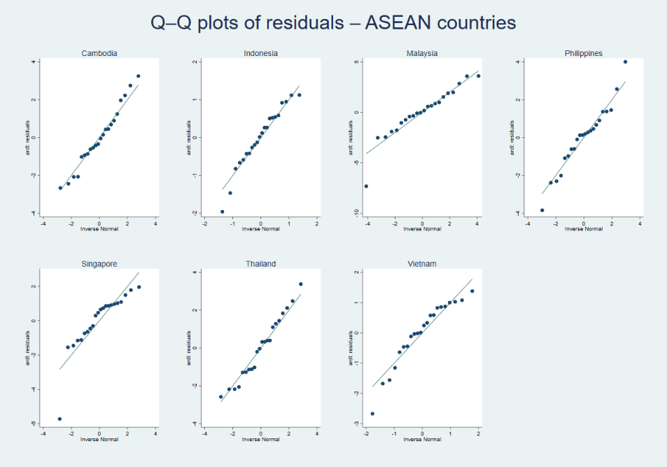
Figure B2. Q–Q plot of residuals for ASEAN countries

