Supplementary Data
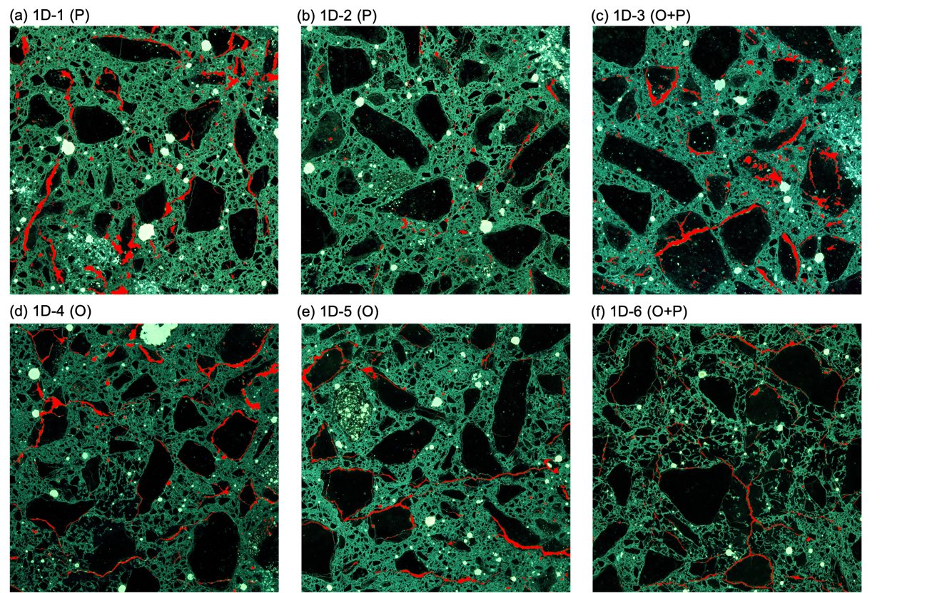
Fig. S1 crack patterns of 1D specimens

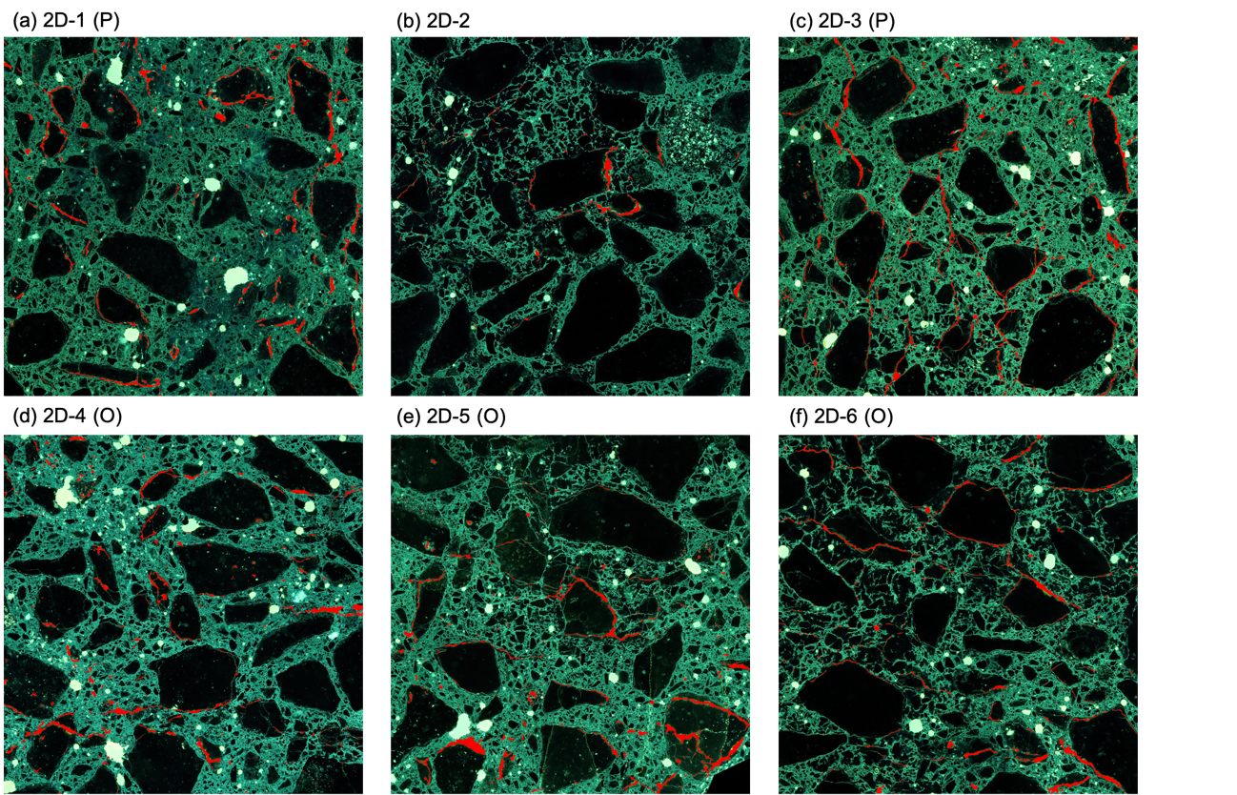
Fig. S2 crack patterns of 2D specimens

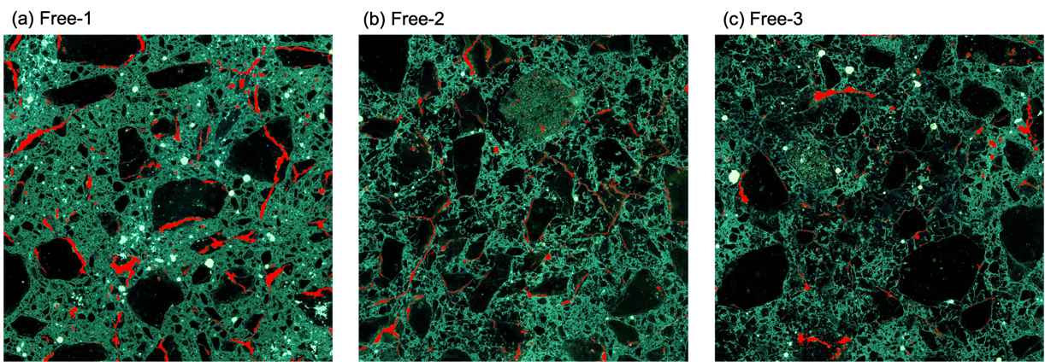
Fig. S3 Crack patterns of Free specimens

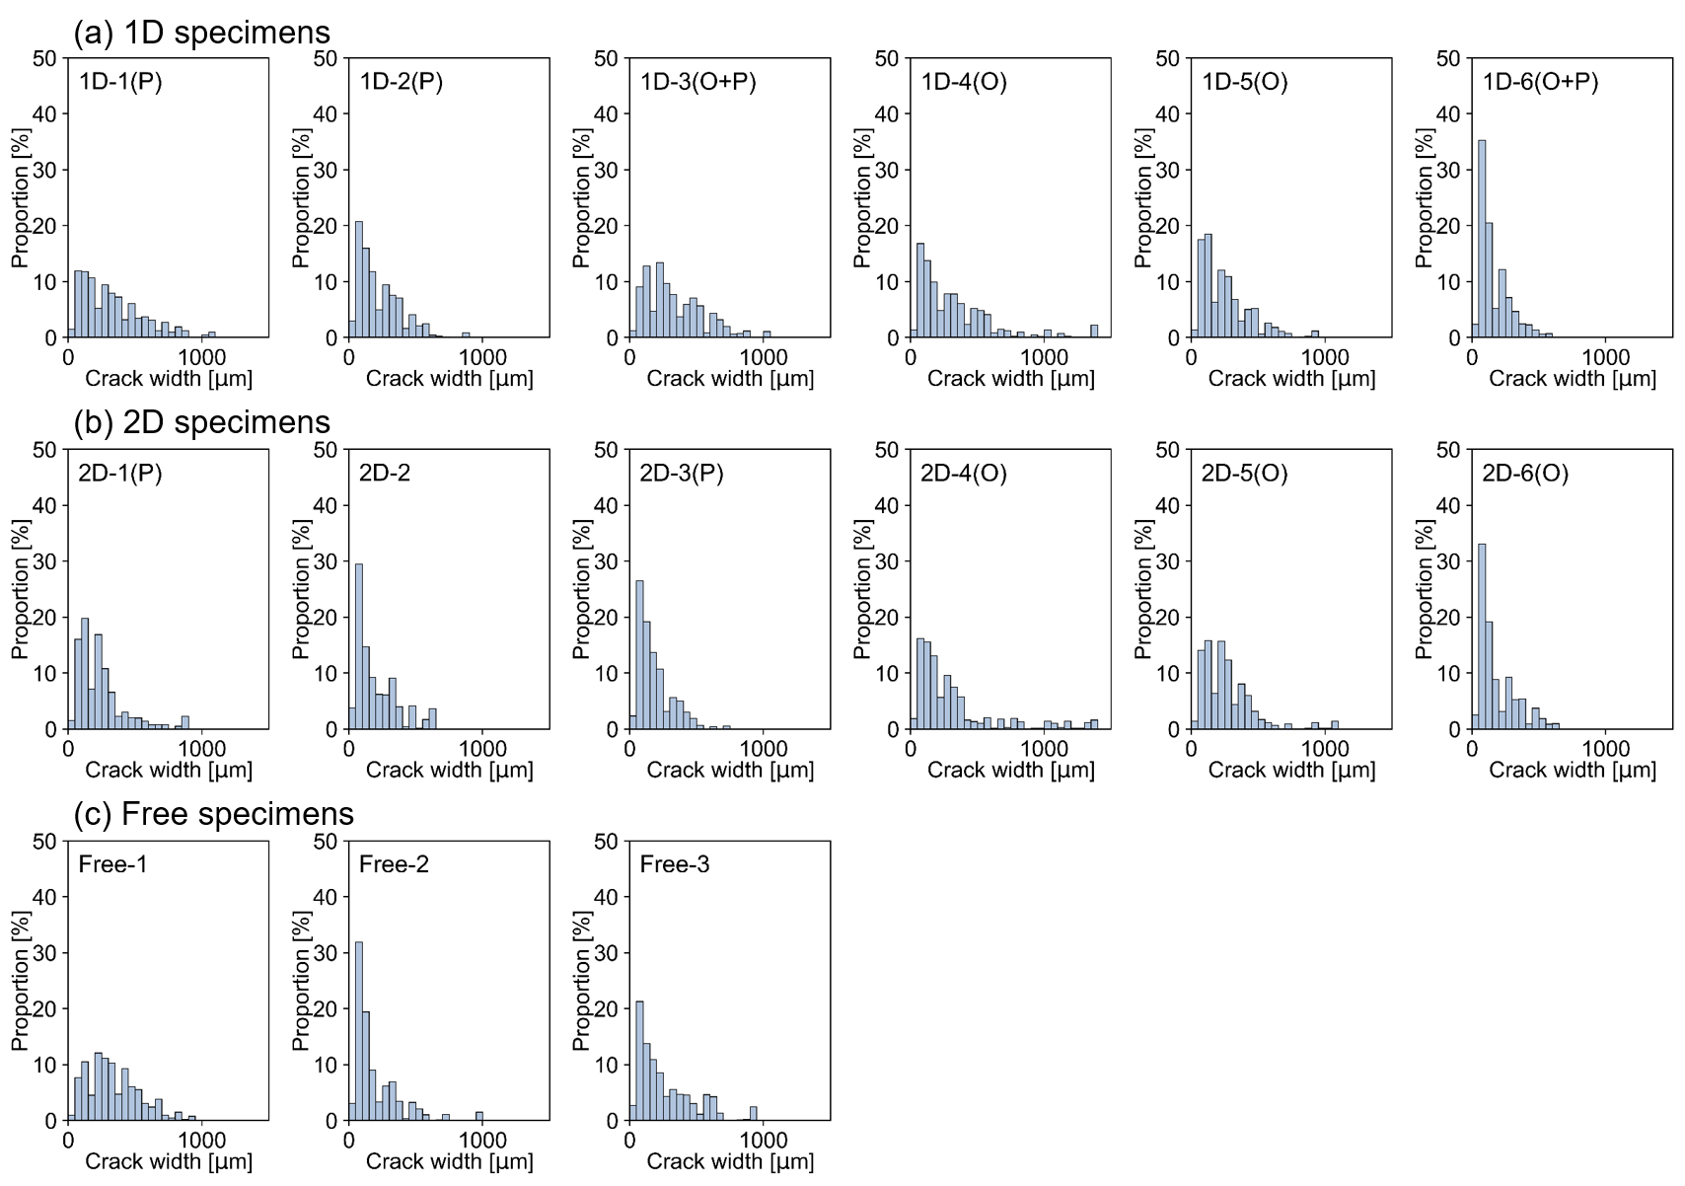
Fig. S4 Width distribution of all the specimens

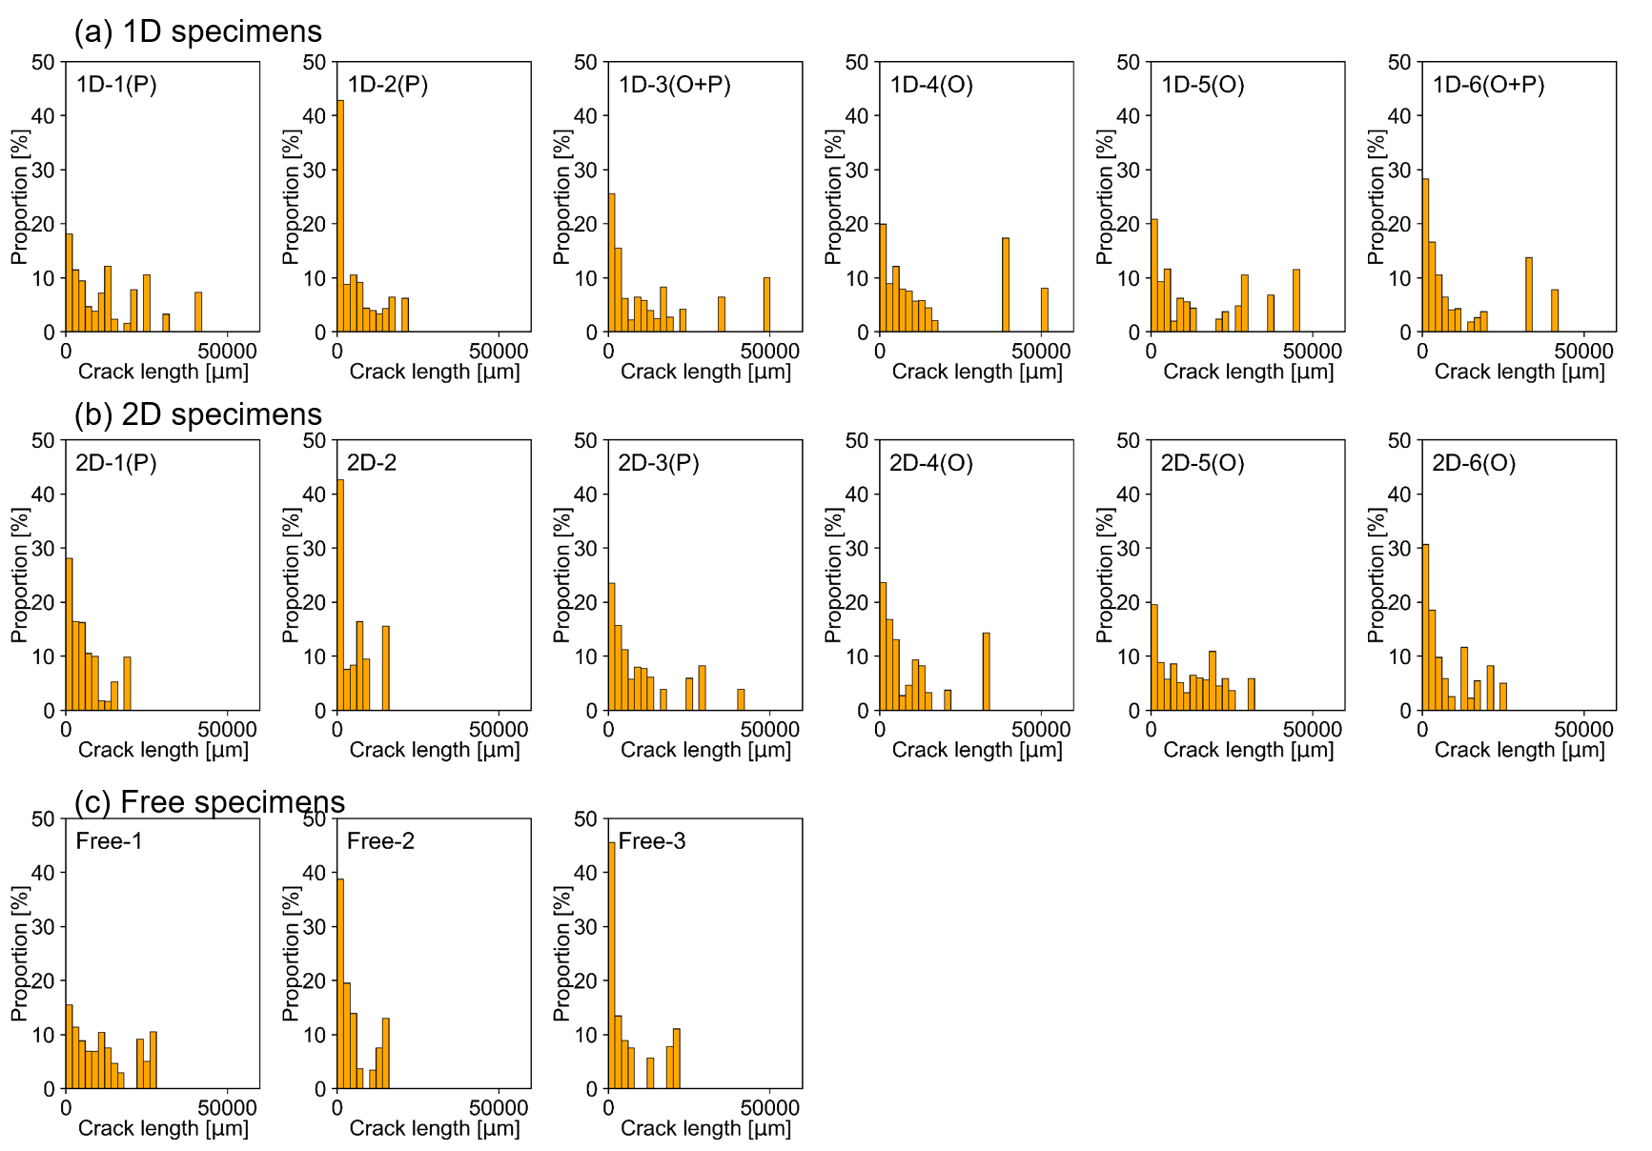
Fig. S5 Length distribution of all the specimens

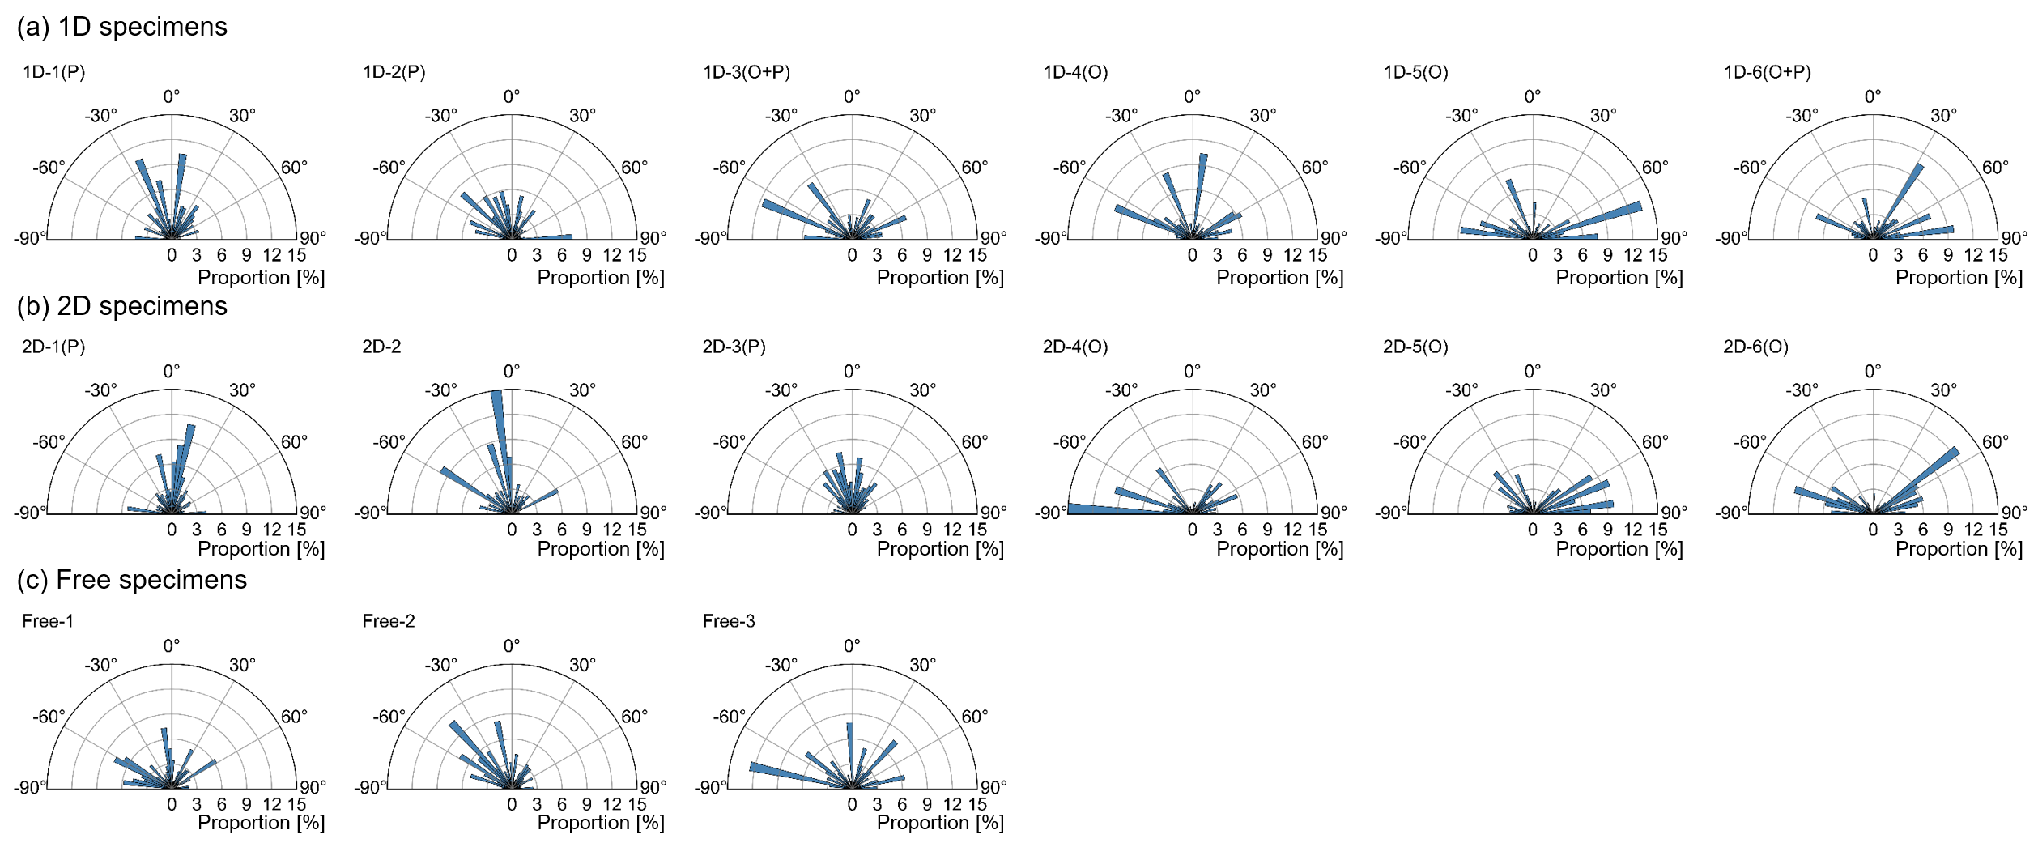
Fig. S6 Orientation distribution of all the specimens

