Supplementary Material (A)
Table 1. Description of the primary studies included in the meta-analysis
Authors and publication year | Journal | Country
Aab, Hoejland & Pedersen (2021) | RBF | US
Aabo & Eriksen (2018) | RBF | US
Aabo & Rønnow (2024) | FRL | US
Aabo, Jacobsen, & Stendys (2022) | FRL | US
Aabo, Pantzalis, Park, Trigeorgis & Wulff (2024) | JCF | US
Agnihotri & Bhattacharya (2019) | MIR | India
Agnihotri & Bhattacharya (2024) | SBR | India
Ahmad, Ishaq & Raza (2024) | CP | Pakistan
Ahn, Assaf, Josiassen, Baker, Lee, Kock & Tsionas (2020) | IJHM | US
Almaleki, Salehi & Moradi (2021) | JFM | Iran
Al-Shammari, Banerjee, Rasheed, Al-Shammari & Swimberghe (2024) | JBE | US
Al-Shammari, Rasheed & Al-Shammari (2019) | JBR | US
Al-Shammari, Rasheed & Banerjee (2022) | GOM | US
Anita, Widya, Abdillah, Hadiyati & Zakaria (2025) | JMD | Indonesia
Awuah, Elbardan & Yazdifar (2024) | BSE | UK
Bachrach, Guedes, Harms & Patel (2022) | EJWOP | Portugal
Bachrach, Kim, Patel & Harms (2023) | TLQ | South Korea
Bassyouny, Abdelfattah & Tao (2020) | IRFA | UK
Beauchesne (2014) | Thesis | US, Canada
Bildirici, Ersin & Fidan (2024) | JCP | US
Biru, Filatotchev, Bruton & Gilbert (2023) | IBR | US
Boswell (2020) | Thesis | US
Bouncken, Cesinger & Tiberius (2020) | IJEV | Germany
Bouzouitina, Khaireddine & Jarboui (2021) | SBR | UK
Buchholz, Jaeschke, Lopatta & Maas (2018) | AAAJ | US
Buchholz, Lopatta & Maas (2020) | JBE | US
Buyl, Boone & Wade (2019) | JM | US
Byun & Al-Shammari (2021) | JBR | US
Cao & Xu (2022) | JAMS | US
Capalbo, Frino, Lim, Mollica & Palumbo (2018) | A | US
Cragun (2018) | Thesis | US
Dabbebi, Lassoued & Khanchel (2022) | MDE | US
Engelen, Neumann & Schmidt (2016) | JM | US
Fung, Qiao, Yau & Zeng (2020) | IBR | China
Gao, Gao & Zhang (2024) | BS | China
Gao, Gao, Long & Wang (2023) | PRBM | China
García-Meca, Ramón-Llorens & Martínez-Ferrero (2021) | JBR | Spain
Garrido‐Ruso, Aibar‐Guzmán & Suárez‐Fernández (2023) | SD | Spain
Gerstner, König, Enders & Hambrick (2013) | ASQ | US
Greiner, Kim & Thor (2023) | JBR | US
Gupta & Misangyi (2018) | SMJ | US
Gupta, Nadkarni & Mariam (2019) | ASQ | US
Ham, Seybert & Wang (2018) | RAS | US
Hong, Lee & Roh (2022) | MDE | US
Hou, Fairchild & Perotti (2024) | JBE | US
Huang, Chen, Wang & Zeng (2019) | ITEM | China
Chang, Liang, Zhang, Yan, Tao & Zhu (2023) | H | China
Chatterjee & Hambrick (2007) | ASQ | US
Chatterjee & Hambrick (2011) | ASQ | US
Chen, Zhang & Jia (2021) | APJM | China
Chugh, Mockaitis, Lanivich & Nooshabadi (2025) | ISBJ | 6 countries (Australia, New Zealand, Canada, Ireland, UK, USA)
Ingersoll, Glass, Cook & Olsen (2019) | JBE | US
Jeon (2024) | NAJEF | US
Judd, Olsen & Stekelberg (2017) | AH | US
Junge, Graf-Vlachy, Hagen & Schlichte (2024) | JM | US
Kalbuana, Taqi, Uzliawati & Ramdhani (2023) | CBM | Indonesia
Kashmiri, Nicol & Arora (2017) | JAMS | US
Khanchel, Lassoued & Ferchichi (2025) | TIBR | 12 Middle East and North African countries
Khanchel, Lassoued & Khiari (2024) | BEER | US
Khanchel, Lassoued & Khiari (2024) | JOCM | US
Kim (2018) | S | South Korea
Kim, Lee & Kang (2018) | TM | US
Kim, Lee, Gao & Johnson (2021) | JAP | US, Canada, UK
Kind, Zeppenfeld & Lueg (2023) | BEER | Germany
Kontesa, Brahmana & Tong (2021) | JMG | Malaysia
Lassoued & Khanchel (2023) | RMS | US
Le Maux & Smaili (2024) | IJDG | France
Lee, Ha, Wei & Sarala (2023) | BJM | South Korea
Li, Wang, Yang & Tang (2022) | IMR | China
Li,Wang, Yang & Tang (2021) | JIM | China
Liao, Hu & Ye (2024) | HSSC | China
Lin, Chen, Yuan, Yu, Mao & Tao (2021) | SD | China
Lin, Lin & Fang (2022) | NAJEF | Taiwan
Lin, Sui, Ma, Wang & Zeng (2018) | JME | China
Liu, Li, Hao & Zhang (2019) | JBV | China
Liu, Y. (2009) | Thesis | US
Mahmood, Qadeer, Sattar, Ariza-Montes, Saleem & Aman (2020) | S | Pakistan
Marquez-Illescas, Zebedee & Zhou (2019) | JBE | US
Martínez‐Ferrero, García‐Meca & Ramón‐Llorens (2023) | BEER | Spain
Martínez-Ferrero, Ramón-Llorens & García-Meca (2024) | RIBS | Spain
Maux & Smaili (2024) | JCAF | France
Nie, Yu, Zhai & Lin (2022) | JBR | China
Nooshabadi, Mockaitis & Chugh (2024) | IBR | US, UK
Oesterle, Elosge & Elosge (2016) | IBR | Germany
Oktari & Dianawati (2023) | CEF | Indonesia
Olsen & Stekelberg (2016) | JATA | US
Olsen, Dworkis & Young (2014) | JMAR | US
O'Reilly III, Doerr, Caldwell & Chatman (2014) | TLQ | US
Patel & Cooper (2014) | SMJ | US
Peterson, Galvin & Lange (2012) | PP | US
Petrenko, Aime, Ridge & Hill (2016) | SMJ | US
Putra & Setiawan (2024) | CG | Indonesia
Qiao, Long, Fung & Kao (2022) | NAJEF | China
Reina, Zhang & Peterson (2014) | TLQ | US
Riera & Iborra (2025) | EJMBE | Spain
Rovelli & Curnis (2021) | TLQ | Italy
Rovelli, Massis & Gomez-Mejia (2023) | HR | Italy
Salehi, Naeini & Rouhi (2020) | TQMJ | Iran
Salehi, Rajaeei & Edalati Shakib (2021) | ARJ | Iran
She, Li,London,Yang & Yang (2020) | JMP | China
Shen, Mollica & Dalla Costa (2024) | JAL | US
Shirokova, Galieva, Doktorova, White & Marino (2024) | JSBED | Russia
Shirokova, Selivanovskikh, Morris & Bordunos (2023) | BJM | Russia
Song, Peng, Ali, Horsey & Huang (2024) | ABM | China
Steinberg, Asad & Lijzenga (2022) | JPIM | US
Tailab, BenYoussef Al-Okaily (2023) | JFRA | US
Tang, Mack & Chen (2018) | SMJ | US
Tuggle, Borgholthaus, Harms & O'Brien (2024) | SMJ | US
Turner, Adigüzel & Sidhu (2024) | SO | US
Uppal (2020) | EBR | India
Wales, Patel & Lumpkin (2013) | JMS | US
Wang (2016) | Thesis | US
Wang, Hu & Yu (2023) | PO | China
Wang, Li & Mu (2022) | FP | China
Wang, Shen & Yuan (2024) | IJEBR | China
Yang, Lin, Quan, Cunningham & Huang (2024) | IJEBR | China
Yang, Shi & Wang (2021) | FP | China
Yang, Yang, Zhang & Lu (2023) | ABM | China
Yook & Lee (2020) | CSREM | South Korea
Zaher & Marquez‐Illescas (2024) | AF | US
Zhang, Liang, Bi, Zhou & Yu (2021) | FP | China
Zhang, Ou, Tsui & Wang (2017) | TLQ | China
Zhu & Chen (2015) | SMJ | US
Zhu & Chen (2015). | ASQ | US

Source: Created by authors

A= Abacus, AAAJ= Accounting, Auditing & Accountability Journal, ABM= Asian Business & Management, AF= Accounting & Finance AH = Accounting Horizons, APJM= Asia Pacific Journal of Management, ARJ= Accounting Research Journal, ASQ= Administrative Science Quarterly, BE= Behavioral Sciences, BEER= Business Ethics, the Environment & Responsibility, BJM= British Journal of Management, BSE= Business Strategy and the Environment, CBM= Cogent Business & Management, CG= Corporate Governance: The International Journal of Business in Society, CP= Current Psychology, CEF= Cogent Economics & Finance, CSREM= Corporate Social Responsibility and Environmental Management, EBR= European Business Review, EJMBE= European Journal of Management and Business Economics, EJWOP= European Journal of Work and Organizational Psychology, FP= Frontiers in Psychology, FRL= Finance Research Letters, GOM= Group & Organization Management, H= Heliyon, HR= Human relations, HSSC= Humanities and Social Sciences Communications, IBR= International Business Review, IJDG= International Journal of Disclosure and Governance, IJEBR= International Journal of Entrepreneurial Behavior & Research, IJEV= International Journal of Entrepreneurial Venturing, IJHM= International Journal of Hospitality Management, IMR= International Marketing Review, IRFA= International Review of Financial Analysis, ISBJ= International Small Business Journal, ITEM= IEEE Transactions on Engineering Management, JAL= Journal of Accounting Literature, JAMS= Journal of the Academy of Marketing Science, JAP= Journal of Applied Psychology, JATA= The Journal of the American Taxation Association, JBR= Journal of Business Research, JBV= Journal of Business Venturing, JCAF= Journal of Corporate Accounting & Finance, JFM= Journal of Facilities Management, JFRA= Journal of Financial Reporting and Accounting, JIM= Journal of International Management, JM= Journal of Management, JMAR= Journal of Management Accounting Research, JMD= Journal of Management Development, JME= Journal of Management in Engineering, JMG= Journal of Management and Governance, JMP= Journal of Managerial Psychology, JMS= Journal of Management Studies, JOCM= Journal of Organizational Change Management, JPIM= Journal of Product Innovation Management, JSBED, Journal of Small Business and Enterprise Development, MDE= Managerial and Decision Economics, MIR= Management International Review, NAJEF= North American Journal of Economics and Finance, PO= Plos one, PP= Personnel Psychology, PRBM= Psychology Research and Behavior Management, RAS= Review of Accounting Studies, RIBF= Research in International Business and Finance. RBF= Review of Behavioral Finance, RMS= Review of Managerial Science, S= Sustainability, SBR= Society and Business Review, SD= Sustainable Development, SMJ= Strategic Management Journal, SO= Strategic Organization, TIBR= Thunderbird International Business Review, TLQ= The Leadership Quarterly, TM= Tourism Management, TQMJ= The TQM Journal

References
Aabo, T., & Eriksen, N. B. (2018). Corporate risk and the humpback of CEO narcissism. Review of Behavioral Finance, 10(3), 252-273.
Aabo, T., & Rønnow, S. K. (2024). Female CEOs with a squeeze of narcissism: A perfect cocktail for corporate performance?. Finance Research Letters, 64, 105469.
Aabo, T., Hoejland, F., & Pedersen, J. (2021). Do narcissistic CEOs rock the boat?. Review of Behavioral Finance, 13(2), 141-164.
Aabo, T., Jacobsen, M. L., & Stendys, K. (2022). Pay me with fame, not mammon: CEO narcissism, compensation, and media coverage. Finance Research Letters, 46, 102495.
Aabo, T., Pantzalis, C., Park, J. C., Trigeorgis, L., & Wulff, J. N. (2024). CEO personality traits, strategic flexibility, and firm dynamics. Journal of Corporate Finance, 84, 102524.
Agnihotri, A., & Bhattacharya, S. (2019). CEO narcissism and internationalization by Indian firms. Management International Review, 59, 889-918.
Agnihotri, A., & Bhattacharya, S. (2024). CEO narcissism and CSR: role of organizational virtue orientation. Society and Business Review, 19(2), 316-335.
Ahmad, R., Ishaq, M. I., & Raza, A. (2024). Impression management as a friend or foe? Testing mediating role of narcissism and moderating role of ingratiation. Current Psychology, 43(4), 3657-3668.
Ahn, J. S., Assaf, A. G., Josiassen, A., Baker, M. A., Lee, S., Kock, F., & Tsionas, M. G. (2020). Narcissistic CEOs and corporate social responsibility: Does the role of an outside board of directors matter?. International Journal of Hospitality Management, 85, 102350.
Almaleki, M., Salehi, M., & Moradi, M. (2021). The relationship between narcissism, managerial overconfidence and comparability of financial statements of listed companies. Journal of Facilities Management, 19(5), 681-700.
Al-Shammari, M., Banerjee, S. N., Rasheed, A., Al-Shammari, H., & Swimberghe, K. (2024). Sameness and/or Otherness: What Matters More for Narcissist CEOs in the Context of Non-market Strategy?. Journal of Business Ethics, 1-28.
Al-Shammari, M., Rasheed, A. A., & Banerjee, S. N. (2022). Are all narcissistic CEOs socially responsible? An empirical investigation of an inverted U-shaped relationship between CEO narcissism and corporate social responsibility. Group & Organization Management, 47(3), 612-646.
Al-Shammari, M., Rasheed, A., & Al-Shammari, H. A. (2019). CEO narcissism and corporate social responsibility: does CEO narcissism affect CSR focus?. Journal of Business Research, 104, 106-117.
Anita, R., Widya, R., Abdillah, M. R., Hadiyati, H., & Zakaria, N. B. (2025). CEO narcissism and financial performance: the role of corporate social responsibility. Journal of Management Development.
Awuah, B., Elbardan, H., & Yazdifar, H. (2024). Chief executive officer narcissism, power and sustainable development goals reporting: An empirical analysis. Business Strategy and the Environment, 33(7), 7630-7650.
Bachrach, D. G., Guedes, M. J., Harms, P. D., & Patel, P. C. (2022). CEO narcissism, top management team transactive memory systems, and firm performance: an upper echelons perspective on CEO admiration and rivalry narcissism. European Journal of Work and Organizational Psychology, 31(1), 61-76.
Bachrach, D. G., Kim, K. Y., Patel, P. C., & Harms, P. D. (2023). Birds of a feather?: firm sales growth and narcissism in the upper echelons at the CEO-TMT interface. The Leadership Quarterly, 34(2), 101621.
Bassyouny, H., Abdelfattah, T., & Tao, L. (2020). Beyond narrative disclosure tone: The upper echelons theory perspective. International Review of Financial Analysis, 70, 101499.
Beauchesne, M. M. (2014). CEO humility: Development of an unobtrusive measure and strategic implications.
Bildirici, M. E., Ersin, Ö. Ö., & Fidan, S. S. (2024). Long and short-run impacts of CEO narcissism on the nexus between financial performance and environmental and social governance: Evidence from new quantile-based panel cointegration and causality techniques. Journal of Cleaner Production, 451, 142075.
Biru, A., Filatotchev, I., Bruton, G., & Gilbert, D. (2023). CEOs’ regulatory focus and firm internationalization: The moderating effects of CEO overconfidence, narcissism and career horizon. International Business Review, 32(3), 102078.
Boswell, S. (2020). An Examination of Optimal Level of CEO Narcissism: Why, How, and when Narcissism Impacts Firm Performance (Doctoral dissertation, University of Missouri-Saint Louis).
Bouncken, R., Cesinger, B., & Tiberius, V. (2020). Narcissism, Machiavellianism, and psychopathy of top managers: Can Entrepreneurial Orientation secure performance?. International Journal of Entrepreneurial Venturing, 12(3), 273-302.
Bouzouitina, A., Khaireddine, M., & Jarboui, A. (2021). Do CEO overconfidence and narcissism affect corporate social responsibility in the UK listed companies? The moderating role of corporate governance. Society and Business Review, 16(2), 156-183.
Buchholz, F., Jaeschke, R., Lopatta, K., & Maas, K. (2018). The use of optimistic tone by narcissistic CEOs. Accounting, Auditing & Accountability Journal, 31(2), 531-562.
Buchholz, F., Lopatta, K., & Maas, K. (2020). The deliberate engagement of narcissistic CEOs in earnings management. Journal of Business Ethics, 167, 663-686.
Buyl, T., Boone, C., & Wade, J. B. (2019). CEO narcissism, risk-taking, and resilience: An empirical analysis in US commercial banks. Journal of Management, 45(4), 1372-1400.
Byun, K. A. K., & Al-Shammari, M. (2021). When narcissistic CEOs meet power: Effects of CEO narcissism and power on the likelihood of product recalls in consumer-packaged goods. Journal of Business Research, 128, 45-60.
Cao, Z., & Xu, K. (2022). CEO narcissism, brand acquisition and disposal, and stock returns. Journal of the Academy of Marketing Science, 50(4), 777-799.
Capalbo, F., Frino, A., Lim, M. Y., Mollica, V., & Palumbo, R. (2018). The impact of CEO narcissism on earnings management. Abacus, 54(2), 210-226.
Chang, L., Liang, R., Zhang, J., Yan, X., Tao, H., & Zhu, T. (2023). Narcissistic CEOs, dynamic capability, and green innovation. Heliyon, 9(8).
Chatterjee, A., & Hambrick, D. C. (2007). It's all about me: Narcissistic chief executive officers and their effects on company strategy and performance. Administrative science quarterly, 52(3), 351-386.
Chatterjee, A., & Hambrick, D. C. (2011). Executive personality, capability cues, and risk taking: How narcissistic CEOs react to their successes and stumbles. Administrative science quarterly, 56(2), 202-237.
Chen, J., Zhang, Z., & Jia, M. (2021). How CEO narcissism affects corporate social responsibility choice?. Asia Pacific Journal of Management, 38, 897-924.
Chugh, R., Mockaitis, A. I., Lanivich, S. E., & Nooshabadi, J. E. (2025). It’s all about resources: Narcissistic CEOs and entrepreneurial orientation during disruptions. International Small Business Journal, 43(1), 30-52.
Cragun, O. R. (2018). Antecedents to the selection of CEOs with higher levels of narcissism and how CEOs with higher levels of narcissism affect the CEO succession process Dissertation thesis, University of South Carolina.
Dabbebi, A., Lassoued, N., & Khanchel, I. (2022). Peering through the smokescreen: ESG disclosure and CEO personality. Managerial and Decision Economics, 43(7), 3147-3164.
Engelen, A., Neumann, C., & Schmidt, S. (2016). Should entrepreneurially oriented firms have narcissistic CEOs?. Journal of Management, 42(3), 698-721.
Fung, H. G., Qiao, P., Yau, J., & Zeng, Y. (2020). Leader narcissism and outward foreign direct investment: Evidence from Chinese firms. International Business Review, 29(1), 101632.
Gao, Q., Gao, L., & Zhang, G. (2024). Narcissistic Chief Executive Officers and Their Effects on R&D Investment and Firm Performance: The Moderating Role of Managerial Discretion. Behavioral Sciences, 14(11), 1115.
Gao, Q., Gao, L., Long, D., & Wang, Y. (2023). Influence of narcissistic CEOs on corporate social responsibility (CSR) choices: The moderating role of the legal environment. Psychology Research and Behavior Management, 3199-3217.
García-Meca, E., Ramón-Llorens, M. C., & Martínez-Ferrero, J. (2021). Are narcissistic CEOs more tax aggressive? The moderating role of internal audit committees. Journal of Business Research, 129, 223-235.
Garrido‐Ruso, M., Aibar‐Guzmán, B., & Suárez‐Fernández, Ó. (2023). What kind of leaders can promote the disclosure of information on the sustainable development goals?. Sustainable Development, 31(4), 2694-2710.
Gerstner, W. C., König, A., Enders, A., & Hambrick, D. C. (2013). CEO narcissism, audience engagement, and organizational adoption of technological discontinuities. Administrative science quarterly, 58(2), 257-291.
Greiner, M., Kim, J., & Thor, J. C. (2023). Narcissistic CEOs and their corporate political activity. Journal of Business Research, 163, 113930.
Gupta, A., & Misangyi, V. F. (2018). Follow the leader (or not): The influence of peer CEOs’ characteristics on interorganizational imitation. Strategic Management Journal, 39(5), 1437-1472.
Gupta, A., Nadkarni, S., & Mariam, M. (2019). Dispositional sources of managerial discretion: CEO ideology, CEO personality, and firm strategies. Administrative Science Quarterly, 64(4), 855-893.
Ham, C., Seybert, N., & Wang, S. (2018). Narcissism is a bad sign: CEO signature size, investment, and performance. Review of Accounting Studies, 23, 234-264.
Hong, J. K., Lee, J. H., & Roh, T. (2022). The effects of CEO narcissism on corporate social responsibility and irresponsibility. Managerial and Decision Economics, 43(6), 1926-1940.
Hou, Z., Fairchild, R., & Perotti, P. (2024). CEO Narcissism and Credit Ratings. Journal of Business Ethics, 1-34.
Huang, X., Chen, H., Wang, L., & Zeng, S. (2019). How does leader narcissism influence firm internationalization?. IEEE Transactions on Engineering Management, 67(3), 683-696.
Ingersoll, A. R., Glass, C., Cook, A., & Olsen, K. J. (2019). Power, status and expectations: How narcissism manifests among women CEOs. Journal of Business Ethics, 158, 893-907.
Jeon, H. J. (2024). CEO narcissism and asymmetric cost behavior. The North American Journal of Economics and Finance, 70, 102076.
Judd, J. S., Olsen, K. J., & Stekelberg, J. (2017). How do auditors respond to CEO narcissism? Evidence from external audit fees. Accounting Horizons, 31(4), 33-52.
Junge, S., Graf-Vlachy, L., Hagen, M., & Schlichte, F. (2024). Narcissism at the CEO–TMT Interface: Measuring Executive Narcissism and Testing Its Effects on TMT Composition. Journal of Management, 01492063241226904.
Kalbuana, N., Taqi, M., Uzliawati, L., & Ramdhani, D. (2023). CEO narcissism, corporate governance, financial distress, and company size on corporate tax avoidance. Cogent Business & Management, 10(1), 2167550.
Kashmiri, S., Nicol, C. D., & Arora, S. (2017). Me, myself, and I: influence of CEO narcissism on firms’ innovation strategy and the likelihood of product-harm crises. Journal of the Academy of Marketing Science, 45, 633-656.
Khanchel, I., Lassoued, N., & Ferchichi, S. (2025). Trapped in Grandiosity? Narcissistic CEOs and Risk‐Taking in MENA Banks: The Moderating Effect of CEO Attributes. Thunderbird International Business Review, 67(1), 19-42.
Khanchel, I., Lassoued, N., & Khiari, C. (2024). Is eco-innovation the virtue of CEO grandiosity? The moderating roles of CEO ancestor origins and CEO tenure. Journal of Organizational Change Management.
Khanchel, I., Lassoued, N., & Khiari, C. (2024). Watch me invest: Does CEO narcissism affect green innovation? CEO personality traits and eco‐innovation. Business Ethics, the Environment & Responsibility, 33(3), 486-504.
Kim, B. H. (2018). Is narcissism sustainable in CEO leadership of state-owned enterprises?. Sustainability, 10(7), 2425.
Kim, B., Lee, S., & Kang, K. H. (2018). The moderating role of CEO narcissism on the relationship between uncertainty avoidance and CSR. Tourism Management, 67, 203-213.
Kim, J., Lee, H. W., Gao, H., & Johnson, R. E. (2021). When CEOs are all about themselves: Perceived CEO narcissism and middle managers’ workplace behaviors amid the COVID-19 pandemic. Journal of Applied Psychology, 106(9), 1283.
Kind, F. L., Zeppenfeld, J., & Lueg, R. (2023). The impact of chief executive officer narcissism on environmental, social, and governance reporting. Business Strategy and the Environment, 32(7), 4448-4466.
Kontesa, M., Brahmana, R., & Tong, A. H. H. (2021). Narcissistic CEOs and their earnings management. Journal of Management and Governance, 25, 223-249.
Lassoued, N., & Khanchel, I. (2023). Voluntary CSR disclosure and CEO narcissism: the moderating role of CEO duality and board gender diversity. Review of Managerial Science, 17(3), 1075-1123.
Le Maux, J., & Smaili, N. (2024). CEO narcissism, board of directors and disclosure quality: evidence from the readability of CEO letter. International Journal of Disclosure and Governance, 21(3), 341-358.
Lee, J. Y., Ha, Y. J., Wei, Y., & Sarala, R. M. (2023). CEO Narcissism and Global Performance Variance in Multinational Enterprises: The Roles of Foreign Direct Investment Risk‐Taking and Business Group Affiliation. British Journal of Management, 34(1), 512-535.
Li, X., Wang, Y., Yang, M. M., & Tang, Y. (2021). Owner CEO narcissism, international entrepreneurial orientation and post-entry speed of internationalization: An empirical study of exporting SMEs from China. International Marketing Review.
Li, X., Wang, Y., Yang, M. M., & Tang, Y. (2022). Does owner CEO narcissism promote exporting SMEs' market spreading strategy? Joint effects of asset-specific investments and firm exporting experience. Journal of International Management, 28(3), 100923.
Liao, F., Hu, Y., & Ye, S. (2024). Corporate social responsibility and green supply chain efficiency: conditioning effects based on CEO narcissism. Humanities and Social Sciences Communications, 11(1), 1-11.
Lin, F., Lin, S. W., & Fang, W. C. (2022). Impact of CEO narcissism and hubris on corporate sustainability and firm performance. The North American Journal of Economics and Finance, 59, 101586.
Lin, H., Chen, L., Yuan, M., Yu, M., Mao, Y., & Tao, F. (2021). The eco‐friendly side of narcissism: The case of green marketing. Sustainable Development, 29(6), 1111-1122.
Lin, H., Sui, Y., Ma, H., Wang, L., & Zeng, S. (2018). CEO narcissism, public concern, and megaproject social responsibility: Moderated mediating examination. Journal of Management in Engineering, 34(4), 04018018.
Liu, Y. (2009). CEO narcissism in M&A decision-making and its impact on firm performance. (Doctoral dissertation)
Liu, Y., Li, Y., Hao, X., & Zhang, Y. (2019). Narcissism and learning from entrepreneurial failure. Journal of business venturing, 34(3), 496-512.
Mahmood, F., Qadeer, F., Sattar, U., Ariza-Montes, A., Saleem, M., & Aman, J. (2020). Corporate social responsibility and firms’ financial performance: A new insight. Sustainability, 12(10), 4211.
Marquez-Illescas, G., Zebedee, A. A., & Zhou, L. (2019). Hear me write: does CEO narcissism affect disclosure?. Journal of business ethics, 159, 401-417.
Martínez‐Ferrero, J., García‐Meca, E., & Ramón‐Llorens, M. C. (2023). What if my boss is a narcissist? The effects of chief executive officer narcissism on female proportion in top management teams. Business Ethics, the Environment & Responsibility, 32(4), 1201-1216.
Martínez-Ferrero, J., Ramón-Llorens, M. C., & García-Meca, E. (2024). CEO narcissism and ESG misconduct. Research in International Business and Finance, 69, 102284.
Maux, J. L., & Smaili, N. Do CEO gender and narcissism jointly affect CEO letter readability?. Journal of Corporate Accounting & Finance.
Nie, X., Yu, M., Zhai, Y., & Lin, H. (2022). Explorative and exploitative innovation: A perspective on CEO humility, narcissism, and market dynamism. Journal of Business Research, 147, 71-81.
Nooshabadi, J. E., Mockaitis, A. I., & Chugh, R. (2024). Chief executive officer’s dark triad personality and firm's degree of internationalization: The mediating role of ambidexterity. International Business Review, 33(4), 102296.
Oesterle, M. J., Elosge, C., & Elosge, L. (2016). Me, myself and I: The role of CEO narcissism in internationalization decisions. International Business Review, 25(5), 1114-1123.
Oktari, V., & Dianawati, W. (2023). Dividend policy, CEO Narcissism, and its influence on companies in Indonesia: A Behavioral Theory of the Firm approach. Cogent Economics & Finance, 11(2), 2276560.
Olsen, K. J., & Stekelberg, J. (2016). CEO narcissism and corporate tax sheltering. The journal of the American taxation association, 38(1), 1-22.
Olsen, K. J., Dworkis, K. K., & Young, S. M. (2014). CEO narcissism and accounting: A picture of profits. Journal of management accounting research, 26(2), 243-267.
O'Reilly III, C. A., Doerr, B., Caldwell, D. F., & Chatman, J. A. (2014). Narcissistic CEOs and executive compensation. The leadership quarterly, 25(2), 218-231.
Patel, P. C., & Cooper, D. (2014). The harder they fall, the faster they rise: Approach and avoidance focus in narcissistic CEOs. Strategic Management Journal, 35(10), 1528-1540.
Peterson, S. J., Galvin, B. M., & Lange, D. (2012). CEO servant leadership: Exploring executive characteristics and firm performance. Personnel Psychology, 65(3), 565-596.
Petrenko, O. V., Aime, F., Ridge, J., & Hill, A. (2016). Corporate social responsibility or CEO narcissism? CSR motivations and organizational performance. Strategic management journal, 37(2), 262-279.
Putra, A. A., & Setiawan, D. (2024). Do CEO characteristics affect earnings management?. Corporate Governance: The International Journal of Business in Society, 24(5), 1137-1155.
Qiao, P., Long, Y., Fung, H. G., & Kao, E. H. C. (2022). Narcissistic leaders and corporate cash Holdings: Evidence in China. The North American Journal of Economics and Finance, 59, 101567.
Reina, C. S., Zhang, Z., & Peterson, S. J. (2014). CEO grandiose narcissism and firm performance: The role of organizational identification. The leadership quarterly, 25(5), 958-971.
Riera, M., & Iborra, M. (2025). Looking at the darker side of the mirror: the impact of CEO's narcissism on corporate social irresponsibility. European journal of management and business economics, 34(1), 67-87.
Rovelli, P., & Curnis, C. (2021). The perks of narcissism: Behaving like a star speeds up career advancement to the CEO position. The Leadership Quarterly, 32(3), 101489.
Rovelli, P., Massis, A. D., & Gomez-Mejia, L. R. (2023). Are narcissistic CEOs good or bad for family firm innovation?. human relations, 76(5), 776-806.
Salehi, M., Naeini, A. A. A., & Rouhi, S. (2020). The relationship between managers' narcissism and overconfidence on corporate risk-taking. The TQM Journal, 33(6), 1123-1142.
Salehi, M., Rajaeei, R., & Edalati Shakib, S. (2021). The relationship between CEOs’ narcissism and internal controls weaknesses. Accounting Research Journal, 34(5), 429-446.
She, Z., Li, Q., London, M., Yang, B., & Yang, B. (2020). Effects of CEO narcissism on decision-making comprehensiveness and speed. Journal of Managerial Psychology, 35(1), 42-55.
Shen, Y., Mollica, V., & Dalla Costa, A. F. (2024). The bright side of CEO narcissism and its impact on accounting conservatism. Journal of Accounting Literature, 46(1), 1-25.
Shirokova, G., Galieva, N., Doktorova, D., White, J. V., & Marino, L. (2024). Strategic entrepreneurial behaviors and firm performance: the moderating role of narcissism and Machiavellianism. Journal of Small Business and Enterprise Development, 31(1), 191-225.
Shirokova, G., Selivanovskikh, L., Morris, M. H., & Bordunos, A. (2023). Unravelling the Relationship between Dark Triad Traits and Effectuation and Causation within Small‐and Medium‐sized Enterprises. British Journal of Management, 34(3), 1555-1583.
Song, J., Peng, X., Ali, S., Horsey, E. M., & Huang, J. (2024). The relationship between CEO narcissism and hybrid organising. Asian Business & Management, 23(5), 767-791.
Steinberg, P. J., Asad, S., & Lijzenga, G. (2022). Narcissistic CEOs' dilemma: The trade‐off between exploration and exploitation and the moderating role of performance feedback. Journal of Product Innovation Management, 39(6), 773-796.
Tailab, M. M., BenYoussef, N., & Al-Okaily, J. (2023). Firm performance as a mediator of the relationship between CEO narcissism and positive rhetorical tone. Journal of Financial Reporting and Accounting.
Tang, Y., Mack, D. Z., & Chen, G. (2018). The differential effects of CEO narcissism and hubris on corporate social responsibility. Strategic Management Journal, 39(5), 1370-1387.
Tuggle, C. S., Borgholthaus, C. J., Harms, P. D., & O'Brien, J. P. (2024). Setting the tone to get their way: An attention‐based approach to how narcissistic CEOs influence the board of directors to take more risk. Strategic Management Journal.
Turner, K., Adigüzel, F., & Sidhu, J. S. (2024). Chief executive officer narcissism, corporate inertia, and securities analysts’ stock recommendations. Strategic Organization, 14761270231218096.
Uppal, N. (2020). CEO narcissism, CEO duality, TMT agreeableness and firm performance: An empirical investigation in auto industry in India. European Business Review, 32(4), 573-590.
Wales, W. J., Patel, P. C., & Lumpkin, G. T. (2013). In pursuit of greatness: CEO narcissism, entrepreneurial orientation, and firm performance variance. Journal of Management Studies, 50(6), 1041-1069.
Wang, J. (2016). The role of CEO personality in company management: examining how CEO narcissism influences and is influenced by individual and organizational characteristics. (Doctoral dissertation)
Wang, L., Li, H., & Mu, Y. (2022). Study of CEO narcissism and corporate R&D investment. Frontiers in Psychology, 13, 888618.
Wang, W., Shen, Z., & Yuan, W. (2024). Go big or go home: do narcissistic CEOs pursue affordable loss behaviors?. International Journal of Entrepreneurial Behavior & Research, 30(10), 2756-2781.
Wang, Z., Hu, X., & Yu, F. (2023). How does CEO narcissism affect enterprise ambidextrous technological innovation? The mediating role of corporate social responsibility. Plos one, 18(1), e0280758.
Yang, H., Shi, X., & Wang, S. (2021). Moderating effect of chief executive officer narcissism in the relationship between corporate social responsibility and green technology innovation. Frontiers in Psychology, 12, 717491.
Yang, L., Lin, Z., Quan, R., Cunningham, J., & Huang, W. (2024). Internal R&D or external asset growth? A closer look at CEO narcissism and entrepreneurial orientation. International Journal of Entrepreneurial Behavior & Research, 30(1), 110-127.
Yang, L., Yang, J., Zhang, C., & Lu, L. (2023). CEO narcissism and cross-boundary growth: Evidence from Chinese publicly listed manufacturing firms. Asian Business & Management, 22(5), 2164-2188.
Yook, K. H., & Lee, S. Y. (2020). Chief executive officer narcissism and firm value: The mediating role of corporate social responsibility in the South Korean context. Corporate Social Responsibility and Environmental Management, 27(4), 1709-1718.
Zaher, H. F., & Marquez‐Illescas, G. (2024). CEO narcissism and firm's cash conversion cycle: The moderating role of CEO's gender. Accounting & Finance, 64(1), 783-810.
Zhang, H., Ou, A. Y., Tsui, A. S., & Wang, H. (2017). CEO humility, narcissism and firm innovation: A paradox perspective on CEO traits. The Leadership Quarterly, 28(5), 585-604.
Zhang, L., Liang, B., Bi, D., Zhou, Y., & Yu, X. (2021). Relationships among CEO narcissism, debt financing and firm innovation performance: emotion recognition using advanced artificial intelligence. Frontiers in Psychology, 12, 734777.
Zhu, D. H., & Chen, G. (2015). CEO narcissism and the impact of prior board experience on corporate strategy. Administrative science quarterly, 60(1), 31-65.
Zhu, D. H., & Chen, G. (2015). Narcissism, director selection, and risk‐taking spending. Strategic Management Journal, 36(13), 2075-2098.

Supplementary Material (B)
Post-hoc analyses
To test the sensitivity of our results, we performed several post hoc analyses. One of the critical decisions related to the data coding and analytic process that may affect the meta-analytic result is determining a weight to correct the observed effect sizes. We chose a number of firms in order to allow comparison with the prior meta-analysis. The majority of the sampled studies, however, use panel data, and thus a number of firms as the statistical unit of analysis may lead to overestimating the impact of cross-sectional studies at the expense of studies based on longitudinal design. We conducted an additional analysis with the firm-year observations. The results reported below (Supplementary material C) are comparable. The magnitude and significance of all correlations remain the same. For illustration, the most considerable difference is found in the relationship between CEO narcissism and firm age as the original r=.052, p<.01 vs. updated r=.063, p<.01. The directionality remains the same for all relationships but CEO tenure (original r=.0052, n.s. vs. updated r=-.001, n.s.). Moreover, the extended sample sizes significantly increased heterogeneity within the overall relationships and individual subgroups.
Next, while we were careful in the sample selection phase to avoid multiple inclusion of completely overlapping samples (including cases in which a sample is used in the dissertation and later published), bias can as well be introduced by partially overlapping samples. In our sample, numerous primary studies are based on readily available data from listed companies within a major stock market index such as the S&P 1500 or Fortune 500. During coding, we distinguished the type of index and the time window of the collected data for the samples composed of listed firms. We followed Vishwanathan et al. (2020) and compared studies from the same source based on median sampling years and discarded those with smaller sample size. We removed identical correlations from partially overlapping samples as part of our duplicate elimination. After removing about 10 percent of the correlations, the effect sizes remain stable in terms of magnitude and statistical significance of effect size and heterogeneity. For illustration, we dropped 13 effect sizes for the CEO narcissism and financial performance relationship and the updated results (r=.011, 95% CI =[-0.004; 0.027], n.s., I²= 57,1%) are comparable to those reported in Table 2 (r=.010, CI=[-0.0047; 0.0243], n.s., I²= 53,2%)
Another common issue in meta-analyses is the presence of outliers and influential cases, which can bias obtained effect sizes. To test for the presence of outliers and influential cases and following analysis for potential publication bias, we aggregated the effect sizes at the study level, retaining one effect size per study. This was done to meet the assumption of independence required for these tests. We applied influence diagnostics (Viechtbauer and Cheung, 2010) and identified between one and two outliers in each relationship. Removing these outliers had a significant impact only on the relationship with CEO age (original r = .022, p=0.12, CI = [-.005, .048]; without influential cases r = .033, p<.05, CI = [.009, .056]), Importantly, the influential cases did not originate from the same studies across different relationships, suggesting that the issue is not systematic. Therefore, we found no justification for excluding these studies from the final analysis. The diagnostics and recalculated results are presented below (Supplementary material D and E).
We also examined publication bias, where unpublished studies with non-significant results might be systematically excluded, potentially inflating meta-analytic estimates (DeVito and Goldacre, 2019; Kepes et al., 2012). Since publication bias cannot be tested directly, we conducted Begg and Mazumdar's rank correlation test (1994), and Egger's test of the intercept (Egger et al., 1997) to detect funnel plot asymmetry. Among our six effect sizes, the only concerning result was for the CEO narcissism and financial performance relationship. The rank correlation test indicated significant funnel plot asymmetry (Kendall’s tau = .179, p < .05), suggesting potential bias. However, Egger's test was no significant (t = 0.51, p = .61). These mixed results indicate potential for bias, but high degree of between-study heterogeneity can contribute to false positives (Vevea et al., 2019). Therefore, we followed with the Trim and Fill method (Duval & Tweedie, 2000). This approach detects and corrects for funnel plot asymmetry arising from publication bias by estimating and imputing the number of potentially missing studies to adjust the overall effect size. We opted for the conservative L₀ estimator (Duval & Tweedie, 2000) to identify and impute missing studies that would restore plot symmetry, The recalculated results provide potentially less biased estimate of the true effect size. Interestingly, the potential for publication bias was only found for the relationship between CEO narcissism and firm attributes. In case of the focal relationship with financial performance (k= 84, r= 0.010, p= 0.19, CI= [-0.004; 0.025]), the trim and fill analysis imputed 16 studies to restore symmetry resulting in negative effect size (k= 100, r=-0.008, p= 0.34, CI= [-0.025; 0.009]. Therefore, we may conclude that due to publication bias the observed effect size could be slightly inflated due to publication bias. Comparison of original and recalculated results is presented below (Supplementary material E).
Finally, we compared our results with those of Cragun et al. (2020), who applied Hunter and Schmidt’s approach but did not fully detail their methodology. The growing body of empirical studies since their review allowed us to analyze a larger and more robust dataset. Regarding financial performance, the relationship lost statistical significance in our analysis (Cragun et al.: k = 30, r₍cor₎ = .06, 95% CI = [.03, .09]; our study: k = 117, r = .01, 95% CI = [–.005, .024]). In contrast, the relationship with firm size remained significant (Cragun et al.: k = 34, r₍cor₎ = .08, 95% CI = [.04, .13]; our study: k = 107, r = .10, 95% CI = [.064, .137]). These differences, particularly for financial performance, suggest that variability in measurement continues to contribute to inconclusive findings.

Supplementary Material (C)
Table 2. Meta-analytic results showing the relationship between CEO narcissism and firm attributes (financial performance, firm size, firm age) and CEO attributes (gender, age, tenure), broken down by different measurement types of narcissism (N = firm-year observations).

 | n | k | N | Mean r | p-value | LL | UL | Q statistic within group (p-value) |  | I² | Q statistic between groups (p-value)
Meta-Analytic Results of CEO Narcissism and Firm Attributes
Financial performance | 84 | 117 | 235 190 | 0.011 | 0.14 | -0.004 | 0.026 | 910.32 | ** | 87.30% | 15.51 | **
Narcissism measurement type
CEO narcissism index | 16 | 17 | 17 058 | 0.015 | 0.58 | -0.038 | 0.067 | 184.46 | ** | 91.33%
CEO narcissism index altered | 21 | 29 | 55 227 | 0.023 | 0.09 | -0.003 | 0.049 | 212.12 | ** | 86.80%
another construct | 9 | 12 | 49 732 | -0.007 | 0.63 | -0.037 | 0.022 | 123.17 | ** | 91.07%
psychometric third party | 9 | 16 | 13 155 | 0.064 | ** | 0.022 | 0.105 | 57.92 | ** | 74.10%
psychometric self-report | 11 | 12 | 2 005 | 0.015 | 0.74 | -0.076 | 0.106 | 41.23 | ** | 73.32%
single item | 19 | 31 | 98 013 | -0.016 | 0.08 | -0.034 | 0.002 | 165.51 | ** | 81.87%
Firm size | 105 | 107 | 197 069 | 0.102 | ** | 0.066 | 0.138 | 4086.16 | ** | 97.40% | 18.6 | **
CEO narcissism index | 22 | 22 | 21 632 | 0.112 | ** | 0.056 | 0.170 | 349.71 | ** | 93.99%
CEO narcissism index altered | 24 | 24 | 43 613 | 0.160 | ** | 0.080 | 0.242 | 1244.66 | ** | 98.15%
another construct | 12 | 12 | 48 892 | 0.188 | 0.05 | -0.002 | 0.382 | 1189.34 | ** | 99.08%
psychometric third party | 14 | 14 | 9 649 | 0.002 | 0.95 | -0.062 | 0.066 | 102.70 | ** | 87.34%
psychometric self-report | 13 | 14 | 2 637 | 0.019 | 0.32 | -0.019 | 0.058 | 7.98 | 0.85 | 0.00%
single item | 21 | 21 | 70 646 | 0.073 | * | 0.013 | 0.133 | 853.39 | ** | 97.66%
Firm age | 52 | 54 | 74 437 | 0.063 | ** | 0.033 | 0.093 | 878.22 | ** | 94.00% | 24.23 | **
CEO narcissism index | 16 | 16 | 17 963 | 0.089 | ** | 0.046 | 0.133 | 94.53 | ** | 84.13%
CEO narcissism index altered | 10 | 10 | 17 820 | 0.121 | * | 0.027 | 0.218 | 613.78 | ** | 98.53%
another construct | 5 | 5 | 17 478 | 0.062 | * | 0.008 | 0.117 | 28.91 | ** | 86.16%
psychometric third party | 6 | 6 | 5 331 | 0.033 | 0.47 | -0.056 | 0.122 | 20.07 | ** | 75.09%
psychometric self-report | 7 | 8 | 1 707 | -0.057 | * | -0.105 | -0.009 | 5.63 | 0.58 | 0.00%
single item | 9 | 9 | 14 138 | 0.044 | 0.06 | -0.001 | 0.089 | 41.67 | ** | 80.80%
Meta-Analytic Results of CEO Narcissism and CEO Attributes
Woman | 53 | 54 | 96 651 | -0.012 | 0.19 | -0.031 | 0.006 | 256.11 | ** | 79.30% | 42.22 | **
CEO narcissism index | 3 | 3 | 2 175 | 0.004 | 0.92 | -0.067 | 0.075 | 4.95 | 0.08 | 59.57%
CEO narcissism index altered | 13 | 13 | 20 291 | -0.023 | 0.09 | -0.049 | 0.003 | 34.32 | ** | 65.04%
another construct | 6 | 6 | 15 570 | 0.019 | 0.44 | -0.029 | 0.066 | 29.31 | ** | 82.94%
psychometric third party | 4 | 4 | 5 033 | 0.085 | ** | 0.055 | 0.115 | 2.23 | 0.53 | 0.00%
psychometric self-report | 15 | 16 | 2 779 | -0.066 | * | -0.113 | -0.019 | 21.00 | 0.14 | 28.57%
single item | 12 | 12 | 50 803 | -0.017 | 0.32 | -0.050 | 0.016 | 77.56 | ** | 85.82%
Age | 73 | 76 | 109 854 | 0.022 | 0.09 | -0.003 | 0.047 | 628.12 | ** | 88.10% | 8.04 | 0.15
CEO narcissism index | 14 | 14 | 7 253 | 0.045 | 0.09 | -0.007 | 0.098 | 69.17 | ** | 81.20%
CEO narcissism index altered | 18 | 20 | 28 428 | 0.060 | ** | 0.027 | 0.093 | 105.42 | ** | 81.98%
another construct | 6 | 6 | 13 842 | -0.047 | 0.30 | -0.135 | 0.041 | 92.17 | ** | 94.58%
psychometric third party | 7 | 7 | 6 447 | 0.030 | 0.58 | -0.078 | 0.139 | 49.57 | ** | 87.90%
psychometric self-report | 16 | 17 | 3 081 | -0.011 | 0.78 | -0.091 | 0.068 | 81.49 | ** | 80.37%
single item | 12 | 12 | 50 803 | 0.006 | 0.81 | -0.046 | 0.059 | 121.27 | ** | 90.93%
Tenure | 58 | 59 | 98 107 | -0.001 | 0.96 | -0.031 | 0.029 | 756.84 | ** | 92.30% | 6.85 | 0.23
CEO narcissism index | 10 | 10 | 4 965 | -0.021 | 0.67 | -0.117 | 0.075 | 85.80 | ** | 89.51%
CEO narcissism index altered | 13 | 14 | 23 180 | -0.022 | 0.28 | -0.063 | 0.018 | 102.02 | ** | 87.26%
another construct | 6 | 6 | 14 034 | -0.065 | 0.25 | -0.174 | 0.045 | 171.43 | ** | 97.08%
psychometric third party | 6 | 6 | 2 855 | 0.124 | 0.06 | -0.006 | 0.255 | 41.16 | ** | 87.85%
psychometric self-report | 10 | 10 | 1 983 | 0.019 | 0.66 | -0.064 | 0.101 | 27.89 | ** | 67.73%
single item | 13 | 13 | 51 090 | 0.020 | 0.47 | -0.033 | 0.072 | 147.72 | ** | 91.88%
Note: n=number of studies; k = number of effect sizes; N = total sample size (firm-year observations); r= mean correlation; LL=lower level of the 95% confidence interval; UL=upper level of the 95% confidence; Q statistic within group (p-value)= heterogeneity within the subgroup, I²= proportion of variability due to heterogeneity Q statistic between groups (p-value) = heterogeneity between subgroups, sig. **= p<0.01, *p<0.05.

Source: Created by authors
Supplementary Material (D)
Sensitivity tests – outliers and influential case diagnostics and trim and fill funnel plots
We used the metafor package in R (Viechtbauer,2010) to generate the following funnel plots and diagnostic graphs.
Funnel plots Based on Trim and Fill Analyses and the plots of the outlier and influential case diagnostics for the Financial performance-CEO narcissism relationship

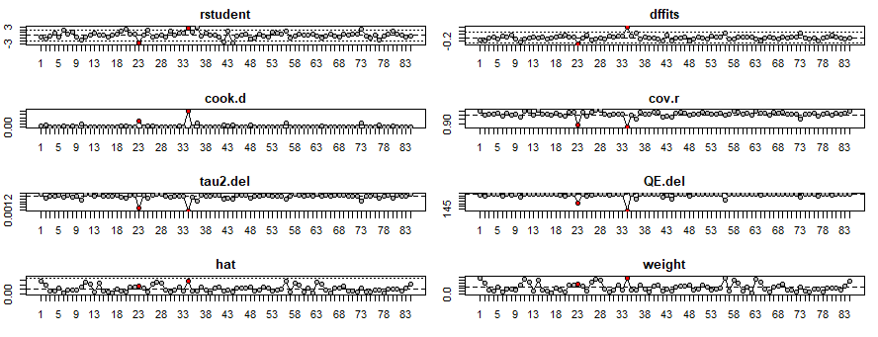
From the top left: 1) externally standardized residuals, 2) difference in fit(s) (DFFITS) values, 3) Cook's distances, 4) covariance ratios, 5) leave-one-out estimates of the amount of heterogeneity, 6) leave-one-out values of the test statistics for heterogeneity, 7) hat values, and 8) weights.
Source: Created by authors

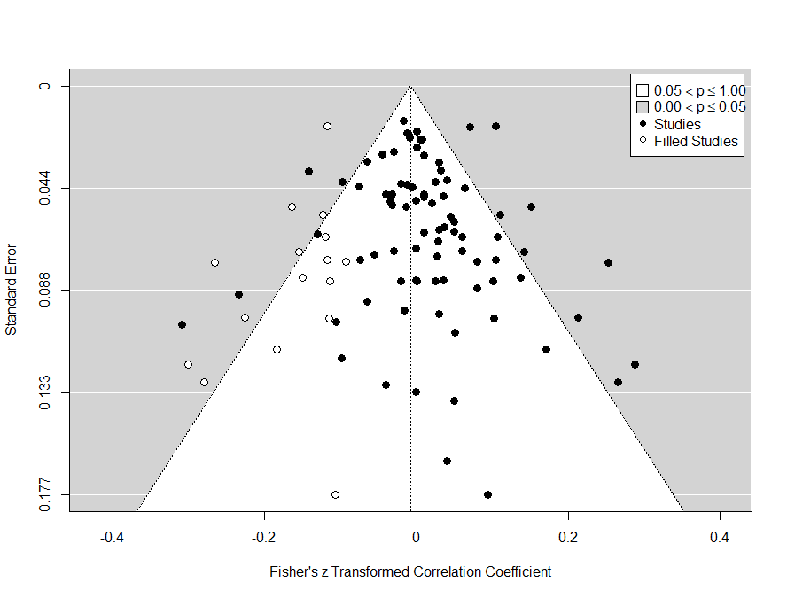
X-Axis refers to Fisher’s Z and Y-Axis is Standard Error
Source: Created by authors

Funnel plots Based on Trim and Fill Analyses and the plots of the outlier and influential case diagnostics for the Firm size-CEO narcissism relationship
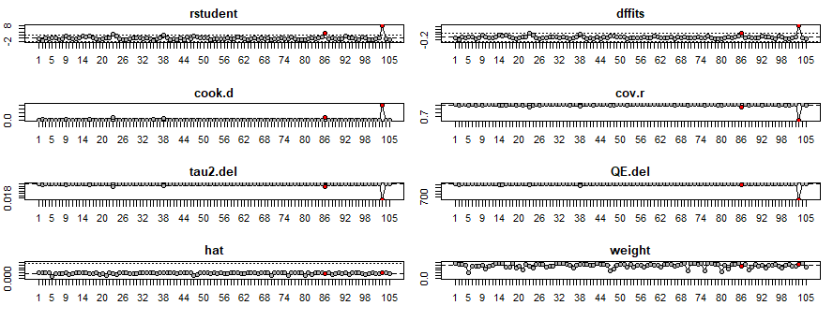
From the top left: 1) externally standardized residuals, 2) difference in fit(s) (DFFITS) values, 3) Cook's distances, 4) covariance ratios, 5) leave-one-out estimates of the amount of heterogeneity, 6) leave-one-out values of the test statistics for heterogeneity, 7) hat values, and 8) weights.
Source: Created by authors

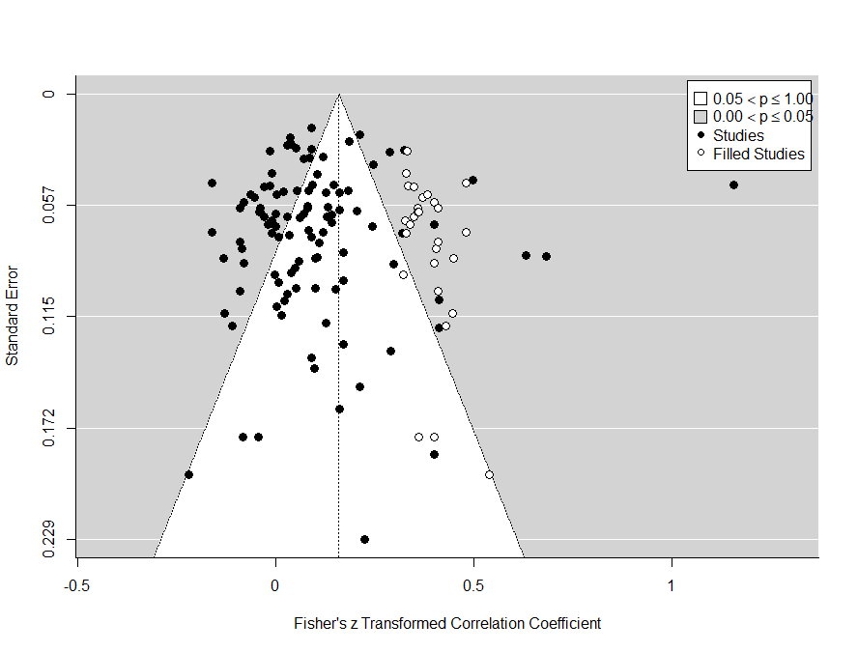
X-Axis refers to Fisher’s Z and Y-Axis is Standard Error
Source: Created by authors

Funnel plots Based on Trim and Fill Analyses and the plots of the outlier and influential case diagnostics for the Firm age-CEO narcissism relationship
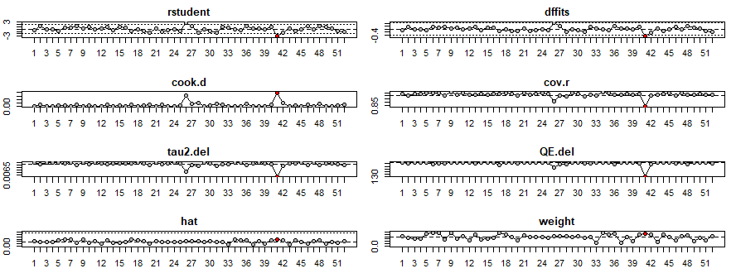
From the top left: 1) externally standardized residuals, 2) difference in fit(s) (DFFITS) values, 3) Cook's distances, 4) covariance ratios, 5) leave-one-out estimates of the amount of heterogeneity, 6) leave-one-out values of the test statistics for heterogeneity, 7) hat values, and 8) weights.
Source: Created by authors

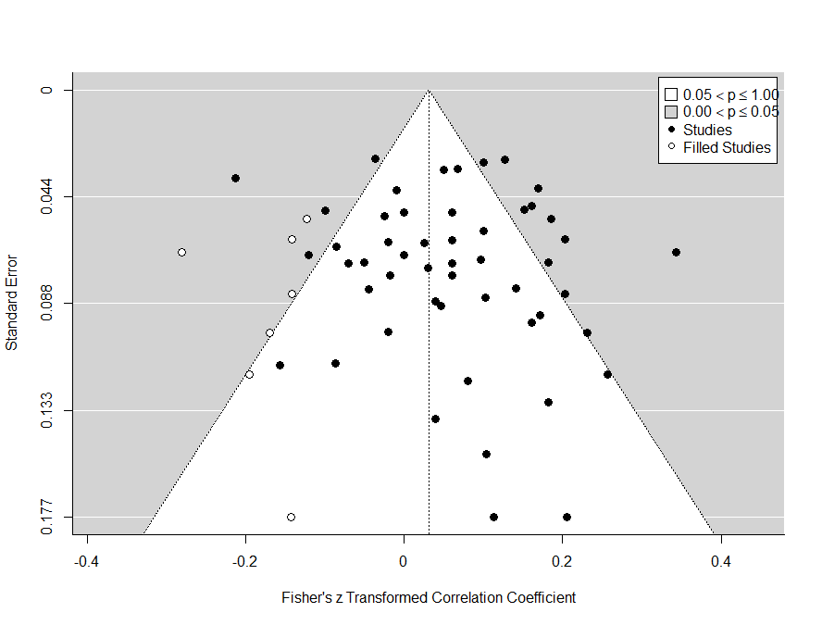
X-Axis refers to Fisher’s Z and Y-Axis is Standard Error
Source: Created by authors

Funnel plots Based on Trim and Fill Analyses and the plots of the outlier and influential case diagnostics for the CEO gender-CEO narcissism relationship

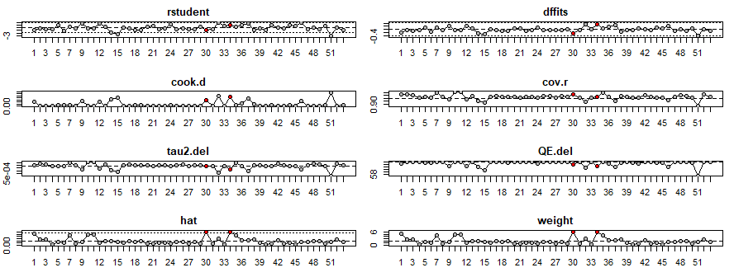
From the top left: 1) externally standardized residuals, 2) difference in fit(s) (DFFITS) values, 3) Cook's distances, 4) covariance ratios, 5) leave-one-out estimates of the amount of heterogeneity, 6) leave-one-out values of the test statistics for heterogeneity, 7) hat values, and 8) weights.
Source: Created by authors

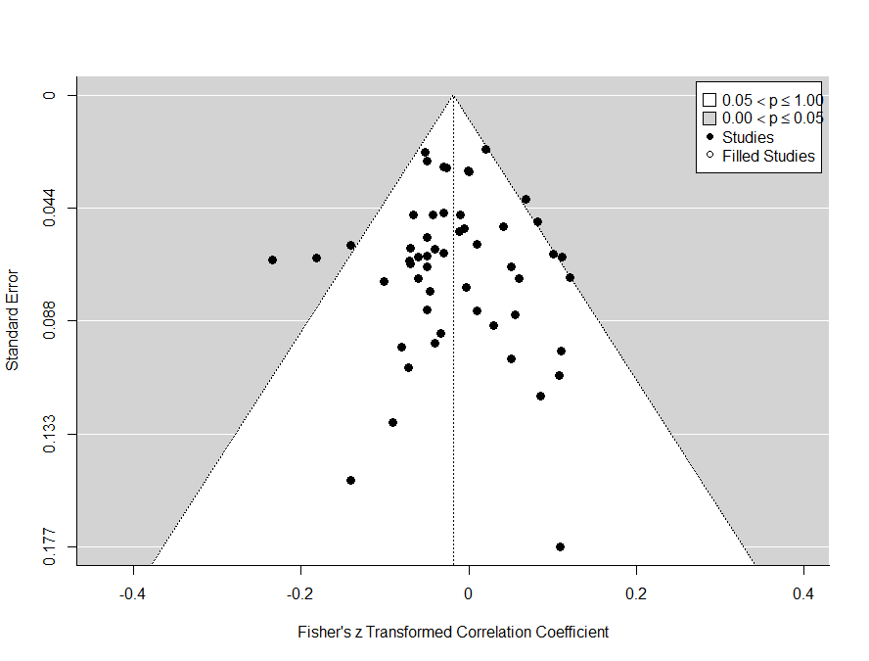
X-Axis refers to Fisher’s Z and Y-Axis is Standard Error
Source: Created by authors

Funnel plots Based on Trim and Fill Analyses and the plots of the outlier and influential case diagnostics for the CEO age-CEO narcissism relationship

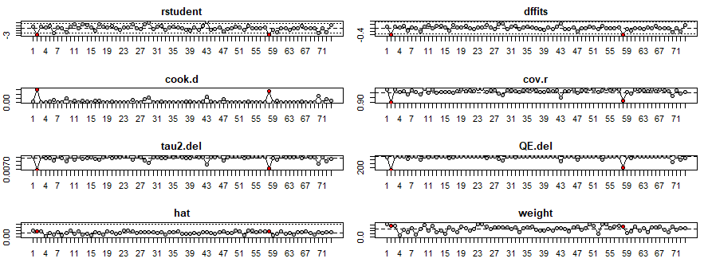
From the top left: 1) externally standardized residuals, 2) difference in fit(s) (DFFITS) values, 3) Cook's distances, 4) covariance ratios, 5) leave-one-out estimates of the amount of heterogeneity, 6) leave-one-out values of the test statistics for heterogeneity, 7) hat values, and 8) weights.
Source: Created by authors

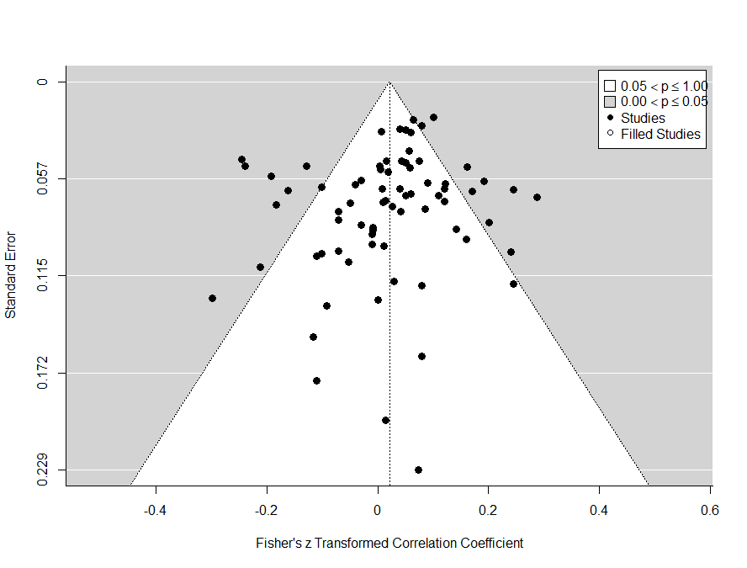

X-Axis refers to Fisher’s Z and Y-Axis is Standard Error
Source: Created by authors

Funnel plots Based on Trim and Fill Analyses and the plots of the outlier and influential case diagnostics for the CEO tenure-CEO narcissism relationship
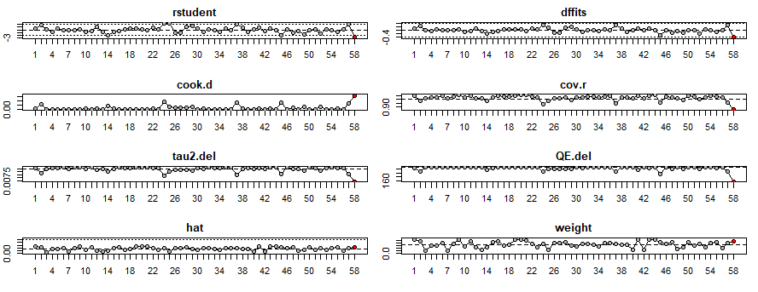
From the top left: 1) externally standardized residuals, 2) difference in fit(s) (DFFITS) values, 3) Cook's distances, 4) covariance ratios, 5) leave-one-out estimates of the amount of heterogeneity, 6) leave-one-out values of the test statistics for heterogeneity, 7) hat values, and 8) weights
Source: Created by authors

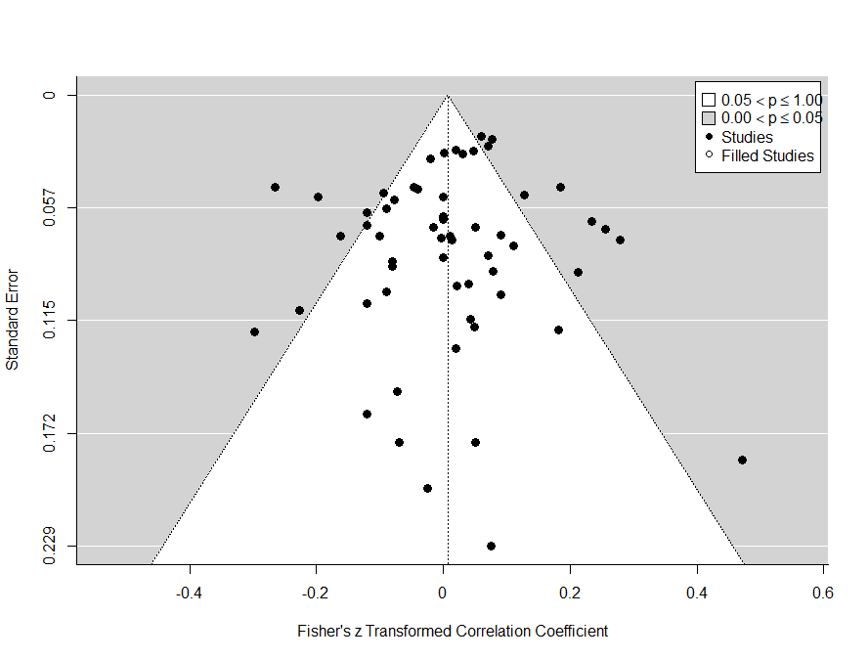

X-Axis refers to Fisher’s Z and Y-Axis is Standard Error
Source: Created by authors

Supplementary Material (E)
Table 3. Meta-analytic results for effect sizes aggregated by study – Influential cases analysis and Trim and fill analysis.
 | Influential cases analysis |  | Trim and fill analysis
CEO Narcissism and Firm Attributes | Original | Without influential cases | Original | With imputed studies
Financial performance | k= 84, r= 0.010, p= 0.19, CI= [-0.004; 0.025] | k= 82, r= 0.008, p= 0.20, CI= [-0.004; 0.021] | k= 84, r= 0.010, p= 0.19, CI= [-0.004; 0.025] | k= 100, r=-0.008, p= 0.34, CI= [-0.025; 0.009]
Firm size | k= 105, r= 0.100, p= <0.01, CI= [0.064; 0.137] | k= 103, r= 0.083, p= <0.01, CI= [0.056; 0.110] | k= 105, r= 0.100, p= <0.01, CI= [0.064; 0.137] | k= 133, r= 0.159, p=<0.01, CI= [0.125; 0.194]
Firm age | k= 52, r= 0.054, p= <0.01, CI= [0.022; 0.086] | k= 51, r= 0.062, p=<.01, CI= [0.032; 0.091] | k= 52, r= 0.054, p= <0.01, CI= [0.022; 0.086] | k= 59, r= 0.031, p= 0.07, CI= [ -0.003; 0.065]
CEO Narcissism and CEO Attributes
Woman | k= 53, r= -0.019, p= 0.03, CI= [-0.036; -0.002] | k= 51, r= -0.019, p= 0.04, CI= [-0.037; -0.001] | k= 53, r= -0.019, p= 0.03, CI= [-0.036; -0.002] | k= 53, r= -0.019, p= 0.03, CI= [-0.036; -0.002]
Age | k= 73, r= 0.022, p= 0.12, CI= [-0.005; 0.048] | k= 71, r= 0.033, p= < 0.05, CI= [0.009; 0.056] | k= 73, r= 0.022, p= 0.12, CI= [-0.005; 0.048] | k= 73, r= 0.022, p= 0.12, CI= [-0.005; 0.048]
Tenure | k= 58, r= 0.007, p= 0.67, CI= [-0.025; 0.039] | k= 57, r= 0.014, p= 0.37, CI= [-0.016; 0.043] | k= 58, r= 0.007, p= 0.67, CI= [-0.025; 0.039] | k= 58, r= 0.007, p= 0.67, CI= [-0.025; 0.039]
Note: k = number of studies; r= mean correlation; CI==lower and upper level of the 95% confidence interval.

Source: Created by authors

References
Begg, C.B. and Mazumdar, M. (1994), "Operating characteristics of a rank correlation test for publication bias", Biometrics, Vol. 50 No. 4, pp. 1088-1101.
DeVito, N.J. and Goldacre, B. (2019), "Catalogue of bias: Publication bias", BMJ Evidence-Based Medicine, Vol. 24 No. 2, pp. 53-54.
Duval, S. and Tweedie, R. (2000), "Trim and fill: a simple funnel-plot–based method of testing and adjusting for publication bias in meta-analysis", Biometrics, Vol. 56 No. 2, pp. 455-463.
Egger, M., Smith, G.D., Schneider, M. and Minder, C. (1997), "Bias in meta-analysis detected by a simple, graphical test", BMJ, Vol. 315 No. 7109, pp. 629-634.
Kepes, S., Banks, G.C., McDaniel, M. and Whetzel, D.L. (2012), "Publication bias in the organizational sciences", Organizational Research Methods, Vol. 15 No. 4, pp. 624-662.
Vevea, J.L., Coburn, K.M. and Sutton, A.J. (2019), "Publication bias", in Cooper, H.V. (Ed.), Handbook of Research Methods in Psychology, APA, Washington, DC.
Viechtbauer, W. (2010), "Conducting meta-analyses in R with the metafor package", Journal of Statistical Software, Vol. 36 No. 3, pp. 1-48.
Viechtbauer, W. and Cheung, M.W.L. (2010), "Outlier and influence diagnostics for meta-analysis", Research Synthesis Methods, Vol. 1 No. 2, pp. 112-125.
Vishwanathan, P., van Oosterhout, H., Heugens, P.P., Duran, P. and Van Essen, M. (2020), "Strategic CSR: A concept building meta-analysis", Journal of Management Studies, Vol. 57 No. 2, pp. 314-350.

