Data for Enhancing Strategy for Industry 4.0 Implementation through Maturity Models and Standard Reference Architectures Alignment - NOTES
Manuscript ID: JMTM-07-2022-0269.R4

Enhancing Strategy for Industry 4.0 Implementation through Maturity Models and Standard Reference Architectures Alignment, Journal of Manufacturing Technology Management
Types of Publication
Source(s): Authors work
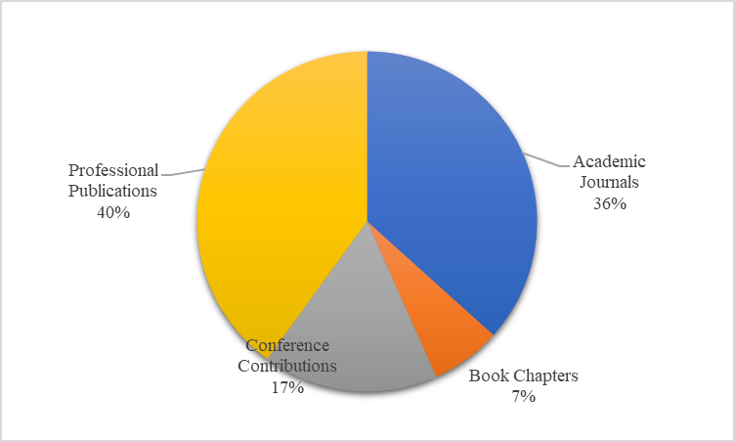 Source(s): Authors work
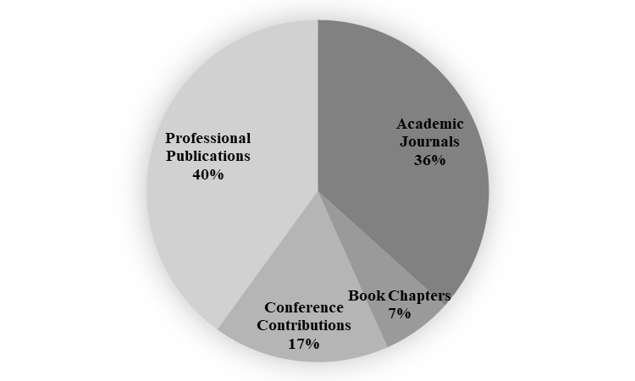 Source(s): Authors work
Source(s): Authors work
Source(s): Authors work
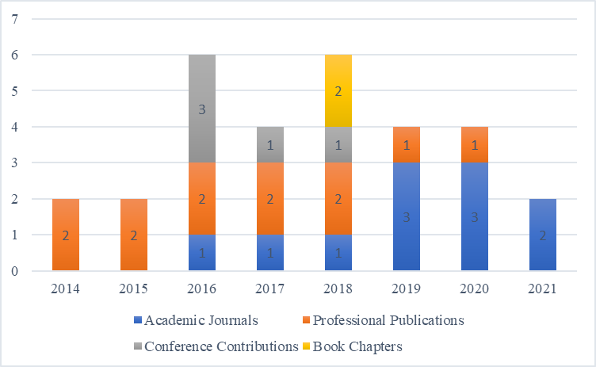 Source(s): Authors work
Source(s): Authors work

Source(s): Authors work
Quality Assessment
Source(s): Authors work
Source(s): Authors work
Source(s): Authors work
Source(s): Authors work
Source(s): Authors work
Source(s): Authors work

Taxonomy Development Steps
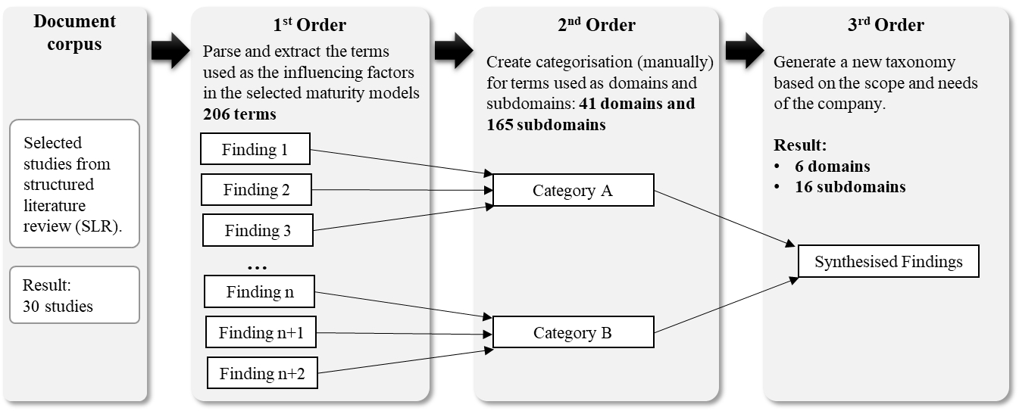 Source(s): Authors work adapted from Dekkers (2017)
- Step 1: Document corpus.
The document corpus, the result of the structured literature review (SLR) containing 30 selected studies, was analysed to determine the factors influencing the maturity model for I4.0.
- Step 2: Terms extraction (1st Order).
We parsed and extracted the terms used in the maturity models presented in the selected studies. We filtered and removed redundant words based on string equality, and as a result, we identified 206 as the influencing factors of the whole terms found.
- Step 3: Terms categorisation (2nd Order).
We separated the 206 terms obtained in step 2 into two levels at this step. The separation of terms that fall into the level 1 (domain) and level 2 (subdomain) categories is based on the scope of the literature. We initially categorised the 206 terms into 41 domains and 165 subdomains, and we then filtered out terms with the same meaning and scope to remove redundancy.
- Step 4: New taxonomy generation (3rd Order).
In this final step of taxonomy development, we created a new taxonomy consisting of 6 domains and 16 subdomains by using the following way:
- We generalised some terms to have a term with a broader scope. For example, we created a new term: Advanced Information Technology (Advanced IT), and we moved the terms artificial intelligence (AI) and internet of things (IoT) as instances of Advanced IT.
- The domain in the new taxonomy includes technology, product, operation/process, resource, culture, and organisational governance.
- All domains and subdomains used in the new taxonomy with a multidomain focus are discussed in most selected papers (see Table 2).

Influencing factors of maturity models (MMs) for Industry4.0
Source(s): Authors work
Source(s): Authors work
Source(s): Authors work
Source(s): Authors work
Source(s): Authors work

Influencing factors of MMs for Industry4.0: Domains & Sub-domains
1. Domain: Technology
The "Technology" domain within I4.0 MMs encompasses various aspects related to adopting and implementing advanced technologies in the context of I4.0 that play a fundamental role in guiding organisations through the digital transformation process. This domain describes the technologies needed and used by companies to adopt I4.0. The technology domain examines the stages of I4.0 technology in companies, consisting of two subdomains: advanced IT and data & information.
More than 76% of selected primary studies discuss technology. It shows that advanced IT and data & information are the main requirements for I4.0, although I4.0 (Kagermann et al., 2013) stated that I4.0 does not pose an exclusively IT-related challenge. (Calabrese et al., 2020) and (Schumacher et al., 2016) considered technologies as the primary innovation factor in adopting I4.0. (Lee et al., 2017) and (Schuh et al., 2020) use the specific term information systems. However, some MMs only include advanced IT as enablers in other domains. For example, , (Agca et al., 2017) and (Akdil et al., 2018) associate advanced IT in different domains such as manufacturing and operations, and smart products and services. Nevertheless, some MMs do not include factors related to data and information, such as , (Agca et al., 2017), (Brozzi et al., 2020) and (Garzoni et al., 2020).
1.1. Sub-domain: Advanced IT
The "Advanced IT" sub-domain focuses on utilising cutting-edge information technology (IT) solutions within an organisation's manufacturing and operational processes. It involves integrating innovative IT systems to enhance automation, connectivity, and real-time data processing.
Advanced information technology plays a crucial role in Industry 4.0 by facilitating the conversion of conventional manufacturing procedures into highly interconnected, data-driven systems. This sub-domain encompasses technologies like IoT, cloud computing, and AI, which, when successfully integrated, can enhance process efficiency, enable predictive maintenance, and improve decision-making.
1.2. Sub-domain: Data and Information
The "Data and Information" sub-domain emphasises the significance of data collection, analysis, and utilisation in I4.0. It involves strategies for managing, processing and leveraging vast amounts of data generated by connected devices and systems.
This sub-domain includes data management and analytics and data-driven decision-making. In the age of I4.0, organisations must leverage data analytics to extract insights, make well-informed choices, and enhance their operations.

2. Domain: Product
The "Product" domain within I4.0 MMs deals with the aspects related to product development, enhancement, and evolution in the context of I4.0. It is critical to guide organisations in harnessing the power of digital technologies and data-driven strategies. The product domain contains features on products that support I4.0. Many features of I4.0 and other potential benefits depend on information about a product (Lichtblau et al. 2015). For example, equipment manufacturers need information about how long and often a product or its component is used to offer a predictive maintenance plan based on actual usage. This domain consists of two subdomains: ICT functionalities and data analytics features on products.
Of 30 papers in the primary studies, 29 papers included factors related to the product domain in their maturity models. All of them involves ICT functionalities on products. Most of these papers include the factors specified in the product or service domain, such as Agca et al. (2017), Lichtblau et al. (2015), Wagire et al. (2021). However, some of them include it in other domains related to processes or operations. Calabrese et al. (2020) do not include Data analytics in their product domain.

2.1. Sub-domain: Data Analytics
The "Data Analytics" sub-domain emphasises the importance of data-driven decision-making and optimisation of product-related processes. It involves applying analytics techniques to derive valuable insights from product-related data.
Data analytics enables organisations to make informed decisions about product development, quality control, and customisation. By analysing data from sensors, production lines, and customer feedback, companies can identify improvement areas, predict maintenance needs, and tailor products to meet customer demands more effectively.
2.2. Sub-domain: ICT Add-On Functionalities
The "ICT Add-On Functionalities" sub-domain focuses on integrating Information and Communication Technology (ICT) enhancements to the product development process. It includes incorporating digital technologies, software, and connectivity to enhance product functionality and value.
In the age of I4.0, products are becoming smarter and more connected. The incorporation of ICT add-on functionalities involves aspects like IoT integration, cloud connectivity, and software-defined features. This sub-domain acknowledges the shift from traditional, standalone products to smart, connected products that can interact with other devices, systems, and users. It enables product differentiation, personalisation, and remote monitoring, which can lead to improved customer satisfaction and competitive advantages.

3. Domain: Operation/Process
The "Operation/Process" domain within I4.0 MMs encompasses various aspects related to the optimisation and transformation of operational processes in the context of I4.0. It plays a pivotal role in guiding organisations through the digital transformation of their processes. The operation/process domain discusses how the company’s operations are prepared to implement the I4.0 system, including integration, inventory & supply chain, and quality. More than 80% or 40 of the selected studies describe operations/processes in their maturity model. This domain includes three subdomains: integration, inventory & supply chain, and quality.
Thirty-one papers include inventory and supply chain in their MMs. However, we identified papers discussing supply chains in separate domains of their MMs, such as Facchini et al. (2020) and Garay-Rondero et al. (2020). The quality subdomain has contents related to quality in the operation/process, including digital quality management, real-time yield optimisation, and statistical and advanced process control. There are 23 papers discussing quality in their MMs. We identified that some literature does not explicitly discuss quality-related factors as independent factors. Nevertheless, some literature retains it explicitly as a domain or subdomain, such as Saad et al. (2021) and Santos & Martinho (2020).
3.1. Sub-domain: Integration
The "Integration" sub-domain emphasises the integration of various components and systems within an organisation's operational processes. It involves connecting people, processes, and technologies to streamline operations and foster collaboration.
Integration is a fundamental aspect of I4.0. It includes the seamless connection of machines, data sources, and software to enable real-time data exchange and process optimisation. Integration allows for the creation of cyber-physical systems (CPS) that enable better coordination and control of manufacturing processes. This sub-domain promotes efficient resource utilisation, reduced operational silos, and improved communication between different parts of an organisation.
3.2. Sub-domain: Inventory and Supply-Chain Management
This sub-domain focuses on the digitisation and optimisation of inventory and supply-chain processes, which includes using digital technologies to enhance visibility, control, and efficiency in managing inventory and the supply chain.
Effective inventory and supply chain management are critical for achieving operational excellence. Technologies like RFID and IoT sensors are used to track and manage inventory and goods in transit. This sub-domain enables real-time inventory tracking, demand forecasting, and the reduction of supply chain bottlenecks. It promotes leaner and more agile supply chains, which can lead to cost savings and improved customer satisfaction.
3.3. Sub-domain: Quality
The "Quality" aspect underscores improving the quality of products and processes within an Industry 4.0 setting. This requires utilising data and digital technologies to monitor and enhance the quality of both products and services.
This sub-domain leverages data analytics, sensors, and automation to monitor product quality in real-time. It enables predictive maintenance, early defect detection, and a reduction in defects, ultimately improving product quality. Organisations can enhance customer satisfaction, reduce waste, and maintain a competitive edge by focusing on quality.

4. Domain: Resource
The "Resource" domain within I4.0 MMs addresses aspects related to the efficient utilisation and management of resources, both physical and human, in the context of I4.0. This domain is instrumental in guiding organisations towards optimising resource allocation. This domain outlines the resource factors supporting the company’s I4.0 internally and externally. Besides asset utilisation, we use another subdomain, human resource or employee, as it is counted as an asset of a company. Regarding the relationship of assets, Kagermann (2015) stated that in I4.0, human resources and other assets, such as machinery and equipment, communicate in a social network.
We captured 27 articles out of 33 that discuss asset utilisation in their MMs. Most of them include asset utilisation as part of the resource domain, while some include it as a smart operation or factory, such as Akdil et al. (2018) and Lichtblau et al. (2015). Thirty-one papers discuss the employee subdomain in their MMs, while two articles that do not discuss it as part of specific influencing factors in their MMs are VDMA Industrie 4.0 Forum (2016) and Weber et al. (2017).
4.1. Sub-domain: Asset Utilisation
The "Asset Utilisation" sub-domain emphasises the effective and efficient use of physical assets, such as machinery, equipment, and facilities, within an organisation. It involves monitoring, analysing, and improving asset performance and uptime.
Asset utilisation is a critical factor in I4.0, where organisations aim to maximise the value derived from their investments in physical assets. This sub-domain encompasses predictive maintenance, condition monitoring, and asset tracking using IoT sensors. By leveraging these technologies, organisations can reduce downtime, extend the lifespan of assets, and minimise unplanned maintenance costs. Improved asset utilisation can result in enhanced operational efficiency and reduced resource waste.
4.2. Sub-domain: Employee
The "Employee" sub-domain focuses on the role of the workforce in the I4.0 landscape. It includes aspects related to employee skills, engagement, and well-being in the digitalised workplace.
The sub-domain "Employee" acknowledges the importance of upskilling and reskilling the workforce to adapt to the changing technological landscape. It also considers factors like employee engagement and well-being in a technologically advanced workplace. A motivated and well-trained workforce can contribute to increased productivity, innovation, and overall company success. This sub-domain recognises the need for a harmonious balance between technological advancements and the human element in organisations.

5. Domain: Culture
The "Culture" domain within I4.0 MMs addresses the cultural and organisational aspects that play a critical role in the successful implementation of Industry 4.0. It emphasises the need for cultural shifts and alignment within organisations. This domain describes the maturity of companies to transform to I4.0 in terms of organisational and employee culture. The domain is also included as one of the readiness indicators in I4.0 adoption (Nafchi & Mohelsk´a 2020). The culture domain consists of two subdomains: collaboration and willingness to change.
The collaboration subdomain includes dynamic collaboration within the company and networking with customers and other companies. 60% of 22 articles that include collaboration subdomain in their MMs discussed dynamic collaboration within the company, while the remaining nine papers also present the importance of networking in partnerships. The willingness to change refers to the willingness to change in the organisation’s culture, including open mindset, open innovation, and digital attitude. We found that 15 articles discuss this subdomain.
5.1. Sub-domain: Collaboration
The "Collaboration" sub-domain highlights the importance of fostering a culture of collaboration and teamwork within an organisation. It involves breaking down silos and encouraging cross-functional cooperation to drive innovation and achieve common goals.
Collaboration is fundamental in I4.0, as it enables organisations to harness the collective intelligence of their workforce. This sub-domain promotes sharing knowledge, expertise, and ideas internally and externally across departments and teams, including with the clients. By fostering a collaborative culture, organisations can tackle complex challenges, develop innovative solutions, and respond more effectively to rapidly changing market demands. Collaboration enhances adaptability and promotes a culture of continuous improvement.
5.2. Sub-domain: Willingness to Change
The "Willingness to Change" sub-domain focuses on the organisation's readiness and openness to embrace change, especially technological and process-related changes. It requires nurturing a mentality open to fresh concepts, technologies, and methods of operation.
This sub-domain recognises the necessity of overcoming resistance to change and encouraging a culture of innovation and continuous improvement. It promotes a willingness to adopt new technologies, processes, and practices that can drive operational excellence. A culture that is open to change can help organisations remain agile and competitive in an ever-evolving business landscape.

6. Domain: Organisation Governance
The "Organisation Governance" domain within I4.0 MMs deals with the governance and management aspects necessary for the successful implementation of Industry 4.0. It encompasses various sub-domains, each of which plays a vital role in shaping the strategic direction and capabilities of organisations in the digital age. This domain expresses how much management and organisational support in the transformation manifested in organisational governance towards I4.0. It contains four subdomains: digital leadership capability, innovation management, investment for I4.0, and strategy for I4.0. From 27 publications in the organisational governance domain, 14 describe digital leadership capability. Only 11 papers mention agility in their MMs, and 13 studies discuss factors related to the investment for I4.0 and innovation management. All papers describing organisation governance factors consider the strategy for I4.0.
6.1. Sub-domain: Digital Leadership Capability
The "Digital Leadership Capability" sub-domain underscores the significance of effective leadership in guiding an organisation through the digital transformation journey. It involves the cultivation of leaders who understand digital technologies, can drive change, and champion the adoption of I4.0 principles.
Digital leadership is crucial in I4.0, as leaders need to set the vision, create a digital strategy, and lead the cultural and organisational changes required for digital transformation. This sub-domain recognises the need for leaders who can navigate the complexities of the digital landscape, inspire the workforce, and make informed decisions about technology adoption.
6.2. Sub-domain: Innovation Management
The "Innovation Management" sub-domain focuses on the organisation's ability to manage and foster innovation that involves developing processes and practices that encourage and facilitate innovation, particularly in the context of I4.0.
Innovation is a driving force behind I4.0, and this sub-domain acknowledges the importance of systematically managing and supporting innovation efforts. It includes processes for idea generation, testing, and scaling innovations. Innovation management can result in developing new products, services, and processes that keep organisations competitive in a rapidly changing environment.
6.3. Sub-domain: Agility
The "Agility" sub-domain emphasises the need for organisational agility, which is the capacity to quickly respond to changing market conditions, customer needs, and technological advancements. It involves adopting agile methodologies and practices.
Agility is a fundamental aspect of I4.0, allowing organisations to adapt rapidly to changing circumstances. This sub-domain promotes adopting agile practices and methodologies such as Scrum or Kanban. Organisational agility enables quicker decision-making, faster product development, and more effective responses to disruptions or market shifts.
6.4. Sub-domain: Investment for I4.0
The "Investment for I4.0" sub-domain allocates financial resources to support I4.0 initiatives. It involves strategic financial planning and investment decisions to fund digital transformation efforts.
This sub-domain acknowledges the need for a clear investment strategy that aligns with the organisation's goals and ensures the availability of resources for digital transformation. Effective investment management can lead to adopting cost-efficient technology and improved financial performance.
6.5. Sub-domain: Strategy for I4.0
The "Strategy for I4.0" sub-domain is about developing a clear and well-defined strategy for I4.0 implementation. It includes setting objectives, defining the roadmap, and aligning digital initiatives with overall business strategy.
A well-crafted strategy is essential for navigating the complexities of I4.0. This sub-domain recognises the need for a strategic approach to digital transformation that considers long-term goals, identifies key performance indicators, and outlines the steps for achieving success. A robust strategy ensures digital initiatives align with the organisation's mission and vision.

