SUPPLEMENTARY MATERIALS
A – CFA UTAUT factors
To ensure construct validity, we performed a confirmatory factor analysis (CFA). Our results showed that the four-factor model (Performance Expectancy, Effort Expectancy, Social Influence, and Facilitating Conditions). This model fitted the data well: χ2(71) = 226.69, p < .01; TLI = .91, CFI = .93, RMSEA = .089, SRMR = .054. The standardized factor loadings ranged from .629 to .949.

B - Construct-level LPA analysis

Table I. Summary of LPA for different models (construct level).
 | LL | FP | AIC | BIC | SABIC | Entropy | LMR | BLRT | Smallest class %
1 profile | -1543.735 | 8 | 3103.47 | 3132.519 | 3107.152 | X | X | X | X
2 profile | -1411.569 | 13 | 2849.137 | 2896.343 | 2855.121 | 0.904 | 0.0071 | < .001 | 19%
3 profile | -1381.74 | 18 | 2799.481 | 2864.843 | 2807.766 | 0.924 | 0.018 | < .001 | 9%
4 profile | -1363.847 | 23 | 2773.694 | 2857.212 | 2784.281 | 0.892 | 0.61 | < .001 | 7%
5 profile | -1346.093 | 28 | 2748.186 | 2849.860 | 2761.075 | 0.775 | 0.23 | < .001 | 3%
Notes. Dashes indicate criterion was not calculated for the model. LL = Loglikelihood; FP = free parameters; AIC = Akaike information criterion; BIC = Bayesian information criterion; SABIC = Sample-size adjusted BIC; LMR = Lo-Mendel-Rubin likelihood ratio test; BLRT = Bootstrap Likelihood Ratio Test.
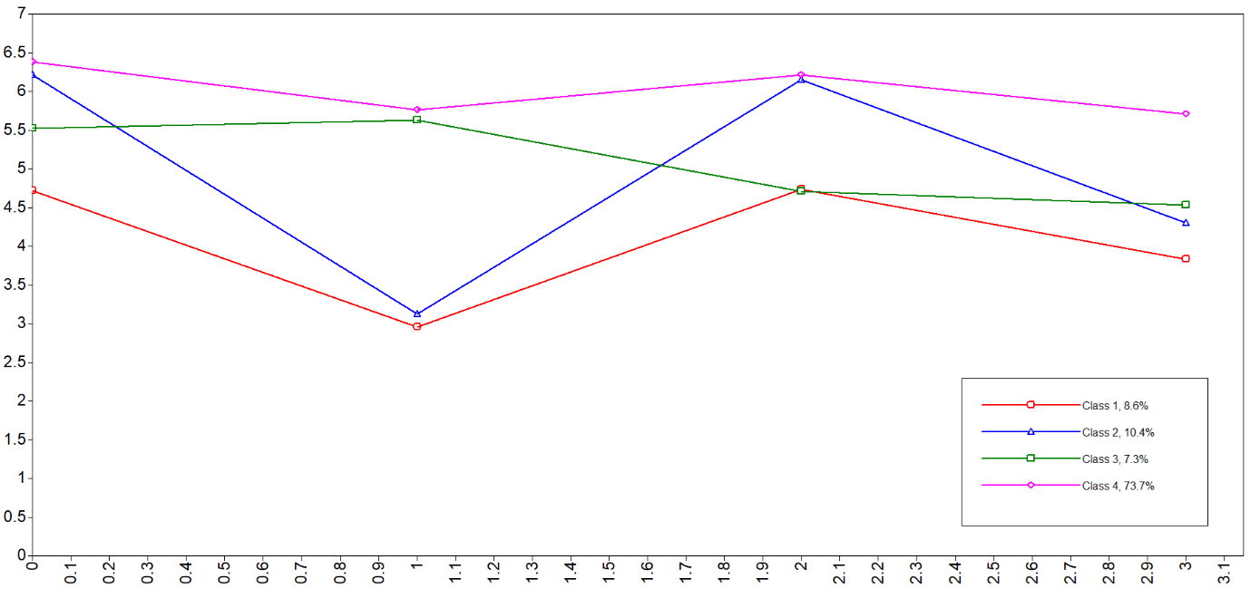
Figure 1. Profile plot four-profiles solution (construct level).
Notes. Each dot represents one construct. From left to right: PE, EE, SI, and FC.

Table II. Means and standard deviations for each profile (construct level).
Item | Red profile | Blue profile | Green profile | Pink profile
PE | 6.212 (.281) | 5.519 (.364) | 4.716 (.174) | 6.378 (.060)
EE | 3.121 (.252) | 5.626 (.470) | 2.958 (.370) | 5.759 (.061)
SI | 6.151 (.107) | 4.712 (.625) | 4.731 (.434) | 6.215 (.069)
FC | 4.297 (.273) | 4.529 (.391) | 3.831 (.295) | 5.707 (.071)
Notes. PE = Performance expectancy; EE = Effort expectancy; SI = Social influence; FC = Facilitating conditions. Standard deviations in between brackets.

