Appendix A
Table A1
Demographic characteristics of the final sample.
 |  | N (%)
Gender | Male | 169 (60.1%)
Gender | Female | 100 (35.6%)
Gender | Nonbinary | 1 (0.4%)
Gender | Prefer not to say | 11 (3.9%)
Age (years) | 18–24 | 1 (0.4%)
Age (years) | 25–34 | 40 (14.2%)
Age (years) | 35–44 | 69 (24.6%)
Age (years) | 45–54 | 93 (33.1%)
Age (years) | 55–64 | 72 (25.6%)
Age (years) | 65+ | 6 (2.1%)
Organisational Tenure | < 1 year | 14 (5.0%)
 | 1–3 years | 30 (10.7%)
 | 4–6 years | 40 (14.2%)
 | 7–10 years | 33 (11.7%)
 | 11–15 years | 45 (16.0%)
 | 16–20 years | 32 (11.4%)
 | > 20 years | 87 (31.0%)
Managerial Role | Yes | 44 (15.7%)
 | No | 237 (84.3%)

Appendix B
A confirmatory factor analysis (CFA) confirmed the convergent and discriminant validity of our measures. Specifically, the measurement model including the six fully latent factors demonstrated a good fit of χ2/df = 2.17; TLI = .94; CFI = .95; and RMSEA = .06 (Hu and Bentler, 1999). Table B1 reports the measurement items, the corresponding factor loadings and standard errors for all constructs. All latent constructs demonstrated good measurement properties, with standardised factor loadings ranging from .693 to .921, and all loadings are statistically significant at p < .001 (see Table B1). Each latent variable was measured by at least three indicators, and the confidence intervals for all estimates were narrow and excluded zero, supporting the overall adequacy of the measurement model. The average variance extracted (AVE) for all constructs is above .50, indicating good convergent validity. Additionally, the maximum shared variance (MSV) between constructs is lower than the AVE, except for the in-role PEB and environmental advocacy scales (MSV = .80), exceeding their respective AVEs (.62 and .60). This suggests these constructs are closely related (Fornell and Larcker, 1981). Given that both represent pro-environmental action at work, albeit having a different focus, some overlap is expected. Given the goal of the study to examine whether similar factors underlie in-role behaviours and environmental advocacy, we decided to analyse them as separate variables, as originally planned.

Table B1
Measurement items and standardized factor loadings from the confirmatory factor analysis
Construct Items |  | R² |  | Unst. Factor loadingª |  | SE |  | St. Factor loading
Individual Biospheric Values
Protecting the environment: preserving nature. |  |  | .640 | 1.000b |  | - |  |  | .800
Respecting the earth: harmony with other species |  |  | .607 | 1.235 |  | .081 |  |  | .779
Unity with nature: fitting into nature |  |  | .715 | 1.094 |  | .089 |  |  | .846
Preventing pollution: protecting natural resources |  |  | .674 | 1.091 |  | .079 |  |  | .821
Organisational Biospheric Values
Protecting the environment: preserving nature. |  |  | .718 | 1.000b |  | - |  |  | .848
Respecting the earth: harmony with other species |  |  | .621 | .936 |  | .056 |  |  | .788
Unity with nature: fitting into nature |  |  | .829 | 1.017 |  | .052 |  |  | .911
Preventing pollution: protecting natural resources |  |  | .803 | 1.046 |  | .053 |  |  | .896
Self-Efficacy
I am able to change the way I work to reduce my negative impact on the environment at work |  |  | .745 | 1.000b |  | - |  |  | .863
I am able to adapt my work to reduce my negative impact on the environment at work |  |  | .819 | 1.050 |  | .041 |  |  | .905
I am able to make changes in my work to reduce my negative impact on the environment |  |  | .736 | .964 |  | .046 |  |  | .858
Collective Outcome Efficacy
Together, we, [organisation] employees, can contribute to reducing [organisation’s] negative impact on the environment by acting environmentally friendly at work |  |  | .805 | 1.000b |  | - |  |  | .897
Together we, [organisation] employees, can reduce [organisation’s] negative impact on the environment |  |  | .829 | 1.036 |  | .066 |  |  | .911
Together, we, [organisation] employees, can contribute to reducing [organisation’s] negative impact on the environment by choosing environmentally friendly ways of working |  |  | .849 | 1.054 |  | .069 |  |  | .921
Pro-environmental Behaviours at Work
I contribute to projects and events that help reduce [organisation’s] negative impact on the environment |  |  | .633 | 1.000b |  | - |  |  | .795
I help establish procedures and policies to reduce [organisation’s] negative impact on the environment |  |  | .562 | .954 |  | .065 |  |  | .750
I help to design products and services for colleagues and/or customers to reduce [organisation’s] negative impact on the environment |  |  | .675 | .961 |  | .068 |  |  | .822
Environmental Advocacy
At [organisation], I advise colleagues and/or customers on how to reduce their negative environmental impact. |  |  | .660 | 1.000b |  | - |  |  | .813
At [organisation], I advise colleagues and/or customers on how to prevent the negative impacts of climate change on themselves |  |  | .644 | .976 |  | .043 |  |  | .803
At [organisation], I motivate colleagues and/or customers to opt for pro-environmental options and products |  |  | .598 | .984 |  | .045 |  |  | .773
I talk with my colleagues at [organisation] about how we can reduce our negative impact on the environment at work |  |  | .603 | .893 |  | .048 |  |  | .777
I draw management's attention to potentially environmentally unfriendly activities or policies of [organisation] |  |  | .576 | .853 |  | .064 |  |  | .759
I collaborate with colleagues and/or customers of [organisation] to find the most sustainable and financially viable options |  |  | .480 | .979 |  | .064 |  |  | .693
I put forward ideas to reduce [organisation’s] negative impact on the environment. |  |  | .652 | .913 |  | .045 |  |  | .808
Note. Factor loadings are from the confirmatory factor analysis of the six factor measurement model. b Marker loading fixed to 1.00 for model identification.

Appendix C
Model comparison: PEB vs advocacy
To address the correlation between in-role pro-environmental behaviour and environmental advocacy, we compared a six-factor model with a five-factor model in which all behaviour items were collapsed into one environmental behaviour factor.
- Six-factor model: χ²(237)=467, CFI=.959, TLI=.952, RMSEA=.055, SRMR=.039
- Five-factor model: χ²(242)=513, CFI=.951, TLI=.944, RMSEA=.059
- Model comparison: Δχ²(5)=46, p<.001

Appendix D
Table D1
Spearman Correlation Table

Variable | 1 | 2 | 3 | 4 | 5 | 6
1. Individual Biospheric Values | —
2. Organisational Biospheric Values | .26*** | —
3. Self-Efficacy | .23*** | .31*** | —
4. Collective Outcome Efficacy | .28*** | .26*** | .48*** | —
5. Pro-environmental Behaviours | .22*** | .28*** | .43*** | .34*** | —
6. Environmental Advocacy | .29*** | .30*** | .47*** | .38*** | .74*** | —
Note. N = 304. *p < .05, **p < .01, ***p < .001.

Appendix E

Testing the Full Model: Relationships between individual and organisational biospheric values, self-efficacy, collective outcome-efficacy and in-role pro-environmental behaviours and environmental advocacy
The full model (see Figure E1) explained 32.4% of the variance for in-role pro-environmental behaviours, 16.3% for self-efficacy, 12.8% for collective outcome efficacy, and exhibited good model fit (χ2/df = 1.9; TLI = .97; CFI = .97; and RMSEA = .05). Figure E1 shows that biospheric values, both individual and organisational, both uniquely relate to in-role pro-environmental behaviours, by strengthening collective outcome efficacy and especially by strengthening self-efficacy.
Figure E1
Structural Model representing the Standardised Direct Effects between Individual and Organisational Biospheric Values, Self-Efficacy, Outcome Efficacy, and In-Role Pro-environmental Behaviour.
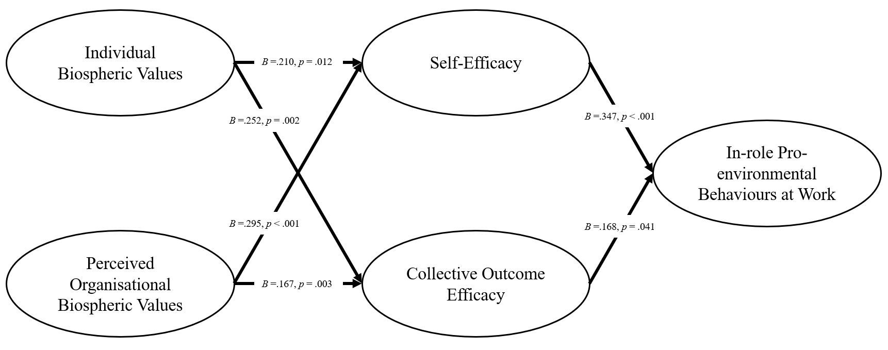
Note. Standardised path coefficients (B) are displayed. All p-values are two-tailed. All direct paths are shown, even ones not formally hypothesised.
The full model explained 33.2% of the variance in environmental advocacy, 16.3% in self-efficacy, 12.8% in collective outcome efficacy, and exhibited good model fit (χ2/df = 2.05; TLI = .95; CFI = .96; and RMSEA = .06). Figure E2 shows that both individual and perceived organisational biospheric values also uniquely relate to environmental advocacy, by strengthening self-efficacy, while collective outcome efficacy does not significantly relate to environmental advocacy when the other variables are controlled for.
Figure E2
Structural model representing the standardised direct effects between individual and organisational biospheric values, self-efficacy, outcome efficacy, and environmental advocacy.
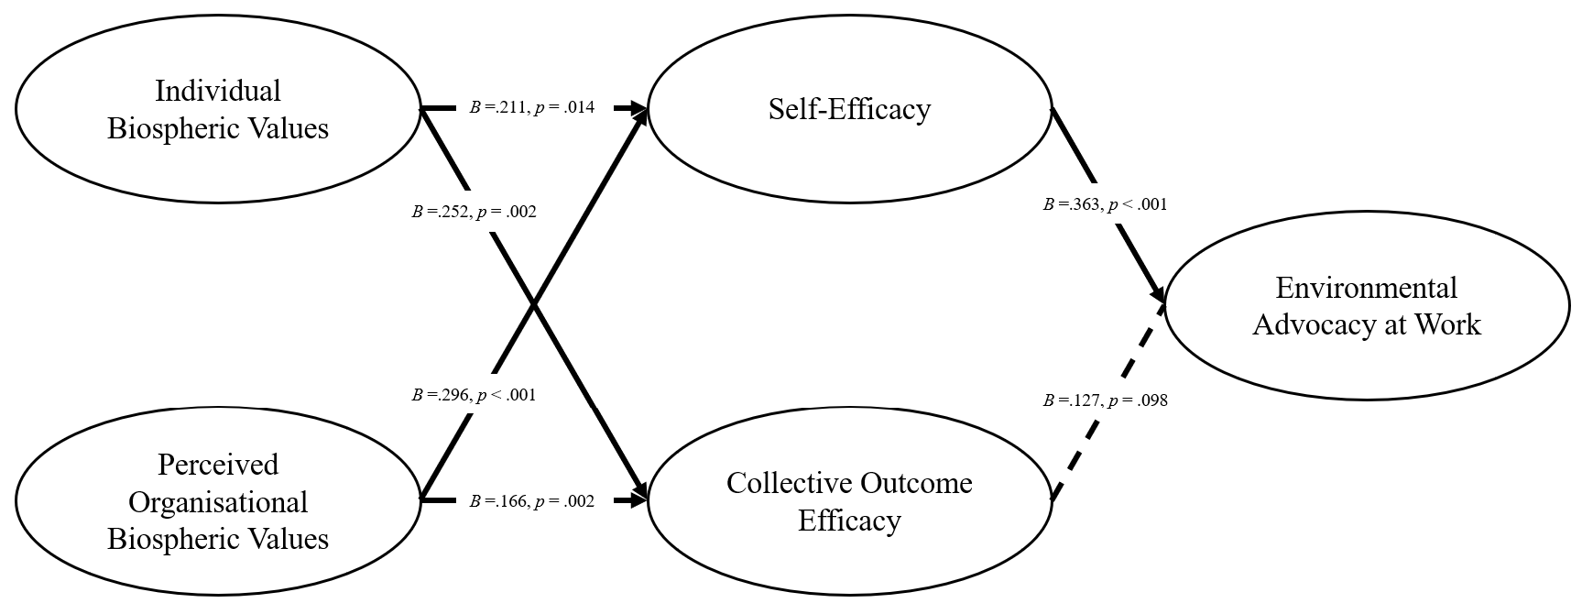Note. Standardised path coefficients (B) are displayed. All p-values are two-tailed. Solid lines indicate significant paths (p < .05). All direct paths are shown, even ones not formally hypothesised.
Table E1 summarises the mediation tests for the full model for each behavioural outcome. The results show that both individual and organisational biospheric values relate to in role behaviour and environmental advocacy through self-efficacy. In contrast, once self-efficacy and collective outcome efficacy are entered in the same model, the indirect paths through collective outcome efficacy are no longer significant. This pattern indicates that self-efficacy carries the stronger portion of the shared variance between the two mediators.

Table E1
Results of Mediation Tests from the full Structural Equation Model.

Predictor | Mediator | Outcome | Indirect effect B [95 % CI] | p | Supported
Individual Biospheric Values | Self-efficacy | In role PEB | .073 [.020, .147] | .021 | ✓
Organisational Biospheric Values | Self-efficacy | In role PEB | .103 [.052, .179] | .002 | ✓
Individual Biospheric Values | Collective Outcome Efficacy | In role PEB | .042 [.007, .106] | .080 | -
Organisational Biospheric Values | Collective Outcome Efficacy | In role PEB | .028 [.003, .072] | .113 | -
Individual Biospheric Values | Collective Outcome Efficacy | Environmental Advocacy | .032 [−.003, .100] | .165 | -
Organisational Biospheric Values | Collective Outcome Efficacy | Environmental Advocacy | .021 [−.002, .059] | .168 | -
Individual Biospheric Values | Self-efficacy | Environmental Advocacy | .076 [.022, .159] | .026 | ✓
Organisational Biospheric Values | Self-efficacy | Environmental Advocacy | .107 [.058, .189] | < .001 | ✓

We find also support for the expected pathways when testing them in one model, indicating that individual and perceived biospheric values, self-efficacy, and outcome efficacy are uniquely related to both types of pro-environmental behaviour at work, although in the full model collective outcome efficacy is only weakly and not significantly uniquely related to environmental advocacy. This pattern is consistent with Social Cognitive Theory (Bandura, 2001) and the dual pathway model of collective action (van Zomeren et al., 2008, 2012), which argue that behaviour depends on both self-efficacy and collective outcome efficacy beliefs. Notably, our model explained a similar (substantial) proportion of the variance in both types of pro-environmental behaviour at work. Self-efficacy showed the strongest unique association with both types of pro-environmental behaviour, indicating that employees’ confidence in their own ability to act plays a more central role in workplace pro-environmental behaviour than their beliefs about the collective impact of joint efforts.

We tested a parsimonious model collapsing all behaviour items into one factor. The six-factor model distinguishing PEB and advocacy has a significantly better fit (Δχ²(5)=46, p<.001). Despite their high correlation, we distinguish them theoretically and empirically and retain them as separate constructs while reporting robustness checks with the collapsed factor in Appendix C.

