Online appendix

Table A. Comparing the clusters of DSI studies. 'Source: Authors own creation'
 | Innovation for digital servitization | Service innovation in the digital age | Adoption of novel e-services enabled by information system development
Central topics | - Digital tools,  - Service offerings,  - Digital transformation and related capabilities. | - Knowledge sharing,  - Organizational capabilities,  - Resource integration and value co-creation for digital service innovation in smart service systems,  - The role of digital technologies in service-centric business models,  - Human-material service practices and service materializations,  - The role of boundary resources,  - The role of power and user innovation. | - How are novel and innovative digital services (e.g., augmented reality, AR) adopted/perceived or rejected among customers, clients, and citizens?  - Service innovations,  - Service science and service systems.
Theoretical background | - Business model innovation,  - Resource-based view/strategic capabilities,  - Dynamic capabilities,  - Servitization. | - S-D-L and some concepts of service innovation,  - S-D-L with inputs from other specific approaches (e.g., sociomateriality, affordance theory).  - Technological innovation and user innovation approach. | - (Dynamic) Capability view,  - Cognitive fit theory,  - Executive cognitions,  - S-D-L,  - Game theory.
Antecedents | - Offerings,  - Level of customization,  - Technical and organizational architectures,  - Resources and capabilities,  - Pricing logic,  - Digitalization. | - Innovation strategies,  - Digital technologies,  - Big data-related investments,  - Resources (e.g., technology, knowledge, and human) from providers, users, and other stakeholders,  - Capabilities (e.g., technological, collaboration, marketing, and co-creation). | - Functional, psychological, and individual barriers.  - (Lack of) Trust,  - Perceived security,  - External pressures (e.g., competition, institutional pressures, and maturity of ICT infrastructure).
Processes | - Digital servitization paths,  - Firm boundary decisions,  - Co-creation process,  - Platforms development. | - Stakeholder engagement and involvement,  - Stakeholder management,  - Knowledge sharing,  - Interaction and value co-creation. | - Value co-creation,  - Interaction,  - Knowledge/data-sharing,  - Learning,  - Capability-building processes between providers and clients.
Outcomes | - Sales growth,  - Gross margin,  - Profit increase,  - Financial performance,  - Decreased service costs,  - Return on sales,  - Business model innovation,  - Innovation performance,  - Product innovation,  - Digital service innovation,  - Scalable offerings,  - Market expansion. | - Digital service innovation,  - Service innovation,  - Open service innovation,  - New digital service development,  - Media-driven innovation. | - Adoption of new e-services,  - The perceived value of services,  - Resistance among clients and users.
Methodological emphasis | - Multiple and single case studies (few processual studies),  - Conceptual papers,  - Literature reviews,  - A few quantitative studies. | - Conceptual (foundational) studies,  - Qualitative research in service industries,  - Only a handful of quantitative studies. | - Quantitative studies (majority of the articles)  - Some qualitative studies and conceptual papers.
Example studies (most cited presented in alphabetical order) | Coreynen et al. (2017); Kohtamäki et al. (2019, 2020); Lerch and Gotsch (2015); Zheng et al. (2018). | Barrett et al. (2015); Eaton et al. (2015); Lehrer et al. (2018); Lusch and Nambisan (2015); Nylén and Holmström (2015); Orlikowski and Scott (2015); Srivastava and Shainesh (2015). | Bolton et al. (2018); Mani and Chouk (2018); Scherer et al. (2015); Yuan et al. (2016).

Table B. The manifestation of themes in the three clusters.
Dimension | Theme | Innovation for digital servitization | Service innovation in the digital age | Adoption of novel e-services enabled by information system development
Service | T3 Service | T3 includes topics related to the role of software (remote diagnostics, remote monitoring, remote technologies, IOT) in product-service systems and the role of relational characteristics (e.g., trust, relational practices, data exchange) within digital servitization ecosystems and networks. | T3 comprises service design and considers the value proposition, including critical characteristics (price, benefits, risks, costs, data management, and the channels) and customers' expectations (use value, security, trust, price, ease of use, and reliability). | T3 accords with designing and adopting new, innovative digital services in different contextual settings and how customers and end-users perceive their value (e.g., perceived value-in-use, trust, security, price, and ease of use affect their usability).
Service | T10 Use | T10 relates to the use-value of product-service systems and how companies reported co-create value for their customers. Use-value is a significant part of the manufacturer's value proposition and business model innovation in digital servitization. | T10 relates to service experience, which includes users' value perception and satisfaction and a behavioral component linked to users' adoption decisions, where privacy and trust considerations are essential. Real-time data from users' experiences provide inputs for the innovation process critical for designing new strategies and value propositions through service innovation. | T10 is at the core of this cluster as it reviews how customers and end-users adopt new digital services and how they perceive their value in use.
Service | T4 Customers | T4 emphasizes how the digital servitization business models intend to add value to the customer experience through improved customer data analysis and value proposition design. | T4 refers to customer data and embraces collecting, storing, and monitoring data linked to digital technology, which is an enabler. | T4 is about collecting customer and user data through different platforms and information systems.
Service/Digital | T5 Offerings | T5 concerns product-service-software integration, starting from physical products with embedded technologies (device-dependent) that allow the configuration of alternative service offerings. The integration enables innovative service-oriented value propositions that use data in the value-creation and capture process. | T5 concerns integrating digital and non-digital assets, strongly focusing on device-independent digitally-enabled services (although not exclusively). | T5 includes service offerings provided through modern information systems and platforms (the focus is not on proprietary systems).
Digital | T6 Digital | T6 involves a variety of physical and digital technologies, including IoT, sensors, remote monitoring and data processing and analytics, and location technologies that enable the configuration of smart solutions. | T6 refers to the technology as active agents that allow co-creation, co-design, and information sharing, among actors enabling opportunities for service and business model innovations and impact offering design. | T6 reviews digital technologies through the lenses of customers and end-users.
Digital | T11 Ecosystems | T11 involves multiple stakeholders in the same value-creating system and accepts the interdependency and alignment between them in a collaboration structure that can be organized in different alternative forms. | T11 refers to the role of actor-to-actor networks in enabling co-creation/co-design and information sharing among stakeholders in service systems through digital technologies and service platforms for service innovation. | T11 refers to ecosystem-related factors  such as perceived government surveillance and general skepticism toward modern ICT technologies and how these factors promote clients' resistance to smart, innovative services.
Digital/Innovation | T1 Business Model | T1 refers to configurations (ideal types), arranging business model dimensions and processes based on specific routines and capabilities to create and capture value, and ensuring product-service-software integrations' viability and scalability. | T1 denotes co-creating service-centric business models enabled by digital transformation and ecosystem collaboration but without focusing much on business model configurations and specific development matters. | T1 concerns especially on value proposition building block of the business model, hence contributing to the discussion of the role of value proposition (what creates value for the client?), customer relationships (types of relationships), and channels (e.g., how firms reach their clients?)
Innovation | T9 Innovation | T9 in digital servitization reflects the business model innovation from the perspective of digital product-service systems. Digital servitization puts business model innovation at the forefront of manufacturing companies' transition agenda. | T9 comprises creating digital artifacts and services based on the possibility of decoupling material from non-material components, opened by a layered modular architecture in physical products and layered digital technology that allow recombination (generativity). | T9 reflects the adoption of novel and innovative e-services from the information system development viewpoint.
Innovation | T2 Development | T2 focuses on the development of digital servitization business models and related capabilities. This stream of literature is all about business model innovation and the development of related strategic capabilities. | T2 involves exploiting generativity and modularity to develop ecosystem-based offerings and business models. | T2 concentrates on how developing novel and innovative e-services can benefit from customer adoption and co-creation viewpoint.
Innovation | T8 Applications | T8 emphasizes the applications of product-service systems and their design processes. Digital servitization literature is not particularly strong regarding micro-level applications. | T8 embodies the technical side of innovation, which must consider experience cognition-related issues and context-specific social norms, policies, regulations, and political concerns. | T8 highlights the role of cognition-related issues when developing and adopting novel e-services.
Digital/Service/  Innovation | T7 Control | T7 control in this literature is related to implementing smart product-service systems. Control means management control, quality control, and controllership. | T7 refers to infrastructural control, which allows the combination of digital and non-digital assets and data and creates practices and structures for resource integration and value co-creation following standards and institutional logic, conditions for ecosystem generative innovation. | T7 is linked to the transparency of (platform) data ownership, distribution, and usage. Especially distribution of sensitive data can hinder the adoption of digital services.

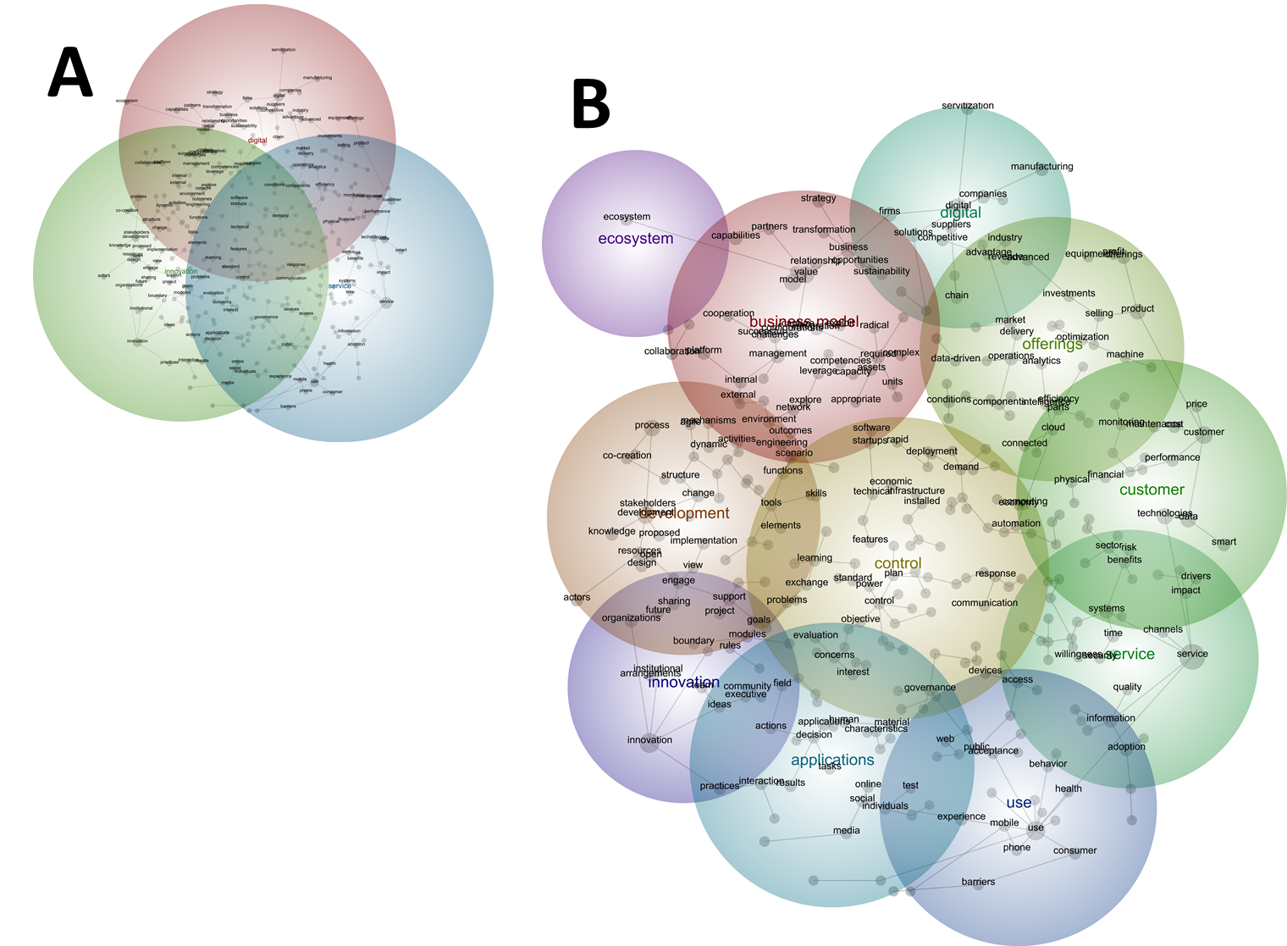
Figure A. Main DSI-related themes and concepts from Leximancer. 'Source: Authors own creation'

