Hybrid Human-Robot Teams in the Frontline: Automated Social Presence and the Role of Corrective Interrogation

WEB APPENDIX

Appendix A: Scenarios and descriptions
Pre-study
You just moved to a new home and would like to have a Wi-Fi connection for both work and leisure purposes. Therefore, you call your preferred internet provider to request an installation date. ​The internet company technician visits you on the agreed date. You kindly welcome the technician, and he enters your home. He holds a tablet.​ After agreeing on the internet subscription which suits your needs, an important issue is on your mind. Friends have advised you to pay specific attention to this. Hence, you ask the technician about where to install the Wi-Fi router and repeaters for a fast internet connection in every room.

FLR with speech and name
(https://www.dropbox.com/scl/fi/8fzopyomzdoxetxlekxjj/YesSpeechxYesName.mp4?rlkey=xkqgr1vxq42h5395w61wrib1h&dl=0)
The technician thanks you for your question and picks up his tablet that features the digital assistant Casey. He talks to Casey and describes some data about your home, including the number of rooms, squared meters, wall construction material, and fuse box location. After listening to the technician’s input, Casey provides a recommendation. Casey says: "the optimal location for the router is in the living room, right next to the TV. Besides, we should place one repeater at the entrance and a second one in your living room".​
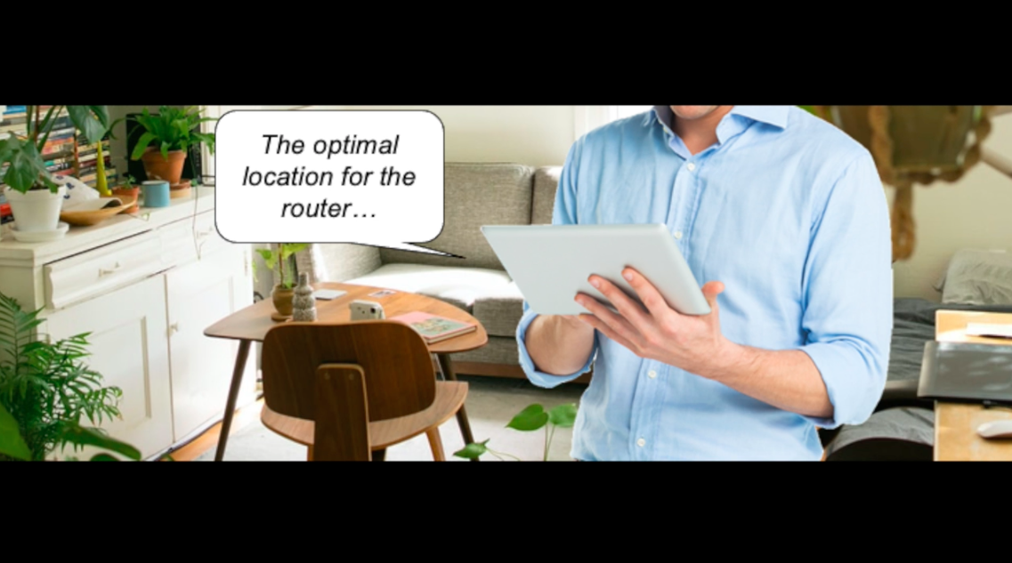

FLR with speech only
(https://www.dropbox.com/scl/fi/ldowqz6e1n9kh1s9rsk2e/YesSpeechxNoName.mp4?rlkey=q8v5lgge27p8dd0vbk36ok87j&dl=0)
The technician thanks you for your question and picks up his tablet that features a digital assistant. He talks to the digital assistant and describes some data about your home, including the number of rooms, squared meters, wall construction material, and fuse box location. After listening to the to the technician’s input, the digital assistant provides a recommendation. The digital assistant says: "the optimal location for the router is in the living room, right next to the TV. Besides, we should place one repeater at the entrance and a second one in your living room".​

FLR with name only
(https://www.dropbox.com/scl/fi/lhz6zmvx18n57fiuckie0/NoSpeechxYesName.mp4?rlkey=08nm82ebnfxyaetv2n7rzylhz&dl=0)
The technician thanks you for your question and picks up his tablet that features the digital assistant Casey. He types down in Casey’s interface some data about your home, including the number of rooms, squared meters, wall construction material, and fuse box location. After processing the technician's input, Casey provides the recommended location on the screen. The technician reads Casey's recommendation and tells you: "the optimal location for the router is in the living room, right next to the TV. Besides, we should place one repeater at the entrance and a second one in your living room".​


FLR without speech or name
(https://www.dropbox.com/scl/fi/i1eljwhzaot8akcih4m6g/NoSpeechxNoName.mp4?rlkey=tpoza05bqwtxdqdf7zitellhk&dl=0)
The technician thanks you for your question and picks up his tablet that features a digital assistant. He types down in the digital assistant’s interface some data about your home, including the number of rooms, squared meters, wall construction material, and fuse box location. After processing the technician's input, the digital assistant provides the recommended location on the screen. The technician reads the digital assistant's recommendation and tells you: "the optimal location for the router is in the living room, right next to the TV. Besides, we should place one repeater at the entrance and a second one in your living room".​

Study 1
You just moved to a new home and would like to have a Wi-Fi connection for both work and leisure purposes. Therefore, you call your preferred internet provider to request an installation date. ​The internet company technician visits you on the agreed date. You kindly welcome the technician, and he enters your home. He holds a tablet.​ After agreeing on the internet subscription which suits your needs, an important issue is on your mind. Friends have advised you to pay specific attention to this. Hence, you ask the technician about where to install the Wi-Fi router and repeaters for a fast internet connection in every room.

High-ASP FLR (https://www.dropbox.com/s/dou61sktgx33eeb/High_ASP_18.03.2023.mp4?dl=0)
The technician thanks you for your question and picks up his tablet that features the digital assistant Casey. He talks to Casey and describes some data about your home, including the number of rooms, squared meters, wall construction material, and fuse box location. After listening to the technician’s input, Casey provides a recommendation. Casey says: "the optimal location for the router is in the living room, right next to the TV. Besides, we should place one repeater at the entrance and a second one in your living room".​
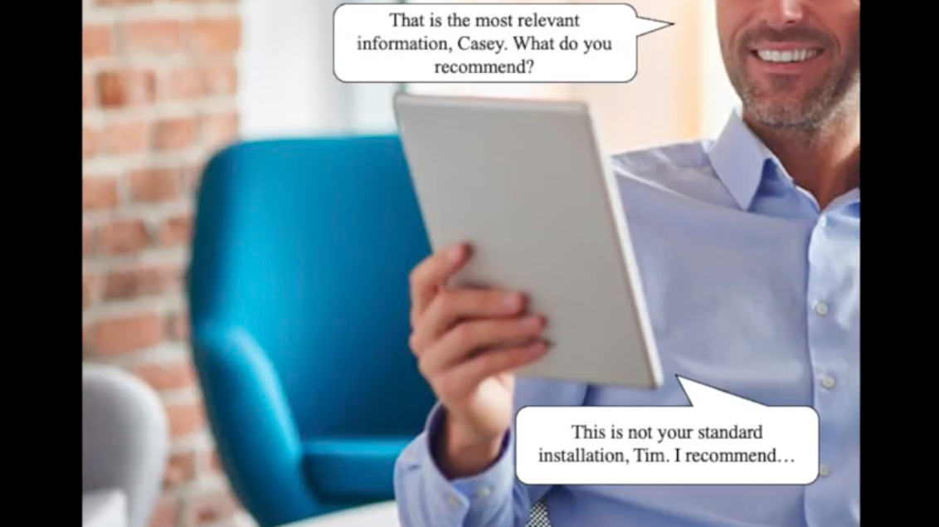

Low-ASP FLR
(https://www.dropbox.com/s/obikdptpw6keost/Low_ASP_18.03.2023.mp4?dl=0)
The technician thanks you for your question and picks up his tablet that features a digital assistant. He types down in the digital assistant’s interface some data about your home, including the number of rooms, squared meters, wall construction material, and fuse box location. After processing the technician's input, the digital assistant provides the recommended location on the screen. The technician reads the digital assistant's recommendation and tells you: "the optimal location for the router is in the living room, right next to the TV. Besides, we should place one repeater at the entrance and a second one in your living room".​
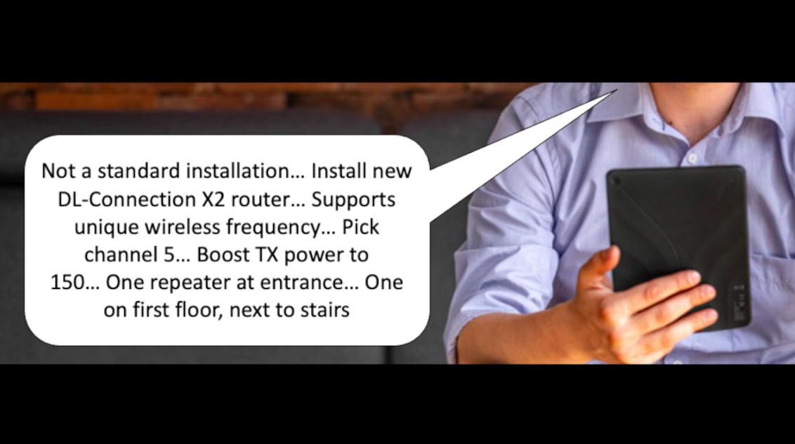

Study 2a
You just moved to a new home and would like to have a Wi-Fi connection. You call your preferred internet provider, which offers a service to arrange the entire installation of the connection for you. You select this option because you are not technically proficient, and because the neighbors told you that the installation in your new home is complex due to digital interference caused by the rooftop antennas and new wall construction materials. The provider’s technician, Tim, then visits you on the agreed date. You kindly welcome Tim, he comes in and starts the installation process.

High-ASP FLR x Confirmatory interrogation
(https://www.dropbox.com/s/z3ml2nmzayl2qpy/High_ASP_Yes_Inter_08.04.2023.mp4?dl=0)
The technician thanks you for your question and picks up his tablet that features the digital assistant Casey. He talks to Casey and describes some data about your home, including the number of rooms, squared meters, wall construction material, and fuse box location. After listening to the technician’s input, Casey provides a recommendation. Casey says: "the optimal location for the router is in the living room, right next to the TV. Besides, we should place one repeater at the entrance and a second one in your living room".​ After that, the technician double-checks if Casey took into consideration a relevant new element of your neighborhood by asking to his tablet: “Casey, have you also accounted in your recommendation for the new building under construction next to this apartment?”. Ultimately, Casey responds: “yes, I confirm that I did also factor in this aspect”.
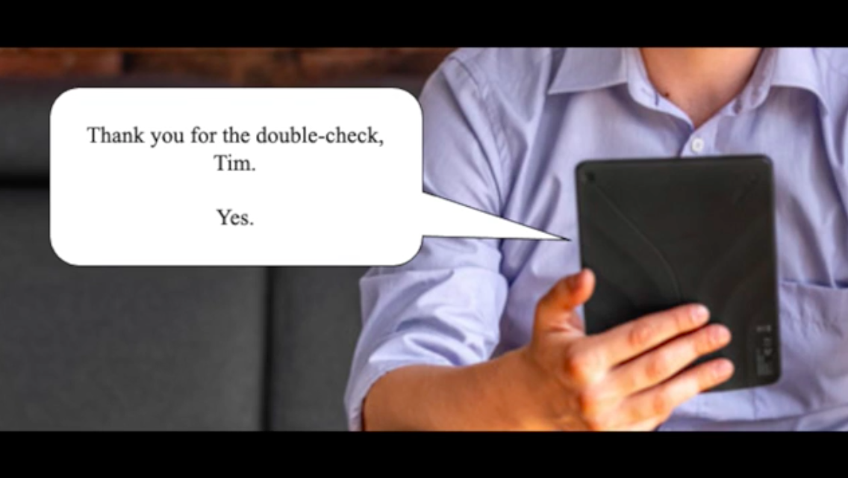

High-ASP FLR x No interrogation
(https://www.dropbox.com/s/t5k6t9dcdgu23xz/High_ASP_No_Inter_08.04.2023.mp4?dl=0)
The technician thanks you for your question and picks up his tablet that features the digital assistant Casey. He talks to Casey and describes some data about your home, including the number of rooms, squared meters, wall construction material, and fuse box location. After listening to the technician’s input, Casey provides a recommendation. Casey says: "the optimal location for the router is in the living room, right next to the TV. Besides, we should place one repeater at the entrance and a second one in your living room".​

Low-ASP FLR x Confirmatory interrogation
(https://www.dropbox.com/s/n4at716ddnea0vh/Low_ASP_Yes_Inter_08.04.2023.mp4?dl=0)
The technician thanks you for your question and picks up his tablet that features a digital assistant. He types down in the digital assistant’s interface some data about your home, including the number of rooms, squared meters, wall construction material, and fuse box location. After processing the technician's input, the digital assistant provides the recommended location on the screen. The technician reads the digital assistant's recommendation and tells you: "the optimal location for the router is in the living room, right next to the TV. Besides, we should place one repeater at the entrance and a second one in your living room".​ After that, the technician tells you he would like to double-check if the digital assistant took into consideration a relevant new element of your neighborhood. The technician types down in the digital assistant’s interface if the recommendation accounted for the new building under construction next to your apartment. Ultimately, the technician checks the output in his tablet and confirms that the recommendation already took into consideration this aspect.
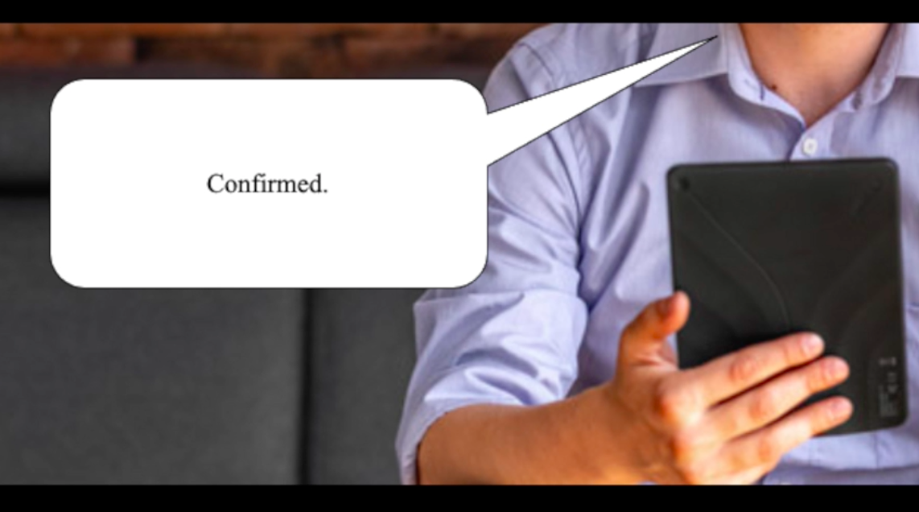

Low-ASP FLR x No interrogation
(https://www.dropbox.com/s/hgovtwe6qhyngse/Low_ASP_No_Inter_08.04.2023.mp4?dl=0)
The technician thanks you for your question and picks up his tablet that features a digital assistant. He types down in the digital assistant’s interface some data about your home, including the number of rooms, squared meters, wall construction material, and fuse box location. After processing the technician's input, the digital assistant provides the recommended location on the screen. The technician reads the digital assistant's recommendation and tells you: "the optimal location for the router is in the living room, right next to the TV. Besides, we should place one repeater at the entrance and a second one in your living room".​

Study 2b
You just moved to a new home and would like to have a Wi-Fi connection. You call your preferred internet provider, which offers a service to arrange the entire installation of the connection for you. You select this option because you are not technically proficient, and because the neighbors told you that the installation in your new home is complex due to digital interference caused by the rooftop antennas and new wall construction materials. The provider’s technician, Tim, then visits you on the agreed date. You kindly welcome Tim, he comes in and starts the installation process.

High-ASP FLR x Corrective interrogation
(https://www.dropbox.com/s/kif6hurjqifv8cp/High_ASP_Corrective_Inter_24.04.2023.mp4?dl=0)
Tim introduces you to his digital colleague called Casey. He says: “Good morning, Casey. How are you?”. Casey responds: “Good morning, Tim. All fine here. And good morning, dear customer. Nice to meet you! I help Tim analyze complex situations and provide advice for optimal Wi-Fi installations. I am happy to offer my sensorics and algorithmic power to solve your problems. Let’s get started!”. Tim then walks around your home with Casey and communicates some observations to Casey, such as the number of rooms, square meters, fuse box location, the location of the antenna and wall construction material. He finishes by saying: “That is the most relevant information, Casey. What do you recommend?” Casey responds: “This is not your standard installation, Tim. I recommend that we install the new DL-Connection X2 router because it supports a unique wireless frequency. We should pick channel 5 and boost the TX power to 125. Also, we should place one repeater at the front door and a second one on the first floor, next to the stairs”.​ Tim says: “Casey, I think you made a mistake on the interference parameter for the number of home appliances. Did you change back to the default settings after the last client? Casey responds: “Oh you’re right, I forgot to reset it to default. Thanks for catching that. After re-running the analysis, Casey continues: With what I see now, we should boost the TX power to 150”. Tim says: “Excellent. That sounds more like it, Casey. Let’s do it”.
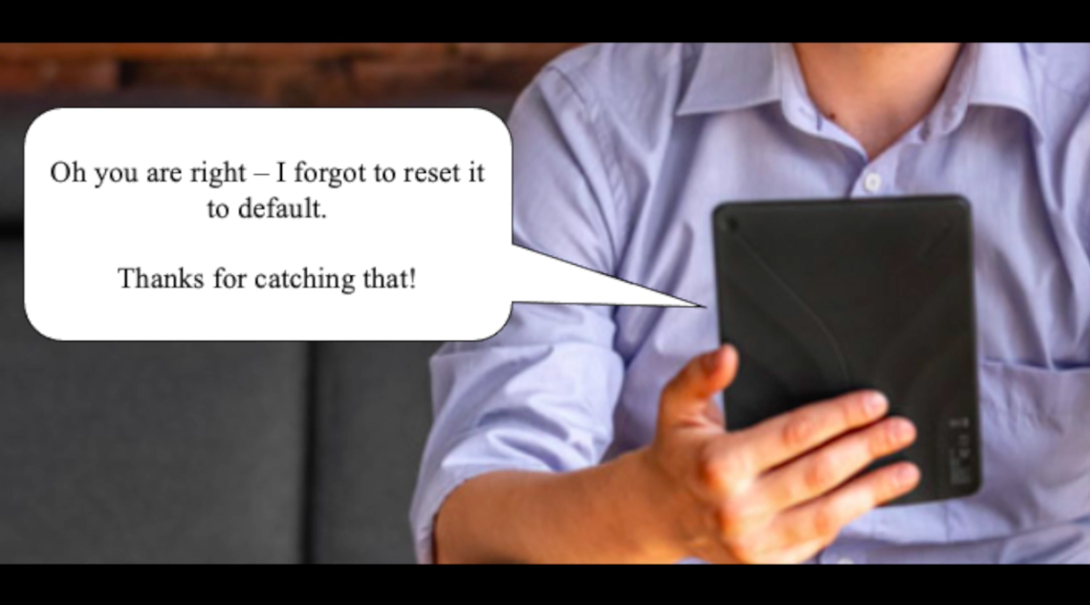

High-ASP FLR x No interrogation
(https://www.dropbox.com/s/i7zto1me7b8zfnz/High_ASP_No_Inter_24.04.2023.mp4?dl=0)
Tim introduces you to his digital colleague called Casey. He says: “Good morning, Casey. How are you?”. Casey responds: “Good morning, Tim. All fine here. And good morning, dear customer. Nice to meet you! I help Tim analyze complex situations and provide advice for optimal Wi-Fi installations. I am happy to offer my sensorics and algorithmic power to solve your problems. Let’s get started!”. Tim then walks around your home with Casey and communicates some observations to Casey, such as the number of rooms, square meters, fuse box location, the location of the antenna and wall construction material. He finishes by saying: “That is the most relevant information, Casey. What do you recommend?” Casey responds: “This is not your standard installation, Tim. I recommend that we install the new DL-Connection X2 router because it supports a unique wireless frequency. We should pick channel 5 and boost the TX power to 150. Also, we should place one repeater at the front door and a second one on the first floor, next to the stairs”. Tim says: “Excellent; thanks Casey. Let’s do it”.

Low-ASP FLR x Corrective interrogation
(https://www.dropbox.com/s/pgzgqau1t9p3uo5/Low_ASP_Corrective_Inter_24.04.2023.mp4?dl=0)
Tim picks up his tablet. He explains to you that the tablet can analyze complex situations and provide advice for optimal Wi-Fi installations, thanks to its sensorics and algorithmic power.
Tim then walks around your home with the tablet and enters in its interface some observations, such as the number of rooms, square meters, fuse box location, the location of the antenna and wall construction material. He finishes by saying to you: “I entered the most relevant information. Now let’s see what the tablet recommends.” Tim interprets the information from the screen, and says to himself: “Hmm, not a standard installation… Install new DL-Connection X2 router… Supports unique wireless frequency… Pick channel 5… Boost TX power to 125… One repeater at the front door… One on first floor, next to stairs”.​ “That can’t be right with all these appliances here”. Tim double-checks the tablet’s recommendation and says: “This is the interference parameter from the last client – the tablet should have updated it automatically!”. Tim re-runs the analysis and receives a new recommendation that suggests boosting the TX power to 150. He says: “Ok, this makes better sense. Let’s do it”.
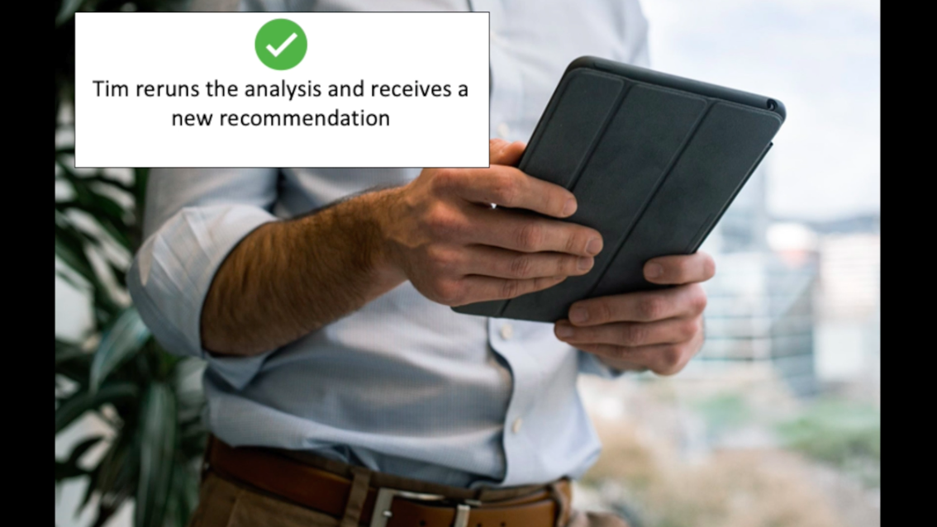

Low-ASP FLR x No interrogation
(https://www.dropbox.com/s/2utkk73b74cfmao/Low_ASP_No_Inter_24.04.2023.mp4?dl=0)
Tim picks up his tablet. He explains to you that the tablet can analyze complex situations and provide advice for optimal Wi-Fi installations, thanks to its sensorics and algorithmic power.
Tim then walks around your home with the tablet and enters in its interface some observations, such as the number of rooms, square meters, fuse box location, the location of the antenna and wall construction material. He finishes by saying to you: “I entered the most relevant information. Now let’s see what the tablet recommends.” Tim interprets the information from the screen, and you hear him say to himself: “Hmm, not a standard installation… Install new DL-Connection X2 router… Supports unique wireless frequency… Pick channel 5… Boost TX power to 150… One repeater at the front door… One on first floor, next to stairs”. Tim says to you: “Ok, I got it. Let’s do it”.

Appendix B: Constructs and items
Constructs and items |  | Cronbach’s alpha |  |  |  | Source
Constructs and items | Pre-study | Study 1 | Study 2a | Study 2b | Post hoc
Automated social presence  To which extent do you agree with the following statements?  - I feel like the technician interacts with another being when dealing with his support technology  - I feel like the support technology is a living being  - I feel like the support technology is present in a human-like way  - When using his support technology, it was almost as if the technician was accompanied by a “colleague”  [Calibration for Post hoc study]  - I see JENS as my colleague  - I consider JENS as my friend during customer visits  - In my job, JENS functions like a true sales associate  - I see JENS as my partner when interacting with customers  - JENS’ presence does not go unnoticed in talks with customers  - JENS is perceived as a present actor during customer interactions  - JENS is acknowledged as another party in the conversations with customers | .87 | .90 | .89 | .88 | .92 | Čaić et al. (2020), Odekerken-Schröder et al. (2021)
Teamwork quality | - | .89 | .87 | .87 | .96 | Guzzo and Shea (1992), Hatcher and Ross (1991)
To which extent do you agree with the following statements? |  |  |  |  |  | Guzzo and Shea (1992), Hatcher and Ross (1991)
- The technician and the support technology help one another  - The technician and the support technology communicate effectively  - The technician and the support technology work well together  - The technician and the support technology work as a team  - The technician and the support technology are commited to the same goal  [Calibration for Post hoc study]  - The interaction between JENS and me is smooth  - JENS and I make up a strong pair  - JENS and I produce good quality work  - JENS and I help one another  - JENS and I communicate effectively  - JENS and I work well together  - JENS and I work as a team  - JENS and I are committed to the same goal |  |  |  |  |  | Guzzo and Shea (1992), Hatcher and Ross (1991)
Competence  I would say the FLE was…  - Incompetent – Competent  - Unintelligent – Intelligent  - Poorly-trained – Well-trained | - | .90 | .90 | .91 | - | Scott et al. (2013)
Warmth  I would say the FLE was…  - Unhelpful – Helpful  - Selfish – Unselfish  - Uncaring – Caring | - | .86 | .80 | .81 | - | Scott et al. (2013)
Interrogation  To which extent do you agree with the following statements?  - I often choose to ignore or disregard JENS’ insights  - In many situations, I rely on my own judgement rather than on JENS’  - I frequently deviate from JENS’ suggestions and follow my own intuition  - I often double-check JENS’ outcomes  - I regularly verify JENS’ recommendations  - I tend to carefully check, or even respecify, JENS’ advice parameters when I doubt the validity of its advice | - | - | - | - | .68 | Castelo, Bos, and Lehmann (2019); Kaiser, Schreier, and Janiszewski (2017)

