Supplementary Materials

Appendix 1: Study 1, 2 and 4 Online Scenarios
Humanoid Social Robot (Sophia) performing a Master (Boss) Role during a Human-Robot Collaboration in an electronics retail store. | Humanoid Social Robot (Sophia) performing a Servant (Employee) Role during a Human-Robot Collaboration in an electronics retail store.
Imagine that you want to purchase a new high-performance laptop computer for your personal business.  You visit your preferred electronics store, which always has the best product offerings, advice and customer service.  As you enter the store, you see a humanoid social robot working alongside a human salesperson. Its name is Sophia.  Before asking for assistance, you observe the interaction between the salesperson and Sophia and quickly realize that Sophia is acting like a boss over the salesperson.  You notice that Sophia is a human replica. It mimics unique human behaviors. Sophia does not look or act like a mechanical device.  Sophia is as autonomous and intelligent as any other human being. Sophia performs without human assistance and cognitively is better than the artificial intelligence chatbots, like ChatGTP or Bing Chat, but with a humanoid body.  You realize that Sophia’s social interactions with other staff members and customers resemble human-to-human interactions. | Imagine that you want to purchase a new high-performance laptop computer for your personal business.  You visit your preferred electronics store, which always has the best product offerings, advice and customer service.  As you enter the store, you see a humanoid social robot working alongside a human salesperson. Its name is Sophia.  Before asking for assistance, you observe the interaction between the salesperson and Sophia and quickly realize that the salesperson is acting like a boss over Sophia.  You notice that Sophia is a human replica. It mimics unique human behaviors. Sophia does not look or act like a mechanical device.  Sophia is as autonomous and intelligent as any other human being. Sophia performs without human assistance and cognitively is better than the artificial intelligence chatbots, like ChatGTP or Bing Chat, but with a humanoid body.  You realize that Sophia’s social interactions with other staff members and customers resemble human-to-human interactions.
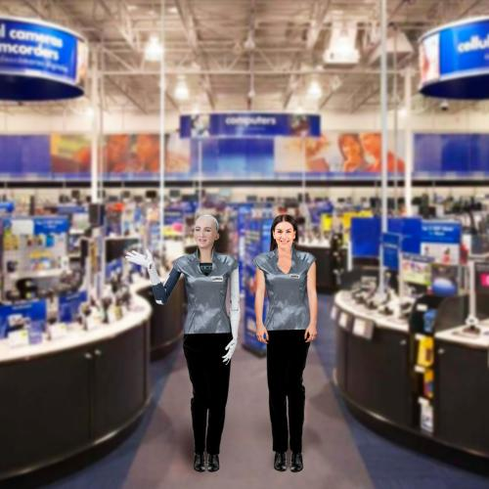 | 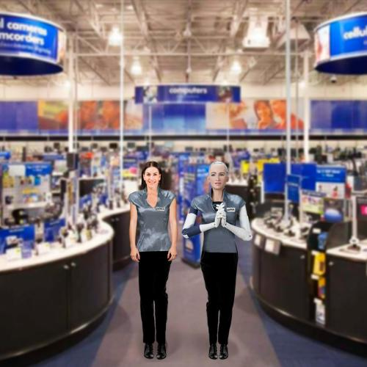
You perceive that Sophia can work alongside other staff and customers and that interacting with Sophia is similar to or better than interacting with human staff.  You realize that consumers are enjoying their in-store experience with the humanoid-social robot. | You perceive that Sophia can work alongside other staff and customers and that interacting with Sophia is similar to or better than interacting with human staff.  You realize that consumers are enjoying their in-store experience with the humanoid-social robot.
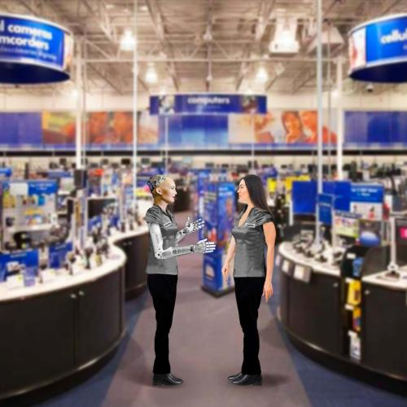 | 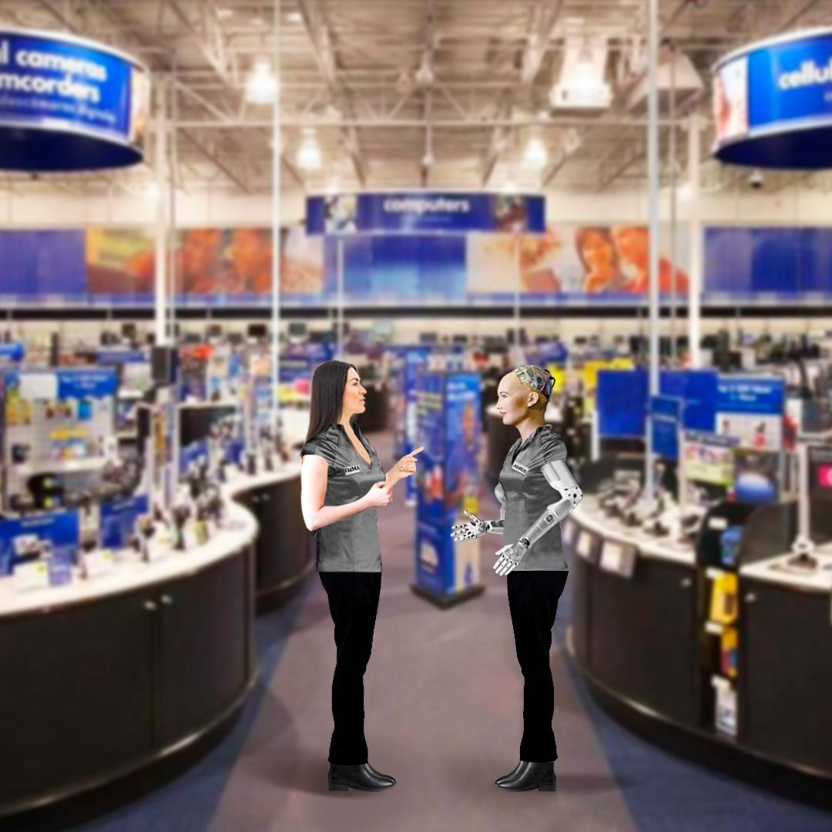
Sophia orders the salesperson to follow its instructions, and you see that the salesperson complies with the humanoid social robot’s commands. | The salesperson orders Sophia to follow her instructions, and you see that Sophia complies with the human’s commands.
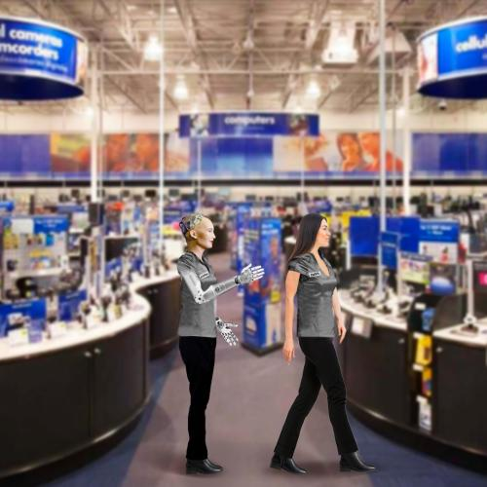 | 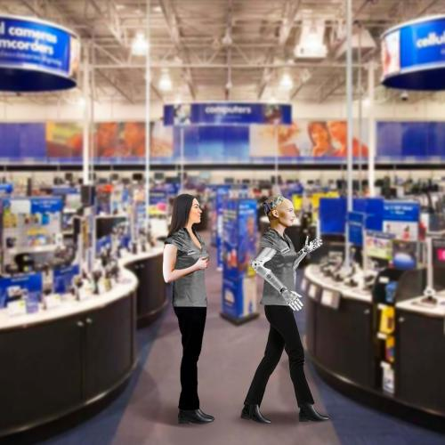
After witnessing the interaction between Sophia and the salesperson, you approach Sophia to ask about the best choice of laptops for your needs and budget.  When you finished interacting with Sophia, you felt pleased by its customer service and the options offered. She performed better than a salesperson.  When you left you saw a sign informing customers that more human-social robots will be hired by the store as service staff. | After witnessing the interaction between Sophia and the salesperson, you approach Sophia to ask about the best choice of laptops for your needs and budget.  When you finished interacting with Sophia, you felt pleased by its customer service and the options offered. She performed better than a salesperson.  When you left you saw a sign informing customers that more human-social robots will be hired by the store as service staff.

Appendix 2: Study 3 Scenarios
Humanoid Social Robot (Sophia) performing a Master (Boss) Role during a Human-Robot Collaboration in a camping retail store. | Humanoid Social Robot (Sophia) performing a Servant (Employee) Role during a Human-Robot Collaboration in a camping retail store.
Imagine that you want to purchase camping equipment for a vacation trip.  You visit your preferred camping store, which always has the best product offerings, advice and customer service.  As you enter the store, you see a humanoid social robot working alongside a human salesperson. Its name is Sophia.  Before asking for assistance, you observe the interaction between the salesperson and Sophia and quickly realize that Sophia is acting like a boss over the salesperson.  You notice that Sophia is a human replica. It mimics unique human behaviors. Sophia does not look or act like a mechanical device.  Sophia is as autonomous and intelligent as any other human being. Sophia performs without human assistance and cognitively is better than the artificial intelligence chatbots, like ChatGTP or Bing Chat, but with a humanoid body.  You realize that Sophia’s social interactions with other staff members and customers resemble human-to-human interactions. | Imagine that you want to purchase camping equipment for a vacation trip.  You visit your preferred camping store, which always has the best product offerings, advice and customer service.  As you enter the store, you see a humanoid social robot working alongside a human salesperson. Its name is Sophia.  Before asking for assistance, you observe the interaction between the salesperson and Sophia and quickly realize that the salesperson is acting like a boss over Sophia.  You notice that Sophia is a human replica. It mimics unique human behaviors. Sophia does not look or act like a mechanical device.  Sophia is as autonomous and intelligent as any other human being. Sophia performs without human assistance and cognitively is better than the artificial intelligence chatbots, like ChatGTP or Bing Chat, but with a humanoid body.  You realize that Sophia’s social interactions with other staff members and customers resemble human-to-human interactions.
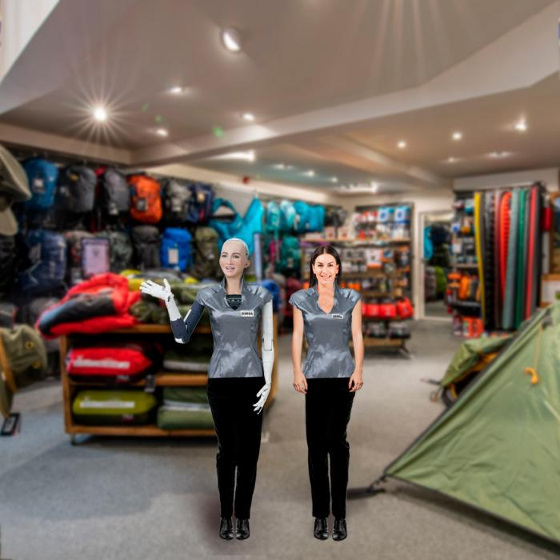 | 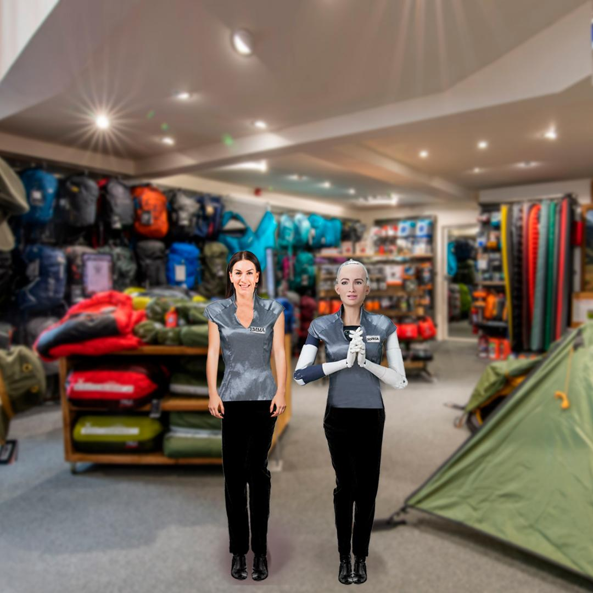
You perceive that Sophia can work alongside other staff and customers and that interacting with Sophia is similar to or better than interacting with human staff.  You realize that consumers are enjoying their in-store experience with the humanoid-social robot. | You perceive that Sophia can work alongside other staff and customers and that interacting with Sophia is similar to or better than interacting with human staff.  You realize that consumers are enjoying their in-store experience with the humanoid-social robot.
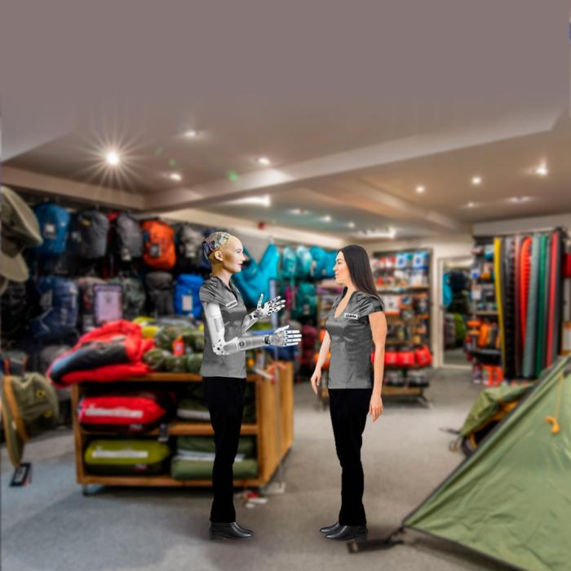 | 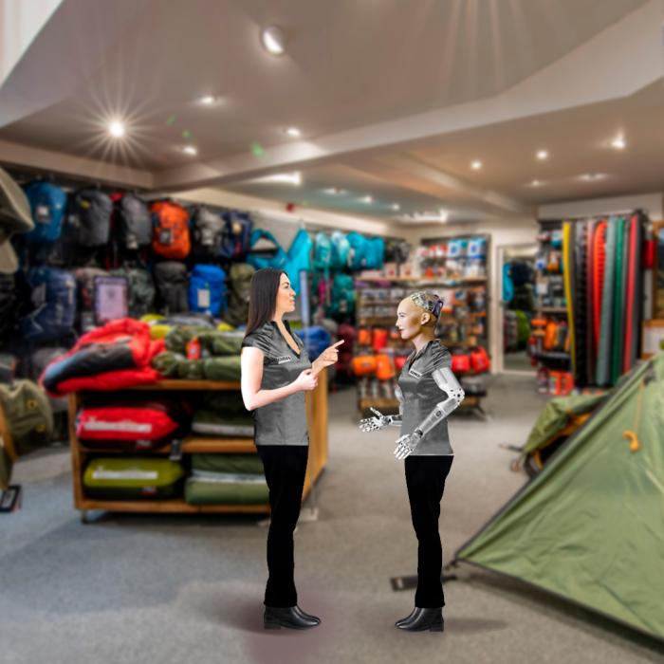
Sophia orders the salesperson to follow its instructions, and you see that the salesperson complies with the humanoid social robot’s commands. | The salesperson orders Sophia to follow her instructions, and you see that Sophia complies with the human’s commands.
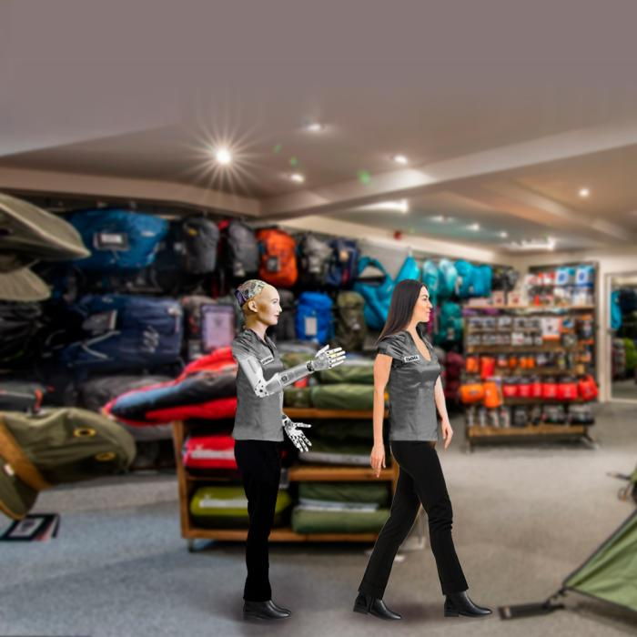 | 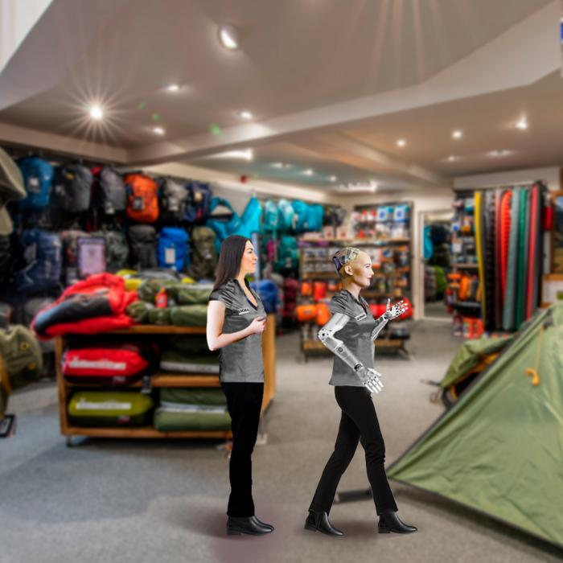
After witnessing the interaction between Sophia and the salesperson, you approach Sophia to ask about the best choice of camping equipment for your needs and budget.  When you finished interacting with Sophia, you felt pleased by its customer service and the options offered. She performed better than a salesperson.  When you left you saw a sign informing customers that more human-social robots will be hired by the store as service staff. | After witnessing the interaction between Sophia and the salesperson, you approach Sophia to ask about the best choice of camping equipment for your needs and budget.  When you finished interacting with Sophia, you felt pleased by its customer service and the options offered. She performed better than a salesperson.  When you left you saw a sign informing customers that more human-social robots will be hired by the store as service staff.

Appendix 3: Study 4 Prime
Robot Threats | No Robot Threats
Please read the following news article carefully, as we will be asking you some related questions.  The Robot Takeover! Industry trends suggest that 40% of all retail jobs will disappear in 20 years!  Autonomous robots are taking on inventory management and customer service roles. The International Federation of Robotics (IFR) reported that the retail sector saw a 60% increase in the use of robots in the past year. Robots have found roles in tasks such as sales assistance, restocking and cleaning duties. The IFR says that these robots aim to enhance guest experiences. However, Sam (a retail service assistant) said: “I was replaced by a robot, and my job was made redundant.”  Robots are changing the nature of work. As these industries continue to adapt to technological advancements, workers like Sam will face many challenges ahead. | Please read the following news article carefully, as we will be asking you some related questions.  The Robot Revolution! Industry trends suggest that 40% of all retail jobs will be improved in the next 20 years!  Autonomous robots are helping to improve inventory management and customer service roles. The International Federation of Robotics (IFR) reported that the retail sector saw a 60% increase in the use of robots in the past year. Robots have helped to improve the performance of roles such as sales assistance, restocking and cleaning duties. The IFR says that these robots aim to enhance guest experiences. In support, Sam (a retail service assistant) said: “My performance improved so much by working with a robot.”  Robots are changing the nature of work. As these industries continue to adapt to technological advancements, workers like Sam will see their performance skyrocket.
Please state whether you agree or disagree with the following statements:
(7-point Likert scale ranging from 1 = strongly disagree to 7 = strongly agree)
- Robots pose a direct threat to humans.
- I feel threatened by Robots.

Appendix 4: Overview of demographics (Source: Authors own work)

Category | Frequencies
 | Study 1 | Study 2 | Study 3 | Study 4
Gender
Female | 88 | 93 | 259 | 281
Male | 100 | 102 | 220 | 216
Age
18-25 | 30 | 31 | 59 | 57
26-30 | 27 | 31 | 69 | 69
31-40 | 64 | 65 | 142 | 135
41-50 | 29 | 29 | 102 | 105
51-60 | 19 | 20 | 79 | 94
Over 60 | 19 | 19 | 28 | 37
Education
Less than High School | 0 | 0 | 7 | 1
High School / GED | 31 | 31 | 89 | 78
Some College Degree | 117 | 124 | 310 | 334
Masters/Doctoral Degree/PhD | 37 | 37 | 64 | 73
Professional Degree (JD, MD) | 3 | 3 | 9 | 11
Income
Under $10,000 | 12 | 13 | 30 | 28
$10,001 - $20,000 | 11 | 11 | 26 | 31
$20,001 - $30,000 | 15 | 15 | 49 | 51
$30,001 - $50,000 | 40 | 41 | 91 | 105
$50,001 - $70,000 | 33 | 35 | 87 | 94
$70,001 - $90,000 | 20 | 20 | 52 | 66
$90,001 - $100,000 | 15 | 17 | 32 | 26
Over $100,000 | 42 | 43 | 112 | 96
Total | 188 | 195 | 479 | 497

Appendix 5: Construct reliability and convergent validity (Source: Authors own work)

Constructs and their items | Study 3 |  |  |  | Study 4
 | Loads | α | CR | AVE | Loads | α | CR | AVE
Intention to use |  | .979 | .983 | .929 |  | .978 | .983 | .919
- I will use the humanoid social robot to search for information on products | .957 |  |  |  | .944
- I will use the humanoid social robot to select my products at the store. | .948 |  |  |  | .952
- I intend to use the humanoid social robot to proceed with my purchase at the store. | .966 |  |  |  | .964
- I plan to use the humanoid social robot in the future. | .960 |  |  |  | .968
- I will use the humanoid social robot at this store to make a purchase. | .973 |  |  |  | .967
Trust |  | .880 | .869 | .808 |  | .904 | .941 | .841
- The humanoid social robot is trustworthy. | .832 |  |  |  | .933
- I have a good feeling when relying on the humanoid social robot. | .906 |  |  |  | .920
- I can trust the information presented by the humanoid social robot. | .747 |  |  |  | .898
Realistic threat |  |  |  |  |  | .722 | .845 | .646
- The increased use of humanoid social robots in our everyday life is causing more job losses for humans. |  |  |  |  | .751
- In the long run, humanoid social robots pose a direct threat to human safety and wellbeing. |  |  |  |  | .886
- I would feel very nervous just standing in front of a humanoid social robot. |  |  |  |  | .768
Speciesism |  | .776 | .933 | .690 |  | .759 | .862 | .676
- Interacting with humanoid social robots rather than human might make me angry. | .852 |  |  |  | .809
- When I interact with humanoid social robots, I do not feel as good as I do with human. | .940 |  |  |  | .909
- I think there’s a big difference between talking to real people or talking to humanoid social robots. | .930 |  |  |  | .741
Note: All items have high loadings. Criteria: Cronbach’s α > 0.70 (Peterson, 1994), Composite Reliability (CR) > 0.70 and Average Variance Extracted (AVE) > 0.50 (Hair et al., 2010).

