Web Appendix 2. Bibliographic Analysis
First, keyword analysis explored the topical focus of the selected studies. To ensure consistency, we standardized similar keywords (e.g., “NLP” and “natural language processing”). Figure 1 shows the keyword co-occurrence graph, where dots represent keywords and connecting lines show relationships. Nodes with low connectivity were filtered out to focus on significant relationships. As a result, “natural language processing” appeared most frequently (24). Next are “machine learning” (21) and “sales” (20), followed by “customer service” (16) and “call center” (15). Most other keywords are focused on modeling and techniques, including “artificial intelligence”, “neural networks”, and “speech recognition.” The visualization highlights central research domains and illustrates how key concepts interconnect, revealing dominant focus areas and topic clustering within the literature.
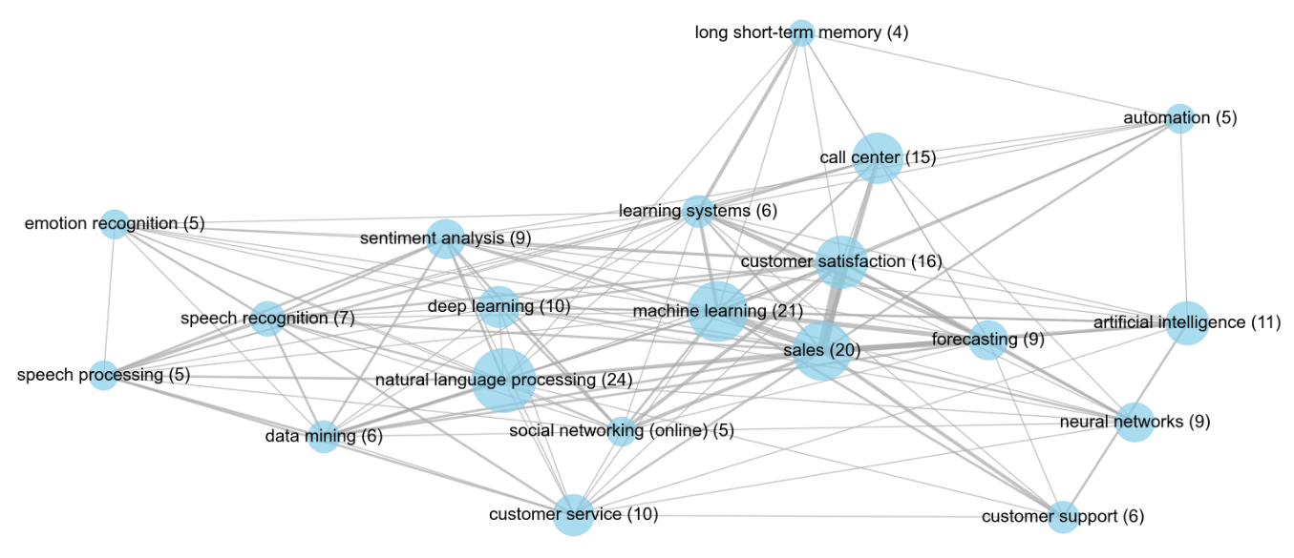
Figure 1: Keyword Co-Occurrence Network Graph
Notes: The dots represent the keywords, with larger dots indicating higher keyword frequencies. The lines between the keywords represent their relation, with the keywords co-occurring more frequently for wider lines.
Based on our six themes, we can explore further insights. First, we analyze both yearly distribution per theme and total annual publications (see Figure 3). Overall, there has been a steady increase in publications on these topics, with a slight dip observed in 2022. As articles are only included up to April 2025, a growth trend is expected, as denoted by the star in Figure 2. Notably, themes 6 (augmentation) and 3 (service agent well-being) peak in 2024, highlighting both the recency and rising importance of these topics. This trend reflects growing research interest not only in applying technical methods to service data but also in how technology supports augmentation and service agent well-being.
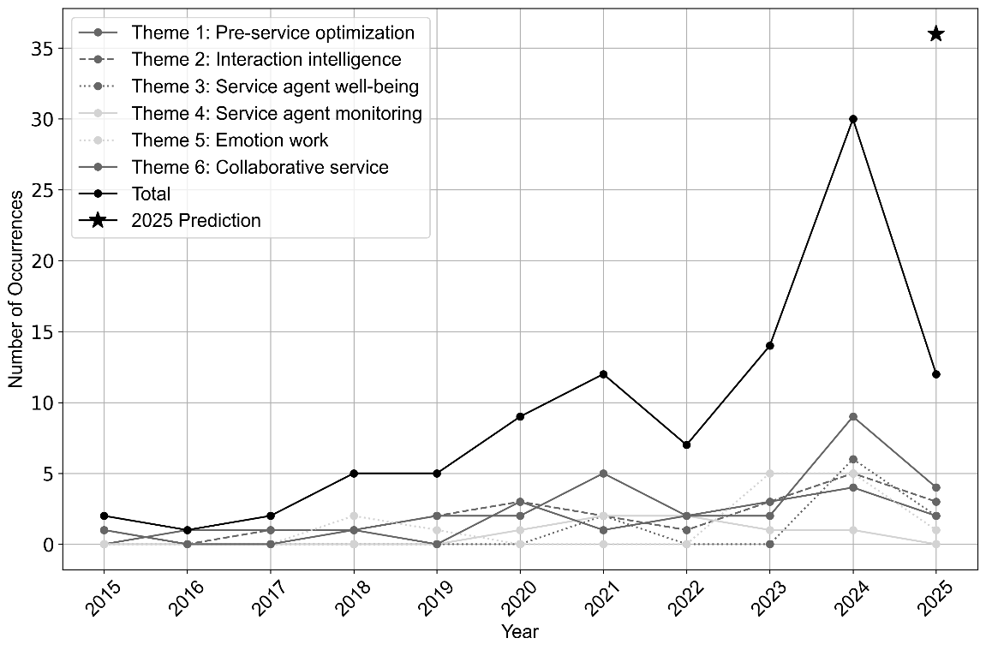
Figure 2: Distribution of Papers over Time
Subsequently, we examined the types of modalities employed in the articles (see Figure 3). The majority rely on text-based communication, such as live chat or transcribed audio. This reflects the continued centrality of written communication in organizational service interactions. Speech is the second most commonly used modality, typically analyzed in phone-based customer service. While speech data enables the analysis of tone and paralinguistic cues, it is often treated separately from textual data, limiting opportunities to understand how service agents shift across modalities in real-time or utilize them in tandem. Only six studies combine text and speech, suggesting that multimodal analysis remains relatively rare, despite its potential to capture the complexity of frontline service interactions. This scarcity may stem from methodological difficulties or data availability constraints, but it also signals a missed opportunity to better reflect the hybrid nature of modern service interactions.
Remarkably, just one study includes video as a modality. This underrepresentation may reflect both the limited availability in practice and the methodological or privacy-related constraints of studying such data. It also indicates that, to date, service research has focused predominantly on text and speech, with minimal attention to visual modalities.
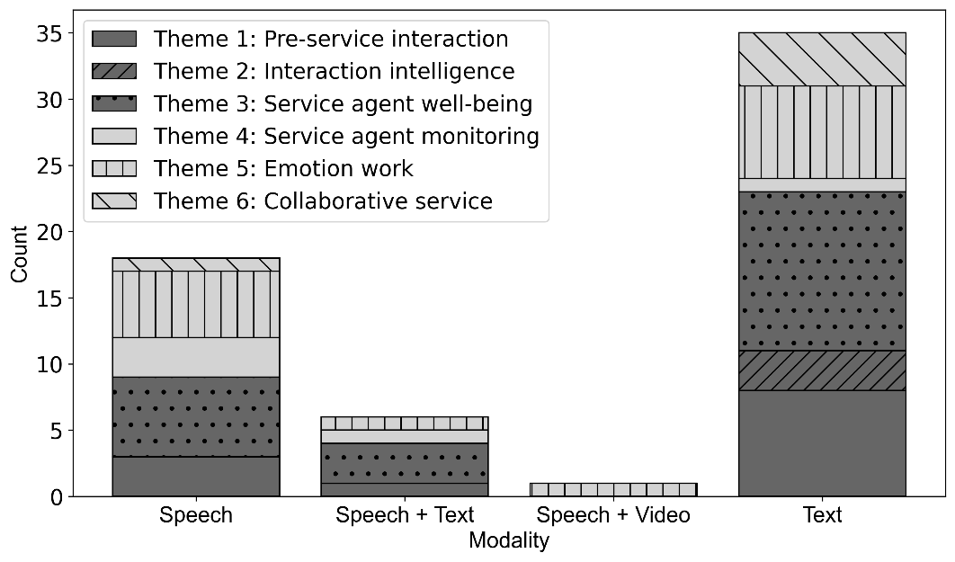
Figure 3: Distribution of Modalities
Finally, we examined model types (see Figure 4). Most studies rely on ML models, particularly neural networks. ML is a type of AI where models learn patterns from data to make predictions about unseen data (Janiesch et al., 2021). Neural networks are ML models that mirror how the human brain processes information, breaking inputs into smaller parts, processing them in steps, and identifying patterns (Janiesch et al., 2021). Additionally, studies explore various model types, including robots, mobile applications, augmented reality systems, and simulation-based studies, highlighting the diverse applications of technology in this field. Then, classification models, including statistical approaches like regression, are the third most common type. Notably, few studies utilize a generative AI model, indicating this area remains in an early exploration stage. Except for one study in 2023, all generative research was published later, highlighting its recent emergence.
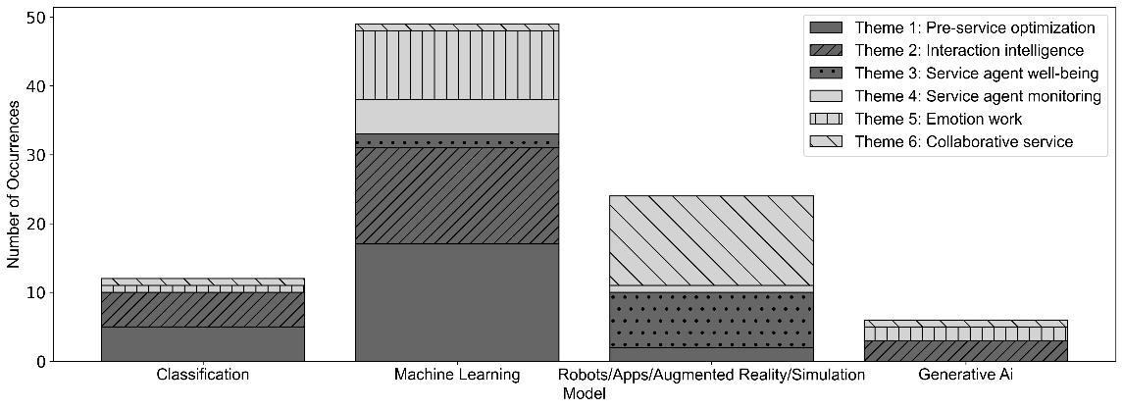
Figure 4: Distribution of Types of Models

