Some Agents are more Similar than Others:
Customer Orientation of Frontline Robots and Employees

WEB APPENDIX

Appendix A: Scenarios and descriptions

Study 1
FLE
You are considering to buy a new television. Therefore, you visit a consumer electronics store with brands and models you find interesting.
A sales agent welcomes you:
Good morning, welcome to our store.
Please, let me know in case you would appreciate some assistance. I will be glad to help.
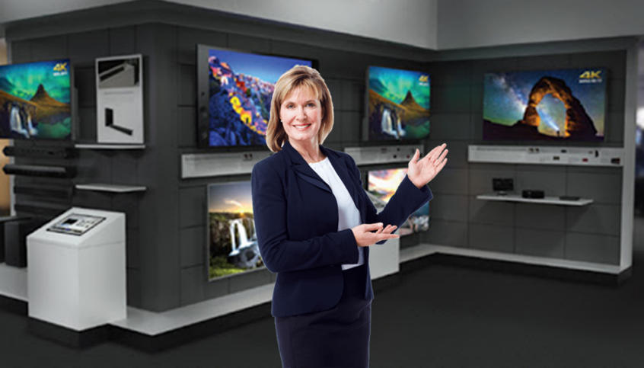

FLR
You are considering to buy a new television. Therefore, you visit a consumer electronics store with brands and models you find interesting.
A sales agent welcomes you:
Good morning, welcome to our store.
Please, let me know in case you would appreciate some assistance. I will be glad to help.
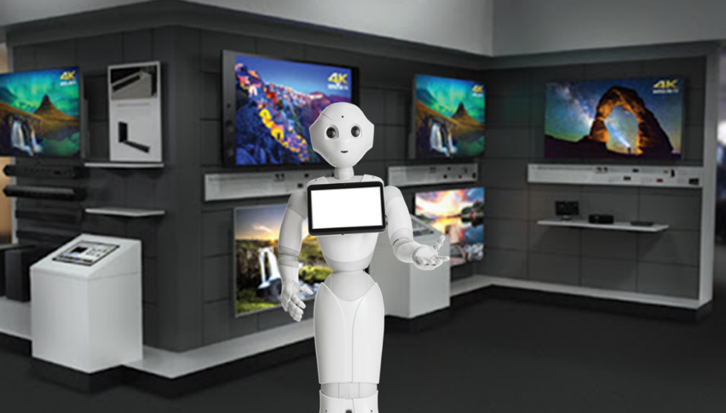

Study 2
FLE using relational style
You are considering buying a new coffee table for your living room. Therefore, you visit a furniture store you like, from where you bought a couch last year.
A sales agent welcomes you:
Good morning, I am happy to see you are back at our store.
I hope you still enjoy the couch you bought from us last year. This season we have new furniture pieces matching your style – I would be glad to walk you through them.
Is there anything in particular you are looking for?
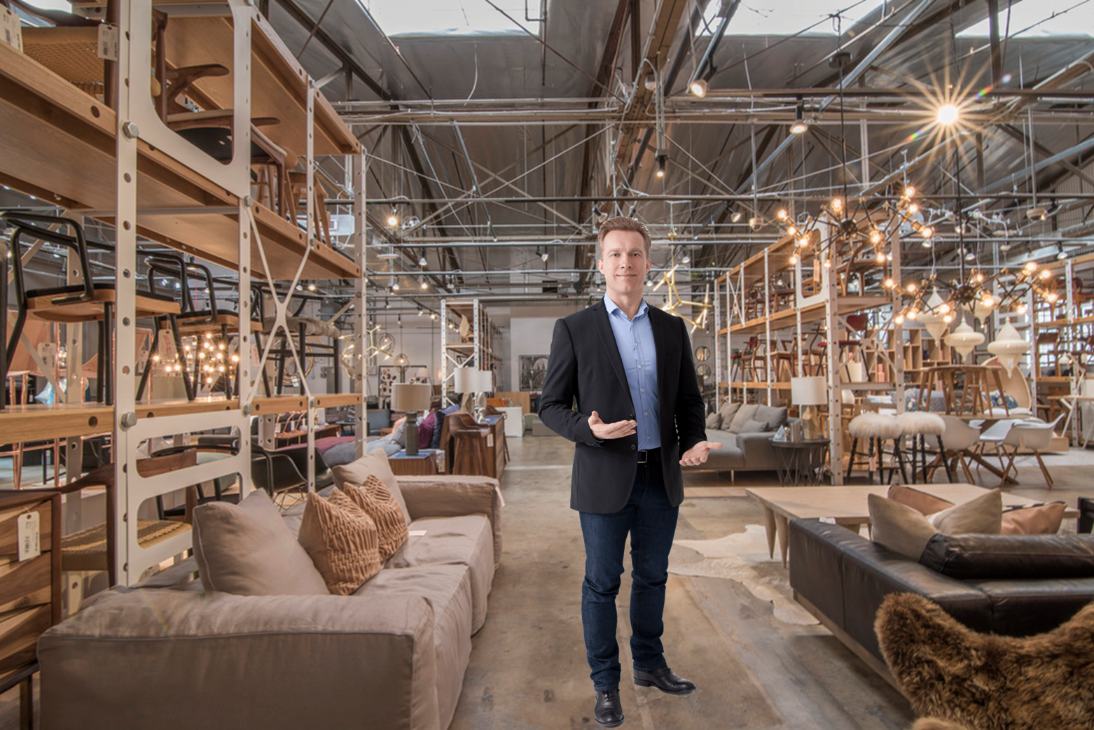

FLE using transactional style
You are considering buying a new coffee table for your living room. Therefore, you visit a furniture store you like, from where you bought a couch last year.
A sales agent welcomes you:
Good morning, welcome to our store.
We have a wide variety of furniture pieces and interesting offers for today – I would be glad to walk you through them.
Is there anything in particular you are looking for?

FLR using relational style
You are considering buying a new coffee table for your living room. Therefore, you visit a furniture store you like, from where you bought a couch last year.
A sales agent welcomes you:
Good morning, I am happy to see you are back at our store.
I hope you still enjoy the couch you bought from us last year. This season we have new furniture pieces matching your style – I would be glad to walk you through them.
Is there anything in particular you are looking for?
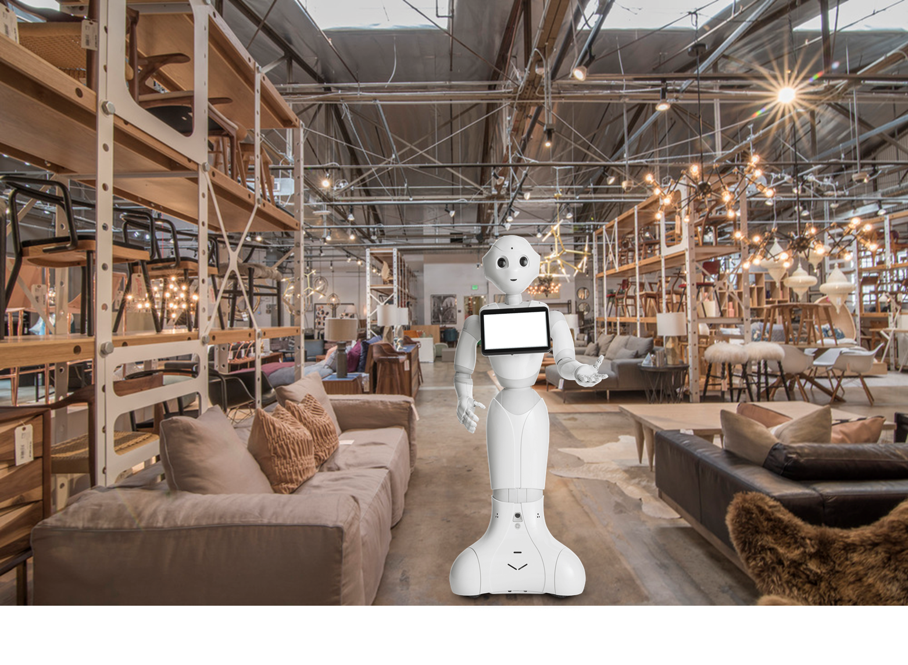

FLR using transactional style
You are considering buying a new coffee table for your living room. Therefore, you visit a furniture store you like, from where you bought a couch last year.
A sales agent welcomes you:
Good morning, welcome to our store.
We have a wide variety of furniture pieces and interesting offers for today – I would be glad to walk you through them.
Is there anything in particular you are looking for?

Study 3b
FLE in the negotiation stage
You are considering to buy a new automobile for private use. You gathered some information on the different options to make the right decision and already made up your mind on which specific automobile brand and model you want to purchase. Therefore, you made an appointment at an automobiles dealership to see whether you can come to an agreement.
A sales agent welcomes you:
Good morning, welcome to our store.
You made an appointment because you are interested in buying one of our cars and are ready to negotiate a purchase. I would be happy to discuss the price, payment options, promotions and more. Shall we head to my office?
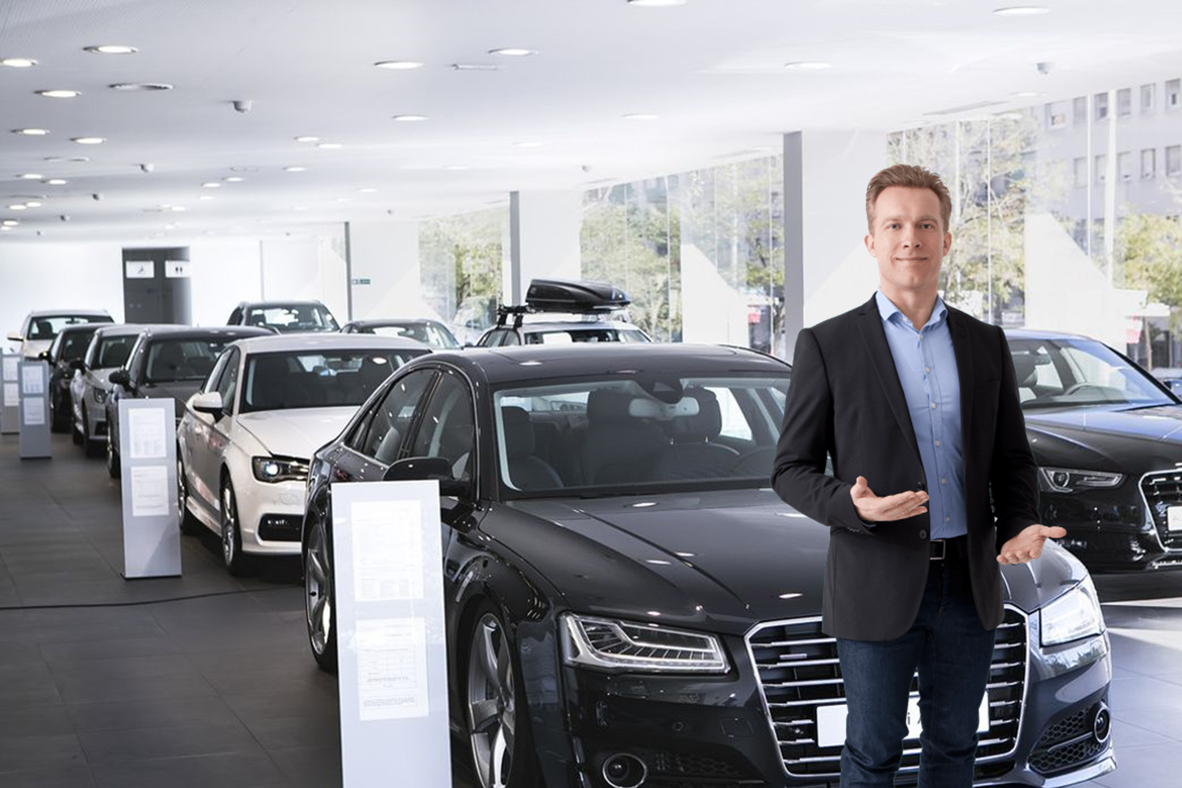

FLE in the information stage
You are considering to buy a new automobile for private use. You are gathering some information on the different options to make the right decision. Therefore, you visit an automobiles dealership with brands and models you find interesting.
A sales agent welcomes you:
Good morning, welcome to our store.
I would be happy to assist you. I can provide you with all necessary information you may need regarding our cars, such as performance, dimensions, trunk space, navigation system, energetic efficiency and fuel consumption, model price, and any other topic you might be interested in.
Is there anything in particular you are looking for?

FLR in the negotiation stage
You are considering to buy a new automobile for private use. You gathered some information on the different options to make the right decision and already made up your mind on which specific automobile brand and model you want to purchase. Therefore, you made an appointment at an automobiles dealership to see whether you can come to an agreement.
A sales agent welcomes you:
Good morning, welcome to our store.
You made an appointment because you are interested in buying one of our cars and are ready to negotiate a purchase. I would be happy to discuss the price, payment options, promotions and more. Shall we head to my office?
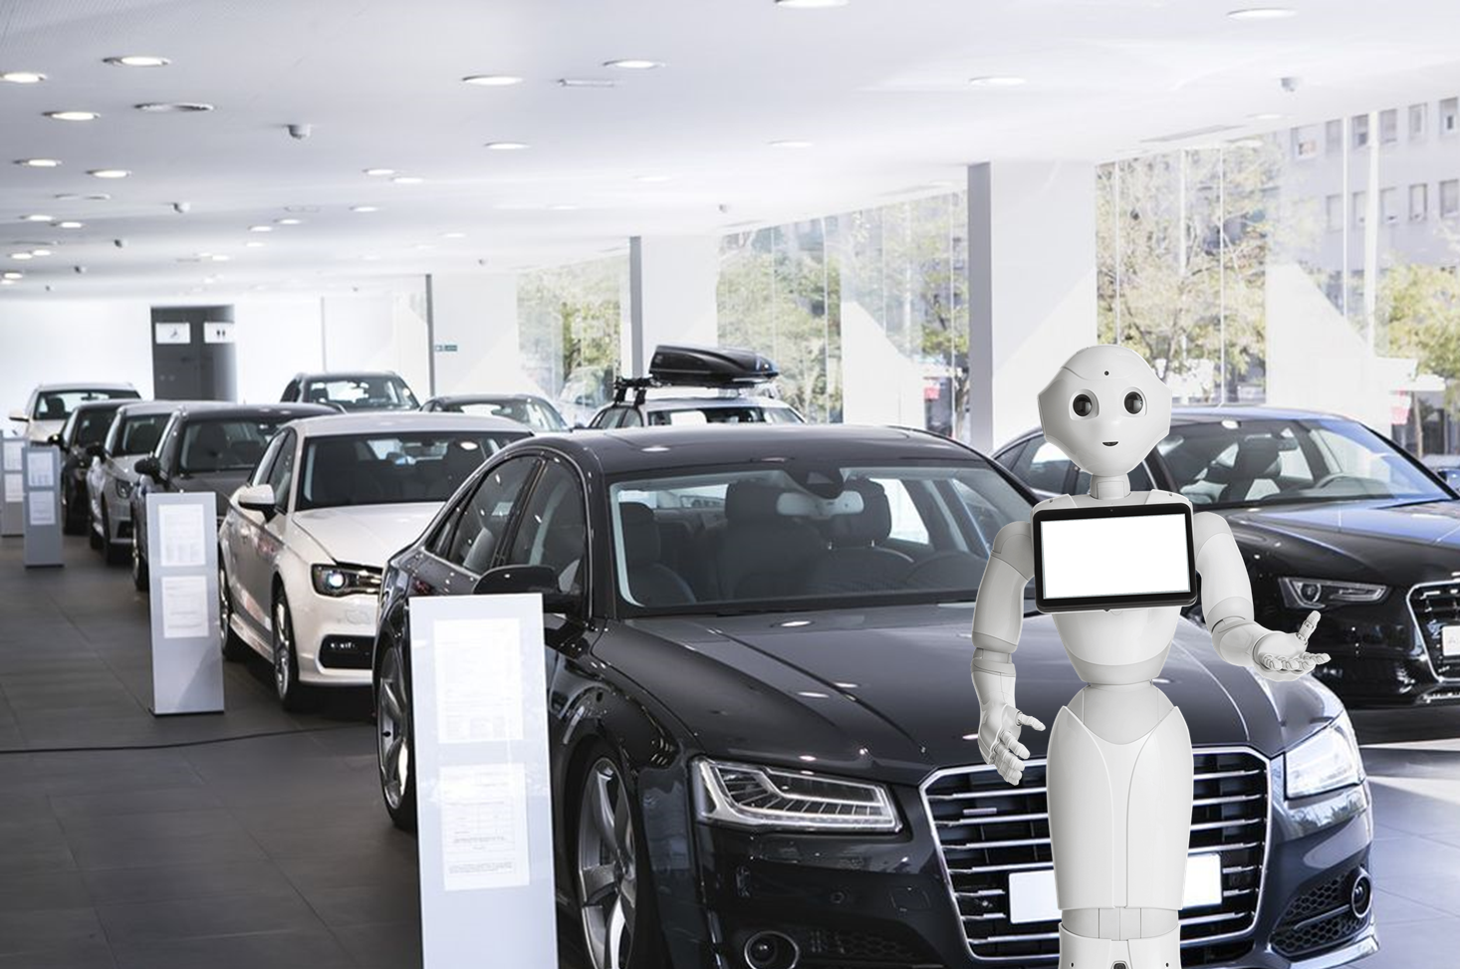

FLR in the information stage
You are considering to buy a new automobile for private use. You are gathering some information on the different options to make the right decision. Therefore, you visit an automobiles dealership with brands and models you find interesting.
A sales agent welcomes you:
Good morning, welcome to our store.
I would be happy to assist you. I can provide you with all necessary information you may need regarding our cars, such as performance, dimensions, trunk space, navigation system, energetic efficiency and fuel consumption, model price, and any other topic you might be interested in.
Is there anything in particular you are looking for?

Study 3c
FLE in the negotiation stage
After your information gathering and test drive at the automobiles dealership, you made up your mind on which specific automobile brand and model you want to purchase. Therefore, you made an appointment at the dealership to see whether you can come to an agreement.
A salesperson welcomes you:
"Good morning, welcome to our dealership. You made an appointment because you are interested in buying one of our cars and would like to discuss the purchase terms. I would be happy to talk about the price, payment options, promotions and more. Shall we head to my office?"
You follow the salesperson to his office. Together, you configure the car with the different features that resonate most with you. You decide on your optimal car configuration and get into the final price negotiation. After some back and forth you agree on the final offer and feel ready to purchase the car.
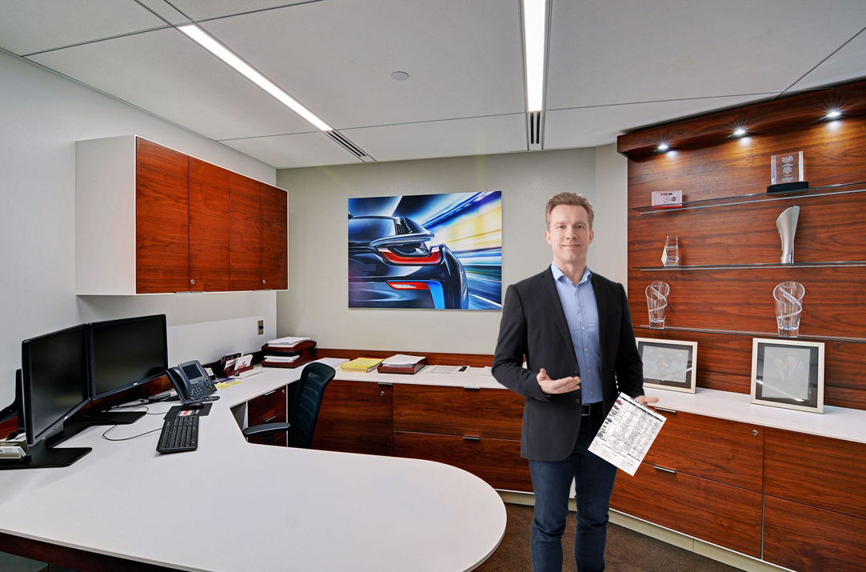

FLE in the information stage
You are considering to buy a new automobile for private use. You are gathering some information on the different options to make the right decision. Therefore, you visit an automobiles dealership with brands and models you find interesting. Note that this dealership is operated by humans and robots.
A salesperson welcomes you:
"Good morning, welcome to our store. I would be happy to assist you. I can provide you with all necessary information you may need regarding our cars, such as performance, dimensions, trunk space, navigation system, energetic efficiency and fuel consumption, model price, and any other topic you might be interested in. Which automobile model are you interested in?"
You engage in a conversation with the salesperson about a specific car and its features. At the end of the conversation, you are provided with the information you were looking for.
Ultimately, you agree to have a test drive the day after.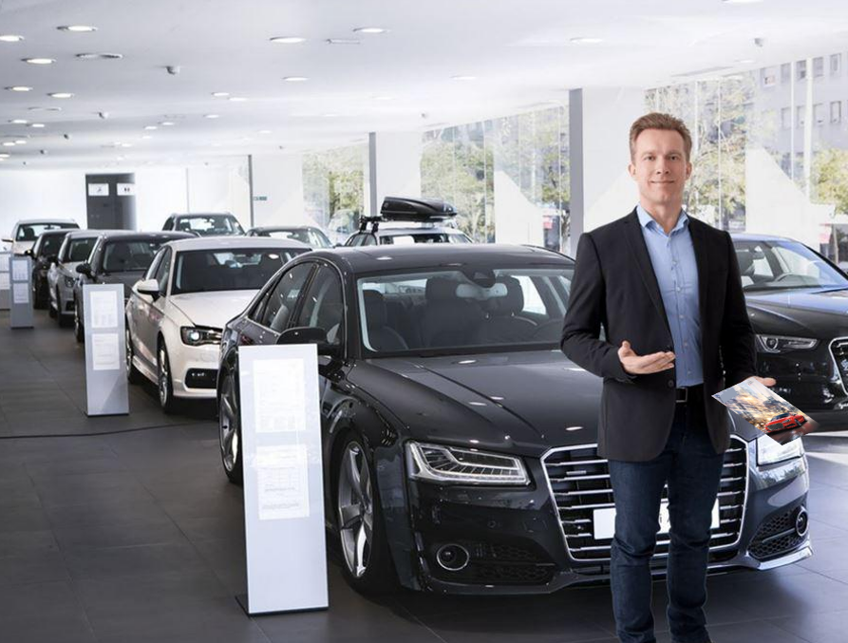

FLR in the negotiation stage
After your information gathering and test drive at the automobiles dealership, you made up your mind on which specific automobile brand and model you want to purchase. Therefore, you made an appointment at the dealership to see whether you can come to an agreement.
A sales robot welcomes you:
"Good morning, welcome to our dealership. You made an appointment because you are interested in buying one of our cars and would like to discuss the purchase terms. I would be happy to talk about the price, payment options, promotions and more. Shall we head to my office?"
You follow the sales robot to its office. Together, you configure the car with the different features that resonate most with you. You decide on your optimal car configuration and get into the final price negotiation. After some back and forth you agree on the final offer and feel ready to purchase the car.
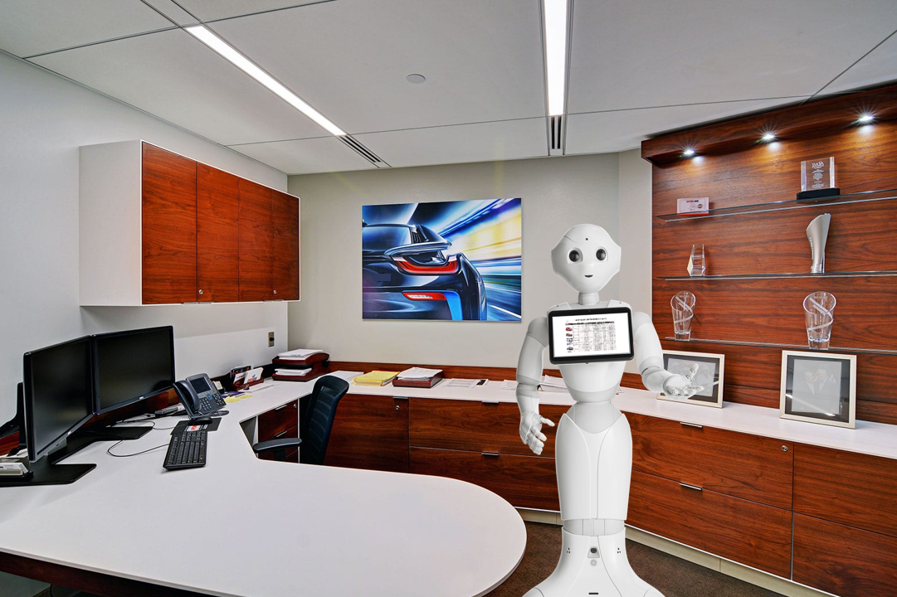

FLR in the information stage
You are considering to buy a new automobile for private use. You are gathering some information on the different options to make the right decision. Therefore, you visit an automobiles dealership with brands and models you find interesting. Note that this dealership is operated by humans and robots.
A sales robot welcomes you:
"Good morning, welcome to our store. I would be happy to assist you. I can provide you with all necessary information you may need regarding our cars, such as performance, dimensions, trunk space, navigation system, energetic efficiency and fuel consumption, model price, and any other topic you might be interested in. Which automobile model are you interested in?"
You engage in a conversation with the sales robot about a specific car and its features. At the end of the conversation, you are provided with the information you were looking for.
Ultimately, you agree to have a test drive the day after.
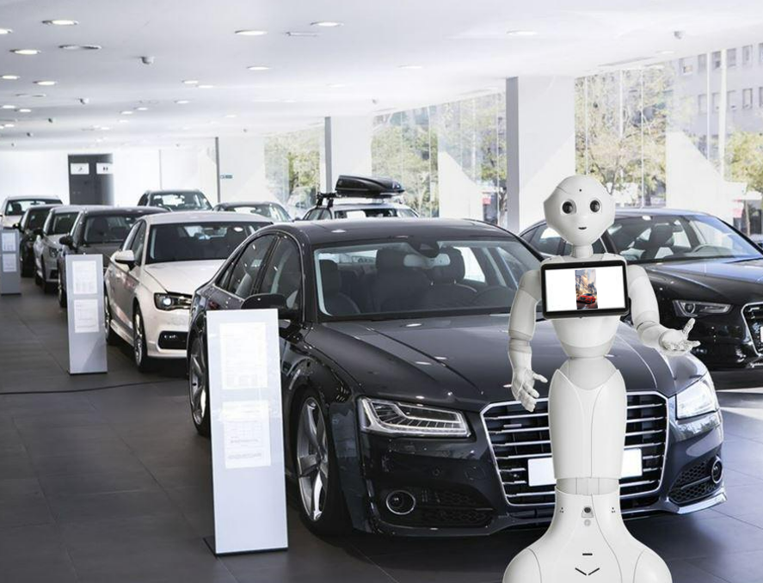

(Appendix by authors)

Appendix B: Constructs and items
Constructs and items | Cronbach’s alpha |  |  |  | Source
Constructs and items | Study 1 | Study 2 | Study 3b | Study 3c
Customer orientation  I felt that the sales agent would…  - have my best interests in mind  - try to figure out what my needs are  - enjoy interacting with me  - have the goal to be customer oriented | .83 | .81 | .81 | .84 | Stock and Hoyer (2005)
Competence  I would say this sales agent was…  - Incompetent – Competent  - Unintelligent – Intelligent  - Poorly-trained – Well-trained | .83 | .85 | .80 | .89 | Scott et al. (2013)
Warmth  I would say this sales agent was…  - Unhelpful – Helpful  - Selfish – Unselfish  - Uncaring – Caring | .60 | .70 | .60 | .74 | Scott et al. (2013)

(Appendix by authors)

Appendix C: Correlation Matrices

Study 1

 | Competence | Warmth | Customer Orientation
Competence | 1 | .56 | .50
Warmth | .56 | 1 | .59
Customer Orientation | .50 | .59 | 1

Study 2

 | Competence | Warmth | Customer Orientation
Competence | 1 | .61 | .54
Warmth | .61 | 1 | .60
Customer Orientation | .54 | .60 | 1

Study 3b

 | Competence | Warmth | Customer Orientation
Competence | 1 | .69 | .59
Warmth | .69 | 1 | .63
Customer Orientation | .59 | .63 | 1

Study 3c

 | Competence Information Stage | Warmth Information Stage | Customer Orientation Information Stage
Competence Information Stage | 1 | .67 | .72
Warmth Information Stage | .67 | 1 | .58
Customer Orientation Information Stage | .72 | .58 | 1

 | Competence Information Stage | Warmth Information Stage | Customer Orientation Information Stage
Competence Negotiation Stage | 1 | .50 | .70
Warmth Negotiation Stage | .50 | 1 | .56
Customer Orientation Negotiation Stage | .70 | .56 | 1

(Appendix by authors)

