Do Heritage Recognition and Disclosure Matter? Evidence from University Students

Appendices

Appendix 1 – Vignettes (English translation)

Group 1 (no recognition nor extensive disclosure)

Municipality of Atlantis: Statement of Financial Position (condensed)
ASSETS | Amounts (EUR) |  | LIABILITIES | Amounts (EUR)
Intangible assets (e.g., software) | 270,000 |  | Provisions for risks and charges | 30,000,000
Tangible assets (e.g., land, buildings, equipment) | 440,000,000 |  | Payables | 460,000,000
Financial assets (e.g., equity investments) | 200,000,000 |  | TOTAL LIABILITIES | 490,000,000
Inventories | 170,000
Receivables | 80,000,000
Cash and Cash Equivalents (e.g., bank deposits) | 100,000,000
TOTAL ASSETS | 820,440,000

Accounting information relating to heritage items: The heritage items of the Municipality of Atlantis are not recognised as assets.

Accounting policies and measurement bases: The heritage items of the Municipality of Atlantis have significant cultural, historical, and educational value, but they are not recognized as assets in the Statement of Financial Position because their monetary values cannot be measured reliably.

Detailed information on heritage items:
Heritage items | Description
Civic Museum | Collection of approximately 9,000 items including paintings, engravings, and manuscripts from the Renaissance.
Renaissance Villa | 16th-century villa designed by a prominent Renaissance architect, famous for its library and conference hall.
Archaeological Site | Roman archaeological site (2nd–1st century BC) covering 150 sqm, with a pedestrian archeological walk.
Historic Palace | Renaissance palace adorned with frescoes and artworks by prominent artists of the period.

Appendix 1 – Vignettes (cont’d)

Group 2 (recognition only)

Municipality of Atlantis: Statement of Financial Position (condensed)
ASSETS | Amounts (EUR) |  | LIABILITIES | Amounts (EUR)
Intangible assets (e.g., software) | 270,000 |  | Provisions for risks and charges | 30,000,000
Tangible assets (e.g., land, buildings, equipment, heritage assets) | 540,000,000 |  | Payables | 460,000,000
Financial assets (e.g., equity investments) | 200,000,000 |  | TOTAL LIABILITIES | 490,000,000
Inventories | 170,000
Receivables | 80,000,000
Cash and Cash Equivalents (e.g., bank deposits) | 100,000,000
TOTAL ASSETS | 920,440,000

Accounting information relating to heritage items: The heritage items of the Municipality of Atlantis are recognised as assets. Their total carrying amount is 100,000,000.

Accounting policies and measurement bases: The heritage assets of the Municipality of Atlantis are measured at value in use and are not depreciated because of their indefinite useful lives.

Detailed information on heritage assets:
Heritage assets | Description | Amounts (EUR)
Civic Museum | Collection of approximately 9,000 items including paintings, engravings, and manuscripts from the Renaissance. | 27,000,000
Renaissance Villa | 16th-century villa designed by a prominent Renaissance architect, famous for its library and conference hall. | 18,000,000
Archaeological Site | Roman archaeological site (2nd–1st century BC) covering 150 sqm, with a pedestrian archeological walk. | 10,000,000
Historic Palace | Renaissance palace adorned with frescoes and artworks by prominent artists of the period. | 45,000,000
TOTAL HERITAGE ASSETS |  | 100,000,000

Appendix 1 – Vignettes (cont’d)

Group 3 (extensive disclosure only)

Municipality of Atlantis: Statement of Financial Position (condensed)
ASSETS | Amounts (EUR) |  | LIABILITIES | Amounts (EUR)
Intangible assets (e.g., software) | 270,000 |  | Provisions for risks and charges | 30,000,000
Tangible assets (e.g., land, buildings, equipment) | 440,000,000 |  | Payables | 460,000,000
Financial assets (e.g., equity investments) | 200,000,000 |  | TOTAL LIABILITIES | 490,000,000
Inventories | 170,000
Receivables | 80,000,000
Cash and Cash Equivalents (e.g., bank deposits) | 100,000,000
TOTAL ASSETS | 820,440,000

Accounting information relating to heritage items: The heritage items of the Municipality of Atlantis are not recognised as assets.

Accounting policies and measurement bases: The heritage items of the Municipality of Atlantis have significant cultural, historical, and educational value, but they are not recognized as Assets in the Statement of Financial Position because their monetary values cannot be measured reliably.

Detailed information on heritage items:
Heritage items | Description
Civic Museum | Collection of approximately 9,000 items including paintings, engravings, and manuscripts from the Renaissance. The permanent collection is open to the public. The Museum also hosts temporary exhibitions. It receives approximately 80,000 visitors annually.
Renaissance Villa | 16th-century villa designed by a prominent Renaissance architect, famous for its library and conference hall. The library contains more than 7,000 historical volumes. The villa regularly hosts conferences and cultural events. Overall, it receives approximately 46,500 visitors annually.
Archaeological Site | Roman archaeological site (2nd–1st century BC) covering 150 sqm, with a pedestrian archeological walk. The site is open to the public year-round and offers guided tours for schools and groups. It receives approximately 25,000 visitors annually.
Historic Palace | Renaissance palace adorned with frescoes and artworks by prominent artists of the period. The palace regularly hosts temporary exhibitions and cultural events of national significance. Overall, it receives approximately 100,000 visitors per year.

Appendix 1 – Vignettes (cont’d)

Group 4 (recognition and extensive disclosure)

Municipality of Atlantis: Statement of Financial Position (condensed)
ASSETS | Amounts (EUR) |  | LIABILITIES | Amounts (EUR)
Intangible assets (e.g., software) | 270,000 |  | Provisions for risks and charges | 30,000,000
Tangible assets (e.g., land, buildings, equipment, heritage assets) | 540,000,000 |  | Payables | 460,000,000
Financial assets (e.g., equity investments) | 200,000,000 |  | TOTAL LIABILITIES | 490,000,000
Inventories | 170,000
Receivables | 80,000,000
Cash and Cash Equivalents (e.g., bank deposits) | 100,000,000
TOTAL ASSETS | 920,440,000

Accounting information relating to heritage items: The heritage items of the Municipality of Atlantis are recognised as assets. Their total carrying amount is 100,000,000.

Accounting policies and measurement bases: The heritage assets of the Municipality of Atlantis are measured at value in use and are not depreciated because of their indefinite useful lives.

Detailed information on heritage assets:
Heritage assets | Description | Amounts (EUR)
Civic Museum | Collection of approximately 9,000 items including paintings, engravings, and manuscripts from the Renaissance. The permanent collection is open to the public. The Museum also hosts temporary exhibitions. It receives approximately 80,000 visitors annually. | 27,000,000
Renaissance Villa | 16th-century villa designed by a prominent Renaissance architect, famous for its library and conference hall. The library contains more than 7,000 historical volumes. The villa regularly hosts conferences and cultural events. Overall, it receives approximately 46,500 visitors annually. | 18,000,000
Archaeological site | Roman archaeological site (2nd–1st century BC) covering 150 sqm, with a pedestrian archeological walk. The Site is open to the public year-round and offers guided tours for schools and groups. It receives approximately 25,000 visitors annually. | 10,000,000
Historic Palace | Renaissance palace adorned with frescoes and artworks by prominent artists of the period. The palace regularly hosts temporary exhibitions and cultural events of national significance. Overall, it receives approximately 100,000 visitors per year. | 45,000,000
TOTAL HERITAGE ASSETS |  | 100,000,000

Appendix 2
The hypotheses were tested using regression analysis with robust standard errors. Model 1 only included the main effects for heritage recognition and extensive disclosure. Model 2 added the interaction term. Models 3 and 4 introduced two subsets of controls, designed to avoid the simultaneous presence of the two variables reflecting experience with heritage (Visits to cultural establishments in the previous twelve months and Propensity to spend free time in cultural events), which were highly correlated.

Models 1 and 2

 | Perceived economic value (H1) |  | Perceived cultural and social value (H2) |  | Attitude towards the sale of heritage (H3) |  | Propensity to donate (H4) |  | Perceived solvency (H5) |  | Acceptance of conservation and promotion costs (H6) |  | Propensity to coproduce (H7)
 | Model 1 | Model 2 | Model 1 | Model 2 | Model 1 | Model 2 | Model 1 | Model 2 | Model 1 | Model 2 | Model 1 | Model 2 | Model 1 | Model 2
Recognition | 2.100*** | 2.217*** | 0.321 | 0.490 | 1.842*** | 2.642*** | -1.479*** | -1.514*** | 2.298*** | 2.204*** | 1.672*** | 1.976*** | 1.096*** | 1.344***
 | (0.248) | (0.401) | (0.244) | (0.416) | (0.309) | (0.453) | (0.335) | (0.528) | (0.323) | (0.499) | (0.249) | (0.371) | (0.232) | (0.380)
Extensive disclosure | 1.217*** | 1.333*** | 1.777*** | 1.946*** | -0.658** | 0.142 | 0.946*** | 0.911** | 0.421 | 0.334 | 1.110*** | 1.414*** | 1.602*** | 1.851***
Extensive disclosure | (0.247) | (0.454) | (0.245) | (0.401) | (0.311) | (0.355) | (0.337) | (0.399) | (0.328) | (0.512) | (0.248) | (0.397) | (0.233) | (0.350)
Recognition * extensive disclosure |  | -0.230 |  | -0.332 |  | -1.577** |  | 0.069 |  | 0.181 |  | -0.600 |  | -0.491
Recognition * extensive disclosure |  | (0.500) |  | (0.492) |  | (0.608) |  | (0.674) |  | (0.652) |  | (0.497) |  | (0.466)
Constant | 3.145*** | 3.083*** | 3.755*** | 3.667*** | 2.504*** | 2.083*** | 5.120*** | 5.139*** | 3.233*** | 3.281*** | 3.146*** | 2.986*** | 3.624*** | 3.493***
 | (0.286) | (0.372) | (0.276) | (0.357) | (0.244) | (0.253) | (0.290) | (0.336) | (0.327) | (0.407) | (0.260) | (0.328) | (0.238) | (0.297)
N | 154 | 154 | 154 | 154 | 154 | 154 | 154 | 154 | 136 | 136 | 154 | 154 | 154 | 154
R² | 0.388 | 0.389 | 0.270 | 0.272 | 0.211 | 0.244 | 0.158 | 0.158 | 0.277 | 0.277 | 0.301 | 0.307 | 0.311 | 0.316

Appendix 2 (cont’d)

Models 3 and 4

 | Perceived economic value (H1) |  | Perceived cultural and social value (H2) |  | Attitude towards the sale of heritage (H3) |  | Propensity to donate (H4) |  | Perceived solvency (H5) |  | Acceptance of conservation and promotion costs (H6) |  | Propensity to coproduce (H7)
 | Model 3 | Model 4 | Model 3 | Model 4 | Model 3 | Model 4 | Model 3 | Model 4 | Model 3 | Model 4 | Model 3 | Model 4 | Model 3 | Model 4
Recognition | 2.148*** | 2.041*** | 0.347 | 0.261 | 2.579*** | 2.630*** | -1.632*** | -1.654*** | 2.233*** | 2.198*** | 1.909*** | 1.860*** | 1.120*** | 1.039***
 | (0.371) | (0.351) | (0.393) | (0.378) | (0.411) | (0.410) | (0.531) | (0.528) | (0.493) | (0.493) | (0.384) | (0.374) | (0.354) | (0.340)
Extensive disclosure | 1.213*** | 0.977** | 1.890*** | 1.696*** | -0.207 | -0.104 | 0.897** | 0.847* | 0.253 | 0.180 | 1.284*** | 1.172*** | 1.622*** | 1.440***
Extensive disclosure | (0.446) | (0.433) | (0.388) | (0.375) | (0.390) | (0.405) | (0.425) | (0.433) | (0.522) | (0.530) | (0.418) | (0.413) | (0.351) | (0.348)
Recognition * extensive disclosure | -0.203 | -0.187 | -0.295 | -0.275 | -1.619*** | -1.607*** | 0.086 | 0.092 | 0.088 | 0.128 | -0.660 | -0.646 | -0.360 | -0.341
Recognition * extensive disclosure | (0.505) | (0.482) | (0.470) | (0.455) | (0.583) | (0.587) | (0.685) | (0.684) | (0.664) | (0.663) | (0.515) | (0.509) | (0.458) | (0.442)
Age | 0.081* | 0.064 | 0.110** | 0.093** | -0.049 | -0.050 | 0.049 | 0.045 | -0.013 | -0.012 | 0.038 | 0.027 | -0.019 | -0.035
 | (0.045) | (0.046) | (0.043) | (0.044) | (0.061) | (0.062) | (0.072) | (0.074) | (0.078) | (0.079) | (0.049) | (0.049) | (0.055) | (0.059)
Gender (female) | 0.052 | -0.099 | 0.637*** | 0.513** | -0.652** | -0.586* | 0.449 | 0.417 | -0.572 | -0.591 | -0.068 | -0.138 | 0.540** | 0.423*
 | (0.244) | (0.234) | (0.232) | (0.234) | (0.305) | (0.310) | (0.361) | (0.367) | (0.357) | (0.359) | (0.250) | (0.250) | (0.223) | (0.221)
Gender (prefers not to answer) | 1.015* | 0.227 | 0.159 | -0.507 | 0.454 | 0.743 | -1.161 | -1.335 |  |  | 0.910* | 0.521 | 2.581*** | 1.953***
Gender (prefers not to answer) | (0.552) | (0.554) | (0.500) | (0.533) | (0.547) | (0.598) | (0.786) | (0.845) |  |  | (0.524) | (0.557) | (0.514) | (0.564)
Field of education (Humanities) | -0.365 | -0.451* | -0.220 | -0.298 | -0.374 | -0.360 | 0.269 | 0.248 | -0.771** | -0.765** | 0.290 | 0.243 | 0.278 | 0.204
Field of education (Humanities) | (0.254) | (0.244) | (0.256) | (0.247) | (0.341) | (0.342) | (0.383) | (0.384) | (0.362) | (0.363) | (0.268) | (0.272) | (0.242) | (0.234)
Field of education (Other) | -0.685 | -0.530 | -0.236 | -0.124 | -1.517*** | -1.627*** | -0.126 | -0.098 | -0.286 | -0.273 | -0.463 | -0.404 | -0.693 | -0.589
Field of education (Other) | (0.477) | (0.460) | (0.419) | (0.449) | (0.549) | (0.536) | (0.701) | (0.715) | (0.769) | (0.768) | (0.499) | (0.501) | (0.450) | (0.448)
Degree programme (graduate and doctoral) | -1.171*** | -1.121*** | -0.713** | -0.624** | 0.301 | 0.416 | 0.310 | 0.338 | -0.602 | -0.575 | 0.105 | 0.174 | 0.026 | 0.115
Degree programme (graduate and doctoral) | (0.290) | (0.259) | (0.279) | (0.247) | (0.350) | (0.350) | (0.398) | (0.392) | (0.407) | (0.406) | (0.303) | (0.296) | (0.284) | (0.272)
Family’s place of residence (Center) | -0.063 | -0.159 | 0.442 | 0.328 | -0.845** | -0.903** | 0.215 | 0.182 | -0.005 | -0.015 | -0.482 | -0.560 | -0.105 | -0.215
Family’s place of residence (Center) | (0.378) | (0.375) | (0.340) | (0.350) | (0.403) | (0.402) | (0.504) | (0.512) | (0.455) | (0.461) | (0.389) | (0.377) | (0.330) | (0.316)
Family’s place of residence (South) | 0.346 | 0.159 | 0.704** | 0.515* | -0.995** | -1.015** | 0.350 | 0.298 | 0.161 | 0.067 | 0.119 | -0.002 | 0.185 | 0.004
Family’s place of residence (South) | (0.295) | (0.299) | (0.321) | (0.300) | (0.501) | (0.511) | (0.534) | (0.532) | (0.487) | (0.482) | (0.348) | (0.339) | (0.311) | (0.298)
Visits to cultural establishments in the previous twelve months | 0.303*** |  | 0.358*** |  | 0.176 |  | 0.104 |  | 0.168 |  | 0.244** |  | 0.347***
 | (0.103) |  | (0.094) |  | (0.117) |  | (0.139) |  | (0.146) |  | (0.113) |  | (0.100)
Propensity to spend free time in cultural events |  | 0.330*** |  | 0.318*** |  | -0.011 |  | 0.087 |  | 0.137 |  | 0.199** |  | 0.303***
Propensity to spend free time in cultural events |  | (0.071) |  | (0.071) |  | (0.082) |  | (0.099) |  | (0.105) |  | (0.082) |  | (0.068)
Constant | 1.027 | 1.051 | -0.175 | 0.039 | 3.613** | 4.155*** | 2.978* | 3.054* | 4.031** | 3.961* | 1.258 | 1.453 | 2.542* | 2.763**
 | (1.160) | (1.165) | (1.040) | (1.026) | (1.449) | (1.434) | (1.701) | (1.705) | (1.953) | (2.002) | (1.285) | (1.230) | (1.318) | (1.380)
N | 154 | 154 | 154 | 154 | 154 | 154 | 154 | 154 | 136 | 136 | 154 | 154 | 154 | 154
R² | 0.486 | 0.531 | 0.408 | 0.441 | 0.348 | 0.340 | 0.191 | 0.192 | 0.333 | 0.337 | 0.373 | 0.381 | 0.461 | 0.490
Note: Robust standard errors in parenthesis. *, **, and *** denote significance at the 0.1, 0.05, and 0.01 levels, respectively.

Appendix 3 – Marginal effects of recognition and extensive disclosure on each dependent variable

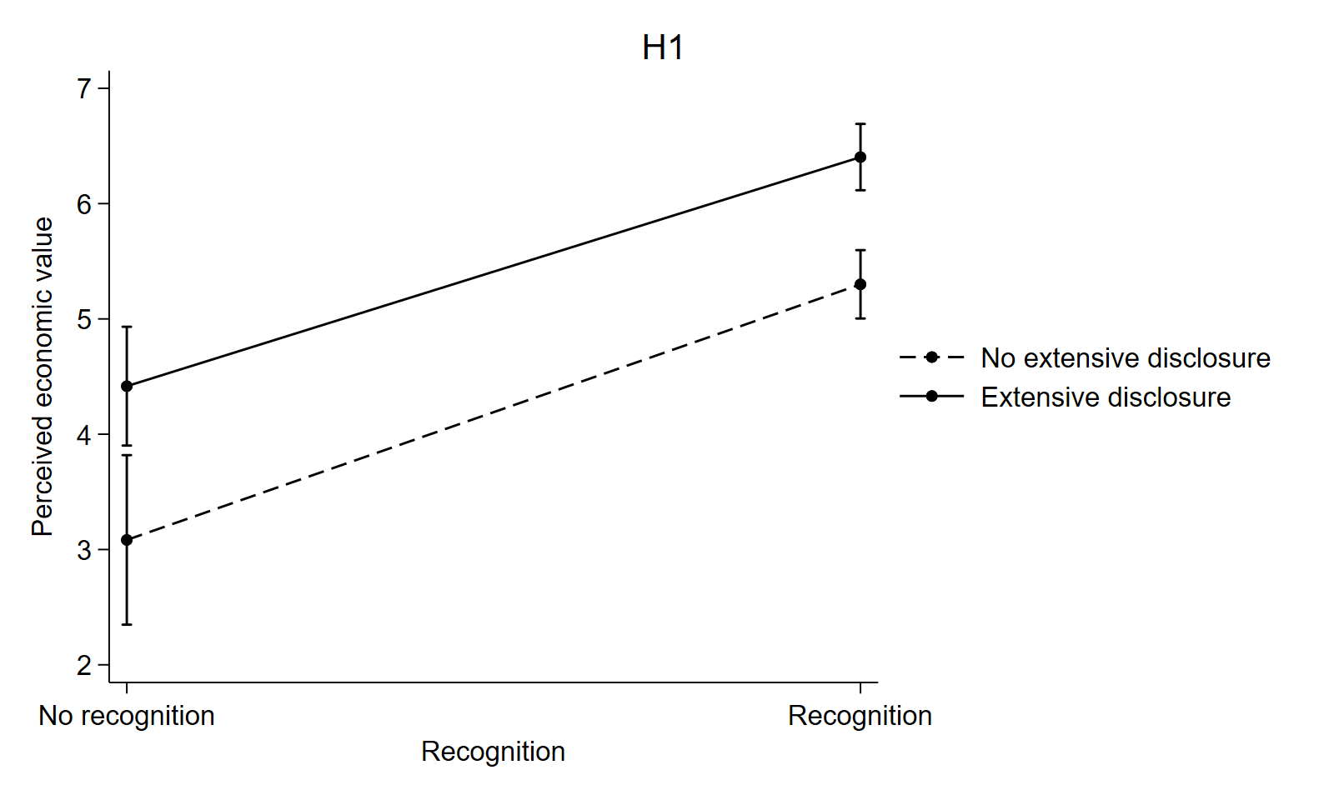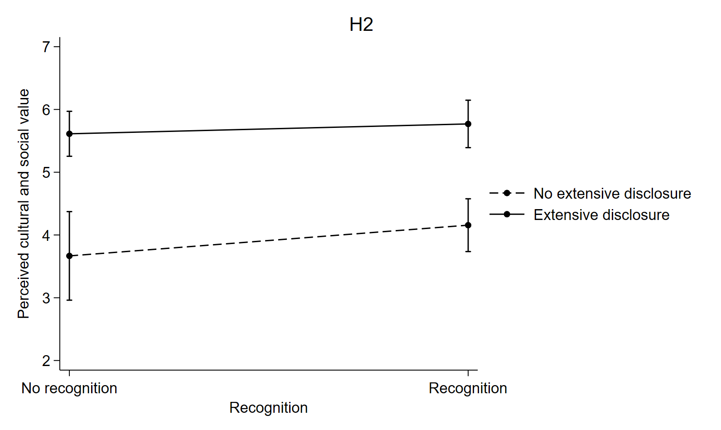

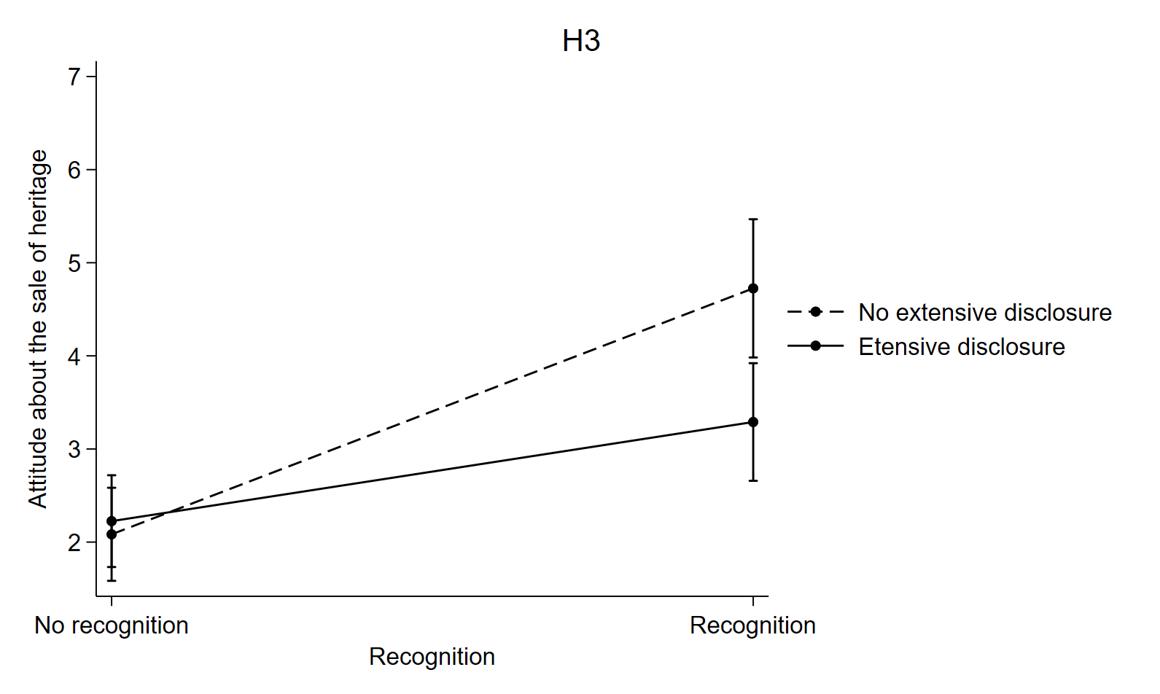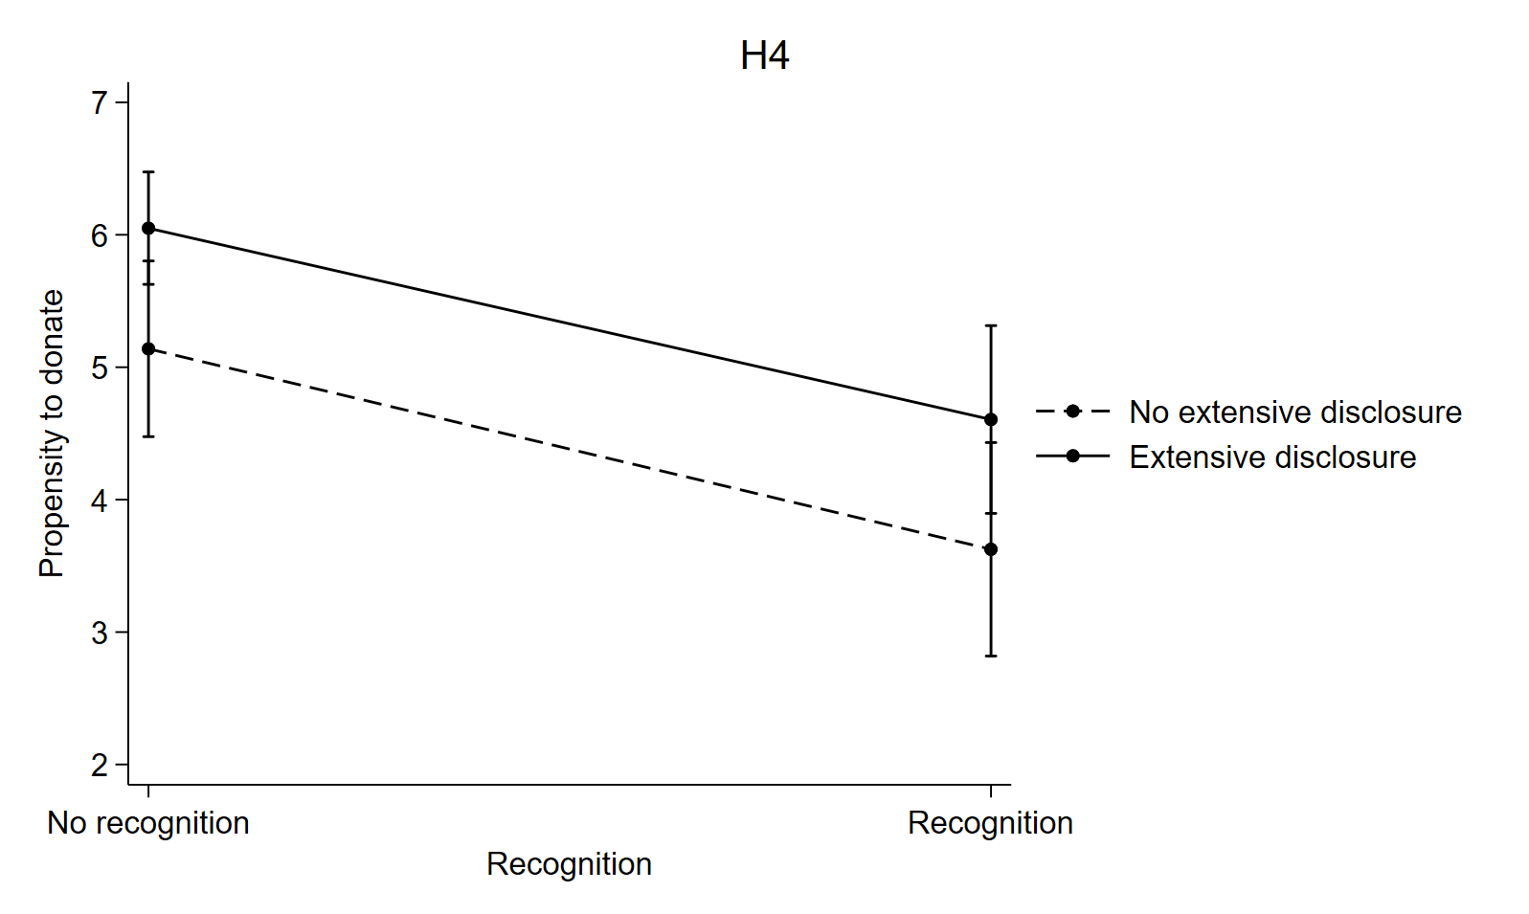

Appendix 3 – Marginal effects of recognition and extensive disclosure on each dependent variable (cont’d)

