Supplementary Material Appendix

Contents
Appendix A: Experimental condition stimuli (Study 1 & 2) 2
Appendix B : Scale Items 3
Appendix C: Means and SDs for each condition (Study 1 & 2) 4
Appendix D : Promotional Display, Product Type, and Religious Identity on Self-Continuity 4
Appendix E: Product-specific patronage intentions (Study 1) 5
Appendix F: Product-specific patronage intentions (Study 2) 6

Appendix A: Experimental condition stimuli (Study 1 & 2)

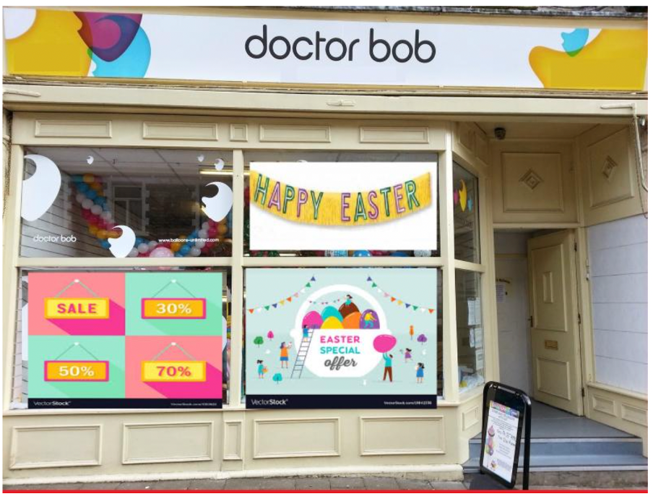
Source: Authors’ own work

Control Condition

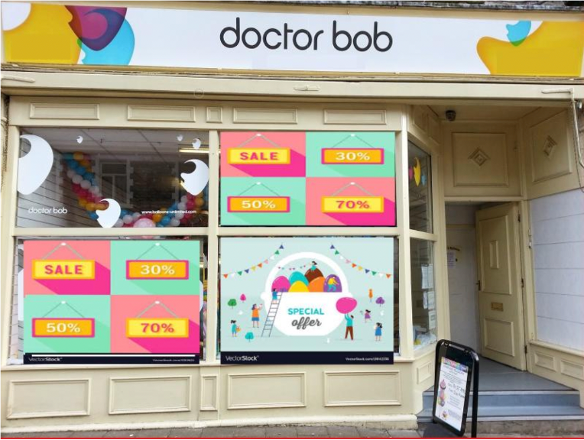

Source: Authors’ own work

Appendix B : Scale Items

Scale
Patronage Intention Sweeney and Soutar (2001)
The likelihood of purchasing products from this store is very high
will strongly recommend my friends to buy from this store
I would be very happy to buy products from this store

Self-continuity Sedikides et al. (2015)
Shopping in this shop makes me feel connected with my religion
This shop makes me feel that it is a place that people like me shop often
Shopping in this shop makes me to feel good about me

Religiosity Adapted from Vitell et al., (2005)
I believe in god
I think god influences me
I think that god answers all my prayers
I often read religious literature in order to have a better understanding of my god
I pray alone
I pray with others
I attend church services
I give time to the church/temple/ mosque

1= strongly disagree to 7 = strongly agree
Source: Authors’ own work

Appendix C: Means and SDs for each condition (Study 1 & 2)

 | Patronage Intentions  α = 0.91¹ α = 0.92 |  | Self-Continuity  α = 0.83²
Study 1 | M | SD | M |  |  | SD
Easter products/Easter Sale | 4.10 | 1.24 | --- |  | ---
Easter products/Special Sale | 3.63 | 1.50 | --- |  | ---
Easter-incongruent products/Easter Sale | 3.49 | 1.34 | --- |  | ---
Easter incongruent products /Special Sale | 4.23 | 1.62 | --- |  | ---
Study 2
Easter products/Easter Sale | 3.86 | 1.44 | 3.38 |  |  | 1.44
Easter products/Special Sale | 3.36 | 1.76 | 2.73 |  |  | 1.33
Easter-incongruent products/Easter Sale | 3.77 | 1.62 | 3.07 |  |  | 1.39
Easter-incongruent products /Special Sale | 4.00 | 1.57 | 3.40 |  |  | 1.29
¹ Study 1
² Study 2
Source: Authors’ own work

Appendix D : Promotional Display, Product Type, and Religious Identity on Self-Continuity

Effect of Congruent Promotional Display and Product Type on Self-Continuity.
An ANOVA exploring the moderating effect of promotional display and product type on self-continuity was conducted. Consistent with study 1, there was a significant interaction on self-continuity F(1,166) = 5.33, p = .02. Unpacking the interaction, results reveal that self-continuity was greater when the Easter products were paired with an Easter display (M= 3.38, SD= 1.44) compared to when they were paired with the non-Easter (special sale) display (M= 2.73, SD = 1.33, p= .03). Conversely, there was no impact of self-continuity for the Easter-incongruent products between the Easter display (M= 3.07, SD= 1.39) and the non-Easter (special sale) display (M= 3.39, SD= 1.29, p= .30).

The Moderating Role of Religious Identity.
We then tested the moderating role of religious identity. Consistent with the theorizing and with study 1, there was a significant three-way interaction F(1,162) = 4.86, p = 0.03). Following, the three-way interaction was unpacked utilizing a spotlight analysis via PROCESS Model 3 (Hayes, 2017) at +/- 1 SD of religious identity. In line with results on patronage from study 1, there was no interaction between the promotional display and product type conditions on self-continuity for those that were low in religious identity (b= .02, p = .97) but there was an interaction for those high in religious identity (b = 1.86, p = .002). Unpacking the interaction for those high in religious identity, reveals that, again consistent with study 1, self-continuity was significantly greater when Easter products were paired with the Easter sale (compared to the Special sale; b = 1.13, p= .009), while marginally significantly lower when the Easter-incongruent products (whiskey and condoms) were paired with Easter sale (compared to the Special Sale (b = .91, p = .06). Religious identity also resulted in significantly greater self-continuity in the congruent Easter condition (b = .31, p= .002). Similarly, and consistent with Study 1, the same pattern of interaction was seen when examining the moderating effect on patronage intentions F(1,162) = 3.96, p = 0.05). Specifically, there was no interaction between promotional display and product type on patronage intentions for those that were low in religious identity (b = -.52, p = .51), but there was an interaction for those high in religious identity (b = 1.88, p =.02)

Appendix E: Product-specific patronage intentions (Study 1)

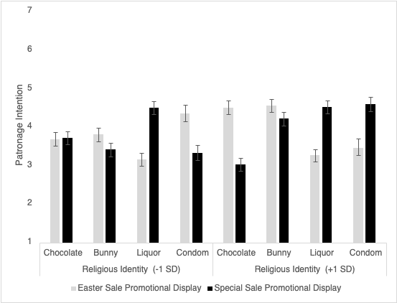
Study 1: Product-specific patronage intentions
Source: Study 1, Authors’ own work

Appendix F: Product-specific patronage intentions (Study 2)

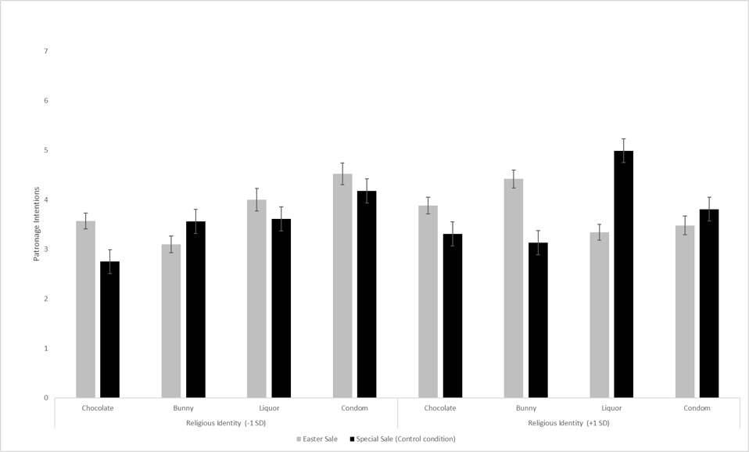
Study 2: Product-specific patronage intentions
Source: Authors’ own work

