Web Appendix A: Manipulation of nostalgic brands

Study 1:

Nostalgic brand Non nostalgic brand
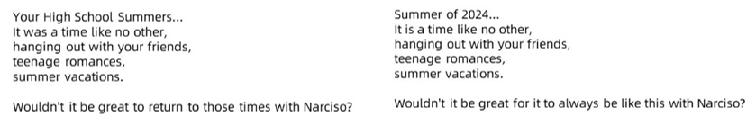
Source: Adapted from Barauskaitė et al. (2022)

Study 2:
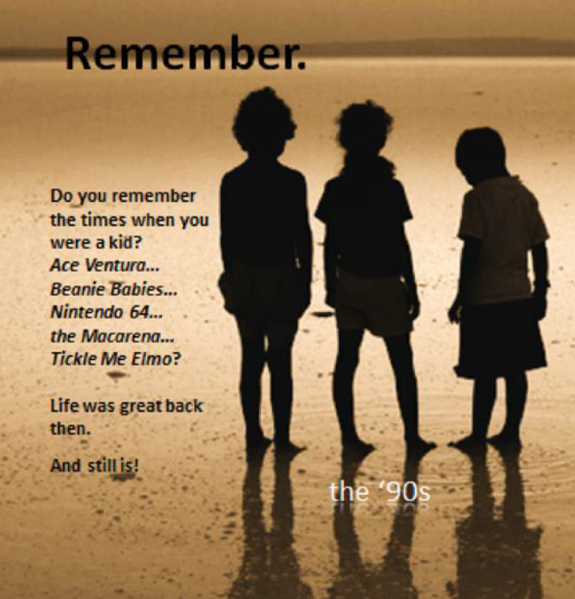
Source: Adapted from Muehling et al. (2014)

Study 3:
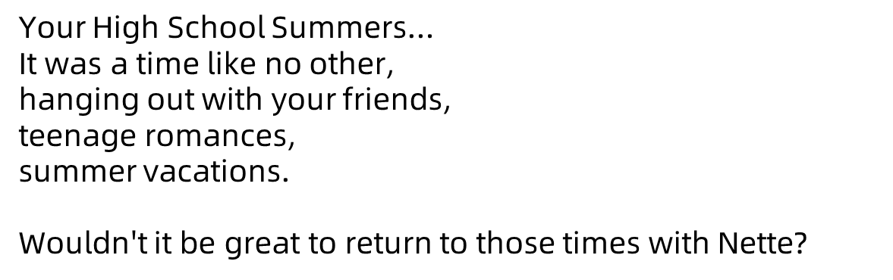
Source: Adapted from Barauskaitė et al. (2022)

Web Appendix B: Logos used in studies
 | Stable | Unstable
Study 1 | 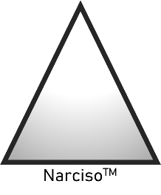 | 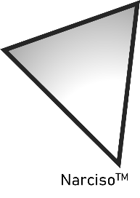
Study 2 | 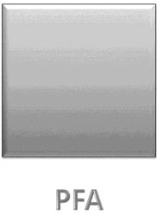 | 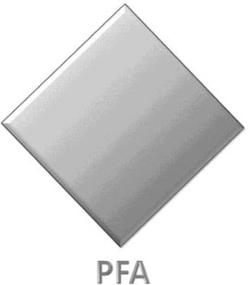
Study 3 | 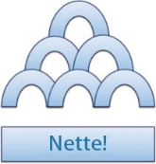 | 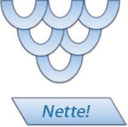
Source: Authors’ own work. The logo images were adapted from Rahinel and Nelson (2016) and Huang et al. (2021)

Web Appendix C: Mediation model with alternative explanations in Study 2

Mediation Model with Alternative Explanations in Study 2
.51
.08
Perceived
Brand Stability
.37**
.03
Consumer Attitudes
Attractive
Complex
Familiar
Novel
Arousal
.71***
.14
.11
Logo Visual Stability
(Unstable = 0, Stable = 1)
-.03
-.06
.09
.04
-.18
.35
-.28
.03
Uncommon

NOTE: ***p < .001, **p < .01, *p < .05
Source: Authors’ own work

Indirect Effect of Mediators and Alternative Explanations
 | b | SE | CI_{95%}
Perceived brand stability | .26 | .11 | [ .06, .50]
Attractive | .01 | .04 | [-.08, .09]
Complex | .01 | .03 | [-.07, .07]
Familiar | .01 | .03 | [-.05, .10]
Novel | -.02 | .04 | [-.12, .06]
Arousal | -.03 | .05 | [-.14, .03]
Uncommon | .04 | .04 | [-.02, .14]
Source: Authors’ own work
Web Appendix D: Pretests for logos

Measures of alternative constructs used in pretest:

Stable
The brand logo is stable (1=Strongly disagree, 7= Strongly agree)
Attractive
The logo is attractive (1=Strongly disagree, 7= Strongly agree)
The logo is aesthetically appealing (1=Strongly disagree, 7= Strongly agree)
Complex
The logo is complex (1=Strongly disagree, 7= Strongly agree)
How would you evaluate this logo? (1=Not complicated, 7= Very complicated)
Familiar
How familiar is this logo? (1=Not at all, 7= Very much)
Novel
To what extent is this logo unusual? (1=Not at all, 7= Very much)
To what extent is this logo original? (1=Not at all, 7= Very much)
To what extent is this logo new? (1=Not at all, 7= Very much)
Arousal
The brand logo is exciting. (1=Strongly disagree, 7= Strongly agree)
Uncommon
The brand logo is uncommon (1=Strongly disagree, 7= Strongly agree)

Results of Pretests for Logos
Studies | Variables | Results
Study 1 Logos | Stable | M_{stable}= 5.90, SD = 1.61, M_{unstable}= 3.47, SD = 1.99; t(58) = 5.20, p < .001
Study 1 Logos | Attractive | M_{stable}= 3.17, SD = 1.39, M_{unstable}= 3.13, SD = 1.62; t(58) = .09, p = .932
Study 1 Logos | Complex | M_{stable}= 2.40, SD = 1.28, M_{unstable}= 2.60, SD = 1.41; t(58) = -.58, p = .568
Study 1 Logos | Familiar | M_{stable}= 3.90, SD = 2.22, M_{unstable}= 3.77, SD = 1.99; t(58) = .25, p = .807
Study 1 Logos | Novel | M_{stable}= 3.38, SD = 1.38, M_{unstable}= 3.60, SD = 1.65; t(58) = -.57, p = .573
Study 1 Logos | Arousal | M_{stable}= 2.67, SD = 1.65, M_{unstable}= 2.70, SD = 1.73; t(58) = -.08, p = .939
Study 1 Logos | Uncommon | M_{stable}= 3.43, SD = 1.96, M_{unstable}= 3.33, SD = 1.95; t(58) = -.20, p = .844
Study 2 Logos | Stable | M_{stable}= 4.93, SD = 2.33, M_{unstable}= 2.73, SD = 1.66; t(58) = 4.21, p < .001
Study 2 Logos | Attractive | M_{stable}= 2.92, SD = 1.81, M_{unstable}= 3.05, SD = 1.38; t(58) = -.32, p = .749
Study 2 Logos | Complex | M_{stable}= 2.65, SD = 1.65, M_{unstable}= 2.87, SD = 1.63; t(58)= -.51, p = .611
Study 2 Logos | Familiar | M_{stable}= 4.10, SD = 2.23, M_{unstable}= 3.93, SD = 2.15; t(58) = .30, p = .769
Study 2 Logos | Novel | M_{stable}= 3.27, SD = 1.65, M_{unstable}= 3.16, SD = 1.50; t(58) = .27, p = .785
Study 2 Logos | Arousal | M_{stable}= 2.57, SD = 1.65, M_{unstable}= 2.73, SD = 1.66; t(58) = -.39, p = .698
Study 2 Logos | Uncommon | M_{stable}= 3.00, SD = 1.68, M_{unstable}= 3.10, SD = 1.81; t(58) = -.22, p = .825
Study 3 Logos | Stable | M_{stable}= 5.20, SD = 1.90, M_{unstable}= 3.20, SD = 2.01; t(58) = 3.96, p < .001
Study 3 Logos | Attractive | M_{stable}= 4.08, SD = 1.83, M_{unstable}= 3.72, SD = 1.80; t(58) = .78 p = .438
Study 3 Logos | Complex | M_{stable}= 3.85, SD = 1.92, M_{unstable}= 3.73, SD = 1.68; t(58) = .25, p = .803
Study 3 Logos | Familiar | M_{stable}= 3.73, SD = 1.82, M_{unstable}= 3.20, SD = 1.75; t(58) = 1.16, p = .252
Study 3 Logos | Novel | M_{stable}= 4.09, SD = 1.69, M_{unstable}= 3.70, SD = 1.84; t(58) = .85, p = .397
Study 3 Logos | Arousal | M_{stable}= 3.73, SD = 1.93, M_{unstable}= 3.30, SD = 1.78; t(58) = .90, p = .370
Study 3 Logos | Uncommon | M_{stable}= 4.07, SD = 2.03, M_{unstable}= 3.70, SD = 1.95; t(58) = .71, p = .479
Note. The pretest for logos used the between-participants design (logo design: stable vs. unstable). Participants were recruited from Credamo (N = 60).
Source: Authors’ own work

Web Appendix E: Pretest for Manipulation of Nostalgic Brands

Participants were recruited from Prolific (N = 70, 52.86% female, M_{age} = 38.07, SD = 11.95). They were randomly assigned to view either two nostalgic or two non-nostalgic advertisements adapted from prior research (Barauskaitė et al., 2022; Muehling et al., 2014). Brand nostalgia perception was measured using four items (e.g. “I still feel positive about this brand today because it reminds me of my childhood”; 1 = Strongly disagree, 7 = Strongly agree; α = .96; Shields and Johnson, 2016).
As shown in the Table below, both nostalgic advertisement conditions significantly increased perceived brand nostalgia. Advertisements from Barauskaitė et al. (2022) were used in Studies 1 and 3, while the nostalgic advertisement from Muehling et al. (2014) was used in Study 2 (see Web Appendix A).

Ads | Reference | Results
The ad for study 1&3 | Barauskaitė et al. (2022) | Nostalgic condition: M = 4.43, SD = 1.73;  Non-nostalgic condition: M = 3.27, SD = 2.04;  t(68) = 2.56, p = .013, Cohen’s d = .62
The ad for study 2 | Muehling et al. (2014) | Nostalgic condition: M = 4.41, SD = 1.88;  Non-nostalgic condition: M = 3.08, SD = 2.01;  t(68) = 2.87, p = .006, Cohen’s d = .70
Source: Authors’ own work

References
Barauskaitė, D., Gineikienė, J. and Fennis, B.M. (2022), “Saved by the past? disease threat triggers nostalgic consumption”, Psychology & Marketing, Vol. 39 No. 8, pp. 1433-1450, doi: 10.1002/mar.21663.
Huang, H., Cai, Y. and Xu, L. (2021), “Stability or instability: the impact of brand concepts on logo design preferences”, Journal of Brand Management, Vol. 28 No. 5, pp. 465-480, doi: 10.1057/s41262-021-00238-6.
Muehling, D.D., Sprott, D.E. and Sultan, A.J. (2014), “Exploring the boundaries of nostalgic advertising effects: a consideration of childhood brand exposure and attachment on consumers’ responses to nostalgia-themed advertisements”, Journal of Advertising, Vol. 43 No. 1, pp. 73-84, doi: 10.1080/00913367.2013.815110.
Rahinel, R. and Nelson, N.M. (2016), “When brand logos describe the environment: design instability and the utility of safety-oriented products”, Journal of Consumer Research, Vol. 43 No. 3, pp. 478-496, doi: 10.1093/jcr/ucw039.
Shields, A. B. and Johnson, J. W. (2016), “What did you do to my brand? the moderating effect of brand nostalgia on consumer responses to changes in a brand”, Psychology & Marketing, Vol. 33 No. 9, pp. 713-728, doi: 10.1002/mar.20912.

