Supplementary material
Section 1. Stimulus declaration of authorship and development process
Declaration of authorship
All advertising stimulus designs used in this research were created by the authors. No third-party advertisements or proprietary brand materials were reproduced. Where built-in Canva visual elements were used, those elements were sourced from Canva’s licensed content library and incorporated into original author-created advertisement designs under Canva’s Content License Agreement. In compliance with Emerald Publishing requirements, a note stating “Authors own work” has been added to the bottom of each stimulus image.
Design platform and tools
All stimulus materials were designed using Canva (www.canva.com), a cloud-based graphic design platform. The specific Canva plan used permits academic and non-commercial use of design elements sourced from Canva’s built-in content library, subject to Canva’s Content License Agreement. All visual elements incorporated into the stimuli, including images, icons, illustrations, and graphical components, were sourced exclusively from Canva’s licensed content library and used within original author-created designs for academic publication.
Stimulus development process
The advertising stimuli were developed through this process:
Step 1. Conceptual development
The advertising concepts for each study were developed by the authors based on the JOMO (joy of missing out) appeals. Two advertising conditions were created for each study: a JOMO appeal condition and a non-JOMO (control) condition.
Step 2. Visual design
Visual layouts for each advertisement were designed by the authors using Canva’s design tools. All images, icons, and graphical elements were selected from Canva’s licensed content library and incorporated into original author-created advertisement designs. No visual assets outside Canva’s licensed content library were incorporated. The design choices, including color schemes, typography, layout, and imagery, were made by the authors to reflect the intended advertising appeal for each condition.
Step 3. Textual content
All textual content appearing in the stimulus materials was independently developed by the authors. This includes:
- Brand names, specifically fictitious brands created for the purpose of this study
- Advertising headlines and taglines
- Body copy and message framing
- Any slogans or calls to action appearing in the advertisements
No existing advertising copy, brand slogans, or proprietary textual content from real brands was used or adapted in the stimulus materials.
Step 4. Fictitious brand development
To control for prior brand knowledge and extraneous brand associations, all stimuli featured fictitious brands created by the authors. Brand names, logos, and identities were developed independently and do not replicate or imitate any existing brand. This approach is consistent with established experimental methodology in advertising and consumer behavior research (Park and Minton, 2025; Tan et al., 2025).
Step 5. Review and finalization
All stimulus materials were reviewed by the research team for conceptual clarity, internal consistency, and fidelity to the experimental manipulation prior to use in data collection. The final stimuli were pre-tested to confirm that participants correctly identified the intended JOMO versus non-JOMO framing, as assessed through a manipulation-check measure.
Section 2. Stimuli across Study 1, Study 2, and Study 3
Figure A1. Stimuli
Panel A. Stimuli for Study 1
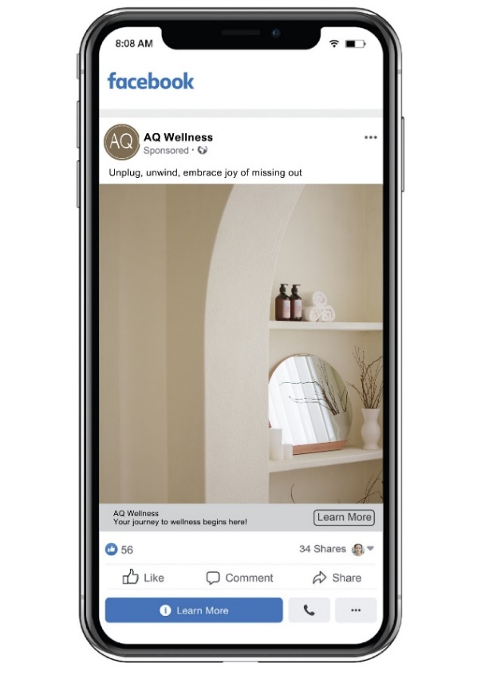 | 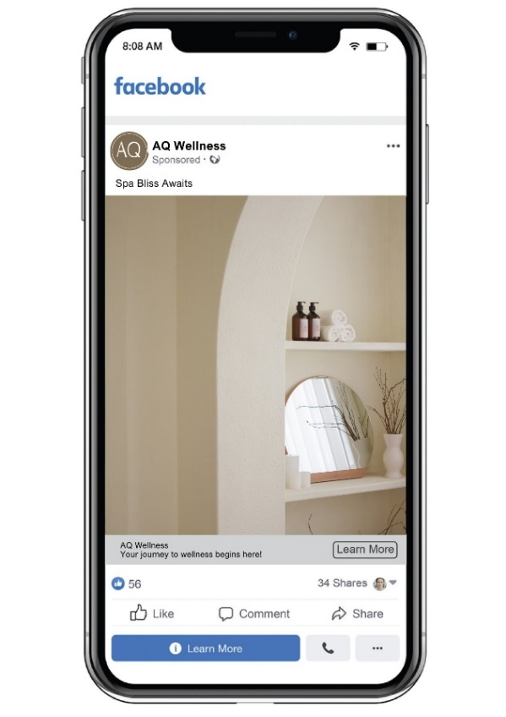
JOMO | Non-JOMO

Source: Authors’ own work.
Panel B. Stimuli for Study 2
 | 
JOMO | Non-JOMO

Source: Authors’ own work.
Panel C. Stimuli for Study 3
 | 
JOMO | Non-JOMO
Source: Authors’ own work.

Section 3. Study measures
Table A1. Overview of study measures
Study | Purpose | N | Product context | Independent variable & manipulation check | Measured constructs & sources
1 | Main effects and mechanism (H₁ and H₂) | 221 | Wellness center | IV: JOMO vs. non-JOMO advertising appeal  Manipulation check (1 item):  “The ad makes me feel a sense of enjoyment in disconnecting from distractions” | Self-brand congruity (M1): 4 items (adapted from Sirgy et al., 1997)  Purchase intention (Y): 3 items (adapted from Ajzen, 1991)
2 | Main effects and mechanism (H₁ and H₃) | 202 | Bookstore | IV: JOMO vs. non-JOMO advertising appeal  Manipulation check: same as Study 1 | Self-brand congruity (M1): 4 items (adapted from Sirgy et al., 1997)  Brand authenticity (M2): 5 items (adapted from Cinelli and LeBoeuf, 2020 and Warren et al., 2019)  Purchase intention (Y): 3 items (adapted from Ajzen, 1991)
3 | Main effects, mechanism, and boundary (H₁, H₃ and H_{4a-c}) | 202 | Furniture brand | IV: JOMO vs. non-JOMO advertising appeal  Manipulation check: same as Study 1 | Self-brand congruity (M1): 4 items (adapted from Sirgy et al., 1997)  Brand authenticity (M2): 5 items (adapted from Cinelli and LeBoeuf, 2020 and Warren et al., 2019)  Social comparison orientation (W1): 5 items (adapted from Gibbons and Buunk, 1999)  Purchase intention (Y): 3 items (adapted from Ajzen, 1991)
Notes: N = Sample size; IV = Independent variable; M1/M2 = Mediators; W1 = Moderator; Y = Dependent variable. JOMO = Joy of missing out. All measured construct scales were evaluated on a 7-point Likert scale. Item-level loadings, means, standard deviations, and psychometric evaluation parameters (CR, AVE) are fully reported in Table A2 below.
Source: Authors’ own work.
Table A2. Measurement evaluation: reliability and validity
Construct and item | Study 1 |  |  |  |  | Study 2 |  |  |  |  | Study 3
Construct and item | SFL | Mean | SD | CR | AVE | SFL | Mean | SD | CR | AVE | SFL | Mean | SD | CR | AVE
Self-brand congruity (SBC) |  | 3.46 | 1.47 | 0.96 | 0.87 |  | 2.99 | 1.19 | 0.93 | 0.76 |  | 3.43 | 1.29 | 0.91 | 0.71
SBC1: I am very much like the typical user of brand X | 0.94 |  |  |  |  | 0.88 |  |  |  |  | 0.86
SBC2: I can identify with the typical user of brand X. | 0.93 |  |  |  |  | 0.86 |  |  |  |  | 0.83
SBC3: I resemble the typical user of brand X. | 0.95 |  |  |  |  | 0.88 |  |  |  |  | 0.85
SBC4: Brand X and I are very similar. | 0.92 |  |  |  |  | 0.87 |  |  |  |  | 0.83
Purchase intention (PI) |  | 3.41 | 1.52 | 0.96 | 0.89 |  | 2.96 | 1.24 | 0.92 | 0.79 |  | 3.71 | 1.37 | 0.96 | 0.88
PI1: I would buy brand X. | 0.94 |  |  |  |  | 0.85 |  |  |  |  | 0.93
PI2: I would seriously consider buying brand X. | 0.96 |  |  |  |  | 0.91 |  |  |  |  | 0.94
PI3: It is very likely that I would buy brand X. | 0.94 |  |  |  |  | 0.91 |  |  |  |  | 0.94
Brand authenticity (BA) |  |  |  |  |  |  | 2.97 | 1.05 | 0.93 | 0.72 |  | 4.05 | 1.15 | 0.91 | 0.68
BA1: This brand is authentic. |  |  |  |  |  | 0.88 |  |  |  |  | 0.83
BA2: This brand is true to its roots. |  |  |  |  |  | 0.90 |  |  |  |  | 0.87
BA3: This brand doesn’t seem artificial. |  |  |  |  |  | 0.79 |  |  |  |  | 0.82
BA4: This brand doesn’t try to be something it’s not. |  |  |  |  |  | 0.82 |  |  |  |  | 0.87
BA5: This brand is motivated by passion rather than profit. |  |  |  |  |  | 0.86 |  |  |  |  | 0.72
Social comparison orientation (SCO) |  |  |  |  |  |  |  |  |  |  |  | 5.05 | 1.32 | 0.90 | 0.68
SCO1: I often like to talk with others about mutual opinions and experiences. |  |  |  |  |  |  |  |  |  |  | 0.82
SCO2: I often try to find out what others think who face similar problems as I face. |  |  |  |  |  |  |  |  |  |  | 0.88
SCO3: I always like to know what others in a similar situation would do. |  |  |  |  |  |  |  |  |  |  | 0.85
SCO4: If I want to learn more about something, I try to find out what others think about it. |  |  |  |  |  |  |  |  |  |  | 0.75
SCO5: I never consider my situation in life relative to that of other people (R)* |  |  |  |  |  |  |  |  |  |  | 0.56
Notes: SFL = Standardized factor loadings; CR = Composite reliability; AVE = Average variance extracted; SD = Standard deviation. *Item SCO5 (reverse-coded) was removed due to a low outer loading (0.56). Its removal improved the construct’s AVE from 0.56 to 0.68 and composite reliability from 0.86 to 0.90, consistent with Hair et al.’s (2021) guidance to remove weak indicators when doing so meaningfully improves convergent validity.
Source: Authors’ own work.
Table A3. Measurement evaluation: Fornell-Larcker criterion
Construct |  | Study 1 |  | Study 2 |  |  | Study 3
 |  | 1 | 2 | 1 | 2 | 3 | 1 | 2 | 3 | 4
1 | Self-brand congruity (M1) | (0.93) |  | (0.87) |  |  | (0.84)
2 | Purchase intention (Y) | 0.73 | (0.95) | 0.81 | (0.89) |  | 0.33 | (0.94)
3 | Brand authenticity (M2) |  |  | 0.61 | 0.59 | (0.85) | 0.20 | 0.66 | (0.82)
4 | Social comparison orientation (W1) |  |  |  |  |  | -0.24 | 0.03 | -0.13 | (0.83)
Notes: Values in parentheses along the diagonal are the square root of AVE for each construct; off-diagonal values are inter-construct correlations. Advertising appeal (JOMO vs. non-JOMO) is an experimentally manipulated, single-item variable (√AVE = 1.000 by construction) and is therefore excluded from this discriminant-validity assessment.
Source: Authors’ own work.
Table A4. Measurement evaluation: heterotrait-monotrait (HTMT) ratio of correlation for discriminant validity
Construct |  | Study 1 |  | Study 2 |  |  | Study 3
 |  | 1 | 2 | 1 | 2 | 3 | 1 | 2 | 3 | 4
1 | Self-brand congruity (M1) | — |  | — |  |  | —
2 | Purchase intention (Y) | 0.77 | — | 0.91* | — |  | 0.37 | —
3 | Brand authenticity (M2) |  |  | 0.66 | 0.65 | — | 0.24 | 0.73 | —
4 | Social comparison orientation (W1) |  |  |  |  |  | 0.28 | 0.07 | 0.15 | —
Notes: HTMT ratios are reported only for the multi-item measured constructs. The experimentally manipulated JOMO condition is excluded, as HTMT is not informative for a single-item categorical variable. HTMT values were below the conservative 0.85 threshold (Henseler et al., 2015) for all construct pairs, with one exception. * indicates a value exceeding the 0.85 threshold (self-brand congruity and purchase intention, Study 2). Discriminant validity for this pair was supported by the Fornell-Larcker criterion in Table A3, the nested confirmatory factor analysis reported in the main text, and the additional evidence reported in Table A5.
Source: Authors’ own work.
Table A5. Additional discriminant validity evidence for self-brand congruity and purchase intention (Study 2)
Model / test | Metric | Value
Confirmatory factor analysis (CFA)
Model A: Free two-factor CFA | χ² (df) | 32.70 (13)
 | Standardized inter-factor correlation | 0.92
Model B: Constrained one-factor CFA | χ² (df) | 55.20 (15)
Model comparison
Chi-square difference test | Δχ² (Δdf) | 22.50 (2)*
Heterotrait-monotrait (HTMT) ratio
Self-brand congruity ↔ Purchase intention | Point estimate | 0.91
 | Bootstrapped 95% CI | [0.85, 0.97]
Notes: Model A is a freely estimated two-factor CFA (self-brand congruity and purchase intention allowed to correlate). Model B constrains all items to load on a single common factor, equivalent to fixing the inter-construct correlation to 1. The chi-square difference test compares Model B against Model A. The HTMT bootstrapped confidence interval is based on 5,000 subsamples using the bias-corrected and accelerated (BCa) method. * p < 0.001.
Source: Authors’ own work.

Section 4. Social comparison orientation: variance and distribution checks (Study 3)
Additional analyses were conducted regarding potential range restriction of the moderator (social comparison orientation) in Study 3 (N = 202). Two sets of additional checks were conducted: (1) across social media usage intensity subgroups and (2) across age cohorts based on generational categories. All analyses were performed using SPSS.
Social comparison orientation variance by social media usage
Social comparison orientation exhibited adequate variance across all three social media usage subgroups (Table A6), with scores spanning the full or near-full scale range (1.00–7.00) regardless of usage intensity. Light users showed lower mean social comparison orientation (M = 4.51, SD = 1.39) than moderate (M = 5.21, SD = 1.25) and heavy users (M = 5.31, SD = 1.22), and this difference was statistically significant, F(2, 199) = 6.49, p = 0.002, η² = 0.061. Levene’s test confirmed comparable variance across subgroups (all p > 0.37), ruling out disproportionate compression in any group. These results confirm that range restriction is not a concern across social media usage levels.
Table A6. Descriptive statistics of social comparison orientation by social media usage subgroup
Social media usage | N | Mean | SD | Min | Max | IQR | 95% CI
Less than 3 hours/day | 54 | 4.51 | 1.39 | 1.00 | 7.00 | 2.06 | [4.13, 4.89]
3-6 hours/day | 98 | 5.21 | 1.25 | 1.00 | 7.00 | 1.50 | [4.96, 5.46]
More than 6 hours/day | 50 | 5.31 | 1.22 | 1.25 | 7.00 | 1.56 | [4.96, 5.66]
Total | 202 | 5.05 | 1.32 | 1.00 | 7.00 | — | [4.87, 5.23]
Notes: One-way ANOVA: F(2, 199) = 6.49, p = 0.002, η² = 0.061. Levene’s test: all p > 0.37, confirming homogeneity of variance across social media usage subgroups. Social comparison orientation measured on a 7-point scale. CI = Confidence interval. IQR = Interquartile range. SD = Standard deviation.
Source: Authors’ own work.

Social comparison orientation variance by age cohort
Social comparison orientation varied meaningfully across age cohorts in theoretically expected directions (Table A7), with participants aged 18-24 (M = 5.25, SD = 1.20) and 25-44 (M = 5.14, SD = 1.17) reporting higher mean social comparison orientation than participants aged 45–64 (M = 4.43, SD = 1.57) and 65–74 years (M = 2.50, SD = 1.34). These differences were statistically significant, F(3, 198) = 8.82, p < 0.001, η² = 0.118, with age cohort explaining approximately 12% of the variance in social comparison orientation. All cohorts exhibited meaningful variance (SDs ranging from 1.17 to 1.57), and Levene’s test confirmed homogeneity of variance across groups (all p > 0.14). These results confirm that the moderating role of social comparison orientation is not inflated by demographic homogeneity within any single cohort.
Table A7. Descriptive statistics of social comparison orientation by age cohort
Age cohort | N | Mean | SD | Min | Max | 95% CI
18–24 years | 101 | 5.25 | 1.20 | 1.00 | 7.00 | [5.01, 5.49]
25–44 years | 70 | 5.14 | 1.17 | 2.25 | 7.00 | [4.86, 5.42]
45–64 years | 27 | 4.43 | 1.57 | 1.50 | 7.00 | [3.80, 5.05]
65–74 years | 4 | 2.50 | 1.34 | 1.00 | 4.25 | [0.37, 4.63]
Total | 202 | 5.05 | 1.32 | 1.00 | 7.00 | [4.87, 5.23]
Notes: One-way ANOVA: F(3, 198) = 8.82, p < 0.001, η² = 0.118. Levene’s test: all p > 0.14, confirming homogeneity of variance across age cohorts. Social comparison orientation measured on a 7-point scale. CI = Confidence interval. SD = Standard deviation.
Source: Authors’ own work.

Section 5. Serial mediation model: alternative ordering checks (Study 3)
To assess the plausibility of the proposed ordering of brand authenticity and self-brand congruity, three model specifications were compared using PROCESS Macro v.4.2 (Hayes, 2022), with 5,000 bootstrap samples and 95% percentile bootstrap confidence intervals (N = 202). The specifications were: (1) the proposed serial model, JOMO → BA → SBC → PI; (2) a reversed serial model, JOMO → SBC → BA → PI; and (3) a parallel mediation model in which JOMO predicts BA and SBC simultaneously, with both mediators predicting PI (Table A8).
Table A8. Comparison of alternative mediation models
Model | Pathway | B | Boot SE | LLCI | ULCI
Model 1 (Proposed):  JOMO → BA → SBC → PI | JOMO → BA → PI | 0.42 | 0.08 | 0.28 | 0.58
Model 1 (Proposed):  JOMO → BA → SBC → PI | JOMO → SBC → PI | -0.07 | 0.04 | -0.15 | -0.002
Model 1 (Proposed):  JOMO → BA → SBC → PI | JOMO → BA → SBC → PI | 0.03 | 0.02 | 0.001 | 0.08
Model 1 (Proposed):  JOMO → BA → SBC → PI | Total indirect effect | 0.38 | 0.09 | 0.21 | 0.56
Model 2 (Reversed):  JOMO → SBC → BA → PI | JOMO → SBC → PI | -0.04 | 0.02 | -0.09 | -0.001
Model 2 (Reversed):  JOMO → SBC → BA → PI | JOMO → BA → PI | 0.48 | 0.08 | 0.34 | 0.63
Model 2 (Reversed):  JOMO → SBC → BA → PI | JOMO → SBC → BA → PI | -0.06 | 0.02 | -0.11 | -0.02
Model 2 (Reversed):  JOMO → SBC → BA → PI | Total indirect effect | 0.38 | 0.09 | 0.21 | 0.56
Model 3 (Parallel):  JOMO → BA + SBC → PI | JOMO → BA → PI | 0.42 | 0.08 | 0.28 | 0.58
Model 3 (Parallel):  JOMO → BA + SBC → PI | JOMO → SBC → PI | -0.04 | 0.02 | -0.09 | -0.001
Model 3 (Parallel):  JOMO → BA + SBC → PI | Total indirect effect | 0.38 | 0.09 | 0.21 | 0.56
Notes: JOMO = Joy of missing out. BA = Brand authenticity. SBC = Self-brand congruity. PI = Purchase intention. B values are unstandardized indirect effects. Boot SE = Bootstrap standard error. LLCI = Lower limit confidence interval. ULCI = Upper limit confidence interval. Confidence intervals are 95% percentile bootstrap confidence intervals based on 5,000 bootstrap samples.
Source: Authors’ own work.

Alternative-ordering checks support the plausibility of the proposed serial ordering, in which brand authenticity is positioned as antecedent to self-brand congruity. The proposed model produced a positive serial indirect effect (B = 0.03, Boot SE = 0.02, 95% CI: 0.001 to 0.08) and a positive indirect effect through brand authenticity (B = 0.42, Boot SE = 0.08, 95% CI: 0.28 to 0.58). In contrast, the reversed serial model produced a negative serial indirect effect (B = -0.06, Boot SE = 0.02, 95% CI: -0.11 to -0.02), which is less consistent with the proposed ordering, in which brand-level authenticity judgments are modeled as the first mediator and self-referential brand-fit judgments as the second. The parallel model produced a positive indirect effect through brand authenticity (B = 0.42, Boot SE = 0.08, 95% CI: 0.28 to 0.58) and a small negative indirect effect through self-brand congruity (B = -0.04, Boot SE = 0.02, 95% CI: -0.09 to -0.001), indicating that self-brand congruity does not independently carry the JOMO effect in a positive direction when brand authenticity is modeled simultaneously. These checks are consistent with the proposed ordering, in which JOMO appeals strengthen authenticity inferences that correspond with greater self-brand congruity and, in turn, purchase intention.
Further reading
Ajzen, I. (1991), “The theory of planned behavior”, Organizational Behavior and Human Decision Processes, Vol. 50 No. 2, pp. 179-211. https://doi.org/10.1016/0749-5978(91)90020-T
Cinelli, M.D. and LeBoeuf, R.A. (2020), “Keeping it real: how perceived brand authenticity affects product perceptions”, Journal of Consumer Psychology, Vol. 30 No. 1, pp. 40-59. https://doi.org/10.1002/jcpy.1123
Gibbons, F.X. and Buunk, B.P. (1999), “Individual differences in social comparison: development of a scale of social comparison orientation”, Journal of Personality and Social Psychology, Vol. 76 No. 1, pp. 129-142. https://doi.org/10.1037/0022-3514.76.1.129
Hair, J.F., Hult, G.T.M., Ringle, C.M., Sarstedt, M., Danks, N.P. and Ray, S. (2021), Partial Least Squares Structural Equation Modeling (PLS-SEM) Using R: A Workbook, Springer, Cham. https://doi.org/10.1007/978-3-030-80519-7
Hayes, A.F. (2022), Introduction to Mediation, Moderation, and Conditional Process Analysis: A Regression-Based Approach, 3rd ed., Guilford Press, New York.
Henseler, J., Ringle, C.M. and Sarstedt, M. (2015), “A new criterion for assessing discriminant validity in variance-based structural equation modeling”, Journal of the Academy of Marketing Science, Vol. 43 No. 1, pp. 115-135. https://doi.org/10.1007/s11747-014-0403-8
Sirgy, M.J., Grewal, D., Mangleburg, T.F., Park, J.O., Chon, K.S., Claiborne, C.B., Johar, J.S. and Berkman, H. (1997), “Assessing the predictive validity of two methods of measuring self-image congruence”, Journal of the Academy of Marketing Science, Vol. 25 No. 3, pp. 229-241. https://doi.org/10.1177/0092070397253004
Warren, C., Batra, R., Loureiro, S.M.C. and Bagozzi, R.P. (2019), “Brand coolness”, Journal of Marketing, Vol. 83 No. 5, pp. 36-56. https://doi.org/10.1177/0022242919857698

