Supplemental Material

Supplementary Table S1. List of REITs Targeted by This Study
No. | Name of J-REIT | Property Type
1 | Nippon Building Fund Inc. | Office
2 | Japan Real Estate Investment Corporation | Office
3 | Japan Metropolitan Fund Investment Corporation | Diversified
4 | ORIX JREIT Inc. | Diversified
5 | Japan Prime Realty Investment Corporation | Diversified
6 | NTT UD REIT Investment Corporation | Diversified
7 | United Urban Investment Corporation | Diversified
8 | Frontier Real Estate Investment Corporation | Retail
9 | HEIWA REAL ESTATE REIT, Inc. | Diversified
10 | Japan Logistics Fund, Inc. | Logistics
11 | Fukuoka REIT Corporation | Diversified
12 | Invincible Investment Corporation | Hotel
13 | Ichigo Office REIT Investment Corporation | Office
14 | Hankyu Hanshin REIT, Inc. | Diversified
15 | Daiwa House REIT Investment Corporation | Diversified
16 | Japan Hotel REIT Investment Corporation | Hotel
17 | Daiwa Securities Living Investment Corporation | Diversified
18 | Advance Residence Investment Corporation | Residential
19 | GLP J-REIT | Logistics
20 | Daiwa Office Investment Corporation | Office
21 | Japan Excellent, Inc. | Office
22 | Nippon Accommodations Fund Inc. | Residential
23 | Comforia Residential REIT, Inc. | Residential
24 | Industrial & Infrastructure Fund Investment Corporation. | Diversified
25 | Activia Properties Inc. | Diversified
26 | AEON REIT Investment Corporation | Retail
27 | Nippon Prologis REIT, Inc. | Logistics
28 | Starts Proceed Investment Corporation | Residential
29 | Hoshino Resorts REIT, Inc. | Hotel
30 | MORI TRUST REIT, Inc. | Diversified
31 | TOKYU REIT, Inc. | Diversified
32 | Global One Real Estate Investment Corporation | Office
33 | Mori Hills REIT Investment Corporation | Office
This table lists the 33 J-REITs in the sample, including name and primary property type.
Source: Authors' own creation

Supplementary Table S2. Basic Statistics of Variables
No. | Variable | Minimum | Max | Mean | Standard  Deviation
1 | Foreign Ownership Ratio (%) | 3.80 | 48.63 | 20.33 | 8.35
2 | Market Cap (LN, million JPY) | 9.70 | 13.96 | 12.38 | 0.72
3 | ROA | -1.18 | 9.35 | 2.99 | 0.76
4 | Gearing Ratio (%) | 30.77 | 149.13 | 97.67 | 15.26
5 | Nikkei Stock Average (JPY) | 15162.10 | 33464.17 | 23153.95 | 5141.70
6 | Japan’s Interest Rate (%) | -0.08 | 0.07 | -0.03 | 0.04
7 | Bank of Japan's J-REIT purchase volume (100 million JPY) | 0.00 | 790.00 | 269.45 | 213.50
8 | Global REITs Index | 1609.95 | 2363.86 | 1972.38 | 172.76
9 | Tokyo Stock Exchange REIT Index | 1598.27 | 2150.73 | 1846.23 | 148.05
10 | Foreign Exchange Rate | 101.36 | 144.99 | 117.07 | 12.46
11 | Foreign Co. | 0.00 | 1.00 | 0.16 | 0.37
12 | Real Estate Co. | 0.00 | 1.00 | 0.58 | 0.49
13 | Keiretsu Co. | 0.00 | 1.00 | 0.36 | 0.48
14 | Office | 0.00 | 1.00 | 0.21 | 0.41
15 | Residential | 0.00 | 1.00 | 0.12 | 0.33
16 | Retail | 0.00 | 1.00 | 0.06 | 0.24
17 | Hotel | 0.00 | 1.00 | 0.09 | 0.29
18 | Logistics | 0.00 | 1.00 | 0.09 | 0.29
Note: N = 660 semi-annual firm-period observations (33 J-REITs, 2014–2023).
Source: Authors' own work
This table reports descriptive statistics (minimum, maximum, mean, and standard deviation for continuous variables, and proportions for dummy variables) across 660 semi-annual firm–period observations.

Supplementary Table S3. VIFs of Variables
Variable | VIF
Market Cap | 1.451
ROA | 1.111
Gearing Ratio | 1.931
Nikkei Stock Average | 2.819
Japan’s Interest Rate | 1.730
Bank of Japan's J-REIT purchase volume | 2.260
Global REITs Index | 3.044
Tokyo Stock Exchange REIT Index | 3.503
Foreign Exchange Rate | 1.966
Foreign Co. | 2.410
Real Estate Co. | 1.835
Keiretsu Co. | 1.739
Office | 1.253
Residential | 1.293
Retail | 1.331
Hotel | 2.941
Logistics | 2.110

Source: Authors' own work
This table reports multicollinearity diagnostics for all explanatory variables. All VIF values were well below the conventional threshold of 10, indicating no multicollinearity concerns.

Supplementary Table S4. T-test for Foreign Ownership Ratios Before and After Inclusion in the FTSE EPRA/NAREIT Global Index
 | Change after inclusion in global index | The others
Mean | 4.074 | 0.025
Variance | 8.206 | 5.227
Observations | 13 | 614
df | 12
t Stat | -5.062
P(T<=t) two-tail | 0.000
t Critical two-tail | 2.179

Source: Authors' own work
This table shows the results of the t-test comparing changes in foreign ownership ratios during inclusion events versus other periods, confirming a statistically significant positive effect at the 1% level.

Supplementary Figure S1. Investment Corporation (Toshi-Hojin) Structure
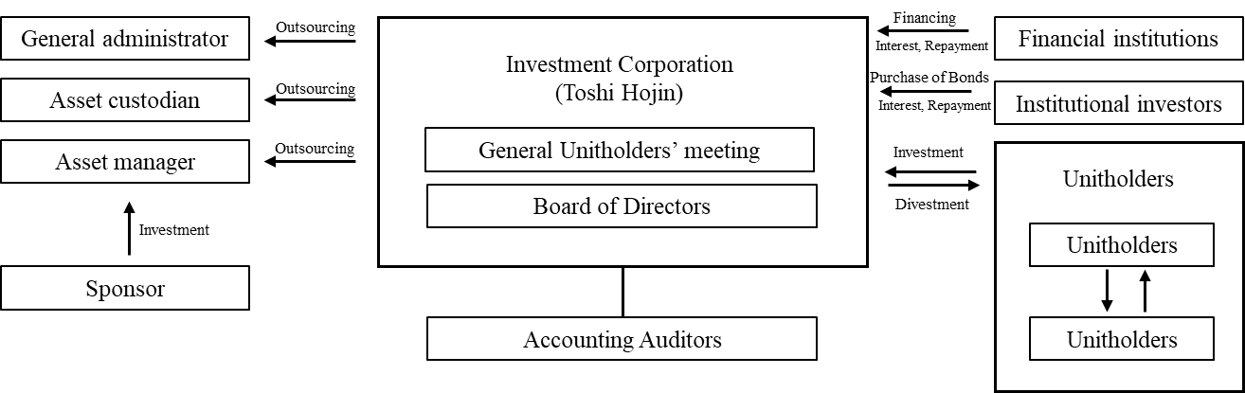
Source: Figure author’s illustration based on the J-REITs structure diagram published by The Association for Real Estate Securitization (ARES), 2025
This figure illustrates the basic structure of a Japanese Real Estate Investment Trust (J-REIT), which is organized as an investment corporation (Toshi-Hojin). It shows the relationships between the investment corporation, asset management company, custodians, and unitholders, as regulated under the Investment Trust Law.

Supplementary Figure S2. Semi-annual trend in the Foreign Ownership Ratio of J-REITs (2014-2023)
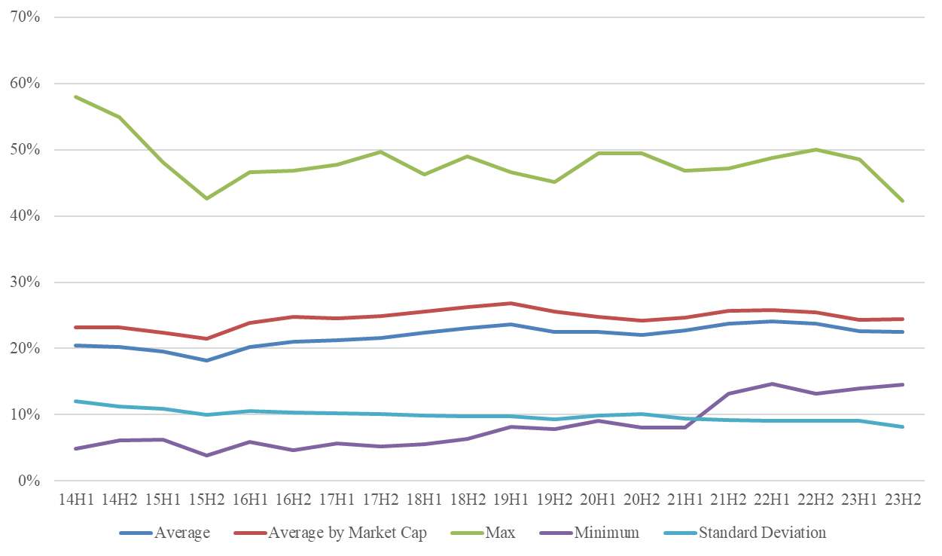
Source: Authors' own work
This figure presents the aggregated foreign ownership ratio across 33 J-REITs over the study period. The average ratio fluctuates between 20% and 25%, with a modest upward trajectory. The narrowing gap between maximum and minimum values indicates reduced dispersion across firms.

Supplementary Figure S3. Trend in average market capitalization owned by foreign investors in J-REITs
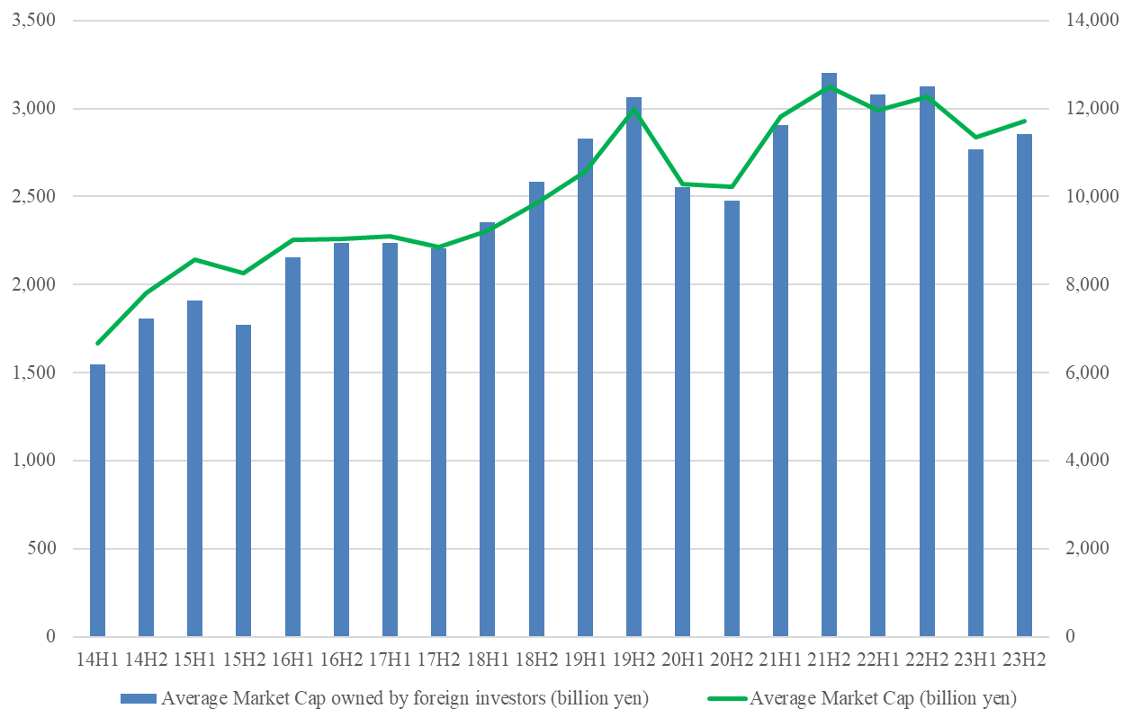
Source: Authors' own work
This figure tracks the growth of market capitalization held by foreign investors relative to overall J-REIT market capitalization. Between 2014 and 2023, foreign-held capitalization increased 1.85 times, slightly outpacing total market growth of 1.76 times.

Supplementary Figure S4 . Trend in average market capitalization and number of foreign investors in J-REITs
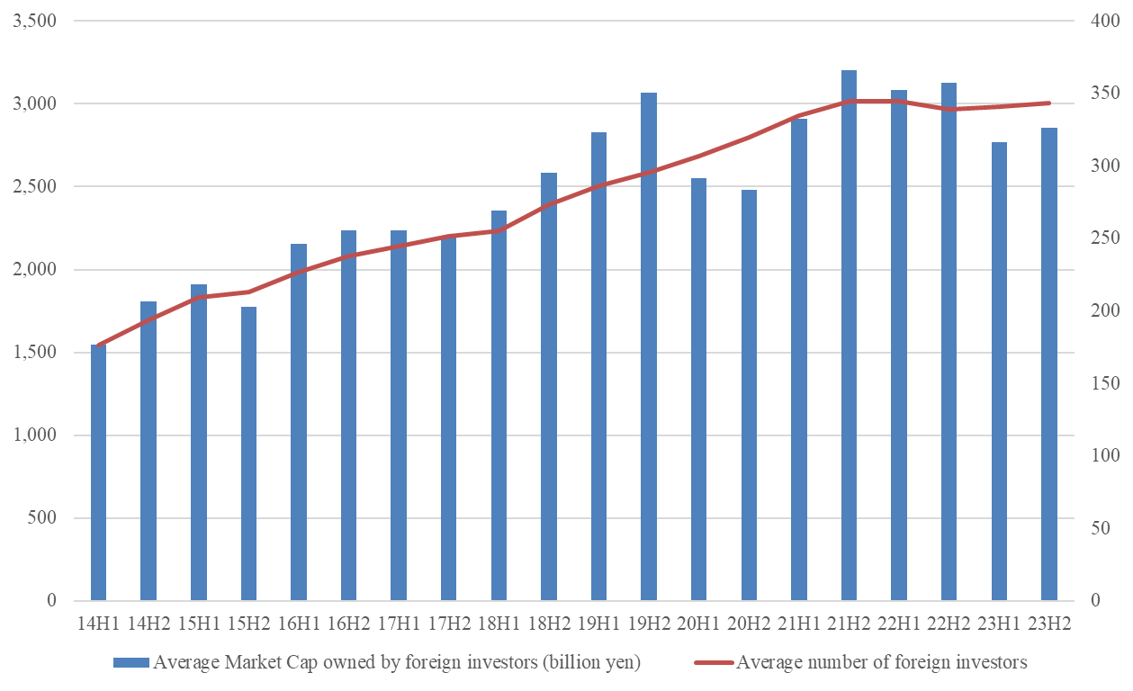
Source: Authors' own work
This figure shows the combined growth in average market capitalization held by foreign investors and the number of foreign investors per J-REIT. The number of foreign investors nearly doubled during the study period, indicating broadening participation alongside rising market capitalization.

