Appendix A: List of n = 90 PropTechs examined during the iterations.
Table A.1. Sample of 90 PropTechs analysed. (Source: Authors own work).
No. | Name | Country (ISO) | No. | Name | Country (ISO)
1 | Eliona by IoTEC | CHE | 44 | Digital Spine | DEU
2 | ARiiVA | AUT | 45 | bGrid | NLD
3 | Novaccess | CHE | 46 | BlueRange | DEU
4 | Technis | CHE | 47 | Automation Intelligence | DEU
5 | VREEDA | DEU | 48 | e-shelter security services | DEU
6 | MYFLEXBOX | AUT | 49 | Pinestack | DEU
7 | Eeproperty | CHE | 50 | wtec | DEU
8 | Akenza | CHE | 51 | Spaceflow | CZE
9 | GROPYUS | AUT | 52 | Animus | DEU
10 | E-nno Switzerland | CHE | 53 | Enerthing | DEU
11 | zevvy | CHE | 54 | Polydigital | DEU
12 | Pult | DEU | 55 | metiundo | DEU
13 | LineMetrics | AUT | 56 | metr | DEU
14 | CLEVERON | CHE | 57 | ROCKETHOME | DEU
15 | aedifion | DEU | 58 | vilisto | DEU
16 | Yuon Control | CHE | 59 | Zählerfreunde | DEU
17 | Almendo Technologies | AUT | 60 | othermo | DEU
18 | YORD | CHE | 61 | BEAD DIGTIAL | DEU
19 | meteoviva | CHE | 62 | Locatee | CHE
20 | Airica | CHE | 63 | Nuki Home Solutions | AUT
21 | Decentlab | CHE | 64 | Technis | CHE
22 | Buchs | CHE | 65 | Tapkey | AUT
23 | Miromico | CHE | 66 | Hotelbird | DEU
24 | Droople | CHE | 67 | ParkHere | DEU
25 | THING TECHNOLOGIES | DEU | 68 | casavi | DEU
26 | intertempi | DEU | 69 | THING TECHNOLOGIES | DEU
27 | Oxoia | CHE | 70 | RYSTA | DEU
28 | POCKET HOUSE | AUT | 71 | SONAH | DEU
29 | LEDCity | CHE | 72 | Animus | DEU
30 | chargebyte austria | AUT | 73 | vilisto | DEU
31 | CLEMAP | CHE | 74 | Basking Automation | DEU
32 | Swissprime Technologies | CHE | 75 | Respory | AUT
33 | Xandar Kardian | CHE | 76 | GOLOG | CHE
34 | neoom | AUT | 77 | Essentry | DEU
35 | HOOC | CHE | 78 | Juconn | DEU
36 | Reisenbauer Solutions | AUT | 79 | thingdust | CHE
37 | Tapkey | AUT | 80 | coapp | DEU
38 | KIWI.KI | DEU | 81 | Security Alarms & Co. | CHE
39 | Sensorberg | DEU | 82 | Pult | DEU
40 | electrojoule | CHE | 83 | aedifion | DEU
41 | puck Immobilien App Services | AUT | 84 | Zählerfreunde | DEU
42 | Airthings | NOR | 85 | HUM Systems | DEU
43 | Allthings Technologies | CHE | 86 | EVOLY | CHE
87 | Oxoia | CHE | 89 | Solarmente | ESP
88 | Deepfinity | GBR | 90 | vSmart | NLD

Appendix B: Taxonomy Development Process – detailed descriptions of each iteration (literature review, analysis of real‑world cases, and expert interviews).
Following Nickerson et al. (2013), the taxonomy should be mutually exclusive and collectively exhaustive in order to maximise selectivity and avoid redundancies. We align with Möller et al. (2022), who note that non-exclusive dimensions have become common practice in the development of business model taxonomies.
In the first iteration, we adopt a conceptual-to-empirical approach and conduct a comprehensive literature search as set forth in Webster and Watson (2002). This approach incorporates the authors’ background knowledge, particularly in the development of the characteristics. Studies were included if they explicitly presented taxonomies or frameworks, literature reviews, or individual, specific solutions in the context of the topic. A comprehensive search was conducted in Scopus (479 results), Google Scholar (1,960 results), ResearchGate (13,640 results), IEEE Xplore Digital Library (83 results), ScienceDirect (78 results), and EBSCOhost (23 results). The following search strings were used: TITLE ("IoT Platform" OR "IIoT Platform" OR "Smart Building" OR "Smart Building Platform") AND ABS (taxonomy OR framework OR classification). The search on Google Scholar was limited to the first 480 results and on ResearchGate to the first 200 results. The initial results were then screened by reading the title and abstract, and eventually the entire paper. If a source appeared relevant, it was checked for duplicates. Using a backward and forward approach, a total of 285 publications were identified, of which 84 were relevant. The first iteration resulted in 23 dimensions, indicating a high granularity of the results. Subsequent iterations remained necessary to identify new relevant dimensions and eliminate less relevant content.
In the second and third iterations, we chose the empirical-to-conceptual approach by analysing real-world objects from the DACH region. The dataset is drawn from startupdetector.de, apti.at, proptechnews.ch, wiredscore.com/accredited-solutions, proptechos.com/apps/#operational-efficiency and participants of the “PropTech Pitches 2024” at the German trade fair “Real Estate Arena 2024” (real-estate-arena.com). We identified 470 relevant PropTechs and selected a sample of 30 PropTechs for each analysis (see Table A.1). The selection criteria for PropTechs are derived from the broad definition of the term and include companies that clearly relate to “smart real estate”. This encompasses not only IoT-related hardware, but also innovative software solutions for managing space and services. We used publicly available information and conducted face-to-face interviews. The second iteration reduced the number of dimensions to 18. After analysing another 30 PropTechs from the same database, no significant changes were observed in the third iteration. One more dimension was removed and another was added. These two iterations helped validate and refine the theory-based taxonomy.
The fourth and fifth iterations were again empirical-to-conceptual and consisted of seven expert interviews each. We used a semi-structured approach that allowed us to address existing theories and consider new ideas. We selected experts with diverse perspectives to fully honour the holistic perspective of the business model (see Table B.1). The interviews lasted on average 71 minutes (fourth iteration) and 85 minutes (fifth iteration). The analysis is based on Rädiker and Kuckartz (2021) and was conducted using MAXQDA. The interview material of a total of 1,097 min was coded and analysed three times, i.e. with three categories (thematic, theoretical; evaluative; general). This triple coding, with a total of 1,847 coded segments, allowed in-depth analyses. After the fourth iteration, the taxonomy was reduced to the essential content of 16 dimensions and prioritised. The fifth iteration resulted in minor changes to the dimensions, although the number remained the same. Significant changes were made to the characteristics. In particular, the technical aspects of system integration in a building were clarified and the terminology was appropriately formulated. Further, the comprehensibility and practicality of the taxonomy were improved. Although the semi-structured interviews were based on the respective version of the taxonomy, they nonetheless provided scope for more in-depth discussion. Additional findings that support the taxonomy’s interpretation and deepen our understanding are presented in the results section.
Table B.1. Overview of the 14 Expert Interviews conducted between June and September 2024. (Source: Authors own work).
 |  | Role of interviewee | Industry | Employees | Expe-rienceª | Codes^{b} | Duration
4th Iteration | E1 | Researcher & Consultant | FM^{c} | 1 | 20 | 123 | 87 min
4th Iteration | E2 | Innovation Manager | PropTech | 11-50 | 5 | 100 | 65 min
4th Iteration | E3 | Co-Founder & CEO | PropTech | 2-10 | 7 | 98 | 53 min
4th Iteration | E4 | Building Tech. Engineer | Certification^{d} | 51-200 | 4 | 105 | 78 min
4th Iteration | E5 | Digital Advisory | Consulting | 10,000+ | 12 | 146 | 83 min
4th Iteration | E6 | Innovation Manager | Real Estate^{e} | 201-500 | 5 | 145 | 72 min
4th Iteration | E7 | Co-Founder & CFO | PropTech | 2-10 | 5 | 117 | 59 min
5th Iteration | E8 | Professor and Consultant | BMS/BAS | 1 | 35+ | 255 | 193 min
5th Iteration | E9 | Digital Real Estate | Consulting | 10,000+ | 5 | 189 | 101 min
5th Iteration | E10 | Business Development | MEP^{f} | 11-50 | 15 | 99 | 80 min
5th Iteration | E11 | Founder & CEO | PropTech | 2-10 | 16 | 89 | 58 min
5th Iteration | E12 | Portfolio Owner | Production | 10,000+ | 8 | 144 | 55 min
5th Iteration | E13 | Co-Founder & Partner | VC^{g} | 11-50 | 23 | 107 | 57 min
5th Iteration | E14 | Strategic Projects Lead | Real Estate^{e} | 201-500 | 9 | 130 | 50 min
ªProfessional experience of interviewee in years. ^{b}Number of codes. ^{c}Facility Management & Digitalisation. ^{d}Building Assessment & Certification Company. ^{e}Real Estate Development & Asset Management with well-known SB projects. ^{f}Mechanical, Electrical and Plumbing Engineering Services. ^{g}Venture Capital Investor.
The sixth iteration, involving 30 PropTechs (see Table A.1), followed an empirical-to-conceptual approach and relied on publicly available information. As the database was largely exhausted, we included Crunchbase (crunchbase.com). Crunchbase is a robust online database of (start-up) companies regularly used in research (e.g. Gimpel et al., 2018; Hodapp et al., 2019). We processed the data of 25,755 companies using “SecondPulse” (secondpulse.ai) employing web scraping and Large Language Models (LLM) of OpenAI’s ChatGPT. This step was necessary because the categorisation of PropTechs in Crunchbase is not sufficiently developed. This might be due, on the one hand, to the ambiguous definition of PropTech as an umbrella term, and on the other hand, to the overlap between PropTech and other tech industries. LLMs can be used in an exploratory manner in qualitative research in different domains (Zhang et al., 2024). As described by Giray (2023), we employed a “mixed prompt” technique. “System prompts” allowed us to define a general context, the role of the GPT model and a framework for action. “Contextual prompts” helped obtain specific answers.
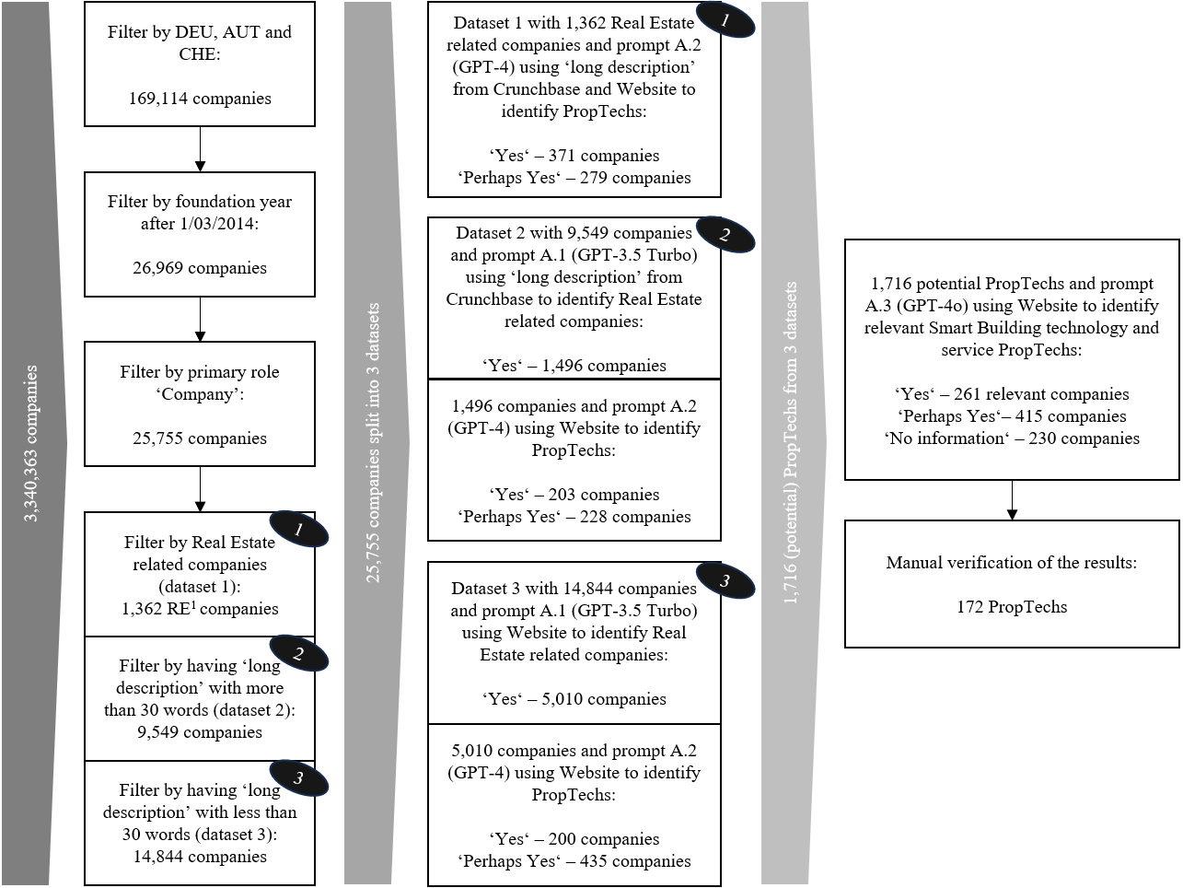Figure B.1. Data Screening and Preparation Method using Large Language Model from ChatGPT by OpenAI. (Source: Authors own work).
To identify our PropTechs from Crunchbase, a total of 11 iterations took place, in which we always optimised the prompts with the help of test datasets and then checked and compared manually. Table C.1 shows the individual iterations with the final prompts as well as the hit ratios. Our procedure can be described in three stages following the prompts (see Figure B.1). First, the companies are filtered according to their relation to the construction and real estate industry (contextual prompt A.1), second according to PropTechs (contextual prompt A.2) and third according to their relation to smart buildings or IoT (contextual prompt A.3), whereby we have also extended this prompt to marketplaces or transaction platforms for further investigations beyond the scope of this work. We split our data set into three in order to optimise the process and save resources. The system prompt B.1 was used in combination with contextual prompt A.1 and A.2, while system prompt B.2 was used with contextual prompt A.3 (see Table C.2). For all prompts, we took care to avoid overfitting and bias reinforcement (Giray, 2023).
The LLM's responses were limited to “yes”, “no” and “perhaps”, and a reason was always requested. The “perhaps” answers were important to avoid forcing the model to make a decision facing reasonable doubts. After final processing of the data and manual review, we obtained a total of 172 relevant PropTechs in the DACH region. Analysing 30 of these PropTechs did not lead to any changes in the taxonomy in the sixth iteration. This indicates that all termination conditions were met, so the iteration was stopped and the taxonomy was completed. The changes at the dimension level in each iteration are illustrated in Figure D.1.

Appendix C: Prompt Engineering
Table C.1. Prompt engineering process for contextual prompts A.1 to A.3. (Source: Authors own work).
Test | Data setª | Finale prompt translated from German | Yes^{b} | Per-haps | No | Hit ratio^{c} | GPT-Model
1. | 252 | Contextual prompt A.2: “You should assess neutrally whether a company is a PropTech in its core business or not. This should be differentiated and justified as clearly as possible.  This is the definition of PropTech: (shortened definition by Westphal (2024))  If ‘PropTech’ is explicitly mentioned on the website or in the description text, the company is definitely a PropTech. Without claiming to be exhaustive, PropTechs also include the digital brokerage of real estate via an online platform, the digital processing of financial investments in real estate, such as real estate crowdfunding platforms, or business models that focus on the temporary provision of space in the sense of the sharing economy, such as co-working spaces. Other typical categories for PropTechs are in the area of smart buildings/cities or the Internet of Things, or in the area of planning and construction, building information modelling, 3D printing or digital procurement platforms. In addition, visualisation using 3D, virtual reality or augmented reality technologies can also be a PropTech segment - as can the segment of property management (such as tenant communication, facility management or data evaluation).  If the categorisation is absolutely unclear, you can use ‘perhaps’.” | 100 | 67 | 85 | 74% | 4
2. | 99 |  | 29 | 20 | 50 | 95% | 4
3. | 98 |  | 23 | 20 | 55 | 95% | 4
4. | 99 | Contextual prompt A.1d: “Assess whether a company belongs to the real estate or construction industry. The core business does not have to be related to the real estate or construction industry. It is sufficient for a company to have a specific overlap with the real estate or construction industry according to the description, even if this overlap is very small. Classify companies with no connection to the real estate or construction industry as ‘no’. Companies that may be relevant or that you are unsure about should be marked with ‘perhaps. Your task is to sort out obviously irrelevant companies. If in any doubt, use ‘perhaps’. Also use perhaps if the business model has anything to do with the real estate world.” | 16 | 1 | 82 | 74% | 3.5 T.
5. | 100 |  | 29 | 23 | 48 | 91% | 4
6. | 100 |  | 60 | 0 | 40 | 86% | 3.5 T.
7. | 100 |  | 28 | 8 | 64 | 79% | 3.5 T.
8. | 100 |  | 34 | 19 | 47 | 90% | 3.5 T. + 4

Table C.1. Continued.
9. | 60 | Contextual prompt A.3: “Assess whether a company's business area is either in the Internet of Things (IoT for short) or in the area of transaction platforms. Companies in the field of the Internet of Things can be in the field of smart buildings or smart homes, so these companies often work with the term ‘smart’. This can also include IoT companies that offer analytical services and automation of processes and applications using smart devices. These devices can be sensors, actuators, gateways or edge devices or other smart installations that can measure and control autonomously. IoT companies can also be cloud  platforms or offer connectivity solutions and operating systems. They provide these services because they want to enhance the user experience, improve sustainability, save costs, improve people's health or optimise processes. Transaction platforms can be conventional marketplaces that essentially want to mediate and connect different players. This can include companies that mediate buildings, space, building materials, professional groups or individual people, among others, without any claim to completeness. When evaluating, always answer with ‘IoT’, ‘perhaps IoT’, ‘marketplace’, ‘perhaps marketplace’ or ‘none’. Use ‘none’ if the website does not meet one of the definitions. If the website is not available, write ‘no information’.” | 20 (I)  16 (M) | 0 | 24 | 80% | 4o
10. | 60 |  | 13 (I)  13 (M) | 8 (I) | 26 | 88% | 4o
11. | 60 |  | 14 (I)  14 (M) | 8 (I) | 24 | 96% | 4o
ªNo. of randomly chosen companies from Crunchbase as test data set. ^{b}(I) for IoT and (M) for marketplace. ^{c}Hit ratio without “Perhaps”. ^{d}Used in combination with contextual prompt A.2.

Table C.2. System prompts B.1 and B.2. (Source: Authors own work).
Description | System prompt
System prompt B.1 | You are an assistant who helps us to pre-filter company types. You are supposed to identify whether companies generally have something to do with real estate or not. After you, a more precise filter is applied. Therefore, your task is to sort out predominantly non-real estate companies with “no”. However, do not sort out too quickly. If in doubt, use “perhaps” more often. Especially if the company may have something to do with real estate in a more distant sense.
System prompt B.2 | You are an assistant who helps us to identify the business area of a company. You only have two business areas to choose from. You have to identify whether companies have something to do with IoT (or smart buildings) or marketplaces (as a transaction platform). If neither of the two business areas apply, you can answer "no". However, do not sort out too quickly. If in doubt, use "perhaps" more often

Appendix D: Summary of taxonomy dimensions considered during the iterative development process
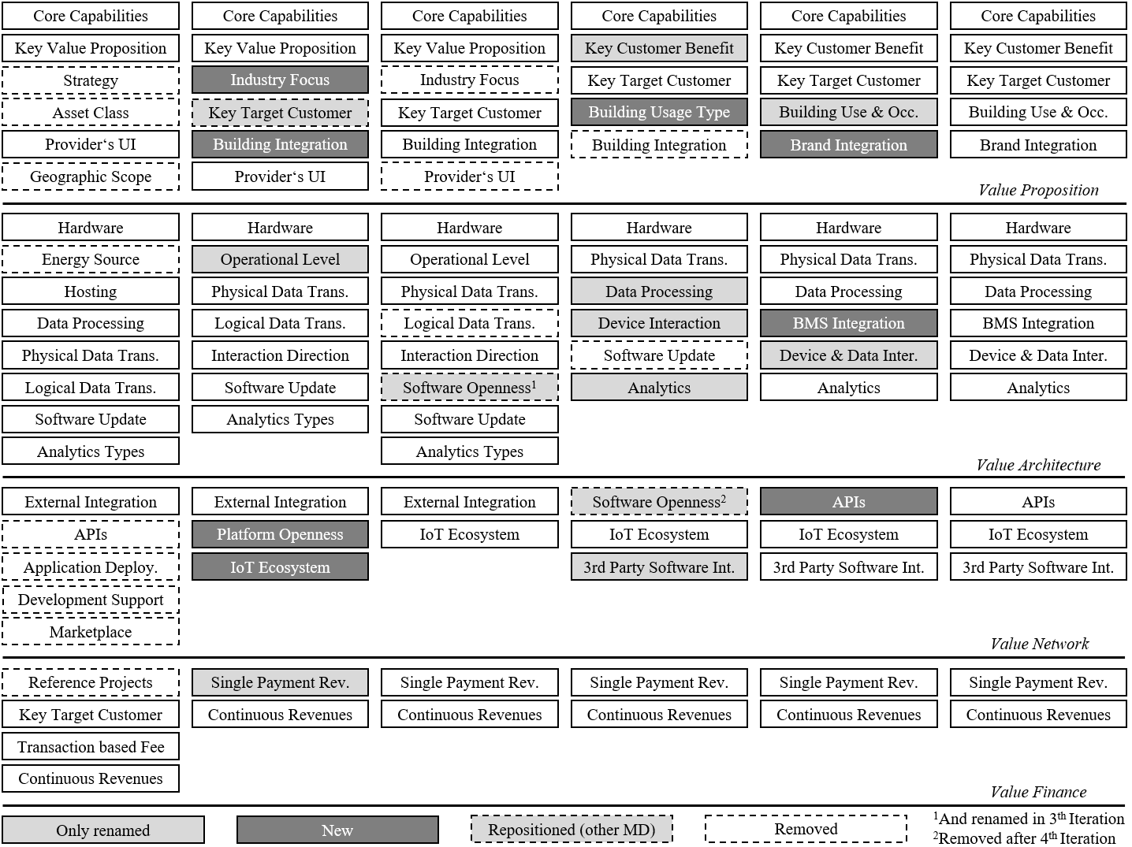Figure D.1. Iterations and Changes in the Taxonomy Building Process from the first Iteration (first column from left) to the sixth Iteration (last/sixth column from the left). (Source: Authors own work).

Appendix E: Application of two anonymised PropTechs
To demonstrate the taxonomy’s applicability, we applied it anonymously to two PropTechs that typify the current market (see Figure E.1). This exercise not only illustrates the taxonomy’s practical use but also clarifies the interrelationships among its dimensions and the attendant implications for diverse stakeholders.
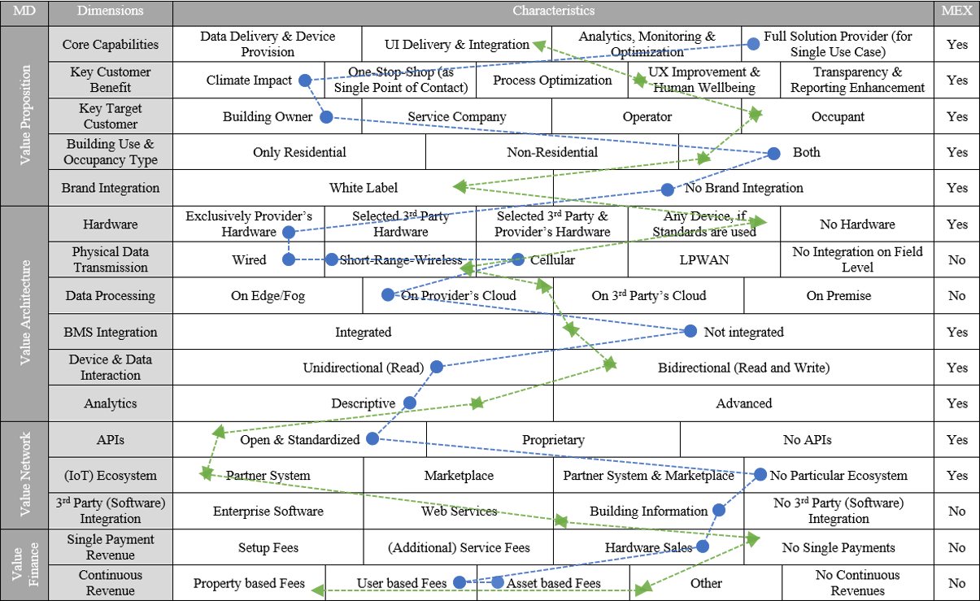Figure E.1. Application of two anonymised PropTechs that are currently active on the market. (Source: Authors own work).

PropTech “Green”
“Green” is a PropTech dedicated to enhancing the tenant and user experience through smart technologies. Its key value proposition is to make doors digitally accessible. The company offers white-label products that can be controlled from any smartphone. Connectivity relies on NFC: a door-mounted device transmits data to the cloud platform, which processes the request and then signals the door controller to unlock. BMS integration is unnecessary, since each door is upgraded independently. The system operates bidirectionally. The data reconciliation carried out in the cloud involves only basic descriptive analytics. The platform is highly open, providing SDKs and APIs. Green maintains partnerships with software providers of office or workplace-management and identity-management platforms, as well as with manufacturers of physical locking systems, thereby increasing market penetration and embedding its product within wider ecosystems and use cases. All revenue is generated through recurring payments.

PropTech “Blue”
“Blue” is a young PropTech focused on a single, isolated use case—monitoring indoor air quality. The product is designed to operate entirely independently as an initial market offering; the customary next step is often to develop an ecosystem around it, making this trajectory typical. Its principal value proposition is not the intuitive improvement of occupants’ well-being but the reduction of operating and maintenance costs by measuring indoor air quality. Quantifiable cost savings are generally easier to market than the promise of enhanced well-being, which is unlikely to command rental premia. Consequently, the primary customers are building owners and landlords The asset class is immaterial. The product functions in isolation, so no white-label version is required. Blue’s core competence lies in its proprietary hardware—specifically, its own air-quality sensors—so no initial integration is necessary. Connectivity options are diverse: Power over Ethernet (PoE) provides simultaneous power supply and secure data transfer via cable, while Wi-Fi and cellular connections allow short-range and mobile transmission respectively, offering deployment flexibility. Data are transmitted to a proprietary cloud platform for evaluation; given the plug-and-play approach, no BMS integration is provided. The platform produces conclusions but cannot automatically adjust the physical environment, rendering the solution unidirectional. Analytics are limited to identifying trends and threshold exceedances, so the approach remains descriptive. Although Blue currently operates outside an ecosystem, it offers APIs so that customers can integrate the platform with their own systems. Building information such as floor plans can be imported, enabling clear visualisation of analyses and room-level reports. Revenue streams are mixed: the hardware is sold outright, whereas the platform is monetised through recurring fees tied to the number of users or active devices.

Discussion
Core Capabilities and Key Customer Benefit strongly shape the remaining dimensions, thereby delineating the use case: they identify the principal customer segment and the building types for which the solution is suitable. The value proposition therefore allows the derivation of structures that map the remaining (meta) dimensions in characteristic configurations. For instance, by prioritising the Key Customer Benefit of ‘Climate Impact’, Blue positions building owners as its primary target customers. If the emphasis were on well-being, tenants or end users would constitute the target group. This example also illustrates how one product can address different value propositions and how customer segments can shift with a firm’s strategic orientation. Even so, the other dimensions remain analytically independent and highlight the diversity of PropTech business models. The value architecture’s hardware dimension, for example, clarifies how the model must be configured, particularly with regard to partners and ecosystems from value network. Where hardware is supplied, proprietary software is typically indispensable, since integrating the devices into third-party systems and managing distribution require considerable effort. Accordingly, hardware-based solutions generally need to be offered as complete, self-contained products that can later be integrated en bloc into external systems. Some elements must be assessed in relative terms: the attribute ‘Any Device, if Standards are used’ is meaningful only within a specific frame of reference. Green, for instance, addresses only door-locking systems, so its application is restricted to that use case from the outset. Only a small subset of PropTechs focus exclusively on hardware; less invasive offerings that prioritise software depend from the outset on external partners, whose involvement can be decisive for success. Within the Value Architecture, the dimensions are arranged in a logical sequence that mirrors the technical operation of the solution—beginning with hardware and ending with software. Green appears more mature owing to its openness and partnerships, whereas Blue still seems to be in a ‘product–market fit’ phase. This distinction also explains why Green’s business model relies more on platform revenues, while Blue continues to depend on hardware sales—although renting the hardware rather than selling it outright would be feasible. The example thus illustrates how the revenue-logic dimension is contingent on the ecosystem dimension. Notably, Green targets tenants—and, by extension, building owners—rather than lock-system OEMs, who might initially seem like the obvious choice. This strategy entails a risk, as individual OEMs could replicate the solution themselves, limiting Green’s added value. The unique benefit instead lies in allowing tenants to use a single system across multiple sites, irrespective of the underlying lock system. By contrast, Blue positions building owners as its primary customers, because they are more likely to invest in a product that lowers operating costs—a benefit that might be harder to monetise with tenants.
In data terms, both firms could deepen their existing use cases without venturing into entirely new application domains. Green could begin by mining its access-control data and applying advanced analytics to detect occupancy patterns, thereby enabling occupancy-based services that integrate naturally with wider workplace-management solutions. Blue, meanwhile, could extend its offering through predictive maintenance and predictive-usage features: building utilisation is often highly regular, allowing early recommendations derived from empirical data. From a cybersecurity and data-protection perspective, Green’s bidirectional model is more sensitive, as it handles access rights and must guard against unauthorised entry; robust security in both connectivity and cloud infrastructure is therefore imperative, especially given the hardware-agnostic approach. Blue’s model is comparatively less sensitive: environmental data typically involve no personal information, and its unidirectional architecture prevents direct manipulation of the physical environment.

References (appendix)
Gimpel, H., Rau, D. and Röglinger, M. (2018), “Understanding FinTech start-ups – a taxonomy of consumer-oriented service offerings”, Electronic Markets, Vol. 28 No. 3, pp. 245–264.
Giray, L. (2023), “Prompt Engineering with ChatGPT: A Guide for Academic Writers”, Annals of biomedical engineering, Vol. 51 No. 12, pp. 2629–2633.
Hodapp, D., Remane, G., Hanelt, A. and Kolbe, L.M. (2019), “Business Models for Internet of Things Platforms: Empirical Development of a Taxonomy and Archetypes”, paper presented at 14th International Conference on Wirtschaftsinformatik, February 24-27, Siegen, Germany, available at: https://aisel.aisnet.org/wi2019/track14/papers/5/ (accessed 25 March 2025).
Möller, F., Stachon, M., Azkan, C., Schoormann, T. and Otto, B. (2022), “Designing business model taxonomies – synthesis and guidance from information systems research”, Electronic Markets, Vol. 32 No. 2, pp. 701–726.
Nickerson, R.C., Varshney, U. and Muntermann, J. (2013), “A method for taxonomy development and its application in information systems”, European Journal of Information Systems, Vol. 22 No. 3, pp. 336–359.
Rädiker, S. and Kuckartz, U. (2021), Focused Analysis of Qualitative Interviews with MAXQDA: Step by Step, Springer Fachmedien Wiesbaden, Wiesbaden.
Webster, J. and Watson, R.T. (2002), “Analyzing the past to prepare for the future: writing a literature review”, MIS Quarterly, Vol. 26 No. 2, pp. 13–23.
Westphal, M. (2024), “blackprint PropTech Report 2023. On the rise of innovation drivers in the construction and real estate sector”, available at: https://www.blackprint.de/veroffentlichungen/blackprint-proptech-report-2023-en (accessed 11 November 2024).
Zhang, H., Wu, C., Xie, J., Lyu, Y., Cai, J. and Carroll, J.M. (2024), “Redefining Qualitative Analysis in the AI Era: Utilizing ChatGPT for Efficient Thematic Analysis”, arXiv, Vol. 1 No. 1, pp. 1–29.

