Supplementary Material

Table 1.
Sample characteristics for each experimental group.
 |  | Total sample (n=211) |  | Life circumstances (n=43) |  | Violence and abuse  (n=41) |  | Relational challenges (n=42) |  | Social and political unrest (n=42) |  | Biological factors  (n=43)
 |  | n | % | n | % | n | % | n | % | n | % | n | %
Age | - | M = 40.35 | SD = 12.11 | M = 38.19 | SD = 13.87 | M = 42.80 | SD = 11.43 | M = 40.81 | SD = 11.99 | M = 39.21 | SD = 10.86 | M = 40.74 | SD = 12.22
Gender | Male | 108 | 51% | 11 | 26% | 28 | 68% | 25 | 60% | 22 | 52% | 22 | 51%
 | Female | 103 | 49% | 32 | 74% | 13 | 32% | 17 | 40% | 20 | 48% | 21 | 49%
Ethnicity | White | 182 | 87% | 35 | 81% | 33 | 80% | 38 | 90% | 38 | 90% | 38 | 88%
 | Other ethnicity | 29 | 13% | 8 | 19% | 8 | 20% | 4 | 10% | 4 | 10% | 5 | 12%
Education | University education | 167 | 79% | 36 | 84% | 35 | 85% | 36 | 86% | 30 | 71% | 30 | 70%
 | No university education | 44 | 21% | 7 | 16% | 6 | 15% | 6 | 14% | 12 | 29% | 13 | 30%
Political affiliation | Left wing | 97 | 46% | 22 | 51% | 13 | 32% | 16 | 38% | 25 | 60% | 21 | 49%
 | Centrist/Neutral | 80 | 38% | 18 | 42% | 21 | 51% | 14 | 33% | 11 | 26% | 16 | 37%
 | Right wing | 34 | 16% | 3 | 7% | 7 | 17% | 12 | 29% | 6 | 14% | 6 | 14%
Prior understanding of depression | Low level of understanding  (never heard of it/knew a little) | 119 | 57% | 19 | 44% | 30 | 73% | 23 | 55% | 20 | 48% | 27 | 63%
 | High level of understanding  (knew a lot/expert) | 92 | 43% | 24 | 56% | 11 | 27% | 19 | 45% | 22 | 52% | 16 | 37%
Personal experience with depression | Little to no experience | 68 | 32% | 13 | 30% | 18 | 44% | 12 | 29% | 10 | 24% | 15 | 35%
 | Has personal experience | 143 | 68% | 30 | 70% | 23 | 56% | 30 | 71% | 32 | 76% | 28 | 65%

Vignettes
Figure 1.
Sample vignette.

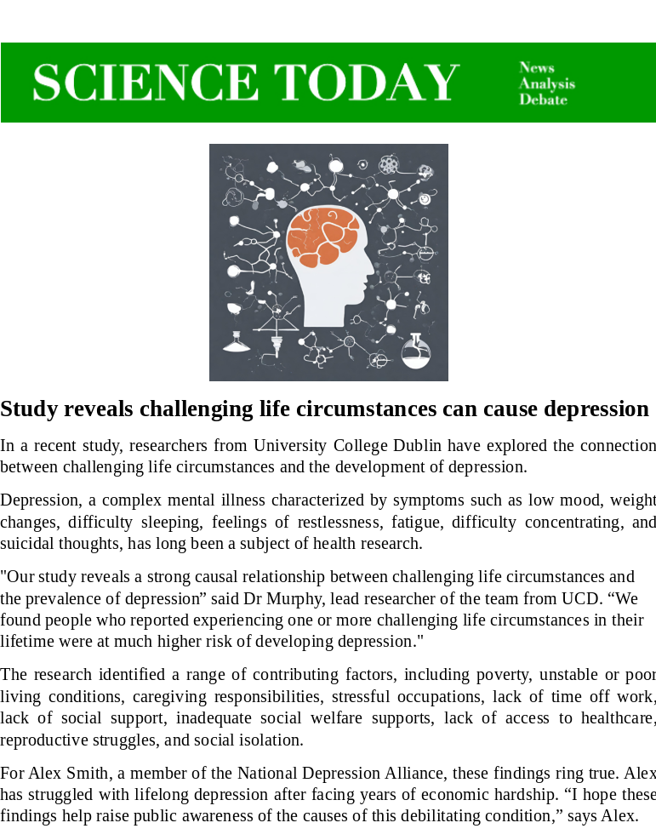
Note. All vignettes were presented using the same image and header of a fictional publication “Science Today”.

Life circumstances
In a recent study, researchers from University College Dublin have explored the connection between challenging life circumstances and the development of depression.
Depression, a complex mental illness characterized by symptoms such as low mood, weight changes, difficulty sleeping, feelings of restlessness, fatigue, difficulty concentrating, and suicidal thoughts, has long been a subject of health research.
"Our study reveals a strong causal relationship between challenging life circumstances and the prevalence of depression” said Dr Murphy, lead researcher of the team from UCD. “We found people who reported experiencing one or more challenging life circumstances in their lifetime were at much higher risk of developing depression."
The research identified a range of contributing factors, including poverty, unstable or poor living conditions, caregiving responsibilities, stressful occupations, lack of time off work, lack of social support, inadequate social welfare supports, lack of access to healthcare, reproductive struggles, and social isolation.
For Alex Smith, a member of the National Depression Alliance, these findings ring true. Alex has struggled with lifelong depression after facing years of economic hardship. “I hope these findings help raise public awareness of the causes of this debilitating condition,” says Alex.

Violence and abuse
In a recent study, researchers from University College Dublin have explored the connection between experiences of violence and abuse and the development of depression.
Depression, a complex mental illness characterized by symptoms such as low mood, weight changes, difficulty sleeping, feelings of restlessness, fatigue, difficulty concentrating, and suicidal thoughts, has long been a subject of health research.
"Our study reveals a strong causal relationship between experiences of violence and abuse and the prevalence of depression” said Dr Murphy, lead researcher of the team from UCD. “We found that people who had one or more experiences of violence or abuse in their lifetime were at much higher risk of developing depression."
The research identified a range of contributing factors, including domestic violence, physical abuse, sexual abuse or harassment, physical injuries, child neglect, or experiences of abuse in childhood.
For Alex Smith, a member of the National Depression Alliance, these findings ring true. Alex has struggled with lifelong depression after growing up in an abusive home where violence was a common occurrence. “I hope these findings help raise public awareness of the causes of this debilitating condition,” says Alex.

Relational challenges
In a recent study, researchers from University College Dublin have explored the connection between interpersonal relationship struggles and the development of depression.
Depression, a complex mental illness characterized by symptoms such as low mood, weight changes, difficulty sleeping, feelings of restlessness, fatigue, difficulty concentrating, and suicidal thoughts, has long been a subject of health research.
"Our study reveals a strong causal effect between relationship challenges and the prevalence of depression” said Dr Murphy, lead researcher of the team from UCD. “We found people who reported experiencing difficulties with relationships in their lifetime were at much higher risk of developing depression."
The research identified a range of contributing factors, including difficulties fitting in, negative influences from social groups, high levels of pressure and expectations, pressures that arise from gender norms, contact with other people with mental illness, and issues with romantic relationships.
For Alex Smith, a member of the National Depression Alliance, these findings ring true. Alex has struggled with lifelong depression stemming from a series of toxic relationships. “I hope these findings help raise public awareness of the causes of this debilitating condition,” says Alex.

Social and political unrest
In a recent study, researchers from University College Dublin have explored the connection between social and political unrest and the development of depression.
Depression, a complex mental illness characterized by symptoms such as low mood, weight changes, difficulty sleeping, feelings of restlessness, fatigue, difficulty concentrating, and suicidal thoughts, has long been a subject of health research.
"Our study reveals a strong causal effect between experiences of social and political unrest and the prevalence of depression” said Dr Murphy, lead researcher of the team from UCD. “We found people who reported experiencing one or more experiences of sociopolitical turmoil in their lifetime were at much higher risk of developing depression."
The research identified a range of contributing factors, including political instability, experiences of armed conflict, natural disasters, protests, revolutions, riots, migration, and experiences of neighbourhood violence.
For Alex Smith, a member of the National Depression Alliance, these findings ring true. Alex has struggled with lifelong depression after years of living in a region with high political instability, where violent protests were a common occurrence. “I hope these findings help raise public awareness of the causes of this debilitating condition,” says Alex.

Biological factors
In a recent study, researchers from University College Dublin have explored the connection between genetics and other biological factors and the development of depression.
Depression, a complex mental illness characterized by symptoms such as low mood, weight changes, difficulty sleeping, feelings of restlessness, fatigue, difficulty concentrating, and suicidal thoughts, has long been a subject of health research.
"Our study reveals a strong causal relationship between various heredity and other biological factors and the prevalence of depression” said Dr Murphy, lead researcher of the team from UCD. “We found that people who had one or more of these biological features were at much higher risk of developing depression."
The research identified a range of contributing factors, including having a family member with depression, injuries to the brain, chemical imbalance in the brain, and other issues with brain functionality.
For Alex Smith, a member of the National Depression Alliance, these findings ring true. Alex has struggled with lifelong depression, much like several of Alex’s family members. “I hope these findings help raise public awareness of the causes of this debilitating condition,” says Alex.

Source: Authors own work.

