Appendix A

Sample and Data Description
American Idol is a singing contest that aims to discover singing talent. It has become popular due to viewers’ ability to vote for their favorites and due to the entertaining input of performers and judges. Over the years, American Idol has featured celebrity judges that offered professional input regarding the quality of the contestants. The contestants undergo several qualifying rounds up until the final stage, when, the final 12 performances are broadcasted in prime time, in front of the entire audience. Each finalist performs songs based on a weekly theme which may be a musical genre or a specific artist’s catalog pick, with the judges making their critiques after each performance. During the show run, every week, each contestant is observed and reviewed by three different celebrity experts. The viewing public then votes for the contestants, and the outcome of the public votes is then revealed in the results show, typically on the following night. In the first part of the show, contestants are required to perform only one musical piece. Later, after seven contestants have been eliminated, the remaining contestants are required to perform two musical pieces. In the final week, the top 2 contestants perform three songs each and the voting ends the same night.
Our data consist of 10 weeks of coded performance evaluations (up to the final week) as well as verbatim judges’ reviews. We also collected ten weeks of performance quality ratings from MSNBC, which runs a weekly American Idol coverage, where, after the show, a non-celebrity expert, assigns grades to each the performers. This was included to capture the unbiased rating from an entity non-associated or affiliated with the show and provides a valid proxy for quality of the performances. Since these ratings are provided after the show, they are unlikely to affect voting.
In general, in studies of user generated content, it is difficult to ensure that review aggregators or consumers that create content have been exposed to the full variety of products available. Therefore, there is an inherent error in all the reviews of ratings. In this regard, our data set offers a unique degree of completeness due to the structure of the show and the fact that the audience enjoying the singing performance is immediately exposed to celebrity expert reviews. Moreover, the entire expert panel reviews all contestants, without exception. This one-to-one correspondence between judges and contestant represents a rare characteristic in online or offline word of mouth, consumer, or expert generated content studies. Also, the format of the show assures the random order of entry for a contestant to perform and for judges to start the performance evaluation. In total, 225 observations have been recorded for the entire show and represent the sample used in subsequent analyses (36 reviews for the first 12 contestants in week 1, 33 for week two and so on).
Appendix B
Table 1: Variable definition, source, and operationalization
Concept | Definition | Data Collection Mode | Source/Adapted from | Operationalization
Dependent Variable

Brand Performance | Probability of surviving the week | Observed | Sinha, R. K., & Noble, C. H. (2008). The adoption of radical manufacturing technologies and firm survival. Strategic Management Journal, 29(9), 943-962. | 0/1 (1 stands for ‘survival’ at the end of the week, and 0 for ‘elimination’)
Independent Variables
Subjective Valence | The strength of a review that contains subjective claims | Coded | Eliashberg, J., & Shugan, S. M. (1997). Film critics: Influencers or predictors? Journal of Marketing, 61, 68–78. | 1 to 7 scale, where 1 represents ‘extremely negative, and 7 represents ‘extremely positive
Objective Valence | The strength a review that contains objective claims | Coded | Eliashberg, J., & Shugan, S. M. (1997). Film critics: Influencers or predictors? Journal of Marketing, 61, 68–78. | 1 to 7 scale, where 1 represents ‘extremely negative, and 7 represents ‘extremely positive
Subjective Depth | The number of statements that fall under the subjective category | Count variable | Mudambi, S. M., & Schuff, D. (2010). Research note: What makes a helpful online review? A study of customer reviews on Amazon. com. MIS quarterly, 185-200.
Objective Depth | The number of statements that fall under the subjective category | Count variable | Mudambi, S. M., & Schuff, D. (2010). Research note: What makes a helpful online review? A study of customer reviews on Amazon. com. MIS quarterly, 185-200.
Control variables
Performance Quality | Professional evaluation of the performance | Secondary data | https://www.today.com/popculture/tuesday-night-six-pack-wbna7646740 | 1 to 10 score
Order of Entry | The order in which the contestant performed on the show during the given week | Count variable |  | 1-12
Week Number | The week of performance | Count variable |  | 1-10
Song Popularity | Popularity of song as measured by highest ranking on Billboard top 100 | Secondary Data | www.billboard.com
Line | The number of different musical genres performed by the contest to date | Count variable | www.billboard.com | 1-5

Appendix C
Independent Variables: Reviews were coded sentence by sentence in accordance with a thought-listing procedure (Cacioppo et al. 1997) and a semantic sentiment analysis technique (de Albornoz et al., 2012; Wei et al., 2010,). Our textual analysis proceeded as follows. First, every review was broken down in simple statements which were then classified based on claim type (Objective/Subjective). To accurately classify statements as subjective, we adopted a list of subjective positive and negative adjectives as defined in the General Inquirer (Stone et al., 1966). This list allows identification of phrases or expressions from the review statements that pertain to the personal subjective self. Furthermore, the valence (numerical score) of each phrase was assessed using a scale of 1 to 7, where 1 represents ‘extremely negative, and 7 represents ‘extremely positive subjective or objective evaluations. The scale intensity was adapted from the comparative and superlative adjective Oxford English dictionary, following accepted procedures in content or text analysis. This is usually done by use of a scaling system where word dictionaries are given associated ratings of intensity, to indicate the extent of positivity or intensity of a certain feature. Each phrase can be associated to an emotion, a product feature, or a specific topic. Adapting these techniques, we proceeded to content code all the reviews. However, to overcome the inherent shortcomings associated with this approach, we aimed to improve the content analysis accuracy by also listening to the live reviews from the show.
In the first phase, the data was coded by a trained research assistant who was provided with the definitions, examples, and word modifier examples to quantify the intensity of the statements. Each statement received a score, and in the end, two average scores were calculated for each performer, for each performance: a subjective and an objective valence.
To assess the quality of the coding, a second (graduate) research assistant was trained to code the same data, separately. The intra-class correlation coefficient for subjective reviews is .811, and .819 for objective reviews, which indicates a good level of inter-coder reliability, based on the criteria of Landis and Koch (1977). This compares favorably with studies that have used a similar approach (i.e., Tellis & Johnson, 2007). The average scores for subjective and objective statements in each review were then computed and form our independent variables, Subjective Valence and Objective Valence. Next, we calculated the total number of objective and subjective statements to form our Objective Depth and Subjective Depth variables.
References:
Cacioppo, J. T., Von Hippel, W., & Ernst, J. M. (1997). Mapping cognitive structures and processes through verbal content: The thought-listing technique. Journal of Consulting and Clinical Psychology, 65(6), 928. https://doi.org/10.1037/0022-006X.65.6.928
de Albornoz, J. C., Plaza, L., & Gervás, P. (2012, May). SentiSense: An easily scalable concept-based affective lexicon for sentiment analysis. LREC, 3562-3567.
Landis, J.R., Koch, G.G. (1977). The measurement of observer agreement for categorical data. Biometrics, 33, 159–174. https://doi.org/10.2307/2529310
Stone, P.J., Dumphy, D.C., and Ogilvie, D.M. (1966) The General Inquirer: A Computer Approach to Content Analysis -((www://wjh.harvard.edu/~inquirer).
Tellis, G. J., & Johnson, J. (2007). The Value of Quality: Stock Market Returns to Published Quality Reviews. Marketing Science, 26, 742-756. https://doi.org/10.2139/ssrn.1121481
Wei, C. P., Chen, Y. M., Yang, C. S., & Yang, C. C. (2010). Understanding what concerns consumers: a semantic approach to product feature extraction from consumer reviews. Information Systems and E-Business Management, 8(2), 149-167. https://doi.org/10.1007/s10257-009-0113-9
Appendix D
Control Variables: To tease out the impact of the reviews and distinguish it from the impact of the quality of the performance on the probability of survival, we used expert quality ratings as a control variable. Each week, an MSNBC expert contributor wrote a review pertaining to last week’s performances on American Idol (see Figure 1). Every contestant was assigned a letter grade, from A to D, which reflected his or her level of performance. The expert assigned the grades by critically evaluating the professional aspects of the performer such as vocals, stage presence, etc. Literature has shown that these types of expert ratings can be used to measure the true quality of a product (Mitra and Golder, 2007). The letter system was transformed into a rating scale to create the Performance Quality variable. For example, letter grade ‘A’ was equivalent of 10 points and letter grade ‘D’ the equivalent of 1 point (Liu, 2006). Note that this expert review is an instrument to control for the quality of the performance on stage.
A viewer’s evaluation of a performance on stage may be different for contestants performing first, compared to contestants performing last. To control for such effects, we used the order of contestant entry as a control variable. Given that, as the weeks progress, the probability of success for a given contestant may increase in part since there are less and less contestants remaining, we controlled for the performance-week number. To control for popularity of the song chosen by competitors, a variable quantifying the highest position a song has attained in Billboard Top 100 was added. As the contestants are trying to prove themselves each week, the ability to navigate between various musical genres is important. We use a Line variable that captures the number of different musical genres (i.e., country, rock, pop) that the contestant has covered in the show. For the first week, each contestant has a line of 1 which will remain unchanged until the contestant tries another genre, then, this variable will increase by 1. Thus, if a contestant has covered three different musical genres, the variable will have the value of 3.
To account for each individual reviewer’s idiosyncratic effects beyond the verbal statements, we used dummy variables (e.g., Randy and Paula to capture the individual reviewer effects in comparison to Simon). Finally, we also control for the contestant gender.
Figure 1: Performance Quality (May 5th, 2005)
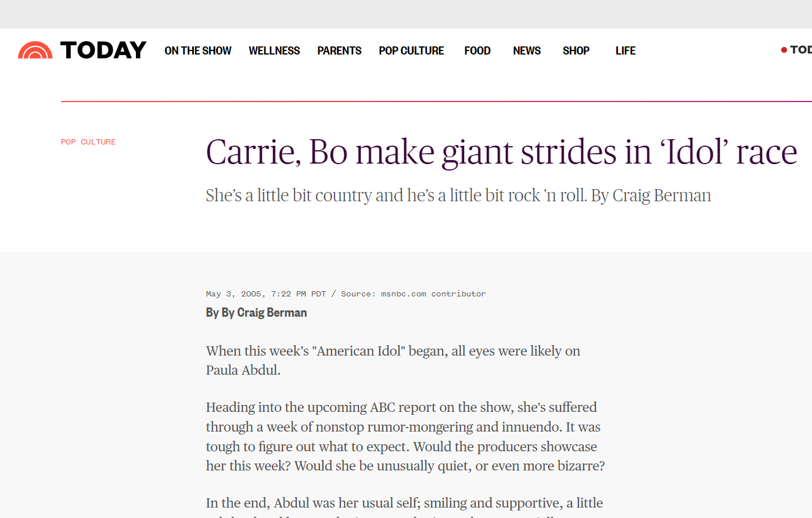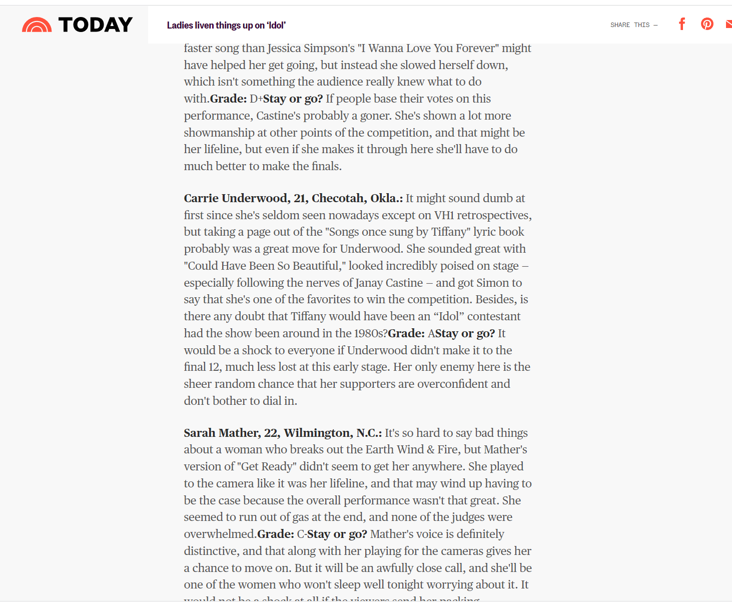
References:
Liu, Y. (2006). Word of mouth for movies: Its dynamics and impact on box office revenue. Journal of marketing, 70(3), 74-89. https://doi.org/10.1509/jmkg.70.3.074
Mitra, D., & Golder, P.N. (2007). Quality is in the Eye of the Beholder. Harvard Business Review, 85, 26-28.

Appendix E
Table 1: Sample codes
Numerical scale | Song /Song choice | Performance/Showmanship/Stage presence | Vocals | Style/Appearance/Outfit | Personality/Likeability/Individuality
1-extremely bad | I think 30 million TV sets in America had their volume turned down simultaneously during that song. | [..]but that definitely sounded like I was  in a bad hotel seeing a very below average performance.
2-very bad | I thought it was just a very boring, uninspiring song. | I don’t know if you were singing completely on mike or not, but it wasn’t my favorite performance | Nikko, forgive me, because I thought you sounded horrible.
3-bad |  | A little pitchy performance here and there; Didn’t show your range | I mean, mostly in tune. |  | I think that what you’ve done throughout the competition since we’ve seen you is stay absolutely in the middle
4-nor good nor bad |  | It was ‘okay’
5-good |  | Jessica, you got it going on. | Carrie, Carrie, Carrie. I have high hopes for you because  I think you got one of the better voices in this competition |  | You were having fun.
6-very good | Ahh, very ambitious song choice. I mean, it’s a big song. |  |  | You look beautiful and you sounded really lovely tonight. | There are three people in this competition who actually know who they are musically and you are one of them
7-extremely good |  |  | We’re used to hearing your voice extremely open and big because your voice is flawless. | I think if this was smoldering idol, you’d win hands down | You’re already a superstar. You’re a superstar

*Bolded codes are examples of subjective claims
Appendix F
Comparison of early versus late inception periods:
Given that H3 and H4 involve the comparison of early versus late inception periods, we included a dummy variable called LateStageDummy to denote the late inception period (defined as periods 9 and above). We selected the last two weeks of the show to be designated as ‘late inception’ because after week 8, there is a natural break in the show format, where the remaining contestants are required to have a double stage performance and because the last two weeks have been symbolically associated with ‘coming of age’ during the show run. After including a dummy variable for the late inception period, we estimated the following model:

(2)Supplementary file

