Appendix
A. Pretest

1. If you want to plan a one-day family-trip, which information is relevant to planning this trip?
A. Tourist spots, Restaurants, Souvenir shops
B. Duration, Tourist spots, Distance
C. Hotels, Duration, Distance
D. Restaurants, Hotels, Tourist spots

2. Why should we set decision criteria for purchasing goods instead of buying based solely on desire?
A. It ensures getting the cheapest products.
B. It prevents fraud when purchasing goods online.
C. It allows comprehensive consideration of information and reveals valuable options.
D. All the above.

3. Before scanning a PromtPay QR code to pay for goods/services, what should you check?
A. Recipient's name and amount
B. Account number and transfer time
C. Recipient's name and account number
D. Transfer time and amount

4. If you are working with an online application and cannot save the latest work, what do you think is the cause?
A. The device screen is malfunctioning.
B. The device's memory is full.
C. You do not have permission to access the file.
D. Internet connection was interrupted while working.

5. Which of the following is a work without copyright?
A. A journalist reporting daily news
B. Tony writing a new song titled "After the rain stops"
C. Joey creating and posting a quote on Facebook
D. Emma adding text to a photo she took, saying "Happy Monday"

6. Which statements show an action that prevents social media AI technology from influencing behavior and thoughts?
A. Setting time limits for social media usage
B. Disabling notification recommendations
C. Thoroughly researching information
D. All the above

B. Posttest

1. A family wants to choose a place to go for a weekend trip. They are interested in six places: the zoo, floating market, waterfall, café, museum, and dam. Each family member rated these places from most to least interested as follows:
Father: Zoo > Dam > Museum > Waterfall > Floating Market > Café
Mother: Floating Market > Café > Waterfall > Zoo > Dam > Museum
Child 1: Zoo > Museum > Dam > Waterfall > Floating Market > Café
Child 2: Café > Floating Market > Waterfall > Dam > Zoo > Museum
Based on the given information, which places can be arranged for a trip that satisfies everyone the most?

A. Zoo, Floating Market, Dam, Waterfall
B. Museum, Zoo, Café, Floating Market
C. Floating Market, Café, Dam, Waterfall
D. Café, Museum, Dam, Waterfall

2. A shop has a payment process as shown in the flowchart (See Fig. A1). If Albert buys items price 350 THB for rice, 65 THB for water, 60 THB for cooking oil, and 70 THB for chicken breast, which step in the payment process will not be performed?

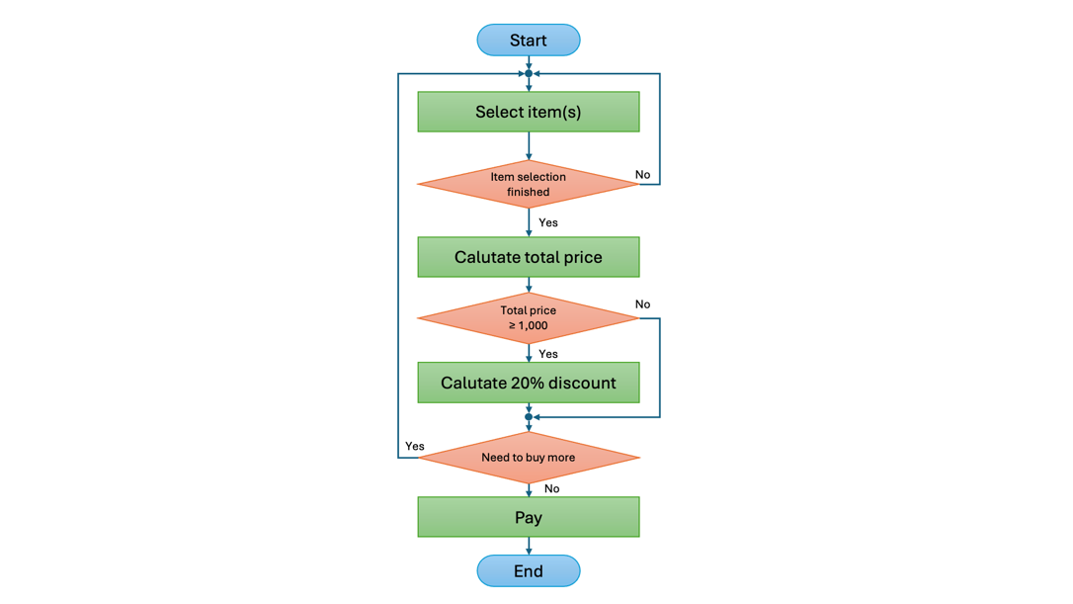
Fig A1: A payment process flowchart

A. Selecting item(s)
B. Calculating the total price
C. Calculating a 20% discount
D. All the above performed

3. See the comparison table below (Table A1) for answer. If you are deciding to buy an electric car, from which dealer is worth to buy it?

Table A1: conditions of electric car dealers’ sale promotions.
Promotion | Dealer A | Dealer B | Dealer C
Price | 835,000 THB | 825,500 THB | 830,000 THB
Reservation Fee | 1,000 THB | 3,000 THB | Free
Discount | Cash discount of 25,000 THB | 2% cashback | None
Freebies | Compulsory Motor Insurance + First Class Insurance + Car Accessories + Car Cover + Free Car Wash for 1 Year | Compulsory Motor Insurance + First Class Insurance | Compulsory Motor Insurance + First Class Insurance + Electric Bicycle worth 5,000 THB
Waiting Time for Car Delivery | Not more than 1 month | Not more than 2 months | Not more than 3 months
Warranty | 5 years or 100,000 kilometers | 5 years or 100,000 kilometers | 5 years or 100,000 kilometers

A. Dealer A
B. Dealer B
C. Dealer C
D. Dealer A or C

4. Vichai underwent COVID-19 screening using technology according to the flowchart below (See Fig. A2). After the test, Vichai said, “Luckily, the ATK test result is negative.” Which step in the flowchart will not be performed based on Vichai’s statement?

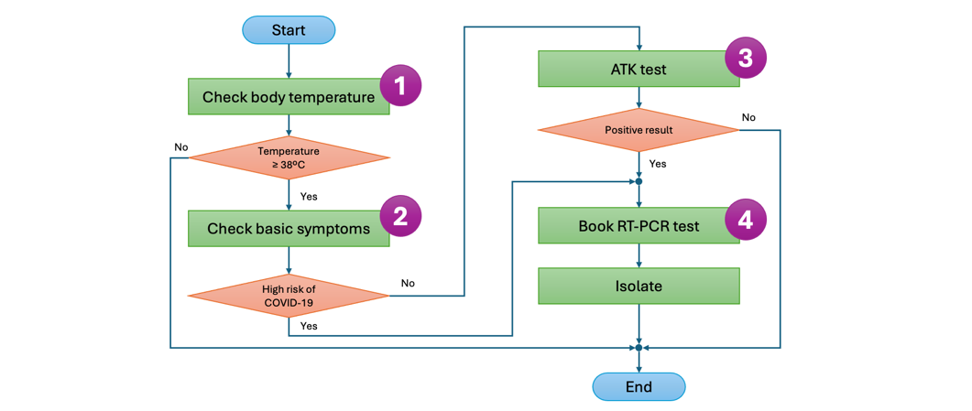
Fig. A2: The COVID-19 screening process flowchart

A. Step 1
B. Step 2
C. Step 3
D. Step 4

5. Robert, a new delivery employee, was assigned to deliver goods to 4 spots (i.e., A, B, C, D), each at different distances according to the map (See Fig. A3). The company requires the delivery to be as fuel-efficient as possible. What should be Robert's shortest route to save fuel?

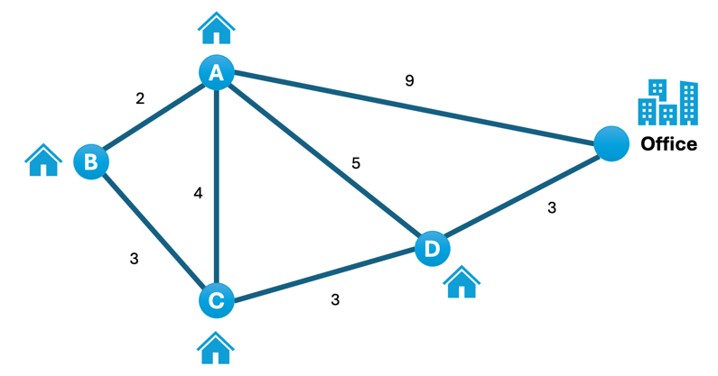
Fig. A3: Delivery spots map

A. Office > D > C > B > A > D > Office
B. Office > D > A > B > C > D > Office
C. Office > D > A > C > B > A > Office
D. Routes in choices A and B are correct

6. If you want to buy a vacuum cleaner sold online, what do you need to check before purchasing?

1) Click to buy from a shop offering flash deals before the desired vacuum cleaner price disappears
2) Read reviews from previous buyers, compare the prices of the desired vacuum cleaner, and choose a shop with more than 4 stars rating
3) Research and buy from platforms that allow customers to accept the product and get a refund if it’s not as described
4) Chat directly with the seller and transfer 50% of the payment through chat to reserve the vacuum cleaner

A. Options 1 and 2
B. Options 2 and 3
C. Options 1 and 4
D. Options 2 and 4

7. Which method is used to verify and authenticate the account owner from the bank's automatic system when using an application to pay for goods or services?

A. Victor scans a QR Code to pay at the Robert Café and Mr. Robert’s name appears on the payment receipt
B. Tommy creates a QR Code to receive money from customers to transfer into his wallet account and prints the code for customers to see
C. George sets up facial recognition instead of entering a password to verify his identity before using the wallet app
D. Willson pays for a hotel by transferring money via the app and receives an OTP code via SMS to confirm the payment

8. What are the advantages of using online working applications?

1) Collaborating with others instantly, even from different locations
2) Automatically saving work without needing the computer’s memory
3) Accessible when connected to the internet
4) Restricting file access; if access is not granted, the file cannot be edited

A. Options 1 and 2
B. Options 3 and 4
C. Options 1, 2, and 4
D. Options 1, 2, 3, and 4

9. Read the following scenarios of using smartwatches in daily life:

1) Sarah sets an alarm with music, checks the weather forecast through the Weather app, and can receive important calls or urgent messages without carrying her smartphone.
2) Kim connects wireless earphones to listen to music through the Music app.
3) Tatum keeps records of the calories burned, exercise time, heart rate, and blood oxygen level.
4) Poppy measures ECG with the EKG app due to a heart condition, and if a severe fall occurs, it automatically calls emergency numbers.

If you have a smartwatch and want to manage and analyze data for planning your weight control, whom should you consult?

A. Sarah
B. Kim
C. Tatum
D. Poppy

10. The current process of paying with a QR Code instead of cash involves the following steps:
1) Entering the password to open the wallet application
2) Selecting scan to pay
3) Scanning the QR Code
4) Entering the amount to be paid
5) Reviewing and confirming the payment
6) Saving the payment receipt image

Which steps should users be aware of and cautious about regarding personal data and preventing transaction errors?

A. Steps 1 and 5
B. Steps 3 and 5
C. Steps 1, 3, and 5
D. Steps 1, 5, and 6

11. From the news “State Welfare Card” in July 2022, extending the LPG discount is real or fake, and why?
Source: https://www.bangkokbiznews.com/business/1012718

A. It’s a fake news because the details are insufficient and its propaganda
B. It’s a real news because people agree with the government and like the policy
C. It’s a fake news because it’s an unnamed news website with unclear intentions
D. It’s a real news because the source and reliability of the news can be verified

12. How to use images from the internet legally?
A. Search on Google, find a liked image, and use it immediately
B. Search on Google, then use images considering the Creative Commons license
C. Use images from a famous photographer’s website and credit the image in the work
D. Use images sent by friends through LINE

13. Which action is inappropriate when dealing with cyberbullying?
A. Stay strong, endure, smile, and not value the hurtful words
B. Block the bully to prevent them from posting or contacting you
C. Use harsher words to retaliate and show the bully you’re not weak
D. Tell a trusted person for help, and if it’s a serious legal matter, gather information and report it to the officers

14. Which statement indicates the use of artificial intelligence to analyze and utilize human data?

1) Recommending products and displaying ads on the feed based on Google searches
2) Showing photos, news, videos of favorite actors on social media like Facebook, Instagram, Twitter based on likes and follows
3) Suggesting new friends or acquaintances from the same school or with similar interests like diving, photography through social media
4) Selling movie tickets, recommending payment methods like bank transfers or QR code payments with special discounts from various companies

A. Option 4
B. Options 3 and 4
C. Options 1, 2, and 3
D. Options 1, 2, and 4

15. Who evaluates information in the most unbiased manner?

A. Charlie starts trying the keto diet after receiving shared benefits from a friend in a Line group and researching drawbacks from online articles
B. Nina buys all products endorsed by a famous idol in advertisements
C. Garfield imagines buying a house in the Romyen village after seeing its grand opening
D. Yuya books a ticket to see the movie "Love Destiny 2" after media reported it grossed over 100 million Baht

